INTERNET PROGRAMMING LAB RECORD
PROGRAM 12
INSUREEASY – ONLINE INSURANCE MANAGEMENT SYSTEM
Name:P.Ranjithkumar
Regno:192411119
Course code:CSA4304
AIM
To design a simple, responsive InsureEasy website that allows users to view insurance policies, compare policy details, register as users, and manage insurance information using HTML, CSS, and JavaScript.
TOOLS REQUIRED
HTML5, CSS3, JavaScript, and a web browser such as Google Chrome or Microsoft Edge.
ALGORITHM
- Start the program.
- Create the webpage structure using HTML.
- Add insurance policy cards for health, auto, and home insurance.
- Style the webpage and policy cards using CSS.
- Use JavaScript to search and filter insurance policies.
- Display policy details when the user clicks the View Details button.
- Test the webpage in a browser.
- Stop the program.
PROGRAM
Create a folder named InsureEasy and save the following three files inside it.

1. index.html
<!DOCTYPE html>
<html lang="en">
<head>
<meta charset="UTF-8">
<meta name="viewport" content="width=device-width, initial-scale=1.0">
<title>InsureEasy - Insurance Management</title>
<link rel="stylesheet" href="style.css">
</head>
<body>
<header>
<h1>InsureEasy</h1>
<p>Your Protection, Our Priority</p>
<nav>
<a href="#home">Home</a>
<a href="#policies">Policies</a>
<a href="#login">Login / Register</a>
</nav>
</header>
<main id="home">
<section class="welcome">
<h2>Welcome to InsureEasy</h2>
<p>Compare and choose the right insurance policy for you.</p>
</section>
<section id="policies">
<h2>Available Insurance Policies</h2>
<div class="filters">
<input type="text" id="search" placeholder="Search insurance policies...">
<select id="category">
<option value="all">All Policies</option>
<option value="Health">Health Insurance</option>
<option value="Auto">Auto Insurance</option>
<option value="Home">Home Insurance</option>
</select>
<button onclick="searchPolicies()">Search</button>
</div>
<div class="policy-grid">
<article class="policy" data-category="Health">
<div class="policy-image">🏥</div>
<h3>Health Insurance</h3>
<p>Medical expenses and hospital coverage.</p>
<p class="price">₹8,000 / year</p>
<button onclick="viewDetails('Health Insurance', '₹8,000 per year', 'Medical expenses and hospital coverage.')">View Details</button>
</article>
<article class="policy" data-category="Auto">
<div class="policy-image">🚗</div>
<h3>Auto Insurance</h3>
<p>Protection against vehicle accidents.</p>
<p class="price">₹5,000 / year</p>
<button onclick="viewDetails('Auto Insurance', '₹5,000 per year', 'Vehicle accident and damage coverage.')">View Details</button>
</article>
<article class="policy" data-category="Home">
<div class="policy-image">🏠</div>
<h3>Home Insurance</h3>
<p>Protect your home and belongings.</p>
<p class="price">₹6,000 / year</p>
<button onclick="viewDetails('Home Insurance', '₹6,000 per year', 'Protection for your home and belongings.')">View Details</button>
</article>
</div>
<p id="message" aria-live="polite"></p>
<div id="details" class="details" hidden>
<h3 id="detailName"></h3>
<p id="detailDescription"></p>
<p id="detailPrice"></p>
<button onclick="applyPolicy()">Apply Now</button>
<button onclick="closeDetails()">Close</button>
</div>
</section>
<section id="login" class="login-section">
<h2>User Registration</h2>
<form id="registerForm">
<input type="text" id="name" placeholder="Enter your name" required>
<input type="email" id="email" placeholder="Enter your email" required>
<input type="password" id="password" placeholder="Create a password" minlength="6" required>
<button type="submit">Register</button>
</form>
<p id="registerMessage" aria-live="polite"></p>
</section>
</main>
<footer>
<p>&copy; 2026 InsureEasy Insurance Management System</p>
</footer>
<script src="script.js"></script>
</body>
</html>

2. style.css
* {
box-sizing: border-box;
}
body {
margin: 0;
font-family: Arial, sans-serif;
background: #f3f6fa;
color: #263445;
}
header {
background: #155e9b;
color: white;
text-align: center;
padding: 20px;
}
header h1 {
margin: 0;
}
nav {
margin-top: 15px;
}
nav a {
color: white;
text-decoration: none;
margin: 0 12px;
}
main {
max-width: 1100px;
margin: 25px auto;
padding: 0 16px;
}
.welcome {
text-align: center;
background: #dceeff;
padding: 25px;
border-radius: 10px;
margin-bottom: 25px;
}
h2 {
color: #155e9b;
}
.filters {
display: flex;
flex-wrap: wrap;
gap: 10px;
margin-bottom: 20px;
}
input, select, button {
padding: 11px;
border: 1px solid #bdc9d6;
border-radius: 5px;
font-size: 15px;
}
input {
flex: 1;
min-width: 180px;
}
button {
background: #155e9b;
color: white;
border: none;
cursor: pointer;
}
button:hover {
background: #0d416e;
}
.policy-grid {
display: grid;
grid-template-columns: repeat(3, 1fr);
gap: 18px;
}
.policy {
background: white;
padding: 18px;
border-radius: 10px;
text-align: center;
box-shadow: 0 2px 8px #d6dfe8;
}
.policy-image {
background: #e3f0fc;
padding: 20px;
font-size: 45px;
border-radius: 8px;
}
.price {
color: #155e9b;
font-weight: bold;
}
.details {
background: white;
padding: 20px;
margin-top: 20px;
border-radius: 8px;
box-shadow: 0 2px 8px #d6dfe8;
}
.login-section {
margin-top: 35px;
padding: 20px;
background: white;
border-radius: 10px;
}
#registerForm {
display: flex;
flex-direction: column;
gap: 12px;
max-width: 450px;
}
#message, #registerMessage {
font-weight: bold;
color: #155e9b;
}
footer {
text-align: center;
background: #dce6ef;
padding: 15px;
margin-top: 30px;
}
@media (max-width: 750px) {
.policy-grid {
grid-template-columns: repeat(2, 1fr);
}
}
@media (max-width: 480px) {
.policy-grid {
grid-template-columns: 1fr;
}
nav a {
display: inline-block;
margin: 6px;
}
.filters {
flex-direction: column;
}
.filters input,
.filters select,
.filters button {
width: 100%;
}
}

3. script.js
function searchPolicies() {
const searchText = document.getElementById("search")
.value.trim().toLowerCase();
const category = document.getElementById("category").value;
const policies = document.querySelectorAll(".policy");
let count = 0;
policies.forEach(function(policy) {
const name = policy.querySelector("h3")
.textContent.toLowerCase();
const categoryMatch =
category === "all" || policy.dataset.category === category;
const searchMatch = name.includes(searchText);
if (categoryMatch && searchMatch) {
policy.style.display = "block";
count++;
} else {
policy.style.display = "none";
}
});
document.getElementById("message").textContent =
count + " insurance policy/policies found.";
document.getElementById("details").hidden = true;
}
function viewDetails(name, price, description) {
document.getElementById("detailName").textContent = name;
document.getElementById("detailPrice").textContent =
"Premium: " + price;
document.getElementById("detailDescription").textContent = description;
document.getElementById("details").hidden = false;
document.getElementById("details").scrollIntoView({
behavior: "smooth",
block: "nearest"
});
}
function closeDetails() {
document.getElementById("details").hidden = true;
}
function applyPolicy() {
const name = document.getElementById("detailName").textContent;
alert("You selected " + name +
". Contact the insurance agent to complete your application.");
}
document.getElementById("registerForm").addEventListener("submit", function(event) {
event.preventDefault();
const name = document.getElementById("name").value.trim();
document.getElementById("registerMessage").textContent =
"Registration successful! Welcome, " + name + ".";
this.reset();
});

OUTPUT
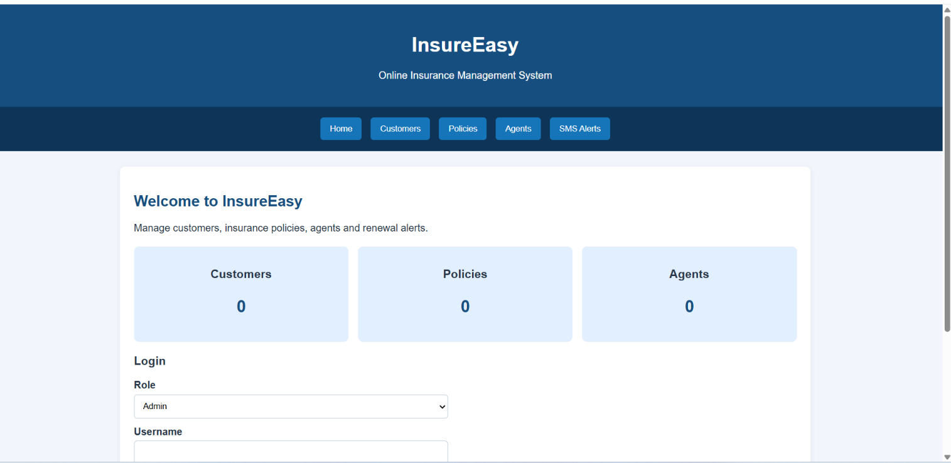
RESULT
Thus, a responsive InsureEasy insurance management webpage was created successfully using HTML, CSS, and JavaScript. It supports policy searching, category filtering, viewing policy details, and a demonstration registration form. This is a frontend demonstration; it does not connect to a real database, payment gateway, SMS service, or insurance provider.

