INTERNET PROGRAMMING LAB
EXPERIMENT – 5
ONLINE FLIGHT RESERVATION SYSTEM
Name | P. Ranjithkumar
Register Number | 192411119
Course code | CSA4304

AIM
To design a simple Online Flight Reservation System using HTML, CSS, and JavaScript that allows users to search for flights by entering the departure and destination cities and view the available flights and fares.

TOOL REQUIRED
1. Visual Studio Code or any text editor
2. Web browser (Google Chrome, Microsoft Edge, etc.)
3. HTML, CSS, and JavaScript

ALGORITHM
1. Start the program.
2. Create an HTML page containing input fields for the departure and destination cities.
3. Use CSS to style the page, search form, and flight result cards.
4. Create sample flight data in JavaScript with source, destination, flight name, and fare.
5. Read the cities entered by the user and compare them with the sample flight data.
6. Display matching flights and their fares. If no flight matches, display a message.
7. Stop the program.

PROGRAM

File 1: index.html
<!DOCTYPE html>
<html lang="en">
<head>
<meta charset="UTF-8">
<meta name="viewport" content="width=device-width, initial-scale=1.0">
<title>Online Flight Reservation</title>
<link rel="stylesheet" href="style.css">
</head>
<body>
<div class="container">
<h1>Online Flight Reservation</h1>
<p>Search available flights and check fares</p>
<div class="search-box">
<input type="text" id="from" placeholder="Departure city">
<input type="text" id="to" placeholder="Destination city">
<button onclick="searchFlights()">Search Flights</button>
</div>
<div id="results"></div>
</div>
<script src="script.js"></script>
</body>
</html>

File 2: style.css
body {
font-family: Arial, sans-serif;
background: #eef4fa;
margin: 0;
padding: 20px;
}
.container {
max-width: 800px;
margin: 30px auto;
background: white;
padding: 25px;
border-radius: 10px;
text-align: center;
box-shadow: 0 3px 12px #ccd4dd;
}
h1 { color: #174a7e; }
.search-box {
display: flex;
gap: 10px;
justify-content: center;
flex-wrap: wrap;
margin: 20px 0;
}
input, button {
padding: 12px;
border: 1px solid #bbb;
border-radius: 5px;
font-size: 15px;
}
button {
background: #1769aa;
color: white;
border: none;
cursor: pointer;
}
button:hover { background: #0d4f85; }
.flight {
border: 1px solid #d5e0eb;
padding: 15px;
margin: 12px 0;
border-radius: 7px;
text-align: left;
}
.flight h3 { margin-top: 0; color: #174a7e; }
.fare { font-weight: bold; color: #16804a; }
@media (max-width: 600px) {
.container { padding: 15px; margin: 10px auto; }
input, button { width: 100%; box-sizing: border-box; }
.search-box { flex-direction: column; }
}

File 3: script.js
const flights = [
{ name: "Air India AI101", from: "Chennai", to: "Delhi", fare: 5200 },
{ name: "IndiGo 6E202", from: "Chennai", to: "Mumbai", fare: 4300 },
{ name: "SpiceJet SG303", from: "Bengaluru", to: "Hyderabad", fare: 2800 },
{ name: "IndiGo 6E404", from: "Delhi", to: "Chennai", fare: 5100 },
{ name: "Air India AI505", from: "Mumbai", to: "Bengaluru", fare: 3900 }
];
function searchFlights() {
const from = document.getElementById("from").value.trim().toLowerCase();
const to = document.getElementById("to").value.trim().toLowerCase();
const results = document.getElementById("results");
if (!from || !to) {
results.innerHTML = "<p>Please enter both departure and destination cities.</p>";
return;
}
const found = flights.filter(f =>
f.from.toLowerCase() === from && f.to.toLowerCase() === to
);
if (found.length === 0) {
results.innerHTML = "<p>No flights found for this route.</p>";
return;
}
results.innerHTML = found.map(f => `
<div class="flight">
<h3>${f.name}</h3>
<p><strong>From:</strong> ${f.from}</p>
<p><strong>To:</strong> ${f.to}</p>
<p class="fare">Fare: ₹${f.fare}</p>
</div>
`).join("");
}

OUTPUT
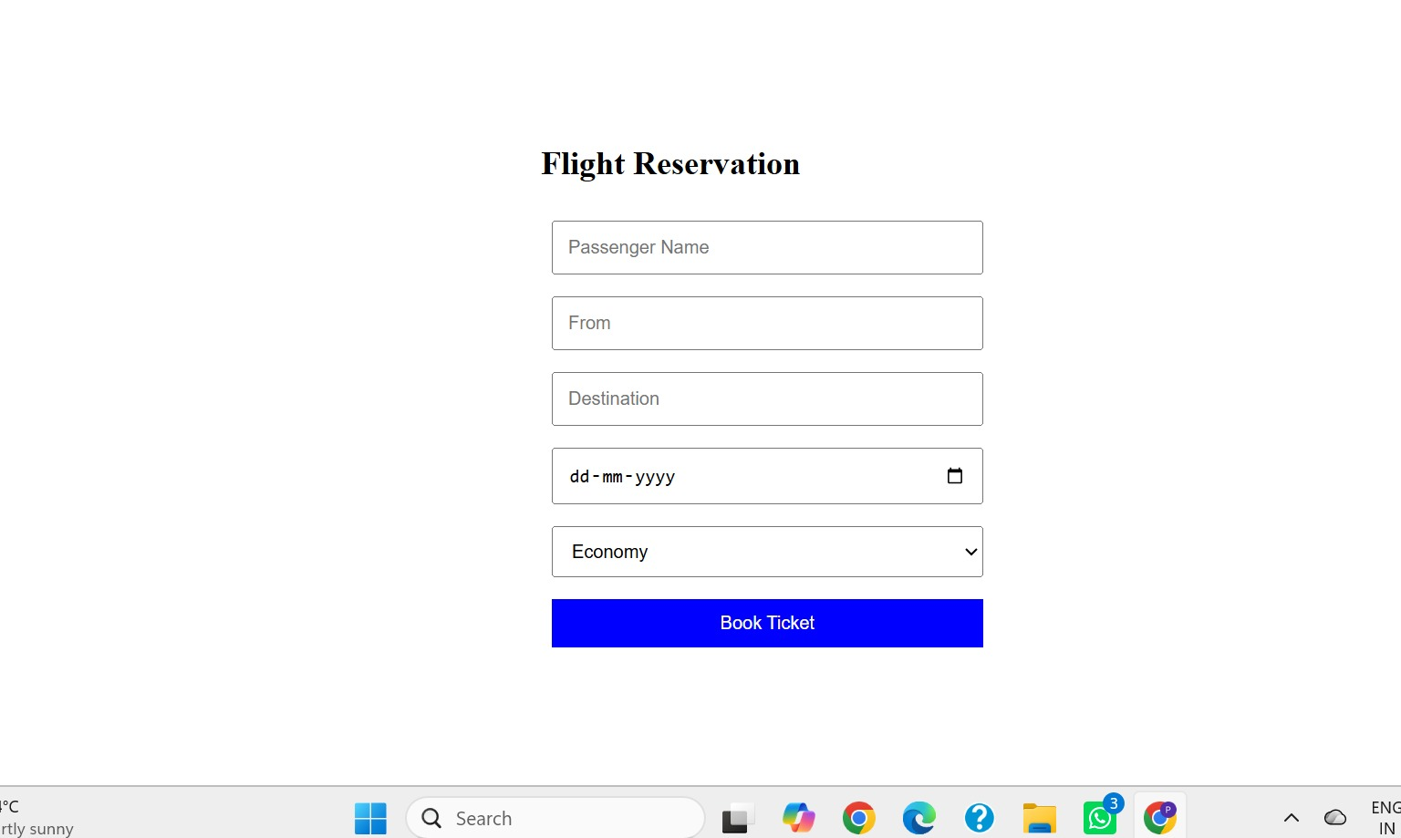

RESULT
Thus, a simple Online Flight Reservation System was designed successfully using HTML, CSS, and JavaScript. It allows users to search sample flight routes and view their fares. This is a front-end demonstration and does not perform real booking or payment.

