INTERNET PROGRAMMING LAB
Name: P. Ranjithkumar
Reg: 192411119
Course code: CSA4304
Experiment: Online Hotel Room Booking System
1. AIM
To design and develop a simple Online Hotel Room Booking System using HTML, CSS, and JavaScript to search hotels, view room details, and check room availability.
2. TOOL
- Visual Studio Code
- Web Browser
- HTML
- CSS
- JavaScript
3. ALGORITHM
- Start the program.
- Create the hotel booking webpage using HTML.
- Apply styles using CSS.
- Display the available hotels and room prices.
- Allow users to enter a destination and number of guests.
- Use JavaScript to search hotels matching the destination.
- Display matching hotels or a no-results message.
- Stop the program.
4. PROGRAM
File 1: index.html
<!DOCTYPE html>
<html>
<head>
<title>Hotel Room Booking</title>
<link rel="stylesheet" href="style.css">
</head>
<body>
<h1>Online Hotel Booking</h1>

<input type="text" id="destination"
placeholder="Enter destination">
<button onclick="searchHotels()">Search Hotels</button>

<div id="hotels">
<div class="hotel" data-city="chennai">
<h3>Sea View Hotel</h3>
<p>Destination: Chennai</p>
<p>Price: Rs. 2500 per night</p>
</div>

<div class="hotel" data-city="bangalore">
<h3>Green Park Hotel</h3>
<p>Destination: Bangalore</p>
<p>Price: Rs. 3000 per night</p>
</div>

<div class="hotel" data-city="hyderabad">
<h3>City Comfort Hotel</h3>
<p>Destination: Hyderabad</p>
<p>Price: Rs. 2200 per night</p>
</div>
</div>

<p id="message"></p>
<script src="script.js"></script>
</body>
</html>
File 2: style.css
body {
font-family: Arial, sans-serif;
text-align: center;
background-color: #f2f2f2;
padding: 20px;
}
h1 {
color: darkblue;
}
input {
padding: 10px;
width: 220px;
}
button {
padding: 10px 15px;
background-color: darkblue;
color: white;
border: none;
cursor: pointer;
}
.hotel {
background-color: white;
border: 1px solid gray;
border-radius: 6px;
padding: 12px;
margin: 15px auto;
max-width: 350px;
}
#message {
color: red;
}
File 3: script.js
function searchHotels() {
let destination = document.getElementById("destination")
.value.toLowerCase().trim();
let hotels = document.getElementsByClassName("hotel");
let found = 0;

for (let i = 0; i < hotels.length; i++) {
let city = hotels[i].getAttribute("data-city");

if (city.includes(destination)) {
hotels[i].style.display = "block";
found++;
} else {
hotels[i].style.display = "none";
}
}

if (found === 0) {
document.getElementById("message").innerText =
"No hotels found.";
} else {
document.getElementById("message").innerText =
found + " hotel(s) found.";
}
}
- OUTPUT
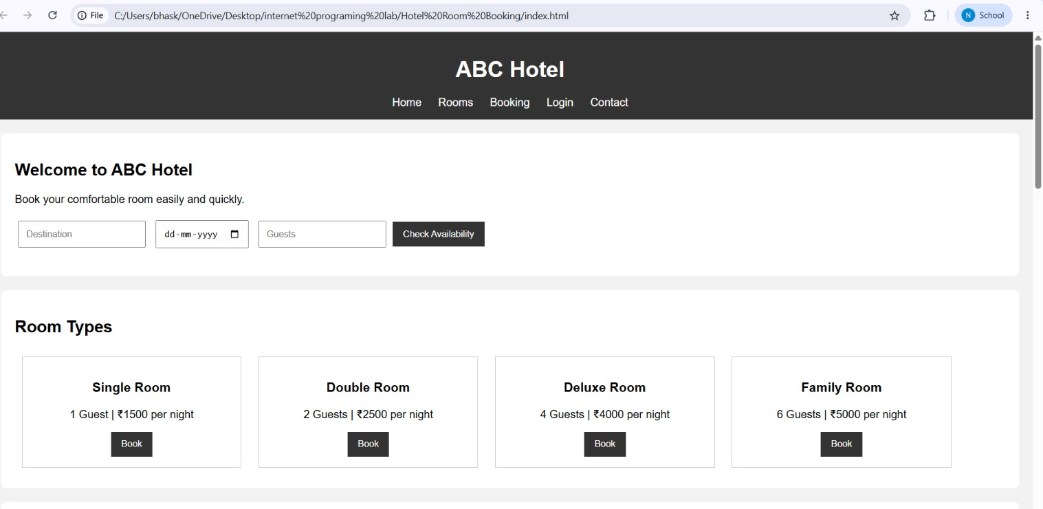
6. RESULT
The Online Hotel Room Booking System webpage was created successfully using HTML, CSS, and JavaScript. Users can search for hotels by destination and view the available hotel details and prices.

