INTERNET PROGRAMMING LAB
Name:P.Ranjithkumar
Reg:192411119
Course code:CSA4304

Experiment: Library Management System
1. AIM
To design and develop a simple Library Management System using HTML, CSS, and JavaScript to display and search available books.
2. TOOL
- Visual Studio Code
- Web Browser
- HTML
- CSS
- JavaScript
3. ALGORITHM
- Start the program.
- Create the webpage using HTML.
- Apply styles using CSS.
- Display the available books.
- Allow users to enter a book name in the search box.
- Use JavaScript to filter books based on the search input.
- Display matching books and hide non-matching books.
- Stop the program.

4. PROGRAM
File 1: index.html
<!DOCTYPE html>
<html>
<head>
<title>Library Management System</title>
<link rel="stylesheet" href="style.css">
</head>
<body>
<h1>Library Management System</h1>
<input type="text" id="search" placeholder="Search books..."
onkeyup="searchBooks()">
<div id="books">
<div class="book">HTML Basics</div>
<div class="book">CSS for Beginners</div>
<div class="book">JavaScript Guide</div>
<div class="book">Python Programming</div>
<div class="book">Web Development</div>
</div>
<script src="script.js"></script>
</body>
</html>
File 2: style.css
body {
font-family: Arial, sans-serif;
text-align: center;
background-color: #f2f2f2;
padding: 20px;
}
h1 {
color: darkblue;
}
input {
width: 250px;
padding: 10px;
margin-bottom: 20px;
}
.book {
background-color: white;
padding: 15px;
margin: 10px auto;
width: 250px;
border: 1px solid gray;
border-radius: 5px;
}
.book:hover {
background-color: lightblue;
}

File 3: script.js
function searchBooks() {
let input = document.getElementById("search")
.value.toLowerCase();
let books = document.getElementsByClassName("book");

for (let i = 0; i < books.length; i++) {
let title = books[i].innerText.toLowerCase();

if (title.includes(input)) {
books[i].style.display = "block";
} else {
books[i].style.display = "none";
}
}
}
- OUTPUT
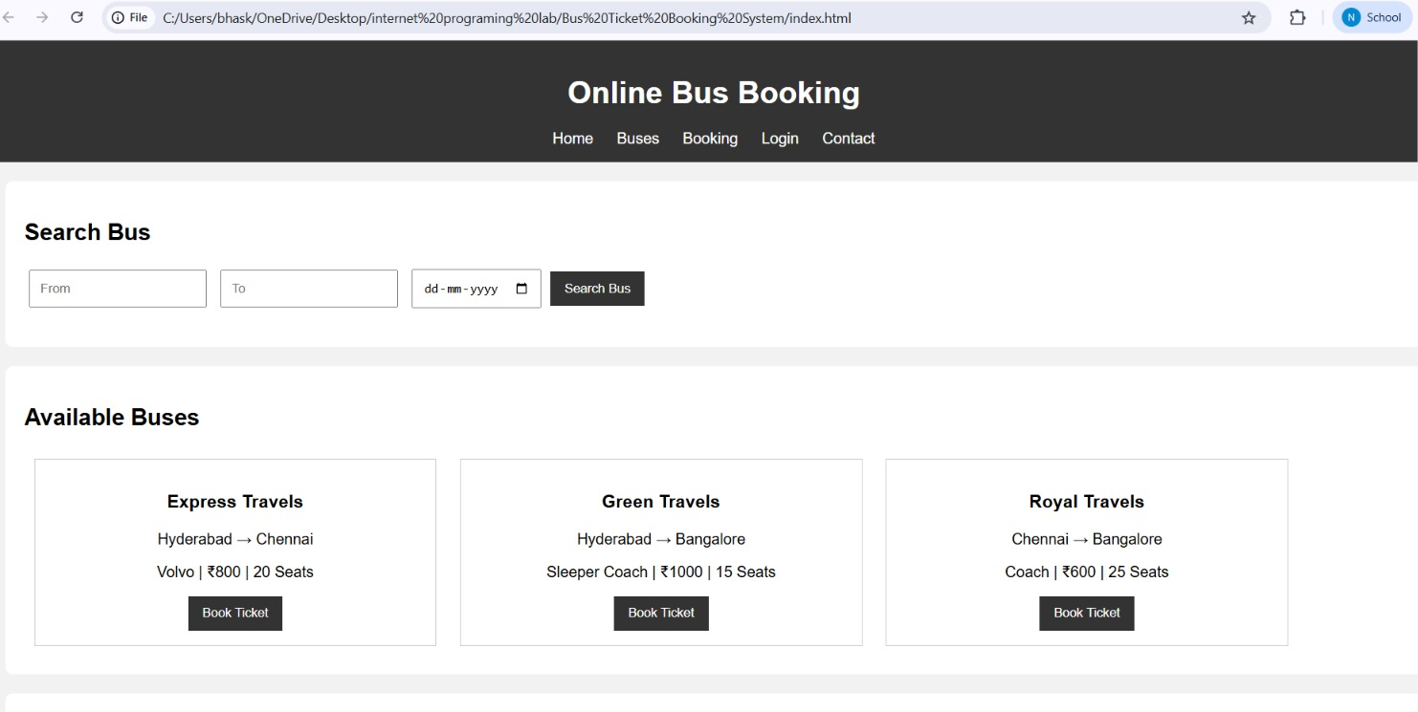

6. RESULT
The Library Management System webpage was created successfully using HTML, CSS, and JavaScript. It displays available books and allows users to search for books dynamically.

