INTERNET PROGRAMMING LAB EXPERIMENTS
Name: P.Ranjithkumar
Reg: 192411119
Course code:CSA4304

Experiment: VoteOnline – E-Voting System
1. AIM
To design and develop a simple VoteOnline e-voting webpage using HTML, CSS, and JavaScript to demonstrate voter ID entry, sample OTP verification, candidate selection, and vote submission.
2. TOOL
- Visual Studio Code
- Web Browser
- HTML
- CSS
- JavaScript
3. ALGORITHM
1. Start the program.
2. Create the webpage structure using HTML.
3. Apply styling using CSS.
4. Display a voter login form that accepts a voter ID.
5. Generate a demonstration OTP and ask the user to verify it.
6. Display the available candidates after successful sample verification.
7. Allow the voter to select one candidate.
8. Ask the voter to confirm and submit the vote.
9. Display a confirmation message and update the sample vote count.
10. Stop the program.
4. PROGRAM
File 1: index.html
<!DOCTYPE html>
<html lang="en">
<head>
<meta charset="UTF-8">
<meta name="viewport" content="width=device-width, initial-scale=1.0">
<title>VoteOnline - E-Voting System</title>
<link rel="stylesheet" href="style.css">
</head>
<body>
<header>
<h1>🗳 VoteOnline</h1>
<p>Your vote, your voice, your future.</p>
</header>

<nav>
<a href="#home">Home</a>
<a href="#voter-login">Voter Login</a>
<a href="#candidates">Candidates</a>
<a href="#results">Demo Results</a>
</nav>

<main>
<section id="home" class="welcome">
<h2>Welcome to VoteOnline</h2>
<p>A simple demonstration of a digital voting process.</p>
<p class="notice">Demonstration only — do not use this webpage for a real election.</p>
</section>

<section id="voter-login" class="panel">
<h2>Voter Verification</h2>
<label for="voter-id">Voter ID</label>
<input type="text" id="voter-id" placeholder="Enter sample voter ID">
<button onclick="sendOTP()">Get Demo OTP</button>

<div id="otp-section" hidden>
<label for="otp-input">Enter OTP</label>
<input type="text" id="otp-input" placeholder="Enter the displayed demo OTP"
maxlength="6">
<button onclick="verifyOTP()">Verify OTP</button>
</div>
<p id="login-message" class="message" aria-live="polite"></p>
</section>

<section id="candidates" class="panel" hidden>
<h2>Select Your Candidate</h2>
<p>Select one candidate and submit your demonstration vote.</p>
<form id="vote-form">
<label class="candidate">
<input type="radio" name="candidate" value="Candidate A" required>
<span class="symbol">🌞</span>
<strong>Candidate A</strong>
<span>Development and public services</span>
</label>
<label class="candidate">
<input type="radio" name="candidate" value="Candidate B" required>
<span class="symbol">🌳</span>
<strong>Candidate B</strong>
<span>Environment and community welfare</span>
</label>
<label class="candidate">
<input type="radio" name="candidate" value="Candidate C" required>
<span class="symbol">⭐</span>
<strong>Candidate C</strong>
<span>Education and digital services</span>
</label>
<button type="submit" id="submit-vote">Submit Vote</button>
</form>
<p id="vote-message" class="message" aria-live="polite"></p>
</section>

<section id="results" class="panel">
<h2>Demo Election Summary</h2>
<p>Total votes submitted in this browser session: <strong id="total-votes">0</strong></p>
<p class="notice">This is sample data only, not official election results.</p>
</section>
</main>

<footer>
<p>&copy; 2026 VoteOnline | Every voice matters</p>
</footer>
<script src="script.js"></script>
</body>
</html>

File 2: style.css
* {
box-sizing: border-box;
}
body {
margin: 0;
font-family: Arial, sans-serif;
background: #f3f6fb;
color: #263238;
}
header {
background: #254d82;
color: white;
text-align: center;
padding: 22px 12px;
}
header h1 {
margin: 0;
}
nav {
background: #17345b;
text-align: center;
padding: 13px;
}
nav a {
color: white;
text-decoration: none;
margin: 0 14px;
}
main {
max-width: 900px;
margin: auto;
padding: 20px;
}
.welcome, .panel {
background: white;
padding: 22px;
margin-bottom: 20px;
border-radius: 10px;
box-shadow: 0 2px 8px #dce4ed;
}
.welcome {
background: #e2ecfa;
text-align: center;
}
h2 {
color: #254d82;
}
.notice {
color: #8a4c00;
font-weight: bold;
}
label {
display: block;
margin: 12px 0 6px;
}
input[type="text"] {
width: 100%;
max-width: 420px;
padding: 11px;
border: 1px solid #bdcbd8;
border-radius: 6px;
font-size: 15px;
}
button {
margin-top: 12px;
padding: 11px 16px;
border: none;
border-radius: 6px;
background: #254d82;
color: white;
cursor: pointer;
}
button:hover {
background: #17345b;
}
.candidate {
display: flex;
flex-direction: column;
gap: 7px;
padding: 15px;
margin: 12px 0;
border: 1px solid #ccd8e8;
border-radius: 8px;
cursor: pointer;
}
.candidate input[type="radio"] {
width: auto;
}
.symbol {
font-size: 28px;
}
.candidate span:last-child {
color: #586875;
}
.message {
color: #17683a;
font-weight: bold;
}
footer {
background: #17345b;
color: white;
text-align: center;
padding: 14px;
}

File 3: script.js
let demoOTP = "";
let verifiedVoter = false;
let voteSubmitted = false;
let totalVotes = 0;

function sendOTP() {
const voterId = document.getElementById("voter-id").value.trim();
const message = document.getElementById("login-message");

if (voterId === "") {
message.textContent = "Please enter a voter ID.";
return;
}

// Demo OTP only: shown on screen, not sent by SMS.
demoOTP = String(Math.floor(100000 + Math.random() * 900000));
document.getElementById("otp-section").hidden = false;
document.getElementById("otp-input").value = "";
message.textContent = "Demo OTP: " + demoOTP +
". This code is displayed for practice only.";
}

function verifyOTP() {
const enteredOTP = document.getElementById("otp-input").value.trim();
const message = document.getElementById("login-message");

if (demoOTP === "" || enteredOTP !== demoOTP) {
message.textContent = "Invalid OTP. Please request or enter the correct demo OTP.";
return;
}

verifiedVoter = true;
document.getElementById("candidates").hidden = false;
message.textContent = "Demo verification successful. You may select a candidate.";
document.getElementById("candidates").scrollIntoView({ behavior: "smooth" });
}

document.getElementById("vote-form").addEventListener("submit", function(event) {
event.preventDefault();

if (!verifiedVoter) {
document.getElementById("vote-message").textContent =
"Please complete voter verification first.";
return;
}

if (voteSubmitted) {
document.getElementById("vote-message").textContent =
"A vote has already been submitted in this demo session.";
return;
}

const selected = document.querySelector('input[name="candidate"]:checked');
if (!selected) {
document.getElementById("vote-message").textContent =
"Please select a candidate.";
return;
}

const confirmed = confirm("Submit your demo vote for " + selected.value + "?");
if (!confirmed) return;

voteSubmitted = true;
totalVotes++;
document.getElementById("total-votes").textContent = totalVotes;
document.getElementById("vote-message").textContent =
"Demo vote submitted successfully for " + selected.value + ".";
document.getElementById("submit-vote").disabled = true;
});

5. OUTPUT
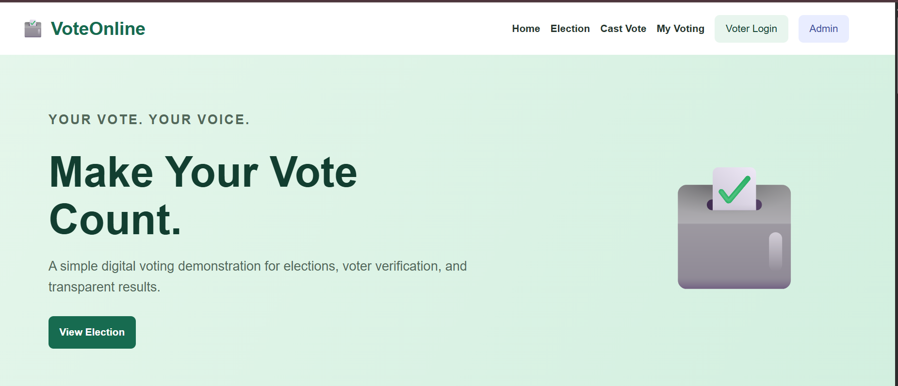
6. RESULT
The VoteOnline e-voting demonstration webpage was created successfully using HTML, CSS, and JavaScript. It demonstrates voter ID entry, sample OTP verification, candidate selection, vote submission, and a session-based vote counter. This is not a secure or production-ready election system. Real elections require server-side authentication, secure OTP delivery, protected vote storage, independent security audits, and compliance with applicable electoral laws.

