INTERNET PROGRAMMING LAB EXPERIMENTS
Name:P.Ranjithkumar
Reg:192411119
Course code: CSA4304

Experiment: AgriMart – Online Agricultural Shopping System
1. AIM
To design and develop a simple AgriMart online agricultural shopping webpage using HTML, CSS, and JavaScript to display farming products, search and filter items, add products to a shopping cart, and manage a sample cart total.
2. TOOL
- Visual Studio Code
- Web Browser
- HTML
- CSS
- JavaScript
3. ALGORITHM
1. Start the program.
2. Create the webpage structure using HTML.
3. Apply styling to the webpage using CSS.
4. Display agricultural products with names, categories, descriptions, and prices.
5. Provide a search box and category filter for products.
6. Use JavaScript to show products matching the search and selected category.
7. Allow users to add products to the shopping cart.
8. Update the cart item count and total price dynamically.
9. Display a confirmation message when an item is added to the cart.
10. Stop the program.
4. PROGRAM
File 1: index.html
<!DOCTYPE html>
<html lang="en">
<head>
<meta charset="UTF-8">
<meta name="viewport" content="width=device-width, initial-scale=1.0">
<title>AgriMart - Agricultural Shopping</title>
<link rel="stylesheet" href="style.css">
</head>
<body>
<header>
<h1>🌾 AgriMart</h1>
<p>Quality farming supplies for a better harvest</p>
<div class="cart">🛒 Cart Items: <span id="cart-count">0</span> |
Total: ₹<span id="cart-total">0</span></div>
</header>

<nav>
<a href="#home">Home</a>
<a href="#products">Shop Products</a>
<a href="#about">About</a>
</nav>

<main>
<section id="home" class="welcome">
<h2>Welcome to AgriMart</h2>
<p>Find seeds, fertilizers, pesticides, and farming tools in one place.</p>
</section>

<section id="products">
<h2>Agricultural Products</h2>
<div class="filters">
<input type="text" id="search" placeholder="Search products..." oninput="filterProducts()">
<select id="category" onchange="filterProducts()">
<option value="all">All Categories</option>
<option value="Seeds">Seeds</option>
<option value="Fertilizers">Fertilizers</option>
<option value="Pesticides">Pesticides</option>
<option value="Equipment">Farming Equipment</option>
</select>
</div>
<p id="message" class="message" aria-live="polite"></p>

<div id="product-list" class="product-grid">
<article class="product" data-name="Tomato Seeds" data-category="Seeds" data-price="120">
<div class="emoji">🌱</div>
<h3>Tomato Seeds</h3>
<p>Quality seeds for home gardens and farms.</p>
<p class="price">₹120</p>
<button onclick="addToCart('Tomato Seeds', 120)">Add to Cart</button>
</article>

<article class="product" data-name="Wheat Seeds" data-category="Seeds" data-price="250">
<div class="emoji">🌾</div>
<h3>Wheat Seeds</h3>
<p>Seeds for seasonal crop cultivation.</p>
<p class="price">₹250</p>
<button onclick="addToCart('Wheat Seeds', 250)">Add to Cart</button>
</article>

<article class="product" data-name="Organic Fertilizer" data-category="Fertilizers" data-price="350">
<div class="emoji">🌿</div>
<h3>Organic Fertilizer</h3>
<p>Organic soil nutrient product for gardening.</p>
<p class="price">₹350</p>
<button onclick="addToCart('Organic Fertilizer', 350)">Add to Cart</button>
</article>

<article class="product" data-name="Garden Spray" data-category="Pesticides" data-price="280">
<div class="emoji">🧴</div>
<h3>Garden Spray</h3>
<p>Plant-care spray; follow the product label directions.</p>
<p class="price">₹280</p>
<button onclick="addToCart('Garden Spray', 280)">Add to Cart</button>
</article>

<article class="product" data-name="Hand Trowel" data-category="Equipment" data-price="180">
<div class="emoji">🛠️</div>
<h3>Hand Trowel</h3>
<p>A useful hand tool for planting and soil work.</p>
<p class="price">₹180</p>
<button onclick="addToCart('Hand Trowel', 180)">Add to Cart</button>
</article>

<article class="product" data-name="Watering Can" data-category="Equipment" data-price="220">
<div class="emoji">🚿</div>
<h3>Watering Can</h3>
<p>Convenient watering tool for plants and seedlings.</p>
<p class="price">₹220</p>
<button onclick="addToCart('Watering Can', 220)">Add to Cart</button>
</article>
</div>
</section>

<section id="about" class="about">
<h2>About AgriMart</h2>
<p>AgriMart brings essential agricultural supplies together to make shopping easier for farmers
and gardening enthusiasts.</p>
</section>
</main>

<footer>
<p>&copy; 2026 AgriMart | Growing a better future</p>
</footer>
<script src="script.js"></script>
</body>
</html>

File 2: style.css
* {
box-sizing: border-box;
}
body {
margin: 0;
font-family: Arial, sans-serif;
background: #f4f8f0;
color: #29372b;
}
header {
background: #397443;
color: white;
text-align: center;
padding: 22px 12px;
}
header h1 {
margin: 0;
}
.cart {
margin-top: 10px;
font-weight: bold;
}
nav {
background: #244e2b;
text-align: center;
padding: 13px;
}
nav a {
color: white;
text-decoration: none;
margin: 0 15px;
}
main {
max-width: 1050px;
margin: auto;
padding: 20px;
}
.welcome, .about {
background: #e1efd9;
text-align: center;
padding: 24px;
border-radius: 10px;
margin-bottom: 24px;
}
h2 {
color: #2e6738;
}
.filters {
display: flex;
gap: 10px;
flex-wrap: wrap;
margin-bottom: 15px;
}
input, select {
padding: 11px;
border: 1px solid #b9cfb4;
border-radius: 6px;
font-size: 15px;
}
input {
flex: 1;
min-width: 200px;
}
.product-grid {
display: grid;
grid-template-columns: repeat(auto-fit, minmax(220px, 1fr));
gap: 18px;
}
.product {
background: white;
padding: 18px;
text-align: center;
border: 1px solid #d0dfca;
border-radius: 10px;
box-shadow: 0 2px 7px #dce7d8;
}
.emoji {
font-size: 45px;
}
.product h3 {
color: #2e6738;
}
.price {
font-size: 18px;
font-weight: bold;
color: #397443;
}
button {
background: #397443;
color: white;
border: none;
padding: 10px 15px;
border-radius: 6px;
cursor: pointer;
}
button:hover {
background: #244e2b;
}
.message {
color: #216b35;
font-weight: bold;
}
footer {
background: #244e2b;
color: white;
text-align: center;
padding: 14px;
margin-top: 20px;
}

File 3: script.js
function filterProducts() {
const searchText = document.getElementById("search").value.toLowerCase();
const selectedCategory = document.getElementById("category").value;
const products = document.getElementsByClassName("product");
let visibleCount = 0;

for (let i = 0; i < products.length; i++) {
const name = products[i].dataset.name.toLowerCase();
const category = products[i].dataset.category;
const matchesSearch = name.includes(searchText);
const matchesCategory =
selectedCategory === "all" || category === selectedCategory;

if (matchesSearch && matchesCategory) {
products[i].style.display = "block";
visibleCount++;
} else {
products[i].style.display = "none";
}
}

document.getElementById("message").textContent =
visibleCount === 0 ? "No products found. Try another search." : "";
}

let cartCount = 0;
let cartTotal = 0;

function addToCart(productName, price) {
cartCount++;
cartTotal += price;

document.getElementById("cart-count").textContent = cartCount;
document.getElementById("cart-total").textContent = cartTotal;
document.getElementById("message").textContent =
productName + " added to your cart!";
}
5. OUTPUT
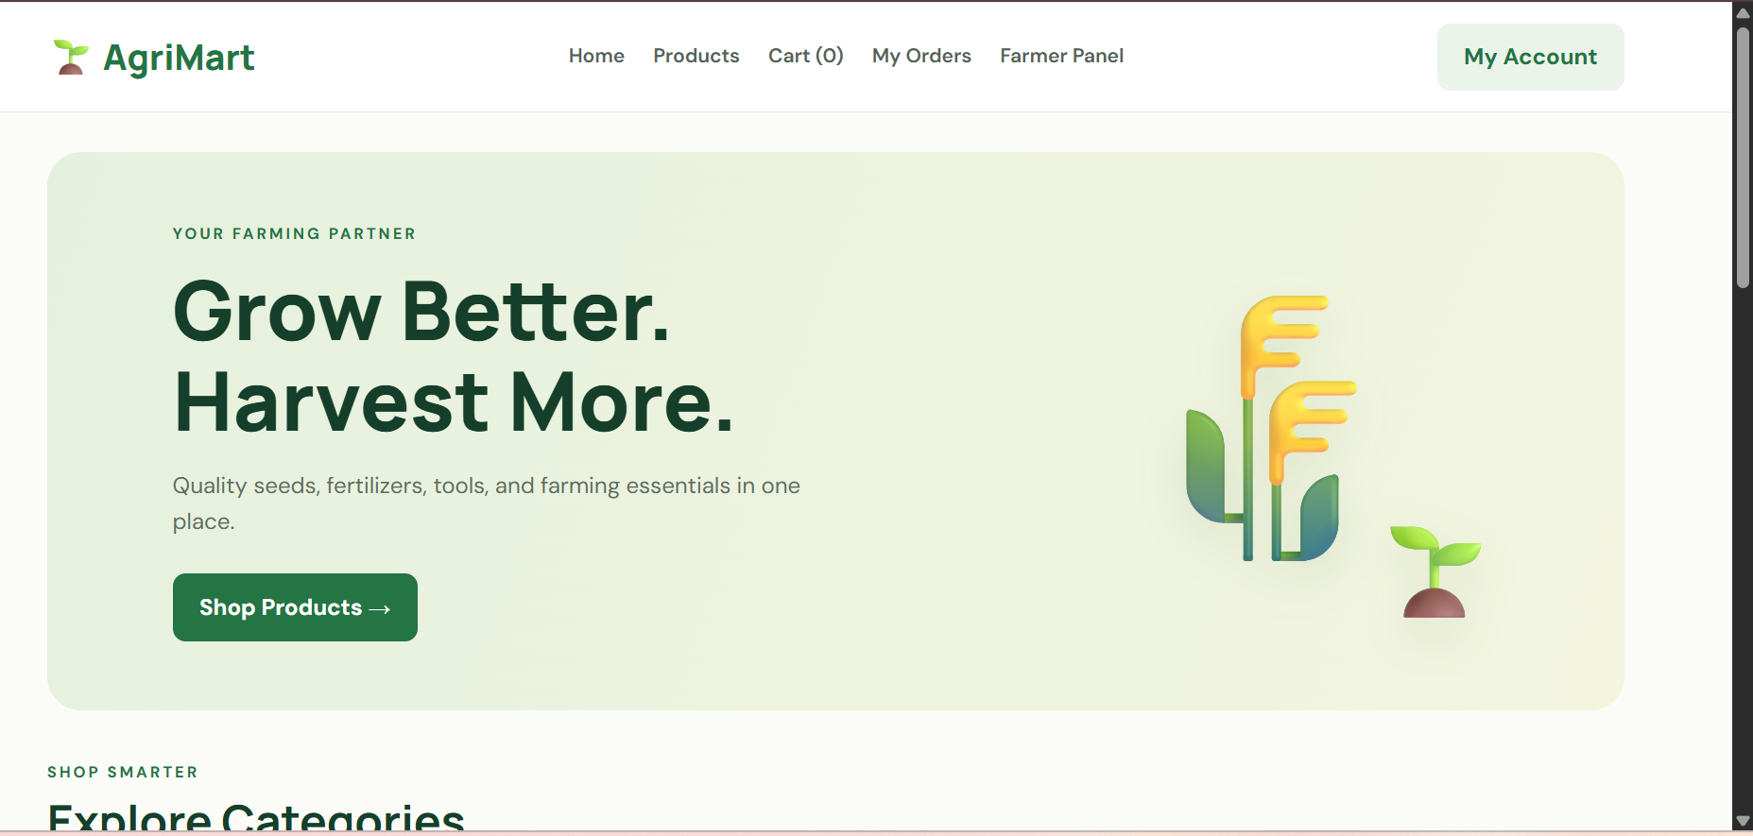
6. RESULT
The AgriMart agricultural shopping webpage was created successfully using HTML, CSS, and JavaScript. It displays agricultural products, supports searching and category filtering, and updates the shopping cart count and total price dynamically. This is a front-end demonstration; real registration, OTP, farmer product management, order tracking, shipping updates, wallet management, and secure payments require backend services and suitable integrations.

