INTERNET PROGRAMMING LAB
Name: P. Ranjithkumar
Reg: 192411119
Course code: CSA4304
Experiment: Online Train Reservation System

1. AIM
To design and develop a simple Online Train Reservation System using HTML, CSS, and JavaScript to search trains by source and destination and display train details and fares.

2. TOOL
- Visual Studio Code
- Web Browser
- HTML
- CSS
- JavaScript

3. ALGORITHM
- Start the program.
- Create the train reservation webpage using HTML.
- Apply styles using CSS.
- Display sample train routes and fares.
- Allow users to enter source and destination stations.
- Use JavaScript to search for matching trains.
- Display matching trains or a no-trains-found message.
- Stop the program.

4. PROGRAM
File 1: index.html
<!DOCTYPE html>
<html>
<head>
<title>Train Reservation System</title>
<link rel="stylesheet" href="style.css">
</head>
<body>
<h1>Online Train Reservation</h1>
<input type="text" id="source" placeholder="Enter source station">
<input type="text" id="destination" placeholder="Enter destination">
<button onclick="searchTrains()">Search Trains</button>
<div id="trains">
<div class="train" data-source="chennai" data-destination="bangalore">
<h3>Chennai Express</h3>
<p>Chennai to Bangalore</p>
<p>Fare: Rs. 450</p>
</div>
<div class="train" data-source="chennai" data-destination="hyderabad">
<h3>Charminar Express</h3>
<p>Chennai to Hyderabad</p>
<p>Fare: Rs. 520</p>
</div>
<div class="train" data-source="bangalore" data-destination="hyderabad">
<h3>City Express</h3>
<p>Bangalore to Hyderabad</p>
<p>Fare: Rs. 400</p>
</div>
</div>
<p id="message"></p>
<script src="script.js"></script>
</body>
</html>
File 2: style.css
body {
font-family: Arial, sans-serif;
text-align: center;
background-color: #f2f2f2;
padding: 20px;
}
h1 {
color: darkblue;
}
input {
padding: 10px;
margin: 5px;
width: 190px;
}
button {
padding: 10px 15px;
background-color: darkblue;
color: white;
border: none;
cursor: pointer;
}
.train {
background-color: white;
border: 1px solid gray;
border-radius: 6px;
padding: 12px;
margin: 15px auto;
max-width: 350px;
}
#message {
color: red;
}
File 3: script.js
function searchTrains() {
let source = document.getElementById("source").value.toLowerCase().trim();
let destination = document.getElementById("destination").value.toLowerCase().trim();
let trains = document.getElementsByClassName("train");
let found = 0;
for (let i = 0; i < trains.length; i++) {
let trainSource = trains[i].getAttribute("data-source");
let trainDestination = trains[i].getAttribute("data-destination");
if (trainSource.includes(source) &&
trainDestination.includes(destination)) {
trains[i].style.display = "block";
found++;
} else {
trains[i].style.display = "none";
}
}
if (found === 0) {
document.getElementById("message").innerText = "No trains found.";
} else {
document.getElementById("message").innerText = found + " train(s) found.";
}
}

OUTPUT
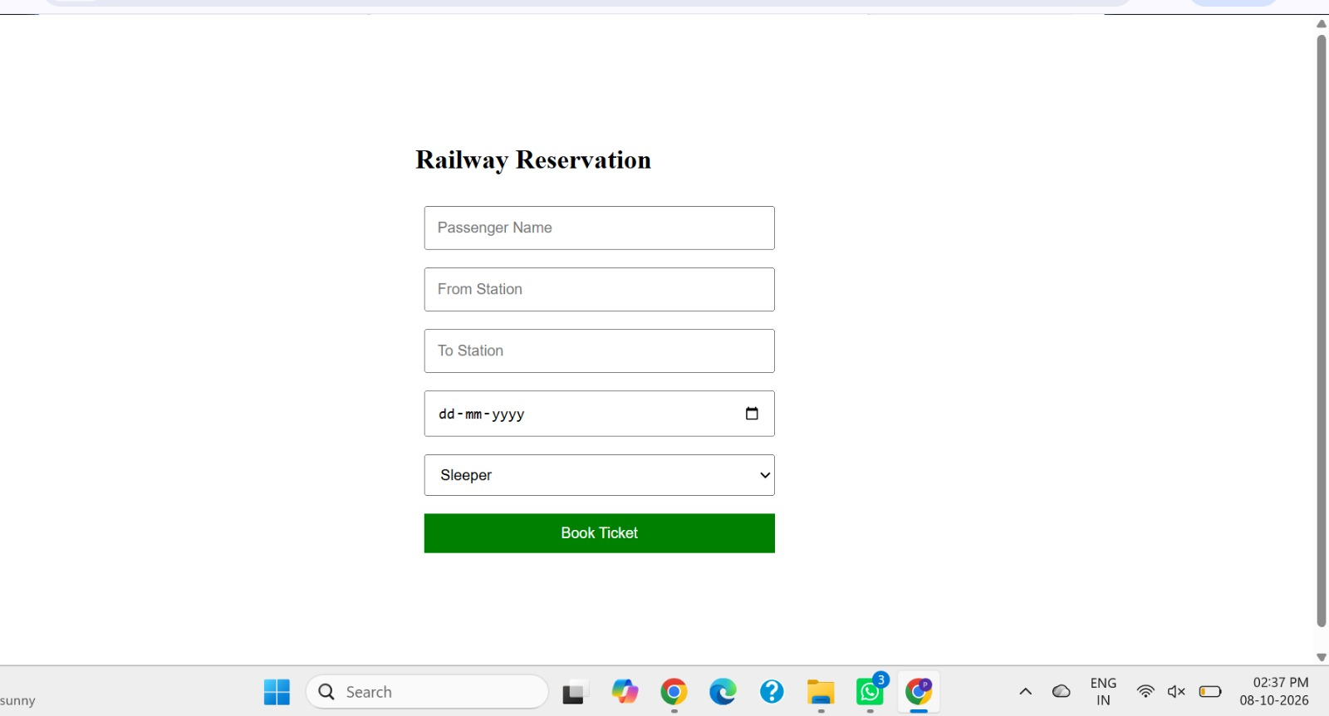

6. RESULT
The Online Train Reservation System webpage was created successfully using HTML, CSS, and JavaScript. Users can search for trains by source and destination and view the available sample train details and fares.

