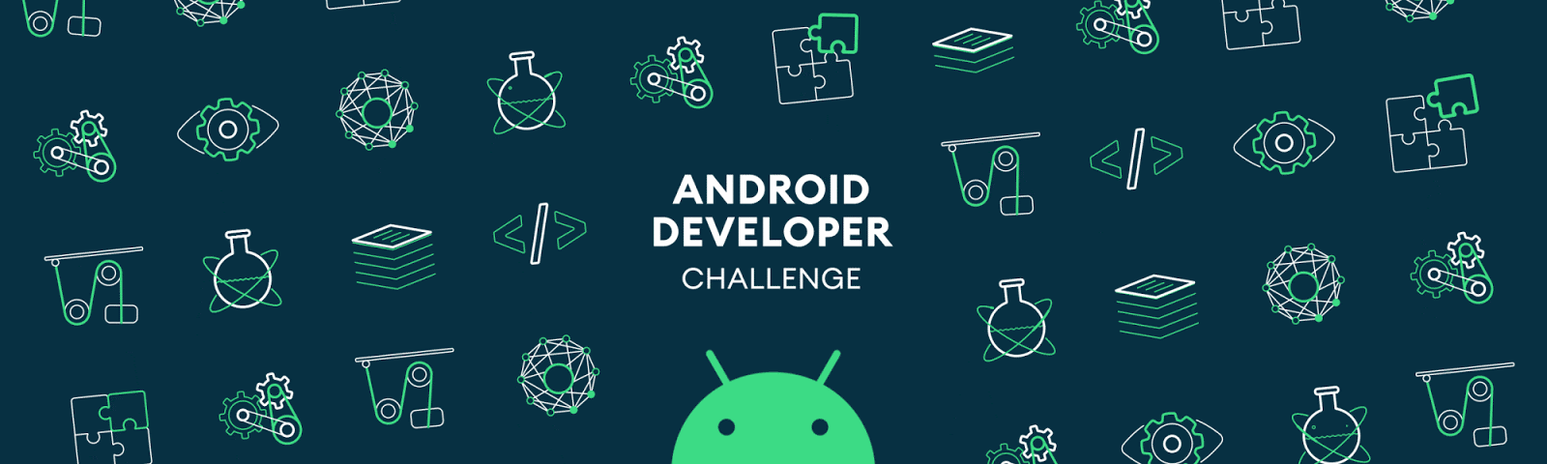

**Idea:**

Belonging to a developing country India has ever been a motivational aspect to look upon for students like me for whom eradicating human errors plays a major role in their mindset. My country is still brimming with several cases of reported deafness and dumbness and I pledge to remove them off from the face of my country. Using the world’s best-in-class Tech-Giant’s help, I would like to strive ahead in this direction and hope to help millions of people with them being deaf and dumb. Using Google’s live-caption features integrated with text-to-speech as well as live-caption input libraries, I am looking forward to bring the sound of everything to deaf and also gift a voice to dumb people. Apart from this, I would also like to mention that this technology I am planning to build can be deployed for a minimum and fair charge and hence, can be provided to as many people as possible. Using ear-bone we can directly send the electric pulse to the middle ear and hence, provide a minimal amount of sound and in the same way, using vocal cord contraction and relaxation integrated with neuromuscular pulses upon ML training, to correspond to specific frequencies matching with our phone, we can predict what the person is trying to say. Though this idea is still in its infant stage, it can still be brought to life, if only right nurture is provided which from my perspective can only be provided by Google. More than I need this opportunity, I really hope, countries like mine are god blessed with this miracle.

**Plan on bringing it to life:**

The basic idea is to create and deploy an app that for now, contains mostly three primary features:

1. Speech-to-text and live converting of text to different languages and text-to-speech integrations to help people of different languages communicate directly without any middle-man or translator.
2. Connecting a wearable that can be put on the ear that sends the electric impulses directly to the middle ear via bones and hence, allows their mind to interpret and hear the voice of surroundings.
3. Developing a wearable that fits on the neck and can sense Neuromuscular pulses below the vocal cord and hence, interprets them in the sound and emits them as a voice using the app connection.

Here, the integration of live language translators uses live caption integration to recognize and convert inputs and ML libraries to overtime provide faster responses and hence provide the user with a better experience during his/her visit to different countries.

Apart from this, wearables developed for Deaf and Dumb people not only interpret data in real-time but analyses and rather come up with some of regularly and frequently used words and hence serve the respective person with better user experience by constantly popping those phrases to rather provide an option to carry it forward. Also, this more often daily used words are then stored in temporary memory and just like smart write used in Gmail, it automatically kicks in, whenever it feels it needs to be. This idea may be still out of phase for a person like me, but surely it has the potential to work and of course, many technical oriented people like you may be able to bring it to life one day.

Briefing down further, APIs, SDKs and frameworks that are to be incorporated in the processing of the app that not only includes converting speech and text and other features mentioned earlier but also taking logs and manipulating the data in real-time across the world to better understand the need of the same wearable technology and also accordingly distribute the marketing sales as well as production and provide with low-cost upgrades immediately in those areas, and hence uplift the scale of our global community. Furthermore, the list of APIs that are to be integrated into the model is listed down as follows:

* Ad Experience Report API
* Admin Directory API 1
* Admin Reports API 1
* AI Platform Training & Prediction API
* Analytics Core Reporting API v3
* Analytics Metadata API v3
* Analytics Reporting API
* App Engine Admin API
* Apps Script API
* Big Query API
* Cloud Asset API
* Cloud Build API
* Cloud Composer API
* Cloud Data Fusion API
* Cloud Datastore API v1
* Google Cloud Deployment Manager API
* Google Cloud DNS API
* Cloud Filestore API
* Cloud Key Management Service API
* Cloud Speech-to-Text API v1 and v2 beta 1
* Cloud SQL Admin API
* Cloud Testing API
* Drive Activity API
* Google Fonts Developer API
* People API
* Service Consumer Management API
* Stackdriver Error Reporting API
* Web Security Scanner API

Scaling down the use of all the APIs incorporates the crystal-clear working of all the primary features with a full-proof backend firewall to protect it against intruders as well as using real-time data analysis and analytics to scale the productivity of the deployed app and hence, come up with a better solution to all the bugs and misguidance that might be served to users. Ad Experience Report API analyzes the interest of the person in the respective faculties and in turn, provides him/her with more information regarding the same. This will also, in turn, provide better help for secondary business in their growth market that is connected with Google for business. AI Platform Training & Prediction API is the core concept used for analyzing, training and finally, coming up with best-in-class data query that not only depicts real-time growth and need in the required area but also speculates what changes are needed to be made for better efficiency. For supporting the above big data analysis, incorporation of Analytics Core Reporting API v3, Analytics Metadata API v3, and Analytics Reporting API is provided, to get the most efficient and best of results, for handling this big of query responses integration of Big Query API is implemented. App Engine Admin API and Apps Script API are used for not much but administrating the entire procedures and logs that are to be parsed in the backend system of the app. Furthermore, cloud services provided by Google like Cloud Asset API, Cloud Build API, Cloud Composer API, Cloud Data Fusion API, Cloud Datastore API v1, Google Cloud Deployment Manager API, Google Cloud DNS API, Cloud Filestore API, Cloud Key Management Service API, Cloud Speech-to-Text API v1 and v2 beta 1, Cloud SQL Admin API, Cloud Testing API are used for providing, managing and storing data for the entire human resource market to better understand the market as well as for the means of external reviews such as customer surveys, focus groups, beta-testers, subject-matter experts and potential investors. For beta testing and provisions for security APIs like Stackdriver Error Reporting API, Web Security Scanner API is to be incorporated for further acknowledging the security and privacy of data of users connected. Google Fonts Developer API, People API, Service Consumer Management API are the UI prospects that will help us with providing better user experience as well as developing simplified-ambient UI to interact with and hence, provide an impact in sales and marketing services.

Using the above-mentioned APIs as parsed dependencies for the app, not only will it provide the data manipulation for the app but also provide a real-time test model data-set for Google AI to interpret and train itself to better understand the need of the people and hence, better provide us with sufficient as well as necessary information to uplift those sectors of under developing countries.

**SDKs to be used:**

Tensorflow

Firebase

Live Caption

Flutter

Kubernetes

Google Cloud Platform

**Timeline:**

**By mid-January**: I tend to complete the development of the app for the above-mentioned purposes and also finish the integration of a live language translator.

**By March-end:** I tend to complete the developing and processing of wearable for a deaf person and hence integrate it in my app and be ready for use.

**By May-end**: I finish the most important and toughest part of my idea i.e. finishing the developing of wearable for a dumb person to help them provide a voice

**About me:**

Currently, I am an undergrad sophomore at Pandit Deendayal Petroleum University, Gujarat, India pursuing a degree in Information and Communication Technology. Apart from academia, I possess a very extraordinary skill-set in knowing almost every other technical field ranging from Programming to ML, Al, Deep learning to Blockchain and Ethical Hacking. I possess quite very expertise with the ergonomics section as of now, I have worked upon many projects relatable to my University.

* Served the world’s largest known non-governmental youth-run organization AIESEC as a head EP manager for tracking and pitching participants across the globe for providing them with an internship opportunity in India.
* Known across the university as one of the best graphic designers for any event on or off-campus. Also served as T-shirt Designer for OIR (Office of International Relation). Apart from this, I have a UI/UX portfolio saved on my cloud space for further reference. Known with every other Adobe software.
* Performing a certified course of Ethical Hacking upon the platform of NPTEL(National-Level Program for Technology Enhanced Learning). Hence, very well aware of cyber-security as well as cyber breaching.
* Developed an android app for attendance management and student analysis based on academic and non-academic purposes as a part of the In-House Hackathon under 24 hours.
* Won 1st prize for developing an algorithm and deploying as an Android app for “Traffic Clearance for Priority vehicles using Artificial Intelligence” Let’s Hack 2.0, a mock hackathon designed for university students to appear for SSIP(Student Start-up Innovation Policy) Gujarat Hackathon.
* Published 1 Research Paper related to General Relativity on Anisotropic compact star model satisfying Karmakar conditions in Astrophysics and space science journal and is available on arXiv.org.