**Chapter 3 Homework**

Web Development Technologies



Inside your **git** repo, use the folder named **HTML_CH03_HW**

Create an **"About Me"** page for yourself. Use this page to tell a little about yourself and to practice your HTML skills. *(See Example On Page 2.)*

1. Write the HTML to display your name with the largest heading element.
2. Write the HTML to create an absolute link to your school’s website.
3. Write the HTML for an unordered list to display the days of the week.
4. Write the HTML for an ordered list that uses **UPPERCASE LETTERS** to order the items. This ordered list should display the following terms: HTML, XML, and XHTML.
5. Think of a favorite quotation by someone you admire. Write the HTML code to display the person’s name in a heading and the quotation in a blockquote element.

(Also use the <q> element to add quotation marks.)

1. Modify the code you from #5. Add a URL to an external hyperlink about the person you admire. (With target="_blank")
2. Include the following code snippet and mark the term “site map” with a **strong** tag:

*<p>A diagram of the organization of a website is called a site map. A site map represents the structure, or organization, of pages in a website in a visual manner. Creating the site map is one of the initial steps in developing a website.</p>*

1. Create a web page (network_protocols.html) that uses a **description list tag** to display three network protocols (see Chapter 1) and their descriptions. Include a



1/2



hyperlink to a website that provides information about the protocols. Add an appropriate heading to the page.

*Hint:* [*https://developer.mozilla.org/en-US/docs/Web/HTML/Element/dl*](https://developer.mozilla.org/en-US/docs/Web/HTML/Element/dl)

1. Create a web page (music_group.html) about your favorite musical group. Include the name of the group, the individuals in the group, a hyperlink to the group’s website, your favorite three (or fewer if the group is new) CD releases, and a brief review of each CD. Use an unordered list to organize the names of the individuals. Use a description list for the names of the CDs and your reviews.
2. Create a web page (recipe.html) about your favorite recipe. Use an unordered list for the ingredients and an ordered list to describe the steps needed to prepare the food. Include a hyperlink to a similar recipe.

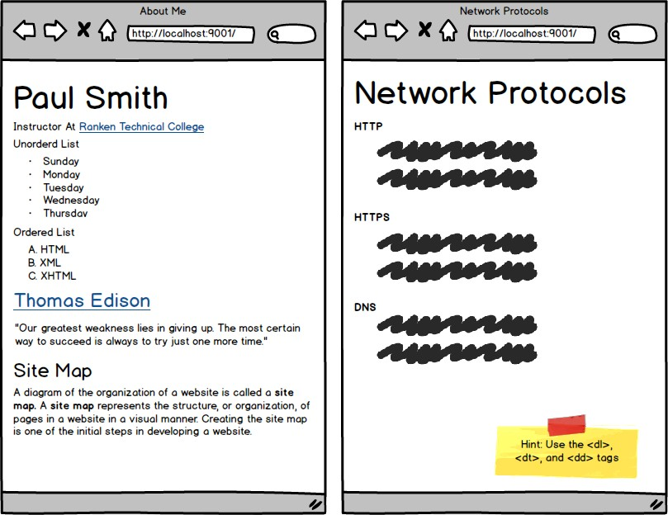



2/2