Chapter 3 Homework
Web Development Technologies
Inside your git repo, use the folder named HTML_CH03_HW
Create an "About Me" page for yourself. Use this page to tell a little about yourself and to practice your HTML skills. (See Example On Page 2.)
- Write the HTML to display your name with the largest heading element.
- Write the HTML to create an absolute link to your school’s website.
- Write the HTML for an unordered list to display the days of the week.
- Write the HTML for an ordered list that uses UPPERCASE LETTERS to order the items. This ordered list should display the following terms: HTML, XML, and XHTML.
- Think of a favorite quotation by someone you admire. Write the HTML code to display the person’s name in a heading and the quotation in a blockquote element.
(Also use the <q> element to add quotation marks.)
- Modify the code you from #5. Add a URL to an external hyperlink about the person you admire. (With target="_blank")
- Include the following code snippet and mark the term “site map” with a strong tag:
<p>A diagram of the organization of a website is called a site map. A site map represents the structure, or organization, of pages in a website in a visual manner. Creating the site map is one of the initial steps in developing a website.</p>
- Create a web page (network_protocols.html) that uses a description list tag to display three network protocols (see Chapter 1) and their descriptions. Include a
1/2
hyperlink to a website that provides information about the protocols. Add an appropriate heading to the page.
Hint: https://developer.mozilla.org/en-US/docs/Web/HTML/Element/dl
- Create a web page (music_group.html) about your favorite musical group. Include the name of the group, the individuals in the group, a hyperlink to the group’s website, your favorite three (or fewer if the group is new) CD releases, and a brief review of each CD. Use an unordered list to organize the names of the individuals. Use a description list for the names of the CDs and your reviews.
- Create a web page (recipe.html) about your favorite recipe. Use an unordered list for the ingredients and an ordered list to describe the steps needed to prepare the food. Include a hyperlink to a similar recipe.
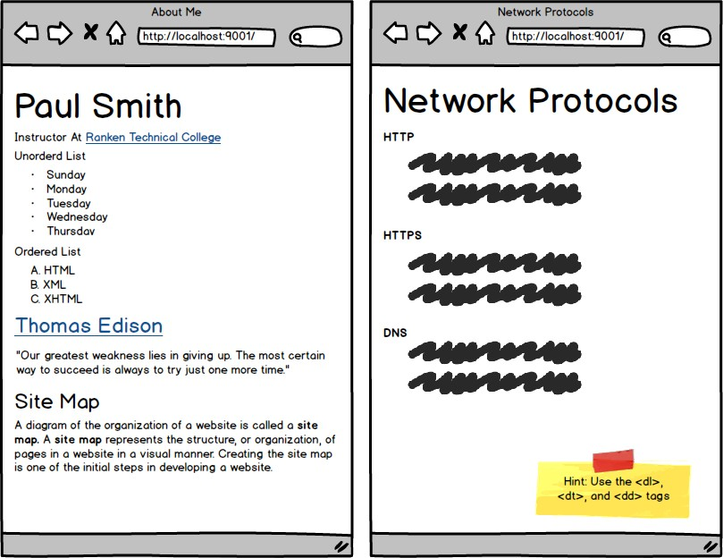
2/2

