Personal Portfolio Website Plan

Your Name:
Yehoshua Anton

Ideas for your website
Determine how you will use your personal portfolio website to showcase your skills.
Idea 1: Different pages for each language

Idea 2:

Idea 3:

Idea 4:

Idea 5:

Website Plan
Topic | Questions | Answers
Purpose of Website | What is the purpose and goal of the website? | The purpose of this website is to show others my work
Target Audience | Describe the target audience (age, gender, demographics) | Employers
Graphics | What graphics will you use on the website? | I’ll need projects first
Color | What colors will you use within the site to enhance the purpose and brand? | Blue, white, black
Accessibility | How will the website accommodate people with disabilities? | By having alternate text for the pictures
Project Timeline | Identify the project timeline | By the time I finish college

Wireframe
Sketch the wireframe for your home page below.
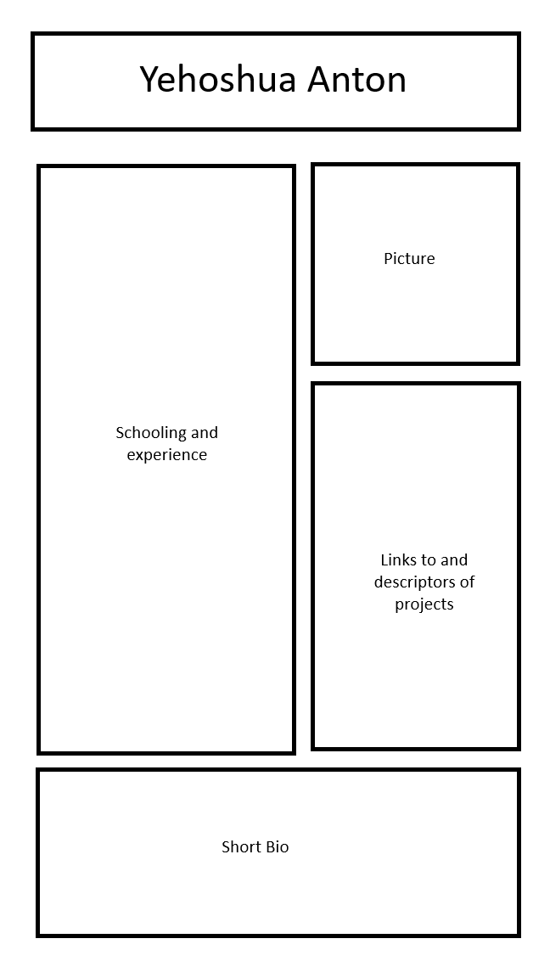

Site map
Create a site map for the website below.

