Dog Grooming Website Plan

Your Name: Alexcia Franks

Name of the Dog Grooming Business:
Dog Grooming Co.

Ideas for your website
Determine the type of information the website will provide.
Idea 1: home page

Idea 2: services and pricing

Idea 3: online booking

Idea 4: gallery

Idea 5: contact & about us

Website Plan
Topic | Questions | Answers
Purpose of Website | What is the purpose and goal of the website? | To provide customers with information about the dog grooming business and make it easy for them to book appointments
Target Audience | Describe the target audience (age, gender, demographics) | Dog owners and pet parents
Graphics | What graphics will you use on the website? | Photos of freshly groomed dogs, dog paw print graphics, a logo representing the grooming business, before/after photos, and grooming tool icons
Color | What colors will you use within the site to enhance the purpose and brand? | Teal, white and brown; using a mixture of these colors provides a clean easy to read design dedicated to dogs
Accessibility | How will the website accommodate people with disabilities? | Make buttons larger and easy to click, use descriptive headings and labels
Project Timeline | Identify the project timeline | 4-6 weeks

Wireframe
Sketch the wireframe for the home page below.
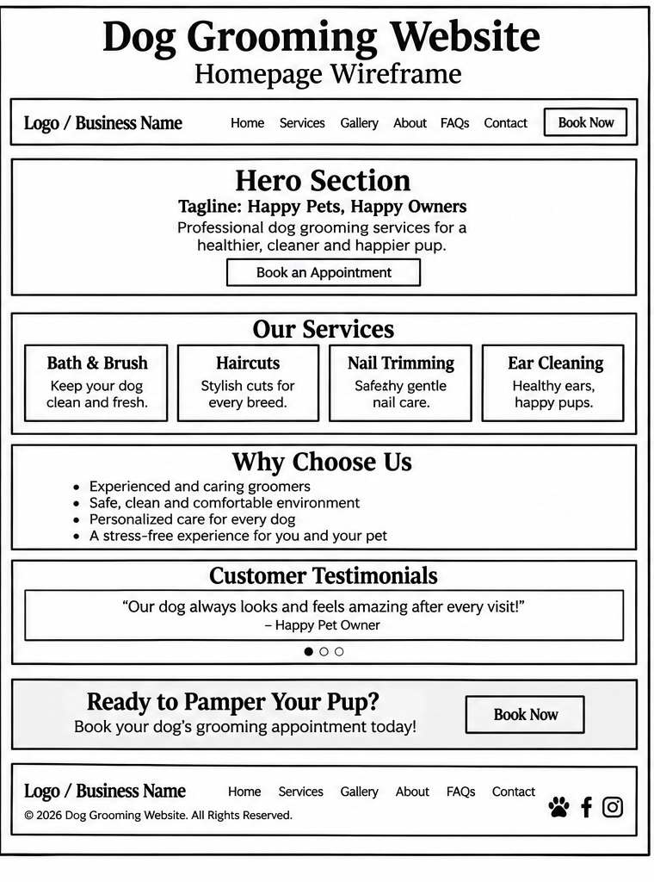

Site map
Create a site map for the website below.
