100%

Using your textbook and notes complete the following Hands-On Test in 4 hours or less.
Use Bootstrap v5 to implement all of the requirements below.
Create/Use the tests/BOOTRAP_HOT directory in your local repository.
Create a small 3-page website for a fictional business.
Home Page (index.html)
- The home page includes the following sections: header, main, footer.

- The header contains the name of the company and the navbar. - 15pts
  - Use the Bootstrap's responsive navbar component, to implement a navbar that is expanded on medium or larger devices, and collapsed on smaller devices.
  - The navbar has links to each page: Home, Products, Team
  - The Home page link has the active class.

- The main area contains a jumbotron and three columns of information about the company.
  - Include the company name, a tag line, and contact information on the jumbotron. - 12pts
    - Use a suitable background image for the jumbotron.
    - Use text-shadow to make the text in the jumbotron more readable.
    - Use padding/margin classes to adjust spacing.
    - Use the correct semantic tags! (generally just divs)
  - Include three sections of information about the company. This can be whatever you choose. - 12pts
    - Each section must have a heading and at least one paragraph of text.
    - Layout the sections responsively using a Bootstrap Grid.
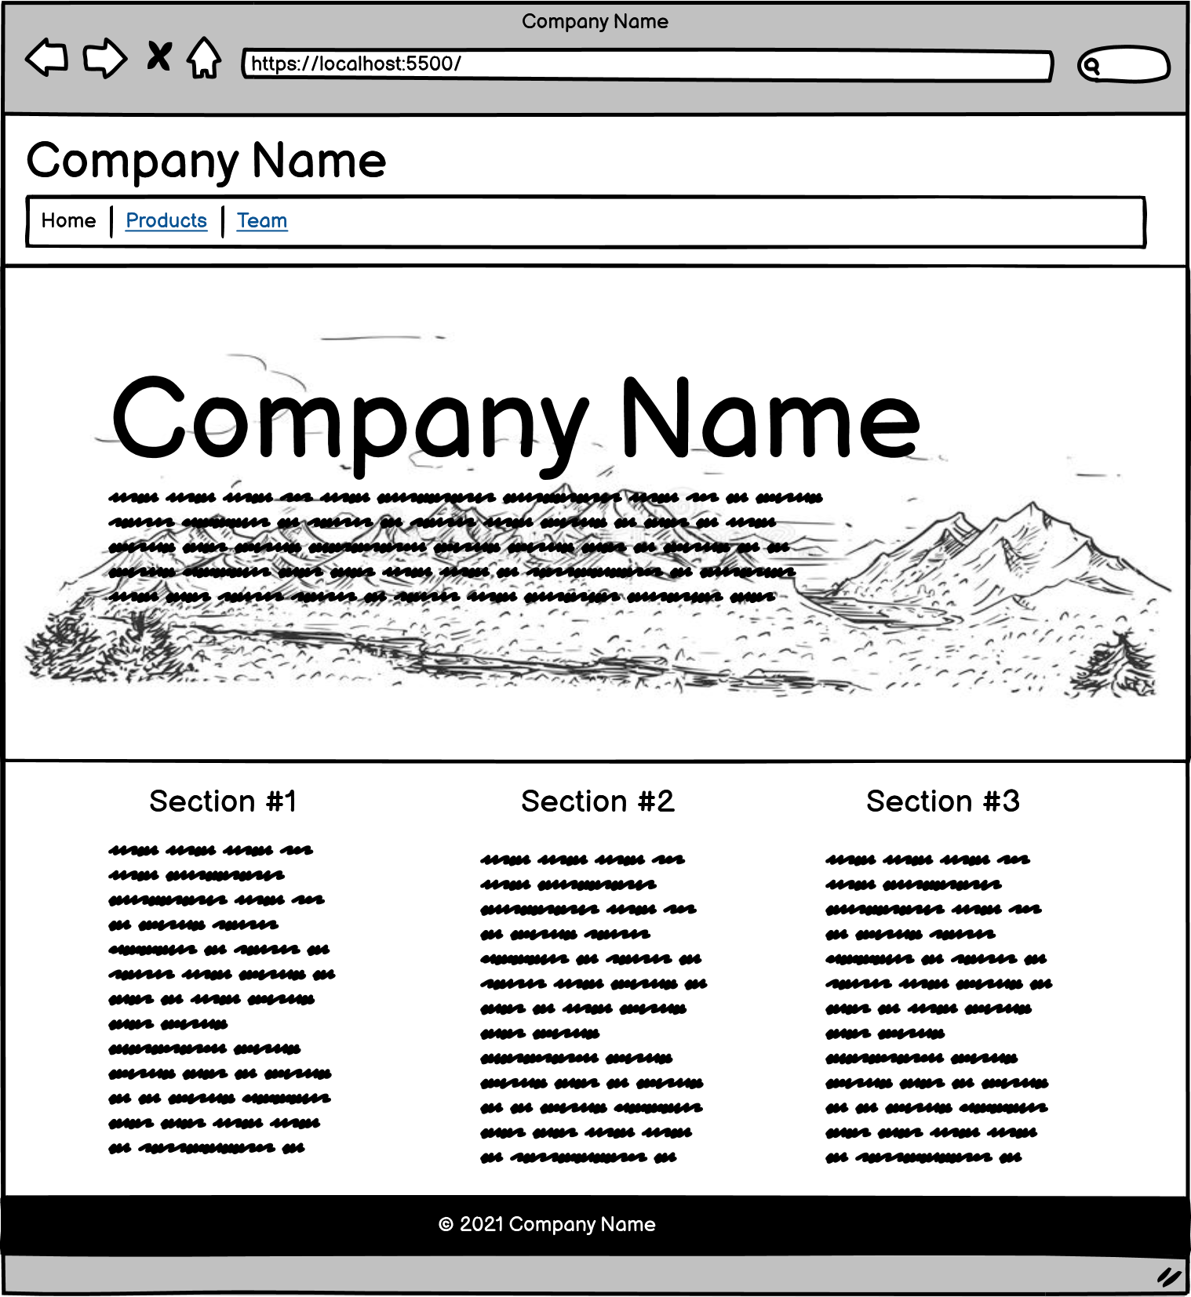
    - The columns must be ⅓ of the container width on large screens, and 100% of the container width on smaller screens.

- The footer contains the copyright line. Such as "© 2021 Company Name" - 5pts
  - Center the text using Bootstrap's text utilities.
  - Give the footer a dark background color and white text using Bootstrap's color utilities.

Products Page (products.html)
- The products page includes the following sections: header, main, footer.
- The header is the same as the home page. Except that:
  - The Products page link has the active class. - 5pts

- The main area contains a jumbotron and a small selection of products.
  - The jumbotron provides information about a current sale. - 12pts
    - Use a suitable background image for the jumbotron.
    - Use text-shadow to make the text in the jumbotron more readable.
    - Use padding/margin classes to adjust spacing.
    - Use the correct semantic tags! (generally just divs)
  - Include information and images for at least 4 products. - 12pts
    - Layout the products responsively using a Bootstrap Grid. This layout must show 4 items per row at the largest screen size, 2 items per row on a smaller screen size, and 1 item per row at the smallest screen size. (You can pick the actual breakpoints to fit your content, but use Bootstrap's column classes to implement this.)
    - Implement each product as a Bootstrap Card. This card must include the following classes: card, card-img-top, card-body, card-title, card-text
      - Each product includes an image.
      - Each product includes a name
      - Each product includes a link to view more information.
      - Each product includes a short description. (1 sentence)

- The footer is the same as the home page. - 5pts

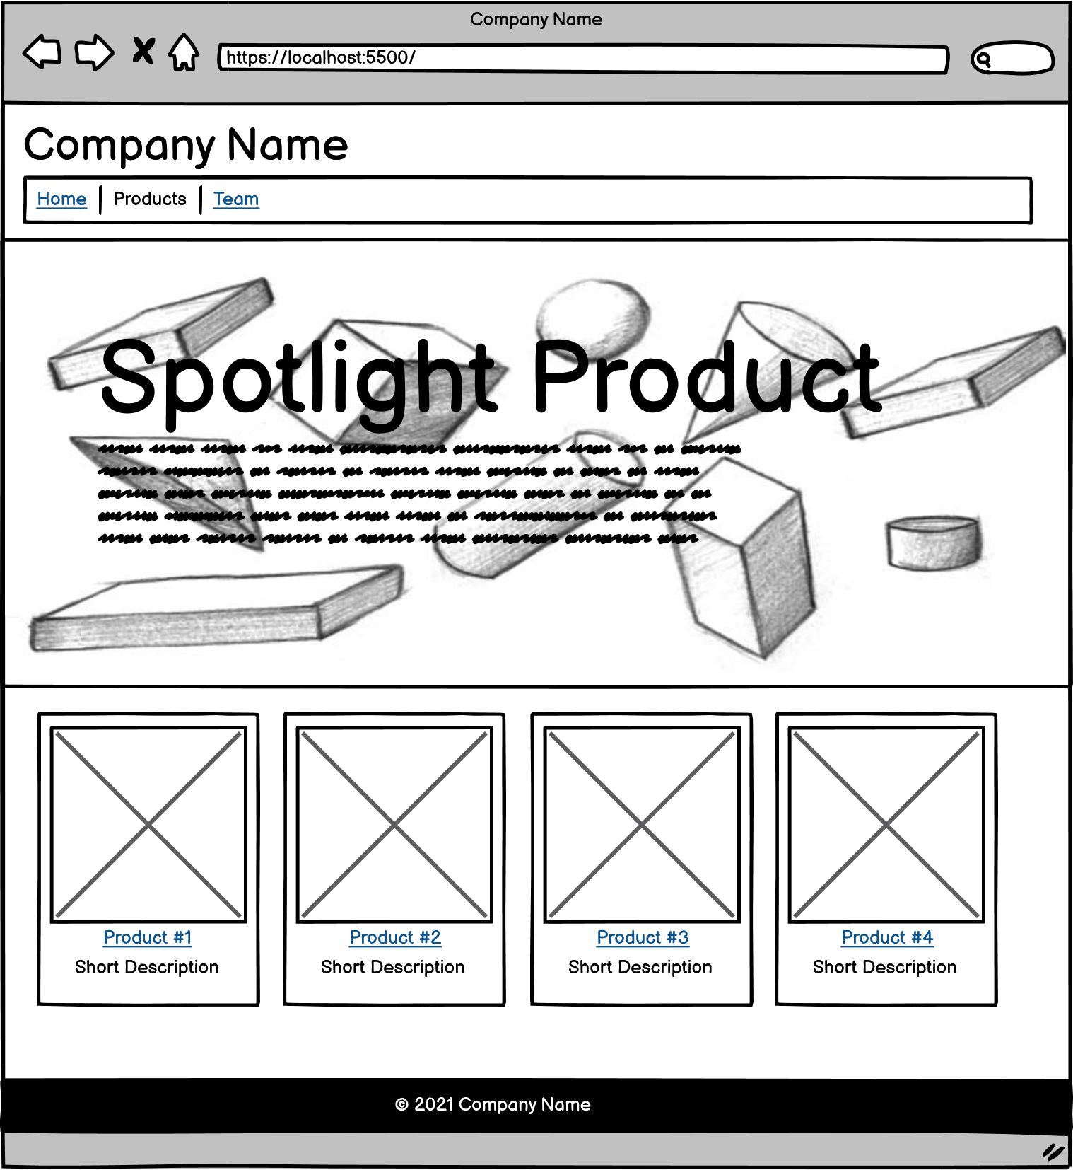

Team Page (team.html)
- The team page includes the following sections: header, main, footer.
- The header is the same as the home page. Except that:
  - The Team page link has the active class. - 5pts

- The main area contains information about at least 2 employees. - 12pts
  - Layout the products responsively using a Bootstrap Grid. This layout must show 2 items per row at the largest screen size, and 1 item per row at the smallest screen size. (You can pick the actual breakpoints to fit your content, but use Bootstrap's column classes to implement this.)
  - Implement each product as a Bootstrap Card. This card must include the following classes: card, card-img-top, card-body, card-title, card-text
  - Each employee includes an image.
  - Each employee includes a name.
  - Each employee includes a short bio. (1-2 paragraphs)

- The footer is the same as the home page. - 5pts

