1) Select all edges that are present in the above schedule's dependency graph.

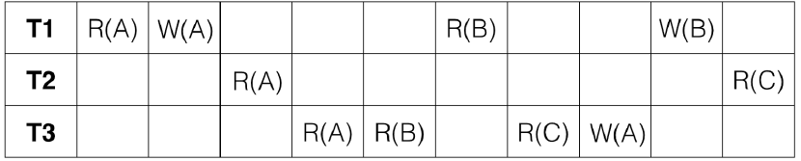

2) This schedule is:

~~Serial~~

~~Serializable~~

~~Conflict Serializable~~

None of the above.

3) 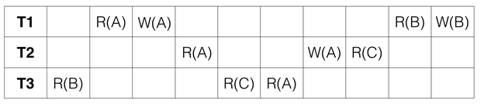

False

4) True or False: Every serializable schedule is also conflict serializable.

False

5) True or False: If its dependency graph has no cycles, a schedule is always conflict serializable.

True

6)

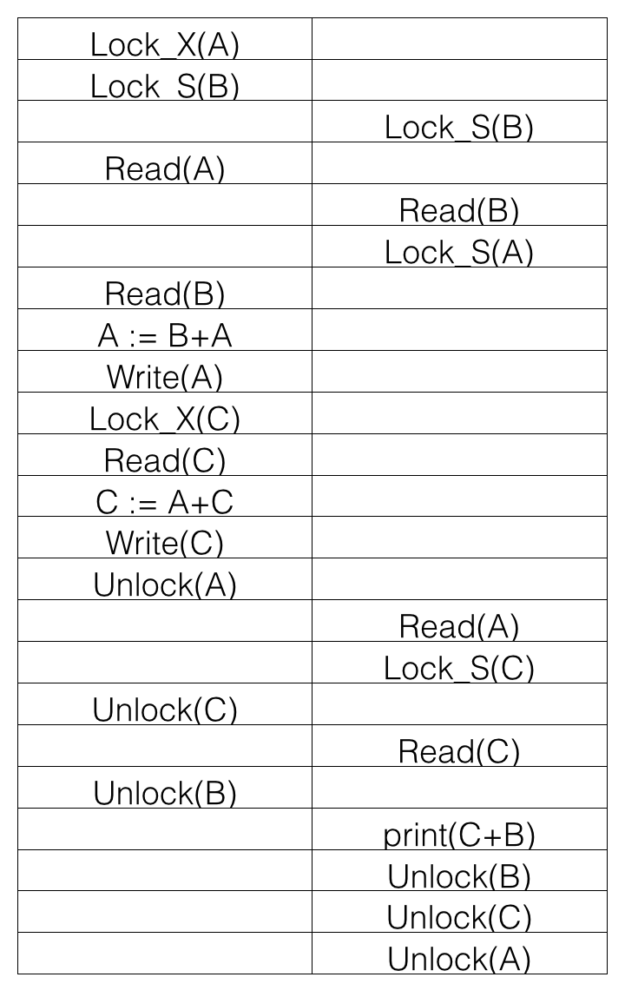

If the initial values of A, B, and C are 20, 30, 45 respectively, what is printed by print(C+B)?

125

7) The given schedule follows:

2PL

Strict 2PL