1) Select all edges that are present in the above schedule's dependency graph.

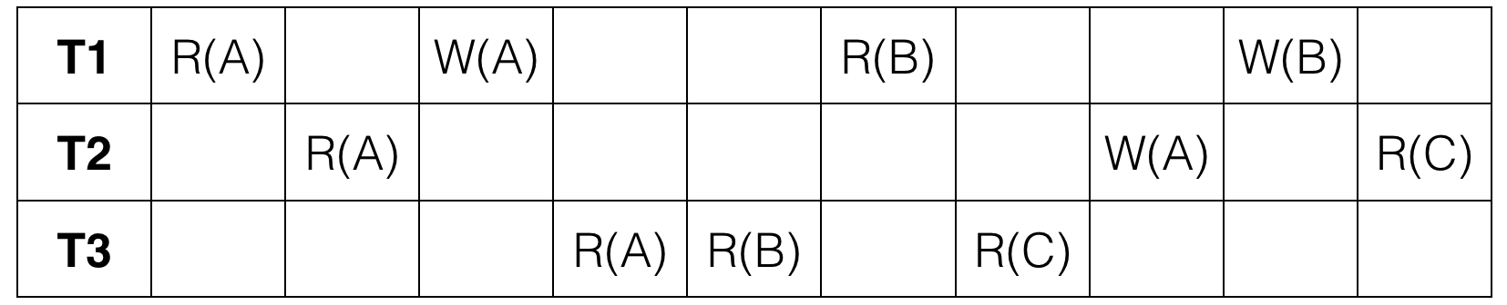

(T1, T2) (T1, T3) (T2, T1) (T3,T1) (T3, T2)

2) This schedule is:

~~Serial~~

~~Serializable~~

~~Conflict Serializable~~

None of the above.

3) 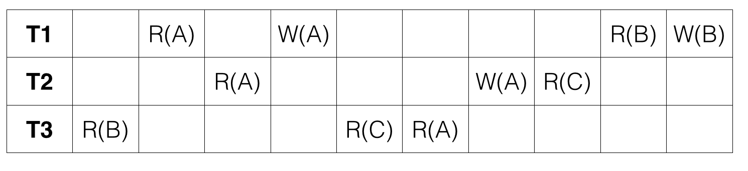

This schedule isconflict equivalent

True

4) True or False: Every serializable schedule is also conflict serializable.

False

5) True or False: If its dependency graph has no cycles, a schedule is always conflict serializable.

True

6)

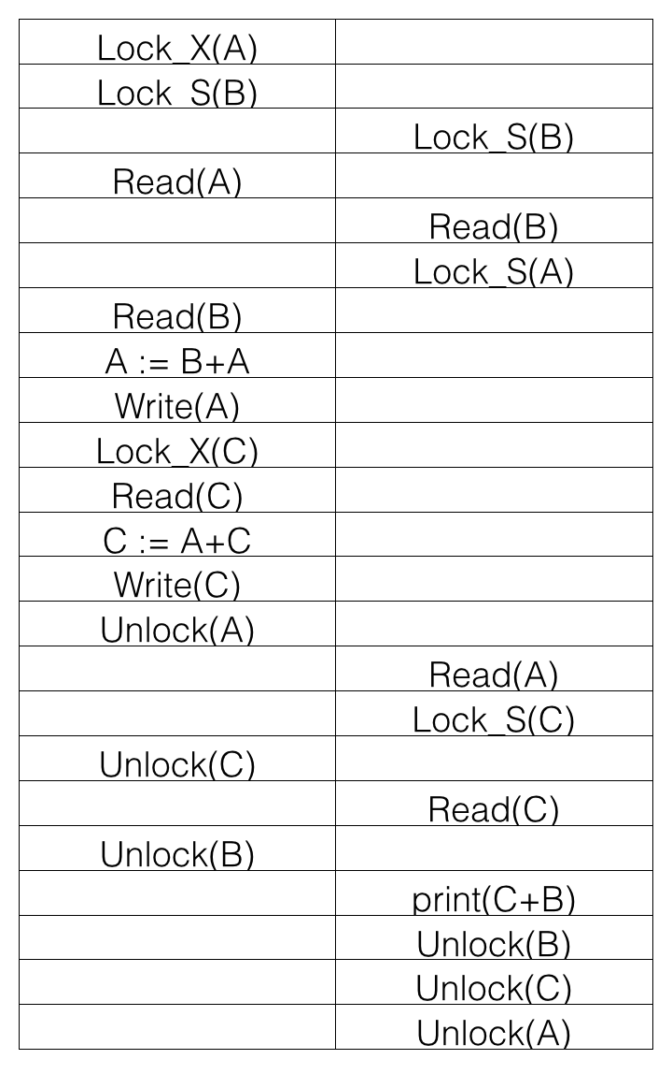

If the initial values of A, B, and C are 10, 50, 75 respectively, what is printed by print(C+B)?

185

7) The given schedule follows:

2PL

Strict 2PL