**MARELLI CASE: Production system description**

**OVERVIEW_______________________________________________________________________________**

Montly production schedule

Parallel machines

Daily production schedule

Customer

Stock, very few units



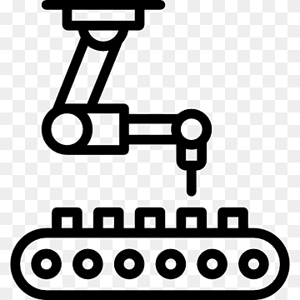

**FACTORY LAYOUT AND MACHINES____________________________________________________________**

SP1-SP2-SP3: flat printing machines: low speed

SP3-SP4: rotating printing machines: high speed

SP7: one-customer dedicated machine (not analysed)

SP6: protective layer machine (FIFO logic)

Production process:

1. Loading of all polycarbonate foils of the lot
2. One foil at time is printed and sent to oven
3. (Cooling of the foil)
4. The foil is deposited at the end of machine
5. Once all the foils of the lot have been passed the first layer, they are sent back to “Loading” for the next layers

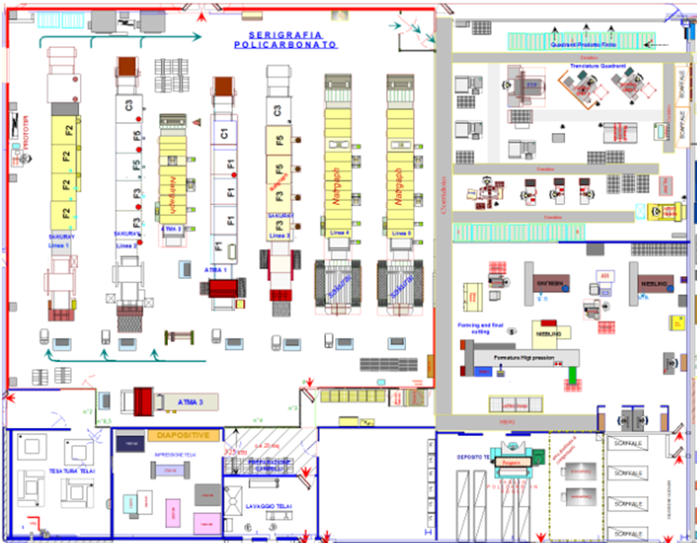

**SP 1**

**SP 2**

**SP 3**

**SP 4**

**SP 5**

**SP 6**

**SP 7**

1 LINE = 1 MACHINE that includes different STEPS. The entire batch of raw foils is loaded (manually or automatically) at the beginning of the line and then the sheets pass successively along the line, without reworking, in a sequence flow. There’s no passage from one line to another one, except for the batches that needs the dedicated protective layer (from SPX to SP6).

Each line has a known production rate [#foils per minute] that is fixed for each machine (SP1,…) and do not depend on the product.

Information about SP6 it’s an a priori information to make the technologist job, since also SP4 and SP5 makes protective layer: allocate the codes that do not need particular protective layout on 4 or 5 (independently), or without difference in the other lines if at the end SP6 is strictly needed;

SP3 is quite independent because it deals for the most part of “Ducato” codes, but we still include this because it’s not completely dedicated.

Products have constraints on the machine typology: some can be worked only on flat, other only on rotating ones.

**SETUP___________________________________________________________________________________**

There are two different set up types that can be identified, we call them A and B.

Set up A is the set up between one layer and another one, so if a sheet of a code must undergo 12 layers, there are 11 A setup times, of the same value (10 minutes).

Setup B is the set up among batches (15 minutes).

Setup times A and B are the same for all machines and independent from the product.

**PRODUCTION POLICY_______________________________________________________________________**

Customers send orders. The logistic planner can see the customer requirement per each week at least 4 weeks in advance.



A daily production plan is set, considering the units already available in stock.

The problem of defects and scrap are NOT SOLVED WITH REWORKING, but instead it is computed a 15% of overproduction to face the possible defect over the total required order quantity. If this 15% at the end is not or not completely used because of good production, the excess goes into the warehouse that at his point we can consider as a buffer: the products in fact are utilized for future orders.

|  |  |
| --- | --- |
| Product code | #foils |
| 089FG | 80 |
| 023GH | 120 |
| … | … |

**PRODUCTION SCHEDULING__________________________________________________________________**

* Technologist employee allocates codes to machine feasibility: he evaluates if the product can be manufactured on the flat machine or on the rotating machines.
* Logistic employee, based on his experience allocates to the daily production plan to the machines.

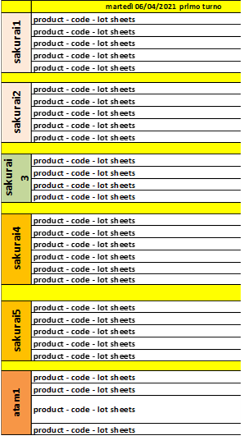

**OBJECTIVE________________________________________________________________________________**

**Main goal:** to optimize the balance of workload on the machines in order to avoid not-working time. This means to improve the OEE.

N.B: OEE is not only affected by not-working time due to lack of work, but also due to failures, holidays, strikes, maintenance, but we don’t have responsibility on this.

**Output of the project**: provide a model that consider the input data of the daily production plan to create the production scheduling of lots on the machines. This will also help the company to have knowledge in advance about queues and time required to product batches.

We’ll have to compute processing time of an entire order(batch) considering **the number of sheets** per batch (see daily scheduling table), the **number of layers** required for the sheet/code, the **machine/line cycle time** and the **set-up times** between layers and batches.

Production plan

Batch processing time (production + setups)

Production scheduling

**Other tasks:**

* Create a value stream map
* Evaluation of the as is “logistic man” method to get the current performances (current OEE and completion time)
* Get information from real visit