实验二
1.B+Tree Pages
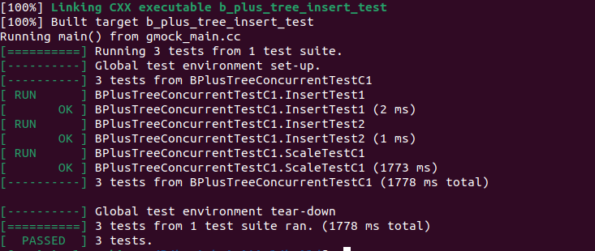
2. B+Tree Delete
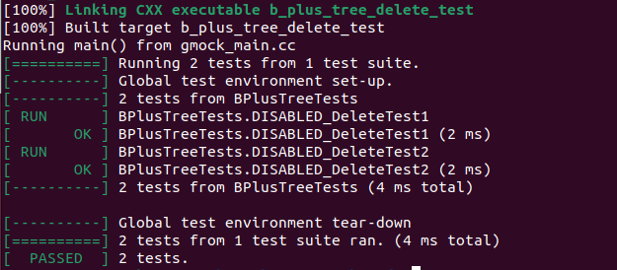
3. Concurrent B+Tree (Latch Crabbing)
