

# University Admission System

|  |
| --- |
| Team |
| Kalpesh Kandi (Scrum Master) |
| Vrushali Patil |
| Piyush Gautam |

**Team Members:**

# Problem Statement

## Objective

Development of an online University Admission System (UAS) that will replace

## Abstract of the project

This project is aimed at developing an online University Admission System (UAS)for applicants. This is a web based application that can be accessed throughout the web. This system can be used to search a university program for which an applicant wishes to take admission; apply online for a selected university program without any login and fill up the form, administration staff can add/update/delete any program that university offers. Members of admission committee have the responsibility to filter the candidates for a specific program on the basis of application data and interview. There are features like report generators etc. in this system.

The model followed was an agile model. Agile SDLC model is a combination of iterative and incremental process models with focus on process adaptability and customer satisfaction by rapid delivery of working software product. Agile Methods break the product into small incremental builds. These builds are provided in iterations.

## Functional components of the project

There are three categories of people who would access the system viz. applicants, members of admission **c**ommittee (mac) and administrators. Each one of them would have some exclusive privileges (for e.g. Applicants can apply for a program by filling up the online form without any login process, members of admission committee alone will be able to view applicant details and filter the applicants for a specific program they have applied for and only the administrator has the right to keep track of the university’s program details.)

1. **Applicant** 
   * Browse through the courses offered by the university
   * Register for the course offered by the university, and will receive an auto generated application ID
   * Check the status of an application, with the application ID provided
2. **Admission Committee(MAC):**
   * Login into the system using his/her credentials.
   * View applications for a specific program.
   * Accept/Reject an application on the basis of the details of the applicant. If accepted, fill in the scheduled date for an interview of the applicant before confirming the applicant to take the program.
   * After the interview, update the status of the application to Confirmed/Rejected
3. **Admin(Administration):**
   * Login to the system using his/her credentials
   * Update and manage (add or delete) information of the programs offer by the university
   * Manage (add or delete) schedules of the programs offered by the university
   * Generate various reports like:
     + View List of applicants confirmed/ accepted (waiting for interview)/rejected for a scheduled program.
     + View list of programs scheduled to commence in a given time period

Transition of Status: Applied ->Accepted/Rejected->Confirmed/Rejected

# Use Case Diagram

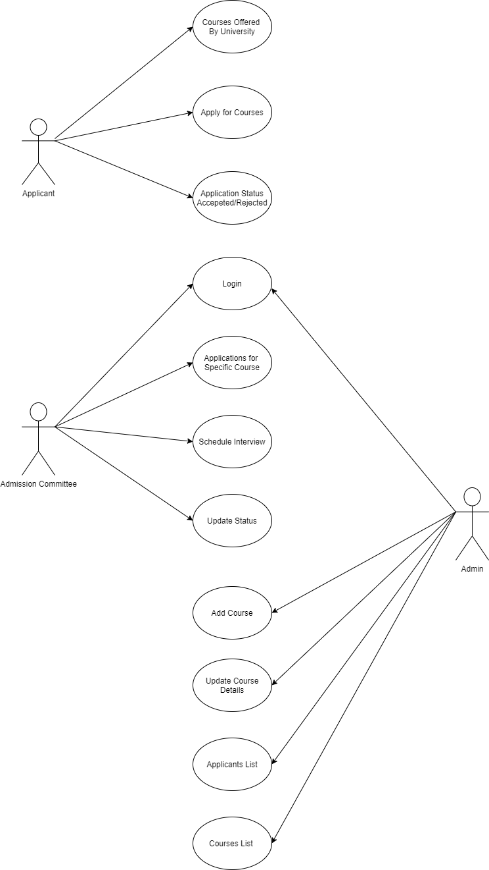

# Class Diagram

**Applicant Class Diagram**

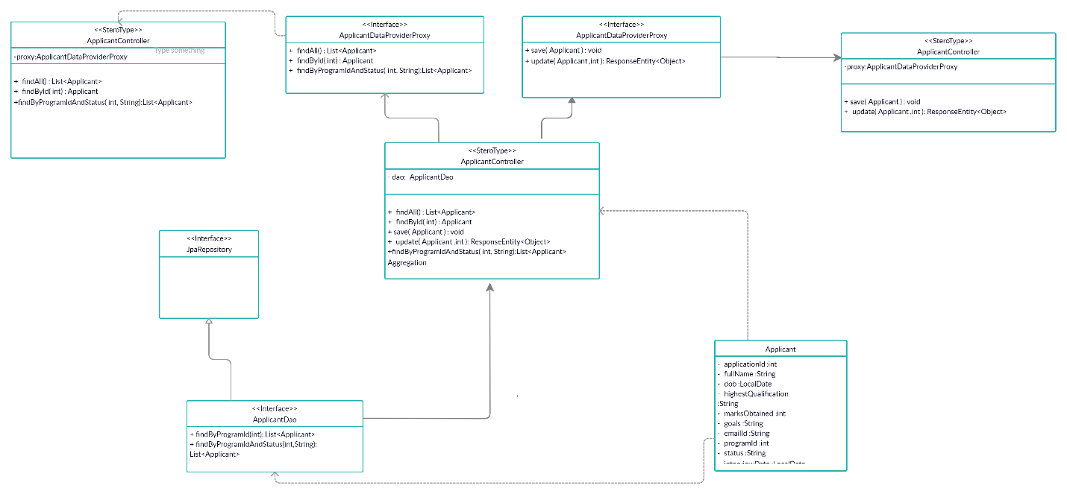

**Program Class Diagram**

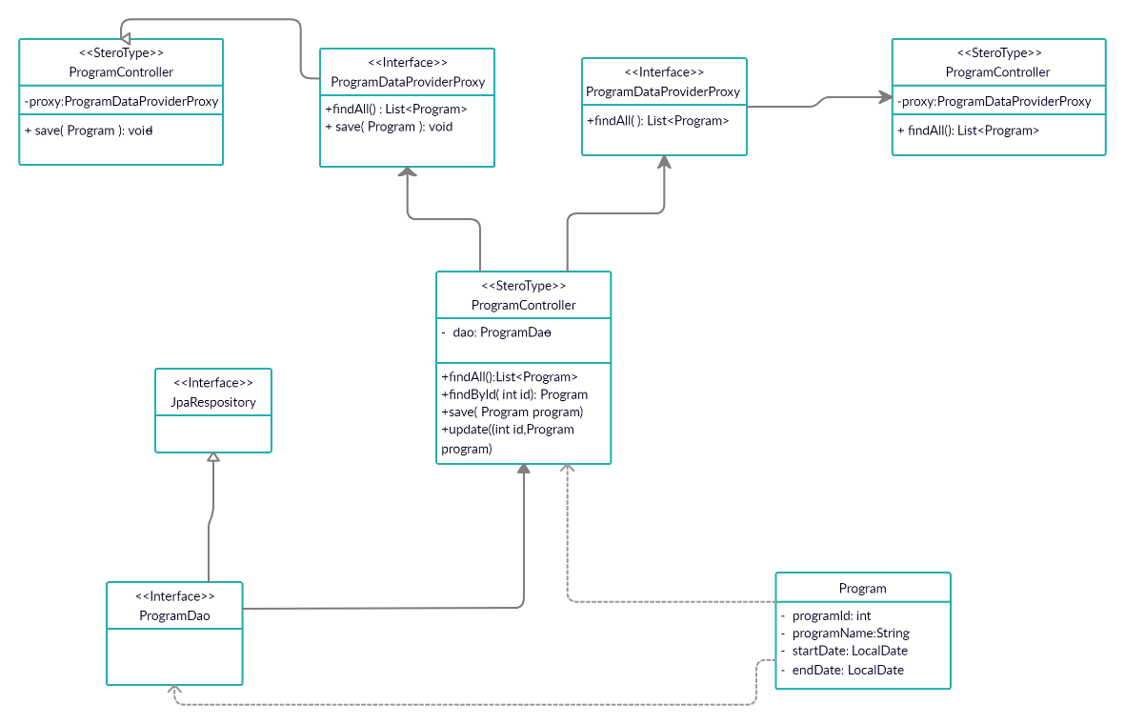

# Epic & Stories

|  |  |  |  |  |
| --- | --- | --- | --- | --- |
| Epic | Stories | As a/an | I want to | So that .. |
| University Admission System | Accessing the portal | Applicant | View the courses offered by the university. | An Applicant apply for a particular course in the university. |
| Registering for a particular course | Applicant | Enter all the required details in the form. | An applicant can get an applicant ID, and check his status for application being accepted or rejected |
| Checking Status | Applicant | Check the status of application. | If the application is accepted then an interview will be scheduled, If rejected then the applicant is not selected |
| Login | Admission Committee | Login to the portal | View applications for a particular program |
| Updating Status of Application on basis of details entered.  (Accepted/Rejected) | Admission Committee | Accept/Reject the application on basis of details entered | The interview can be scheduled for the accepted applicants |
| Scheduling the interview | Admission Committee | Schedule an interview for the accepted applicants | The applicant is accepted before the course |
| Update Status of Application after interview.  (Confirmed/  Rejected) | Admission Committee | Update the status of application. | If the applicant is Confirmed then it is now a Participant to a course, If rejected then applicant is rejected. |
| Login | Admin | Login to Admin | Admin functionalities can be carried. |
| Update information regarding the courses | Admin | Update and manage information of courses offered by university. | The courses offered by the university is available for an applicant with all details provided. |
| Manage schedules of the courses offered | Admin | Add or delete a course offered by the university | There will be more options available for an applicant for enrolment to a course |
| List of applicants (Accepted/Rejected)  for a scheduled program. | Admin | View list of students that are confirmed/accepted  Or pending for interview or rejected for a program. | A list of confirmed, accepted participants is available, |
| List of courses scheduled to commence at a given time period | Admin | View list of courses to be commenced at a given course of time. | A list of courses starting at a particular time is provided. |