**>> Launch one EC2 Instance with below configuration.**

**Instance type –t2.micro**

**Ubuntu machine   
Remaining all default configuration**

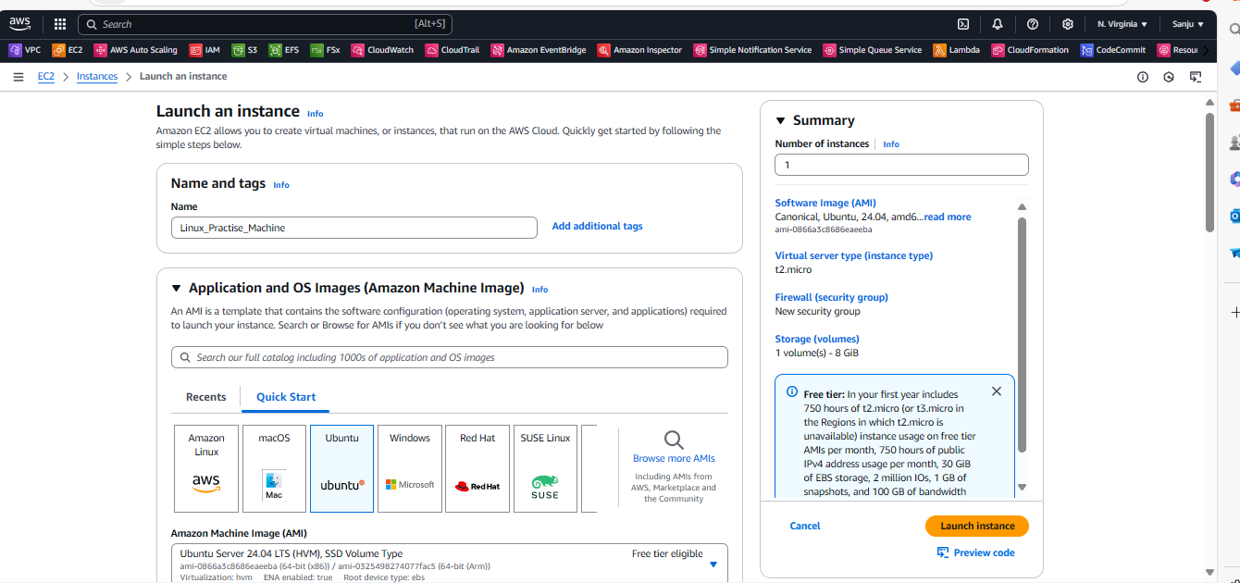

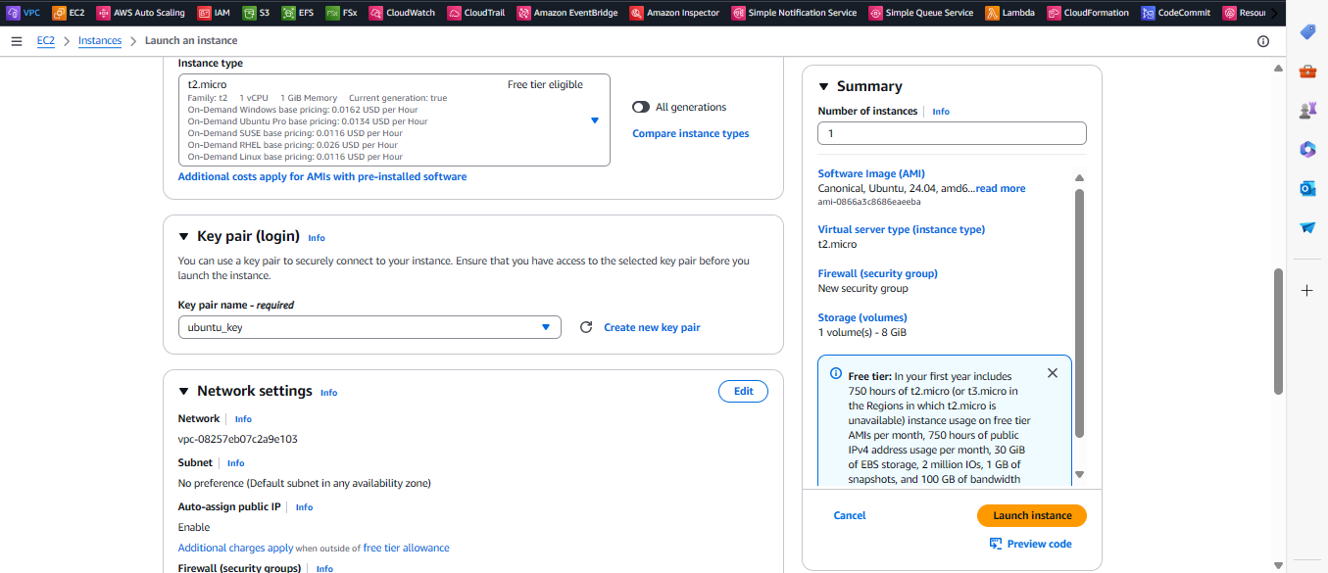  
  
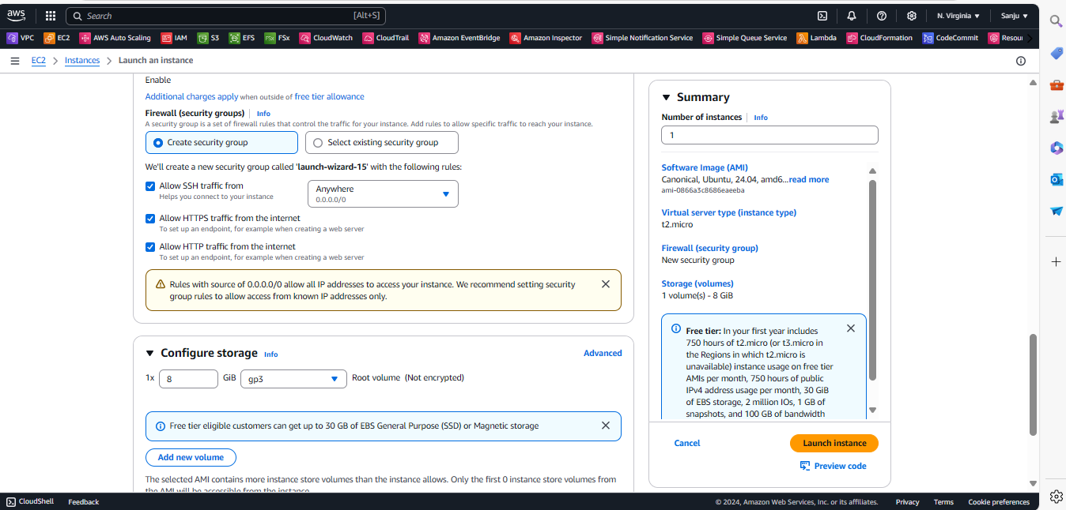  
  
  
**>> Click on connect**  
  
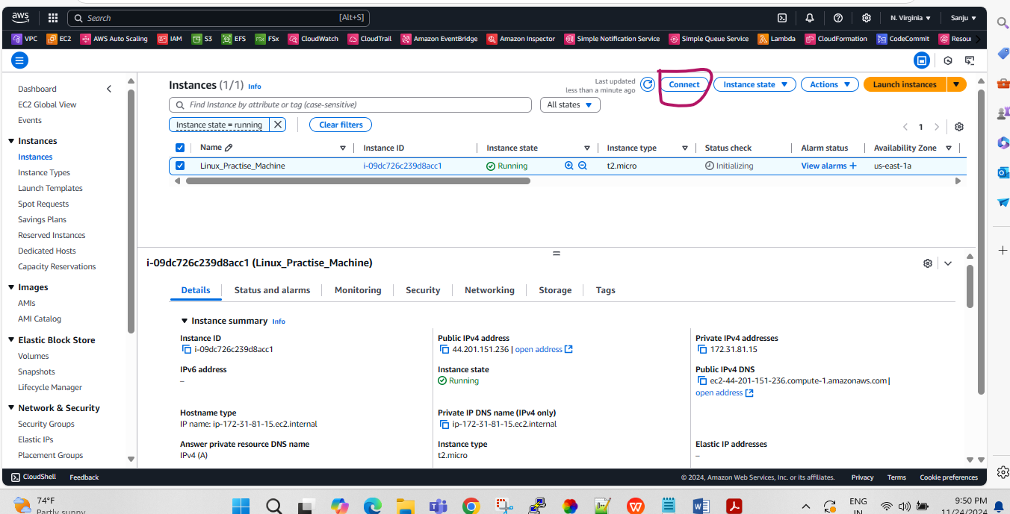  
  
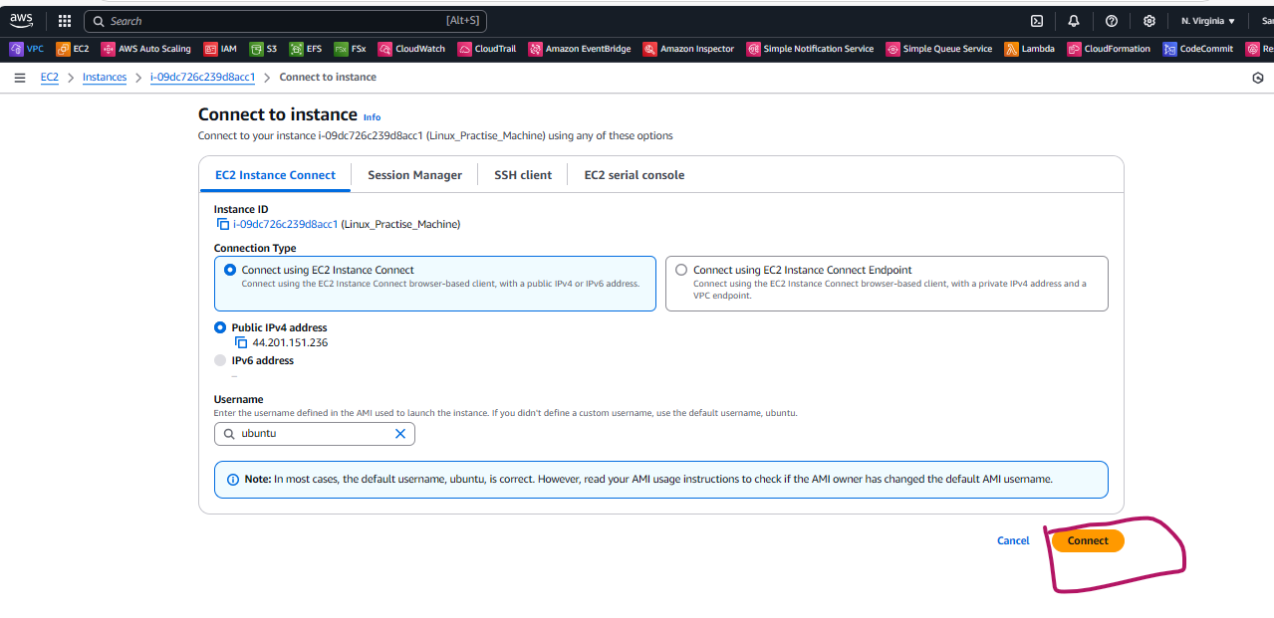  
  
  
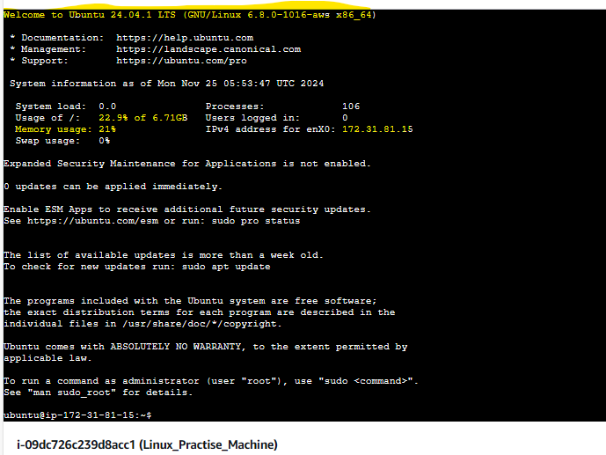  
  
**Type of Shell:**  
**1. bash – born again shell**

**2. zsh**

**3.csh**

**NOTE:- In Linux everything either a file or directory.**

>> sudo hostnamectl set-hostname Linux_machine - **This is for set the host name of machine .**

1. **date** – **It is used to print the date and time at terminal.**



1. **echo "hello world" – used for displaying lines of text or string which are passed as arguments on the command line.**  
   
2. **ls** – **List the directory**   
     
     
     
   4. **pwd** – **Present working directory**   
     
     
     
   5. **whoami** - **displays the username of the user currently logged in .**  
     
     
     
   6. **mkdir** - **creates one or more directories.** **7. touch - used to update the access and modification times of files, and to create new, empty files.** **8. cd directory name - The cd command in Linux stands for change directory. It is used to change the current directory of the terminal.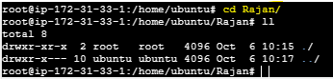 9. cd – In case of only cd and press enter then we reach into home directory .  
     
     
     
     
   10. cd / - / (Slash is root directory) here all important file present for Linux .  
     
   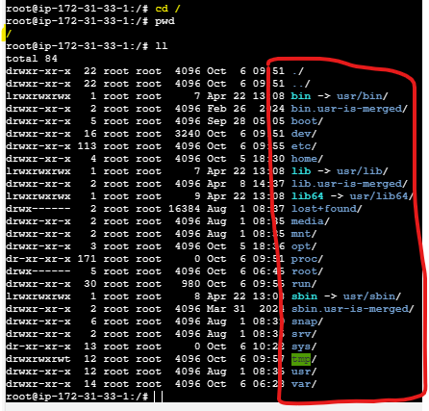**

**11. df –h - show the amount of free disk space on each mounted disk.** 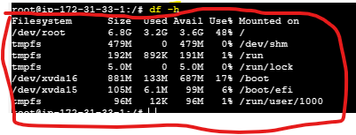 **12. man - Provides detailed information about a command or function, including its syntax, options, and examples .  
  
  
  
  
  
13 . cd .. – Came back to one directory back.   
  
  
**  
  
14. **ping -** PING**(Packet Internet Groper)**command**is used to check the network connectivity between the host and server/host.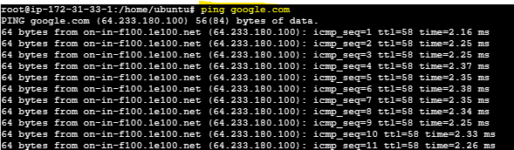 15 . touch file{2..10}.txt – It will create files from 2 to 10 and extension will be .txt.**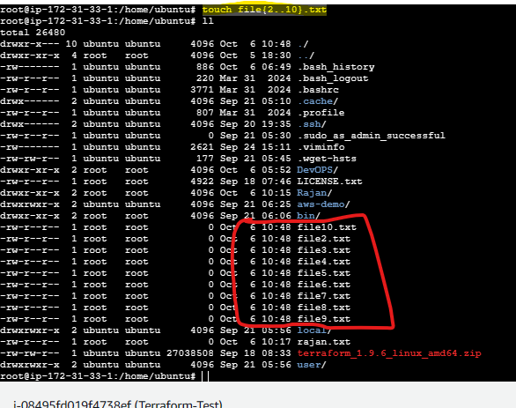

* **16 . rm -rf file* - The rm command lets you delete a file or directory passing its name: "rm filename" or "rm -d directory." You can include a directory path, too. If there are files in the directory, use the -r option "rm -r directory" to delete files and folders recursively.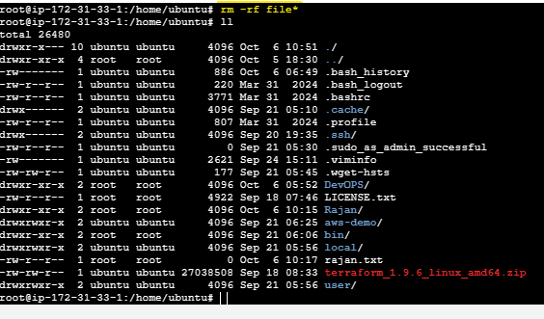 17. sudo - The Linux sudo command stands for**Super User Do**. Generally, it is applied as a prefix of a few commands that superuser is allowed to execute.  
    
    
  18. sudo apt-get update – It is used to update the linux if we are using Ubuntu .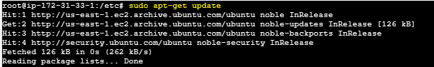 19. sudo apt-get install docker.io - It will install docker.io at Linux .  
    
    
  20. sudo apt purge docker - It will uninstall Docker image from system .  
    
  21. vi file name - vi command in Linux is a command-line text editor that allows users to create and edit files.   
    
  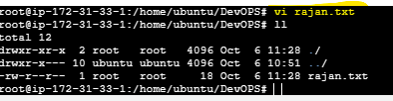**

22. **uptime** - up time for server   
  
  
  
23 . **cd home** - Go to home directory.  
  
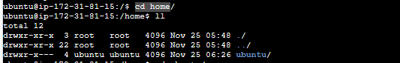  
  
24. **mkdir -p /Rajan/file/myfile** - it will create multiple directory   
  
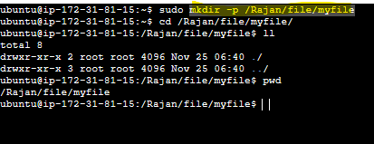  
  
25. **cd ~ - it will take us in home directory   
  
  
  
26. In below snap d- represent directory and (-)- Represent Files   
  
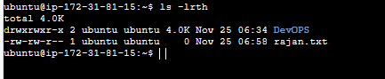**  
**27 . ls -a - It will hidden files as well   
  
**

28. **echo "hello-world" > hello.txt - It will redirect the hello-world in hello.txt  
  
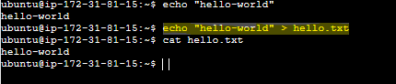  
  
  
29. vi is used to create edit and modify files in Linux   
  
  
  
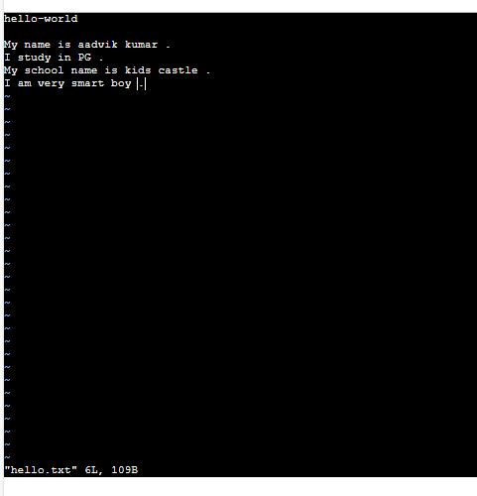  
  
30. :wq! - used for save the text file in vi ,vim editor.**

**Below is some useful cmd which we can use in vi or vim .**i — Switch to Insert mode.

* **Esc** — Switch to Command mode.
* :w — Save and continue editing.
* :wq or ZZ — Save and quit/exit vi.
* :q! — Quit vi and do not save changes.
* yy — Yank (copy) a line of text.
* p — Paste a line of yanked text below the current line.
* o — Open a new line under the current line.
* O — Open a new line above the current line.
* A — Append to the end of the line.
* a — Append after the cursor’s current position.
* I — Insert text at the beginning of the current line.
* b — Go to the beginning of the word.
* e — Go to the end of the word.
* x — Delete a single character.
* dd — Delete an entire line.
* Xdd — Delete X number of lines.
* Xyy — Yank X number of lines.
* G — Go to the last line in a file.
* XG — Go to line X in a file.
* gg — Go to the first line in a file.
* :num — Display the current line’s line number.
* h — Move left one character.
* j — Move down one line.
* k — Move up one line.
* l — Move right one character.  
    
  31. **head hello.txt -n 2 - It will show first two lines of files**   
    
    
  22. **cat file name - The cat (concatenate) command in Linux displays file contents. It reads one or multiple files and prints their content to the terminal**.

  
  
  
  
23. head - **The Linux**head**command prints the first lines of one or more files (or piped data) to standard output. By default, it shows the first 10 lines** .  
  
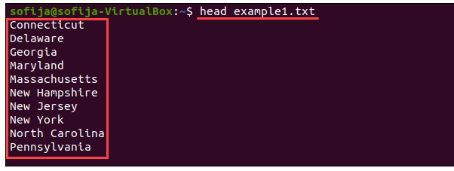  
  
  
24. **head -n 4 example1.txt - It will print first 4 lines of files .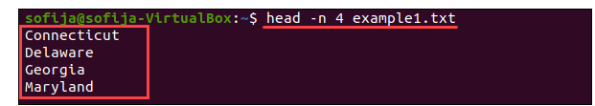 25. tail - Linux tail command is used to display the last ten lines of one or more files. Its main purpose is to read the error message.   
  
26. head hello.txt -n 2 – It will display top 2 lines   
  
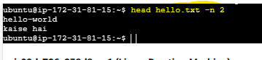  
  
27 . tail hello.txt -n 3 – It will display last 3 lines .  
  
  
  
28. sudo apt install nginx – This is for install NGINX**

**>> copy public IP os EC2 instances and put another browser   
  
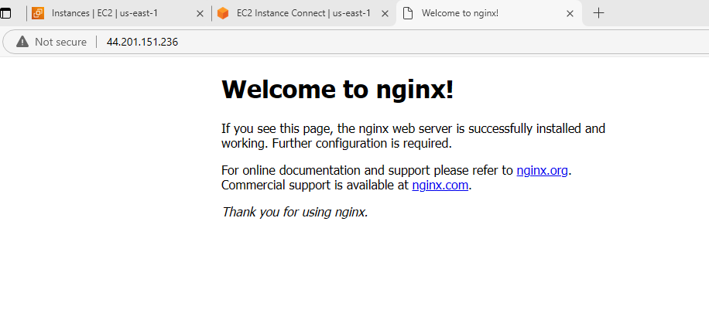**

**>> Go to this path - cd /var/www/html – This is path for nginx at server .  
  
vi sudo vi index.nginx-debian.html – Change as per requirement .  
  
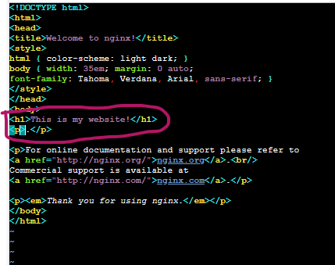  
  
copy public IP os EC2 instances and put another browser  
  
  
  
===================================================================**

**Users and Group   
  
>> root@ip-172-31-33-1:/home/ubuntu/DevOPS# ls -l rajan.txt**

**-rw-r--r-- 1 root root 63 Oct 6 11:39 rajan.txt - Here green color one is user and yellow one group or primary group .  
  
>> sudo useradd -m rajan – Add user and create folder at /home  
  
>> sudo passwd rajan - For add password   
  
>> cat /etc/passwd – This is path for user .  
  
>> groupadd grp name – This cmd will add group .   
  
>> cat /etc/group- This is path for group . Also user is persent here . Whenever we craete user automatically group will be created .  
  
>> usermod -aG devOPS aadvik - This cmd is use to add user in group . Here devOPS is group and aadvik is user .   
  
cat /etc/group - Go to this path and we can see user added in grp .  
  
  
  
  
>> gpasswd -M rajan1,Rajan1 tester - This cmd is used to add multiple usr in grp .  
Below is the example .  
  -   
  
>> chgrp grpname file name – It will change grp of file .  
  
  
  
**

**File or Folder Permissions   
  
>> drwxr-xr-x - Here d-directory , rwx – User , r-xr –group , -x- - others   
  
**

**>> -rw-rw-r-- - Here hyphen symbol – represent file .  
  
r- Read**

**w- Write**

**x- Execute**

**>>**

|  |  |  |  |
| --- | --- | --- | --- |
| Permisions | R (Read) | W (Write) | X (Execute) |
| 7 | 1 | 1 | 1 |
| 6 | 1 | 1 | 0 |
| 5 | 1 | 0 | 1 |
| 4 | 1 | 0 | 0 |
| 3 | 0 | 1 | 1 |
| 2 | 0 | 1 | 0 |
| 1 | 0 | 0 | 1 |
| 0 | 0 | 0 | 0 |

**>> chmod 764 file name - User – having all permission rwx , group having – rw and others having – only write permission .  
  
  
  
  
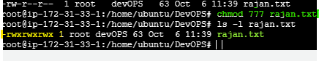  
  
  
>> By default whenever we create any file they having below permission   
  
-rw- rw- r- - - 664 – User-read write , group- read write and others having read only .  
  
  
========================================================================**

**SSh (Secure shell )   
  
>> There is two types of keys :**

1. **Private key**
2. **Public key**

**>> Using SSh we can connect any remote server using private and public key .  
  
===================================================================================**

**Systemctl(system controller )**

**>>systemctl status ssh – It will tell about status of ssh   
  
  
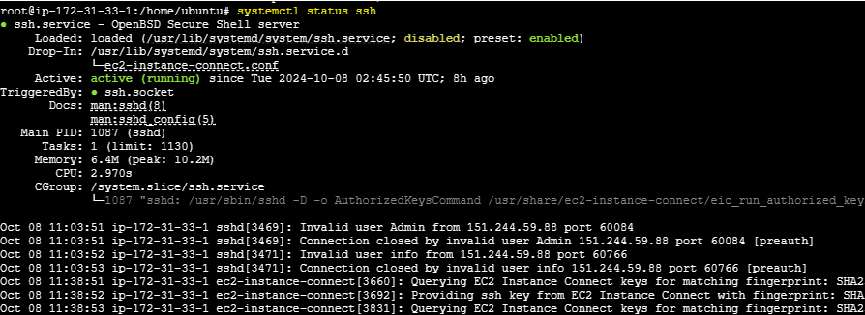  
  
  
>> systemctl stop docker - For stop docker   
  
>> systemctl restart {servicename} -   
  
systemctl reboot**

**systemctl poweroff**

**systemctl start {servicename}**

**systemctl stop {servicename}**

**systemctl enable {servicename}**

**systemctl disable {servicename**}  
  
  
===================================================================

**Grep/Find/AWK/Sed  
  
  
>> grep grant LICENSE.txt – It will grep grant in License,txt file .  
  
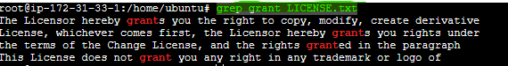  
  
>> grep "keyword" file1 file2 file3  
  
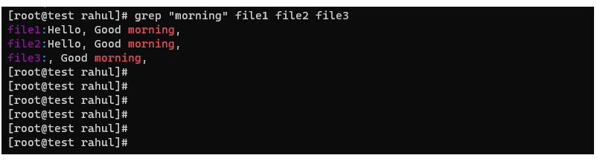  
>> grep -e "keyword1" -e "keyword2" file_name – This will multiple keyword .  
  
  
  
  
>> grep "banana$" fruits.txt  
  
  
**

>> **grep -n “keyword” file_name - If you want to show line numbers along with the matching lines, you can use the “-n” option with the grep command. Here’s an example:**

  
  
  
>> **grep "keyword" file_name >> output.txt** - **The “>” operator overwrites the contents of the output file if it exists or creates a new file if it doesn’t. If you need to add the output to an existing file, you can utilize the “>>” operator instead:**  
  
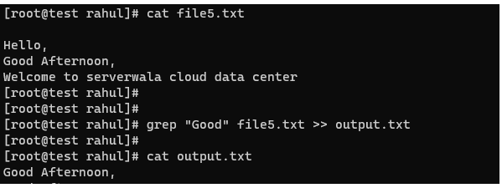  
  
  
>> ***grep "example" data.txt > output.txt***  -   
  
  
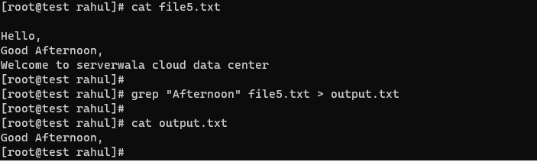  
  
  
**>> grep -i grant LICENSE.txt :- this will take all keyword irrespective of case sensitive .**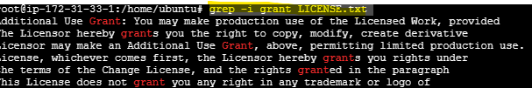  
  
  
>> **grep -r grant /home/ubuntu/** - This will search from directory .

**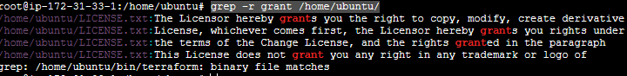  
=====================================================================================  
 >> Find CMD   
  
  
1. find / -name file name - use for find the path file**

**[root@ip-172-31-47-107 ~]# find / -name Rajan**

**/root/Rajan**

**2. find / -iname file name - use this cmd to find the file irrespective of case sensitiveness**

**[root@ip-172-31-47-107 home]# find / -iname Rajan**

**/home/rajan**

**3. find / -type d -name file name - If we want to check directory**

**[root@ip-172-31-47-107 home]# find / -type d -name rajan**

**/home/rajan**

**4. find / -name "*.txt" - If we know only extention of file use this cmd .**

**[root@ip-172-31-47-107 home]# find / -name "*.txt"**

**5. find / -name "*va*"**

**6. find / -perm 0777 -print - It wil print all file which having 0777 permission**

**7. find / ! -perm 0777 -print - It wil print all file which not having 0777 permission**

**8. find / -perm /a=x - it tells all files which having execute permission.**

**9. find . -perm 0777 -print -exec chmod 755 {} \; - It will change permission from 0777 to 755 in current directory**

**10. find . -type f -name abc.txt -exec rm -rf {} \; - This is for find and delete specfic file or directory .  
  
  
===================================================================================  
 How we can compress the file**

**1.gzip -r name of folder.zip file name - This is fo zip the folder**

**[root@ip-172-31-18-112 ~]# zip Rajan1.zip Rajan1/**

**2. Unzip cmd - unzip folder name**

**3. tar -cvzf file name.tar.tgz file name - For tar the file**

**4. tar -xvzf - for untar the file .  
  
  
==========================================================================  
 awk   
  
>> awk '/HashiCorp/' LICENSE.txt – It will print only Hashicorp in License.txt   
  
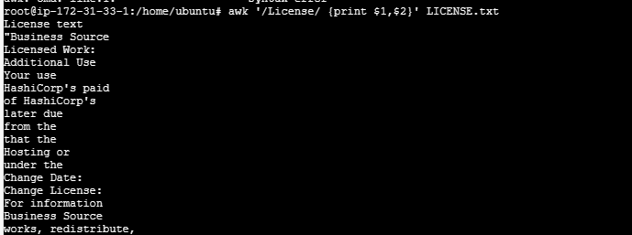  
  
>> awk '/License/ {print $1,$2}' LICENSE.txt - It will only print column no -1 and 2 .  
  
   
  
  
>> awk 'NR>=1 && NR<=10 && /License/ {print NR $1,$2}' LICENSE.txt   
  
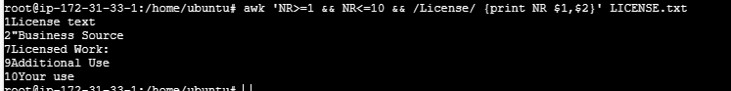  
  
  
>>** **awk '{print $2 "\t" $3}' file.txt - To print the 2nd and 3rd columns, execute the command below**.  
  
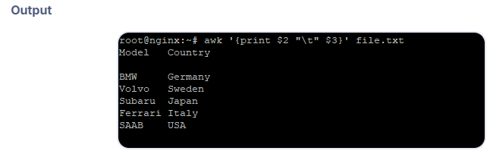  
  
  
>> **awk ' {print $0}' file.txt**  - **If you wish to list all the lines and columns in a file, execute .  
  
 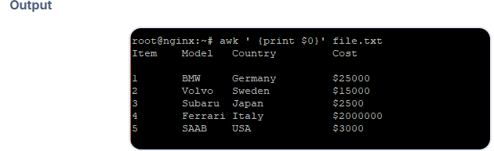**

**>> awk '/o/ {print $0}' file.txt - For instance, to match all entries with the letter ‘o’, the syntax will be   
  
**

**>> awk '/e/ {print $0}' file.txt - To match all entries with the letter ‘e’  
  
  
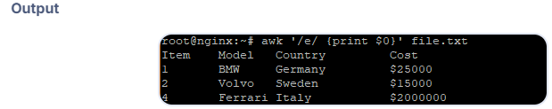**

**=====================================================================================  
 sed (Stream Editor )  
  
>> sed 's/cool/hot/g' noopur.txt - It will replace the content in files .  
  
