**Jai Maa Sharde   
  
  
>> Shell – It is utility which allow us to talk to kernel .   
  
>> Bash – It is kind of shell. It is more popular shell. Born again shell. It is end with .sh .  
  
>> sh – It is also shell.   
  
>> write the first bash scripting .  
  
shebang - #!/bin/bash - This will always come whenever we start script .  
  
>>vi hello.sh and write below script**

**#!/bin/bash**

**echo "Gabbar: Kitne aadmi the"**

**echo "Sambha: 2 sarkar"**

**>> then chmod 777 hello.sh**

**Below is the output of script:**

**>> ./hello.sh**

**root@ip-172-31-45-40:~/Scripts# ./hello.sh**

**Gabbar: Kitne aadmi the**

**Sambha: 2 sarkar  
  
  
==================================================================================  
  
  
>>Second script**

**#!/bin/bash**

**echo "Gabbar: Kitne aadmi the"**

**echo "Sambha: 2 sarkar"**

**echo "Gabbar: Kitna bja hai"**

**date**

**echo "Gabbar : kitne baje se class chal rha hai"**

**uptime  
  
  
>> output :  
  
root@ip-172-31-45-40:~/Scripts# ./hello.sh**

**Gabbar: Kitne aadmi the**

**Sambha: 2 sarkar**

**Gabbar: Kitna bja hai**

**Tue Oct 15 10:20:43 UTC 2024**

**Gabbar : kitne baje se class chal rha hai**

**10:20:43 up 4 min, 2 users, load average: 0.02, 0.13, 0.07  
  
==============================================================================  
 Another script where we can write Comment .  
  
#!/bin/bash**

**#this is sholay story by Rajan**

**<<Comment**

**This is multiline comment**

**Comment**

**echo "Gabbar: Kitne aadmi the"**

**echo ""**

**echo "Sambha: 2 Sarkar"**

**echo ""**

**echo "Gabbar: Kitna bja hai"**

**echo ""**

**date**

**echo ""**

**echo "Gabbar: kitne der se class chal rha hai"**

**echo ""**

**uptime  
  
  
output of script :  
  
root@shellMachine:/home/ubuntu/script# ./hello.sh**

**Gabbar: Kitne aadmi the**

**Sambha: 2 Sarkar**

**Gabbar: Kitna bja hai**

**Mon Dec 2 02:34:07 UTC 2024**

**Gabbar: kitne der se class chal rha hai**

**02:34:07 up 38 min, 1 user, load average: 0.00, 0.00, 0.00   
  
=====================================================================================  
 Variables and Constant   
  
>> Variable – Anything that is vary called variable .  
  
a = 2 - Here a is variable and 2 is constant .  
  
write the below script :  
  
  
>> variable.sh   
  
#!/bin/bash**

**<<Note**

**This is demo for variables.**

**Note**

**Name="Rajan"**

**echo "My name is $Name"**

**Output :  
  
root@shellMachine:/home/ubuntu/script# ./variables.sh**

**My name is Rajan  
  
==============================================================================**

**>> Another script for variables  
  
  
#!/bin/bash**

**<<Note**

**This is demo for variables.**

**Note**

**Name="Rajan"**

**echo "My name is $Name"**

**echo "What is your name"**

**Name2="Anoop"**

**echo "My name is $Name2  
  
  
output :  
  
root@shellMachine:/home/ubuntu/script# ./variables.sh**

**My name is Rajan**

**What is your name**

**My name is Anoop**

**>> We can ask input from users as well :  
  
  
  
#!/bin/bash**

**<<Note**

**This is demo for variables.**

**Note**

**echo "Enter the name"**

**read Name**

**echo "My name is $Name"**

**echo "What is your name"**

**read Name2**

**echo "My name is $Name2"  
  
Output :  
  
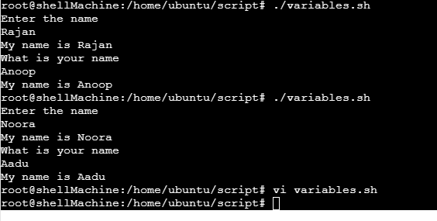  
  
>> vi greeting.sh  
  
#!/bin/bash**

**# Define variables**

**USER_NAME="User"**

**GREETING="Hello"**

**COUNTER=1**

**# Greeting the user**

**echo "$GREETING, $USER_NAME!"**

**# Loop to count from 1 to 5**

**echo "Counting from 1 to 5:"**

**while [ $COUNTER -le 5 ]**

**do**

**echo "$COUNTER"**

**COUNTER=$((COUNTER + 1))**

**done**

**# Conditional statement**

**if [ $COUNTER -gt 5 ]; then**

**echo "Count complete!"**

**else**

**echo "Count failed."**

**fi**

**>> Explanation for above script:  
  
#!/bin/bash -** This line indicates that the script should be run using the Bash shell.

**USER_NAME="User"**

**GREETING="Hello"**

**COUNTER=1**

**These lines define three variables:**

* USER_NAME is set to "User".
* GREETING is set to "Hello".
* COUNTER is initialized to 1.

# Greeting the user

* echo "$GREETING, $USER_NAME!"  
    
  **This line outputs a greeting message to the user by combining the GREETING and USER_NAME variables. It will display: Hello, User!**

# Loop to count from 1 to 5

echo "Counting from 1 to 5:"

while [ $COUNTER -le 5 ]

do

echo "$COUNTER"

COUNTER=$((COUNTER + 1))

done

* **This section starts a loop:**
  + **It first prints "Counting from 1 to 5:".**
  + **The while loop checks if COUNTER is less than or equal to 5 (-le stands for "less than or equal").**
  + **Inside the loop:**
    - **It prints the current value of COUNTER.**
    - **It increments COUNTER by 1 using the expression COUNTER=$((COUNTER + 1)).**
* The loop continues until COUNTER exceeds 5, resulting in the numbers 1 to 5 being printed.

# Conditional statement

if [ $COUNTER -gt 5 ]; then

echo "Count complete!"

else

echo "Count failed."

fi

* **This part contains a conditional statement:**
  + **The if checks if COUNTER is greater than 5 (-gt stands for "greater than").**
  + **Since the loop increments COUNTER to 6 after counting to 5, the condition will be true.**
  + **If true, it prints "Count complete!".**
  + **If never true (which in this script will not happen), it would print "Count failed."**

**==================================================================================**

**Here we can use -p (prompt)  
  
  
vi prompt.sh  
  
#!/bin/bash**

**# This script is used for reading variables.**

**# Prompt for the first name**

**read -p "Enter your name: " name**

**echo "My name is $name"**

**# Prompt for the second name**

**echo "What is your name?"**

**read name2**

**echo "My name is $name2"**

**Outputs :  
  
oot@Scripting:/home/ubuntu/scripting# ./prompt.sh**

**Enter your name: Rajan**

**My name is Rajan**

**What is your name?**

**aadu**

**My name is aadu**

**=====================================================================================  
 // Below script will install NGINX and enable it also //**

**#!/bin/bash**

**<<Note**

**This script will install NGINX.**

**Note**

**echo "******************************************Installing_NGINX*****************************************"**

**sudo apt-get update**

**sudo apt-get install nginx -y**

**sudo systemctl start nginx**

**sudo systemctl enable nginx**

**echo "***********************************Installation_Complete*******************************************"**

**sudo nginx -v**

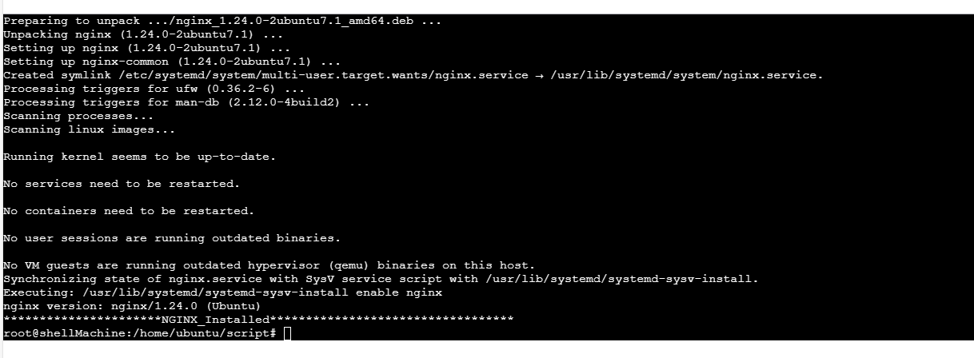

**Arguments : We can pass any arguments   
  
  
#!/bin/bash**

**# This script will install any package.**

**# Usage: ./Install_package.sh <package-name>**

**# Check if a package name is provided**

**if [ -z "$1" ]; then**

**echo "Error: No package name provided."**

**echo "Usage: ./Install_package.sh <package-name>"**

**exit 1**

**fi**

**# Display the package name provided**

**echo "Package to install: $1"**

**# Start installation process**

**echo "******************** Installing $1 ********************************"**

**# Update package list**

**sudo apt-get update**

**# Install the package**

**sudo apt-get install "$1" -y**

**# Start the service (if it has a service associated with it)**

**sudo systemctl start "$1"**

**# Enable the service to start on boot**

**sudo systemctl enable "$1"**

**# Installation complete**

**echo "********************** $1 Installed Successfully **********************************"**

**>> Outputs Below : In Below script we can pass any arguments and it will work accordingly .  
  
  
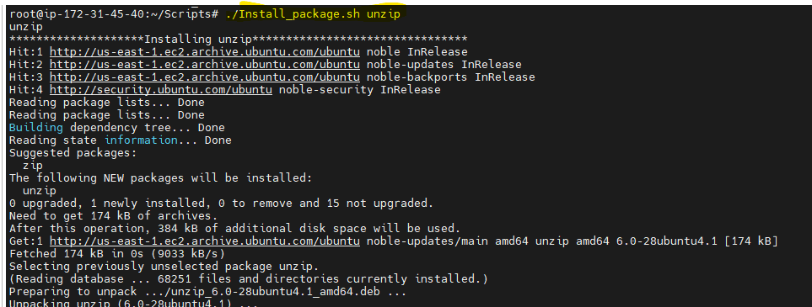**

**=====================================================================================  
  
  
  
#!/bin/bash**

**<<disclaimer**

**Is kahani ke sabhi patr and Ghatnaye kalpnic**

**disclaimer**

**read -p "Enter Gabbar's Dilogue:" gb**

**read -p "Enter Thakur's Dilogue:" th**

**echo "$gb"**

**echo "$th"  
  
  
Output :  
  
root@ip-172-31-45-40:~/Scripts# ./Gabbar_Thakur.sh**

**Enter Gabbar's Dilogue:ye hath hmko de thakur**

**Enter Thakur's Dilogue:Nahi**

**ye hath hmko de thakur**

**Nahi  
  
  
=====================================================================================**

**Conditional Statement If and Else   
  
>> If and Else are conditional statements ;  
  
>> scripts below :  
  
#!/bin/bash**

**<<disclaimer**

**Iss kahani ke sabhi patr and ghatnaye kalpnic hai**

**disclaimer**

**read -p "Enter gabbar's dialogoue" gb**

**read -p "Enter Thakur's dialogue" th**

**echo "$gb"**

**echo "$th"**

**if [[ $th == "nahi" ]];**

**then**

**echo "Jai veeru ki entry and bhsad"**

**else**

**echo "chop chop"**

**fi**

**echo "sholay kahtam"  
  
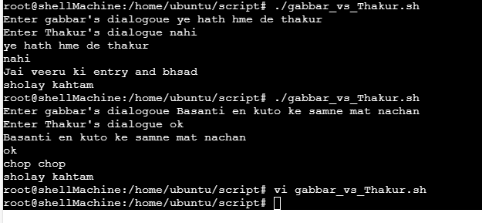**

**====================================================================================  
  
 // Process for take the BKP //  
  
  
./Install-pkg.sh zip - For install the zip  
  
zip -r backup.zip /home/ubuntu/script - This will compress the script and store in backup.zip  
  
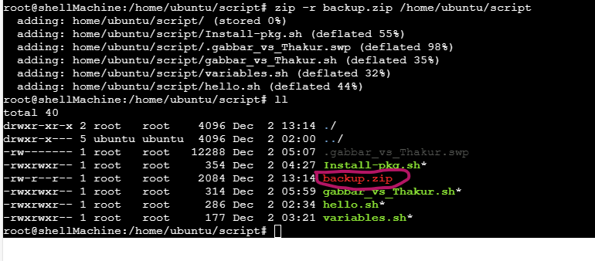  
==================================================================  
  
// Below script will show date in format and take bakup.//  
  
#!/bin/bash**

**<<Note**

**This will take backup of any destination path given in arguments**

**./backup.sh /home/ubuntu/script**

**Note**

**echo "$(date '+%Y-%m-%d')"  
  
  
  
Output :  
  
root@shellMachine:/home/ubuntu/script# ./backup.sh**

**2024-12-02**

**===================================================================**

**>>>Below script will take the backup with timestamp   
  
vi backup.sh  
  
  
#!/bin/bash**

**<<Note**

**This will take backup of any destination path given in arguments**

**./backup.sh /home/ubuntu/script**

**Note**

**timestamp="$(date '+%Y-%m-%d-%H-%M-%S')"**

**backup_dir="${timestamp}_backup.zip"**

**zip -r $backup_dir $1**

**echo "Backup complete"**

**output :  
  
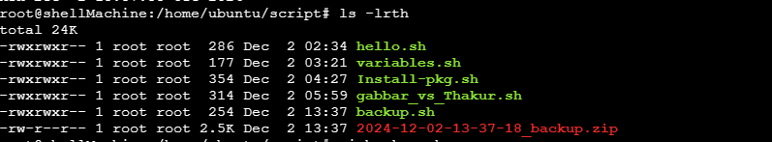  
  
===================================================================  
  
 //CRONE //  
  
>> Use this website for use the crone in better way -** [**https://crontab.guru/#5_4_*_*_1**](https://crontab.guru/#5_4_*_*_1) **>>**

**#!/bin/bash**

**<<Note**

**This will take backup of any destination path given in arguments**

**./backup.sh /home/ubuntu/script**

**Note**

**function show_date {**

**echo "Today is : $(date '+%Y-%m-%d-%H-%M-%S')"**

**}**

**function create_backup {**

**timestamp="$(date '+%Y-%m-%d-%H-%M-%S')"**

**backup_dir="/home/ubuntu/backups${timestamp}_backup.zip"**

**zip -r $backup_dir $1**

**echo "Backup complete"**

**}**

**show_date**

**show_date**

**show_date**

**show_date**

**create_backup  
  
  
Outputs:  
  
  
  
  
