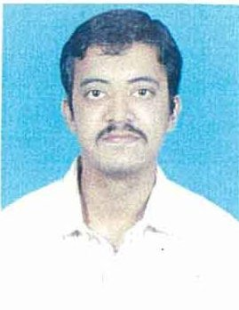

**RESUME**

**NAME : MANDAR. N. PURANDARE**

**DATE OF BIRTH :** 15-12-1992

**ADDRESS :** 202, Ashiana Building, 21. St. Paul’s Road,

Bandra (West), Mumbai – 400 050.

**CONTACT NO. :** Mobile: 9757123779 / 8104441824

Landline: 022-26456354

Email: mnpsmailbox@rediffmail.com

**About myself:** I am a hardworking individual who devotes myself to work that is given to me. As a science student I am curious and eager to study any topic that sparks my interest.

**QUALIFICATION :**

* M.Sc. Degree in Physics with 61.25 % (from 2014–2017)
* B.Sc. Degree in Physics with 52.50% (from 2010 – 2013)
* H.S.C. Examination with 49.33% (2010)
* S.S.C. Examination with 75.84%(2008)
* Applied component in B.Sc. – Electronic Instrumentation
* Applied component in M.Sc. – Electronics – I

(Subject in Electronics – I : I.C. architectures: 8085, 8051, PIC, 8086, ARM-7)

(Programming Languages : C++, VHDL)

Additional Qualification: Diploma course in Web Development from Compufield.

Knowledge of HTML, CSS, MySQL, PHP, Javascript and Jquery.

**WORK EXPERIENCE :**

* Currently working as ‘leadmaker’ (back office) at Commversion Pvt. Ltd
* 7 months experience at Metal Power Analytical (I) pvt.ltd (February 2017 – October 2017) as a **calibration engineer**. Knowledge of Calibration, Regular machine maintenance, Quality related documentation and production process

* 3 months experience at Wipro BPO (November 2016 – February 2017)as an **advisor** for an international process.

**Languages known**: Marathi, English, Hindi

**Hobbies and interests**: Watching wildlife shows, Science and technology shows, reading scientific articles and scientist biographies.