**Formatting Guidelines for Authors Using the Word Template**

First Author Name a,*, Second Author Name a, Third Author Name a,b, Fourth Author Name b, Fifth Author Name b

a University Name, Faculty Group, Department, Street Address, City, Country, Postal Code

b Company Name, Street Address, City, Country, Postal Code

**\* Corresponding author email address**: [author@jscdss.com](mailto:author@jscdss.com)

Abstract

The abstract should contain between 100 and 350 words. A concise and factual abstract is required. The abstract should state briefly the purpose of the research, the principal results and major conclusions. An abstract is often presented separately from the article, so it must be able to stand alone. For this reason, References should be avoided, but if essential, then cite the author(s) and year(s). Also, non-standard or uncommon abbreviations should be avoided, but if essential they must be defined at their first mention in the abstract itself.

Keywords: Keyword1, Keyword2, Keyword3(Please select a maximum of 6 keywords from the keyword list)

1. How to use the template

Using this template will enable you to prepare your paper in accordance with the instructions for authors for JSCDSS papers with a minimal amount of manual styling and formatting.

Please read through the following sections for more information on preparing your paper. However, if you use the template you do not have to worry about setting margins, page size, and column size etc. as the template already has the correct dimensions.

* 1. *Subsections*

Divide your article into clearly defined and numbered sections. Subsections should be numbered 1.1 (then 1.1.1, 1.1.2, ...), 1.2, etc. (the abstract, Acknowledgements, and References are not included in section numbering). Use this numbering also for internal cross-referencing: do not just refer to "the text". Any subsection may be given a brief heading. Each heading should appear on its own separate line.

1. Format

Text should be produced within the dimensions shown on these pages; each column 8.47 cm wide with 0.85 cm middle margin, total width of 17.78 cm and a maximum length of 21cm on the first page and 23.5cm on the second and following pages. Make use of the maximum stipulated length apart from the following two exceptions: (i) do not begin a new section directly at the bottom of a page, but transfer the heading to the top of the next column; (ii) you may exceed the length of the text area by *one line only* in order to complete a section of text or a paragraph.

You must use 1.0 (single) line spacing. However, when typing complicated mathematical text it is important to increase the space between the text lines in order to prevent sub- and superscript fonts overlapping one another and making your printed matter illegible. If you are using a desktop publishing program ensure that your auto adjust for interline spacing is suitably set to prevent overlapping but without leaving too much space.

All text should be Times New Roman (or Times Roman) with font sizes as follow: Title 16pt, Authors 10pt, Addresses 8pt, Article history 8pt, Abstract including abstract title 9pt, Keywords 8pt, Body text 10pt, Level 1 headings 10pt bold, Level 2 headings 10pt italic, Level 3 headings 10pt italic no space below, Level 4 headings 10pt italic no space below and text runs on, Footnotes 8pt.

If corrections are made to the printout, run off completely new replacement pages. The contrast on these pages should be consistent with the rest of the paper, as should text dimensions and font sizes.

1. Figures and graphs

All illustrations should be clearly displayed by leaving at least a single line of spacing above and below them. When placing a figure at the top of a page, the top of the figure should be at the same level as the first text line of the other column. Legends to illustrations should be centred if on one line or aligned left if on two or more lines. Figures and graphs should also be large enough for the figure to be clear. Text within figures must be Times New Roman font, as appropriate for the figure. Font sizes for legends should be 8pt (to be legible). Figure captions should appear below the figure. The captions should be clear and simple, although sufficient information should be provided for the figure to be understood without further reference to the text. Captions should be 8 point Times font, centred with the figure, and have 6pt spacing after and 4pt before the captions. The words “Fig. 1.” should be in bold as shown in the example figure in this document. The caption should end with a full stop. You can also use one column for large figures (**see Fig. 2 in the last page of template for submission**).

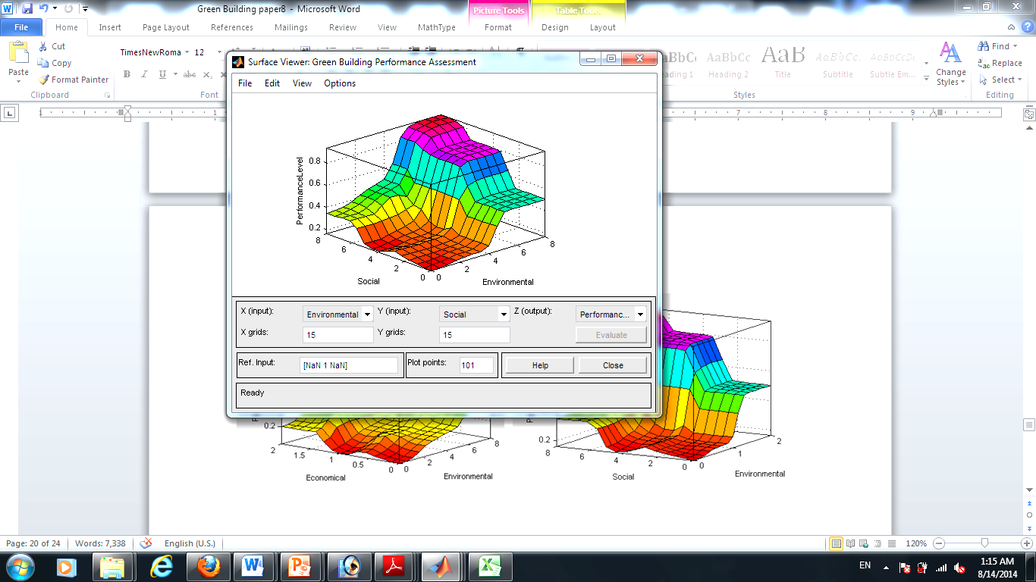

**Fig. 1.** Good quality with clear lettering.

1. Tables

Tables should have a title which makes the general meaning understandable without reference to the text. Tables should be presented in the form shown in Table 1, with all text, including title 8pt. Their layout should be consistent throughout. Horizontal lines should be placed above and below table headings, above the subheadings and at the end of the table above any notes. Vertical lines should be avoided. Table borders should be simple ½ point lines (no double or bold lines). The header row of the table should be in bold type, not italic. If a table is too long to fit onto one page, the table number and headings should be repeated on the next page before the table is continued. Alternatively, the table can be spread over two consecutive pages (first on even-numbered, then on odd-numbered page). Table captions should appear above the table. The captions should be clear and simple, although sufficient information should be provided for the table to be understood without further reference to the text. Captions should be 8 point Times New Roman font, centred with the table, and have 6pt spacing before and 4pt after the captions. The words “Table 1” should be in bold as shown in the example figure in this document. The caption should end with a full stop. You can also use one column for large tables (**see Table 2 in the last page of template for submission**).

**Table 1**

Result of experiments.

|  |  |  |
| --- | --- | --- |
|  | **Method Accuracy** |  |
|  | **Method X** | **Method Y** |
| A | 6.5 | 0.35 |
| B | 4.1 | 0.05 |
| C | 60.0 | 1.0 |
| D | 6.0 | 0.50 |
| E | 1.0 | 0.04 |
| F | 1.2 | 2.1 |

1. Equations

Equations should be placed flush-left with the text margin and should be preceded and followed by one line of white. Equations should appear in line with the text, and should be numbered sequentially in parentheses on the right. The equation number should be flush with the right margin. The style “equation” includes a right tab to place the number correctly. For example:

 (1)

The normal size of variables within the equation should be 10 points, with appropriate changes in size for subscripts, superscripts, etc. You may use either Microsoft Equation Editor or the MathType add-on for all math objects in your paper. A math object is any equation or fragment containing mathematical symbols (including Greek characters, superscripts and subscripts) that appears either in-line (in the flow of normal text) like for example  or as a display equation (in its own space between lines of text) like Eq. (1). For long equations, the equation number may appear on the next line. For very long equations, the right side of the equation should be broken into approximately equal parts and aligned to the right of the equal sign.

**Acknowledgments**

Collate acknowledgements in a separate section at the end of the article before the references and do not, therefore, include them on the title page, as a footnote to the title or otherwise. List here those individuals who provided help during the research (e.g., providing language help, writing assistance or proof reading the article, etc.). Do not number this section.

**References**

The references should be brought together at the end of the article. Authors should check whether every reference in the text appears in the list of references and vice versa. The font size for the reference list should be 9pt. Please follow the style in the examples below for Journal references, Books, Edited Books, and Patents.

References to other publications must be based on APA style and carefully checked for completeness, accuracy and consistency. You should cite publications in the text: (Adams, 2006) using the first named author's name or (Adams and Brown, 2006) citing both names of two, or (Adams et al., 2006) when there are three or more authors. At the end of the paper a reference list in alphabetical order should be supplied:

**For books**

Surname, Initials (year). Title of Book. Place of publication: Publisher. e.g.

Harrow, R. (2005). No Place to Hide. New York, NY: Simon & Schuster.

**For book chapters**

Surname, Initials (year). Chapter title. In Editor's Surname, Initials, Title of Book (pages). Place of publication: Publisher. e.g.

Calabrese, F.A. (2005). The early pathways: theory to practice – a continuum. Iin Stankosky, M. (Ed.), Creating the Discipline of Knowledge Management (pp. 15-20). New York, NY: Elsevier.

**For journals**

Surname, Initials (year). Title of article. Journal Name, volume(number), pages. e.g.

Capizzi, M.T. and Ferguson, R. (2005). Loyalty trends for the twenty-first century. Journal of Consumer Marketing, 22(2), pp. 72-80.

**For published conference proceedings**

Surname, Initials (year of publication). Title of paper. In Surname, Initials (Ed.), Title of published proceedings which may include place and date(s) held (page numbers). Place of publication: Publication place. e.g.

Jakkilinki, R., Georgievski, M. and Sharda, N. (2007). Connecting destinations with an ontology-based e-tourism planner. In Information and communication technologies in tourism 2007 proceedings of the international conference in Ljubljana, Slovenia, 2007 (pp. 12 – 32). Vienna: Springer-Verlag.

**For unpublished conference proceedings**

Surname, Initials (year). Title of paper. Paper presented at Name of Conference, date of conference, place of conference. Retrieved from URL if freely available on the internet. Accessed date. e.g.

Aumueller, D. (2005). Semantic authoring and retrieval within a wiki. Paper presented at the European Semantic Web Conference (ESWC), 29 May-1 June, Heraklion, Crete. Retrieved from http://dbs.uni-leipzig.de/file/aumueller05wiksar.pdf. Accessed 20 February 2007.

**For working papers**

Surname, Initials (year). Title of article. Working paper [number if available]. Institution or organization. Place of organization, date. e.g.

Moizer, P. (2003). How published academic research can inform policy decisions: the case of mandatory rotation of audit appointments. Working paper. Leeds University Business School, University of Leeds. Leeds, 28 March.

Further information about APA style from http://www.apastyle.org.

**Author Biographies**

First Author The first paragraph may contain a place and/or date of birth (list place, then date). Next, the author’s educational background is listed. The degrees should be listed with type of degree in what field, which institution, city, state or country, and year degree was earned. The author’s major field of study should be lower-cased. If a photograph is provided, the biography will be indented around it. The photograph is placed at the top left of the biography.

Second Author The first paragraph may contain a place and/or date of birth (list place, then date). Next, the author’s educational background is listed. The degrees should be listed with type of degree in what field, which institution, city, state or country, and year degree was earned. The author’s major field of study should be lower-cased. If a photograph is provided, the biography will be indented around it. The photograph is placed at the top left of the biography.

|  |  |
| --- | --- |
|  |  |

**Fig. 2.** You can also use one column for large figures.

**Table 2**

Results of experiments and comparisons.

|  |  |  |  |  |  |  |
| --- | --- | --- | --- | --- | --- | --- |
|  | **Method Accuracy** |  |  | **Computation Time** | |  |
|  | **Method X** | **Method Y** |  | **Method X** | **Method Y** | |
| A | 6.5 | 0.35 |  | 2.0 | | 0.30 |
| B | 4.1 | 0.05 |  | 2 | | 0.02 |
| C | 60.0 | 1.0 |  | 50.0 | | <0.10 |
| D | 6.0 | 0.50 |  | 2 | | 0.10 |
| E | 1.0 | 0.04 |  | 1.0 | | 0.05 |
| F | 1.2 | 2.1 |  | 2 | | <0.10 |