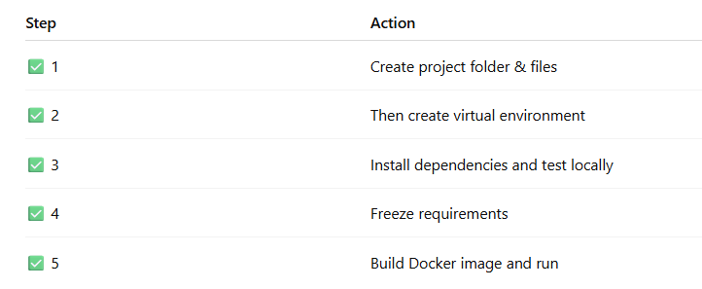

**Step 1: Create the files:**

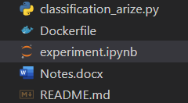

**Step 2: Create the virtual environment:**

py -3.12 -m venv venv

**Step 2.1: activate the environment**

.\venv\Scripts\activate

**Step 2.2: Install & import Arize SDK**

pip install arize

pip freeze > requirements.txt

**Step 3: perform experiments in experiments.ipynb**

**# Create an authenticated Arize client**