Sri Lanka Institute of Information Technology
Fundamentals of Data Mining (IT3051)

Technical Report
Bank Marketing Term Deposit Predictor
An end-to-end data mining system for predicting term deposit subscription from telemarketing campaign data
Group Name - Data Minds
Student ID | Student Name
IT23859456 | Gunathilaka W.A.D.S.
IT23857780 | Edirisinghe E.M.K.L.
IT23557024 | Illesinghe E.S.
IT23544918 | Kaluarachchi R.G.

Submission date: 06 October 2026
Source code: https://github.com/Ranudi-Kaluarachchi/FDM-Bank_Marketing.git

Declaration
We declare that this report and the accompanying software are our own work, that the work was divided equally among the four group members as described in Section 12, and that all external sources, datasets and libraries are acknowledged in the References.

Abstract
Direct-marketing campaigns are expensive because most calls do not lead to a sale. Using the UCI Bank Marketing dataset (Moro, Cortez & Rita, 2014) of 45,211 telemarketing contacts made by a Portuguese bank, we built a complete data mining system that predicts whether a client will subscribe to a term deposit. Only 11.7% of contacts subscribed, so the problem is a highly imbalanced binary classification task. Following the CRISP-DM process, the raw data was cleaned and validated, the leaking duration attribute was removed, five features were engineered, and six classifiers (Logistic Regression, Decision Tree, Random Forest, Gradient Boosting, K-Nearest Neighbours and Gaussian Naive Bayes) were tuned with stratified cross-validation inside a leakage-free scikit-learn pipeline.
Gradient Boosting was selected by cross-validated ROC-AUC (0.795) and achieved a held-out test ROC-AUC of 0.806 and PR-AUC of 0.466 (random baseline 0.117). With a decision threshold of 0.62 tuned on out-of-fold training predictions it reaches F1 = 0.487 (precision 45%, recall 53%). Ranking clients by the model and calling the top 10% reaches 44.4% of all subscribers, a 4.4x lift over random calling. The model is deployed behind a FastAPI REST service and a React dashboard that supports single-client prediction, CSV batch scoring and interactive model and data insights.
Keywords: data mining, classification, class imbalance, gradient boosting, CRISP-DM, bank marketing, FastAPI, React

Table of Contents
Declaration 2
Abstract 2
Table of Contents 3
1. Introduction 5
1.1 Background 5
1.2 Problem statement 5
1.3 Objectives 5
1.4 Scope 5
2. Dataset Description 5
3. Methodology 6
4. Data Preprocessing 7
4.1 Data cleaning 7
4.2 Avoiding target leakage 8
4.3 Feature engineering 8
4.4 Outliers, scaling and encoding 8
5. Exploratory Data Analysis 8
6. Data Mining Techniques and Modelling 11
6.1 Experimental design 11
6.2 Algorithms 11
7. Evaluation and Results 12
7.1 Evaluation metrics 12
7.2 Model comparison 12
7.3 ROC and precision-recall curves 14
7.4 Confusion matrices 15
7.5 Decision threshold tuning 15
7.6 Feature importance 16
7.7 Business evaluation: cumulative gains 17
8. System Design and Implementation 18
8.1 Architecture 18
8.2 Technology stack 18
8.3 Repository structure 19
8.4 Backend REST API 19
8.5 Frontend dashboard 20
9. Testing and Validation 24
10. Deployment and User Guide 25
11. Discussion 25
11.1 Business insights and recommendations 25
11.2 Limitations 26
11.3 Future work 26
12. Individual Contributions 26
12.1 Data Acquisition, Cleaning and Validation 27
12.2 Exploratory Data Analysis and Feature Engineering 27
12.3 Model Training, Tuning and Evaluation 28
12.4 System Implementation (Backend & Frontend) and Testing 29
12.5 Individual Task Allocation (For Reference) 29
13. Conclusion 30
References 30
Appendix A – Per-model Confusion Matrices 31
Appendix B – Configuration and Reproducibility 34

1. Introduction

1.1 Background
Banks promote products such as term deposits through outbound telemarketing. Each call costs agent time and, when repeated, can annoy customers. If the bank could predict which clients are likely to subscribe, it could prioritise those clients, reduce the number of unproductive calls and increase the campaign's conversion rate. This is a classic predictive data mining problem: learn from the outcomes of past campaigns to score future contacts.

1.2 Problem statement
Given a client's demographic, financial and campaign-contact attributes that are known before a call is made, predict whether the client will subscribe to a term deposit (target y = yes/no), and expose this prediction in a usable application for marketing staff.

1.3 Objectives
- Acquire the public UCI Bank Marketing dataset and assess its quality.
- Clean, validate and prepare the data, avoiding target leakage.
- Explore the data to identify the factors associated with subscription.
- Engineer informative features and handle outliers and class imbalance.
- Train, tune and compare at least five classification algorithms using appropriate metrics for imbalanced data.
- Select the best model, tune its decision threshold and explain which features drive its predictions.
- Deploy the model through a REST API and an interactive web dashboard, with automated tests.
- Translate the results into actionable recommendations for the marketing team.

1.4 Scope
The system covers the full pipeline from raw data download to a working web application. It uses the bank-full.csv file (May 2008 – November 2010). Real-time integration with a bank CRM, user authentication and cloud hosting are outside the scope of this project and are listed as future work.

2. Dataset Description
The dataset was published by Moro, Cortez and Rita (2014) and is available from the UCI Machine Learning Repository under a CC BY 4.0 licence. Each row is one client contacted during a campaign. The file contains 45,211 rows and 17 columns (16 input attributes and the target). It is downloaded automatically by ml/download_data.py.
Table 3: Attributes of bank-full.csv
Attribute | Type | Description | Use in model
age | Numeric | Client age in years | Used
job | Categorical (12) | Type of job (admin., blue-collar, student, …) | Used
marital | Categorical (3) | Marital status (divorced includes widowed) | Used
education | Categorical (4) | primary, secondary, tertiary, unknown | Used
default | Binary | Has credit in default? | Used
balance | Numeric | Average yearly balance (EUR) | Used
housing | Binary | Has a housing loan? | Used
loan | Binary | Has a personal loan? | Used
contact | Categorical (3) | Contact communication type (cellular, telephone, unknown) | Used
day | Numeric | Last contact day of the month | Used
month | Categorical (12) | Last contact month of the year | Used
duration | Numeric | Last contact duration in seconds | Removed (leakage)
campaign | Numeric | Number of contacts during this campaign (incl. last) | Used
pdays | Numeric | Days since last contact in a previous campaign (-1 = never) | Replaced by engineered features
previous | Numeric | Number of contacts before this campaign | Used
poutcome | Categorical (4) | Outcome of the previous campaign | Used
y | Binary | Did the client subscribe to a term deposit? | Target

Table 4: Summary statistics of numeric attributes
Attribute | Min | Median | Mean | Max | Std
age | 18 | 39 | 40.94 | 95 | 10.62
balance | -8,019 | 448 | 1,362.27 | 102,127 | 3,044.77
day | 1 | 16 | 15.81 | 31 | 8.32
campaign | 1 | 2 | 2.76 | 63 | 3.10
pdays | -1 | -1 | 40.20 | 871 | 100.13
previous | 0 | 0 | 0.58 | 275 | 2.30

The numeric attributes are strongly right-skewed: balance has a median of 448 EUR but a maximum of 102,127 EUR and negative values down to -8,019 EUR; campaign reaches 63 calls and previous 275 contacts. The target is highly imbalanced, with 5,289 subscribers (11.7%) against 39,922 non-subscribers.
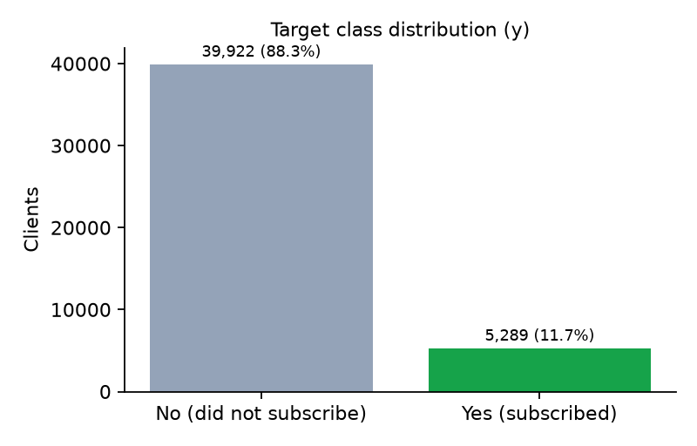
Figure 1: Distribution of the target variable

3. Methodology
The project followed the CRISP-DM (Cross-Industry Standard Process for Data Mining) methodology (Chapman et al., 2000). The table below maps each phase to the work done and the code that implements it.
Table 5: CRISP-DM phases and their implementation
CRISP-DM phase | Activities in this project | Implementation
Business understanding | Define the prediction goal, success metrics (ROC-AUC, F1, lift) and constraints (only pre-call data). | Section 1
Data understanding | Download data, profile attributes, check quality, exploratory analysis. | download_data.py, eda.py
Data preparation | Cleaning, validation, leakage removal, feature engineering, outlier capping, scaling, encoding. | preprocess.py, transformers.py
Modelling | Six algorithms, grid search with 3-fold stratified CV, class weighting. | train.py
Evaluation | Hold-out test metrics, ROC/PR curves, confusion matrices, threshold tuning, permutation importance, cumulative gains. | train.py, report.py
Deployment | Serialised pipeline served by a REST API and React dashboard; automated tests. | backend/, frontend/

The whole data mining process is reproducible with one command (python -m ml.run_pipeline), which runs download → cleaning → EDA → training and writes all artifacts. A fixed random seed (42) makes the data split and models deterministic.

4. Data Preprocessing

4.1 Data cleaning
Data cleaning is implemented in ml/preprocess.py. Every step is logged to artifacts/cleaning_report.json, which is also displayed in the dashboard.
Table 6: Data cleaning steps
# | Step | What was done | Result
1 | Normalise text | Trim whitespace and lower-case column names and categorical values so that “Yes”, “ yes” and “YES” are identical. | Consistent categories
2 | Missing values | Count NaNs; numeric NaNs are median-imputed and categorical NaNs set to “unknown”. Existing “unknown” placeholders are kept as their own category. | 0 NaNs. “unknown”: job 288, education 1,857, contact 13,020, poutcome 36,959
3 | Remove duplicates | Drop exact duplicate rows. | 0 rows removed
4 | Validate domain rules | age 18–100, day 1–31, valid month name, campaign ≥ 1, pdays = -1 or ≥ 0, previous ≥ 0, binary fields yes/no. | 0 rows removed
5 | Remove leakage | Drop duration: the call length is only known after the call ends and is almost a proxy for the outcome. | 16 → 15 inputs
6 | Encode target | y: yes → 1, no → 0. | Positive rate 11.7%

The dataset turned out to be of high technical quality: no missing values, duplicates or rule violations were found, so all 45,211 rows were retained. The main quality issue is semantic: “unknown” placeholders, especially in poutcome (36,959 rows, mostly clients never contacted before) and contact (13,020 rows). Because these groups have very different subscription rates (e.g. contact = unknown subscribes at only 4.1%), they carry signal and were kept as an explicit category rather than imputed or deleted.

4.2 Avoiding target leakage
Two forms of leakage were prevented. First, the duration attribute was removed because the dataset authors note it strongly determines the outcome but is unknown before the call, so a model using it would look excellent offline but be useless in practice. Second, every learned transformation (outlier limits, scaling statistics, one-hot categories) is fitted inside the scikit-learn pipeline, so during cross-validation it only sees the training folds, and the test set is never used for any fitting or tuning.

4.3 Feature engineering
ml/transformers.py defines a stateless FeatureEngineer transformer that derives five features from the raw inputs:
Table 7: Engineered features
Feature | Definition | Rationale
previously_contacted | 1 if pdays ≠ -1, else 0 | pdays = -1 is a code, not a number. Previously contacted clients subscribe at 23.1% vs 9.2%.
days_since_prev | pdays if contacted, else 0 | Keeps recency information without the misleading -1.
log_balance | sign(b) · log(1 + |b|) | Compresses the long tail of balance while keeping negative balances negative.
total_contacts | campaign + previous | Total contact intensity across campaigns.
age_group | 18-25, 26-35, 36-45, 46-55, 56-65, 65+ | Captures the non-linear U-shaped effect of age.

The original pdays column is dropped after these features are created, giving 9 numeric and 10 categorical model inputs.

4.4 Outliers, scaling and encoding
- Outliers: a custom QuantileCapper winsorises each numeric feature to its 1st and 99th percentile learned on the training data. Extreme values (e.g. a balance of 102,127 EUR or 63 calls) are clipped rather than deleted, so no information about the client is lost.
- Scaling: numeric features are standardised (zero mean, unit variance) with StandardScaler, which distance-based (KNN) and linear (Logistic Regression) models require.
- Encoding: categorical features are one-hot encoded with handle_unknown='ignore', so an unseen category at prediction time does not crash the service.
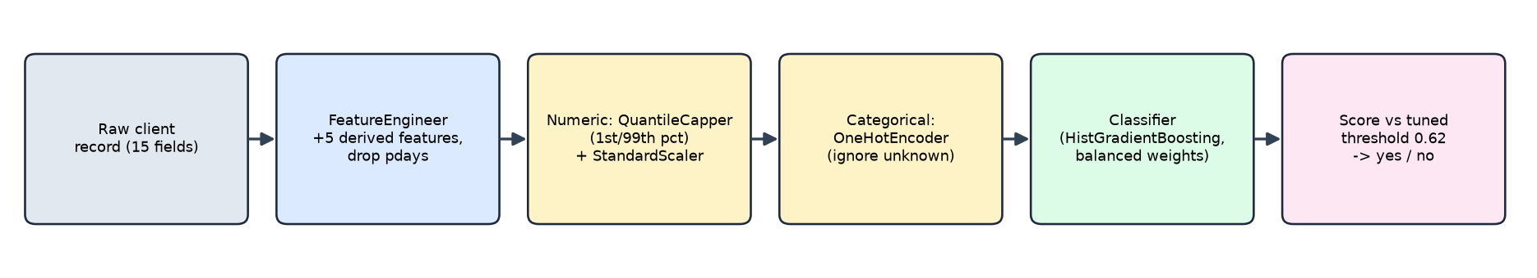
Figure 2: The deployed scikit-learn pipeline: raw record in, decision out
Because the saved artifact is the entire pipeline, the API receives the same 15 raw fields a user types into the form, and training and inference apply identical transformations.

5. Exploratory Data Analysis
ml/eda.py computes the subscription rate for every categorical attribute, an age histogram, the effect of the number of calls and the correlation of numeric attributes with the target. The results are saved to artifacts/insights.json and rendered interactively on the dashboard's EDA page, which also highlights the strongest findings automatically. In the charts below the dashed line is the overall subscription rate (11.7%).
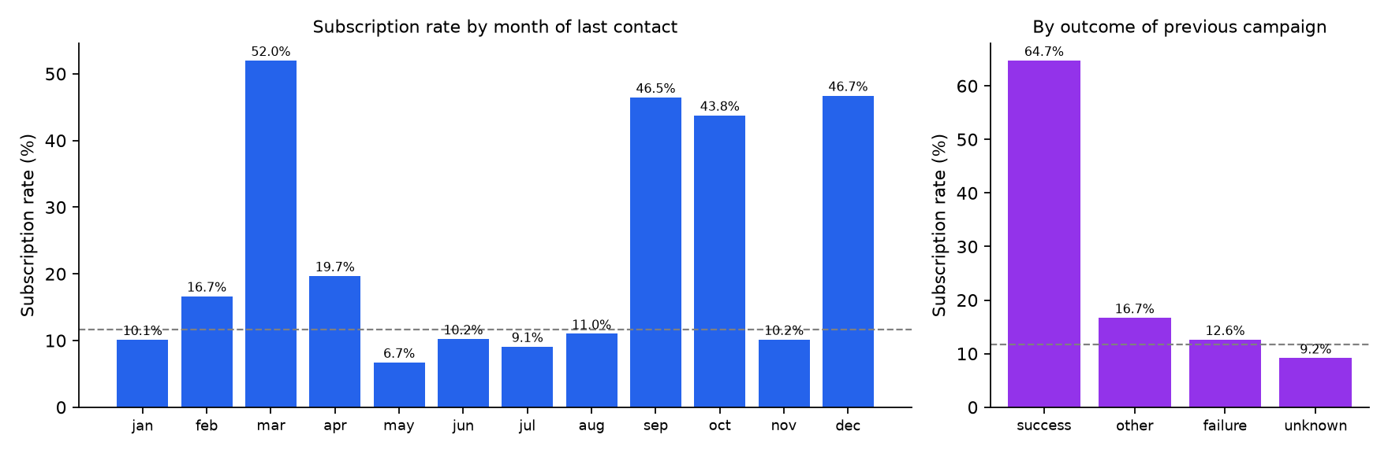
Figure 3: Subscription rate by contact month and previous campaign outcome
Timing matters strongly. May has by far the most contacts (13,766) but the lowest rate (6.7%), whereas the rarely used months of March (52.0%), September (46.5%), October (43.8%) and December (46.7%) convert at four to eight times that rate. Past success is the strongest single signal: clients whose previous campaign was a success subscribe at 64.7%, compared with 9.2% for clients with no previous outcome.
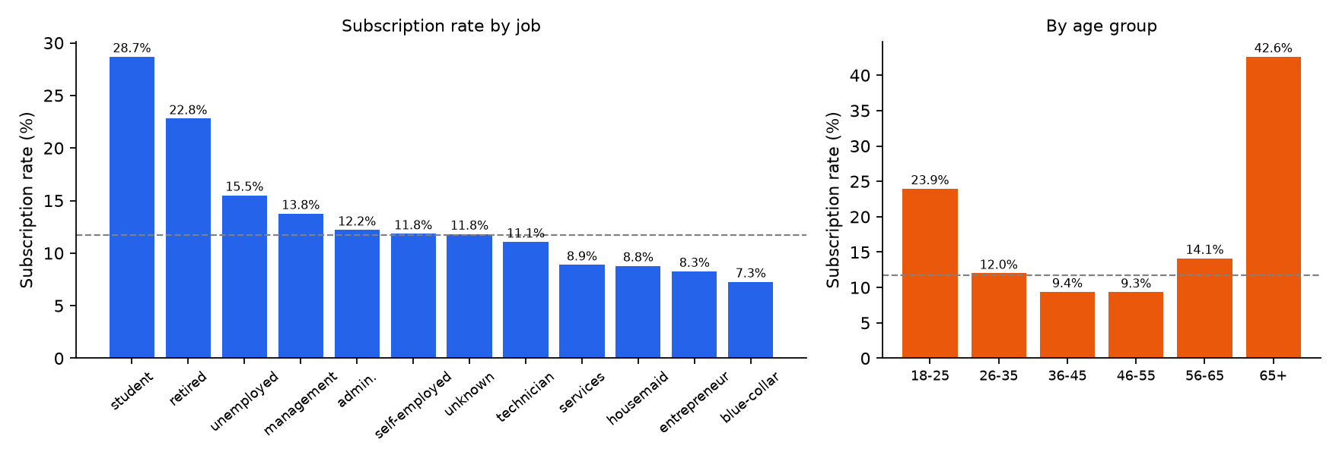
Figure 4: Subscription rate by job and age group
Demographics show a U-shape. Students (28.7%) and retired clients (22.8%) are the most receptive, blue-collar workers the least (7.3%). Similarly, clients over 65 (42.6%) and aged 18–25 (23.9%) subscribe much more often than the 36–55 group (about 9.4%). Tertiary education (15.0%) and single clients (14.9%) are also above average.
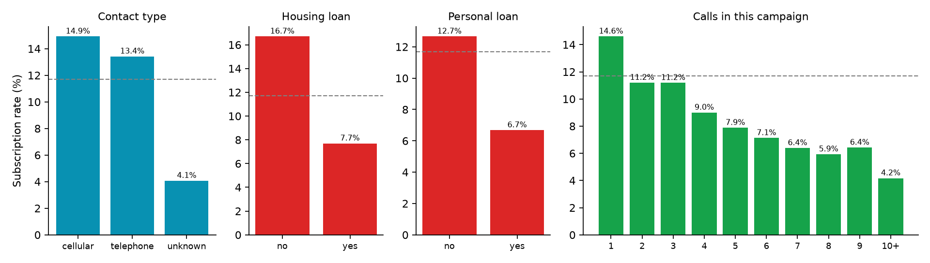
Figure 5: Subscription rate by contact type, existing loans and number of calls
Contact channel and debt. Clients reached on a mobile phone subscribe at 14.9% versus 4.1% when the channel is unknown. Clients with a housing loan (7.7%) or personal loan (6.7%) are roughly half as likely to subscribe as those without. Repeated calls give diminishing returns: the rate falls from 14.6% after one call to 4.2% for ten or more calls.
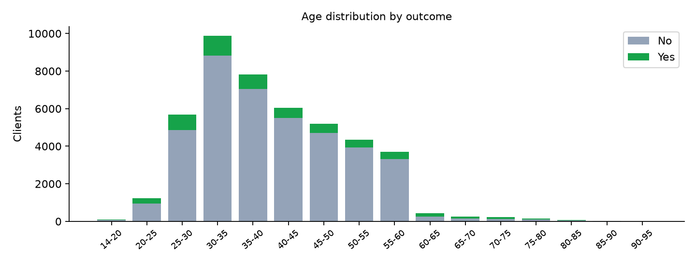
Figure 6: Age distribution split by outcome
Table 8: Linear correlation of numeric attributes with the target
Attribute | Pearson r with y
pdays | +0.104
previous | +0.093
campaign | -0.073
balance | +0.053
day | -0.028
age | +0.025

All linear correlations are weak (|r| ≤ 0.10), which indicates that the relationships are non-linear and driven by interactions and categorical attributes. This motivated the use of tree ensembles in addition to linear models.
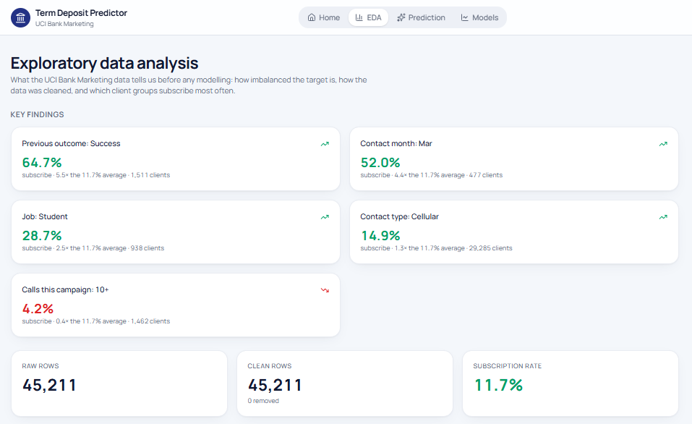
Figure 7: EDA page of the dashboard: automatically derived key findings and dataset KPIs

6. Data Mining Techniques and Modelling

6.1 Experimental design
- Split: stratified 80/20 train/test split (36,168 training rows, 9,043 test rows) so both sets keep the 11.7% positive rate.
- Tuning: GridSearchCV with 3-fold stratified cross-validation on the training set only, scored by ROC-AUC.
- Selection: the model with the highest cross-validated ROC-AUC is chosen, so the test set remains an unbiased estimate of real-world performance.
- Class imbalance: class_weight='balanced' (or balanced_subsample for Random Forest) and balanced per-row sample weights for Gradient Boosting make the rare “yes” class count as much as the “no” class.
- Threshold: the selected model's decision threshold is tuned to maximise F1 on out-of-fold training predictions (cross_val_predict), never on the test set.
- Deployment model: the winner is refit on all clean data with the chosen hyper-parameters and saved to artifacts/model.joblib.

6.2 Algorithms
Six classification algorithms from different families were compared, as summarised below.
Table 9: Classification algorithms compared
Algorithm | Family / principle | Why it was included | Search grid
Logistic Regression | Linear model; estimates log-odds as a weighted sum of features | Interpretable, fast baseline | C ∈ {0.1, 1, 10}
Decision Tree | Recursive partitioning on information gain (Gini) | Human-readable rules, captures interactions | max_depth ∈ {5, 8, 12}; min_samples_leaf ∈ {20, 50}
Random Forest | Bagging ensemble of 300 de-correlated trees (Breiman, 2001) | Robust, low variance, handles mixed data | max_depth ∈ {10, 16}; min_samples_leaf ∈ {5, 10}
Gradient Boosting (HistGB) | Boosting: trees fitted sequentially to residual errors on binned features (Friedman, 2001; Ke et al., 2017) | State of the art for tabular data | learning_rate ∈ {0.05, 0.1}; max_depth ∈ {4, 8}
K-Nearest Neighbours | Instance-based; majority of the k closest clients | Non-parametric, no training assumptions | k ∈ {25, 51}; weights = distance
Gaussian Naive Bayes | Probabilistic; Bayes' theorem with feature independence | Very fast probabilistic baseline | default

Table 10: Best hyper-parameters found by grid search (★ = selected)
Model | Best hyper-parameters | CV ROC-AUC | Train time (s)
Gradient Boosting ★ | learning_rate=0.05, max_depth=8 | 0.7947 | 4.4
Random Forest | max_depth=16, min_samples_leaf=10 | 0.7869 | 15.2
Logistic Regression | C=0.1 | 0.7689 | 7.0
Decision Tree | max_depth=8, min_samples_leaf=50 | 0.7619 | 3.0
K-Nearest Neighbours | n_neighbors=51, weights=distance | 0.7504 | 2.5
Naive Bayes | defaults | 0.7417 | 0.3

7. Evaluation and Results

7.1 Evaluation metrics
Accuracy is misleading for this problem: a model that always predicts “no” is 88.3% accurate but finds no subscribers. We therefore evaluate with metrics suited to imbalanced data:
- ROC-AUC – probability that a random subscriber is ranked above a random non-subscriber (0.5 = random). Used for model selection because it is threshold-independent.
- PR-AUC (average precision) – area under the precision-recall curve; stricter under imbalance (random = 0.117).
- Precision – of the clients flagged “yes”, the share who actually subscribe (call efficiency).
- Recall – of the actual subscribers, the share the model finds (missed sales).
- F1 – harmonic mean of precision and recall; used to choose the decision threshold.
- Cumulative gains / lift – share of subscribers reached when calling the top-k% of ranked clients (business view).

7.2 Model comparison
Table 11: Test-set performance of all models at the default 0.5 threshold, ranked by CV ROC-AUC
Rank | Model | CV ROC-AUC | Test ROC-AUC | PR-AUC | F1 | Precision | Recall | Accuracy
1 | Gradient Boosting ★ | 0.795 | 0.806 | 0.466 | 0.459 | 0.358 | 0.639 | 0.824
2 | Random Forest | 0.787 | 0.797 | 0.442 | 0.457 | 0.377 | 0.580 | 0.839
3 | Logistic Regression | 0.769 | 0.776 | 0.415 | 0.383 | 0.274 | 0.636 | 0.760
4 | Decision Tree | 0.762 | 0.773 | 0.398 | 0.428 | 0.340 | 0.579 | 0.819
5 | K-Nearest Neighbours | 0.750 | 0.767 | 0.396 | 0.208 | 0.674 | 0.123 | 0.890
6 | Naive Bayes | 0.742 | 0.752 | 0.352 | 0.403 | 0.351 | 0.472 | 0.836

Gradient Boosting ranks first on every threshold-independent metric (CV ROC-AUC 0.795, test ROC-AUC 0.806, PR-AUC 0.466), followed closely by Random Forest. The two tree ensembles clearly outperform the single tree and the linear, instance-based and probabilistic models, which confirms the EDA finding that the signal is non-linear. K-Nearest Neighbours illustrates the accuracy paradox: it has the highest accuracy (0.890) but finds only 12.3% of subscribers.
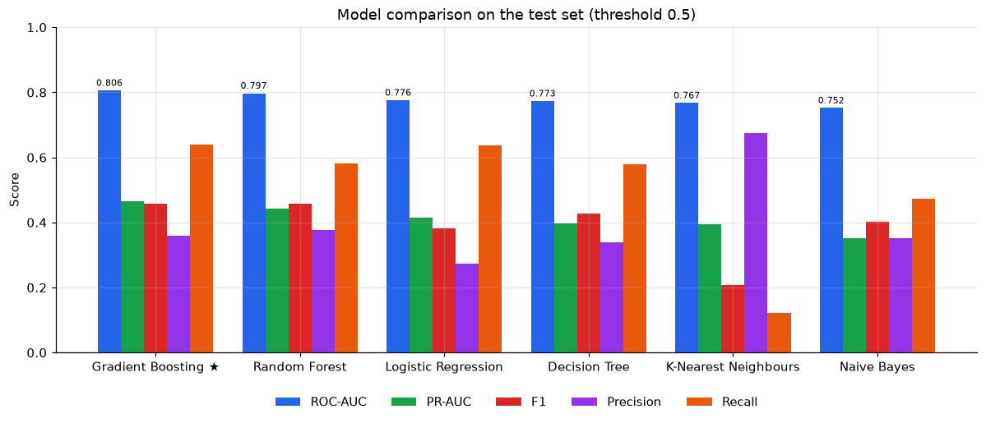
Figure 8: Test metrics of all models (threshold 0.5)
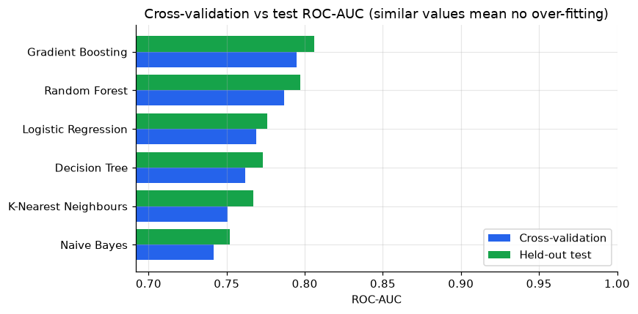
Figure 9: Cross-validation vs held-out test ROC-AUC
Cross-validation and test ROC-AUC differ by at most about 0.02 for every model, so the models generalise well and are not over-fitted to the training data.

7.3 ROC and precision-recall curves
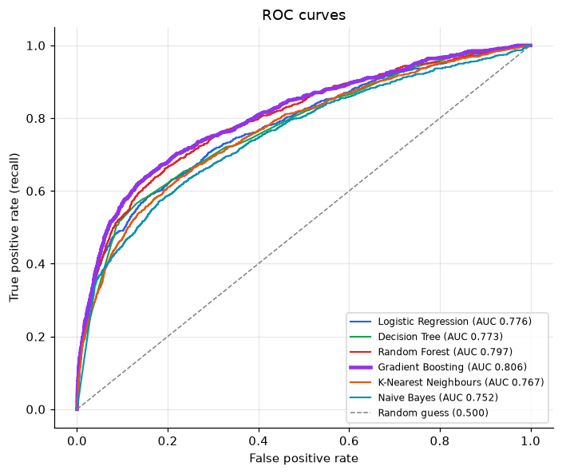
Figure 10: ROC curves of all models on the test set
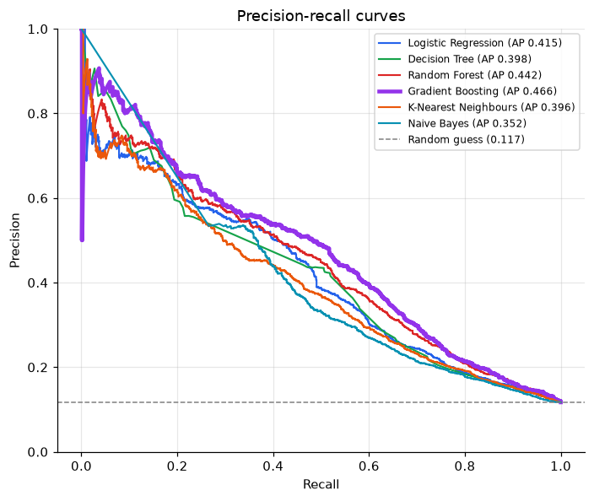
Figure 11: Precision-recall curves of all models on the test set
The selected model dominates the others across most of the ROC and PR space. Its PR-AUC of 0.466 is about 4.0 times the random baseline of 0.117.

7.4 Confusion matrices
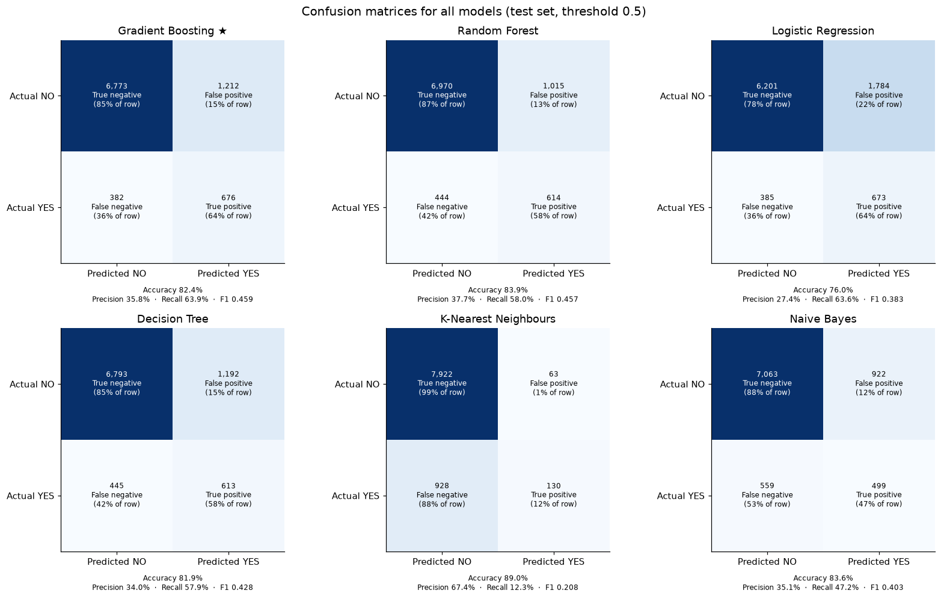
Figure 12: Confusion matrices of all models (test set, threshold 0.5)

7.5 Decision threshold tuning
Class weighting pushes scores upwards, so the default 0.5 threshold flags many clients. Tuning the threshold for F1 on out-of-fold training predictions gave 0.62. On the test set this reduces wasted calls (false positives) from 1,212 to 690 while still finding 562 of 1,058 subscribers:
Table 12: Gradient Boosting on the test set at the default and tuned thresholds
Threshold | TN | FP (wasted call) | FN (missed) | TP | Precision | Recall | F1 | Accuracy
0.50 | 6,773 | 1,212 | 382 | 676 | 0.358 | 0.639 | 0.459 | 0.824
0.62 (tuned) | 7,295 | 690 | 496 | 562 | 0.449 | 0.531 | 0.487 | 0.869

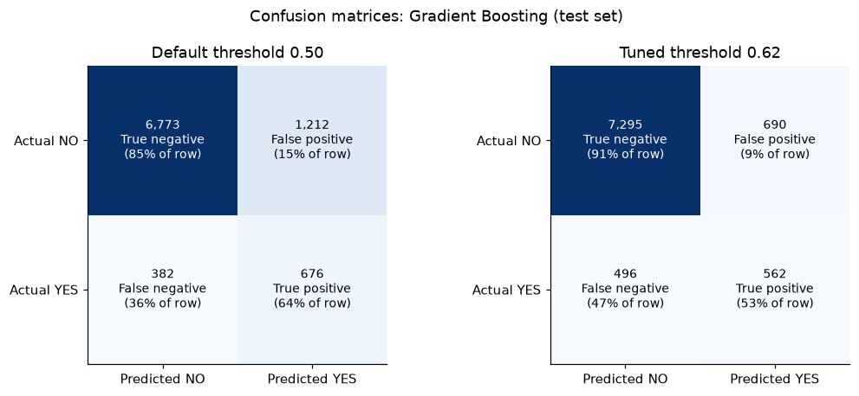
Figure 13: Confusion matrices of Gradient Boosting at the default and tuned thresholds
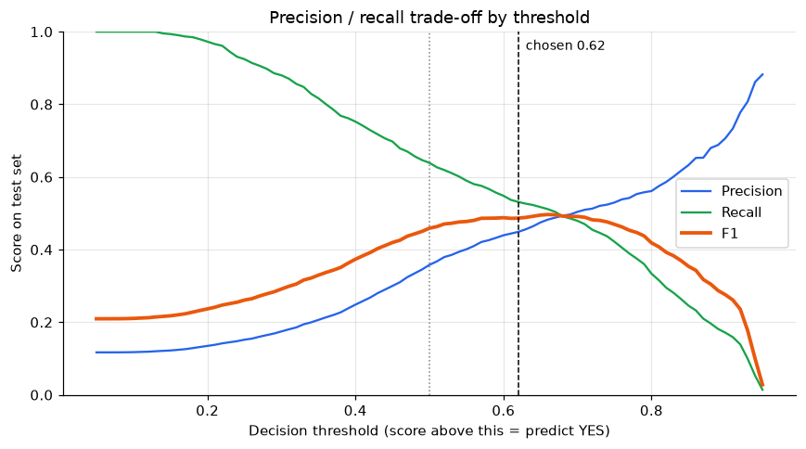
Figure 14: Precision, recall and F1 as the decision threshold changes
The threshold is a business lever: a bank with spare call capacity can lower it to increase recall, while a bank with limited agents can raise it to increase precision.

7.6 Feature importance
Permutation importance measures how much test ROC-AUC drops when the values of one raw input are randomly shuffled (5 repeats on a 4,000-row sample).
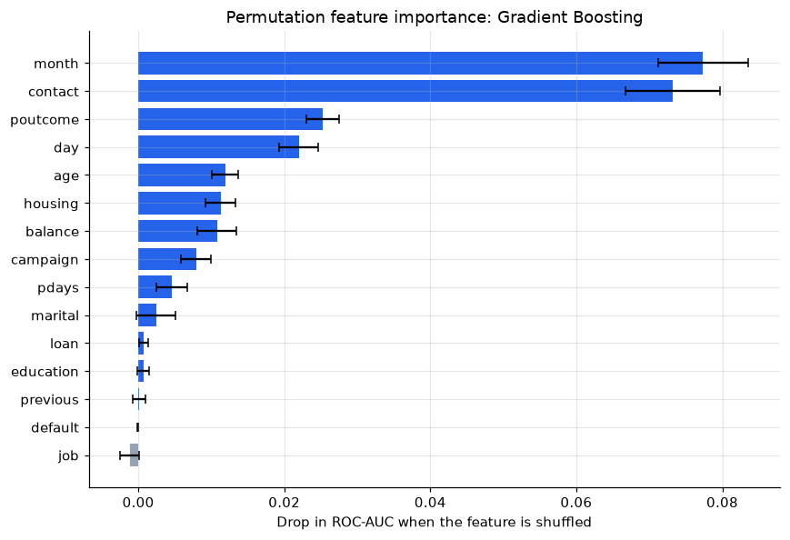
Figure 15: Permutation feature importance of Gradient Boosting
The five most important inputs are month (0.077), contact (0.073), poutcome (0.025), day (0.022), age (0.012). This agrees with the EDA: campaign timing, contact channel and previous outcome dominate, while job, default, previous and education add almost nothing once the other features are known.

7.7 Business evaluation: cumulative gains
Table 13: Cumulative gains of the selected model on the test set
Top % of clients called | Subscribers reached | Lift vs random
5% | 26.4% | 5.27x
10% | 44.4% | 4.44x
20% | 62.8% | 3.14x
30% | 71.7% | 2.39x
40% | 77.5% | 1.94x
50% | 84.1% | 1.68x

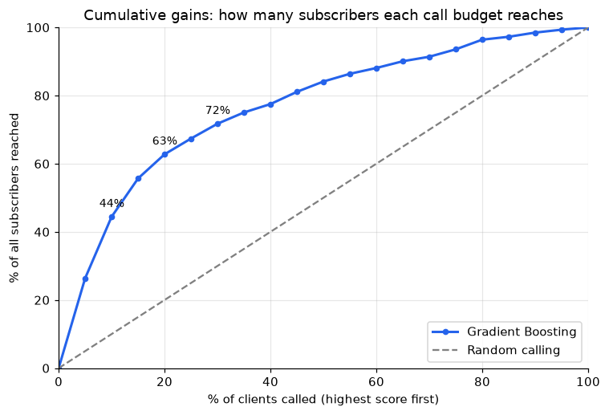
Figure 16: Cumulative gains curve vs random calling
If the bank calls clients in descending order of model score, calling only the top 20% of clients reaches 62.8% of all subscribers, and half the call list reaches 84.1%. In other words, the same number of sales could be achieved with far fewer calls than random dialling.

8. System Design and Implementation

8.1 Architecture
The system has three layers that communicate through files and HTTP/JSON: an offline ML pipeline that produces artifacts, a stateless REST API that loads those artifacts, and a multi-page web dashboard.
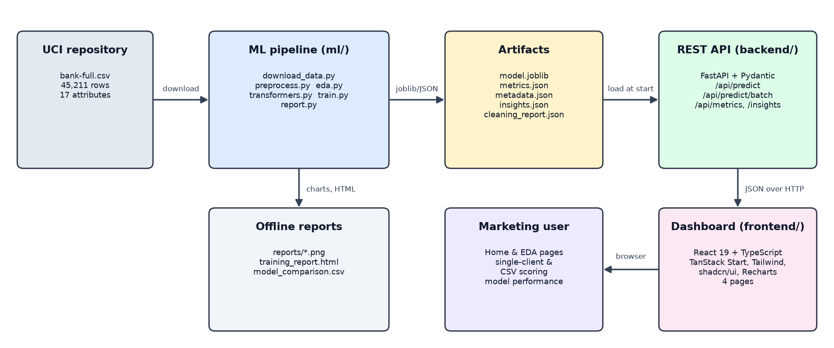
Figure 17: System architecture

8.2 Technology stack
Table 14: Technology stack
Layer | Technologies | Purpose
Data mining | Python 3.11+, pandas, NumPy, scikit-learn, joblib | Cleaning, EDA, pipelines, model training and persistence
Reporting | matplotlib, HTML | Charts and a self-contained training report (reports/)
Backend | FastAPI, Pydantic v2, Uvicorn | REST API, input validation, OpenAPI docs
Frontend | React 19, TypeScript, TanStack Start (Router + Query), Vite, Tailwind CSS v4, shadcn/ui (Radix UI), Recharts, lucide-react, sonner | Routed multi-page dashboard, data fetching and caching, charts and UI components
Testing | pytest, FastAPI TestClient (httpx); Vitest, Testing Library, jsdom | Automated API and frontend tests
Code quality | ESLint, Prettier, TypeScript strict typing | Linting, consistent formatting and static type checks
Version control | Git / GitHub | Collaboration and history

8.3 Repository structure
FDM-Bank_Marketing/
├── ml/ data mining pipeline
│ ├── config.py paths, feature lists, random seed
│ ├── download_data.py fetch UCI archive, extract bank-full.csv
│ ├── preprocess.py cleaning + cleaning_report.json
│ ├── eda.py exploratory aggregates -> insights.json
│ ├── transformers.py FeatureEngineer, QuantileCapper
│ ├── train.py tune/compare 6 models, threshold, importance
│ ├── report.py charts, HTML report, comparison CSV
│ └── run_pipeline.py runs everything in order
├── artifacts/ model.joblib + JSON consumed by the API
├── reports/ PNG charts, training_report.html
├── backend/app/ FastAPI app (main.py, model_service.py, schemas.py)
├── backend/tests/ pytest API tests
└── frontend/ React dashboard (TanStack Start + Vite)
├── vite.config.ts dev server :5173, /api proxy to :8000
└── src/
├── routes/ __root, index (Home), eda, predict, models
├── components/
│ ├── layout/ AppShell: header, navigation, footer
│ ├── dashboard/ PredictPage, BatchPage, PerformancePage, InsightsPage
│ └── ui/ shadcn/ui components (Radix UI)
├── lib/ api.ts (client + demo data), queries.ts, fields.ts
└── test/ Vitest tests

8.4 Backend REST API
The API (backend/app/main.py) loads the model and JSON artifacts once at start-up through a ModelService singleton. Requests are validated by Pydantic schemas (schemas.py) that restrict every categorical field to its allowed values and every numeric field to a sensible range, so invalid input is rejected with HTTP 422 before reaching the model.
Table 15: REST API endpoints
Method | Endpoint | Description
GET | /api/health | Service status and loaded model name
GET | /api/metadata | Input schema (allowed categories, ranges, defaults), threshold, cleaning steps
GET | /api/metrics | All model results, ROC curves, confusion matrix, feature importance
GET | /api/insights | EDA aggregates and the cleaning report
POST | /api/predict | Score one client (JSON body with the 15 input fields)
POST | /api/predict/batch | Score an uploaded CSV (comma or semicolon separated)

Each prediction returns the decision, the score, the threshold and a lead-priority band: high (score ≥ threshold), medium (≥ half the threshold) or low. The batch endpoint auto-detects the delimiter, ignores extra columns such as y or duration (so the original UCI file can be uploaded directly), validates each row independently, scores all valid rows in one vectorised call and reports invalid rows individually. Uploads are limited to 10 MB and 50,000 rows.
POST /api/predict
{"age": 35, "job": "management", "marital": "married", "education": "tertiary",
"default": "no", "balance": 1500, "housing": "yes", "loan": "no", "contact": "cellular",
"day": 15, "month": "may", "campaign": 2, "pdays": -1, "previous": 0, "poutcome": "unknown"}
-> {"prediction": "no", "probability": 0.4659, "threshold": 0.62, "likelihood": "medium"}

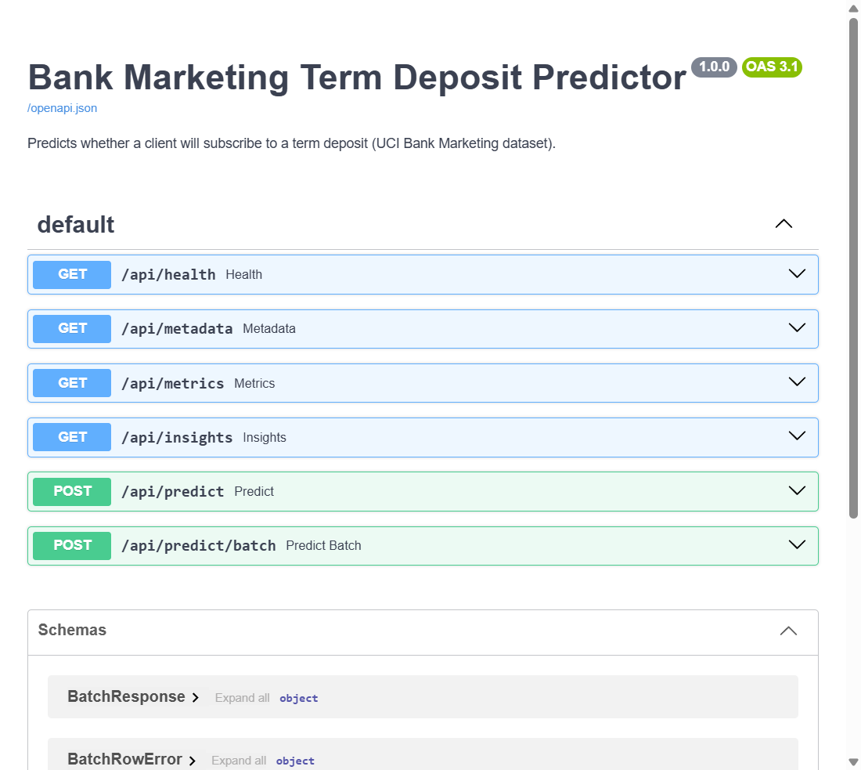
Figure 18: Auto-generated interactive API documentation (/docs)

8.5 Frontend dashboard
The dashboard (frontend/) is a React 19 + TypeScript application built with TanStack Start and Vite. Each page is a file-based route in src/routes/, server data is fetched and cached with TanStack Query, and the interface uses Tailwind CSS, shadcn/ui (Radix UI) components, Recharts and lucide icons. The prediction form is generated from /api/metadata, so dropdown options, defaults and limits always match the trained model. A shared AppShell provides the sticky header with navigation, a pill showing the serving model and its ROC-AUC, and a footer crediting the data source. The dashboard has four pages:
- Home (/) – introduces the problem and shows a “Serving model” card (Gradient Boosting: ROC-AUC 80.6%, recall 53.1%, precision 44.9%, threshold 0.62), KPI cards (45,211 calls analysed, 11.7% subscription rate, 6 models compared, 15 model inputs), a five-step “How it works” timeline (data, cleaning, modelling, threshold, serving) and the inputs the model uses.
- EDA (/eda) – key-finding cards computed from the insights data (previous success 64.7%, March 52.0%, students 28.7%, cellular 14.9%, ten or more calls 4.2%), raw and clean row counts, class balance, cleaning steps, subscription rate by any attribute, age distribution, effect of campaign calls and correlations.
- Prediction (/predict) – two tabs. Single client: a form grouped into client profile, finances, current campaign and previous campaign, with switches for yes/no fields; it shows a YES/NO verdict, the probability bar with the threshold marker and a likelihood badge (lead priority). Batch (CSV): drag-and-drop upload (max 10 MB), KPI cards (total, yes, no, failed rows), a Yes/No filter, sortable and paginated results, a row-error panel and export to *_predictions.csv.
- Models (/models) – comparison table of the six models with the best one highlighted, grouped test-score chart, ROC curves, confusion matrix at the tuned threshold and permutation feature importance with error bars.
API errors such as validation failures are shown as toast notifications. If the backend cannot be reached, the API client (lib/api.ts) falls back to built-in sample data and the header shows a “Demo data” badge, so the interface can still be demonstrated offline; all results in this report come from the live API.
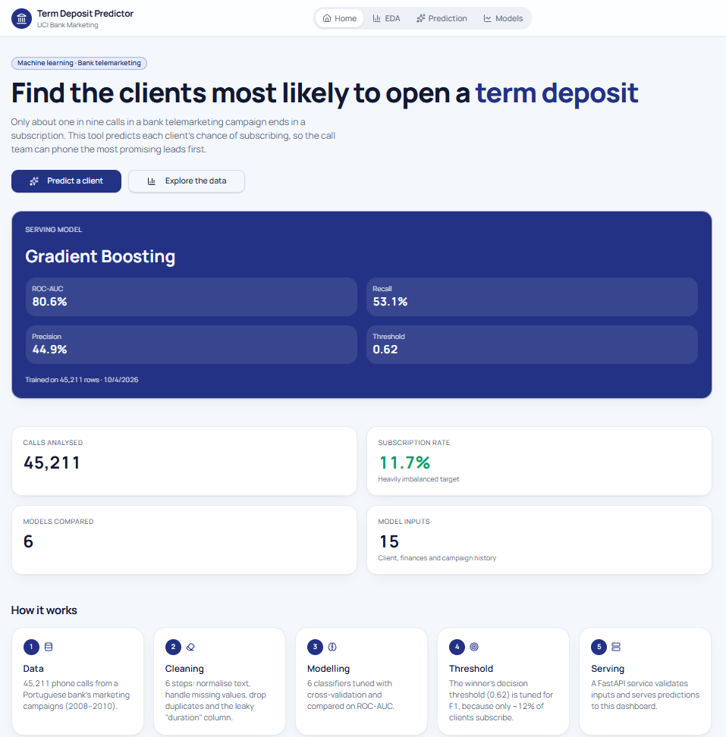
Figure 19: Home page: serving model, dataset KPIs and how the system works
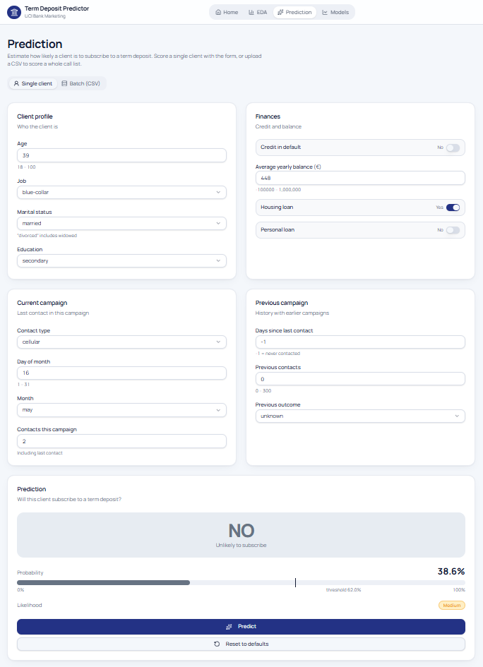
Figure 20: Prediction page, Single client tab: the default client scores 38.6%, below the 0.62 threshold (medium priority)
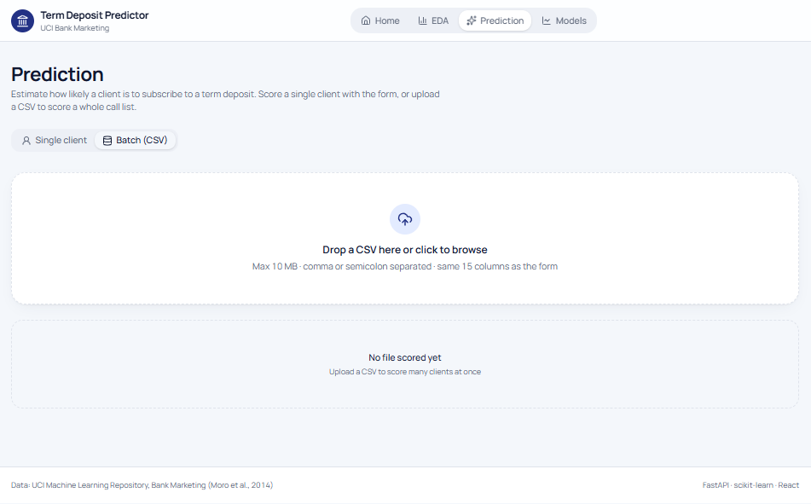
Figure 21: Prediction page, Batch (CSV) tab ready for an upload
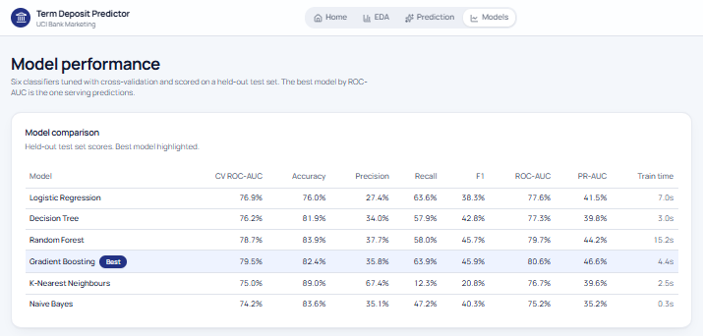
Figure 22: Models page: comparison of the six models on the held-out test set
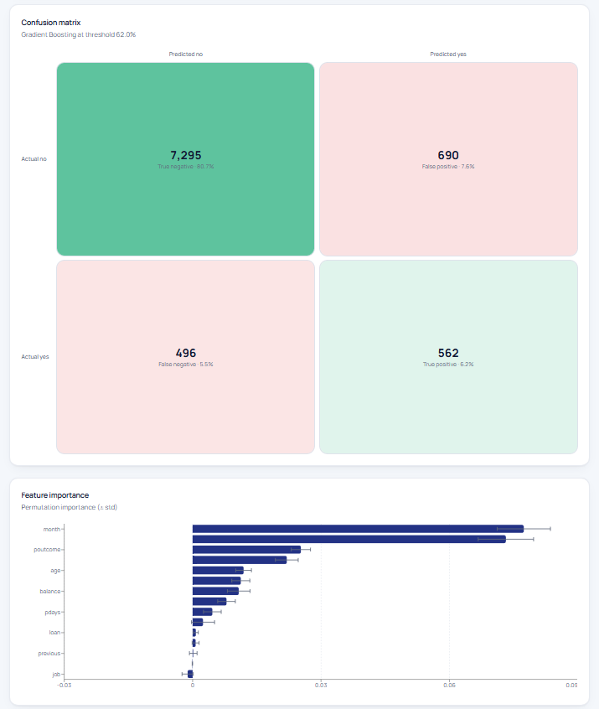
Figure 23: Models page: confusion matrix at the tuned threshold and permutation feature importance

9. Testing and Validation
Automated tests cover both tiers. The API tests in backend/tests/test_api.py run in-process with FastAPI's TestClient and the real trained model (pytest: 8 passed). The frontend uses Vitest with Testing Library in a jsdom environment (frontend/src/test/); its routing test checks the generated route tree (npm test: 1 passed). All 9 tests pass.
Table 16: Automated test cases
# | Test | What it verifies | Result
1 | test_health | API is up and the model is loaded | Pass
2 | test_metadata_and_metrics | Metadata lists categories; metrics contain all 6 models and agree on the selected model | Pass
3 | test_insights | EDA covers the full dataset (> 40,000 rows) and the cleaning report is present | Pass
4 | test_predict_single | A valid record returns a score in [0, 1] and a yes/no decision | Pass
5 | test_previous_success_raises_probability | Domain sanity check: a previous campaign success raises the score | Pass
6 | test_predict_validation_error | Out-of-range age and unknown job are rejected with HTTP 422 | Pass
7 | test_batch | A CSV with one valid and one invalid row scores the valid row and reports row 2 as an error | Pass
8 | test_batch_missing_columns | A CSV without the required columns is rejected with HTTP 400 | Pass
9 | app-routing (Vitest) | The file-based route tree resolves / to the Home page instead of the not-found fallback | Pass

Model validity was assessed separately through stratified cross-validation, a held-out test set that was never used for fitting, selection or threshold tuning, and the comparison of CV and test scores (Section 7.2). The dashboard was tested manually end-to-end with the backend running, including navigation between the four pages, single-client prediction, invalid input messages, CSV upload of the original bank-full.csv, filtering, sorting and CSV export.

10. Deployment and User Guide
Prerequisites: Python 3.11+ and Node.js 20.19+ (required by Vite 8). The training pipeline takes about 1–2 minutes on a laptop.
# 1. Python environment
python -m venv .venv
.\.venv\Scripts\activate # macOS/Linux: source .venv/bin/activate
pip install -r requirements.txt
# 2. Download data, clean, EDA, train and generate reports
python -m ml.run_pipeline
# 3. Backend API on http://127.0.0.1:8000 (docs at /docs)
cd backend
uvicorn app.main:app --port 8000
# 4. Frontend on http://localhost:5173 (new terminal)
cd frontend
npm install
npm run dev # proxies /api to http://127.0.0.1:8000
# Tests and checks
cd backend && pytest
cd frontend && npm test && npm run lint
# Production build of the dashboard
cd frontend && npm run build

The Vite development server proxies /api requests to the backend, so both processes must be running; set VITE_API_URL to call an API hosted elsewhere instead. To retrain on new campaign data, replace the raw CSV and re-run the pipeline; the API picks up the new artifacts on restart and the dashboard adapts automatically through /api/metadata.

11. Discussion

11.1 Business insights and recommendations
- Prioritise calls by model score. Calling the top 20% of ranked clients reaches 63% of subscribers.
- Re-target past successes. Clients with a previous successful campaign convert at 65%.
- Rethink campaign timing. May is heavily used but converts at only 6.7%; March, September, October and December convert above 40% and deserve more capacity.
- Prefer mobile contact and record the contact channel: unknown-channel contacts convert at only 4.1%.
- Cap repeated calls. Conversion drops from 14.6% on the first call to 4.2% after ten; further calls mostly waste effort and risk annoying clients.
- Target receptive segments such as students, retired clients and clients without existing loans.

11.2 Limitations
- Precision at the tuned threshold is about 45%: more than half of flagged clients still do not subscribe. Without duration, the available pre-call attributes contain limited signal.
- Because training uses class weights, the output score ranks clients but is not a calibrated probability.
- The data covers 2008–2010 during the financial crisis; macro-economic conditions have changed, so the model should be retrained on recent data before real use.
- Month and day effects may partly reflect how the bank scheduled campaigns rather than client behaviour.
- The prototype has no authentication, audit logging or production hosting.
- The dashboard's offline demo data is illustrative and differs from the trained model (for example a 0.32 threshold and four models). It is clearly badged, but decisions should only be based on the live API.

11.3 Future work
- Add probability calibration (Platt scaling or isotonic regression) so scores can be read as probabilities.
- Use cost-sensitive threshold selection based on the bank's actual cost per call and profit per deposit.
- Try additional algorithms (XGBoost, LightGBM, CatBoost) and the bank-additional socio-economic indicators.
- Add SHAP explanations for individual predictions in the dashboard.
- Containerise with Docker, add authentication, and deploy to the cloud with CI/CD and model monitoring for drift.

12. Individual Contributions
All four members contributed to every stage of this project, rather than one member owning a single stage outright. Each of the four stages below (data understanding and preprocessing, exploratory data analysis and feature engineering, model development and evaluation, and system implementation and testing) was carried out jointly, with every member doing identifiable work in each stage. The specific task each member performed for that stage is set out below each stage heading. Section 12.5 additionally records, for reference, which files each member primarily worked on within this shared effort.
Table 17: Summary of contribution by project stage
Project stage | Work covered | Report sections
Data understanding, cleaning & validation | Data acquisition, quality assessment, cleaning, domain-rule validation, removal of the leaking duration attribute and target encoding. | 2, 4.1–4.2, 10
Exploratory data analysis & feature engineering | Subscription-rate analysis by category, outlier investigation, feature engineering (previously_contacted, log_balance, total_contacts, age_group) and outlier capping. | 4.3–4.4, 5, 11.1
Model training, tuning & evaluation | Comparison of six classifiers, stratified cross-validation, hyper-parameter tuning, F1-based threshold tuning and permutation feature importance. | 3, 6, 7
System implementation & testing | FastAPI backend (prediction, batch scoring, metrics endpoints), React dashboard (Home, EDA, Prediction and Models pages) and the automated test suites (pytest, Vitest). | 1, 8, 9, 11.2–11.3

All members jointly took part in problem definition, choosing the dataset, weekly progress meetings, code reviews, integration testing, proofreading this report and preparing the presentation.

12.1 Data Acquisition, Cleaning and Validation
Member | What they did for this stage
Gunathilaka W.A.D.S. | Wrote the data-download script and the cleaning/validation logic (ml/download_data.py, ml/preprocess.py, ml/config.py); produced cleaning_report.json.
Edirisinghe E.M.K.L. | Reviewed the cleaning rules and cross-checked the quality report against the raw dataset for consistency.
Illesinghe E.S. | Tested the preprocessing pipeline against edge cases (e.g. the "unknown" categories and the pdays sentinel value).
Kaluarachchi R.G. | Documented the dataset description, data-quality observations and limitations sections of this report.

- Implemented ml/download_data.py, which downloads the UCI archive and recursively searches the nested ZIP files to extract bank-full.csv, skipping the download when the file already exists.
- Created ml/config.py, the single source of truth for folder paths, artifact locations, the raw input columns, engineered columns and the random seed.
- Implemented the cleaning stage in ml/preprocess.py: text normalisation, missing-value analysis and imputation strategy, duplicate removal, domain-rule validation, removal of the leaking duration attribute and target encoding, with every step recorded in cleaning_report.json.
- Analysed the “unknown” placeholders and justified keeping them as a category based on their distinct subscription rates.
- Built the batch-scoring feature: the /api/predict/batch endpoint (delimiter detection, header normalisation, per-row validation and error reporting, upload limits) and the Batch (CSV) tab of the Prediction page (BatchPage.tsx) with drag-and-drop upload, file checks, KPI cards, Yes/No filtering, sorting, pagination, a row-error panel and CSV export.
- Wrote the batch-scoring test cases and the dataset description, data cleaning, leakage and deployment sections of this report.
Main files: ml/download_data.py, ml/config.py, ml/preprocess.py, artifacts/cleaning_report.json, backend/app/main.py (batch endpoint), frontend/src/components/dashboard/BatchPage.tsx

12.2 Exploratory Data Analysis and Feature Engineering
Member | What they did for this stage
Edirisinghe E.M.K.L. | Implemented the EDA script and the feature-engineering transformers (ml/eda.py, ml/transformers.py); built the EDA dashboard page with its key-finding cards (routes/eda.tsx, InsightsPage.tsx).
Illesinghe E.S. | Verified the feature-engineering logic and reproduced the EDA charts independently to confirm the findings.
Kaluarachchi R.G. | Cross-checked the outlier-capping thresholds and reviewed the EDA page for correctness.
Gunathilaka W.A.D.S. | Proofread the EDA findings and feature-engineering write-up in this report.

- Implemented ml/eda.py, which computes subscription rates per category (job, marital, education, contact, previous outcome, housing, loan, month, age group), the age histogram, the campaign-call effect, numeric correlations and summary statistics, saved to insights.json.
- Interpreted the EDA results and identified the key drivers (timing, previous outcome, contact channel, age U-shape, loans, diminishing returns of repeated calls) that guided feature engineering and model choice.
- Designed and implemented the custom transformers in ml/transformers.py: FeatureEngineer (previously_contacted, days_since_prev, log_balance, total_contacts, age_group, removal of pdays) and QuantileCapper for train-only winsorisation of outliers.
- Built the EDA page (routes/eda.tsx, InsightsPage.tsx) with automatically derived key-finding cards (best category per attribute among groups of at least 200 clients, compared with the 11.7% average), the class-balance chart, cleaning steps, attribute selector for subscription rates, age distribution, campaign-call chart and correlations.
- Produced the EDA figures and wrote the feature engineering, outlier handling, EDA and business recommendations sections of this report.
Main files: ml/eda.py, ml/transformers.py, artifacts/insights.json, frontend/src/routes/eda.tsx, frontend/src/components/dashboard/InsightsPage.tsx, docs/figures/eda_*.png

12.3 Model Training, Tuning and Evaluation
Member | What they did for this stage
Illesinghe E.S. | Implemented the model-training pipeline, hyper-parameter grids and evaluation code (ml/train.py, ml/report.py); selected and tuned the final model.
Kaluarachchi R.G. | Reviewed the hyper-parameter grids and verified the metrics.json outputs against the printed training log.
Gunathilaka W.A.D.S. | Tested the training pipeline end-to-end and confirmed the results were reproducible on a fresh run.
Edirisinghe E.M.K.L. | Proofread the methodology and evaluation sections of this report.

- Implemented ml/train.py: the leakage-free preprocessing + model pipeline, the stratified 80/20 split, the six candidate models and their hyper-parameter grids, and grid search with 3-fold stratified cross-validation scored by ROC-AUC.
- Handled class imbalance with balanced class weights and balanced sample weights for Gradient Boosting.
- Implemented model selection by CV ROC-AUC, F1-based threshold tuning on out-of-fold predictions, permutation feature importance and refitting the final model on all data.
- Implemented ml/report.py, which prints the comparison tables and produces the ROC, precision-recall, confusion-matrix, threshold, feature-importance and cumulative-gains charts and the HTML training report.
- Built the Models page (routes/models.tsx, PerformancePage.tsx) with the comparison table highlighting the best model, grouped test-score chart, ROC curves, confusion matrix at the tuned threshold and permutation importance with error bars.
- Wrote the methodology, data mining techniques and evaluation sections of this report.
Main files: ml/train.py, ml/report.py, ml/run_pipeline.py, artifacts/metrics.json, reports/, frontend/src/routes/models.tsx, frontend/src/components/dashboard/PerformancePage.tsx

12.4 System Implementation (Backend & Frontend) and Testing
Member | What they did for this stage
Kaluarachchi R.G. | Implemented the FastAPI backend and the frontend app shell, routing, Home page and Single client prediction (main.py, model_service.py, schemas.py, AppShell.tsx, __root.tsx, index.tsx, PredictPage.tsx); wrote the automated pytest and Vitest tests.
Gunathilaka W.A.D.S. | Tested the REST API endpoints and verified the batch-scoring integration end-to-end.
Edirisinghe E.M.K.L. | Reviewed the four dashboard pages (Home, EDA, Prediction, Models) against the insights requirements.
Illesinghe E.S. | Wrote the testing and deployment sections of this report.

- Designed the overall system architecture and the API contract between the ML pipeline, backend and frontend.
- Implemented the FastAPI application (main.py): start-up model loading, CORS, health, metadata, metrics, insights and single-prediction endpoints, and HTTP 503 handling when the model is not trained.
- Implemented model_service.py (artifact loading, prediction, tuned threshold and lead-priority bands) and the Pydantic request/response schemas with strict category and range validation (schemas.py).
- Built the application shell and data layer: the root route and Home page (__root.tsx, index.tsx), the Prediction route (predict.tsx), the AppShell header and navigation, the typed API client with error toasts and demo-data fallback (api.ts), the TanStack Query hooks (queries.ts) and the field definitions (fields.ts), plus the Single client form (PredictPage.tsx) with the probability bar, threshold marker and likelihood badge.
- Wrote the automated pytest suite (health, metadata/metrics, insights, single prediction, domain sanity check, validation errors) and the Vitest routing test, and carried out end-to-end integration testing.
- Wrote the introduction, system design and implementation, testing, limitations and future work sections of this report.
Main files: backend/app/main.py, backend/app/model_service.py, backend/app/schemas.py, backend/tests/test_api.py, frontend/src/routes/ (__root, index, predict), frontend/src/components/layout/AppShell.tsx, frontend/src/components/dashboard/PredictPage.tsx, frontend/src/lib/ (api, queries, fields), frontend/src/test/

12.5 Individual Task Allocation (For Reference)
Contribution was equal (25% each) across every stage described above. The table below additionally records, purely for traceability and in response to the requirement to state what each member did, which specific files each member primarily implemented within that shared, jointly-reviewed effort.
Table 17b: Individual task allocation by member
Member | Student ID | Primarily worked on (within the shared, equally-contributed effort)
Gunathilaka W.A.D.S. | IT23859456 | ml/download_data.py, ml/config.py, ml/preprocess.py (data acquisition, cleaning, validation); the /api/predict/batch endpoint and BatchPage.tsx (Batch (CSV) tab of the Prediction page).
Edirisinghe E.M.K.L. | IT23857780 | ml/eda.py, ml/transformers.py (EDA, feature engineering, outlier capping); routes/eda.tsx and InsightsPage.tsx (EDA page).
Illesinghe E.S. | IT23557024 | ml/train.py, ml/report.py, ml/run_pipeline.py (model training, tuning, evaluation); routes/models.tsx and PerformancePage.tsx (Models page).
Kaluarachchi R.G. | IT23544918 | backend/app/main.py, model_service.py, schemas.py (REST API); frontend routes (__root, index, predict), AppShell.tsx, api.ts, queries.ts, fields.ts, PredictPage.tsx; automated pytest and Vitest tests.

13. Conclusion
We developed an end-to-end data mining system that predicts term deposit subscription from information available before a telemarketing call. A careful preparation process (validation, leakage removal, feature engineering and a pipeline that is fitted only on training data) and a fair comparison of six algorithms identified Gradient Boosting as the best model, with a test ROC-AUC of 0.806 and a 4.4x lift in the top decile. The analysis produced clear, actionable insights about timing, previous outcomes, contact channel and call frequency. Finally, the model was packaged as a validated REST API and an interactive dashboard with automated tests, turning the data mining results into a tool that marketing staff can use directly to plan more efficient campaigns.

References
[1] Moro, S., Cortez, P. and Rita, P. (2014) ‘A data-driven approach to predict the success of bank telemarketing’, Decision Support Systems, 62, pp. 22–31. doi:10.1016/j.dss.2014.03.001.
[2] Moro, S., Rita, P. and Cortez, P. (2014) Bank Marketing [Dataset]. UCI Machine Learning Repository. doi:10.24432/C5K306. Available at: https://archive.ics.uci.edu/dataset/222/bank+marketing.
[3] Chapman, P. et al. (2000) CRISP-DM 1.0: Step-by-step data mining guide. SPSS Inc.
[4] Han, J., Kamber, M. and Pei, J. (2012) Data Mining: Concepts and Techniques. 3rd edn. Morgan Kaufmann.
[5] Pedregosa, F. et al. (2011) ‘Scikit-learn: Machine learning in Python’, Journal of Machine Learning Research, 12, pp. 2825–2830.
[6] Breiman, L. (2001) ‘Random forests’, Machine Learning, 45(1), pp. 5–32.
[7] Friedman, J.H. (2001) ‘Greedy function approximation: a gradient boosting machine’, Annals of Statistics, 29(5), pp. 1189–1232.
[8] Ke, G. et al. (2017) ‘LightGBM: A highly efficient gradient boosting decision tree’, Advances in Neural Information Processing Systems, 30.
[9] Saito, T. and Rehmsmeier, M. (2015) ‘The precision-recall plot is more informative than the ROC plot when evaluating binary classifiers on imbalanced datasets’, PLoS ONE, 10(3), e0118432.
[10] He, H. and Garcia, E.A. (2009) ‘Learning from imbalanced data’, IEEE Transactions on Knowledge and Data Engineering, 21(9), pp. 1263–1284.
[11] FastAPI (2024) FastAPI documentation. Available at: https://fastapi.tiangolo.com.
[12] React (2024) React documentation. Available at: https://react.dev.

Appendix A – Per-model Confusion Matrices
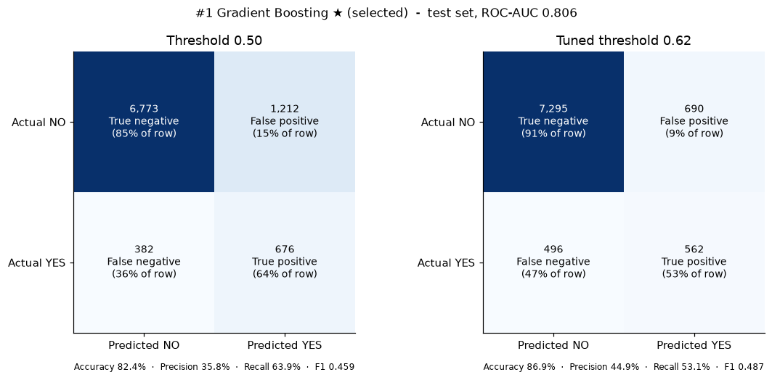
Figure 24: Confusion matrix – Gradient Boosting
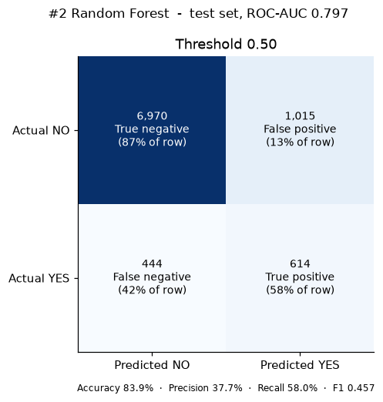
Figure 25: Confusion matrix – Random Forest
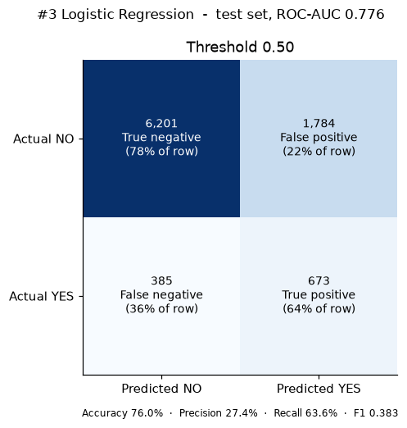
Figure 26: Confusion matrix – Logistic Regression
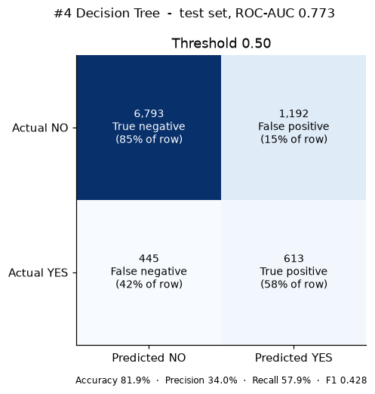
Figure 27: Confusion matrix – Decision Tree
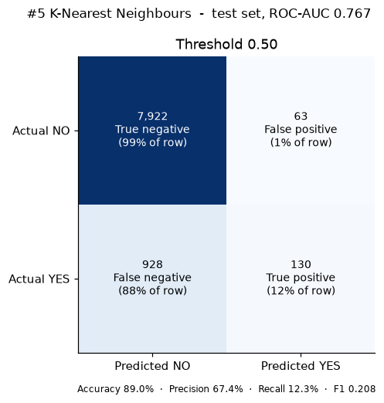
Figure 28: Confusion matrix – K Nearest Neighbours
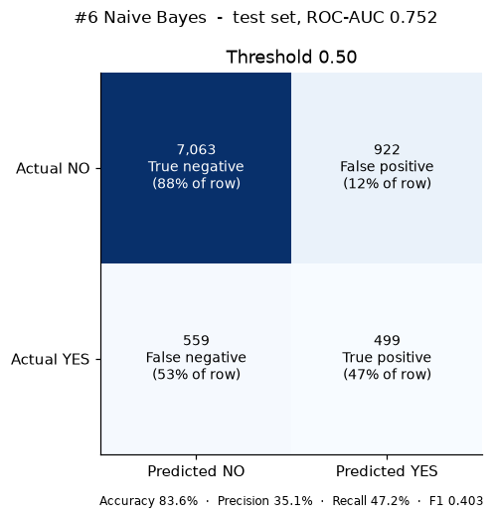
Figure 29: Confusion matrix – Naive Bayes

Appendix B – Configuration and Reproducibility
Table 18: Pipeline configuration
Setting | Value
Random seed | 42
Train / test split | 80 / 20, stratified
Cross-validation | 3-fold stratified, shuffled
Selection metric | Cross-validated ROC-AUC
Threshold rule | Maximise F1 on out-of-fold training predictions
Outlier capping | 1st / 99th percentile (training data)
Permutation importance | 5 repeats, 4,000-row test sample, ROC-AUC
Selected model | Gradient Boosting (learning_rate=0.05, max_depth=8)
Decision threshold | 0.62
Model trained at | 2026-10-04T07:24:56+00:00

