Clario AI Support Pipeline

Data Science Evaluation Test Plan

Version 1.2

Revision History
Date | Version | Description | Author
18/Sep/26 | 1.0 | Initial Data Science Evaluation test plan, covering Tracks A-D | DSE Team
19/Sep/26 | 1.1 | Added the two-phase method, data sources, and the local Llama classifier results | DSE Team
19/Sep/26 | 1.2 | Added data notes, sample sizes, per-fix results, numeric success criteria, and corrections after review | DSE Team

Table of Contents
1. Evaluation Mission and Test Motivation 3
2. Target Test Items 4
2.1 Test Data 4
3. Test Approach 5
3.1 Testing Techniques and Types 5
3.1.1 Data and Knowledge Base Integrity Testing (Track A: Retrieval Quality) 5
3.1.2 Function Testing (Track B: Routing and Escalation Accuracy) 6
3.1.3 Response Quality Testing (Track C: Final Response Quality) 6
3.1.4 Judge Reliability Testing (Track D: Judge Reliability) 6
3.1.5 Model Selection Testing: Local Llama Classifier 7
4. Deliverables 7
4.1 Test Evaluation Summaries 7
4.2 Reporting on Test Coverage 7
5. Risks, Dependencies, Assumptions, and Constraints 7
6. References 8
Appendix: Results by Phase 9
Appendix A: Track A, Retrieval Quality 9
Appendix B: Track B, Routing and Escalation Accuracy 11
Appendix C: Track C, Final Response Quality 14
Appendix D: Track D, Judge Reliability 15
Appendix E: Local Llama Classifier Selection 18

Data Science Evaluation Test Plan

Evaluation Mission and Test Motivation
Clario is an AI support assistant for an online learning platform. When a customer sends a support ticket, Clario reads it, searches the knowledge base (KB), sends the ticket to the right team (technical, billing, or HR), drafts a reply, checks its own draft, and decides when a human must step in before anything is sent.
Before using Clario on real customer tickets, we wanted to know how well the main steps work, using real ticket data. This document is our plan for that evaluation, together with the results.
Mission
Measure retrieval, routing and escalation, reply quality, and the automated judge; fix the issues we find; and check every fix with data.
What HR means in Clario
HR tickets are the ones that need a person's judgement or a policy decision, not just a KB answer. Examples are a bank-slip payment linked to the wrong account, a refund after a medical emergency, parental consent, an instructor change in the middle of a course, and course cancellations. Clario always sends HR tickets to a human reviewer with a draft reply.
Background
A local fine-tuned Llama 3.2 model reads each ticket and predicts its category, priority, and sentiment. Clario then finds the right KB documents, routes the ticket to a specialist, drafts a reply, scores it with an automated judge, and decides on escalation. The figure shows which step each track tests.
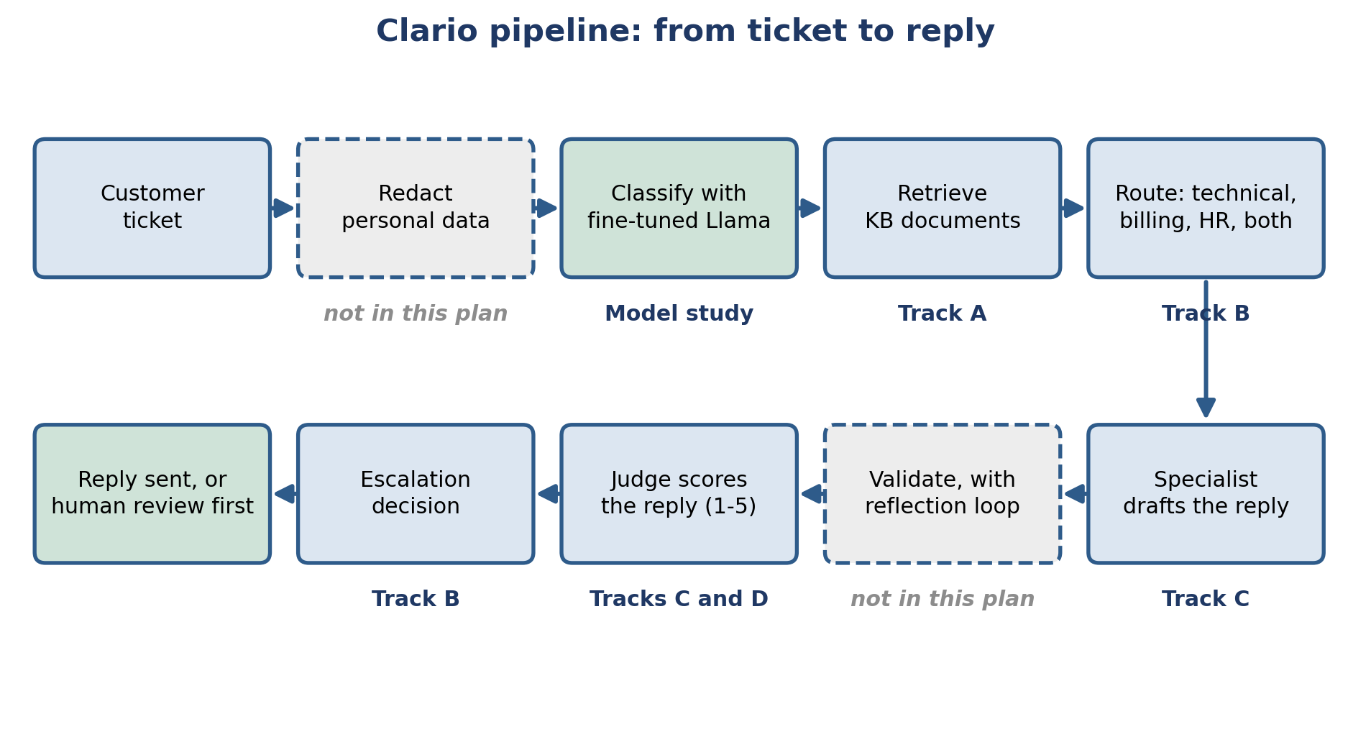
Figure 1: The Clario pipeline. Each step shows the track that tests it.
This plan does not support a whole-pipeline go-live decision. Personal-data redaction, the reflection loop, and the response cache were live in the pipeline that produced the Track C drafts, so their effect is inside those numbers. We did not test them alone, and we report no end-to-end result.
How we ran the evaluation
We ran every track in two phases:
- Phase 1, the 99-query set: two team members annotated the same 99 queries by hand. This showed us the failures, wrong routings, and wrong settings in the pipeline.
- Fix: we fixed the issues and checked the metrics after each fix.
- Phase 2, the 70 real tickets: we ran the 70 real tickets through the fixed pipeline and measured the results.
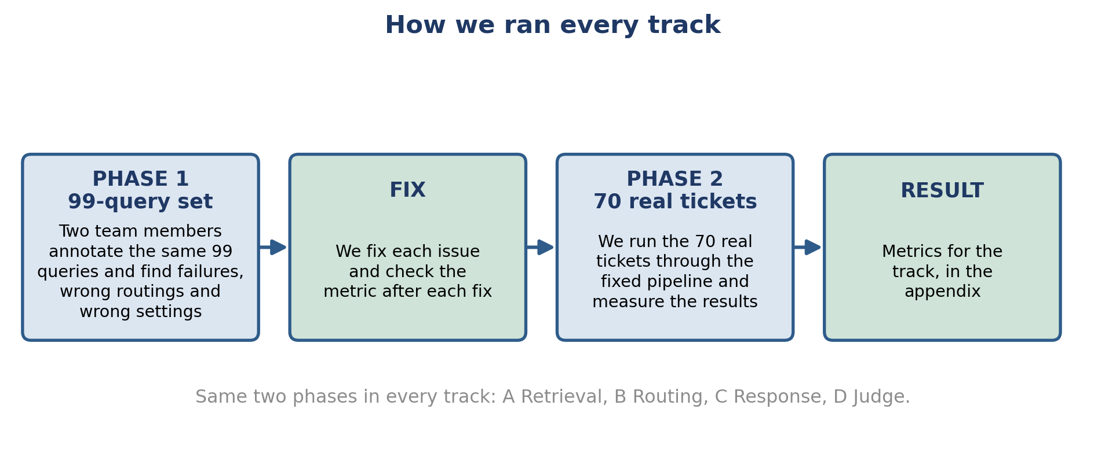
Figure 2: The two-phase method we used in every track.

Target Test Items
The table lists the parts of the Clario pipeline covered by this plan, and the track that tests each one. Personal-data redaction and the reflection loop are outside this plan.
Test Item | Track | Description
Local ticket classifier | Model study | Fine-tuned Llama 3.2 (4-bit) predicts category, priority, and sentiment
Knowledge-base retrieval | A | Vector search that finds the right KB document for a ticket
KB documents and vector store | A | Markdown documents and the ChromaDB store behind every retrieval result
Routing rules | B | Decide which team (technical, billing, HR) handles a ticket
Escalation rules | B | Decide when a ticket needs a human before a reply goes out
Specialist response agents | C | Draft the reply for each domain (technical, billing, HR)
Automated response judge | C and D | LLM-based scoring of every reply (used in C, checked in D)

Test Data
Dataset | Size | Source and use
99-query set | 99 queries | Built from the text of 100 earlier support tickets (payment, refund, billing, login). Each query is labelled with the KB document that should answer it: 59 have a matching document and 40 do not. Used in Phase 1.
Real support tickets | 70 tickets | 70 real support tickets with the real human replies, from a file of 71 (one duplicate removed). Names and emails are removed before any script runs. Used in Phase 2.
Real customer reviews | 54 reviews | Public Trustpilot reviews of Udemy (26), Coursera (12), Pluralsight (10), and Skillshare (6). Real customer wording for KB documents.
Community forum posts | 63 posts | Extra real issues from the Open edX community forum, reviewed for KB ideas.
Model comparison results | 5 models, 3 tasks | Category, priority, and sentiment results used to choose the local classifier.

Test Approach
We organised the evaluation into four tracks (A to D), plus one model-selection study for the local classifier. Every track follows the same steps: annotate the 99-query set to find issues (Phase 1), fix each issue and check the metric, then run the 70 real tickets through the fixed pipeline (Phase 2).
The table shows who annotated or scored in each phase.
Track | Phase 1: 99-query set | Phase 2: 70 real tickets
A: Retrieval | Team-labelled correct KB document for each query | Ranuga and Sineth, independently
B: Routing and escalation | Vinma and Sineth, independently | Vinma and Sineth, independently
C: Response quality | Ranuga and Vinma read all 90 drafts the full pipeline produced | Scored automatically against real human replies
D: Judge reliability | Ranuga and Sineth scored 99 drafts, blind to the judge | Ranuga and Sineth scored 82 rows, blind to the judge

How to read the results
- We set the numeric success criteria in version 1.2 of this plan, after we had the results. They are not pre-registered targets.
- Neither set is a clean hold-out. We used the 99-query set to find issues and to re-check fixes. Some fixes also used wording from the 70 tickets (KB wording in Track A, routing patterns in Track B). We read the 70-ticket results as results on data we worked with.
- In Tracks C and D the before result comes from the 99-query drafts and the after result from the 70 tickets. The two are different data, so the change shows direction. It is not a like-for-like test.
- Group sizes are small. We state n next to every domain result, and the HR recall result rests on 14 tickets.
- Track C scores come from an automated judge. Track D shows the judge is more generous than the humans, so we read Track C scores as upper estimates. The Track D drafts are different from the Track C drafts, so Track D shows how the judge behaves on comparable drafts. It does not directly cover the Track C scores.

Testing Techniques and Types

Data and Knowledge Base Integrity Testing (Track A: Retrieval Quality)
Technique Objective: | Confirm the system retrieves the correct KB document for a customer ticket.
Technique: | Phase 1: run the 99 labelled queries through retrieval and score them with Precision@k, Recall@k, MRR, and nDCG. Phase 2: two annotators label the 70 real tickets, and we check retrieval on them after our fixes.
Oracles: | The team's correct-document labels for the 99 queries, and the two annotators' labels for the 70 tickets (they overlapped on 85.7% of tickets before any discussion).
Required Tools: | The technique requires the following tools:  - ChromaDB vector store  - Sentence-transformers model (all-MiniLM-L6-v2)  - Python precision, recall, MRR, and nDCG scripts  - Real customer reviews and forum posts as a source of KB wording
Success Criteria: | Precision@1 of at least 60% and Recall@4 of at least 85%, on the queries that have a correct KB document, on both sets. Both sets were also used to tune the fixes.
Special Considerations: | - The KB grows from real data. We re-check retrieval every time documents are added or changed.

Function Testing (Track B: Routing and Escalation Accuracy)
Technique Objective: | Confirm each ticket goes to the correct team, and that a human reviews the tickets that need it.
Technique: | Phase 1: two annotators (Vinma and Sineth) label the 99 queries for team and escalation, and we compare the live routing rules to their answers. Phase 2: the same two annotators label the 70 real tickets and we test the fixed rules.
Oracles: | Answers agreed by two independent reviewers. Cohen's kappa shows how well they agree. Tickets where they still disagreed are left out of the scoring.
Required Tools: | The technique requires the following tools:  - The live routing and classification code  - Cohen's kappa calculator  - Confusion-matrix scripts
Success Criteria: | Routing accuracy of at least 80%, HR recall of at least 80%, and escalation F1 of at least 70%, on both sets. We also report missed escalations, because they are the costlier error.
Special Considerations: | - Escalation includes real judgment calls. We record reviewer disagreements openly.

Response Quality Testing (Track C: Final Response Quality)
Technique Objective: | Confirm the reply Clario writes is accurate, grounded in the KB, and matches the tone the ticket needs.
Technique: | Phase 1: two annotators (Ranuga and Vinma) read all 90 drafts the full pipeline produced for the 99 queries and flag problems. Phase 2: we score the drafts for the 70 real tickets on a 1 to 5 rubric, check groundedness against the retrieved KB content, and compare them with the real human reply.
Oracles: | The annotators' notes in Phase 1, and the real human agent replies in Phase 2.
Required Tools: | The technique requires the following tools:  - ResponseJudge scoring tool  - Groundedness checker  - Semantic similarity scorer
Success Criteria: | Judge overall score and tone match of at least 4.0, and groundedness of at least 80%, in each domain. We read these scores together with the Track D judge results.
Special Considerations: | - The head-to-head comparison with a real human reply is a stricter benchmark. We report it separately.

Judge Reliability Testing (Track D: Judge Reliability)
Technique Objective: | Confirm the automated judge agrees with what a real person would say about the same reply.
Technique: | Phase 1: two annotators (Ranuga and Sineth) score 99 drafts without seeing the judge's scores. These drafts come from calling each specialist directly, so all 99 queries have a draft. Phase 2: the same two score 82 rows from the 70 real tickets under the improved rubric. We measure agreement with weighted Cohen's kappa and Spearman correlation.
Oracles: | Two independent human raters, blind to the judge.
Required Tools: | The technique requires the following tools:  - Weighted kappa and Spearman calculators  - Human scoring guide, worded the same as the judge's rubric
Success Criteria: | Judge-versus-human weighted kappa within 0.05 of human-versus-human kappa, and Spearman correlation of at least 0.60. Human-versus-human agreement is the ceiling a judge can reach.
Special Considerations: | - We check how widely raters use the 1 to 5 scale before reading a kappa number.

Model Selection Testing: Local Llama Classifier
Technique Objective: | Choose the local model that reads each ticket first and predicts its category, priority, and sentiment.
Technique: | We fine-tuned four language models (Llama 3.2 3B, Ministral-3 3B, Gemma-3 1B, Qwen2.5 0.5B) and trained one classic machine-learning baseline (TF-IDF with a support vector classifier). We compared them on the same three tasks.
Oracles: | Labelled ticket data from the fine-tuning test set, scored with precision, recall, F1, and overall accuracy.
Required Tools: | The technique requires the following tools:  - QLoRA fine-tuning with 4-bit (NF4) quantization  - scikit-learn classification reports
Success Criteria: | The chosen model has the best overall accuracy on category, priority, and sentiment. Gaps under 2 points count as ties.
Special Considerations: | - These results come from the fine-tuning test set, not from the 70 real tickets. The workbook does not record the test-set size (see Appendix E).  - The chosen model's priority and sentiment output also feeds the reply-drafting step (see Appendix C).

Deliverables

Test Evaluation Summaries
For each track we write a short conclusion and a full final report. Each has the headline metrics, the key diagrams, the issues found, the fixes made, and the result after each fix. Where several fixes went in together, we say so. The results of every track are collected in the Appendix of this document.

Reporting on Test Coverage
We report coverage as the number of queries, tickets, drafts, and rows used in each result, and we state n next to every domain result. Phase 1 used the 99-query set. Phase 2 used the 70 real support tickets. Results are saved as CSV and JSON files next to each track's report.

Risks, Dependencies, Assumptions, and Constraints
Risk | Mitigation Strategy | Contingency (Risk is realized)
The shared daily API quota is limited (Gemini free tier). | Pace requests, run a small check before a full live run, and monitor usage. | Exclude data collected during a quota interruption and re-run after the quota resets.
Language-model output varies slightly from run to run. | Use low-temperature settings and re-run key checks. | Report the observed range.
Test sets are small (70 to 99 items, and fewer per domain). | State n for every result. Read domain results as indicators. | Add more tickets in the next round.
Neither set is a clean hold-out, because fixes used wording from both. | Report both sets side by side and say which fixes used the 70 tickets. | Collect a fresh set of real tickets for a final check.
The automated judge is more generous than human raters. | Check it against two humans (Track D) and read its scores as upper estimates. | Add a low-score example to the judge prompt and re-check.
KB content needs to stay current. | Keep collecting real customer wording from review sites and forums. | Add the missing content and re-check retrieval.
Real ticket text goes to the Gemini free-tier API. Google's terms for unpaid use may allow content to be used to improve its products. | Remove names and emails first (we do). Check Google's current terms before each round. Use a paid tier or fully redacted text for real tickets. | Stop real-ticket runs on the free tier until the terms are confirmed.
The local classifier needs a GPU. | The 4-bit Llama model fits a single local GPU. | Check GPU access before each full run.

References
- Google Gemini API (gemini-3.1-flash-lite and related models): https://ai.google.dev (Accessed 2026).
- ChromaDB vector database: https://www.trychroma.com (Accessed 2026).
- Sentence-Transformers, all-MiniLM-L6-v2 model: https://www.sbert.net (Accessed 2026).
- LangGraph orchestration framework: https://www.langchain.com/langgraph (Accessed 2026).
- Meta Llama 3.2 models: https://www.llama.com (Accessed 2026).
- Dettmers, T., et al. (2023). QLoRA: Efficient Finetuning of Quantized LLMs.
- Hu, E., et al. (2021). LoRA: Low-Rank Adaptation of Large Language Models.
- Trustpilot public review pages (Udemy, Coursera, Skillshare, Pluralsight) and the Open edX community forum, https://discuss.openedx.org (Accessed 2026).
- Cohen, J. (1960). A Coefficient of Agreement for Nominal Scales. Educational and Psychological Measurement.

Appendix: Results by Phase
This appendix shows what we found in each track. In every track, two team members first annotated the 99-query set (Phase 1) to find failures, wrong routings, and wrong settings. We then fixed the issues and checked the metrics. Finally, we ran the 70 real tickets through the fixed pipeline (Phase 2). Please read the notes in Section 3 ("How to read the results") with these numbers.
Results against the success criteria
Track | Criterion | 99-query set | 70 real tickets | Status
A | Precision@1 at least 60%, Recall@4 at least 85% | 64.4%, 86.4% | 71.4%, 89.0% | Met (both sets used for tuning)
B | Routing at least 80%, HR recall at least 80%, escalation F1 at least 70% | 76.1%, 78.9%, 74.1% | 83.9%, 92.9% (13 of 14), 66.7%. On all 70 tickets: 75.7%, F1 about 0.61 | Partly met (in-sample)
C | Overall and tone at least 4.0, groundedness at least 80%, each domain | Not applicable (before fixes) | Met in billing and HR (groundedness of billing and technical is exactly 80.0%). Technical: 3.95 overall, 3.75 tone | Partly met
D | Judge kappa within 0.05 of human kappa, Spearman at least 0.60 | 0.075 (humans 0.080), 0.249 | 0.339 (humans 0.368), 0.764 | Met (kappa in the fair range)
Model study | Best accuracy on all three tasks | Not applicable | Llama first on all three | Met (ties within noise)

Record counts at a glance
Set and track | Records used | Why it is not the full set
99-query set, Track A | 59 of 99 | 40 queries have no matching KB document. They are used to check the relevance gate.
99-query set, Track B | 71 of 99 | 28 queries where the two annotators still disagreed are left out.
99-query set, Track C | 90 drafts from 87 queries | 12 queries were escalated to a human without a draft. Some queries give two drafts.
99-query set, Track D | 99 drafts | Each specialist is called directly, so every query has a draft.
70 tickets, Track A | 70 of 70 | All tickets have a correct KB document.
70 tickets, Track B | 56 of 70 | 14 tickets where the two annotators still disagreed are left out.
70 tickets, Track C scores | 58 drafts from 56 tickets | 14 tickets were escalated to a human without a draft. Two tickets give two drafts.
70 tickets, Track C head-to-head | 55 of 70 | The daily API limit ran out before the other 15 comparisons ran.
70 tickets, Track D | 82 rows from 70 tickets | 12 tickets go to two domains and give two rows each.

Track B left out 14 tickets and Track C has 14 tickets without a draft. These are different sets (5 tickets in common), so the matching size is a coincidence.

Appendix A: Track A, Retrieval Quality
We measured whether Clario finds the right KB document for a ticket. Precision@1 asks if the top result is correct. Recall@4 asks if the correct document is in the top 4 results.
Phase 1: what the 99 queries showed us
Annotating the 99 queries showed four things to improve: old content in the search index, a relevance gate that accepted every match, KB wording that differed from real customers, and 40 queries with no matching KB document.
Fixes and results
Stage | What we changed | 99-query set, Recall@4 | 70 tickets, Recall@4
Start | Nothing yet | 70.3% | Not re-scored
Fixes 1 and 2 | Removed 30 old chunks from the index, and raised the relevance-gate threshold from 0.30 to 0.70 | 89.0% | Not re-scored
Fix 3 | Rewrote KB wording with real customer phrasing, in several rounds | 86.4% (final) | 89.0% (final)

On the 99-query set, Recall@4 fell from 89.0% to 86.4% during the wording rounds (it moved between 88.1% and 90.7% along the way). The 89.0% on the 99-query set and the final 89.0% on the 70 tickets are separate results that happen to match. We corrected the 70-ticket answer key on 8 September. The KB has changed since then, so we cannot re-score the earlier stages and we do not show the old-key values. Fixes 1 and 2 went in together.
What the numbers count
On the 99-query set we score the 59 queries that have a correct KB document (Precision@1 64.4% is 38 of 59, and Recall@4 86.4% is 51 of 59). The other 40 have no matching document, and we use them to check the relevance gate. On the 70 tickets all 70 count (Precision@1 71.4% is 50 of 70). Recall is averaged per ticket, so a ticket with two correct documents can earn half credit. This is why 70.3% and 89.0% are not whole counts.
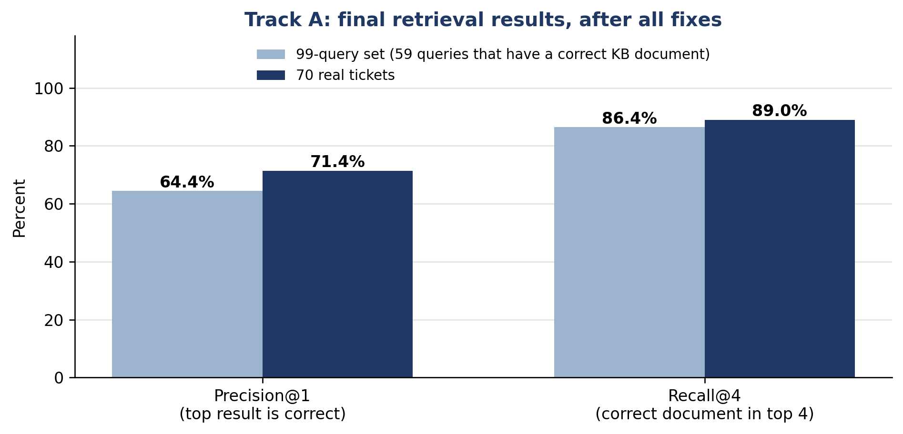
Figure A1: Final retrieval results on the 99-query set and the 70 real tickets.
Relevance gate
The gate accepts or rejects a retrieved document using one threshold (0.70). It behaves differently on the two sets. On the 99 queries it approved 71 results, and 37 of them were wrong. On the 70 tickets it rejected 15 of the 50 correct results. We chose 0.70 because it was reasonable on both sets. A separate threshold check for each set is a next step.
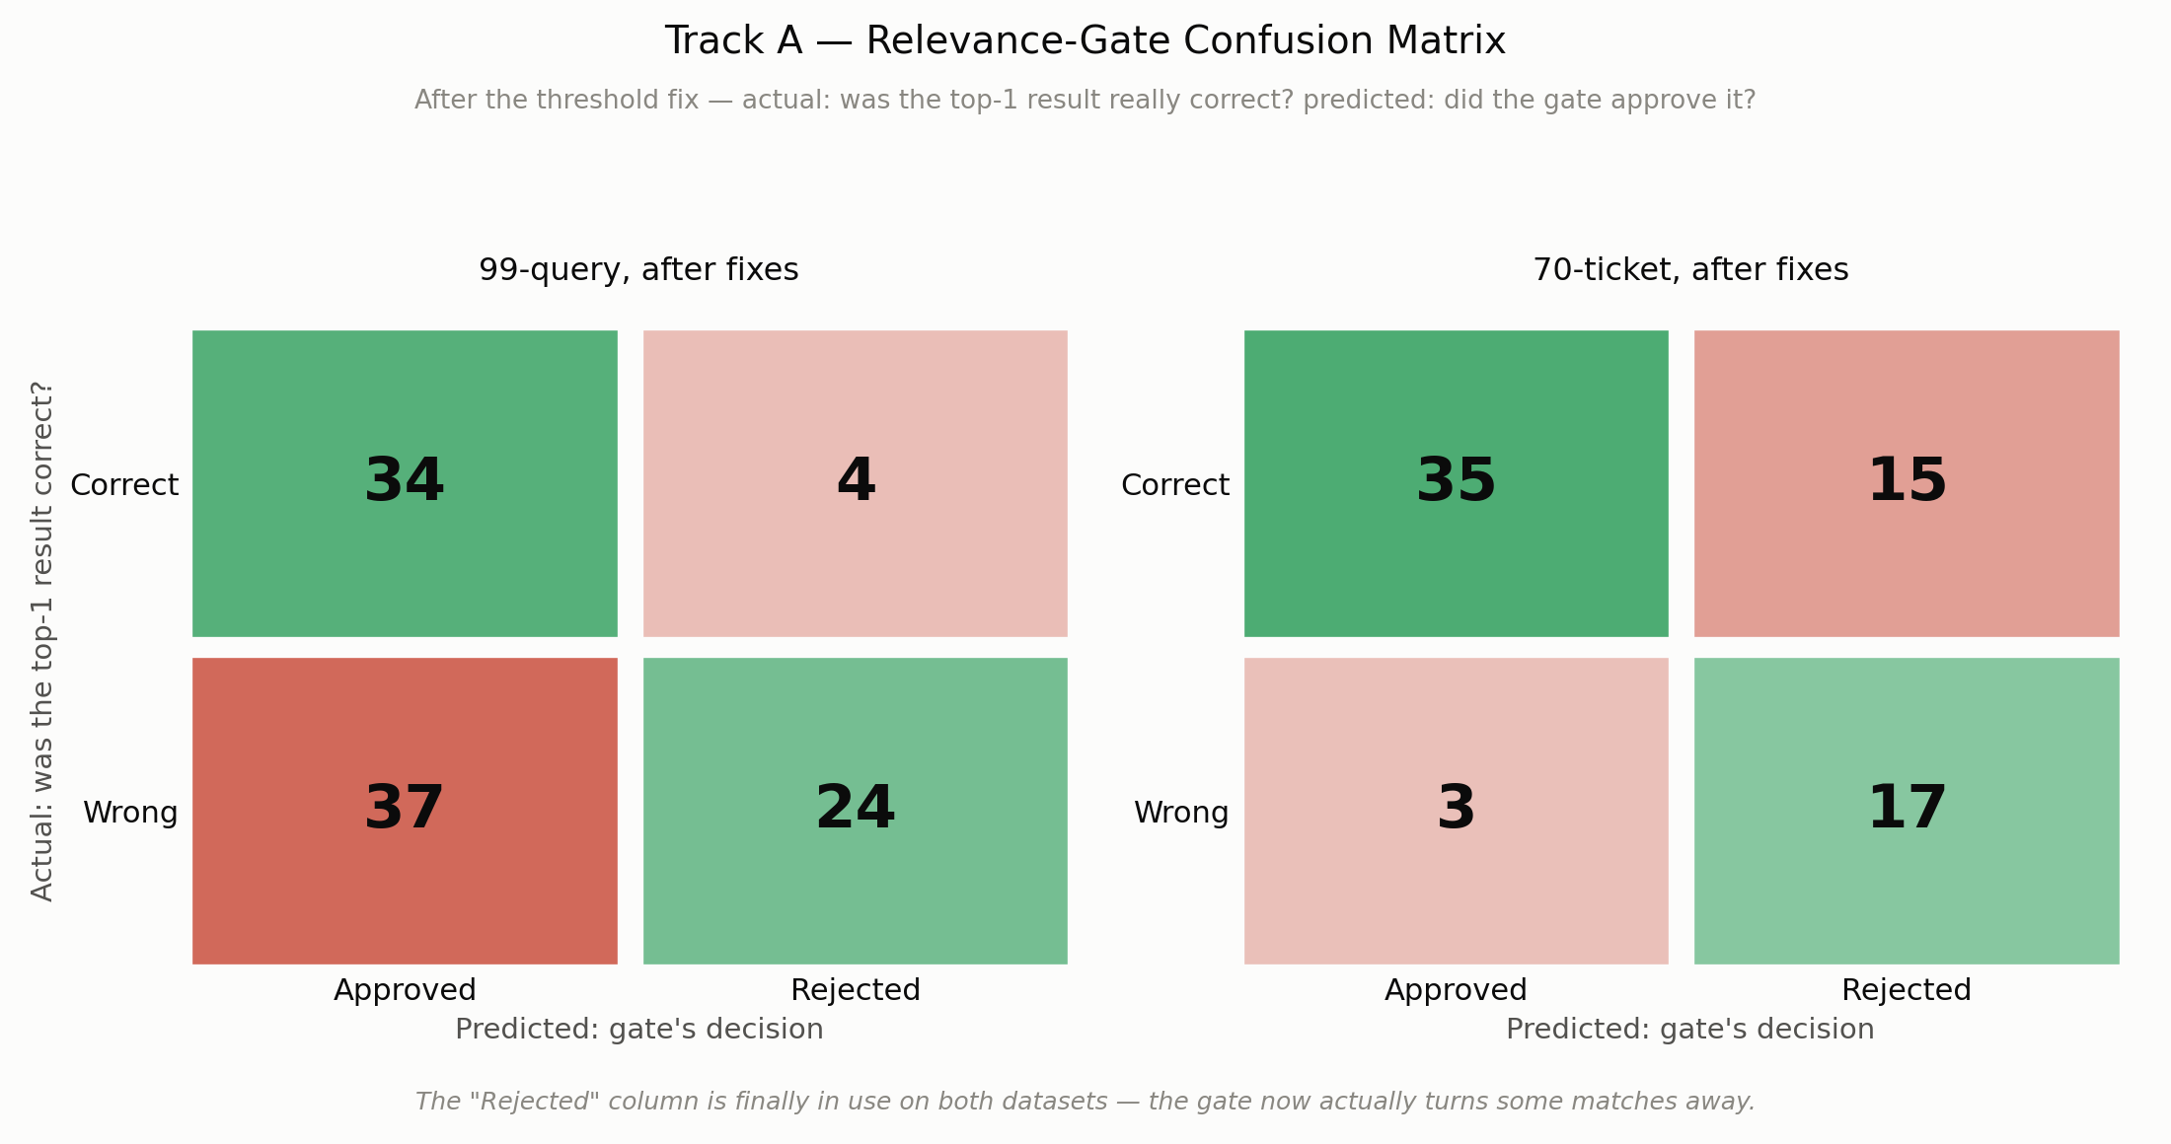
Figure A2: Relevance-gate confusion matrix after the fixes, on both sets.
Real data for KB wording
We collected 54 real customer reviews from Trustpilot pages of Udemy (26), Coursera (12), Pluralsight (10), and Skillshare (6). We also collected 63 real issue posts from the Open edX community forum. The customer reviews gave us natural wording for refunds, cancellations, logins, and app problems, and we added phrases from them to six KB documents. The forum posts came from platform administrators, so we reviewed them for ideas and kept the KB in the customer's voice.
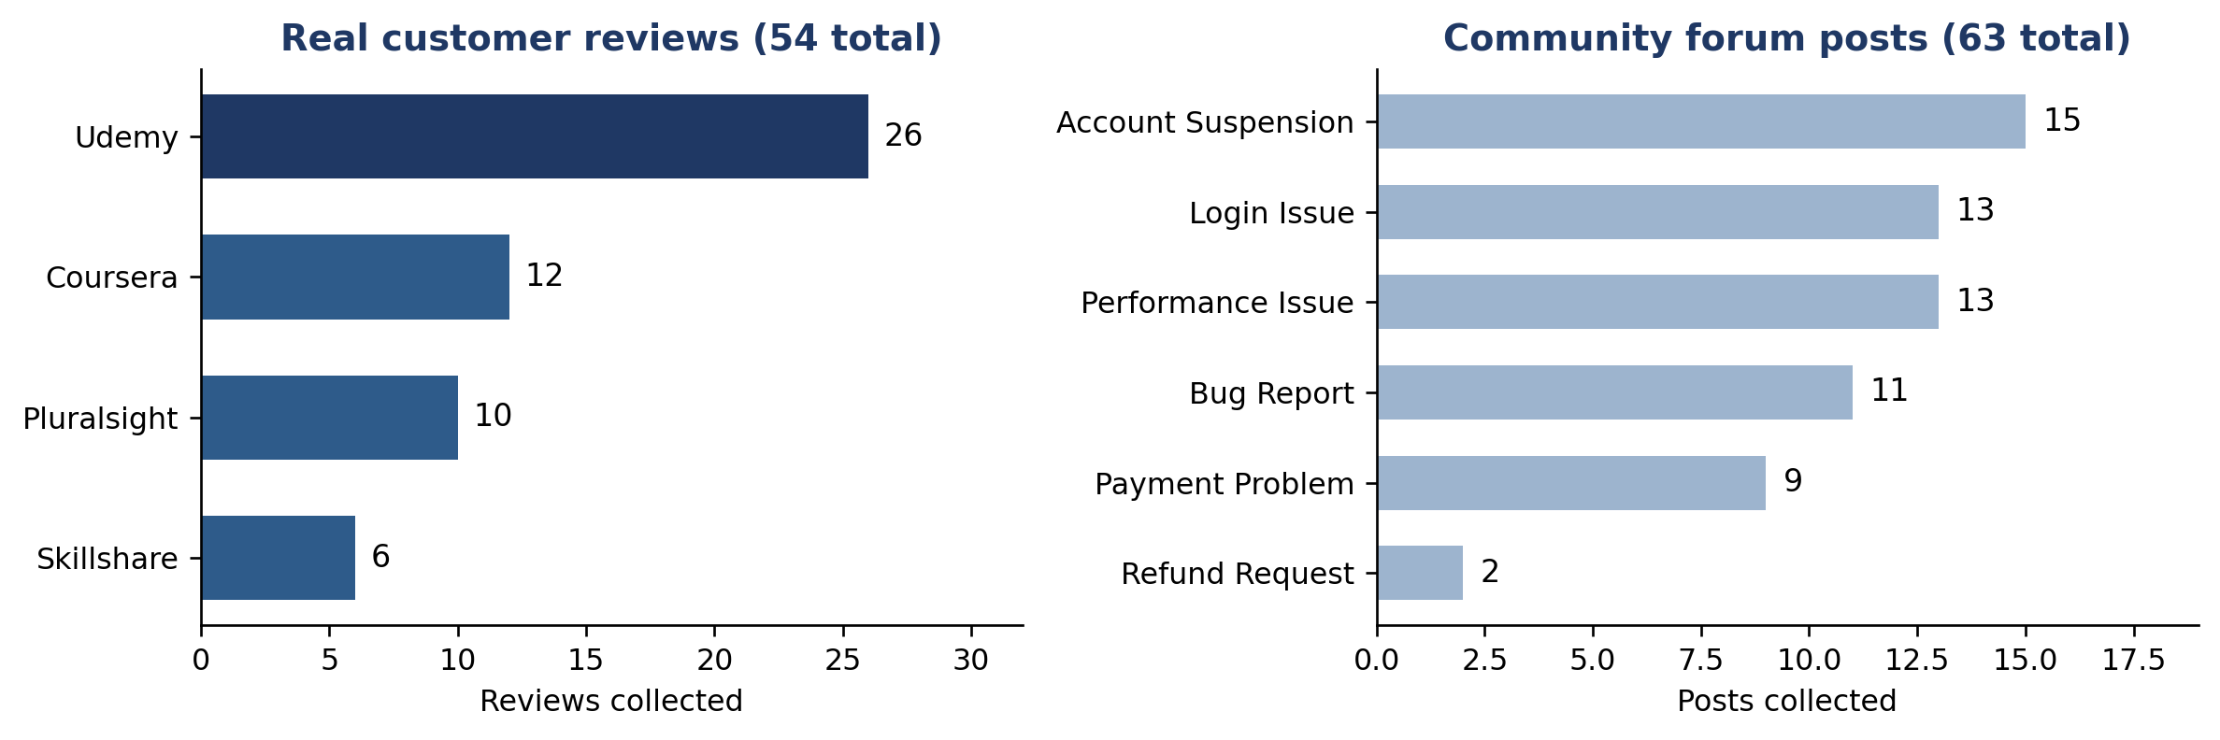
Figure A3: The real issue data we collected for KB ideas.

Appendix B: Track B, Routing and Escalation Accuracy
We measured whether a ticket reaches the right team, and whether a human reviews the tickets that need it.
Phase 1: what the 99 queries showed us
Vinma and Sineth agreed on the team for 95.0% of the flagged queries (kappa 0.922) and on escalation for 71.7% of all queries (kappa 0.430). Where they still disagreed on escalation, we left the query out of scoring, for routing as well: 71 of the 99 queries were scored.
Fixes and results
Stage | What we changed | 99-query set | 70 real tickets
Start | Nothing yet | Routing 63.4%. HR recall 36.8%. Escalation F1 51.9% | Not measured
Fix 1 | Added payment-linkage wording so HR tickets reach HR | Routing 74.6%. HR recall 78.9% | Not measured
Fix 2 | Removed the rule that escalated any negative-sounding ticket | Escalation F1 72.7%. Unnecessary escalations 32 to 7 | Not measured
Fixes 3 and 4 | Added real wording for generic classifier labels and for plain cancellations | Routing 76.1%. HR recall 78.9%. Escalation F1 74.1% | Routing 83.9%. HR recall 92.9%, which is 13 of 14 tickets (7 of 14 before fix 4). Escalation F1 66.7%

What the 70-ticket numbers count
Vinma and Sineth agreed on the team for 90.9% of the 11 unclear tickets (kappa 0.814) and on escalation for 80.0% of tickets (kappa 0.572). We scored the 56 tickets where they reached one answer, and left out the 14 where they still disagreed. So 83.9% routing accuracy is 47 of 56.
For escalation, 19 of the 56 tickets needed a human. Clario sent 13 of them (recall 68%) and missed 6. It also escalated 7 tickets that did not need it. A missed escalation is the costlier error, so this is the first place we will improve.
Checking the left-out tickets
The 14 left-out tickets are probably the harder ones. To check, we scored all 70 tickets against each annotator's labels in turn. We used the pipeline output from the Track C full run, which covers all 70 tickets.
Scoring choice | Tickets | Routing accuracy | Escalation F1
Agreed labels only (headline result, Track B run) | 56 | 83.9% | 66.7%
Agreed labels only (same tickets, Track C run) | 56 | 80.4% | 66.7%
All 70, annotator 1 labels | 70 | 75.7% | 0.62
All 70, annotator 2 labels | 70 | 75.7% | 0.60
The 14 left-out tickets only | 14 | 57.1% | 0.46 and 0.36

Including the left-out tickets lowers routing accuracy from 80.4% to 75.7% and escalation F1 from 0.67 to about 0.60 to 0.62, in the same run. The Track C run differs from the Track B run on 2 of the 56 routing decisions, which explains the gap between 83.9% and 80.4%. We keep both views in this report.
The classifier itself handled cancellations well (F1 1.00 on its test set), so the cancellation gap was in our routing rules, not in the model. On the real tickets the classifier often returned a generic label such as General Support, so the rules also read the ticket wording.
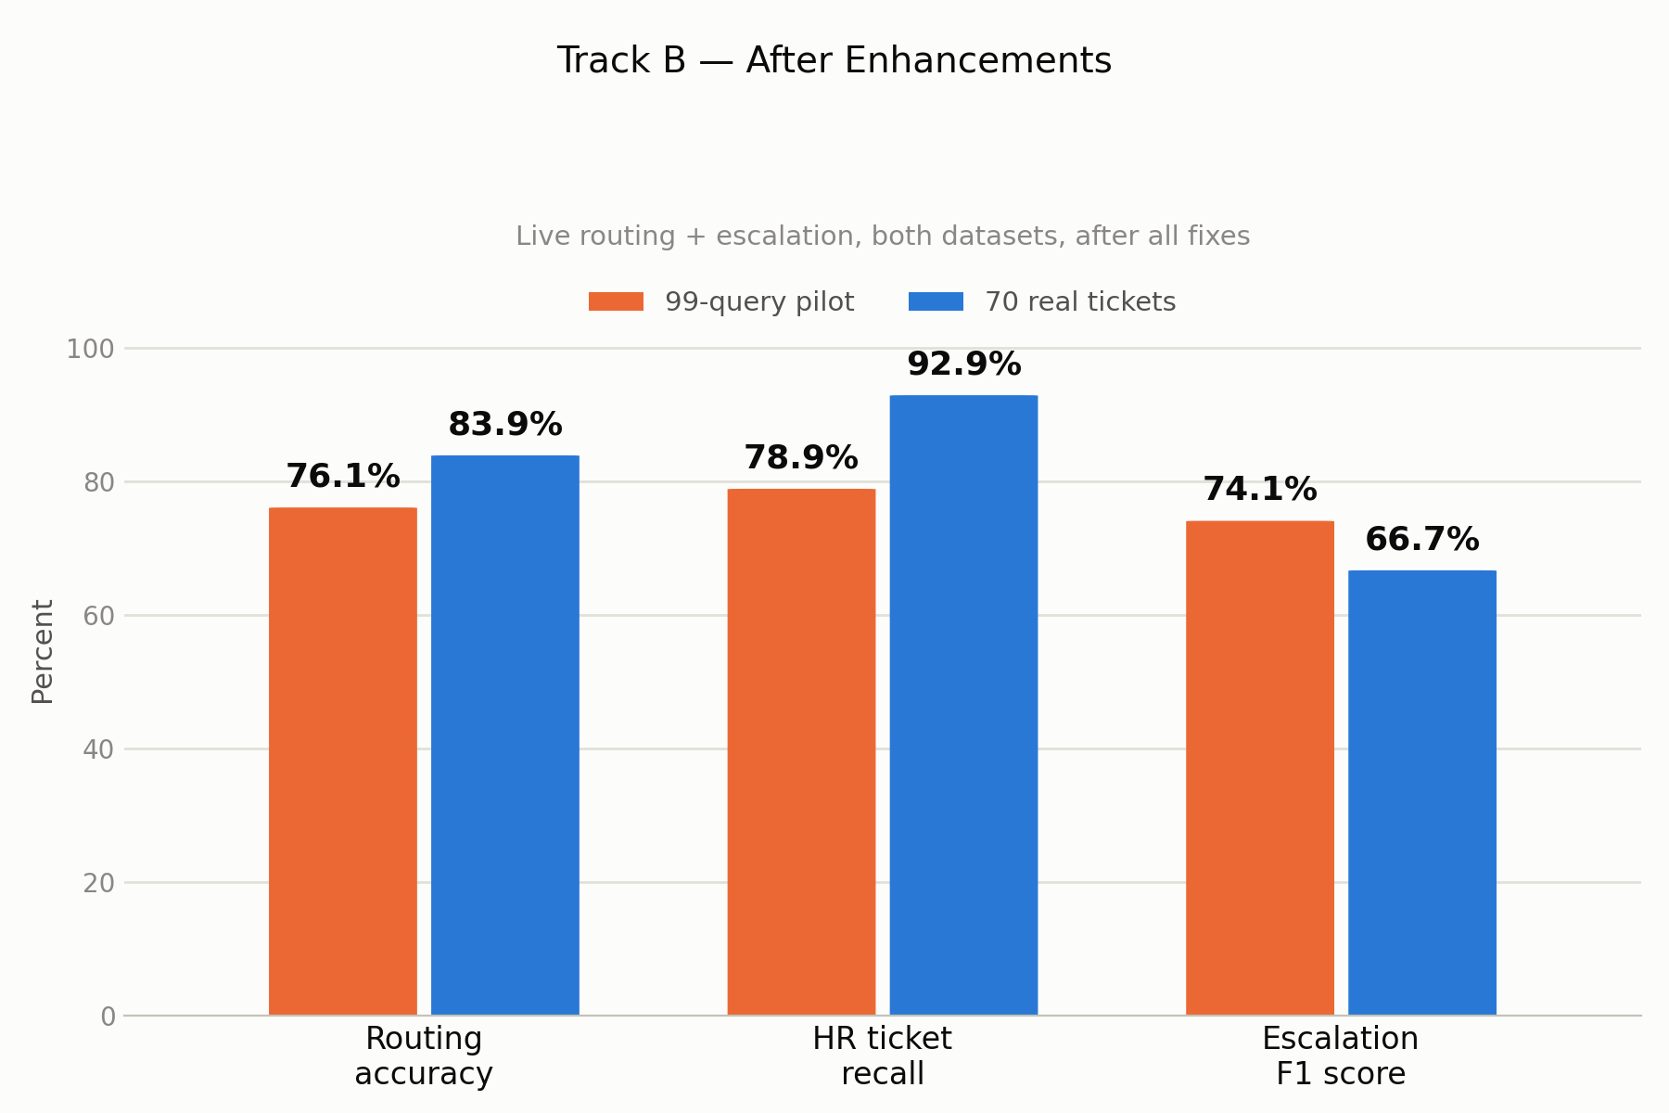
Figure B1: Routing and escalation accuracy after all fixes, on both sets.
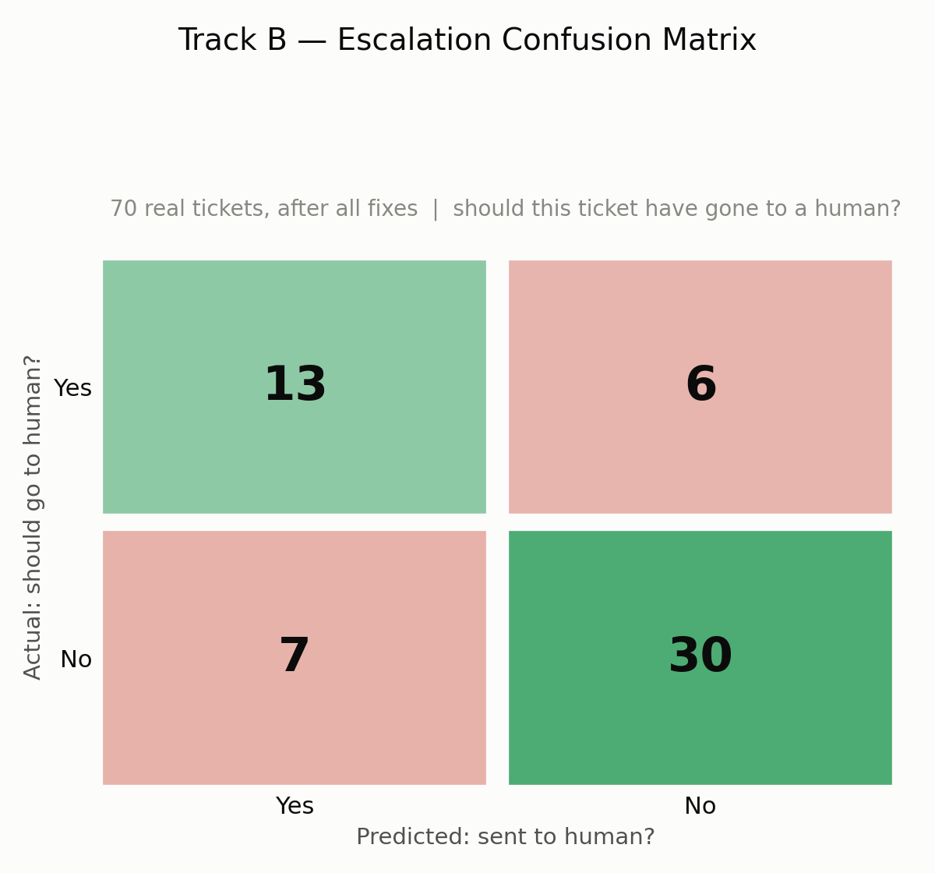
Figure B2: Escalation confusion matrix, 70 real tickets (56 scored).

Appendix C: Track C, Final Response Quality
We measured the reply a customer would receive: a 1 to 5 rubric score, a groundedness check against the KB, and a comparison with the real human reply.
Phase 1: what the 99 queries showed us
The full pipeline produced 90 usable drafts from 87 of the 99 queries. The other 12 queries were escalated to a human without a draft. Ranuga and Vinma read all 90 drafts. The clearest finding was that the drafting step never received the ticket's priority and sentiment, which the classifier had already worked out.
Fixes and results
Fix | What we changed | Result
1. Groundedness checker | Ignore greetings and filler sentences | Flagged sentences 37.9% to 26.3% (same pilot drafts)
2. Drafting prompt | Pass priority and sentiment to every specialist, narrow the HR no-promises rule, and add three rules: do not claim an action is done, do not guess a cause, answer the specific question | Measured together on the 70 tickets (table below). We did not re-run the 99 drafts.
3. Checker, three more rounds | Widen the filler filter for the new empathy and timeframe wording | Final check: 73 sentences counted, 14 flagged (19.2%). We read the 14 by hand and all were procedural filler, so the checker still under-credits

Domain | Drafts (n) before, after | Overall score (1 to 5) | Tone match (1 to 5) | Groundedness, same checker
Billing | 51, 24 | 2.82 to 4.50 | 2.22 to 4.75 | 81.0% to 80.0%
Technical | 21, 21 | 2.81 to 3.95 | 2.24 to 3.75 | 52.1% to 80.0%
HR | 18, 13 | 3.67 to 4.92 | 3.06 to 4.85 | 94.7% to 83.3%

Each cell shows the 99-query result first, then the 70-ticket result. These are different drafts, so the change shows direction and is not a like-for-like test. Tone match rose 2.1 times in billing, 1.7 times in technical, and 1.6 times in HR. Groundedness is the share of sentences supported by the KB. We widened the filler filter between the pilot and the final check, so the pilot figures in our earlier reports (77.0%, 59.2%, 86.4%) used an older checker. Here we ran the final checker on both sets. It counted 248 sentences in the pilot drafts (billing 137, technical 73, HR 38) and 73 in the final drafts (billing 30, technical 25, HR 18). With one checker, only technical clearly improved. Billing is flat, and HR fell from 94.7% to 83.3%. Billing and technical both land on exactly 80.0% because the groups are small (24 of 30 and 20 of 25 sentences). The hand read of the 14 flagged sentences found no invented facts, so these percentages are conservative.
Of the 70 tickets, 58 drafts (from 56 tickets) were scored. The other 14 tickets were escalated to a human without a draft. The judge that gives these scores is more generous than human raters (see Appendix D), so we read the 4.5 to 4.9 scores as upper estimates. The Track D drafts are a different set from these 58 (no draft text is identical), so Track D shows how the judge behaves on comparable drafts. It does not directly cover these scores. Reflection, the cache, and personal-data redaction were live when these drafts were made, so their effect is inside these numbers.
We also compared Clario with the real human reply on 55 tickets. An LLM judge (not a human) chose between the two replies, twice, with the order swapped. It picked the human reply in 42 cases (76%, both passes agreeing), called 7 a tie, and picked Clario in 6. The other 15 tickets were not compared because the daily API limit ran out. We use this as our benchmark for further gains.
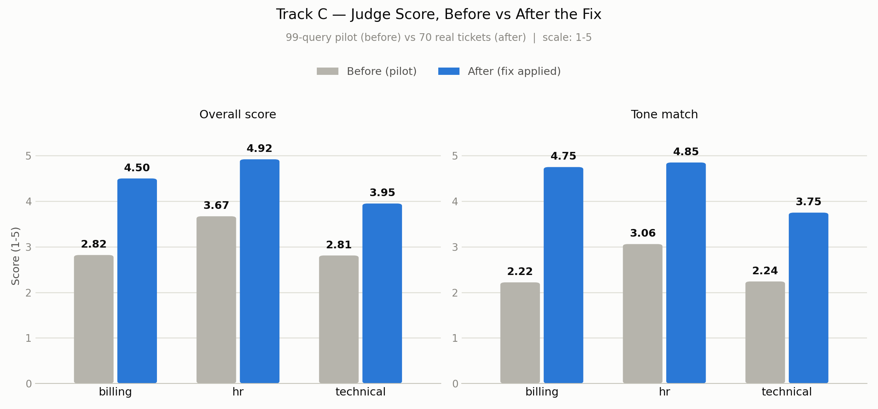
Figure C1: Judge quality score by domain, before and after the fixes.
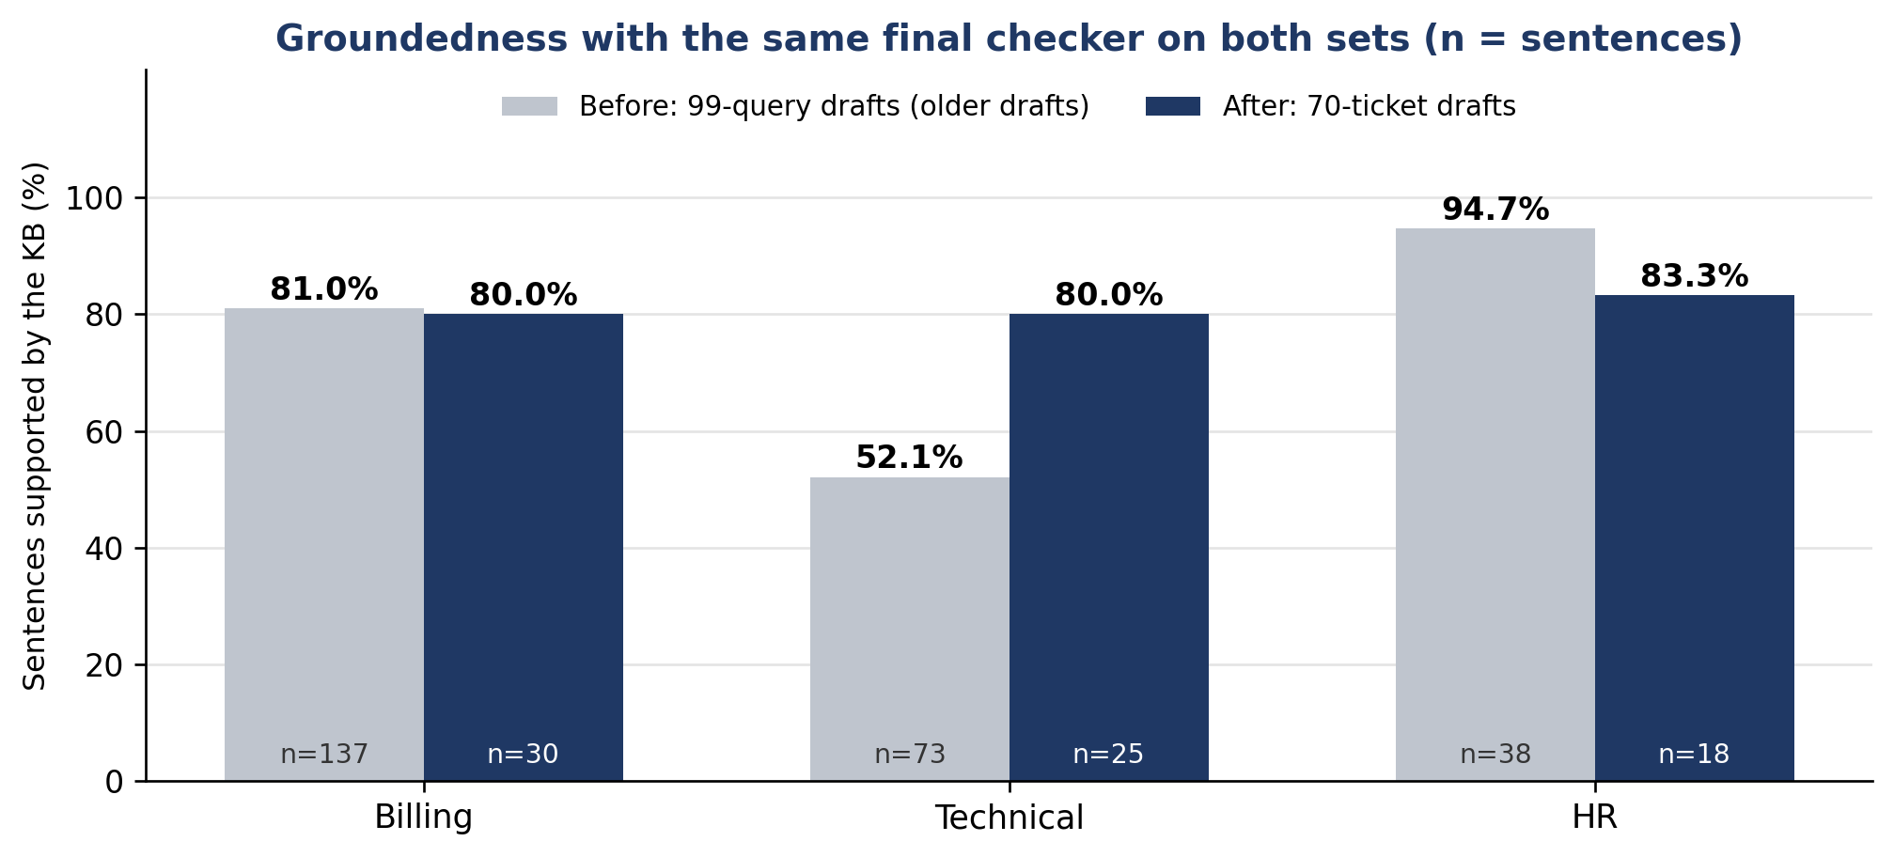
Figure C2: Groundedness by domain with the same final checker on both sets.

Appendix D: Track D, Judge Reliability
Before trusting the automated judge, we checked whether it agrees with real people. Ranuga and Sineth scored the drafts without seeing the judge's scores.
Phase 1: what the 99 queries showed us
Track D scored 99 drafts because it calls each specialist directly, so every query has a draft. Track C used the full pipeline, which escalated 12 queries without a draft (Appendix C). On the 99 drafts, almost every rater and the judge used only scores 3 and 4. This kept kappa low (0.075) even though the judge was within one point of the humans on 94.9% of scores.
Fixes and results
Fix | What we changed | Result
1. Rubric bug | Removed a rule that demanded literal phrases and pushed 96% of scores to 2 out of 5 | Healthy score spread on the pilot
2. Scoring anchors | Gave each of the six dimensions its own concrete 1 to 5 example, in the judge prompt and the human guide | Judge vs humans: kappa 0.075 to 0.339, Spearman 0.249 to 0.764 (different data: 99 drafts before, 70 tickets after)
3. Human recheck | The two raters rechecked the rows where their scores differed by 2 or more points | Human vs human kappa 0.153 to 0.368 (same 82 rows)

What the 82 rows are
The 70 real tickets give 82 rows because 12 tickets go to two domains and get one draft per domain (billing 31, technical 27, HR 24). Both humans scored all 82 rows. The two-domain tickets come from Track A's domain labels, so Track D drafts once per domain. Track B uses one routing label per ticket, so it does not score the second domain.
Comparison | Weighted kappa | Spearman correlation
Judge vs humans, 99 drafts, old rubric | 0.075 | 0.249
Judge vs humans, 82 rows from 70 tickets, new rubric | 0.339 | 0.764

A kappa of 0.339 is in the "fair" range, but the two humans reached only 0.368 with each other, so the judge is close to the human ceiling (0.029 below). On the 99 drafts the humans reached 0.080 and the judge 0.075. Humans gave a 4 for accuracy on 88% of rows, which squeezes kappa, and the judge's accuracy kappa is 0.060. Rank order agrees well (Spearman 0.764), but exact scores do not. The judge is more generous than the humans: it gave 5 for accuracy on 50% of rows (humans 4%) and 5 for groundedness on 48% (humans 21%). It never scored accuracy below 4. So we read the Track C judge scores as upper estimates.
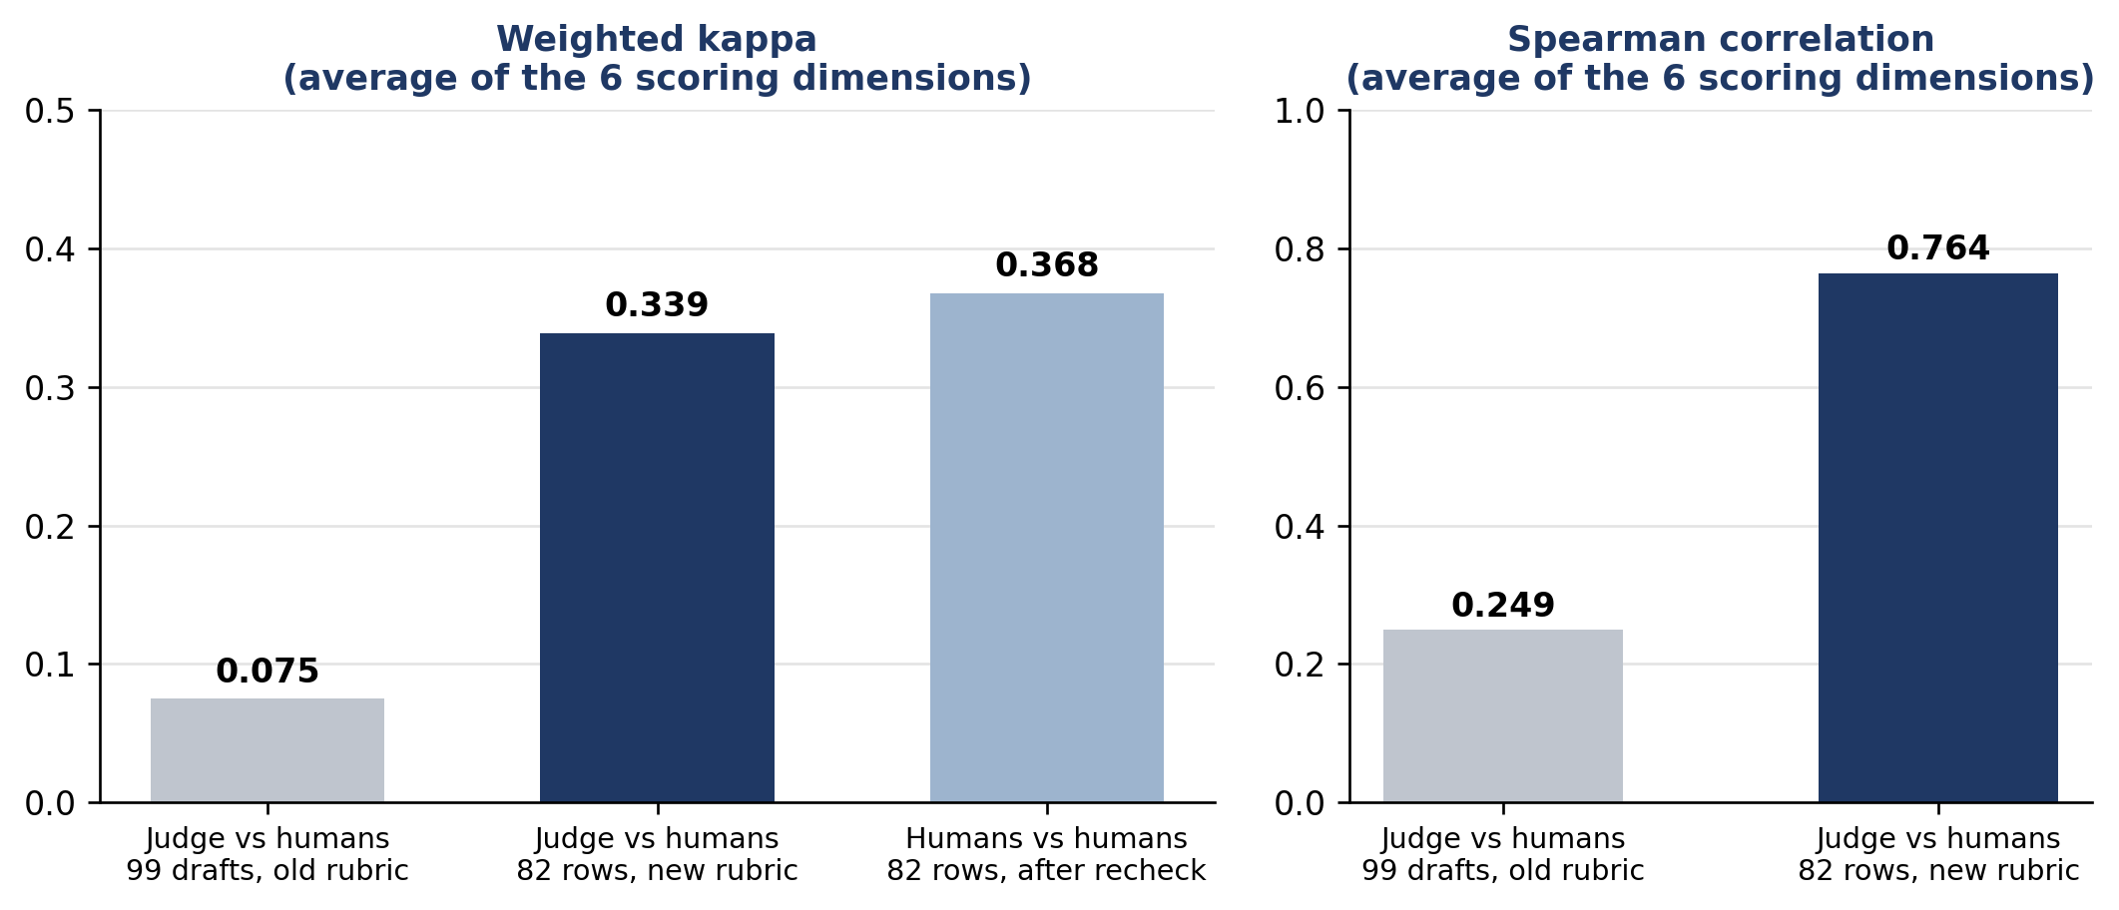
Figure D1: Judge-versus-human agreement and the human-versus-human ceiling. Each value is the average over the six scoring dimensions.
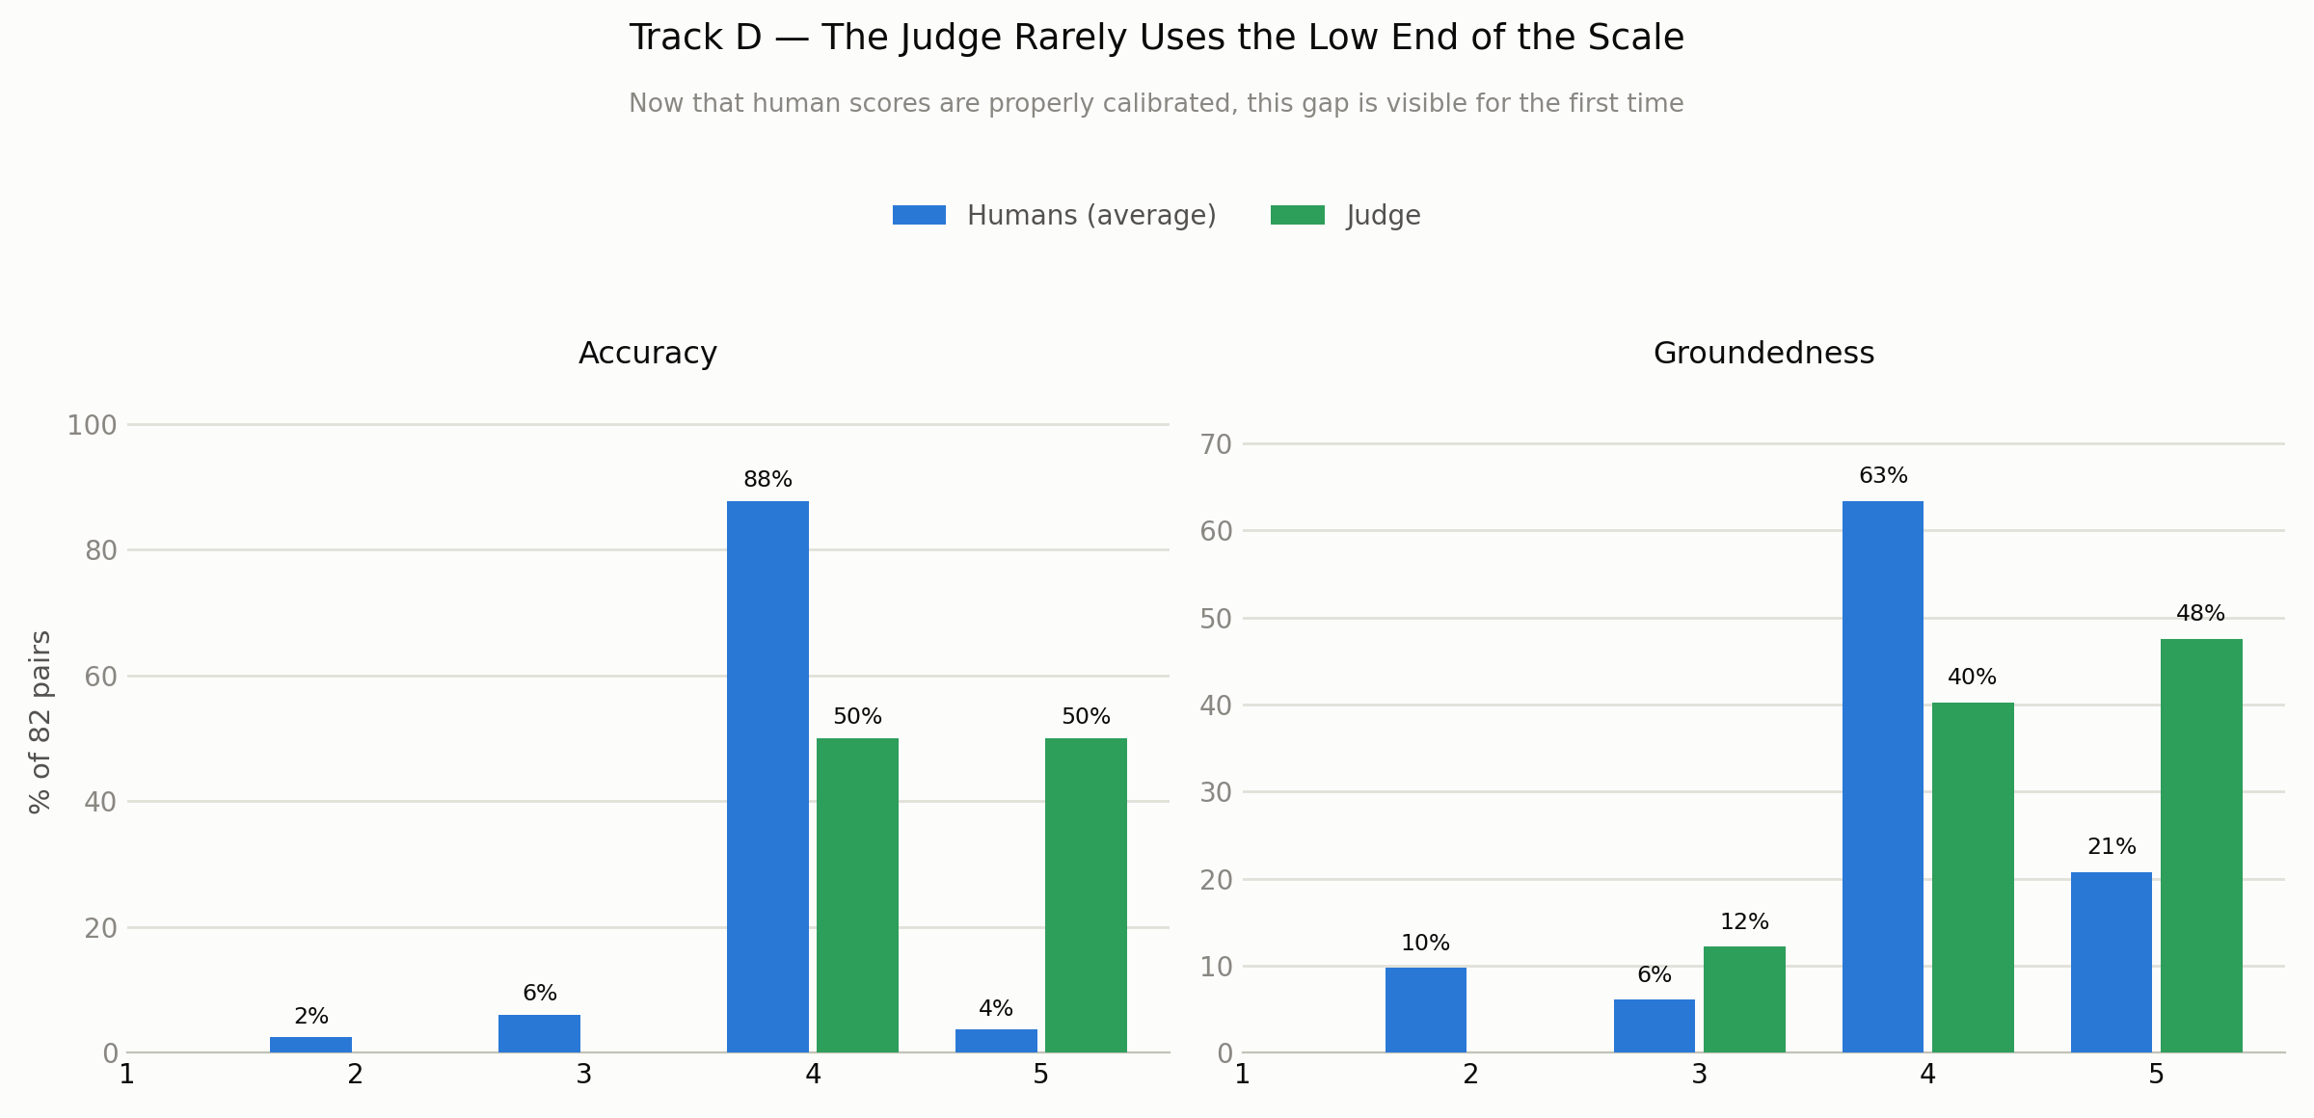
Figure D2: Score spread for accuracy and groundedness, judge and calibrated humans.

Appendix E: Local Llama Classifier Selection
The local classifier reads each ticket first and predicts its category, priority, and sentiment. We fine-tuned four language models on the same ticket data and trained one classic baseline (TF-IDF with a support vector classifier). We then compared all five on the same three tasks.
Model | Category | Priority | Sentiment
Fine-tuned Llama 3.2 (3B, 4-bit) | 96.5% | 77.05% | 77.6%
Fine-tuned Ministral-3 (3B) | 95.95% | 75.4% | 75.75%
Fine-tuned Gemma-3 (1B) | 95.8% | 75.65% | 76.05%
Fine-tuned Qwen2.5 (0.5B) | 95.65% | 75.2% | 62.3%
TF-IDF and SVM (classic ML) | 94.0% | 56.95% | 65.3%

Llama 3.2 came first on all three tasks. Its lead over Ministral-3 and Gemma-3 is 0.5 to 1.9 points. The workbook does not record the test-set size. Scores move in steps of 0.05 points, so the test set has at least 2,000 items. At 2,000 items the 95% interval is about plus or minus 0.8 points at 96.5% and plus or minus 1.8 points at 77%. The leads are inside that range, so we count them as ties. Per-item predictions would allow a paired test. The clear gaps are against the classic baseline on priority (about 20 points) and sentiment (about 12 points), and against Qwen2.5 on sentiment (about 15 points).
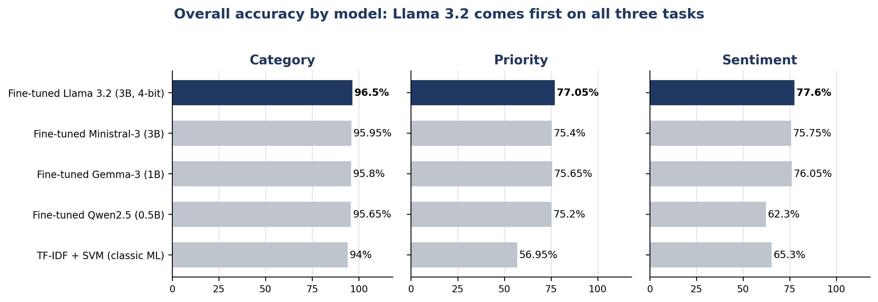
Figure E1: Overall accuracy of the five models on category, priority, and sentiment.
We chose Llama 3.2 (3B) because it ranked first on all three tasks. Gemma-3 (1B) is a close, smaller alternative. We fine-tuned Llama with QLoRA on a 4-bit (NF4) quantized base model with a LoRA adapter (rank 16), so it runs on a single local GPU. Its priority and sentiment predictions also flow into the reply-drafting step, which helped lift tone match in Track C.
These results come from the fine-tuning test set, not the 70 real tickets. On real tickets the classifier often gives a generic label (Track B), so our routing rules also read the ticket wording.

