Clario AI Support Pipeline
Data Science Evaluation — Test Plan
Version 1.1
Prepared by the DSE Team: Ranuga, Vinma, Sineth

Revision History
Date | Version | Description | Author
18/Sep/26 | 1.0 | Initial Data Science Evaluation test plan, covering Tracks A-E | DSE Team
19/Sep/26 | 1.1 | Added the two-phase method, data sources, and the local Llama classifier results | DSE Team

Table of Contents
1. Evaluation Mission and Test Motivation | 4
2. Target Test Items | 5
2.1 Test Data | 6
3. Test Approach | 6
3.1 Testing Techniques and Types | 7
3.1.1 Data and Knowledge Base Integrity Testing (Track A) | 7
3.1.2 Function Testing: Routing and Escalation (Track B) | 7
3.1.3 Response Quality Testing (Track C) | 8
3.1.4 Judge Reliability Testing (Track D) | 8
3.1.5 End-to-End Behaviour Testing (Track E) | 8
3.1.6 Model Selection Testing: Local Llama Classifier | 9
4. Deliverables | 9
5. Risks, Dependencies, Assumptions, and Constraints | 10
6. References | 10
Appendix: Results by Phase | 12
Appendix A: Track A, Retrieval Quality | 12
Appendix B: Track B, Routing and Escalation Accuracy | 13
Appendix C: Track C, Final Response Quality | 15
Appendix D: Track D, Judge Reliability | 16
Appendix E: Track E, End-to-End Behaviour | 18
Appendix F: Local Llama Classifier Selection | 19

1. Evaluation Mission and Test Motivation
Clario is an AI support assistant for an online learning platform. When a customer sends a support ticket, Clario reads it, searches the knowledge base (KB), sends the ticket to the right team (technical, billing, or HR), drafts a reply, checks its own draft, and decides when a human must step in before anything is sent.
Before using Clario on real customer tickets, we wanted to know how well every step works, using real ticket data. This document is our plan for that evaluation, together with the results we achieved.

Mission
Measure every stage of the Clario pipeline (retrieval, routing, response drafting, automated judging, and the pipeline as a whole), fix the issues we find, and confirm every fix with real data.

Background
A local fine-tuned Llama 3.2 model first reads each ticket and predicts its category, priority, and sentiment. Clario then finds the right KB documents, routes the ticket to a specialist, drafts a reply, validates it (with a self-correction step called reflection when needed), scores it with an automated judge, and decides on escalation.
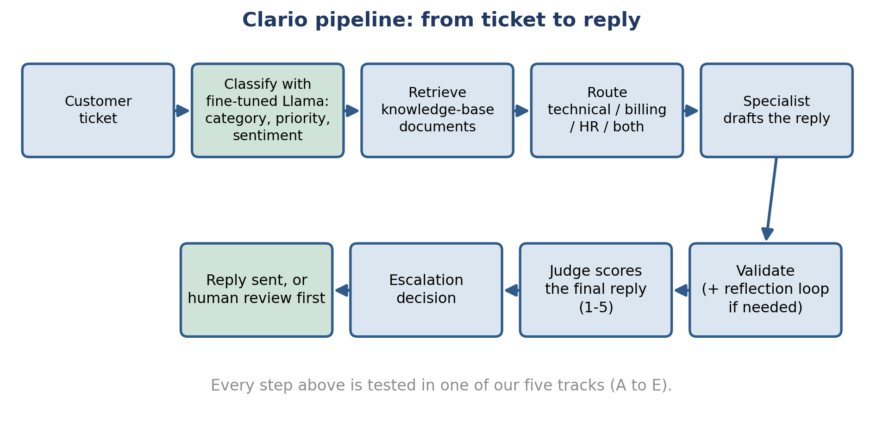
Figure 1: The Clario pipeline, from ticket to reply.

How we ran the evaluation
We ran every track in two phases:
- Phase 1, the 99-query set: two team members annotated the same 99 queries by hand. This showed us the failures, wrong routings, and wrong settings in the pipeline.
- Fix: we fixed the issues one at a time and checked the metrics after each fix.
- Phase 2, the 70 real tickets: we ran the real, live pipeline on 70 real support tickets to test how it behaves after each improvement.
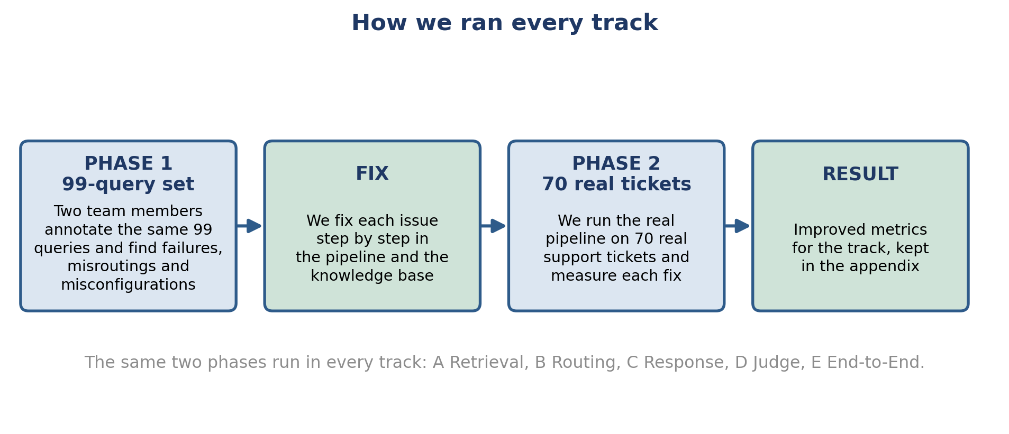
Figure 2: The two-phase method we used in every track.

2. Target Test Items
The table lists the parts of the Clario pipeline covered by this evaluation.
Test Item | Category | Description
Local ticket classifier | Core pipeline | Fine-tuned Llama 3.2 (4-bit) predicts category, priority, and sentiment
Knowledge-base retrieval | Core pipeline | Vector search that finds the right document for a ticket
Routing and classification | Core pipeline | Decides which team (technical, billing, HR) handles a ticket
Escalation logic | Core pipeline | Decides when a ticket needs a human before a reply goes out
Specialist response agents | Core pipeline | Draft the reply for each domain (technical, billing, HR)
Reflection / self-correction | Core pipeline | Reviews and revises a draft that does not meet quality checks
Automated response judge | Supporting component | LLM-based scoring of every final reply
Knowledge-base documents | Supporting content | Markdown documents behind every retrieval result
Vector store and embeddings | Supporting infrastructure | ChromaDB store with sentence-transformer embeddings
Pipeline orchestration | Supporting infrastructure | LangGraph graph that connects every step above

2.1 Test Data
Dataset | Size | How we used it
99-query set | 99 queries | Phase 1. Annotated by hand to find failures, wrong routings, and wrong settings.
Real support tickets | 70 tickets | Phase 2. Real pipeline runs to test each improvement.
Real customer reviews | 54 reviews | Trustpilot reviews of Udemy (26), Coursera (12), Pluralsight (10), and Skillshare (6). Real customer wording for KB documents.
Community forum posts | 63 posts | Extra real issues from the Open edX community forum, reviewed for KB ideas.
Model comparison results | 5 models, 3 tasks | Category, priority, and sentiment results used to choose the local classifier.

3. Test Approach
We organised the evaluation into five tracks, one for each stage of the pipeline in Section 2, plus one model-selection study for the local classifier. Every track follows the same steps: annotate the 99-query set to find issues (Phase 1), fix each issue and check the metric, then run the real pipeline on the 70 real tickets to confirm the improvement (Phase 2).
The table shows who annotated or scored in each phase.
Track | Phase 1: 99-query set | Phase 2: 70 real tickets
A: Retrieval | Team-labelled correct KB document for each query | Ranuga and Sineth, independently
B: Routing and escalation | Vinma and Sineth, independently | Vinma and Sineth, independently
C: Response quality | Ranuga and Vinma read all 90 drafts | Scored automatically against real human replies
D: Judge reliability | Ranuga and Sineth scored every draft, blind to the judge | Ranuga and Sineth scored 82 rows, blind to the judge
E: End-to-end | Uses the findings from Tracks A to D | Ranuga ran the live pipeline on all 70 tickets

3.1 Testing Techniques and Types

3.1.1 Data and Knowledge Base Integrity Testing (Track A: Retrieval Quality)
Technique Objective: Confirm the system retrieves the correct KB document for a customer ticket.
Technique: Phase 1: run the 99 labelled queries through retrieval and score them with Precision@k, Recall@k, MRR, and nDCG. Phase 2: two annotators label 70 real tickets, and we check retrieval on them after our fixes.
Oracles: The team's correct-document labels for the 99 queries, and the two annotators' labels for the 70 tickets (they overlapped on 85.7% of tickets before any discussion).
Required Tools:
- ChromaDB vector store
- Sentence-transformers model (all-MiniLM-L6-v2)
- Python precision, recall, MRR, and nDCG scripts
- Real customer reviews and forum posts as a source of KB wording
Success Criteria: The correct document is the top result most of the time, and is in the top 4 results almost every time, on both datasets.
Special Considerations:
- The KB grows from real data. We re-check retrieval every time documents are added or changed.

3.1.2 Function Testing (Track B: Routing and Escalation Accuracy)
Technique Objective: Confirm each ticket goes to the correct team, and that a human reviews the tickets that need it.
Technique: Phase 1: two annotators (Vinma and Sineth) label the 99 queries for team and escalation, and we compare the live routing rules to their answers. Phase 2: the same two annotators label the 70 real tickets and we test the fixed rules.
Oracles: Answers agreed by two independent reviewers. Cohen's kappa shows how well they agree.
Required Tools:
- The live routing and classification code
- Cohen's kappa calculator
- Confusion-matrix scripts
Success Criteria: Routing accuracy and escalation results improve after each fix, and hold on the 70 real tickets.
Special Considerations:
- Escalation includes real judgment calls. We record reviewer disagreements openly.

3.1.3 Response Quality Testing (Track C: Final Response Quality)
Technique Objective: Confirm the reply Clario writes is accurate, grounded in the KB, and matches the tone the ticket needs.
Technique: Phase 1: two annotators (Ranuga and Vinma) read all 90 drafts made from the 99-query set and flag problems. Phase 2: we score the drafts for the 70 real tickets on a 1 to 5 rubric, check groundedness against the retrieved KB content, and compare them with the real human reply.
Oracles: The annotators' notes in Phase 1, and the real human agent replies in Phase 2.
Required Tools:
- ResponseJudge scoring tool
- Groundedness checker
- Semantic similarity scorer
Success Criteria: Reply quality scores improve after each fix, on the same drafts and on the 70 real tickets.
Special Considerations:
- The head-to-head comparison with a real human reply is a stricter benchmark. We track it separately.

3.1.4 Judge Reliability Testing (Track D: Judge Reliability)
Technique Objective: Confirm the automated judge agrees with what a real person would say about the same reply.
Technique: Phase 1: two annotators (Ranuga and Sineth) score the 99 drafts without seeing the judge's scores. Phase 2: the same two score 82 rows from the 70 real tickets under the improved rubric. We measure agreement with weighted Cohen's kappa and Spearman correlation.
Oracles: Two independent human raters, blind to the judge.
Required Tools:
- Weighted kappa and Spearman calculators
- Human scoring guide, worded the same as the judge's rubric
Success Criteria: Judge-versus-human agreement improves after the rubric fix, confirmed on the 70 real tickets.
Special Considerations:
- We check how widely raters use the 1 to 5 scale before reading a kappa number.

3.1.5 End-to-End Behaviour Testing (Track E: End-to-End Behaviour)
Technique Objective: Confirm the full pipeline works well end to end, and that the reflection step improves replies.
Technique: Phase 1: we use the failures found in Tracks A to D. Phase 2: we run all 70 real tickets through the live pipeline, capture how often each step fires, and record a before and after judge score for every ticket that goes through reflection. We fix one issue at a time and re-run the 70 tickets after each fix.
Oracles: A paired before and after comparison from the same judge. Wilson intervals for rates. The Wilcoxon signed-rank test for the paired scores.
Required Tools:
- Live pipeline trace scripts
- scipy.stats (Wilcoxon signed-rank test)
- Wilson score interval calculator
Success Criteria: Reflection never lowers reply quality, and each fix improves the 70-ticket metrics.
Special Considerations:
- The pipeline uses a shared external API with daily limits. We pace live runs and check them before trusting results.

3.1.6 Model Selection Testing: Local Llama Classifier
Technique Objective: Choose the local model that reads each ticket first and predicts its category, priority, and sentiment.
Technique: We fine-tuned four language models (Llama 3.2 3B, Ministral-3 3B, Gemma-3 1B, Qwen2.5 0.5B) and trained one classic machine-learning baseline (TF-IDF with a support vector classifier). We compared them on the same three tasks.
Oracles: Labelled ticket data, scored with precision, recall, F1, and overall accuracy.
Required Tools:
- QLoRA fine-tuning with 4-bit (NF4) quantization
- scikit-learn classification reports
Success Criteria: The chosen model has the best overall accuracy on category, priority, and sentiment, and runs on a local GPU.
Special Considerations:
- The chosen model's priority and sentiment output also feeds the reply-drafting step (see Appendix C).

4. Deliverables

4.1 Test Evaluation Summaries
For each track we write a short conclusion and a full final report. Each has the headline metrics, the key diagrams, the issues found, the fixes made, and the result after each fix. The results of every track are collected in the Appendix of this document.

4.2 Reporting on Test Coverage
We report coverage as the number of queries and tickets used in each phase. Phase 1 used the 99-query set, annotated by two team members. Phase 2 used the 70 real support tickets to test the real pipeline after each improvement. Results are saved as CSV and JSON files next to each track's report.

5. Risks, Dependencies, Assumptions, and Constraints
Risk | Mitigation Strategy | Contingency
The shared daily API quota is limited (Gemini free tier). | Pace requests, run a small check before a full live run, and monitor usage. | Exclude data collected during a quota interruption and re-run after the quota resets.
Language-model output varies slightly from run to run. | Report results with confidence intervals (Wilson) and significance tests (Wilcoxon). | Re-run the affected check and report the observed range.
Test sets are moderate in size (70 to 99 items). | Find issues on the 99-query set, then confirm each fix with a live run on the 70 real tickets. | Treat a result seen on one set only as preliminary.
KB content needs to stay current. | Keep collecting real customer wording from review sites and forums, and refresh KB documents. | Add the missing content and re-check retrieval before the next round.
The local classifier needs a GPU. | The 4-bit quantized Llama model fits a single local GPU. | Run classification on a GPU machine, and check GPU access before each full run.

6. References
- Google Gemini API (gemini-3.1-flash-lite and related models): https://ai.google.dev (Accessed 2026).
- ChromaDB vector database: https://www.trychroma.com (Accessed 2026).
- Sentence-Transformers, all-MiniLM-L6-v2 model: https://www.sbert.net (Accessed 2026).
- LangGraph orchestration framework: https://www.langchain.com/langgraph (Accessed 2026).
- SciPy statistics library, used for the Wilcoxon signed-rank test: https://scipy.org (Accessed 2026).
- Meta Llama 3.2 models: https://www.llama.com (Accessed 2026).
- Dettmers, T., et al. (2023). QLoRA: Efficient Finetuning of Quantized LLMs.
- Hu, E., et al. (2021). LoRA: Low-Rank Adaptation of Large Language Models.
- Trustpilot public review pages for Udemy, Coursera, Skillshare, and Pluralsight (Accessed 2026).
- Open edX community forum: https://discuss.openedx.org (Accessed 2026).
- Wilson, E.B. (1927). Probable Inference, the Law of Succession, and Statistical Inference. Journal of the American Statistical Association.
- Wilcoxon, F. (1945). Individual Comparisons by Ranking Methods. Biometrics Bulletin.
- Cohen, J. (1960). A Coefficient of Agreement for Nominal Scales. Educational and Psychological Measurement.

Appendix: Results by Phase
This appendix shows what we found in each track. In every track, two team members first annotated the 99-query set (Phase 1) to find failures, wrong routings, and wrong settings. We then fixed each issue and checked the metric after each fix. Finally, we ran the real pipeline on the 70 real tickets (Phase 2) to test the improvements.

Appendix A: Track A, Retrieval Quality
We measured whether Clario finds the right KB document for a ticket. Precision@1 asks if the top result is correct. Recall@4 asks if the correct document is in the top 4 results.

Phase 1: what the 99 queries showed us
Annotating the 99 queries showed four things to improve: old content in the search index, a confidence gate that accepted every match, KB wording that differed from real customers, and 40 queries with no matching KB document. Recall@4 was 70.3% in the first test and rose to 86.4% on the same 99 queries after our fixes.

Phase 2: the 70 real tickets
Metric | 99 queries, after fixes | 70 real tickets, after fixes
Precision@1 | 64.4% | 71.4%
Recall@4 | 86.4% | 89.0%
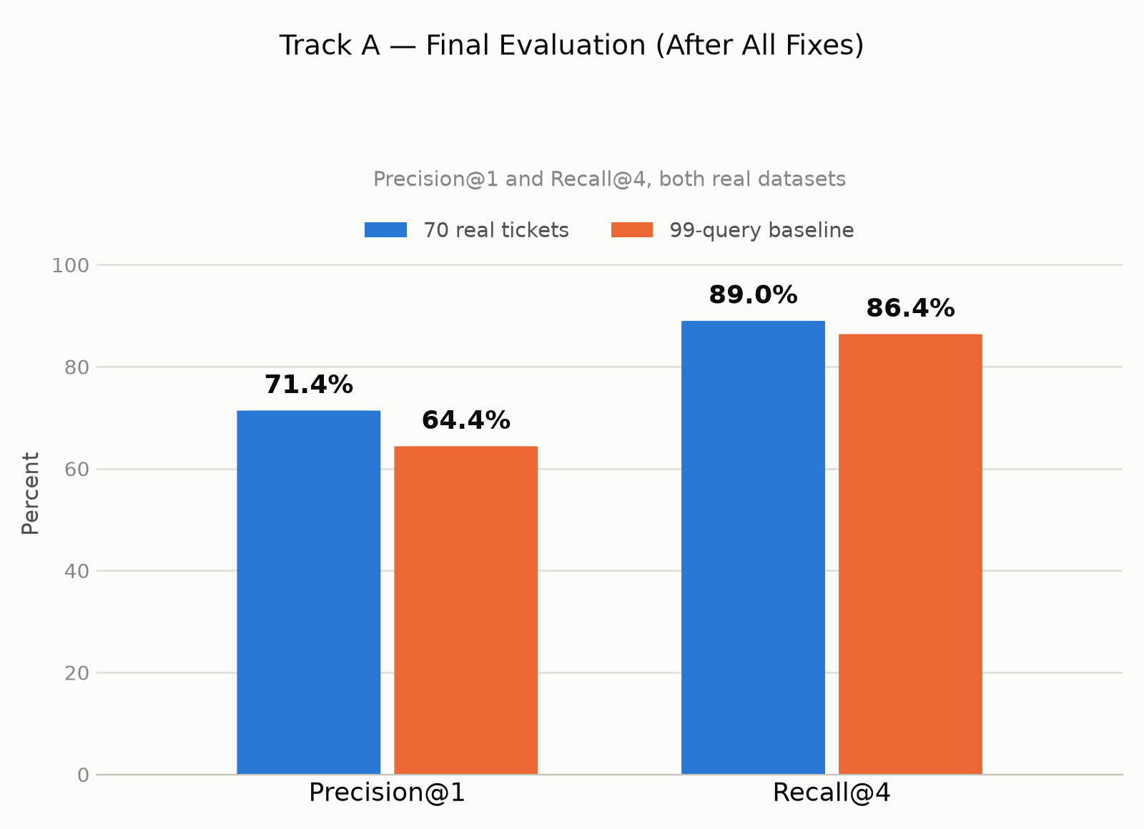
Figure A1: Final retrieval results on the 70 real tickets and the 99-query set.
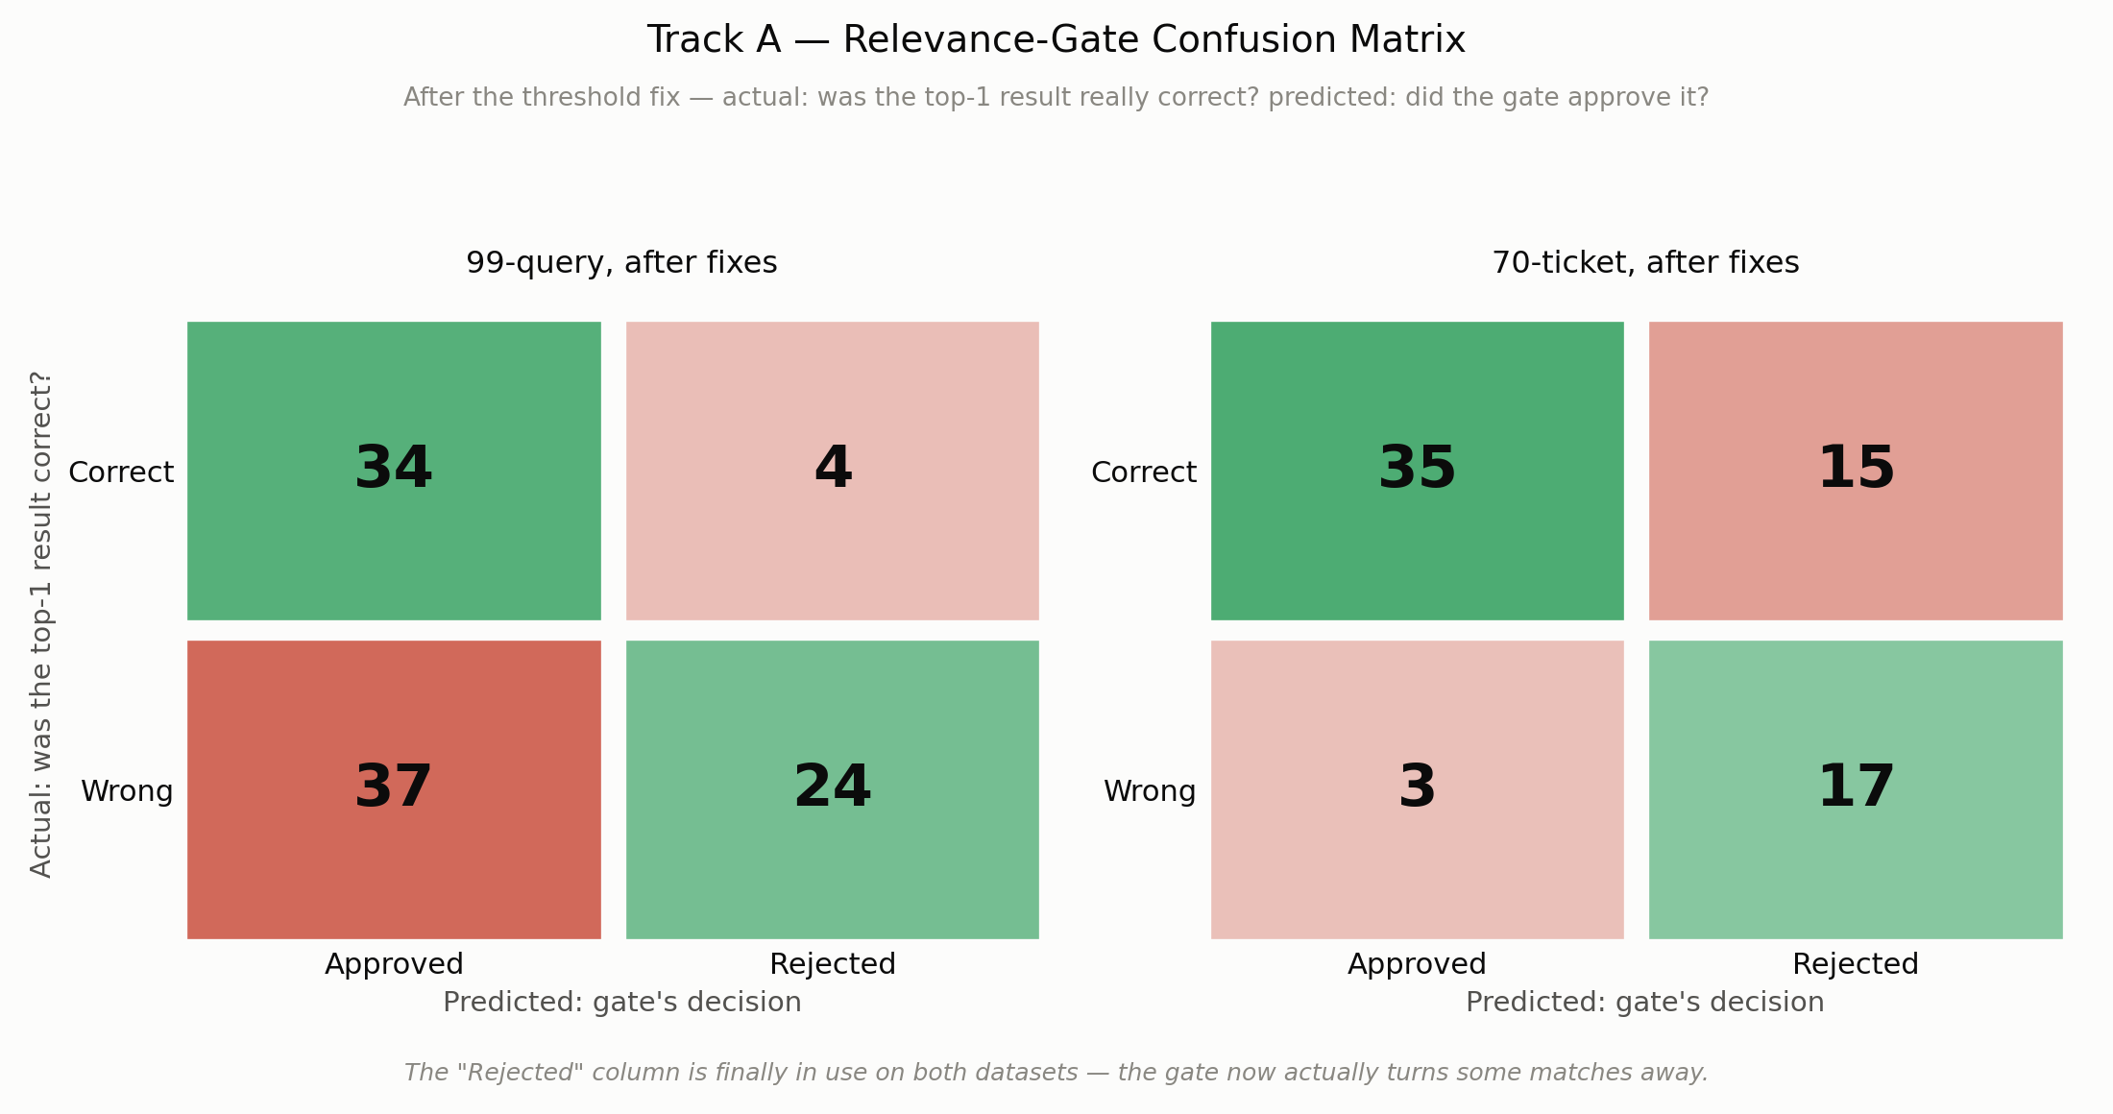
Figure A2: Relevance-gate confusion matrix after the fix, on both datasets.

Real data for KB wording
We collected 54 real customer reviews from Trustpilot pages of Udemy (26), Coursera (12), Pluralsight (10), and Skillshare (6). We also collected 63 real issue posts from the Open edX community forum. The customer reviews gave us natural wording for refunds, cancellations, logins, and app problems, and we added phrases from them to six KB documents. We also wrote new KB documents for the gaps the 99-query annotation found (see Appendix E).
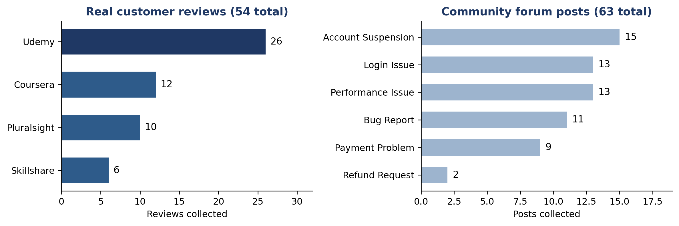
Figure A3: The real issue data we collected for KB ideas.

Appendix B: Track B, Routing and Escalation Accuracy
We measured whether a ticket reaches the right team, and whether a human reviews the tickets that need it.

Phase 1: what the 99 queries showed us
Vinma and Sineth agreed on the team for 95.0% of the flagged queries (kappa 0.922). We found and fixed four issues: HR tickets going to billing, escalations triggered only by a negative tone, a generic classifier label with no routing signal, and plain cancellation requests not being recognised.

Phase 2: the 70 real tickets
Metric | 99 queries, before fixes | 99 queries, after fixes | 70 real tickets, after fixes
Routing accuracy | 63.4% | 76.1% | 83.9%
HR ticket recall | 36.8% | 78.9% | 92.9%
Escalation F1 score | 51.9% | 74.1% | 66.7%
On the 70 real tickets, the two annotators agreed on the team for 90.9% of unclear tickets (kappa 0.814). HR recall on real tickets rose from 50% to 92.9% after the cancellation-wording fix.
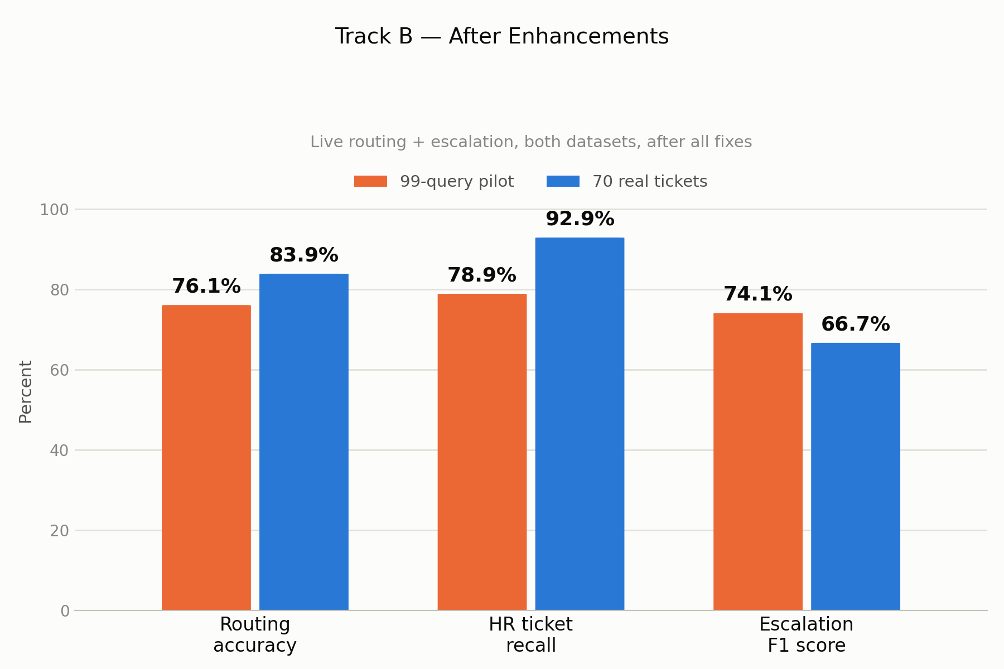
Figure B1: Routing and escalation accuracy after all fixes.
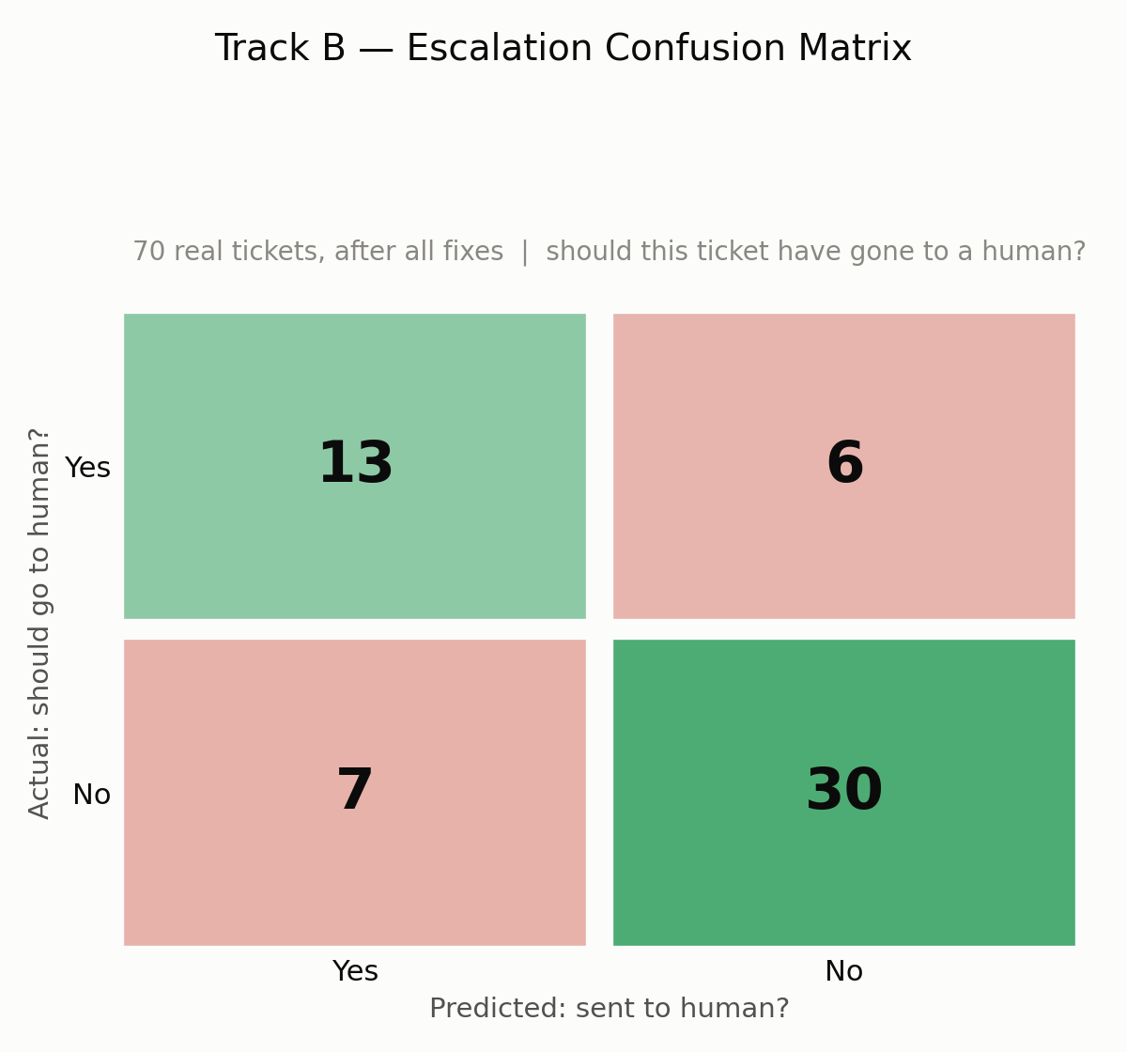
Figure B2: Escalation confusion matrix, 70 real tickets.

Appendix C: Track C, Final Response Quality
We measured the reply a customer would receive: a 1 to 5 rubric score, a groundedness check against the KB, and a comparison with the real human reply.

Phase 1: what the 99 queries showed us
Ranuga and Vinma read all 90 drafts. The clearest finding was that the drafting step never received the ticket's priority and sentiment, which the classifier had already worked out. We passed both into every specialist's prompt and added three drafting rules from real patterns we saw: do not claim an action is done, do not guess a cause, and answer the specific question.

Phase 2: the 70 real tickets
Domain | Overall score (1 to 5) | Tone match (1 to 5) | Groundedness
Billing | 2.82 to 4.50 | 2.22 to 4.75 | 77.0% to 80.0%
Technical | 2.81 to 3.95 | 2.24 to 3.75 | 59.2% to 80.0%
HR | 3.67 to 4.92 | 3.06 to 4.85 | 86.4% to 83.3%
Each cell shows the 99-query result first and the 70-ticket result after our fixes. Tone match roughly doubled in billing and technical. In a head-to-head check against real human agent replies, the human reply was preferred 76% of the time. We use this as our benchmark for further gains.
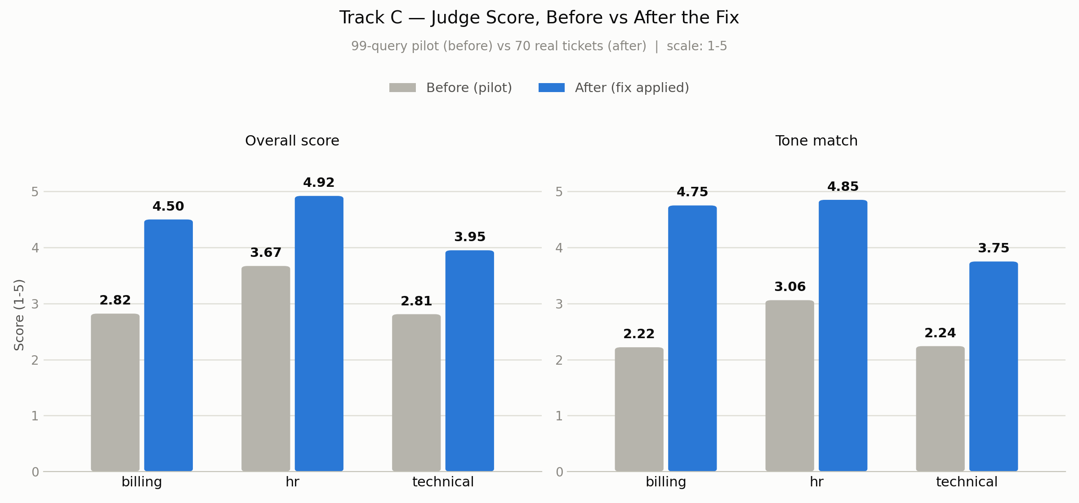
Figure C1: Judge quality score by domain, before and after the tone and priority fix.
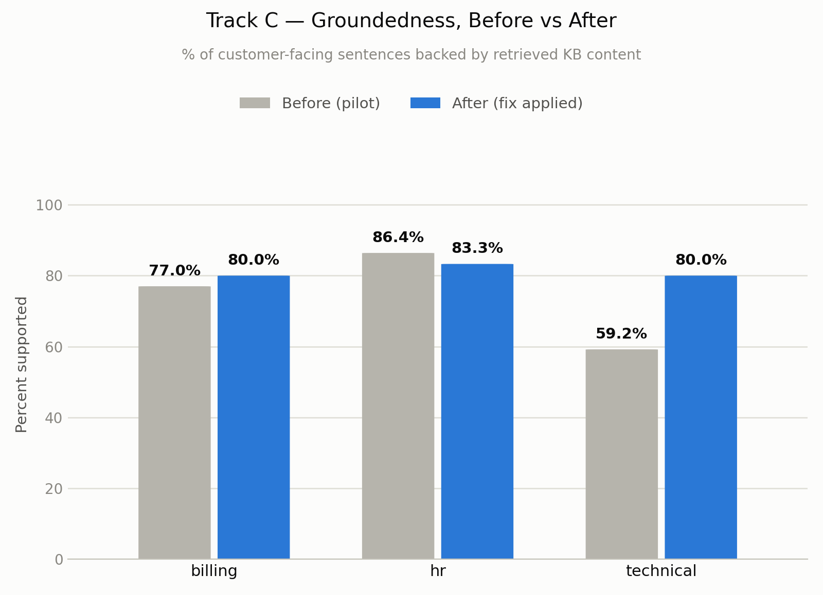
Figure C2: Groundedness by domain, before and after.

Appendix D: Track D, Judge Reliability
Before trusting the automated judge, we checked whether it agrees with real people. Ranuga and Sineth scored the drafts without seeing the judge's scores.

Phase 1: what the 99 queries showed us
On the 99 drafts, almost every rater and the judge used only scores 3 and 4. This kept kappa low (0.075) even though raw agreement within one point was 94.9%. We gave each of the six scoring dimensions its own concrete 1 to 5 example, in both the judge's prompt and the human guide.

Phase 2: the 70 real tickets
Comparison | Weighted kappa | Spearman correlation
Judge vs humans, 99-query drafts, old rubric | 0.075 | 0.249
Judge vs humans, 70 real tickets, new rubric | 0.339 | 0.764
Judge-versus-human agreement more than quadrupled, and rank correlation tripled. After the two raters rechecked the rows where they differed most, human-versus-human kappa rose from 0.153 to 0.368.
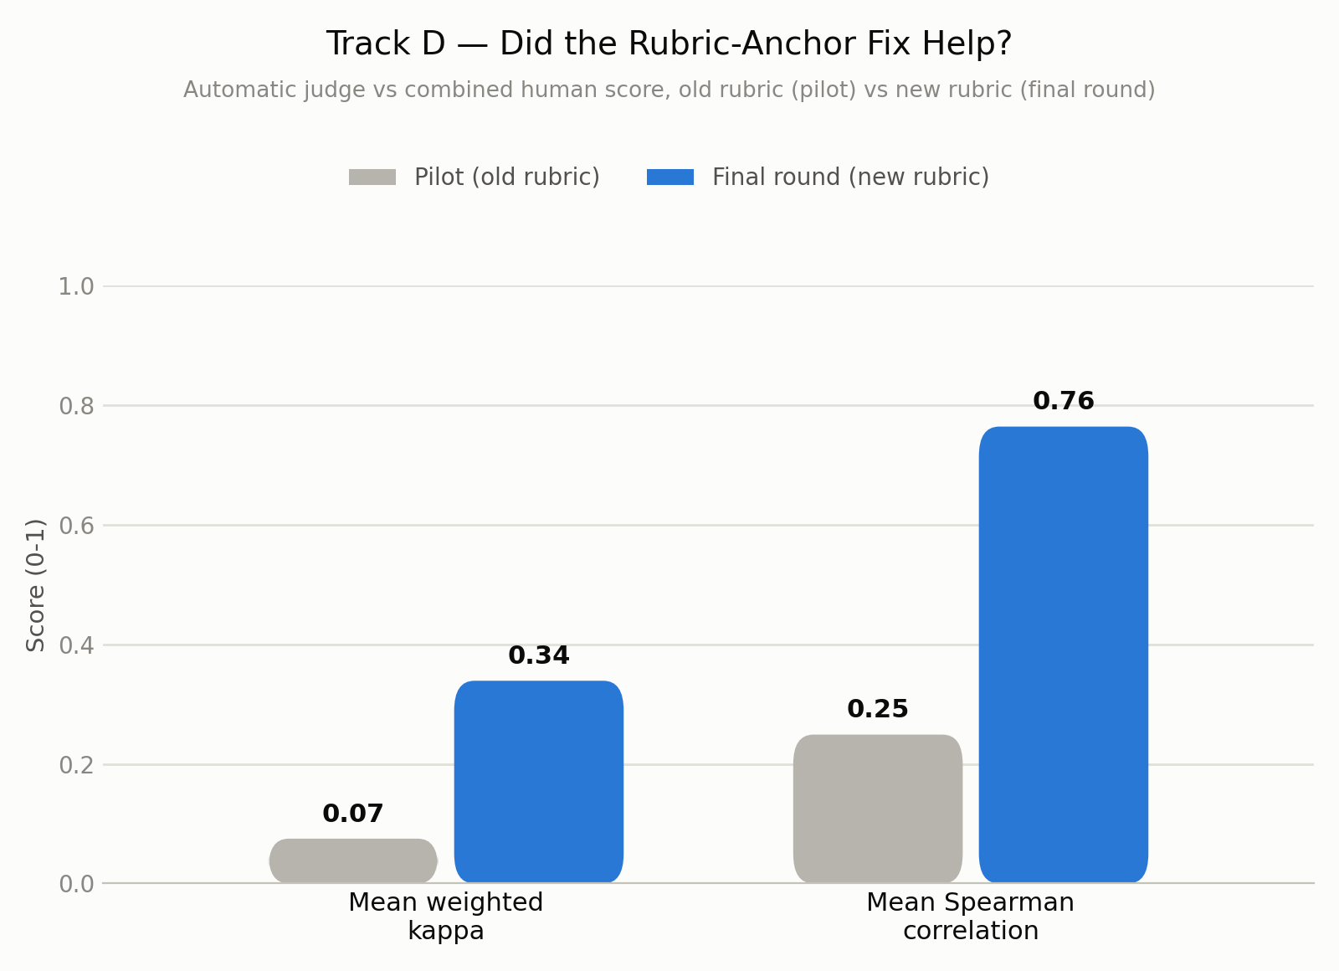
Figure D1: Judge-versus-human agreement, old rubric and new rubric.
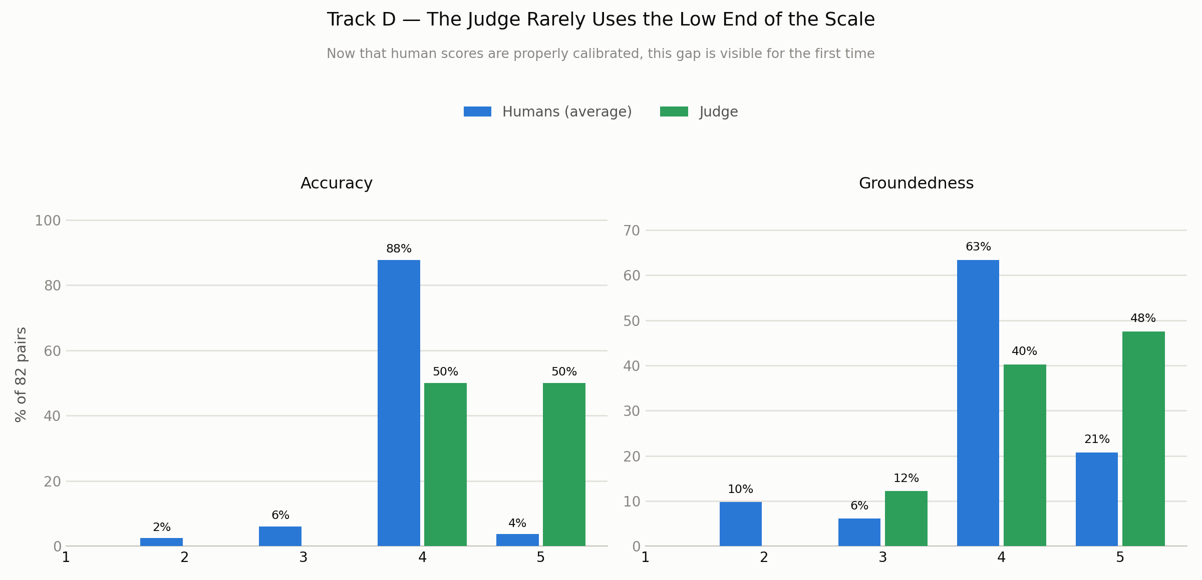
Figure D2: Score spread for accuracy and groundedness, judge and calibrated humans.

Appendix E: Track E, End-to-End Behaviour
We measured the pipeline as a whole: how often each step fires, and whether reflection really improves a reply.

Phase 1: what the 99 queries showed us
Tracks A to D gave us 10 documented failure patterns. We grouped them as wrong retrieval (2), made-up content (2), prompt gaps (4), and genuinely hard cases (2). The 99-query annotation also marked 40 queries with no matching KB document. This became our list of KB content to write.

Phase 2: the 70 real tickets, one fix at a time
After each fix we re-ran the real pipeline and checked the metrics before moving on.
Stage | What we changed | Result on the 70-ticket run
Start | Reflection kept whatever it wrote | Of 29 reflected tickets, 5 improved and 8 got worse
1. Keep the better draft | The pipeline keeps the higher-scoring draft | 0 of 15 reflected tickets got worse (checked live)
2. Specific feedback | Rejection reasons now name the failed check | 28 reflected: 5 improved, 22 unchanged, 1 changed by judge re-scoring noise. Mean score 4.07 to 4.21
3. KB expansion | 5 new KB documents and 2 fixes, from the 40 gaps | Reflection-loop rate 40.0% to 32.9%. Quality and policy failures 24 to 16
Of the 9 tickets that improved after the KB expansion, 4 matched the new content directly (discount and promo-code issues). We also record each draft's score before and after reflection in the pipeline, so future checks read the real decision.
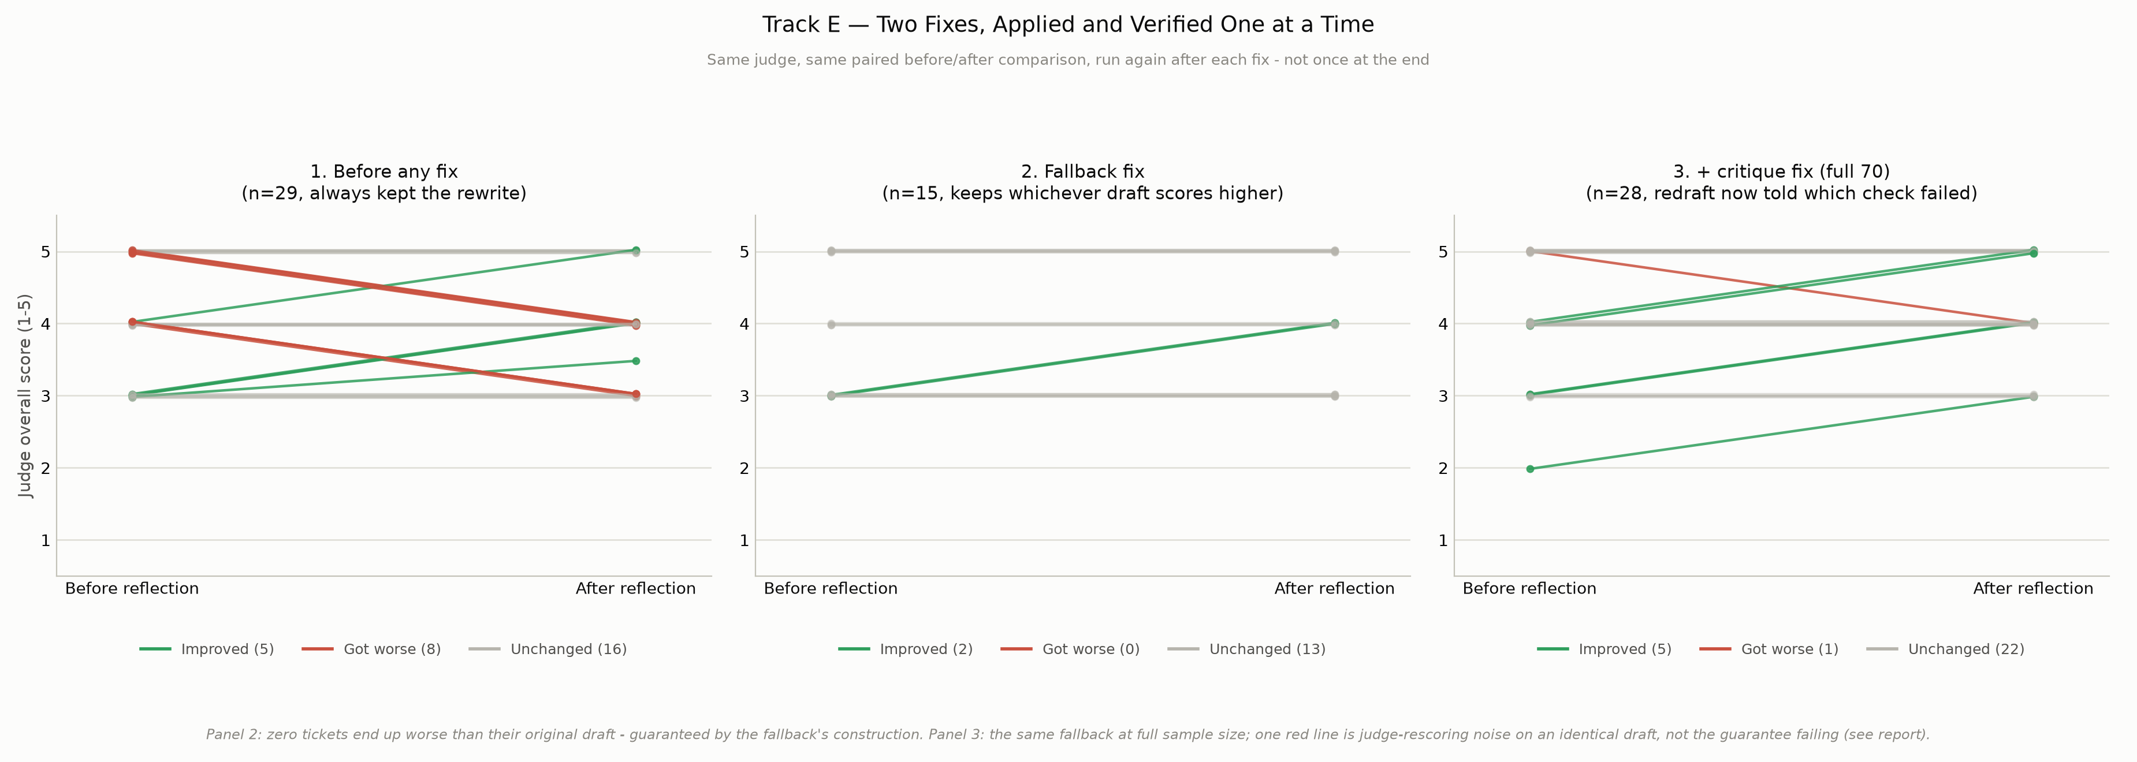
Figure E1: Reflection outcome per ticket at each stage.
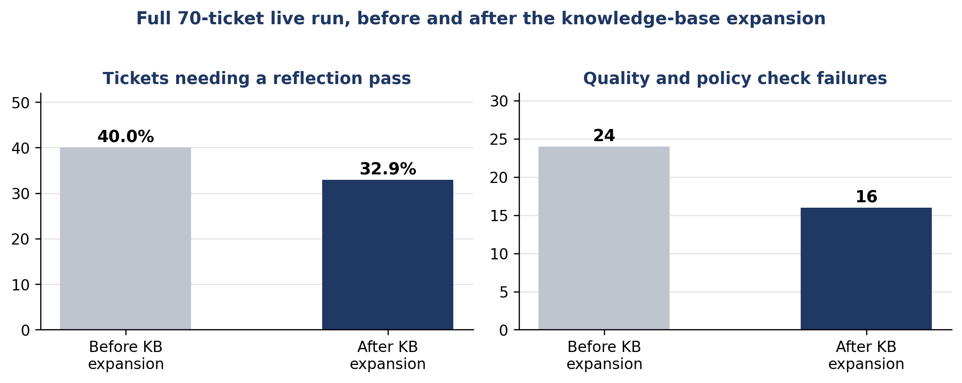
Figure E2: The 70-ticket run, before and after the KB expansion.

Appendix F: Local Llama Classifier Selection
The local classifier reads each ticket first and predicts its category, priority, and sentiment. We fine-tuned four language models on the same ticket data and trained one classic baseline (TF-IDF with a support vector classifier). We then compared all five on the same three tasks.
Model | Category | Priority | Sentiment
Fine-tuned Llama 3.2 (3B, 4-bit) | 96.5% | 77.05% | 77.6%
Fine-tuned Ministral-3 (3B) | 95.95% | 75.4% | 75.75%
Fine-tuned Gemma-3 (1B) | 95.8% | 75.65% | 76.05%
Fine-tuned Qwen2.5 (0.5B) | 95.65% | 75.2% | 62.3%
TF-IDF and SVM (classic ML) | 94.0% | 56.95% | 65.3%
Overall accuracy is shown for each task. Llama 3.2 came first on all three. It also had the best F1 on the Urgent priority class (0.83) and reached an F1 of 1.00 on subscription cancellations.
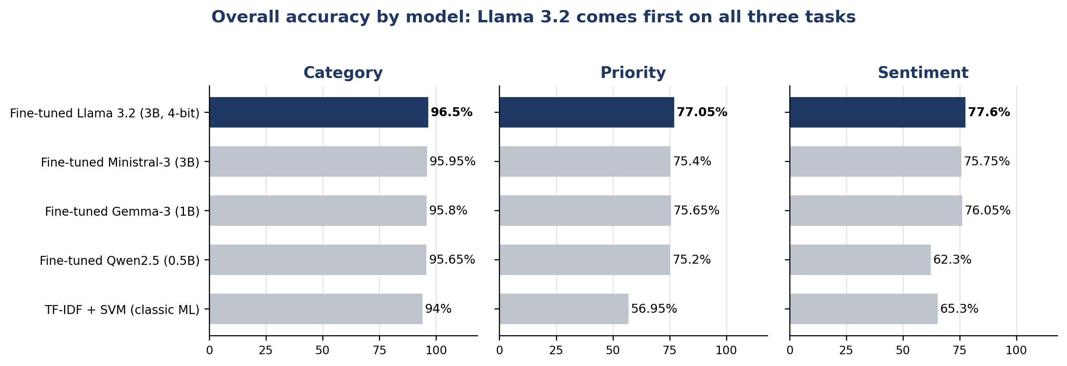
Figure F1: Overall accuracy of the five models on category, priority, and sentiment.
We chose Llama 3.2 (3B). We fine-tuned it with QLoRA on a 4-bit (NF4) quantized base model with a LoRA adapter (rank 16). The small 4-bit model runs on a single local GPU. Its priority and sentiment predictions also flow into the reply-drafting step, which helped lift tone match in Track C.

