Clario AI Support Pipeline

Data Science Evaluation Test Plan

Version 1.6

Revision History
Date | Version | Description | Author
18/Sep/26 | 1.0 | Initial Data Science Evaluation test plan, covering Tracks A-D | DSE Team
19/Sep/26 | 1.1 | Added the two-phase method, data sources, and the local Llama classifier results | DSE Team
19/Sep/26 | 1.2 | Added data notes, sample sizes, per-fix results, numeric success criteria, and corrections after review | DSE Team
19/Sep/26 | 1.3 | Added Appendix F: model study, Track A to C results on the 70 real tickets, after the Gemini-distilled Llama 3.2 adapter | DSE Team
20/Sep/26 | 1.4 | Added Sections 7 and 8: evaluation and error analysis of the DSE parts | DSE Team
20/Sep/26 | 1.5 | Added new-model and live-routing results, validity checks, confidence intervals, Appendix G and new risks. Track D target and pilot groundedness restated (see Section 3). | DSE Team
20/Sep/26 | 1.6 | Added a summary, a note on what was reused in the old-versus-new comparison (code and KB differences), the judge-model check, and wording fixes. | DSE Team

Table of Contents
Summary 4
1. Evaluation Mission and Test Motivation 4
2. Target Test Items 6
2.1 Test Data 6
3. Test Approach 7
3.1 Testing Techniques and Types 8
3.1.1 Data and Knowledge Base Integrity Testing (Track A: Retrieval Quality) 8
3.1.2 Function Testing (Track B: Routing and Escalation Accuracy) 8
3.1.3 Response Quality Testing (Track C: Final Response Quality) 8
3.1.4 Judge Reliability Testing (Track D: Judge Reliability) 9
3.1.5 Model Selection Testing: Local Llama Classifier 9
4. Deliverables 10
4.1 Test Evaluation Summaries 10
4.2 Reporting on Test Coverage 10
5. Risks, Dependencies, Assumptions, and Constraints 10
6. References 11
7. Evaluation of DSE Parts 12
7.1 How we evaluated each part 12
7.2 Results for each part 12
7.3 What each part does well 13
7.4 What got worse or stayed weak 13
7.5 How sure we are 14
7.6 Overall evaluation 14
8. Error Analysis of DSE Parts 15
8.1 Local classifier 15
8.2 Track A: retrieval 16
8.3 Track B: routing and escalation 17
8.4 Track C: reply quality 18
8.5 Track D: judge 19
8.6 Common causes across the parts 20
8.7 Next steps from the error analysis 20
Appendix: Results by Phase 21
Appendix A: Track A, Retrieval Quality 22
Appendix B: Track B, Routing and Escalation Accuracy 24
Appendix C: Track C, Final Response Quality 26
Appendix D: Track D, Judge Reliability 28
Appendix E: Local Llama Classifier Selection 30
Appendix F: After the Gemini-Distilled Llama 3.2 Adapter 31
Appendix G: Reproducibility 39

Data Science Evaluation Test Plan

Summary
We tested five parts of Clario with two data sets: 99 queries and 70 real tickets. Two people annotated the 99 queries first to find failures. We then fixed the issues and ran the 70 real tickets through the pipeline. The pipeline now uses a new local classifier, so most results are shown for the first model and the new model.
- Classifier: the new model is better on priority and sentiment on the test set (with a different label list), and gives every real ticket a real category. Its scores are agreement with Gemini labels. No human has checked it on real tickets.
- Track A, retrieval: it meets the targets when the correct team is given (Precision@1 71.4%, Recall@4 89.0%). It does not meet them when the classifier picks the team (52.9% and 82.9% with the new model).
- Track B, routing: the new model, with its routing changes, routes 92.9% of the 56 agreed tickets correctly (90.0% of all 70). It still misses 6 of the 19 tickets that needed a human.
- Track C, reply quality: every ticket now gets a reply. Overall scores are at or above 4.0, but groundedness is below 80% in billing and technical, and HR scores fell.
- Track D, judge: it ranks replies the way people do (Spearman 0.764). It is too generous on accuracy and groundedness.
Keep in mind: the sets are small, neither is a clean hold-out, and the new model's labels come from Gemini. The old-versus-new comparison also includes code and KB changes made between the runs (Appendix F). We do not claim that the whole pipeline is ready to go live. Section 7 has the full evaluation and Section 8 the error analysis.
Next: label 30 to 50 real tickets with two humans, re-run the first model on the current KB and code, and re-score Track D on the new drafts.

Evaluation Mission and Test Motivation
Clario is an AI support assistant for an online learning platform. When a customer sends a support ticket, Clario reads it, searches the knowledge base (KB), sends the ticket to the right team (technical, billing, or HR), drafts a reply, checks its own draft, and decides when a human must step in before anything is sent.
Before using Clario on real customer tickets, we wanted to know how well the main steps work, using real ticket data. This document is our plan for that evaluation, together with the results.
Mission
Measure retrieval, routing and escalation, reply quality, and the automated judge; fix the issues we find; and check every fix with data.
What HR means in Clario
HR tickets are the ones that need a person's judgement or a policy decision, not just a KB answer. Examples are a bank-slip payment linked to the wrong account, a refund after a medical emergency, parental consent, an instructor change in the middle of a course, and course cancellations. Clario always sends HR tickets to a human reviewer with a draft reply.
Background
A local fine-tuned Llama 3.2 model reads each ticket and predicts its category, priority, and sentiment. Clario then finds the right KB documents, routes the ticket to a specialist, drafts a reply, scores it with an automated judge, and decides on escalation. The figure shows which step each track tests.
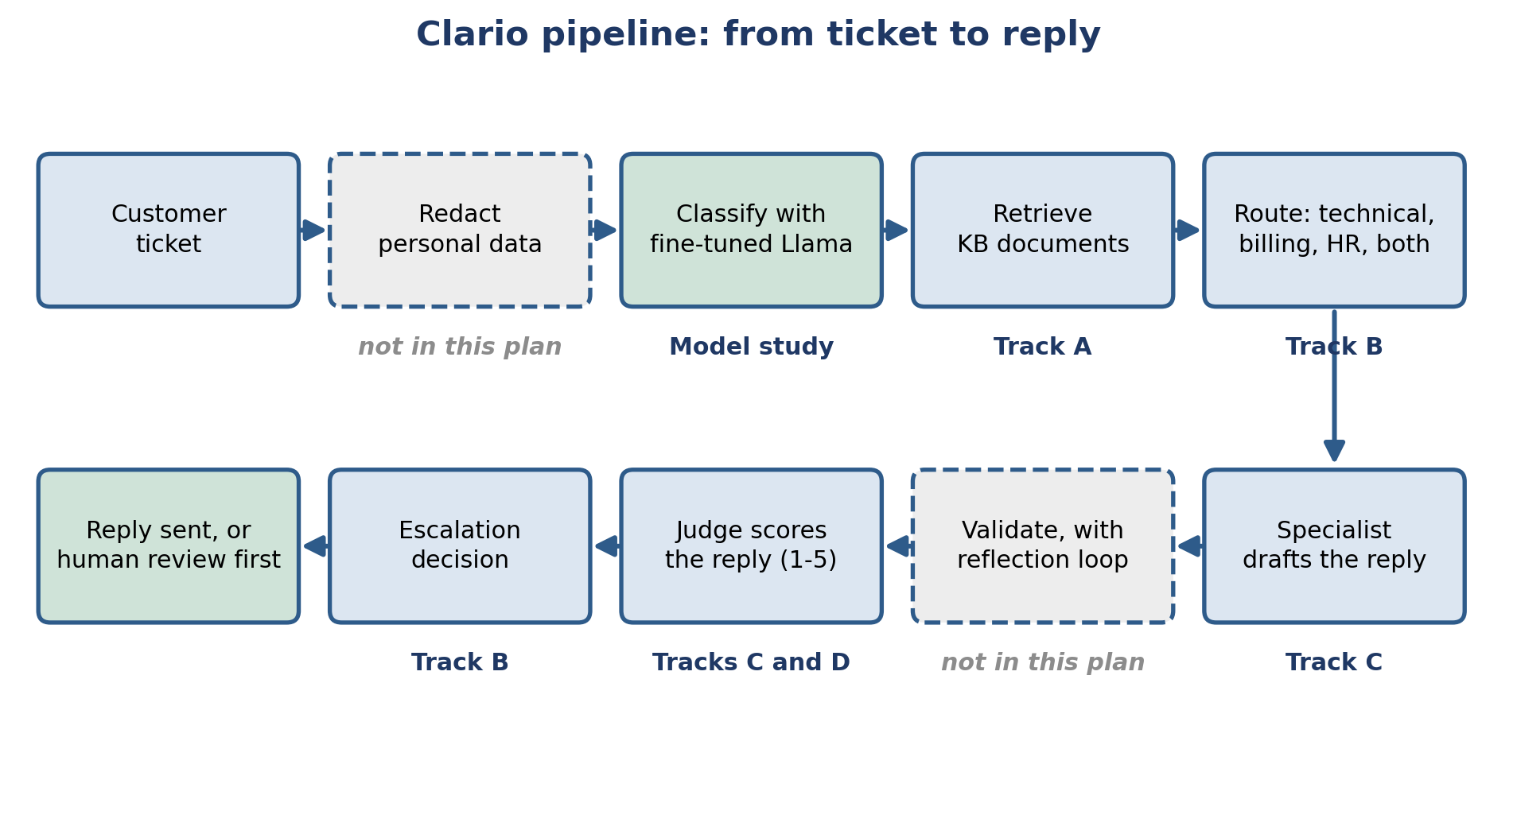
Figure 1: The Clario pipeline. Each step shows the track that tests it. The response cache, which checks each ticket against saved past replies before routing, is not drawn.
This plan does not support a whole-pipeline go-live decision. Personal-data redaction, the reflection loop, and the response cache were live in the pipeline that produced the Track C drafts, so their effect is inside those numbers. We did not test them alone, and we report no end-to-end result. The cache check is in Appendix F, part 4.
How we ran the evaluation
We ran every track in two phases:
- Phase 1, the 99-query set: two team members annotated the same 99 queries by hand. This showed us the failures, wrong routings, and wrong settings in the pipeline.
- Fix: we fixed the issues and checked the metrics after each fix.
- Phase 2, the 70 real tickets: we ran the 70 real tickets through the fixed pipeline and measured the results.
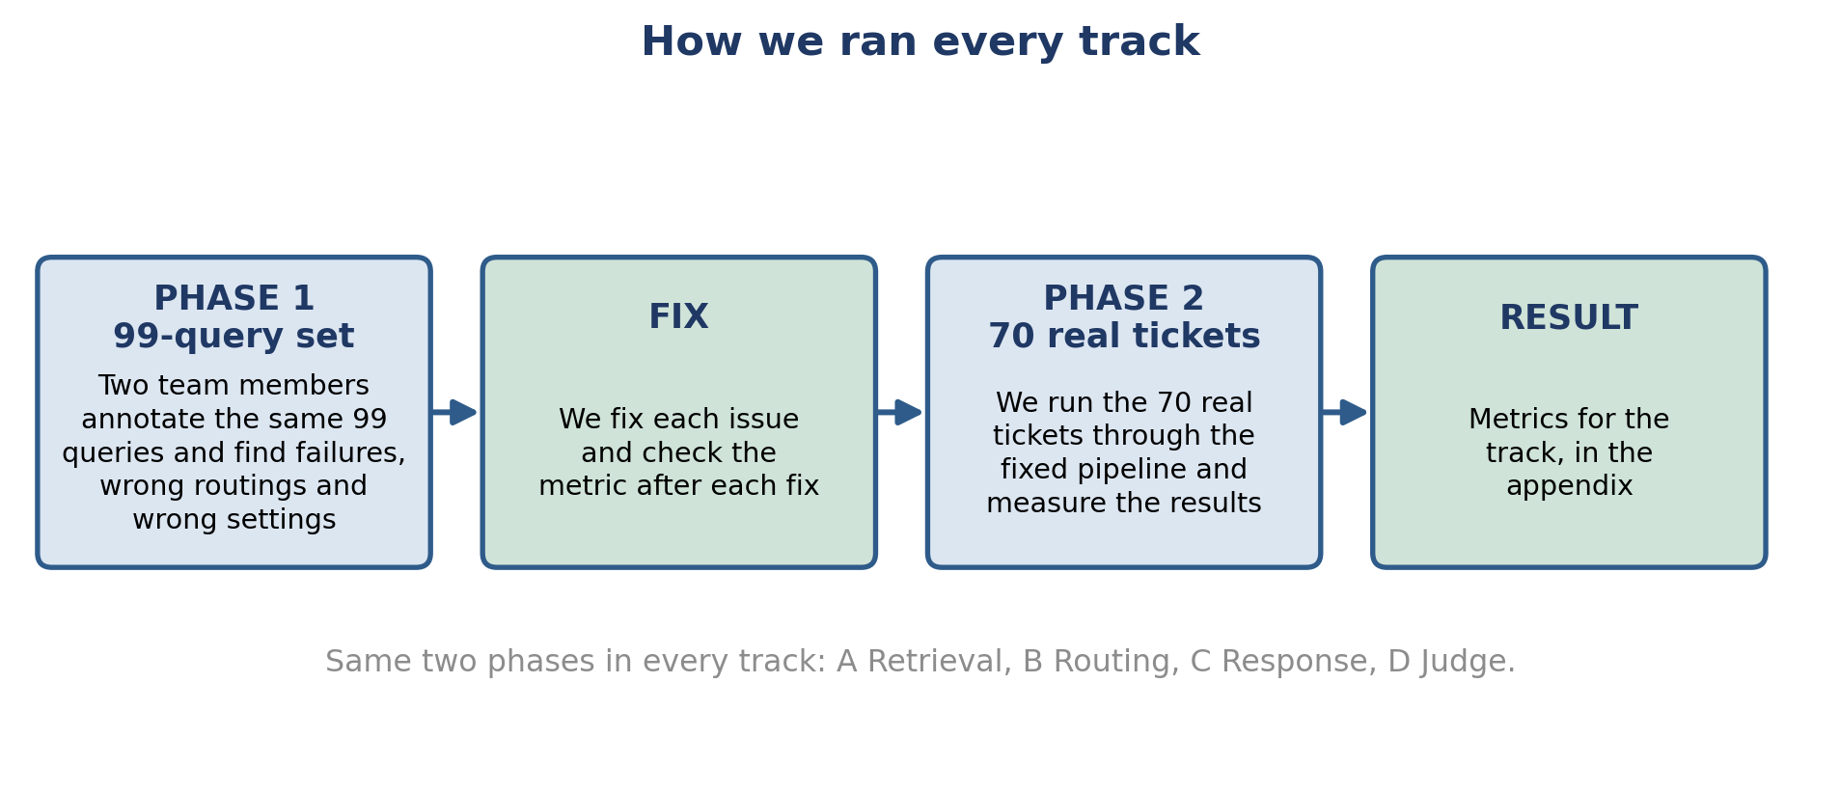
Figure 2: The two-phase method we used in every track.

Target Test Items
The table lists the parts of the Clario pipeline covered by this plan, and the track that tests each one. Personal-data redaction and the reflection loop are outside this plan. The response cache is not scored, but we checked it for hits (Appendix F, part 4).
Test Item | Track | Description
First local ticket classifier | Model study | First fine-tuned Llama 3.2 (4-bit) predicts category, priority, and sentiment
Knowledge-base retrieval | A | Vector search that finds the right KB document for a ticket
KB documents and vector store | A | Markdown documents and the ChromaDB store behind every retrieval result
Routing rules | B | Decide which team (technical, billing, HR) handles a ticket
Escalation rules | B | Decide when a ticket needs a human before a reply goes out
Specialist response agents | C | Draft the reply for each domain (technical, billing, HR)
Automated response judge | C and D | LLM-based scoring of every reply (used in C, checked in D)
New local ticket classifier | Model study, B, C | Gemini-distilled Llama 3.2: 12 multi-label categories, Critical priority, 3 sentiments. It replaced the first model in the pipeline (Appendix F)
Live-routing retrieval | A | The search that uses the team the classifier picks, not the correct team
Response cache | Data check | Reuses a stored reply for a near-identical ticket. Not scored; checked for hits

Test Data
Dataset | Size | Source and use
99-query set | 99 queries | Built from the text of 100 earlier support tickets (payment, refund, billing, login). Each query is labelled with the KB document that should answer it: 59 have a matching document and 40 do not. Used in Phase 1.
Real support tickets | 70 tickets | 70 real support tickets with the real human replies, from a file of 71 (one duplicate removed). Names and emails are removed before any script runs. Used in Phase 2.
Real customer reviews | 54 reviews | Public Trustpilot reviews of Udemy (26), Coursera (12), Pluralsight (10), and Skillshare (6). Real customer wording for KB documents.
Community forum posts | 63 posts | Extra real issues from the Open edX community forum, reviewed for KB ideas.
Model comparison, first round | 5 models, 3 tasks | Category, priority, and sentiment results used to choose the first local classifier.
Gemini-distilled ticket set | 13,184 tickets | Support tickets written by Gemini (synthetic), each labelled by Gemini with step-by-step reasoning. 10,000 for training and 3,184 for testing. Used only for the new classifier. No real customer data.
Gemini reference labels | 70 tickets | Category, priority and sentiment for the 70 real tickets, made by Gemini with the same prompt as the training labels. Used to compare the two classifier versions. Not a human answer key.
Model comparison, second round | 2 models, 3 tasks | Llama 3.2 (3B) and Ministral-3 (3B), both fine-tuned on the Gemini-labelled tickets and scored on the same 3,184 test tickets.

The source, overlap and label checks for the new classifier data are in Appendix F, part 4.

Test Approach
We organised the evaluation into four tracks (A to D), plus one model-selection study for the local classifier. Every track follows the same steps: annotate the 99-query set to find issues (Phase 1), fix each issue and check the metric, then run the 70 real tickets through the fixed pipeline (Phase 2).
The table shows who annotated or scored in each phase.
Track | Phase 1: 99-query set | Phase 2: 70 real tickets
A: Retrieval | Team-labelled correct KB document for each query | Ranuga and Sineth, independently
B: Routing and escalation | Vinma and Sineth, independently | Vinma and Sineth, independently
C: Response quality | Ranuga and Vinma read all 90 drafts the full pipeline produced | Scored automatically against real human replies
D: Judge reliability | Ranuga and Sineth scored 99 drafts, blind to the judge | Ranuga and Sineth scored 82 rows, blind to the judge

How to read the results
- We set all numeric success criteria after we had the results, so they are not pre-registered targets. Some were set or changed later still, and are marked * in the status table: the Track D kappa target (first at least 0.40, then within 0.05 of the human agreement, after the judge reached 0.339 and the humans 0.368), the live-routing retrieval criteria, the escalation-recall criterion, and the new-classifier criteria. We also restated the pilot groundedness figures: with the same final checker on both sets they are 81.0%, 52.1% and 94.7% (billing, technical, HR), against 77.0%, 59.2% and 86.4% with the older checker.
- Neither set is a clean hold-out. We used the 99-query set to find issues and to re-check fixes. Some fixes also used wording from the 70 tickets (KB wording in Track A, routing patterns in Track B). We read the 70-ticket results as results on data we worked with.
- In Tracks C and D the before result comes from the 99-query drafts and the after result from the 70 tickets. The two are different data, so the change shows direction. It is not a like-for-like test.
- Group sizes are small. We state n next to every domain result, and the HR recall result rests on 14 tickets.
- Track C scores come from an automated judge. Track D shows the judge is more generous than the humans on accuracy (+0.55) and groundedness (+0.40). On overall (-0.08) it is close to the humans, and on tone (-0.29) it is stricter, so tone scores may be low. We read accuracy and groundedness scores as upper estimates. The Track D drafts are different from the Track C drafts, so Track D shows how the judge behaves on comparable drafts. It does not directly cover the Track C scores.
- Two model versions. The classifier, Track B and Track C were run with the first Llama 3.2 model and again with the new Gemini-distilled model (Appendix F). The pipeline now runs the new model, so we show both. Track A with the correct team given does not depend on the classifier and was not re-run. Track D was not re-run. The first-model results for Tracks B and C were reused from earlier runs, so the old-versus-new differences also include code and KB changes made in between (Appendix F).
- Correct team or live routing. Appendix A gives the search the correct team (oracle routing). In the pipeline the classifier picks the team (live routing). Live results are lower, and the retrieval criteria are met only when the correct team is given.
- Gemini labels. The new classifier's training labels, its 3,184 test labels and the 70-ticket reference labels all come from Gemini. Those scores show agreement with Gemini, not with a human answer key.
- Uncertainty. Section 7.5 gives 95% intervals and paired tests. Most gains between the two model versions are a few tickets.
- Limitations. Not everything was recorded. The code and settings of each run are not tagged, the KB was not saved for the earlier runs, per-ticket results of the new Track A run were not saved, the first classifier's test-set size is not recorded, and cache results were not logged for each ticket. This limits repeat runs, paired tests for Track A, and the cache check (Section 7.5 and Appendix F).

Testing Techniques and Types

Data and Knowledge Base Integrity Testing (Track A: Retrieval Quality)
Technique Objective: | Confirm the system retrieves the correct KB document for a customer ticket.
Technique: | Phase 1: run the 99 labelled queries through retrieval and score them with Precision@k, Recall@k, MRR, and nDCG. Phase 2: two annotators label the 70 real tickets, and we check retrieval on them after our fixes.
Oracles: | The team's correct-document labels for the 99 queries, and the two annotators' labels for the 70 tickets (they overlapped on 85.7% of tickets before any discussion).
Required Tools: | The technique requires the following tools:  - ChromaDB vector store  - Sentence-transformers model (all-MiniLM-L6-v2)  - Python precision, recall, MRR, and nDCG scripts  - Real customer reviews and forum posts as a source of KB wording
Success Criteria: | Precision@1 of at least 60% and Recall@4 of at least 85%, on the queries that have a correct KB document. We test with the correct team given to the search (oracle routing, Appendix A) and with the team the classifier picks (live routing, Appendix F). We test live routing with the same criteria*, because it is what the pipeline does. Both sets were also used to tune the fixes.
Special Considerations: | - The KB grows from real data. We re-check retrieval every time documents are added or changed.

Function Testing (Track B: Routing and Escalation Accuracy)
Technique Objective: | Confirm each ticket goes to the correct team, and that a human reviews the tickets that need it.
Technique: | Phase 1: two annotators (Vinma and Sineth) label the 99 queries for team and escalation, and we compare the live routing rules to their answers. Phase 2: the same two annotators label the 70 real tickets and we test the fixed rules.
Oracles: | Answers agreed by two independent reviewers. Cohen's kappa shows how well they agree. Tickets where they still disagreed are left out of the scoring.
Required Tools: | The technique requires the following tools:  - The live routing and classification code  - Cohen's kappa calculator  - Confusion-matrix scripts
Success Criteria: | Routing accuracy of at least 80%, HR recall of at least 80%, and escalation F1 of at least 70%, on both sets. Escalation recall of at least 80%* (at most 1 in 5 tickets that need a human is missed), because a missed escalation is the costlier error.
Special Considerations: | - Escalation includes real judgment calls. We record reviewer disagreements openly.

Response Quality Testing (Track C: Final Response Quality)
Technique Objective: | Confirm the reply Clario writes is accurate, grounded in the KB, and matches the tone the ticket needs.
Technique: | Phase 1: two annotators (Ranuga and Vinma) read all 90 drafts the full pipeline produced for the 99 queries and flag problems. Phase 2: we score the drafts for the 70 real tickets on a 1 to 5 rubric, check groundedness against the retrieved KB content, and compare them with the real human reply.
Oracles: | The annotators' notes in Phase 1, and the real human agent replies in Phase 2.
Required Tools: | The technique requires the following tools:  - ResponseJudge scoring tool  - Groundedness checker  - Semantic similarity scorer
Success Criteria: | Judge overall score and tone match of at least 4.0, and groundedness of at least 80%, in each domain. We read these scores together with the Track D judge results.
Special Considerations: | - The head-to-head comparison with a real human reply is a stricter benchmark. We report it separately.

Judge Reliability Testing (Track D: Judge Reliability)
Technique Objective: | Confirm the automated judge agrees with what a real person would say about the same reply.
Technique: | Phase 1: two annotators (Ranuga and Sineth) score 99 drafts without seeing the judge's scores. These drafts come from calling each specialist directly, so all 99 queries have a draft. Phase 2: the same two score 82 rows from the 70 real tickets under the improved rubric. We measure agreement with weighted Cohen's kappa and Spearman correlation.
Oracles: | Two independent human raters, blind to the judge.
Required Tools: | The technique requires the following tools:  - Weighted kappa and Spearman calculators  - Human scoring guide, worded the same as the judge's rubric
Success Criteria: | Judge-versus-human weighted kappa within 0.05 of human-versus-human kappa*, and Spearman correlation of at least 0.60. Human-versus-human agreement is the ceiling a judge can reach.
Special Considerations: | - We check how widely raters use the 1 to 5 scale before reading a kappa number.

Model Selection Testing: Local Llama Classifier
Technique Objective: | Choose the local model that reads each ticket first and predicts its category, priority, and sentiment.
Technique: | First round: we fine-tuned four language models (Llama 3.2 3B, Ministral-3 3B, Gemma-3 1B, Qwen2.5 0.5B) and trained one classic machine-learning baseline (TF-IDF with a support vector classifier), and compared them on the same three tasks. Second round: we fine-tuned Llama 3.2 (3B) and Ministral-3 (3B) on Gemini's step-by-step reasoning (10,000 tickets) and compared them on 3,184 held-out tickets. We then compared the first and new Llama models on the 70 real tickets and through Tracks A, B and C (Appendix F).
Oracles: | First round: labelled ticket data from the fine-tuning test set. Second round: Gemini labels on the 3,184 test tickets, and a Gemini reference labelling of the 70 real tickets. These show agreement with Gemini, not with a human answer key. Tracks A and B use the same human answer keys as before.
Required Tools: | The technique requires the following tools:  - QLoRA fine-tuning with 4-bit (NF4) quantization  - scikit-learn classification reports
Success Criteria: | First round: the chosen model has the best overall accuracy on category, priority, and sentiment. Gaps under 2 points count as ties. Second round*: macro-F1 of at least 0.75 for priority and sentiment, recall of at least 50% for the rarest class (Critical priority, Negative sentiment), and better results than Ministral-3 on all three tasks.
Special Considerations: | - These results come from fine-tuning test sets, not from human labels on the 70 real tickets. The class lists changed between the two rounds (Appendix F).  - The chosen model's priority and sentiment output also feeds the reply-drafting step (see Appendix C).

Deliverables

Test Evaluation Summaries
For each track we write a short conclusion and a full final report. Each has the headline metrics, the key diagrams, the issues found, the fixes made, and the result after each fix. Where several fixes went in together, we say so. The results of every track are collected in the Appendix of this document. Appendix F holds the new-model results and Appendix G holds the run details (model versions, settings, KB version).

Reporting on Test Coverage
We report coverage as the number of queries, tickets, drafts, and rows used in each result, and we state n next to every domain result. Phase 1 used the 99-query set. Phase 2 used the 70 real support tickets. Results are saved as CSV and JSON files next to each track's report.

Risks, Dependencies, Assumptions, and Constraints
Risk | Mitigation Strategy | Contingency (Risk is realized)
The shared daily API quota is limited (Gemini free tier). | Pace requests, run a small check before a full live run, and monitor usage. | Exclude data collected during a quota interruption and re-run after the quota resets.
Language-model output varies slightly from run to run. | Use low-temperature settings and re-run key checks. | Report the observed range.
Test sets are small (70 to 99 items, and fewer per domain). | State n for every result. Read domain results as indicators. | Add more tickets in the next round.
Neither set is a clean hold-out, because fixes used wording from both. | Report both sets side by side and say which fixes used the 70 tickets. | Collect a fresh set of real tickets for a final check.
The automated judge is more generous than human raters on accuracy and groundedness. | Check it against two humans (Track D). Read accuracy and groundedness scores as upper estimates, and note that tone scores may be low. | Add a low-score example to the judge prompt and re-check.
KB content needs to stay current. | Keep collecting real customer wording from review sites and forums. | Add the missing content and re-check retrieval.
Real ticket text (70 tickets, reference labelling) and the 13,184 distillation tickets go to the Gemini free-tier API. Google's terms for unpaid use may allow content to be used to improve its products. | Remove names and emails first (we do). The 13,184 tickets hold no customer data, so the exposure is the 70 tickets and the reference labelling. Check Google's terms before each round. Use a paid tier or redacted text for real tickets. | Stop real-ticket runs on the free tier until the terms are confirmed.
The local classifier needs a GPU. | The 4-bit Llama model fits a single local GPU. | Check GPU access before each full run.
Teacher equals reference. The new classifier, its 3,184 test labels and the 70-ticket reference labels all come from Gemini. | Report scores as agreement with Gemini. Label 30 to 50 real tickets by two humans and score both models on them. | Do not claim the classifier is accurate on real tickets until the human check is done.
The label lists changed between model versions (Urgent to Critical, Positive folded into Neutral, one category to a set of 12). | Compare macro-F1 and rare-class recall. Write down the mapping used for old labels. | Treat any before-and-after classifier number as a guide only.
Versions move between runs. The KB was edited on 18 September, after the earlier results. | Record the versions in Appendix G and run old and new results together. | Re-run the affected tracks on the new versions.
The response cache returns a stored reply instead of a fresh draft. | Record the cache result for every ticket and clear the saved replies before a run. | Exclude cached tickets from the scores.
Same-model bias. The same Gemini model (gemini-3.1-flash-lite) writes the replies and judges them (checked for Track D and the head-to-head). Gemini also makes the training, test and reference labels. | Check the judge against two humans (Track D). Score a sample of replies with a judge from a different model family. | Treat Gemini-judged scores as possibly favourable to Gemini-written text.

References
- Google Gemini API (gemini-3.1-flash-lite and related models): https://ai.google.dev (Accessed 2026).
- ChromaDB vector database: https://www.trychroma.com (Accessed 2026).
- Sentence-Transformers, all-MiniLM-L6-v2 model: https://www.sbert.net (Accessed 2026).
- LangGraph orchestration framework: https://www.langchain.com/langgraph (Accessed 2026).
- Meta Llama 3.2 models: https://www.llama.com (Accessed 2026).
- Dettmers, T., et al. (2023). QLoRA: Efficient Finetuning of Quantized LLMs.
- Hu, E., et al. (2021). LoRA: Low-Rank Adaptation of Large Language Models.
- Trustpilot public review pages (Udemy, Coursera, Skillshare, Pluralsight) and the Open edX community forum, https://discuss.openedx.org (Accessed 2026).
- Cohen, J. (1960). A Coefficient of Agreement for Nominal Scales. Educational and Psychological Measurement.

Evaluation of DSE Parts
The DSE has five parts: the local classifier, and four tracks (A retrieval, B routing and escalation, C reply quality, D judge). This section shows how we evaluated each part and what we found. The Appendix has the full tables and charts. Where two versions of the classifier exist, we show both: the first Llama 3.2 model (Appendix E) and the new Gemini-distilled model (Appendix F).

How we evaluated each part
Part | What we checked | Data used | Measures
Local classifier | Does it read the category, priority, and sentiment of a ticket correctly? | Fine-tuning test set (3,184 tickets for the new model). 70 real tickets, checked against a Gemini reference. | Accuracy, macro-F1, recall per class
Track A: retrieval | Does the search find the right KB document? | 99 queries (59 have a correct document). 70 real tickets. | Precision@1, Recall@4, MRR
Track B: routing and escalation | Does a ticket reach the right team, and does a human review the tickets that need it? | 71 of the 99 queries. 56 of the 70 tickets. | Routing accuracy, HR recall, escalation precision, recall, and F1
Track C: reply quality | Is the reply good, true to the KB, and in the right tone? | 90 drafts (99 queries). 58 drafts (70 tickets, first model) and 74 drafts (new model). 55 head-to-head comparisons. | Judge score 1 to 5, tone match, groundedness, similarity, head-to-head
Track D: judge | Does the automated judge agree with people? | 99 drafts. 82 rows from the 70 tickets. | Weighted kappa, Spearman correlation

Results for each part
Part | First model | New model (Appendix F) | Verdict
Local classifier | Category 96.5% (8 classes). Priority accuracy 77.05%, macro-F1 78.4%. Sentiment accuracy 77.6%, macro-F1 70.0%. First of five models tested. | Priority accuracy 87.6%, macro-F1 80.0%. Sentiment accuracy 82.4%, macro-F1 77.0%. Category 81.0% (the whole set of 12 labels must match, so not comparable). Tickets with no real category: 44 of 70 before, 0 of 70 now. All scores are against Gemini labels. | Met. The class lists changed, so read the change as a guide. Macro-F1 gain: priority +1.6, sentiment +7.0.
Track A: retrieval | Correct team given: Precision@1 71.4% and Recall@4 89.0% on the 70 tickets, 64.4% and 86.4% on the 99 queries. Live routing: 47.1% and 75.7%. | Live routing: Precision@1 52.9% and Recall@4 82.9%. | Met when the correct team is given. Not met with live routing (both models).
Track B: routing and escalation | Routing 83.9% (80.4% in the Track C run). HR recall 92.9%. Escalation F1 66.7%. All 70 tickets: routing 75.7%. | Routing 92.9% (94.6% in the Track C run). All 70 tickets: 90.0%. HR recall 92.9%. Escalation F1 81.2%. Unnecessary escalations 7 to 0. Missed escalations still 6 of 19. | First model: partly met. New model: routing and F1 met on the 56 agreed tickets; missed escalations not met.
Track C: reply quality | Overall score 4.50 (billing), 3.95 (technical), 4.92 (HR). Groundedness 80.0%, 80.0%, 83.3%. The human reply was preferred 76% of the time. | Every one of the 70 tickets gets a reply (56 before). Overall 4.54, 4.00, 4.23. Groundedness 65.8%, 57.9%, 94.4%. | Partly met. First model: technical overall and tone miss 4.0. New model: groundedness misses 80% in billing and technical, and HR scores fell.
Track D: judge | Kappa 0.339 (humans agree with each other at 0.368). Spearman 0.764. | Not re-run. It needs two people to score the new drafts. | Met on the current target*. Partly met on the original 0.40 target.

What each part does well
- Classifier: strong on clear categories (Feature Request F1 0.98). The new model gives a real category to every real ticket (0 of 70 generic labels, against 44 of 70) and beats Ministral-3 on all three tasks on the same test set.
- Track A: with the correct team given, the correct document is in the top 4 results for about 89% of the 70 real tickets (86.4% on the 99 queries). With the team the classifier picks, it is 75.7% (first model) and 82.9% (new model).
- Track B: 13 of 14 HR tickets reach HR with both models. With the new model and the changes that came with it, 92.9% of the 56 agreed tickets are routed correctly (94.6% in the Track C run) and 90.0% of all 70. On the 56 agreed tickets it sends no ticket to a human without a reason.
- Track C: with the new model and the changes that came with it, every one of the 70 tickets gets a drafted reply. Tone match was 1.6 to 2.1 times higher on the 70-ticket drafts than on the 99-query drafts, after the drafting-prompt fix. These are different drafts, so this shows direction, not a test.
- Track D: the judge ranks replies the way people do (Spearman 0.764), and it is close to the level two people reach with each other.

What got worse or stayed weak
These results are as important as the gains. The list covers both model versions.
- HR replies scored lower with the new model: overall 4.92 to 4.23 and tone 4.85 to 4.46. Six of 13 HR drafts scored lower and none higher (paired test p = 0.03, exploratory: one of six paired tests). HR groundedness rose (83.3% to 94.4%), so groundedness does not explain it. The judge's notes point to a 48-hour timeline where its tone rule expects 24 hours for Medium priority, and to the word "escalated" in a Low-priority reply.
- Groundedness fell in billing (80.0% to 65.8%) and technical (80.0% to 57.9%), below the 80% criterion. Most flagged sentences are empathy, but 6 are time promises the KB does not contain, 3 say an action is done or under way, and 2 state facts we could not find in the KB (Appendix F).
- Missed escalations stay at 6 of 19 tickets with both models. No rule covers a billing ticket that needs a person.
- Retrieval with live routing is below the 60% and 85% criteria for both models (Precision@1 47.1% and 52.9%, Recall@4 75.7% and 82.9%).
- The classifier has no human check on real tickets. Its test labels and the 70-ticket reference labels come from Gemini.
- The old-versus-new comparison for Tracks B and C also includes code and KB changes made between the runs (Appendix F), so we cannot credit the gains to the model alone.

How sure we are
The sets are small, so every result has a range. The table shows 95% Wilson intervals for the main counts. Two intervals that overlap do not prove there is no difference, so for the two model versions we also ran paired tests on the same tickets.
Result | Estimate | 95% interval
Routing, first model (56 tickets) | 83.9% (47 of 56) | 72% to 91%
Routing, new model (56 tickets) | 92.9% (52 of 56) | 83% to 97%
HR recall, both models (14 HR tickets) | 92.9% (13 of 14) | 69% to 99%
Escalation recall, both models (19 needed a human) | 68.4% (13 of 19) | 46% to 85%
Escalation precision, first model (20 sent) | 65.0% (13 of 20) | 43% to 82%
Precision@1, correct team given (70 tickets) | 71.4% (50 of 70) | 60% to 81%
Precision@1, live routing, first model | 47.1% (33 of 70) | 36% to 59%
Precision@1, live routing, new model | 52.9% (37 of 70) | 41% to 64%

- Routing: the intervals overlap, and the gain of 9 points is 5 tickets (47 to 52 of 56). On the same 56 tickets in the Track C runs, the new model routes 9 tickets correctly that the first model got wrong, and 1 the other way (exact McNemar test, p = 0.02). The gain is unlikely to be chance, but it belongs to the new model plus the changes that came with it, and its size is uncertain.
- Retrieval with live routing: Precision@1 rose by 4 tickets (33 to 37 of 70) and the intervals overlap. No paired test was possible (see Limitations in Section 3). Read this gain as small and unproven.
- Reply scores: on the 56 drafts both models wrote for the same ticket and domain, overall scores did not change in billing (p = 0.73) or technical (p = 0.70), HR fell (p = 0.03), and tone did not change clearly in any domain (p = 0.16 to 1.0). We used a paired Wilcoxon test. These are six tests, so we treat the HR result as exploratory.
- Track D was not re-run, so it has no paired test.

Overall evaluation
The parts work as a chain. The classifier feeds routing, routing chooses which KB documents are searched, retrieval feeds the reply, and the judge scores it. The new model, plus the changes that came with it, improved routing and gave every ticket a drafted reply (Appendix F). It did not lift every later check: HR reply scores fell, and groundedness fell in billing and technical. Retrieval meets its criteria only when the correct team is given. The sets are small (70 to 99 items), neither is a clean hold-out, and the new classifier's labels come from Gemini, so we read the numbers as indicators. This plan gives no go-live claim. Section 3 explains the limits.

Error Analysis of DSE Parts
We counted the mistakes each part made, looked for the cause, and noted what we fixed and what comes next. We use the first model for the main counts, and add the new model where its result files exist. We do not quote ticket text, so no personal details appear here.

Local classifier
Error | Size | Likely cause (not tested) | Status
Generic label "General Support" on real tickets (first model) | 35 of the 56 scored tickets, and 44 of all 70 | The first model chose from 8 broad classes, and real tickets are worded differently | Fixed. The new model gives 0 of 70 generic labels.
Weak sentiment classes (first model) | Positive recall 42%. Strongly negative recall 57%. | Rare classes are hard to learn (the results file has no class counts) | Not comparable. The new model has no Positive class (folded into Neutral). Its Negative recall is 61%.
Rare priority and sentiment classes (new model) | Critical recall 53% (47 tickets). Negative recall 61% (356 tickets). | Few examples of these classes | Open. Add more examples.
Rare and overlapping labels (new model) | Service Outage recall 62%, F1 0.63 (21 tickets). UI/UX recall 62%, F1 0.67 (72 tickets). | Small counts and close meaning to other labels | Open. Read these as rough.
Tickets with two or more labels (new model) | Whole set correct for 67.5%, against 85.9% for one label | The model must get every label right | Open
Hard label pairs (new model) | Performance with Technical Support: F1 0.09 (30 tickets). Subscription Management alone: F1 0.41 (98 tickets). | The labels overlap in meaning | Open
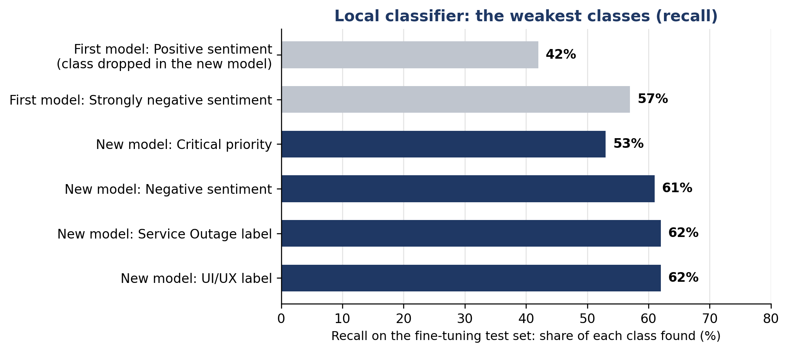
Figure 3: Recall of the weakest classes of the local classifier, measured on the fine-tuning test sets.
All of these come from the fine-tuning test sets. We have no human labels for the 70 real tickets, so we cannot yet count classifier mistakes on real tickets.

Track A: retrieval
Error | Size | Likely cause (not tested) | Status
Correct document is not first | 99 queries: 21 of 59. 70 tickets: 20 of 70. In most cases it is second or third. | Documents with close meaning. Top wrong documents: refund status (5), payment failed (4), login reset (4) on the 99 queries. Subscription cancel (6), HR course issues (5), payment linkage (3) on the 70 tickets. | Partly fixed by wording changes. Open.
Correct document is not in the top 4 | 99 queries: 7 of 59 (5 technical, 2 billing). Recall@4 is 86.4% because 2 more queries have two correct documents and only one was found; 52 of 59 (88.1%) have at least one correct document in the top 4. 70 tickets: 1 missed, and 13 with part credit. | Customer wording is far from the KB wording | Mostly fixed. Open for technical.
Relevance gate lets wrong results through | 99 queries: 37 of the 71 approved results are wrong (22 were for queries with no correct document, 15 were wrong top results) | One threshold (0.70) for both sets | Open. Tune the threshold on each set.
Relevance gate rejects correct results | 70 tickets: 15 of the 50 correct results | Same threshold | Open
No KB document exists | 40 of the 99 queries | Missing KB content | Open. The list of gaps is ready.
Several correct documents, only some found | 13 of the 70 tickets get part credit | Tickets that fit two documents | Open
No search at all (first model) | 11 of the 70 tickets | Routing had no usable team | Fixed. The new model leaves none.
Live routing lowers retrieval | 70 tickets: Precision@1 47.1% and Recall@4 75.7% (first model), 52.9% and 82.9% (new model) | The search uses the team the classifier picks, so a wrong team means a wrong search | Open. Below the 60% and 85% criteria.
KB changed after the results | Eight documents edited on 18 September | The correct-team results in Appendix A were produced on 12 September | Not re-run on the new KB
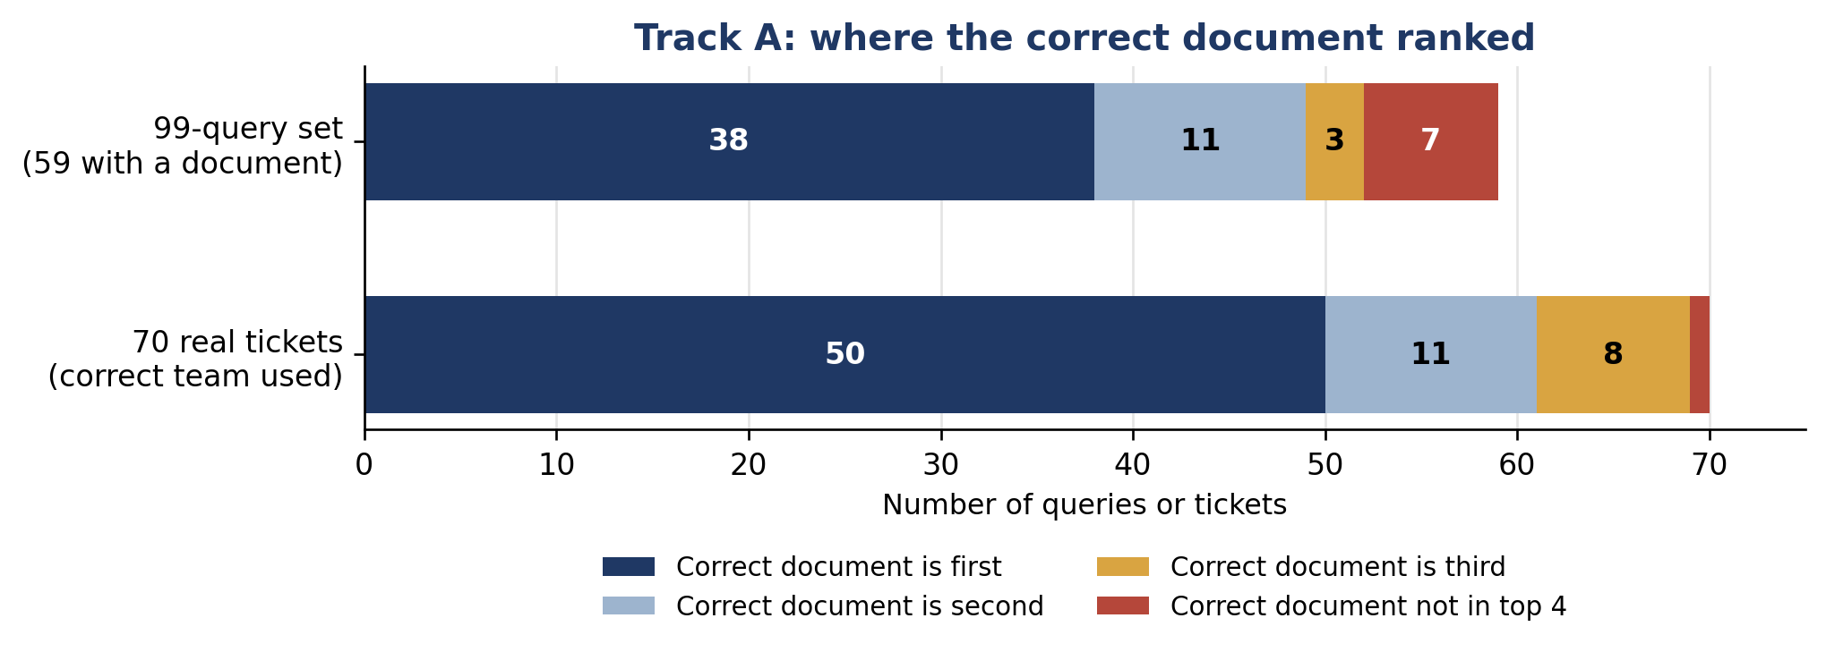
Figure 4: Where the correct document ranked, first model.

Track B: routing and escalation
Error | Size (56 scored tickets) | Likely cause (not tested) | Status
Ticket sent to a human because no team fits (first model) | 7 tickets: 6 technical, 1 billing. These are also the 7 unnecessary escalations. | The classifier gave a generic label, and the keyword rules found no team | Fixed. The new model has 0.
Wrong team (new model) | 4 tickets: 2 billing sent to technical, 1 billing sent to both, 1 HR sent to technical | Overlapping wording | Open
Other wrong team (first model) | 2 tickets: 1 HR ticket sent to billing (a cancellation with no strong phrase), 1 billing ticket sent to both | Missing keyword pattern, overlapping wording | Open
Human review missed | First model: 6 tickets (4 billing, 1 both, 1 HR). The new model also misses 6. | The escalation rules have only two reasons: an HR process, and no usable team. No rule covers a billing ticket that needs a person. | Open. This is the costlier error.
Left-out tickets score lower | The 14 tickets the two annotators disagreed on: routing 57.1% | These are the hard, unclear cases | Reported. We keep both views.
Two answers on the same 56 tickets | First model: 83.9% (Track B run) and 80.4% (Track C run). New model: 92.9% and 94.6%. | First model: the routing code changed between the two runs (committed 14 September). New model: both runs are from 19 September, so the one-ticket gap is run-to-run variation. | Reported. The first model is borderline against the 80% criterion.
All 70 tickets (new model) | Routing 90.0% (63 of 70). Escalation F1 0.65 and 0.68 for the two annotators. The 14 left-out tickets: routing 71.4% (10 of 14). | The left-out tickets are the unclear ones | Reported. F1 is below 70% when all 70 are scored.
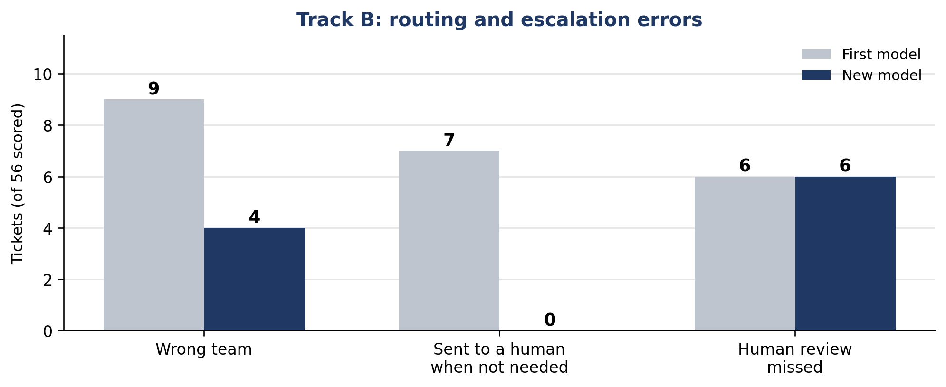
Figure 5: Routing and escalation errors on the 56 scored tickets, first model and new model.

Track C: reply quality
Error | Size | Likely cause (not tested) | Status
Problems flagged by annotators (99-query drafts) | 72 of 180 flags: needs improvement 49, missing information 8, wrong or inaccurate 6, tone issue 6, too generic 3 | The reply step never received the ticket's priority and sentiment. Replies also claimed actions were done, guessed a cause, or gave a generic answer. | Fix made. Not re-checked on the 99 drafts. The 70-ticket scores are different drafts.
Drafts with a low score (first model) | 9 of 58 drafts scored 3 overall (7 technical, 2 billing). 15 drafts scored 3 for tone. | Technical replies | Open
Drafts with a low score (new model) | 19 of 74 drafts scored 3 overall (14 technical, 3 HR, 2 billing). 16 scored 3 or less for tone (14 technical). | The technical group now includes tickets that used to get no draft | Open
No draft | First model: 14 of 70 tickets. New model: 0. | The pipeline sent these tickets to a human before drafting | Fixed (new model plus the changes that came with it)
Human reply preferred | 42 of 55 head-to-head comparisons (76%). First model only. | Possibly small natural touches in real agent replies. The judge is the same model that writes Clario's replies, so any bias favours Clario. | Open
Groundedness flags | New model: 30 of 94 sentences flagged. First model: 14 of 73. We read all of them. New model: 6 are time promises ("within 24 hours", "by the end of tomorrow"), 3 say an action is done or under way, 2 state a fact we could not find in the KB, and 19 are empathy, advice, requests for information or promises with no time. First model: 2 time promises and 12 others. | The checker measures similarity to the KB. The 24-hour promise is not in the KB. The drafting prompt asks for a timeframe, and the judge's tone rule for Medium priority expects "update within 24 hours". | Open
HR replies score lower (new model) | Overall 4.92 to 4.23 and tone 4.85 to 4.46 (details in Section 7.4) | The judge's notes cite its timeline and word rules. Groundedness rose, so it is not the cause (Section 7.4). | Open
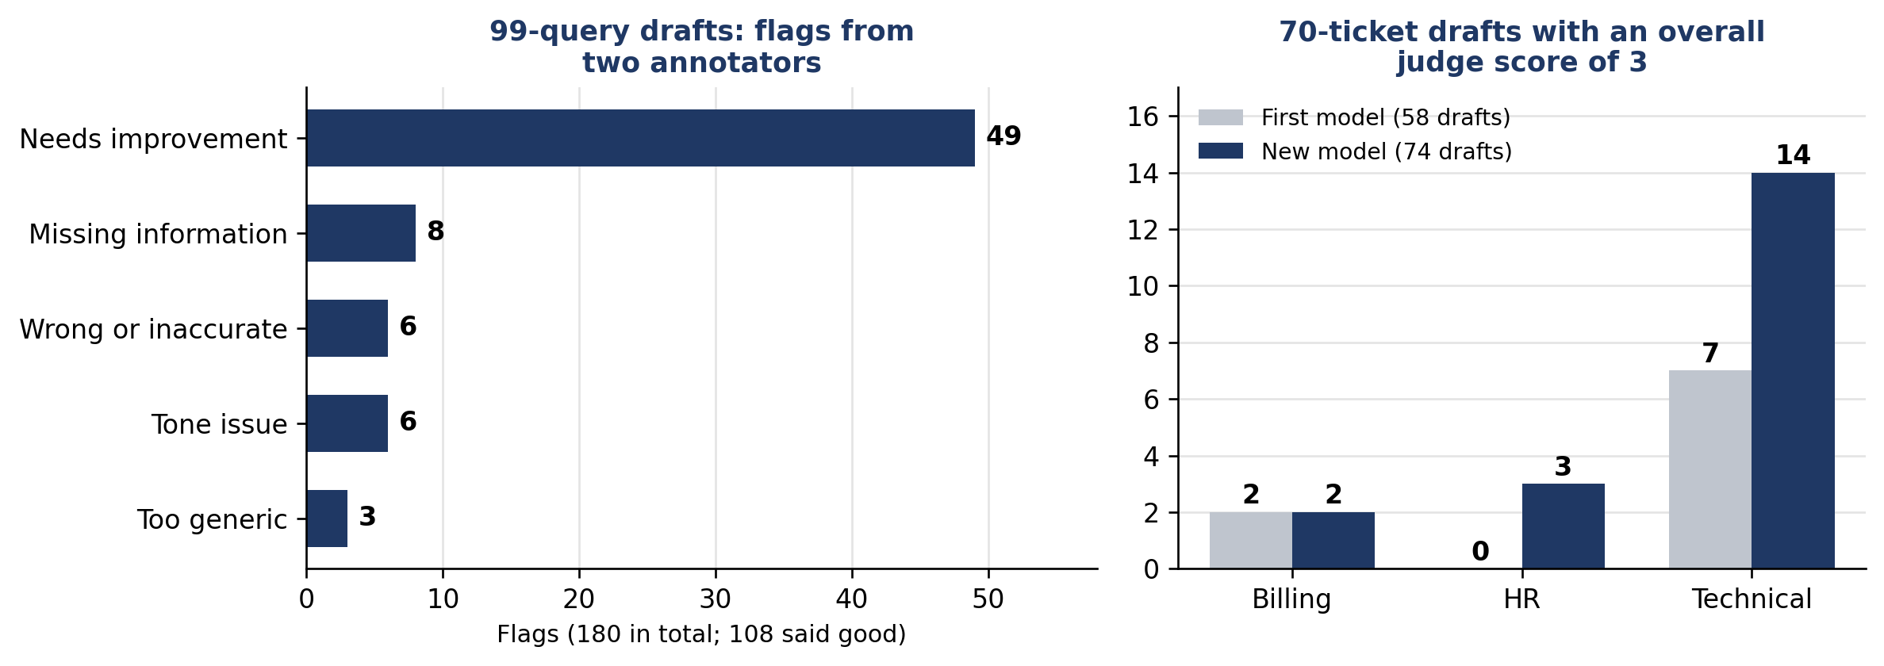
Figure 6: Reply problems flagged in the 99-query drafts, and drafts with a low judge score on the 70 tickets.
The judge scored accuracy 5 for every one of the 74 new drafts. Track D shows the judge is more generous than people on accuracy and groundedness, so accuracy scores are probably too high. On overall and tone the judge was close to people or stricter, so we do not assume the low-score counts for those are too small.

Track D: judge
Error | Size (82 rows) | Likely cause (not tested) | Status
Judge scores accuracy too high | Judge 1 or more points above the humans on 19 rows. Never lower. Average gap +0.55. | The judge rarely uses low scores. It never scored accuracy below 4. | Open
Judge scores groundedness too high | 17 rows. Average gap +0.40. | Same | Open
Policy compliance, overall, completeness | 7, 4, and 4 rows. Average gaps +0.15, -0.08, -0.02. | Small differences | Acceptable
Judge scores tone slightly too low | 0 rows above. Average gap -0.29. | The judge is stricter than people on tone | Acceptable. Judge tone scores may be slightly low.
Humans disagree with each other | Kappa 0.368 after rechecks (0.153 before). A steady 1-point gap on tone and accuracy remains. | The two raters differ by about one point on tone and on accuracy | Open
Kappa squeezed by narrow scores | The average of the two humans was between 3.5 and 4.5 on 88% of rows | Kappa shrinks when almost everyone gives the same score | Understood. Read kappa with Spearman.
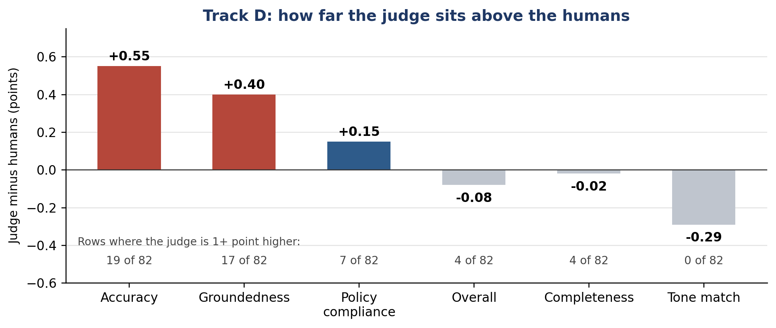
Figure 7: How far the judge's scores sit above the humans' scores, by scoring dimension.
Track D was scored on the first model's drafts. It was not re-run for the new model.

Common causes across the parts
- Weak labels early in the chain. A generic classifier label left tickets with no team, no search, and no draft. The new model removed the generic labels (44 of 70 to 0). With the changes that came with it, every ticket now gets a team, a search and a draft.
- Documents with close meaning. Retrieval mixes up refund, payment, cancellation, and HR documents.
- Rules that do not cover every case. The escalation rules only cover HR and "no usable team", so 6 tickets that needed a person were missed.
- One threshold for two data sets. The relevance gate is too loose on the 99 queries and too strict on the 70 tickets.
- A generous judge. Reply scores are probably a little high, mostly for accuracy and groundedness.
- Small samples. Rare classes and small groups give rough numbers.
- Labels from one source. The new classifier, its test labels and the 70-ticket reference labels all come from Gemini.

Next steps from the error analysis
Part | Biggest error | Next step
Local classifier | Rare priority and sentiment classes; overlapping labels | Add examples for Critical and Negative. Label 30 to 50 real tickets by two humans and score both models on them.
Track A | Wrong or missing top result; gate threshold | Tune the threshold for each set. Clarify documents that overlap. Write the 40 missing documents.
Track B | 6 missed escalations | Add an escalation rule for billing tickets that need a person. Add wording patterns for HR cancellations.
Track C | Low scores on technical replies | Read the 14 low technical drafts. Count time promises and action claims apart from empathy, and confirm the follow-up time in policy. Look at why HR scores fell. Re-run the head-to-head check.
Track D | Judge scores accuracy and groundedness too high | Add a low-score example to the judge. Hold a rater calibration session. Re-score the new drafts. Score a sample with a judge from another model family.
All parts | Versions and cache not recorded per run | Record the cache result, KB version and model settings for every run, and tag the code. Re-run the first model on the current KB and code. Re-run Track A with the new model and save per-ticket results.

Appendix: Results by Phase
This appendix shows what we found in each track. In every track, two team members first annotated the 99-query set (Phase 1) to find failures, wrong routings, and wrong settings. We then fixed the issues and checked the metrics. Finally, we ran the 70 real tickets through the fixed pipeline (Phase 2). Please read the notes in Section 3 ("How to read the results") with these numbers.
Results against the success criteria
Track | Criterion | 99-query set | 70 tickets, first model | 70 tickets, new model | Status
A, correct team given | Precision@1 at least 60%, Recall@4 at least 85% | 64.4%, 86.4% | 71.4%, 89.0% | Same as first model (the classifier is not used) | Met (both sets used for tuning).
A, live routing | Same criteria*, with the team the classifier picks | Not measured | 47.1%, 75.7% | 52.9%, 82.9% | Not met
B | Routing at least 80%, HR recall at least 80%, escalation F1 at least 70% | 76.1%, 78.9%, 74.1% | Routing 83.9% (80.4% in the Track C run), HR recall 92.9% (13 of 14), F1 66.7%. All 70: routing 75.7%, F1 about 0.61 | Routing 92.9% (94.6% in the Track C run), HR recall 92.9% (13 of 14), F1 81.2%. All 70: routing 90.0%, F1 0.65 to 0.68 | First model: partly met, and routing is borderline (80.4% in one run). New model: met on the 56 agreed tickets, F1 below 70% on all 70.
B, missed escalations | Escalation recall at least 80%* | Not reported | 68.4% (13 of 19) | 68.4% (13 of 19) | Not met
C | Overall and tone at least 4.0, groundedness at least 80%, each domain (billing, technical, HR) | Not applicable (before fixes) | Overall 4.50, 3.95, 4.92. Tone 4.75, 3.75, 4.85. Groundedness 80.0%, 80.0%, 83.3% | Overall 4.54, 4.00, 4.23. Tone 4.81, 4.06, 4.46. Groundedness 65.8%, 57.9%, 94.4% | Partly met. First model: technical overall and tone miss 4.0. New model: groundedness misses 80% in billing and technical.
D | Judge kappa within 0.05 of human kappa*, Spearman at least 0.60 | 0.075 (humans 0.080), 0.249 | 0.339 (humans 0.368), 0.764 | Not re-run | Met on the current target*. Against the original 0.40, partly met.
Model study | First round: best accuracy on all three tasks. Second round*: macro-F1 at least 0.75, rare-class recall at least 50%, and better than Ministral-3 | Not applicable | Llama first on all three (first-round test set) | Test set of 3,184: priority macro-F1 80.0%, sentiment 77.0%, Critical recall 53%, Negative recall 61%, better than Ministral-3 | Met, against Gemini labels
* Set or changed after the results (see Section 3).

Record counts at a glance
Set and track | Records used | Why it is not the full set
99-query set, Track A | 59 of 99 | 40 queries have no matching KB document. They are used to check the relevance gate.
99-query set, Track B | 71 of 99 | 28 queries where the two annotators still disagreed are left out.
99-query set, Track C | 90 drafts from 87 queries | 12 queries were escalated to a human without a draft. Some queries give two drafts.
99-query set, Track D | 99 drafts | Each specialist is called directly, so every query has a draft.
70 tickets, Track A | 70 of 70 | All tickets have a correct KB document.
70 tickets, Track B | 56 of 70 | 14 tickets where the two annotators still disagreed are left out.
70 tickets, Track C scores | 58 drafts from 56 tickets | 14 tickets were escalated to a human without a draft. Two tickets give two drafts.
70 tickets, Track C head-to-head | 55 of 70 | The daily API limit ran out before the other 15 comparisons ran.
70 tickets, Track D | 82 rows from 70 tickets | 12 tickets go to two domains and give two rows each.
70 tickets, Track B, new model | 56 of 70 | The same 14 tickets are left out.
70 tickets, Track C scores, new model | 74 drafts from 70 tickets | Every ticket gets a draft. Some tickets give two drafts.

Track B left out 14 tickets and Track C has 14 tickets without a draft. These are different sets (5 tickets in common), so the matching size is a coincidence.

Appendix A: Track A, Retrieval Quality
We measured whether Clario finds the right KB document for a ticket. Precision@1 asks if the top result is correct. Recall@4 asks if the correct document is in the top 4 results. In this appendix the search is given the correct team for every ticket (oracle routing). The pipeline picks the team itself (live routing); those results are lower and are in Appendix F.
Phase 1: what the 99 queries showed us
Annotating the 99 queries showed four things to improve: old content in the search index, a relevance gate that accepted every match, KB wording that differed from real customers, and 40 queries with no matching KB document.
Fixes and results
Stage | What we changed | 99-query set, Recall@4 | 70 tickets, Recall@4
Start | Nothing yet | 70.3% | Not re-scored
Fixes 1 and 2 | Removed 30 old chunks from the index, and raised the relevance-gate threshold from 0.30 to 0.70 | 89.0% | Not re-scored
Fix 3 | Rewrote KB wording with real customer phrasing, in several rounds | 86.4% (final) | 89.0% (final)

On the 99-query set, Recall@4 fell from 89.0% to 86.4% during the wording rounds (it moved between 88.1% and 90.7% along the way). The 89.0% on the 99-query set and the final 89.0% on the 70 tickets are separate results that happen to match. We corrected the 70-ticket answer key on 8 September. The KB has changed since then, so we cannot re-score the earlier stages and we do not show the old-key values. Fixes 1 and 2 went in together. Eight KB documents were edited on 18 September, after the results in this appendix, which were not re-run.
What the numbers count
On the 99-query set we score the 59 queries that have a correct KB document. Precision@1 64.4% is 38 of 59. Recall@4 86.4% is an average with part credit: 7 queries have no correct document in the top 4, and 2 queries have two correct documents with only one found. So 52 of 59 queries (88.1%) have at least one correct document in the top 4, and the average credit is 51.0 of 59. The other 40 queries have no matching document, and we use them to check the relevance gate. On the 70 tickets all 70 count (Precision@1 71.4% is 50 of 70). One ticket has no correct document in the top 4 and 13 earn part credit, which is why 89.0% is not a whole count.
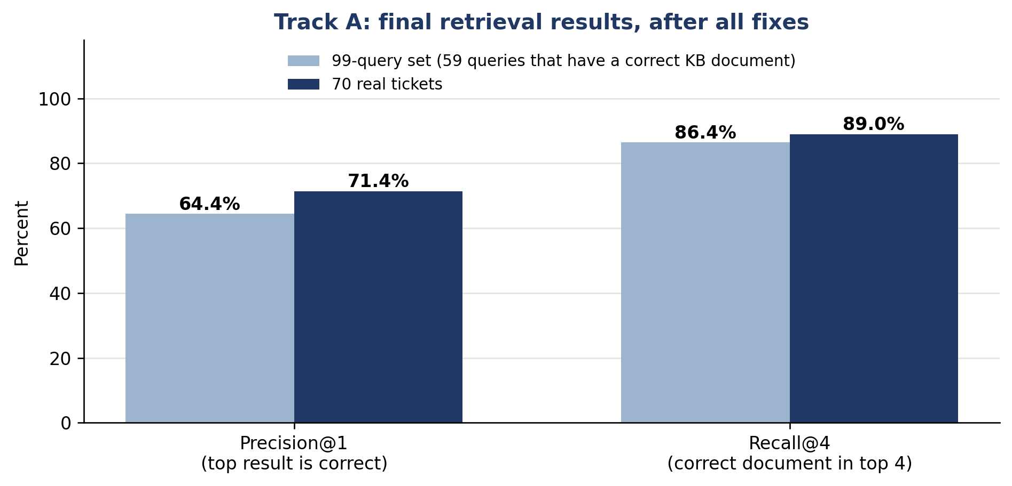
Figure A1: Final retrieval results with the correct team given, on the 99-query set and the 70 real tickets.
Relevance gate
The gate accepts or rejects a retrieved document using one threshold (0.70). It behaves differently on the two sets. On the 99 queries it approved 71 results, and 37 of them were wrong. On the 70 tickets it rejected 15 of the 50 correct results. We chose 0.70 because it was reasonable on both sets. A separate threshold check for each set is a next step.
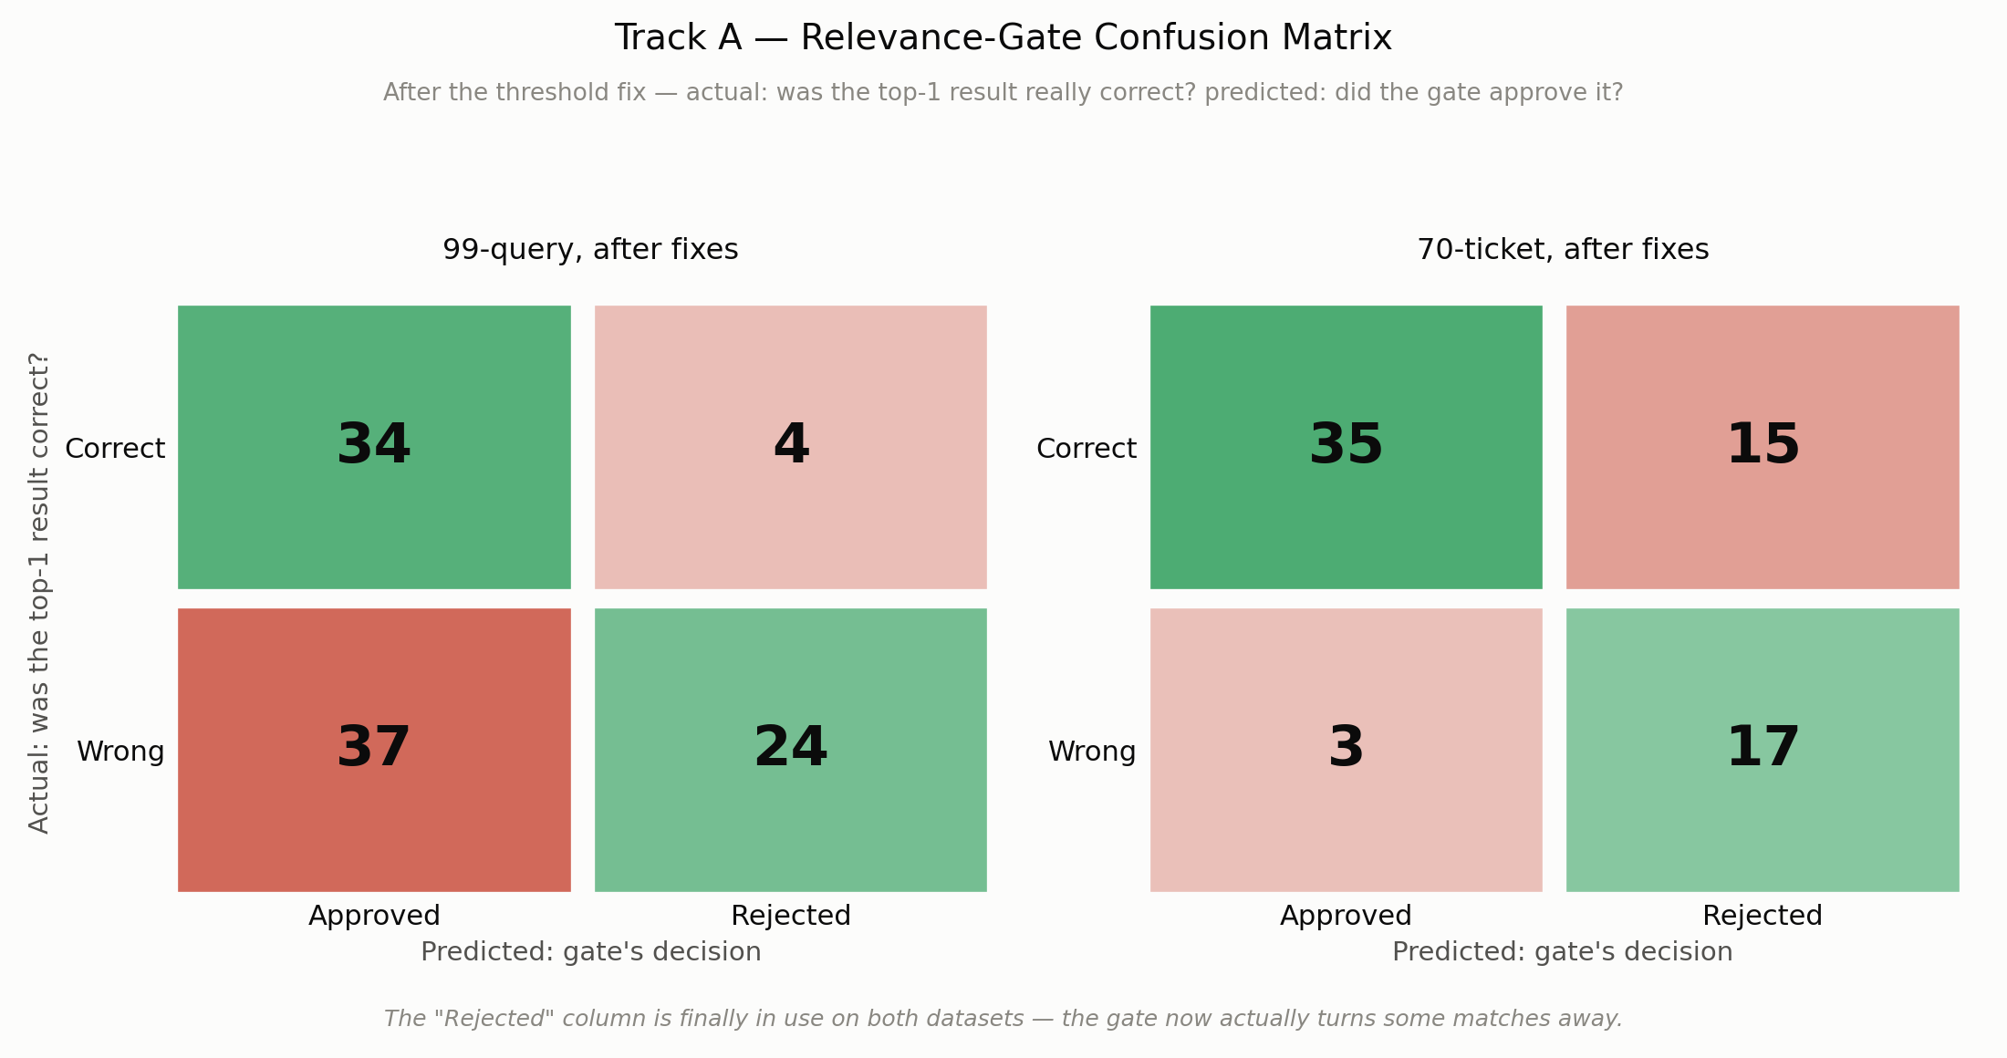
Figure A2: Relevance-gate confusion matrix after the fixes, on both sets.
Real data for KB wording
We collected 54 real customer reviews from Trustpilot pages of Udemy (26), Coursera (12), Pluralsight (10), and Skillshare (6). We also collected 63 real issue posts from the Open edX community forum. The customer reviews gave us natural wording for refunds, cancellations, logins, and app problems, and we added phrases from them to six KB documents. The forum posts came from platform administrators, so we reviewed them for ideas and kept the KB in the customer's voice.
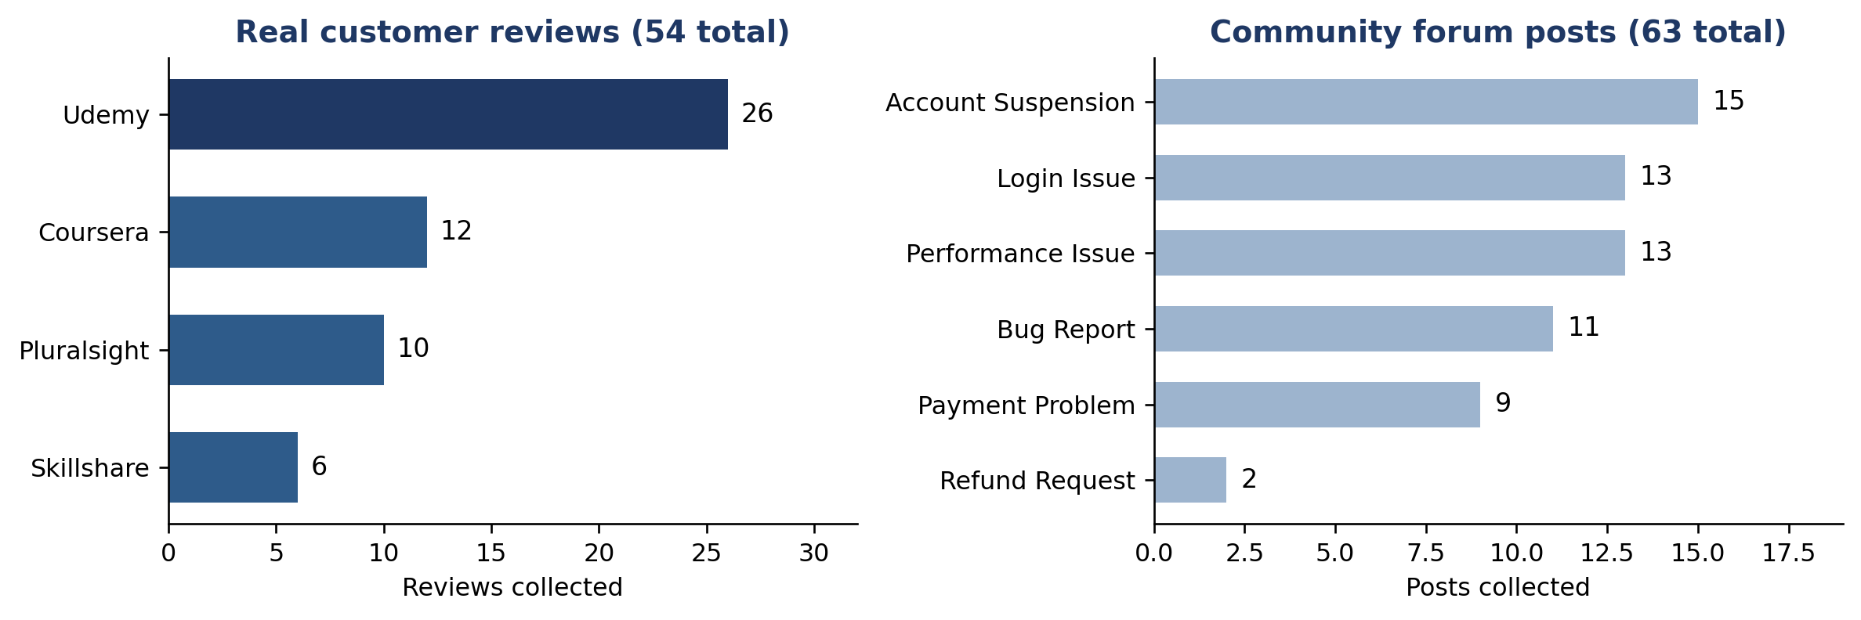
Figure A3: The real issue data we collected for KB ideas.

Appendix B: Track B, Routing and Escalation Accuracy
We measured whether a ticket reaches the right team, and whether a human reviews the tickets that need it.
Phase 1: what the 99 queries showed us
Vinma and Sineth agreed on the team for 95.0% of the flagged queries (kappa 0.922) and on escalation for 71.7% of all queries (kappa 0.430). Where they still disagreed on escalation, we left the query out of scoring, for routing as well: 71 of the 99 queries were scored.
Fixes and results
Stage | What we changed | 99-query set | 70 real tickets
Start | Nothing yet | Routing 63.4%. HR recall 36.8%. Escalation F1 51.9% | Not measured
Fix 1 | Added payment-linkage wording so HR tickets reach HR | Routing 74.6%. HR recall 78.9% | Not measured
Fix 2 | Removed the rule that escalated any negative-sounding ticket | Escalation F1 72.7%. Unnecessary escalations 32 to 7 | Not measured
Fixes 3 and 4 | Added real wording for generic classifier labels and for plain cancellations | Routing 76.1%. HR recall 78.9%. Escalation F1 74.1% | Routing 83.9%. HR recall 92.9%, which is 13 of 14 tickets (7 of 14 before fix 4). Escalation F1 66.7%

What the 70-ticket numbers count
Vinma and Sineth agreed on the team for 90.9% of the 11 unclear tickets (kappa 0.814) and on escalation for 80.0% of tickets (kappa 0.572). We scored the 56 tickets where they reached one answer, and left out the 14 where they still disagreed. So 83.9% routing accuracy is 47 of 56.
For escalation, 19 of the 56 tickets needed a human. Clario sent 13 of them (recall 68%) and missed 6. It also escalated 7 tickets that did not need it. A missed escalation is the costlier error, so this is the first place we will improve.
Checking the left-out tickets
The 14 left-out tickets are probably the harder ones. To check, we scored all 70 tickets against each annotator's labels in turn. We used the pipeline output from the Track C full run, which covers all 70 tickets.
Scoring choice | Tickets | Routing accuracy | Escalation F1
Agreed labels only (headline result, Track B run) | 56 | 83.9% | 66.7%
Agreed labels only (same tickets, Track C run) | 56 | 80.4% | 66.7%
All 70, annotator 1 labels | 70 | 75.7% | 0.62
All 70, annotator 2 labels | 70 | 75.7% | 0.60
The 14 left-out tickets only | 14 | 57.1% | 0.46 and 0.36
Agreed labels only, new model (Track B run) | 56 | 92.9% | 81.2%
Agreed labels only, new model (Track C run) | 56 | 94.6% | 0.79
All 70, annotator 1 labels, new model | 70 | 90.0% | 0.65
All 70, annotator 2 labels, new model | 70 | 90.0% | 0.68
The 14 left-out tickets only, new model | 14 | 71.4% | Not computed

Including the left-out tickets lowers routing accuracy from 80.4% to 75.7% and escalation F1 from 0.67 to about 0.60 to 0.62, in the same run. The Track C run differs from the Track B run on 2 of the 56 routing decisions. The routing code was changed between the two runs (committed 14 September), which may explain the gap between 83.9% and 80.4%. The 80.4% is only 0.4 points above the 80% criterion, so we call routing for the first model borderline. With the new model the same check gives 90.0% on all 70 tickets, against 75.7% for the first model. We keep all views in this report.
The classifier itself handled cancellations well (F1 1.00 on its test set), so the cancellation gap was in our routing rules, not in the model. On the real tickets the classifier often returned a generic label such as General Support, so the rules also read the ticket wording.
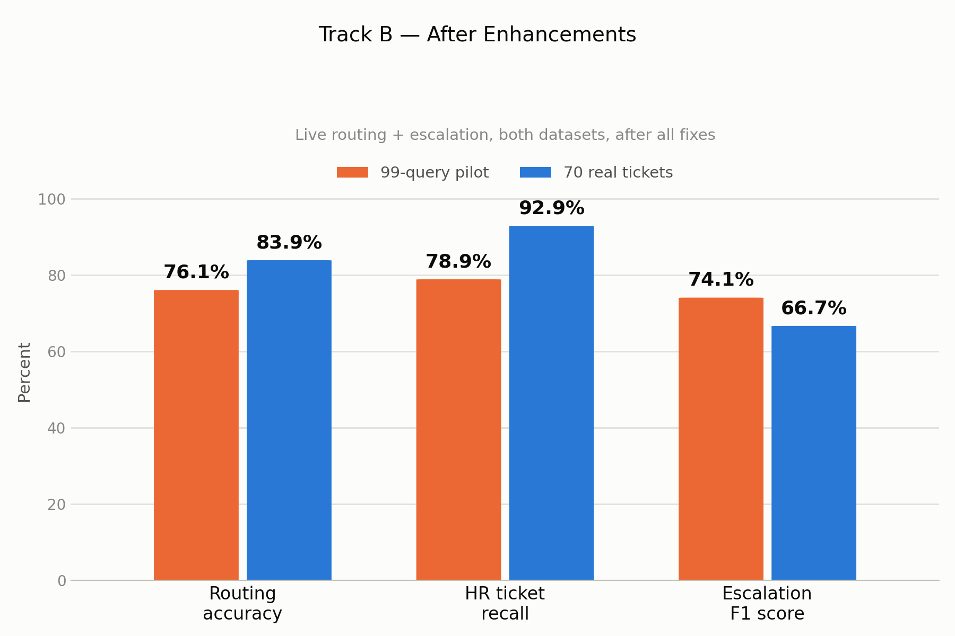
Figure B1: Routing and escalation accuracy after all fixes, on both sets.
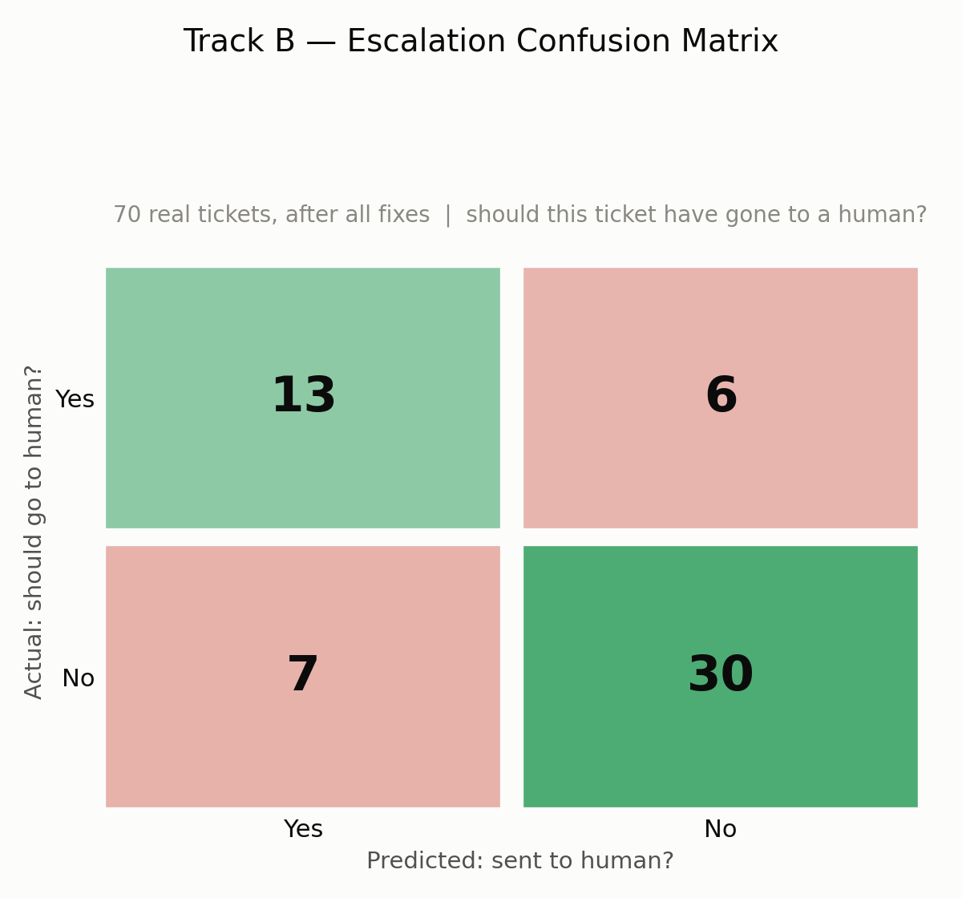
Figure B2: Escalation confusion matrix, 70 real tickets (56 scored).

Appendix C: Track C, Final Response Quality
We measured the reply a customer would receive: a 1 to 5 rubric score, a groundedness check against the KB, and a comparison with the real human reply.
Phase 1: what the 99 queries showed us
The full pipeline produced 90 usable drafts from 87 of the 99 queries. The other 12 queries were escalated to a human without a draft. Ranuga and Vinma read all 90 drafts. The clearest finding was that the drafting step never received the ticket's priority and sentiment, which the classifier had already worked out.
Fixes and results
Fix | What we changed | Result
1. Groundedness checker | Ignore greetings and filler sentences | Flagged sentences 37.9% to 26.3% (same pilot drafts)
2. Drafting prompt | Pass priority and sentiment to every specialist, narrow the HR no-promises rule, and add three rules: do not claim an action is done, do not guess a cause, answer the specific question | Measured together on the 70 tickets (table below). We did not re-run the 99 drafts.
3. Checker, three more rounds | Widen the filler filter for the new empathy and timeframe wording | Final check: 73 sentences counted, 14 flagged (19.2%). We read the 14. Two are "within 24 hours" promises, which the KB does not contain. The other 12 are empathy, advice or process wording. The checker still under-credits, but time promises are not filler.

Domain | Drafts (n) before, after | Overall score (1 to 5) | Tone match (1 to 5) | Groundedness, same checker
Billing | 51, 24 | 2.82 to 4.50 | 2.22 to 4.75 | 81.0% to 80.0%
Technical | 21, 21 | 2.81 to 3.95 | 2.24 to 3.75 | 52.1% to 80.0%
HR | 18, 13 | 3.67 to 4.92 | 3.06 to 4.85 | 94.7% to 83.3%

Each cell shows the 99-query result first, then the 70-ticket result. These are different drafts, so the change shows direction and is not a like-for-like test. Tone match rose 2.1 times in billing, 1.7 times in technical, and 1.6 times in HR. Groundedness is the share of sentences supported by the KB. We widened the filler filter between the pilot and the final check, so we ran the final checker on both sets. It counted 248 sentences in the pilot drafts (billing 137, technical 73, HR 38) and 73 in the final drafts (billing 30, technical 25, HR 18). With one checker, only technical clearly improved. Billing is flat, and HR fell from 94.7% to 83.3%. Billing and technical both land on exactly 80.0% because the groups are small (24 of 30 and 20 of 25 sentences). The hand read of the 14 flagged sentences found 2 time promises ("within 24 hours") that the KB does not contain, and no other invented facts or numbers. So these percentages are conservative, apart from time promises.
Of the 70 tickets, 58 drafts (from 56 tickets) were scored. The other 14 tickets were escalated to a human without a draft. The judge that gives these scores is more generous than human raters on accuracy and groundedness, close to them on overall, and stricter on tone (see Appendix D). So we read accuracy and groundedness scores as upper estimates, and tone scores may be low. The Track D drafts are a different set from these 58 (no draft text is identical), so Track D shows how the judge behaves on comparable drafts. It does not directly cover these scores. Reflection, the cache, and personal-data redaction were live when these drafts were made, so their effect is inside these numbers.
Time promises. The drafting prompt asks for a timeframe when priority is High or Critical or the customer is frustrated, and the judge's tone rule for Medium priority expects "update within 24 hours". The KB has no such promise, so the follow-up time is a commitment not yet confirmed with policy. We count time promises and claims of an action done separately from empathy filler (new-model counts are in Appendix F).
We also compared Clario with the real human reply on 55 tickets. An LLM judge (not a human) chose between the two replies, twice, with the order swapped. It picked the human reply in 42 cases (76%, both passes agreeing), called 7 a tie, and picked Clario in 6. The other 15 tickets were not compared because the daily API limit ran out. We use this as our benchmark for further gains. The judge was gemini-3.1-flash-lite, the same model that writes Clario's replies. If it prefers its own style, that favours Clario, so the 76% for the human reply is, if anything, conservative.
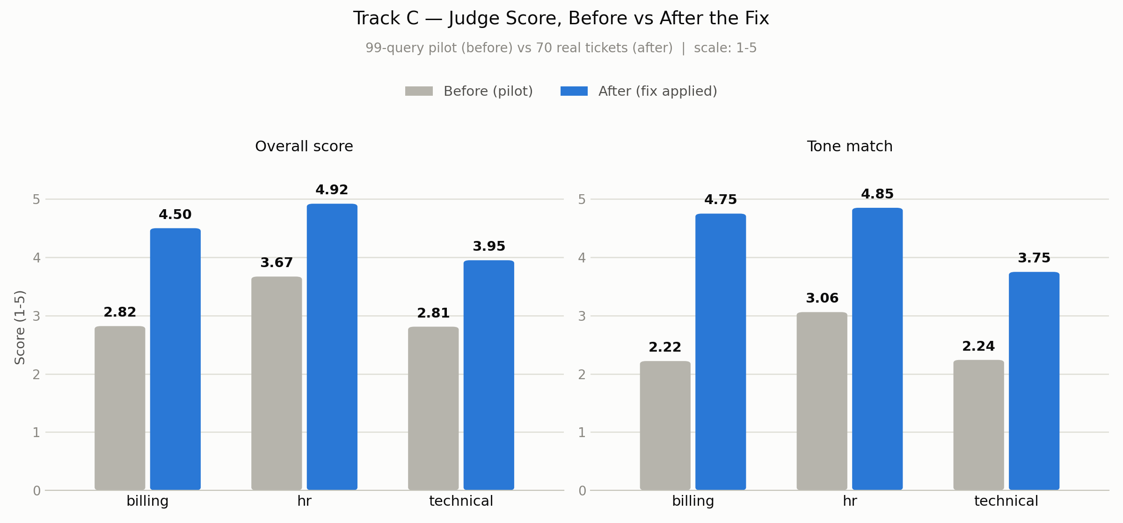
Figure C1: Judge quality score by domain, before and after the fixes.
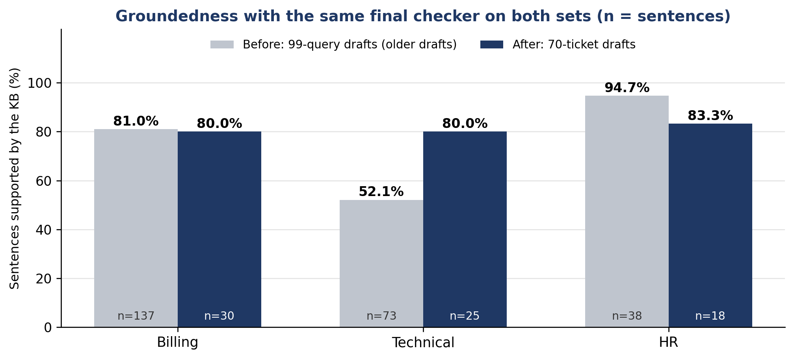
Figure C2: Groundedness by domain with the same final checker on both sets.

Appendix D: Track D, Judge Reliability
Before trusting the automated judge, we checked whether it agrees with real people. Ranuga and Sineth scored the drafts without seeing the judge's scores.
Phase 1: what the 99 queries showed us
Track D scored 99 drafts because it calls each specialist directly, so every query has a draft. Track C used the full pipeline, which escalated 12 queries without a draft (Appendix C). On the 99 drafts, almost every rater and the judge used only scores 3 and 4. This kept kappa low (0.075) even though the judge was within one point of the humans on 94.9% of scores.
Fixes and results
Fix | What we changed | Result
1. Rubric bug | Removed a rule that demanded literal phrases and pushed 96% of scores to 2 out of 5 | Healthy score spread on the pilot
2. Scoring anchors | Gave each of the six dimensions its own concrete 1 to 5 example, in the judge prompt and the human guide | Judge vs humans: kappa 0.075 to 0.339, Spearman 0.249 to 0.764 (different data: 99 drafts before, 70 tickets after)
3. Human recheck | The two raters rechecked the rows where their scores differed by 2 or more points | Human vs human kappa 0.153 to 0.368 (same 82 rows)

What the 82 rows are
The 70 real tickets give 82 rows because 12 tickets go to two domains and get one draft per domain (billing 31, technical 27, HR 24). Both humans scored all 82 rows. The two-domain tickets come from Track A's domain labels, so Track D drafts once per domain. Track B uses one routing label per ticket, so it does not score the second domain.
Comparison | Weighted kappa | Spearman correlation
Judge vs humans, 99 drafts, old rubric | 0.075 | 0.249
Judge vs humans, 82 rows from 70 tickets, new rubric | 0.339 | 0.764

A kappa of 0.339 is in the "fair" range, but the two humans reached only 0.368 with each other, so the judge is close to the human ceiling (0.029 below). On the 99 drafts the humans reached 0.080 and the judge 0.075. The average of the two humans was between 3.5 and 4.5 for accuracy on 88% of rows, which squeezes kappa, and the judge's accuracy kappa is 0.060. Rank order agrees well (Spearman 0.764), but exact scores do not. The judge is more generous than the humans: it gave 5 for accuracy on 50% of rows (humans 4%) and 5 for groundedness on 48% (humans 21%). It never scored accuracy below 4. The gaps are not the same on every dimension: the judge is above the humans on accuracy (+0.55) and groundedness (+0.40), close on overall (-0.08), and below them on tone (-0.29). So we read accuracy and groundedness scores in Track C as upper estimates, and tone scores may be low.
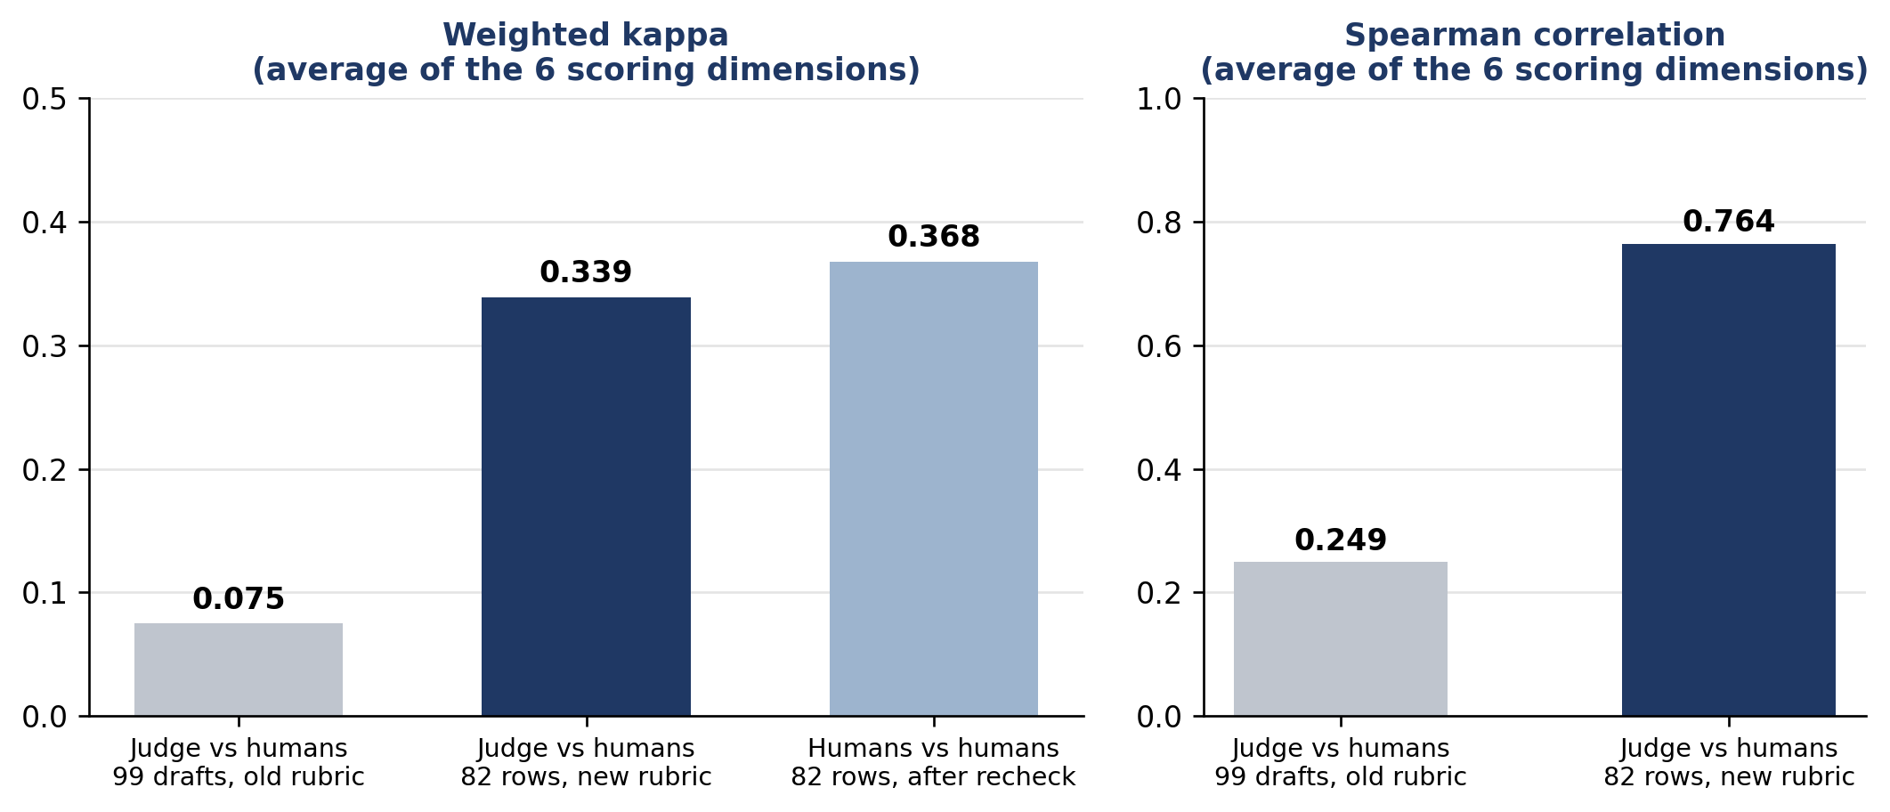
Figure D1: Judge-versus-human agreement and the human-versus-human ceiling. Each value is the average over the six scoring dimensions.
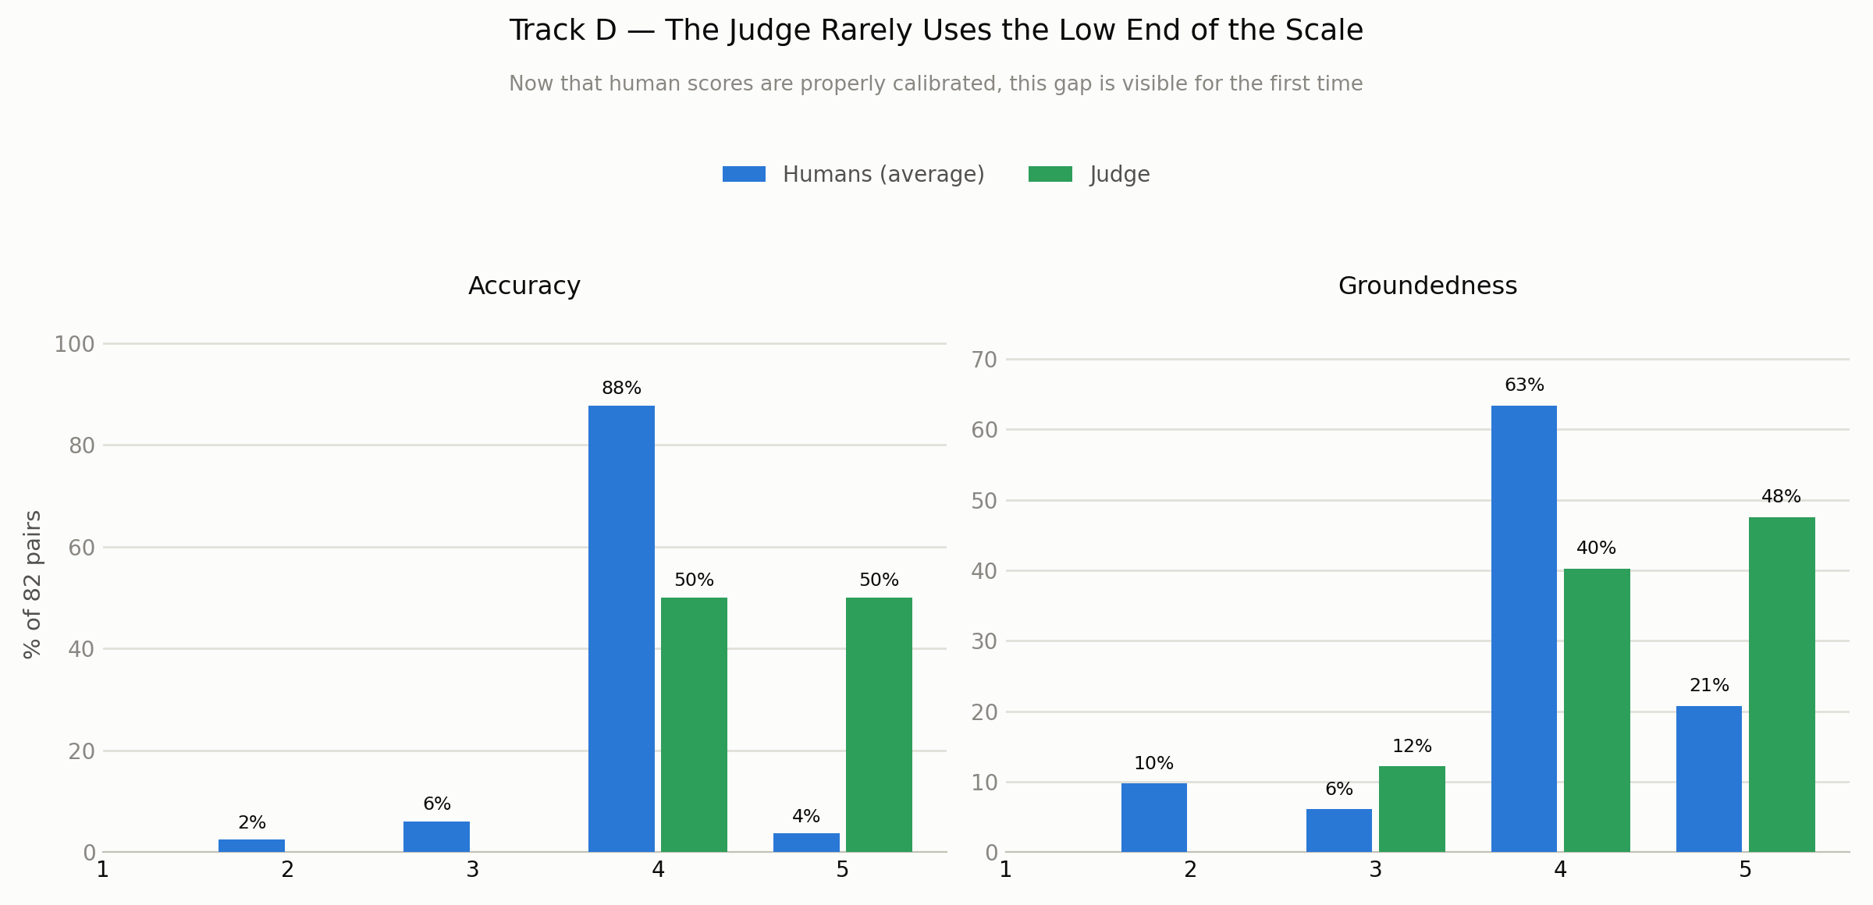
Figure D2: Score spread for accuracy and groundedness, judge and calibrated humans.

Appendix E: Local Llama Classifier Selection
The local classifier reads each ticket first and predicts its category, priority, and sentiment. We fine-tuned four language models on the same ticket data and trained one classic baseline (TF-IDF with a support vector classifier). We then compared all five on the same three tasks.
Model | Category | Priority | Sentiment
Fine-tuned Llama 3.2 (3B, 4-bit) | 96.5% | 77.05% | 77.6%
Fine-tuned Ministral-3 (3B) | 95.95% | 75.4% | 75.75%
Fine-tuned Gemma-3 (1B) | 95.8% | 75.65% | 76.05%
Fine-tuned Qwen2.5 (0.5B) | 95.65% | 75.2% | 62.3%
TF-IDF and SVM (classic ML) | 94.0% | 56.95% | 65.3%

Llama 3.2 came first on all three tasks. Its lead over Ministral-3 and Gemma-3 is 0.5 to 1.9 points. The test-set size is not recorded. Scores move in steps of 0.05 points, so the test set has at least 2,000 items. At 2,000 items the 95% interval is about plus or minus 0.8 points at 96.5% and plus or minus 1.8 points at 77%. The leads are inside that range, so we count them as ties. Per-item predictions would allow a paired test. The clear gaps are against the classic baseline on priority (about 20 points) and sentiment (about 12 points), and against Qwen2.5 on sentiment (about 15 points).
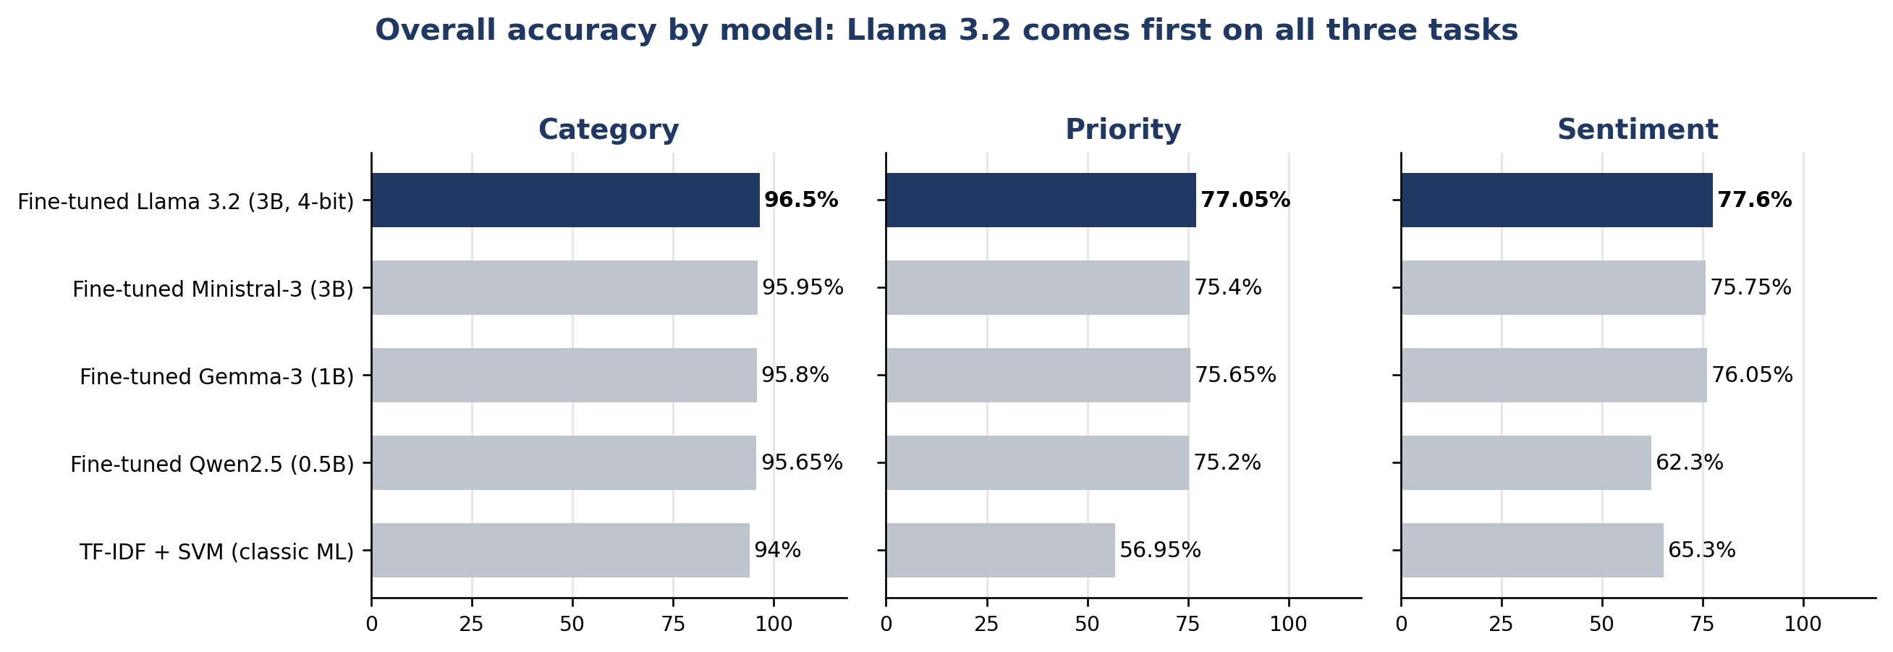
Figure E1: Overall accuracy of the five models on category, priority, and sentiment.
We chose Llama 3.2 (3B) because it ranked first on all three tasks. Gemma-3 (1B) is a close, smaller alternative. We fine-tuned Llama with QLoRA on a 4-bit (NF4) quantized base model with a LoRA adapter (rank 16), so it runs on a single local GPU. Its priority and sentiment predictions also flow into the reply-drafting step (Appendix C).
These results come from the fine-tuning test set, not the 70 real tickets. On real tickets the classifier often gives a generic label (Track B), so our routing rules also read the ticket wording.
Appendix F shows how the classifier changed after we retrained it with Gemini's step-by-step reasoning, and what that did to Tracks A, B and C.

Appendix F: After the Gemini-Distilled Llama 3.2 Adapter
This appendix shows what changed when we replaced the first fine-tuned Llama 3.2 model (Appendix E) with a new one. The new model learned from Gemini's step-by-step reasoning on 13,184 support tickets that Gemini wrote: 10,000 for training and 3,184 held back for testing. Gemini also labelled them. The new model can give one ticket more than one category, from a fixed list of 12. We compare the two models in three places: the fine-tuning test set, our 70 real tickets, and the full pipeline (Tracks A, B and C). All new-model scores on the test set and on the 70 tickets are agreement with Gemini labels, not with human labels.
Short answer: the new model gave every one of the 70 real tickets a real category. With the changes that came with it, every ticket also got a drafted reply, fewer tickets went to a human for no reason, and more were routed correctly. It did not fix every step: HR reply scores fell, groundedness fell in billing and technical, missed escalations stayed at 6 of 19, and retrieval with live routing stays below its criteria.
How the comparison was made
The first-model results were not all made in the same run as the new-model results. The table shows what was reused, as far as file dates and commit dates show.
Result | First model | New model
Track A, live routing | Computed on 19 September, in the same run as the new model | Computed on 19 September
Track B, routing and escalation | The 12 September results, reused (the values are identical). Routing code from before the changes committed on 14 September | 19 September. Routing and escalation code updated to use the new multi-label output
Track C, reply quality | The 16 September drafts and scores, reused. KB before the edits of 18 September | 19 September. KB after the edits (eight documents). Multi-label routing and label-aware search added
Head-to-head with the human reply | 16 September, first model only | Not run

So the Track B and Track C gains combine three changes: the new model, the code changes made to use its labels, and, for Track C, the KB edits. We cannot tell them apart. Only Track A live routing was measured for both models in one run. Read the gains as "the new model plus the changes that came with it". Re-running the first model on the current KB and code would separate them (Section 8.7).
What changed in the model
 | Before (first Llama 3.2) | After (Gemini-distilled Llama 3.2)
Learned from | Ticket labels only | Ticket labels plus Gemini's step-by-step reasoning
Category | One category, 8 classes | One or more categories, 12 labels
Priority | Low, Medium, High, Urgent | Low, Medium, High, Critical
Sentiment | Positive, Neutral, Negative, Strongly Negative | Neutral, Negative, Frustrated

Training setup for the new model: 4-bit QLoRA (rank 16), 3 epochs. The validation loss fell at every check, from 0.398 to 0.279.
1. Fine-tuning test set: before and after
Task | Measure | Before | After | Change
Priority | Macro-F1 | 78.4% | 80.0% | +1.6 points
Priority | Accuracy | 77.0% (with an Urgent class) | 87.6% (with a Critical class) | +10.6 points
Sentiment | Macro-F1 | 70.0% | 77.0% | +7.0 points
Sentiment | Accuracy | 77.6% (4 classes) | 82.4% (3 classes) | +4.8 points
Category | Accuracy | 96.5% (one label, 8 classes) | 81.0% (whole label set must match, 12 labels) | Not comparable

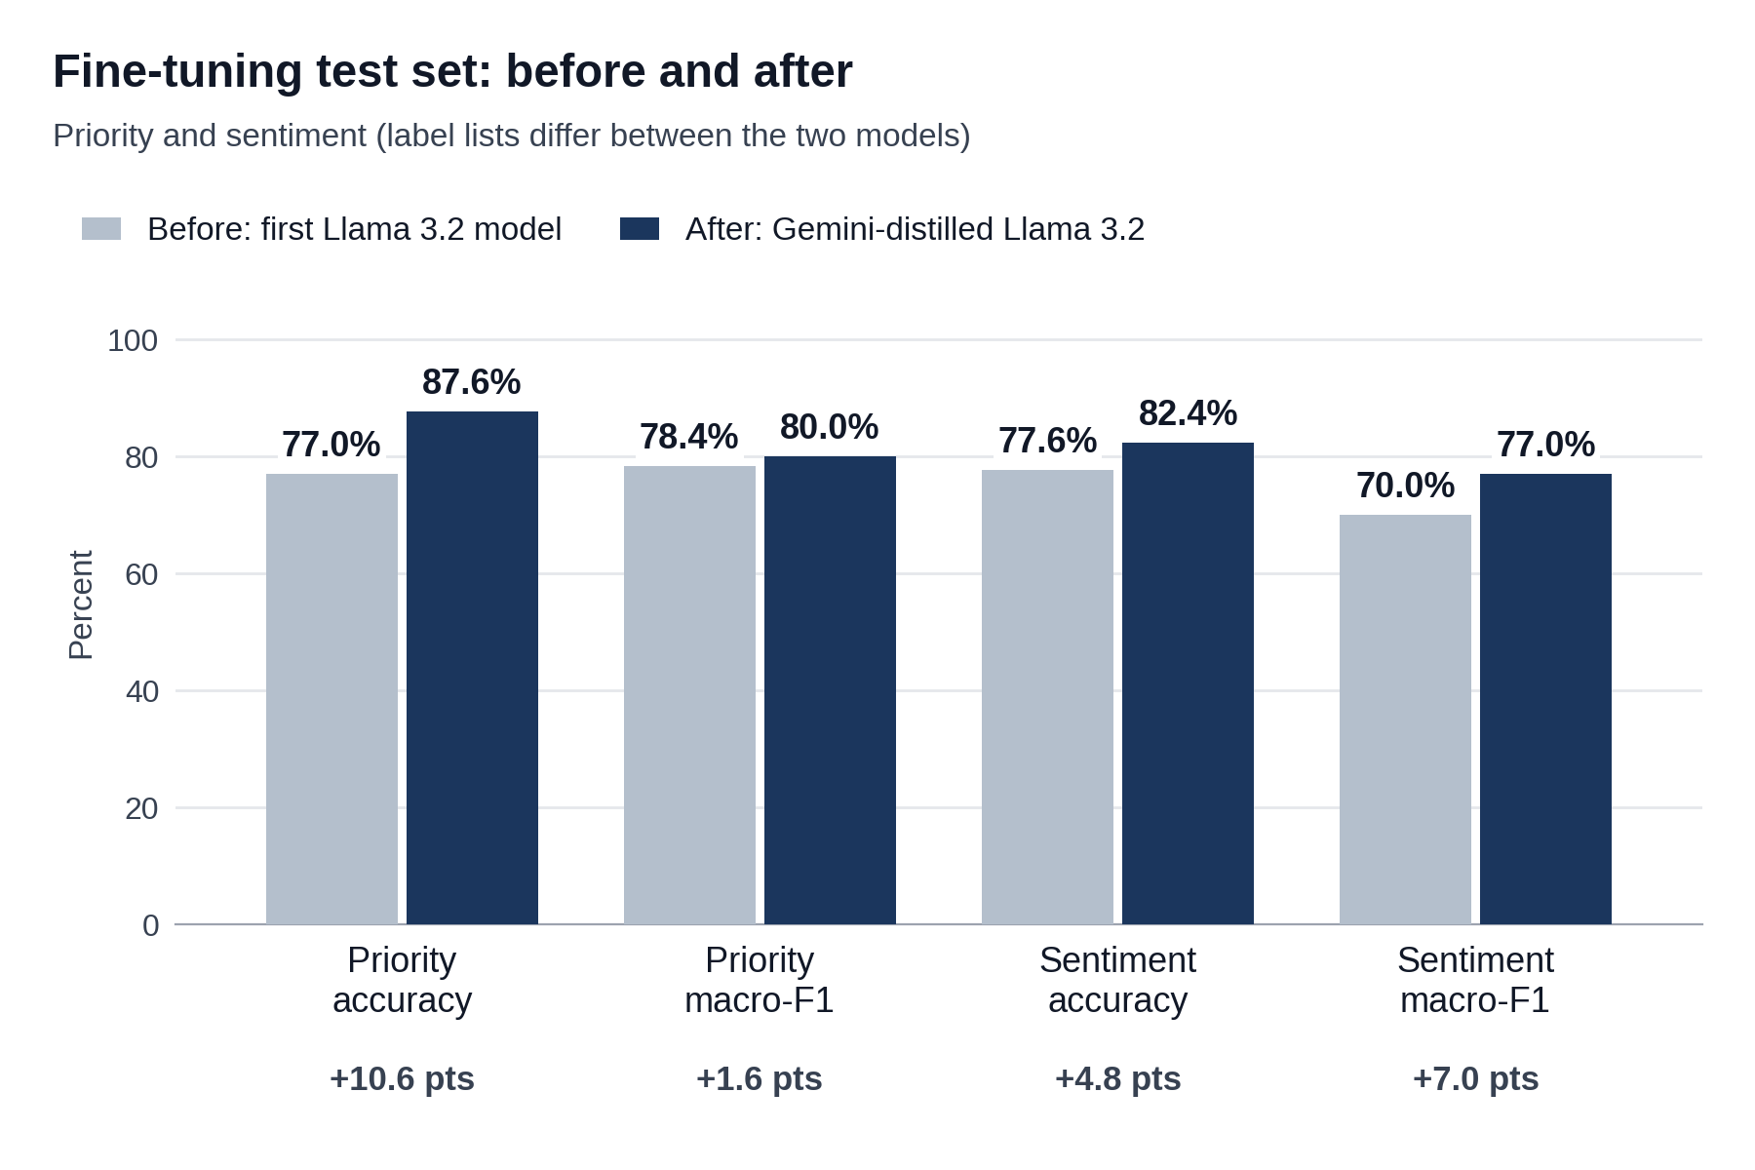
Figure F1: Priority and sentiment results on the fine-tuning test set, before and after.
The two test sets and label lists are different, so read the change as a guide, not a like-for-like result. Priority: Urgent became Critical, and accuracy rose 10.6 points but macro-F1 only 1.6, so most of the accuracy gain is in the large classes. The rarest class (Critical, 47 tickets) still has recall of 53%. Sentiment: the old list had Positive and Strongly Negative. The new list has Neutral (Positive was folded into it), Negative and Frustrated. Because Positive no longer exists, the old weak Positive recall is not fixed; the class was removed. Category: one label from 8 classes against a set of labels from 12, so it cannot be compared.
The new model also beats Ministral-3 (3B) on the same 3,184 test tickets: priority accuracy 87.6% against 85.3%, sentiment accuracy 82.4% against 78.4%, and category exact match 81.0% against 75.1%. It also finds more of the rare classes: Critical priority recall 0.53 against 0.30, and Negative sentiment recall 0.61 against 0.24. Both models were fine-tuned on the same Gemini-labelled tickets and label lists, so the comparison uses the same data and labels.
Strongest category labels: Feature Request (F1 0.98), Performance (0.91), and Billing and Invoicing and Technical Support (0.90 each). The weakest labels are the rare ones, such as Service Outage (21 tickets, F1 0.63) and UI/UX (72 tickets, F1 0.67), so read those as rough.
2. The 70 real tickets
We also ran both models on the 70 real tickets. These tickets have no human labels for category, priority or sentiment, so we made a reference labelling: we ran Gemini on each ticket with the same step-by-step prompt we used to build the training data. The table shows how closely each model agrees with that reference. It is not a human answer key. The reference comes from the same prompt that taught the new model, so it favours the new model. The mapping from the first model's old label names to the new ones (for example Urgent to Critical) was not written down, so read the before-and-after change as a rough guide.
Measure | Before | After
Priority agreement | 42.9% (30 of 70) | 67.1% (47 of 70)
Sentiment agreement | 54.3% (38 of 70) | 67.1% (47 of 70)
Category, whole set matches | 21.4% (15 of 70) | 60.0% (42 of 70)
Category F1, per label | 37.4% | 77.1%
Tickets with no real category | 44 of 70 ("General Support") | 0 of 70

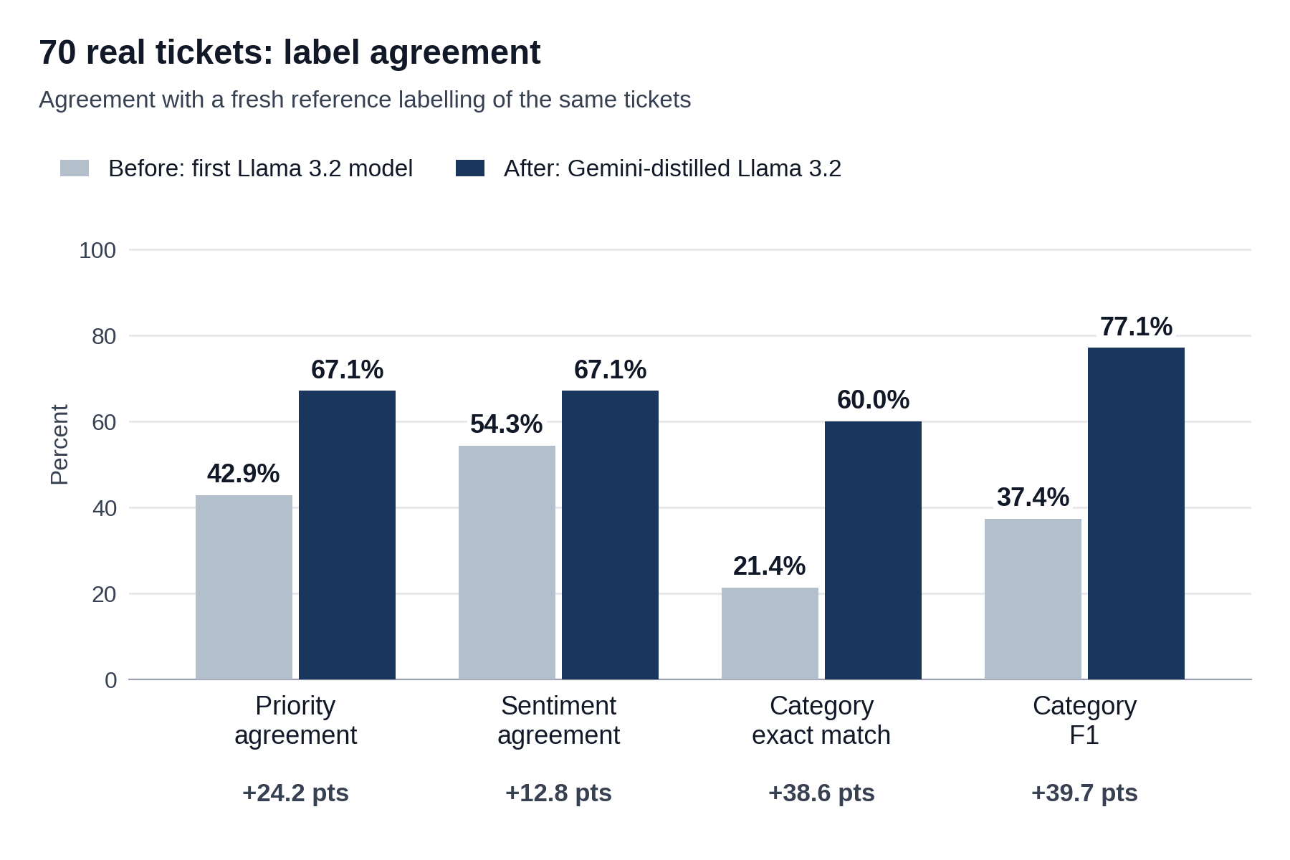
Figure F2: How closely each model agrees with the reference labels on the 70 real tickets.
The old model answered "General Support" for 44 of the 70 tickets (63%), so routing had little to work with. The new model gives a real category for every ticket.
3. Effect on the whole pipeline (70 real tickets)
For each track we ran the same 70 real tickets through the pipeline with the old model and with the new one, and scored them against the same answer keys used in Appendices A to C.
Track A: retrieval
Measure | Before | After | Change
Precision@1 | 47.1% | 52.9% | +5.8 points
Recall@4 | 75.7% | 82.9% | +7.2 points
MRR | 58.2% | 65.5% | +7.3 points

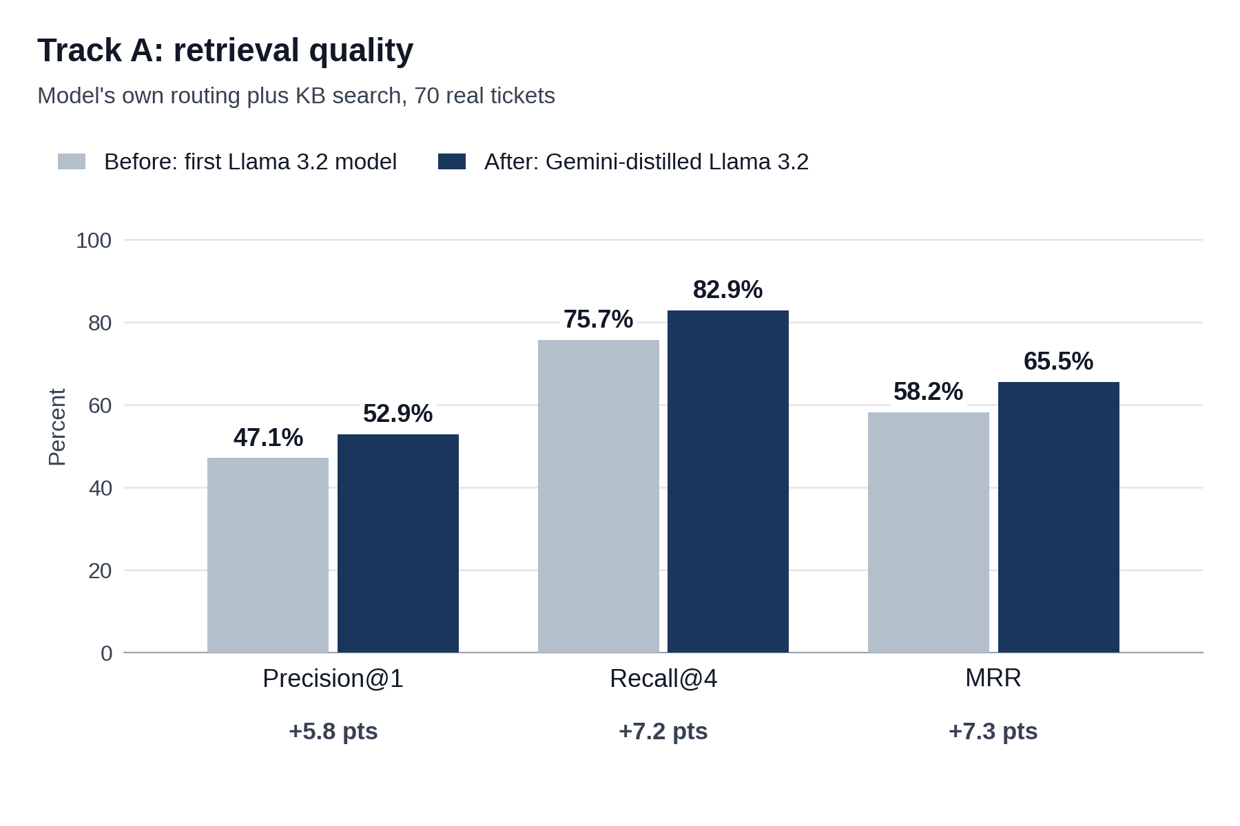
Figure F3: Retrieval results with each model's own routing, 70 real tickets.
These numbers are lower than in Appendix A because the pipeline now picks the team (live routing), where Appendix A gave the correct team. Eight KB documents were also edited on 18 September, after the correct-team results, and that check was not re-run, so we cannot split the drop between the two causes. Both models are below the 60% and 85% criteria. The gain from the new model is 4 more tickets with the right document first (33 to 37 of 70), and the intervals overlap (36% to 59% and 41% to 64%). No paired test was possible for this run. The largest effect is mechanical: the old model left 11 of the 70 tickets with no search at all, and the new model leaves none. We also tried using the model's labels to re-rank the search results. On these 70 tickets it made no clear difference, so we do not count it as a gain.
Track B: routing and escalation
Measure | Before | After | Change
Routing accuracy | 83.9% | 92.9% | +9.0 points
Escalation precision | 65.0% | 100% | +35.0 points
Escalation recall | 68.4% | 68.4% | No change
Escalation F1 | 66.7% | 81.2% | +14.5 points
Tickets sent to a human (of 56) | 20 (35.7%) | 13 (23.2%) | 7 fewer
Unnecessary escalations | 7 | 0 | 7 fewer
Routing accuracy, Track C run (56 tickets) | 80.4% | 94.6% | +8 tickets (+14.3 points)
Routing accuracy, all 70 tickets | 75.7% | 90.0% | +10 tickets (+14.3 points)
Escalation F1, all 70 tickets (two annotators) | 0.62 and 0.60 | 0.65 and 0.68 | +0.03 and +0.08
Missed escalations (of 19 that needed a human) | 6 | 6 | No change

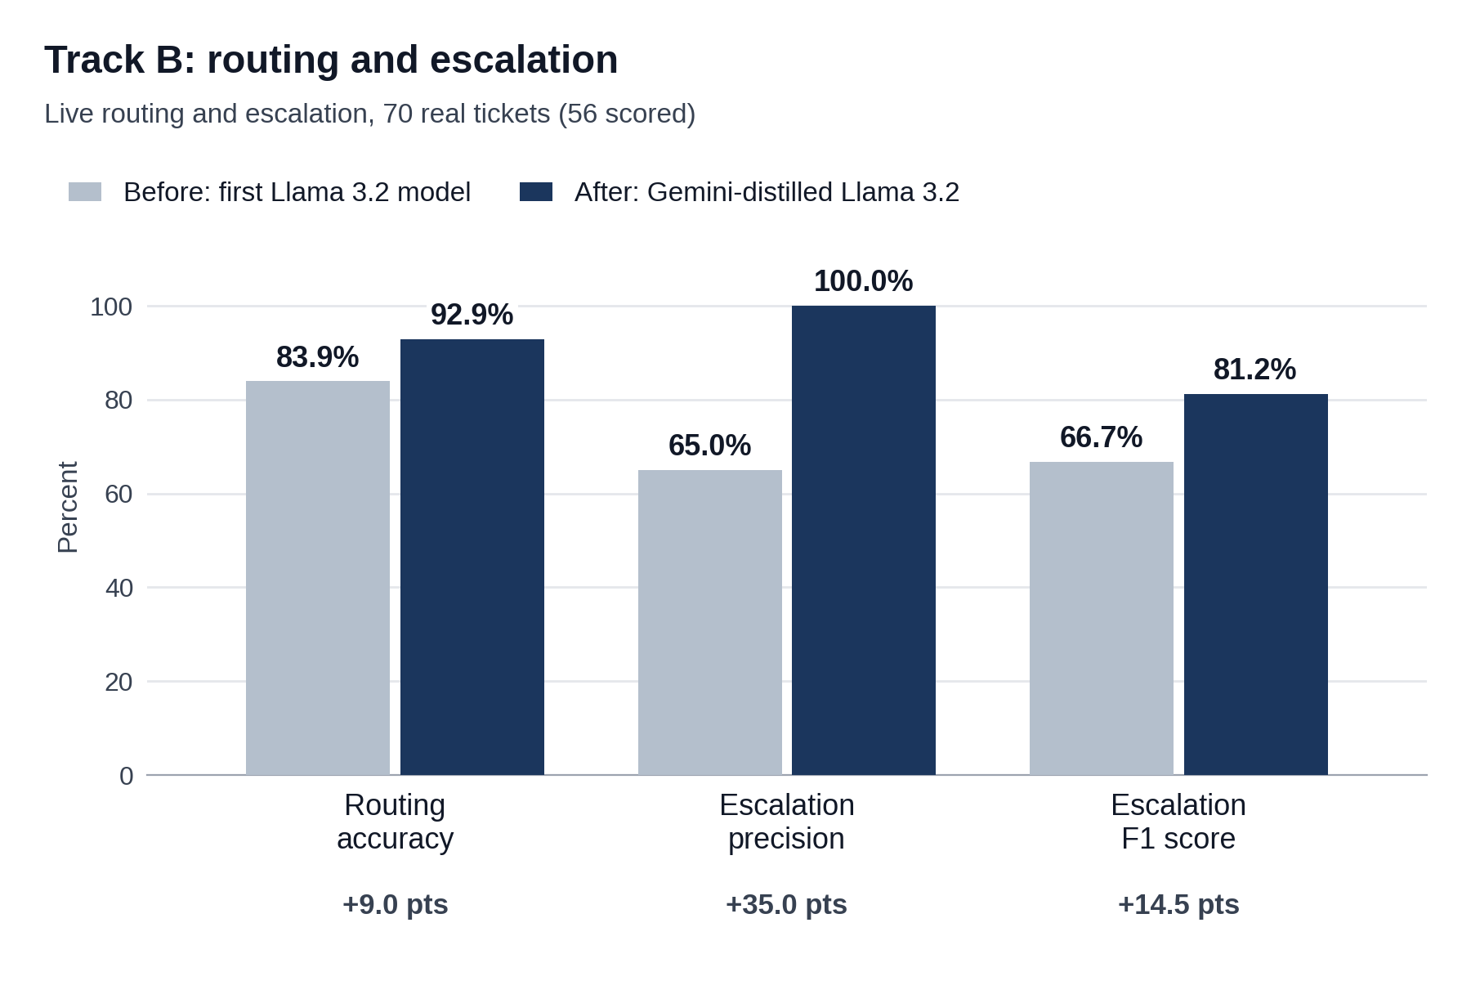
Figure F4: Routing and escalation results, 70 real tickets (56 scored).
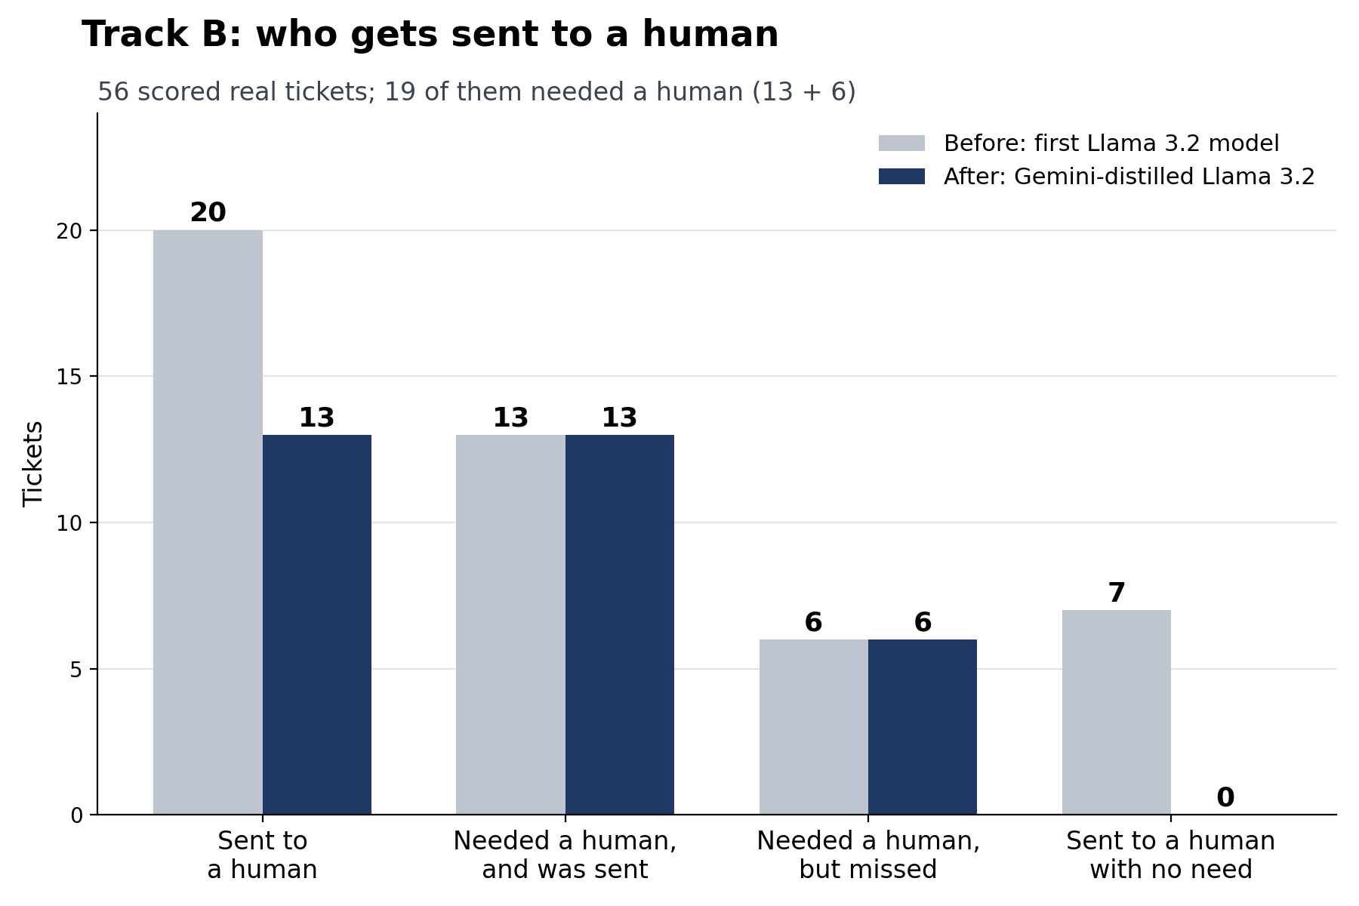
Figure F5: Tickets sent to a human, before and after. 19 of the 56 scored tickets needed one.
Humans now review fewer tickets (13 instead of 20). Of the 19 tickets that needed a human, both models send 13 and miss 6. The new model, with the changes that came with it, routes 9 tickets correctly that the first model got wrong, and 1 the other way (Track C runs, 56 tickets, exact McNemar test p = 0.02). The routing intervals overlap (72% to 91% and 83% to 97%), and the 9-point gain is 5 tickets, so we read the size of the gain as uncertain.
Track C: reply quality
Domain | Drafts (n), before and after | Overall score (1 to 5) | Tone match (1 to 5) | Similarity to human reply | Groundedness, same checker
Billing | 24, 26 | 4.50 to 4.54 | 4.75 to 4.81 | 0.633 to 0.637 | 80.0% to 65.8%
HR | 13, 13 | 4.92 to 4.23 | 4.85 to 4.46 | 0.666 to 0.689 | 83.3% to 94.4%
Technical | 21, 35 | 3.95 to 4.00 | 3.75 to 4.06 | 0.588 to 0.617 | 80.0% to 57.9%

Each cell shows the before result first, then the after result. The biggest change is coverage: the old model left 14 of the 70 tickets with no draft at all, and now every one of the 70 tickets gets a drafted reply (56 of 70 before, 70 of 70 after). On the first pass 2 tickets failed on API errors. We re-ran those two and both produced drafts. On the 56 drafts both models wrote for the same ticket and domain, overall scores did not change in billing (paired p = 0.73) or technical (p = 0.70). HR fell (p = 0.03, one of six paired tests, so exploratory). Tone did not change clearly in any domain (p = 0.16 to 1.0).
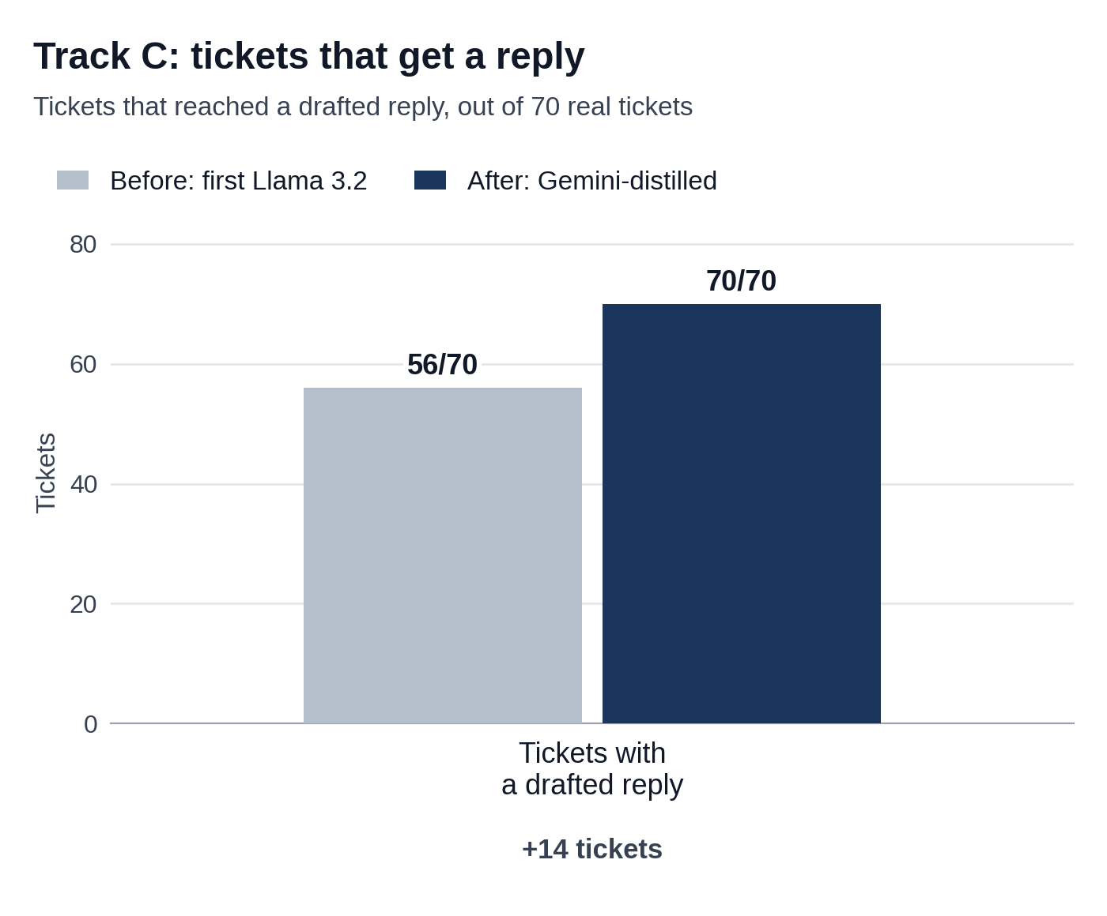
Figure F6: Tickets that received a drafted reply, out of 70.
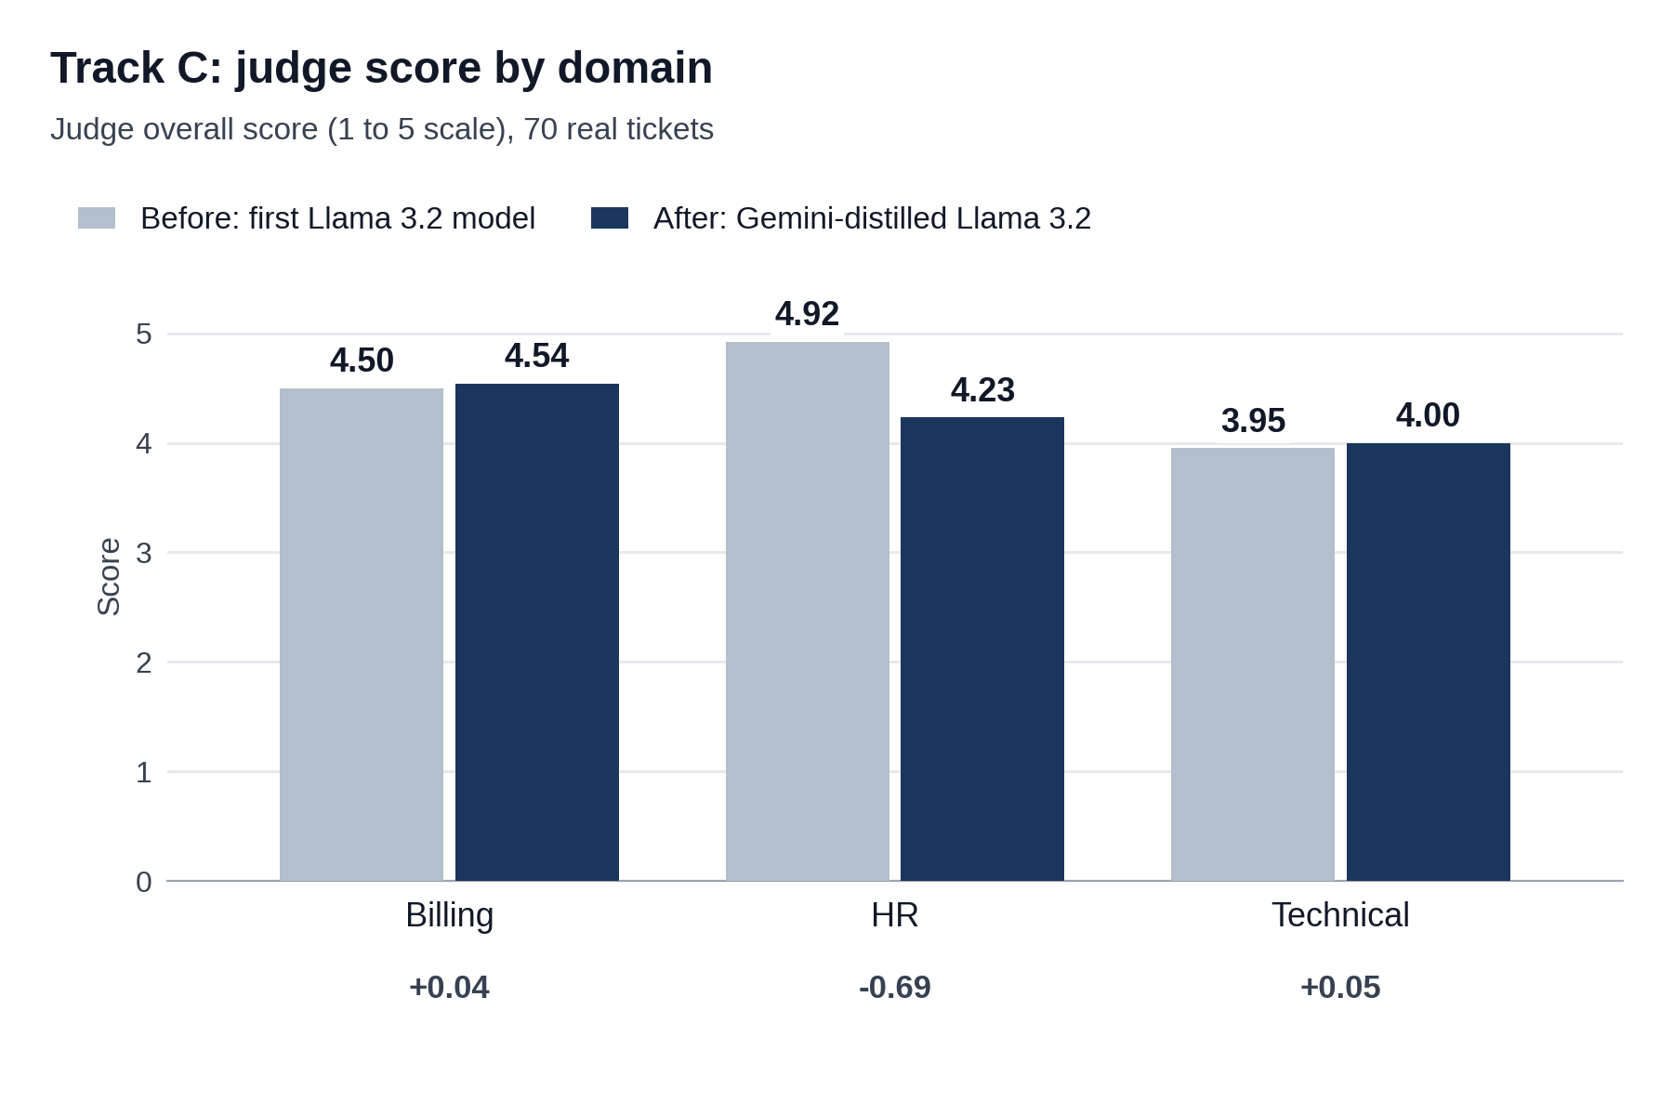
Figure F7: Judge overall score by domain, before and after.
The technical average now covers 35 drafts instead of 21, because tickets that used to get no draft now get one. The groundedness check flagged 30 of 94 sentences as unsupported. We read all 30 by hand and sorted them. Six are time promises ("within 24 hours", "by the end of the day tomorrow"). The KB has no such promise, so these are commitments we have not confirmed. Three say an action is done or under way ("I have forwarded your request to our billing team", "I am escalating this to our technical team", "I am going to look into your account right now"). Two state a fact we could not find in the KB: why access is restricted, and that promotional prices expire. The other 19 are empathy, advice, requests for information, or promises with no time. The first model had 14 flagged sentences: 2 time promises and 12 others. We found no invented numbers other than the time promises. The new replies use more reassuring wording, which is what the tone fix was meant to do, but they also make more promises the KB cannot back.
What we gained with the new model and the changes that came with it
- More tickets get an answer. Tickets with no draft went from 14 to 0. Every ticket now reaches a specialist.
- Fewer needless escalations. Humans review 13 tickets instead of 20, and the 7 unnecessary escalations are gone.
- Routing is right more often. Routing accuracy went from 83.9% to 92.9% (5 more tickets of 56). In the Track C runs the new model plus the changes that came with it gets 9 tickets right that the first model got wrong, and 1 the other way.
- The right KB document may be found more often. Recall@4 went from 75.7% to 82.9%, and Precision@1 from 47.1% to 52.9% (4 more tickets first). The intervals overlap, no paired test was possible, and both are still below the criteria.
- Replies are about as close to real agent replies as before. Similarity moved by +0.004 to +0.029 in every domain, which is small. Tone match did not change clearly on the same drafts (see Section 7.5).
- Labels are specific and can hold more than one topic. A ticket about billing and refunds now keeps both labels instead of one guess. The "General Support" fallback went from 44 of 70 tickets to 0.
Routing, escalation and drafting all start from the classifier's labels, so a classifier change reaches every later step, for better or worse (Section 7.4).
What got worse or stayed weak is in Section 7.4.
4. Validity checks on the new model
The table lists each check and what we found.
Check | What we found
Response cache | The run files do not record cache hits, so we have no per-ticket count. In the saved-reply store as it is now (22 saved replies, all with application ticket IDs; our runs call the pipeline directly and do not save replies), no draft from either run matches a stored reply. We found no sign of cache hits.
Where the 13,184 tickets come from | Gemini wrote them (20,000 synthetic LMS tickets were written; 13,184 were labelled with reasoning). None is a real customer ticket. 10,000 are for training and 3,184 for testing.
Overlap with the 99 queries and the 70 tickets | No identical text. The highest word overlap (Jaccard) between any of the 13,184 tickets and a query or ticket is 0.41 for the 99 queries and 0.45 for the 70 tickets. This is a word check only. We did not run a meaning-level check.
Overlap between training and test | 14 of the 3,184 test texts (0.4%) also appear in the training set. The effect is small.
Who labelled the 3,184 test tickets | Gemini, in the same labelling run as the training tickets. No human labelled them. Scores show agreement with Gemini.
Labels for the 70 real tickets | Made by Gemini with the same prompt that built the training labels. The new model learned from that prompt, so the comparison favours it. It is not a human answer key. Tracks A and B still use the human keys.
Ministral-3 on the same data | Yes. Both were fine-tuned on the same Gemini-labelled tickets and label lists, and scored on the same 3,184 tickets.
Human check on real tickets | None yet (see Section 8.7).

Appendix G: Reproducibility
This table lists the settings needed to repeat the runs. Section 3 lists what we could not record.
Item | Value
Reply-writing model | gemini-3.1-flash-lite, temperature 0.3
Judge model | gemini-3.1-flash-lite, temperature 0.1. This is recorded in the Track D and head-to-head files. The Track C score files do not record it; the settings file names the same model as the reply writer.
Local classifier, new | Llama-3.2-3B-Instruct with a LoRA adapter (rank 16, alpha 32), 4-bit QLoRA, 3 epochs
Local classifier, first | Llama 3.2 (3B) with a rank 16 adapter, 4-bit QLoRA
Data split, new model | 10,000 training tickets and 3,184 test tickets
Search settings | all-MiniLM-L6-v2 embeddings, top 4 results, relevance gate 0.70, groundedness similarity 0.35, cache similarity 0.92
Knowledge base | 29 documents; eight edited on 18 September, after the Appendix A to C results
Result dates | First-model results reused from earlier runs: Track B (12 September) and Track C (16 September). Track A live routing for both models, and all new-model results: 19 September. The code and KB differ between these runs (Appendix F).
Datasets | 99 queries; 70 real tickets (71 rows, one duplicate removed); 13,184 Gemini tickets

