EuqVid-Text: A Dialogue-Based Approach to Gender Bias
Detection in Video Datasets
J26-DS-343
Project Proposal Report
Fernando R. S. R. — IT23449282
B.Sc. (Hons) Degree in Information Technology
Specialized in Data Science
Department of Information Technology
Faculty of Computing
Sri Lanka Institute of Information Technology
September 2026

DECLARATION
I declare that this is my own work and this proposal does not incorporate without acknowledgement any material previously submitted for a degree or diploma in any other university or institute of higher learning, and to the best of my knowledge and belief it does not contain any material previously published or written by another person except where the acknowledgement is made in the text.
Also, I hereby grant to Sri Lanka Institute of Information Technology the non-exclusive right to reproduce and distribute my thesis, in whole or in part, in print, electronic or other medium. I retain the right to use this content in whole or part in future works.

Name | Student ID | Signature
Fernando R. S. R. | IT23449282

The above candidate is carrying out research for the undergraduate Dissertation under my supervision.

Supervisor | Signature | Date
Dr. Prasanna S. Haddela

ABSTRACT
Video datasets used to train multimodal artificial intelligence systems carry gender bias not only in their imagery but in the dialogue transcripts distributed alongside it. Models trained on gender-skewed corpora reproduce and amplify that skew, so disparity present before training surfaces afterwards as measurable performance inequality, at a point where correction is expensive. Dataset documentation records provenance, licence and label schema but carries no quantitative measure of representational disparity, and no method currently converts textual gender disparity in a video dataset into a number a curator can compute before training begins.
This research proposes EuqVid-Text, the textual component of EuqVid, a four-modality pre-training audit metric extending the polynomial regression methodology of EuqAud from the audio modality into video. The component extracts scale-free dialogue disparity features across three levels — volume, interaction structure, and agency and power derived from connotation-frame lexicons — from the speaker-attributed transcripts that ship inside video corpora rather than from screenplays, which are pre-production artefacts distributed with no video dataset.
A quantitative experimental design is adopted. Ground-truth labels are produced by a shared augmentation protocol that reduces one gender’s features at controlled increments, yielding shards of known disparity. A polynomial Ridge regression model with degree capped at two is fitted with feature screening performed inside cross-validation folds, then frozen as an explicit closed-form equation in raw feature units and normalised to a shared scale from −10 to +10 with derived severity tiers. Development follows an iterative software lifecycle, so that every deliverable is assessable independently of the other three components.
Evaluation compares the equation against three dialogue-ratio baselines, reports regression diagnostics per assumption, and characterises stability through 1,000-iteration bootstrap resampling at shard and identity level, leave-one-corpus-out cross-validation, and a monotonicity check on held-out perturbation curves. The frozen equation, its normalisation constants, tier thresholds and per-shard scores are delivered to the fusion stage, where they compose with the visual, temporal and acoustic sub-metrics into the complete EuqVid score.

Keywords — gender bias; dataset auditing; dialogue analysis; polynomial Ridge regression; responsible AI

TABLE OF CONTENTS

LIST OF FIGURES
Figure 1: One scene read through four modalities
Figure 2: The four levels of textual gender bias
Figure 3: Coefficient budget at polynomial degree 2
Figure 4: The EuqVid score scale and severity tiers
Figure 5: Component architecture diagram
Figure 6: Iterative software development lifecycle
Figure 7: Sequence diagram of the EuqVid-Text component
Figure 8: Use case diagram of the EuqVid-Text component
Figure 9: Gantt chart
Figure 10: Work breakdown structure

LIST OF TABLES
Table 1: Research gap
Table 2: Technologies, techniques, architectures and algorithms used
Table 3: Extracted dialogue disparity features
Table 4: Expenses for the proposed component

LIST OF ABBREVIATIONS
Abbreviation | Description
AMI | Augmented Multi-party Interaction Meeting Corpus
ASR | Automatic Speech Recognition
AVA | Atomic Visual Actions dataset
CV | Cross-Validation
MELD | Multimodal EmotionLines Dataset
NLP | Natural Language Processing
OOV | Out-Of-Vocabulary
SDG | Sustainable Development Goal
SDLC | Software Development Life Cycle
VIF | Variance Inflation Factor

1. INTRODUCTION

1.1 Background & Literature survey
Artificial intelligence systems trained on video are now deployed in consequential settings, and the datasets behind them are assembled from film and television material that was never produced with balanced representation as a design goal. Those datasets do not ship only imagery. They ship words — utterance transcripts, subtitles and speaker annotations — distributed as first-class training inputs. MELD, for instance, is an extension of the text-only EmotionLines corpus, so its emotion labels were annotated from dialogue in the first place [1]. Video-language models, captioning systems and video question-answering systems all ingest that text alongside the frames.
Gender bias in the text half of a video corpus is invisible to existing dataset documentation. Dataset cards report clip counts, licences and label schemas; none report whether one gender is written with systematically more to say, or with language that positions them as acting rather than as being acted upon. The distinction matters because the textual channel measures something the other channels cannot reach, as Figure 1 illustrates.
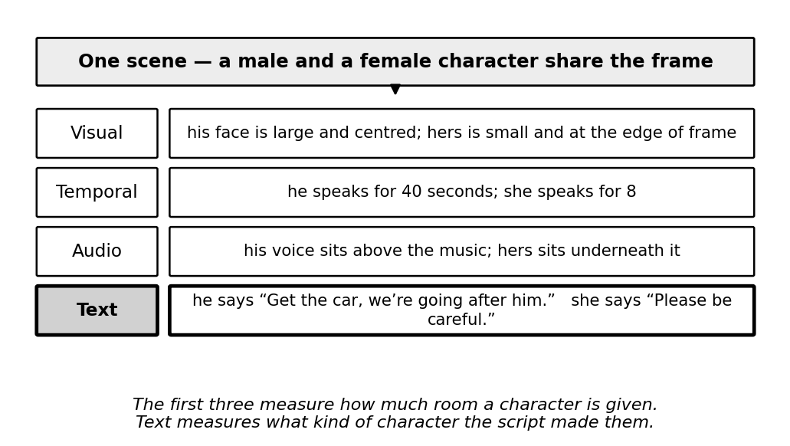
Figure 1: One scene read through four modalities
Equalise a character’s screen time, speaking seconds and loudness, and the language written for that character is unchanged. No visual, temporal or acoustic feature detects that difference, because the difference lies not in how much a character is present but in what the script gives them to do. This is what makes a textual component non-redundant within a multimodal metric rather than a fourth measurement of the same underlying quantity.
Textual gender bias operates at four levels of increasing analytical depth, summarised in Figure 2. The first three are countable and largely restate what visual and temporal measurement already suggests; the fourth requires dependency parsing and a connotation lexicon, and reaches a property of the writing that no other modality exposes.
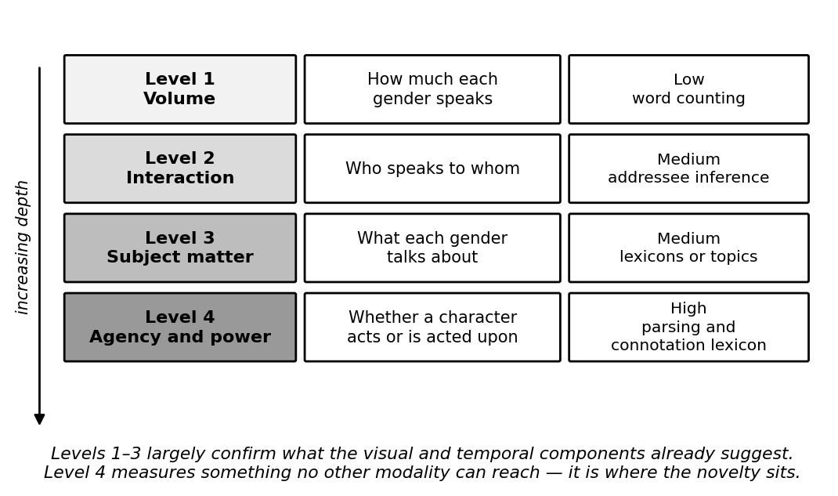
Figure 2: The four levels of textual gender bias
The evidence base divides into two strands. The first establishes that film and television text is gendered. Sap et al. [2] introduced connotation frames of power and agency, annotating verbs for the power differential and level of agency they imply for their syntactic subject, and applying the resulting lexicons to a large corpus of modern film screenplays. They found female characters written with systematically lower agency and lower power than male characters, and released the lexicons publicly. The method is interpretable and the finding robust; its limitation is that the analysis is descriptive, is performed on screenplays rather than on distributed dataset text, and yields no aggregate score. Agarwal et al. [3] built a computational version of the Bechdel test over film scripts using dependency parsing and classification, establishing that interaction structure is machine-detectable. Its output, however, is a binary verdict at film level, which can express neither severity nor comparison between datasets. Bamman et al. [6] learned latent personas of film characters from text and found the recovered archetypes strongly gendered, demonstrating that gendered characterisation is recoverable without supervision, though personas are descriptive clusters rather than a disparity measure.
The second strand justifies measuring bias before training rather than repairing a model afterwards. Zhao et al. [4] measured the gender skew of training corpora and of the predictions of models trained on them, and found that models trained on gender-skewed data are measurably more biased than the data itself. A corpus that is moderately skewed therefore yields a model that behaves as though it were severely skewed, which makes the corpus the efficient point of intervention. Hendricks et al. [7] found that captioning models predicted a subject’s gender from scene context rather than from the person depicted, reproducing dataset stereotypes at inference time; this result also rules out an apparently attractive shortcut, since generating descriptive text with a captioning model for corpora that lack transcripts would measure the captioning model’s bias rather than the dataset’s. Caliskan et al. [8] demonstrated that human-like biases are embedded in language corpora independently of any particular model, which supports treating the corpus rather than the model as the object of measurement.
Recent work confirms the concern remains active. A 2026 network analysis of gendered speaker–addressee patterns in film screenplays [9] examined 4,600 manually annotated directed dialogue events across 38 screenplays and reported male characters dominant as both speakers and addressees even in scenes with a female majority, concluding that bias in film dialogue operates through the architecture of conversation itself. Its output is a set of descriptive findings and network visualisations; it produces no dataset-level score. One methodological caution is inherited from it: that study annotated addressees manually, whereas the present component approximates addressee from turn adjacency, and this is declared as a limitation rather than left to be discovered.
Among applied systems, the Geena Davis Inclusion Quotient is the most established, measuring screen and speaking time by gender in film through automated audio and video analysis. Its function is descriptive analytics, its users are content producers rather than dataset builders, and it does not examine dialogue content, does not emit a continuous score, and is not designed to operate inside a machine-learning dataset pipeline. Dataset rebalancing tools adjust sample counts to equalise representation but operate on counts alone and provide no measure of severity. EuqAud [5] established a regression-derived closed-form gender bias score for audio datasets and is the parent methodology of this project, but its features are acoustic and its corpora are read speech recorded in quiet conditions, so neither the features nor the fitted equation transfer to text.

1.2 Research Gap
While the studies above have each made progress in measuring gendered language in film and in demonstrating how dataset bias propagates into trained models, a detailed comparison reveals gaps in scope and application that this research addresses. Table 1 sets the existing approaches against the capabilities required of a pre-training textual audit metric.
Application reference | Dialogue-level analysis | Continuous severity score | Scale-invariant across corpora | Computable on distributed dataset text | Composes with other modalities
Research A [2] | ✓ | ✗ | ✗ | ✗ | ✗
Research B [3] | ✓ | ✗ | ✗ | ✗ | ✗
Research C [4] | ✗ | ✗ | ✓ | ✓ | ✗
Research D [5] | ✗ | ✓ | ✓ | ✓ | ✗
Proposed system | ✓ | ✓ | ✓ | ✓ | ✓
Table 1: Research gap
Research A [2] measures agency and power in film dialogue using connotation frames, and is the source of the Level 4 features adopted here. It analyses screenplays, which are pre-production artefacts distributed with no video dataset, and reports a descriptive finding rather than producing a score a curator can compute on their own corpus.
Research B [3] automates the Bechdel test over film scripts, establishing that interaction-level structure is machine-detectable. Its verdict is binary and at film level, so it cannot express how severe a disparity is, cannot rank two corpora against each other, and cannot be computed per dataset shard.
Research C [4] demonstrates bias amplification and proposes corpus-level constraints to reduce it. It works on images and structured labels rather than narrative dialogue, and intervenes at inference rather than measuring the dataset, so it motivates a pre-training metric without supplying one.
Research D [5] is EuqAud, which does produce a frozen, regression-derived, scale-invariant score and is the methodological parent of this work. It covers the audio modality only; its features are acoustic and its corpora are read speech recorded in quiet conditions, so neither the feature set nor the equation transfers to text, and it is a single-modality instrument rather than one designed to compose with others.
The proposed component combines dialogue-level analysis at four depths with a continuous, scale-invariant score computed on the transcripts that actually ship inside video corpora, and is designed from the outset to compose with the visual, temporal and acoustic sub-metrics. A structural consequence of that four-component design is shown in Figure 3: distributing the feature space across four sub-metrics keeps the polynomial expansion within a coefficient budget that the available number of independent shards can support, whereas a single equation over the combined feature set would not be reliably fittable.
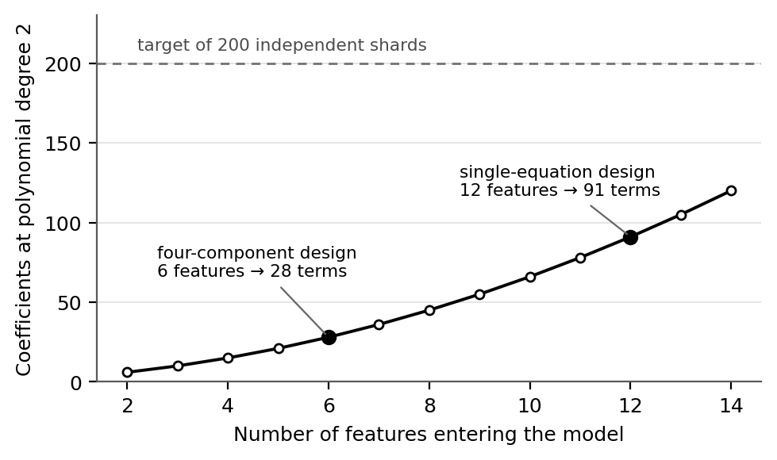
Figure 3: Coefficient budget at polynomial degree 2
Stated precisely, the gap is this: no method exists to compute a continuous, scale-invariant gender-disparity score from the speaker-attributed dialogue distributed inside a video dataset, before any model is trained, on a scale comparable with measures of visual and temporal disparity.

1.3 Research Problem
In consideration of the background and the gap identified above, three principal issues require attention within the framework of the proposed component. These serve as the major factors guiding the development and refinement of the solution.
1. How can gendered language in a video dataset be reduced to a single comparable number?
A feature table is not an answer. Presenting a dataset curator with seven per-gender quantities tells them nothing actionable until those quantities collapse into one score with a severity tier they can act on. The problem is not measurement alone but the construction of an aggregation rule that is defensible, reproducible and comparable across corpora of different sizes.
2. How can ground truth be established when no video dataset carries a bias label?
No corpus is annotated with a dataset-level bias score, so there is nothing to regress against. The problem is to manufacture ground truth under controlled conditions, perturbing real feature data at known increments so that the magnitude and direction of disparity in each training case are known because they were imposed, while keeping the resulting labels meaningful enough that an equation fitted to them transfers to unperturbed data.
3. How can the resulting measure be made auditable rather than merely accurate?
A dataset audit instrument that cannot be inspected is of limited use to the person who must defend a decision made on its output. The problem is to express the fitted relationship as a frozen closed-form equation in raw feature units, with published coefficients, stated normalisation bounds and derived tier thresholds, so that a third party can recompute any score by hand and challenge any term in it.

2. OBJECTIVES

2.1 Main Objectives
The main objective of this research is to develop and freeze a closed-form, scale-invariant polynomial Ridge regression equation that maps dialogue-derived disparity features of a video dataset to a single interpretable gender-bias score on the interval −10 to +10, and to demonstrate that the equation responds monotonically to controlled disparity and that its coefficients are stable under resampling at shard and identity level. By producing a measure that requires no model training to apply, the work aims to make representational disparity in the text track of a video corpus visible at the point where correction is least expensive. The score, its severity tiers and the boundaries between them are shown in Figure 4.
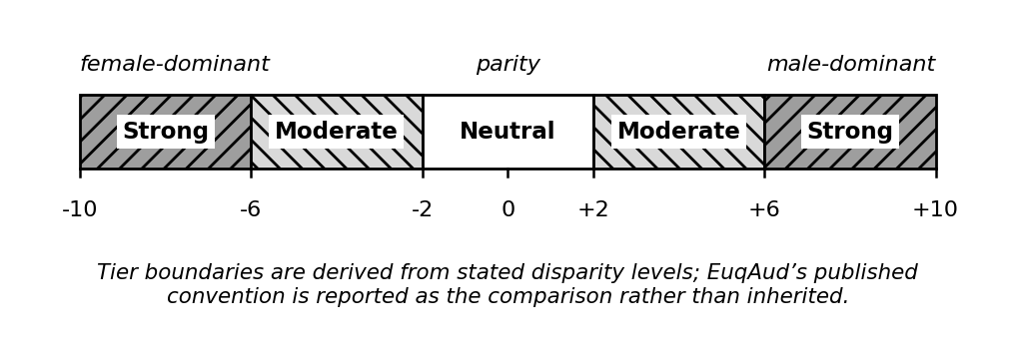
Figure 4: The EuqVid score scale and severity tiers
A score of zero denotes parity between genders, not the naturally occurring distribution of a corpus. Positive values indicate male-dominant disparity and negative values female-dominant disparity, so the sign carries direction while the magnitude carries severity. Because the same scale is used by all four sub-metrics, a reading of +6 is intended to denote the same degree of disparity whichever modality produced it, which is why the calibration reference set is a shared group asset rather than a component-private choice.

2.2 Specific Objectives
There are six sub-objectives that must be achieved in order to complete the main objective.
Construction of the speaker-attributed input corpus
- Build a time-aligned utterance table from MELD and AMI and at least one further dialogue corpus, carrying clip, utterance, speaker, text and timing fields. Map each speaker identifier to male, female or unknown using a documented mapping, and report the proportion of utterances excluded for unresolved or ambiguous identity rather than dropping them silently.
Extraction of the dialogue disparity features
- Compute seven scale-free features per shard per gender across the volume, interaction and agency–power levels. Report the out-of-vocabulary rate of subject–verb pairs against the connotation-frame lexicon, since that rate determines whether the Level 4 features are viable on conversational television dialogue or whether the component falls back to Levels 1 to 3.
Generation of synthetic ground-truth bias labels
- Apply the shared group augmentation protocol to produce shards at controlled incremental disparity levels, yielding a labelled training set of at least 200 independent shards partitioned by identity so that no character spans two shards.
Fitting and selection of the sub-metric
- Fit a polynomial Ridge model with degree capped at two by cross-validated grid search over the regularisation parameter, with feature screening performed inside folds rather than on the full set beforehand, and report both nominal row count and effective sample size.
Freezing of the closed-form equation
- Express the fitted model as an explicit equation in raw feature units with scaling constants folded into the published coefficients, stated min–max normalisation bounds, and severity-tier thresholds derived from stated disparity levels rather than inherited.
Characterisation of stability and generalisation
- Run 1,000-iteration bootstrap resampling at shard and identity level, leave-one-corpus-out cross-validation, and a monotonicity check against held-out perturbation curves, reporting confidence intervals at both score and tier level.

3. METHODOLOGY
The methodology involves reading speaker-attributed dialogue directly from the annotation files distributed with each video corpus, mapping each speaker to a gender using a mapping shared across the whole project, and assigning utterances to identity-partitioned shards. Dependency parsing recovers the subject–verb relations that the agency and power features require, and every feature is converted to a share or a normalised ratio so that no raw magnitude enters the model. A shared augmentation protocol then perturbs the feature data at controlled increments to produce shards of known disparity, against which a polynomial Ridge regression is fitted, frozen as a closed-form equation, normalised to the interval −10 to +10 and assigned severity tiers. No video is opened at any stage of this component.
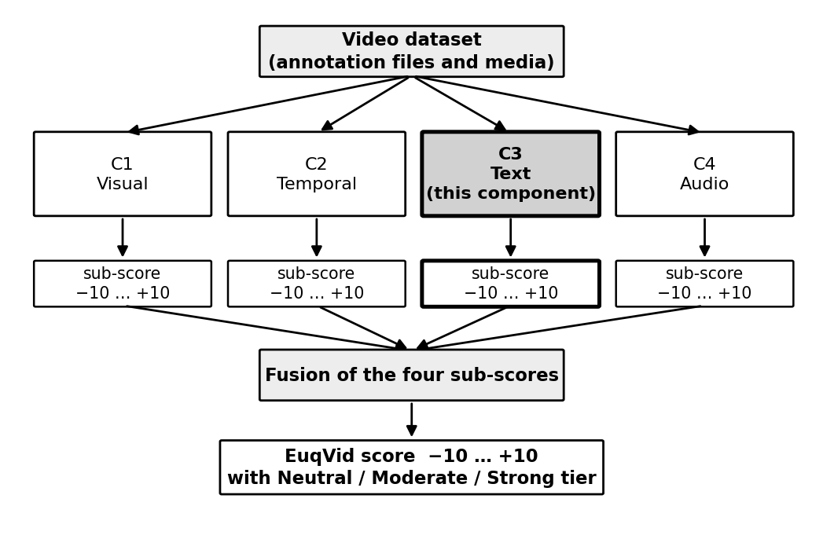
Figure 5: Component architecture diagram
Figure 5 illustrates the overall high-level architectural diagram of the proposed component and its position within the complete solution. Three dependencies between the four components are real and must be managed rather than assumed: all four must aggregate over the same identity-to-gender map, or the sub-scores describe different populations; all four must use the same shard definition, since fusion operates per shard; and all four must share one augmentation and labelling protocol, because four private definitions of a bias level would calibrate the sub-metrics against four different meanings. A fourth constraint determines which corpora the fused score can be computed on at all, since a shard must carry all four sub-scores for fusion to apply and a corpus without a transcript yields no textual sub-score.
A summary of the technologies, techniques, architectures and algorithms used for the measurement of textual gender disparity is shown in Table 2 below.
Technologies | Python, spaCy, scikit-learn, statsmodels, SciPy, NumPy, Git
Techniques | Dependency parsing, connotation-frame lexicon lookup, controlled feature-reduction augmentation, in-fold feature screening, min–max normalisation, bootstrap resampling
Algorithms | Polynomial feature expansion, Ridge (L2) regression, grid search with cross-validation, Pearson and Spearman correlation, Durbin–Watson, Breusch–Pagan, variance inflation factor, Kruskal–Wallis
Architectures | Frozen closed-form regression equation; modular extraction pipeline with a pluggable feature schema
Table 2: Technologies, techniques, architectures and algorithms used
The seven features the pipeline produces are given in Table 3. Means are used rather than standard deviations: EuqAud used standard deviations of pitch, energy and amplitude because those quantities are intrinsically gender-linked, so a mean would merely detect that a woman is present, whereas dialogue volume and agency are not intrinsically gender-linked and the signal lives in the mean.
# | Feature | Definition | Level
F1 | dialogue_volume_share | Words spoken by gender g divided by total words in the shard | Volume
F2 | mean_utterance_length | Mean words per utterance for gender g, normalised by the shard mean | Volume
F3 | agency_score_mean | Mean agency value of verbs for which a character of gender g is the syntactic subject [2] | Agency
F4 | power_score_mean | Mean power value over the same subject–verb pairs [2] | Power
F5 | same_gender_dialogue_share | Proportion of gender g’s utterances in an adjacent turn with a character of the same gender | Interaction
F6 | mention_ratio | Times a character of gender g is named by others, divided by the times they speak | Interaction
F7 | sentiment_valence_mean | Mean sentiment polarity of gender g’s utterances | Subject matter
Table 3: Extracted dialogue disparity features
An eighth candidate, utterance_count_share, was deliberately excluded because it is the same quantity as the temporal component’s turn-count share, and retaining it in both sub-metrics would weight that signal twice in the fused score. This is a cross-component duplication that within-component collinearity screening cannot detect, since screening operates only on the features present in a single model.

3.1.1 Software solution
An iterative software development lifecycle was selected for this component, driven by its adaptability to evolving requirements. The determining factor is a dependency structure rather than a preference: the component consumes a feature schema agreed collectively and not yet frozen, and delivers into a fusion stage that does not yet exist, so a sequential waterfall approach would idle until both are settled. An iterative approach allows the complete pipeline to be built first against a synthetic feature table of the correct shape and real inputs substituted as they arrive, which keeps every deliverable assessable without the fusion stage existing and without any other component being complete. The stages of the lifecycle are set out below and shown in Figure 6.
Requirement gathering
- Surveying the candidate corpora to establish which ship speaker-attributed dialogue, what fields each annotation format carries, and what licence governs its use.
- Agreeing the shared assets with the other three components — the identity-to-gender map, the shard definition and the augmentation protocol — since none of these can be decided by one component alone.
Feasibility study (planning)
- Economic feasibility — the entire toolchain is open-source, the corpora are free for academic use, and no GPU or cloud compute is required, so the direct cost of the component is effectively zero and the dominant cost is human effort.
- Scheduled feasibility — the work divides into five phases across the academic year, with Phase 0 group decisions gating the start of extraction and the Phase 5 handoff gating the fusion stage. The schedule is shown in Section 5.
- Technical feasibility — the heaviest computational stage is dependency parsing, which is parallelisable and runs on standard student hardware. The principal technical risk is not compute but lexicon coverage, since the connotation-frame lexicon was built on screenplays while MELD is informal overlapping conversation; this is measured and reported rather than assumed.
Design (system and software design documents)
- Sequence Diagram — Figure 7 shows the order in which data moves through the component and where responsibility passes between this component and the shared group assets it depends on.
- Use Case Diagram — Figure 8 shows the actors interacting with the component and the operations available to each.
Implementation (development)
- The pipeline is implemented in Python and parameterised over the feature schema, so that a column-name change costs nothing. It is built first against a synthetic feature table and switched to real corpus input as extraction completes, with notebooks and scripts seed-fixed so that any reported result reproduces exactly.
Testing (review and monitor)
- Regression assumptions are tested per fit using Durbin–Watson, Breusch–Pagan and the variance inflation factor, and reported as pass or fail rather than suppressed. Stability is tested by 1,000-iteration bootstrap resampling at shard and identity level, generalisation by leave-one-corpus-out cross-validation, and sensitivity by a monotonicity check on held-out perturbation curves.
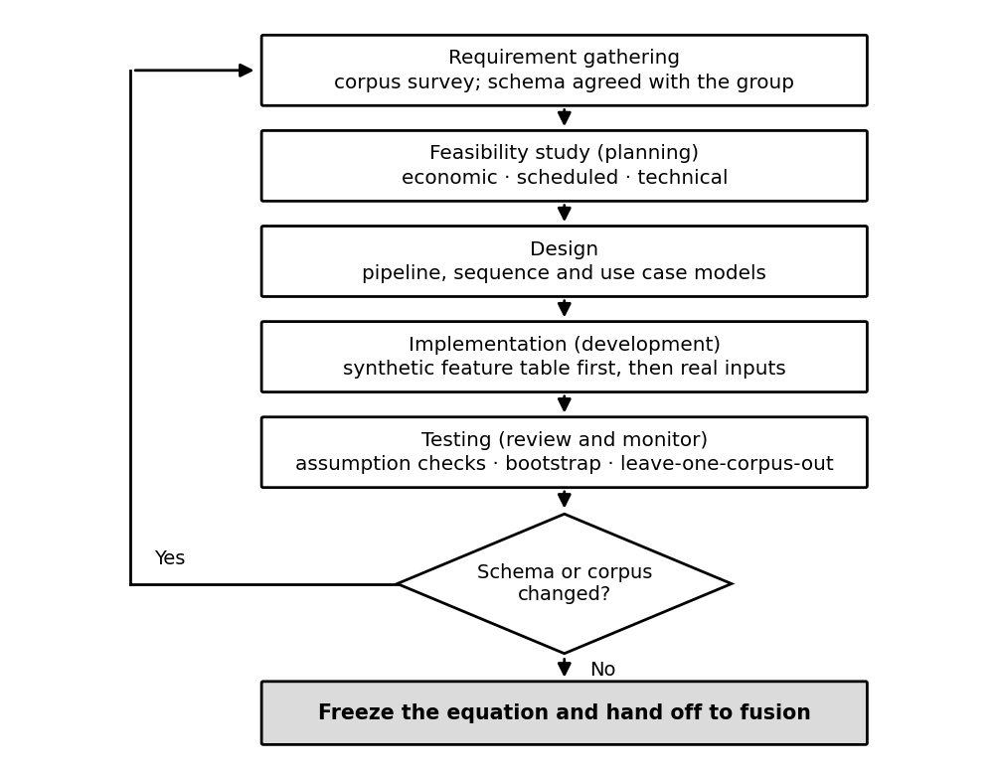
Figure 6: Iterative software development lifecycle
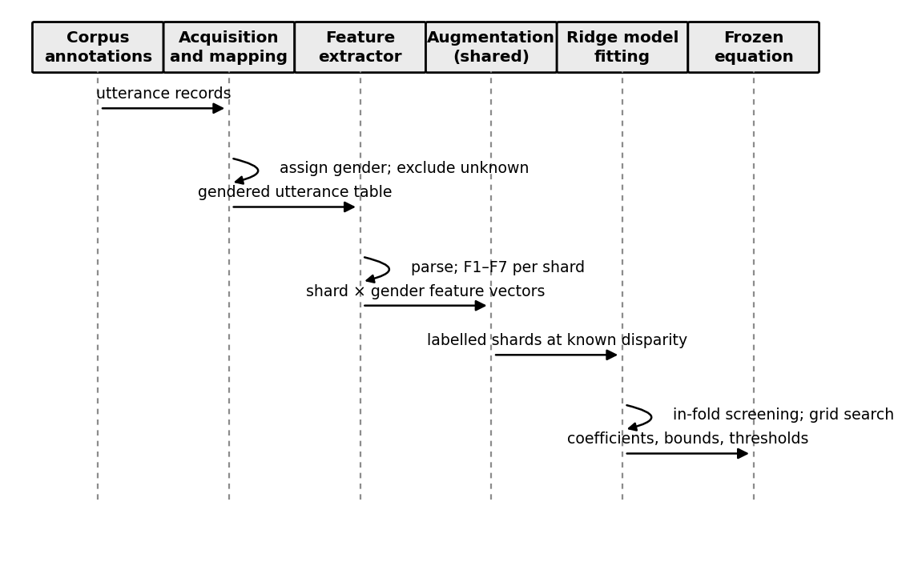
Figure 7: Sequence diagram of the EuqVid-Text component
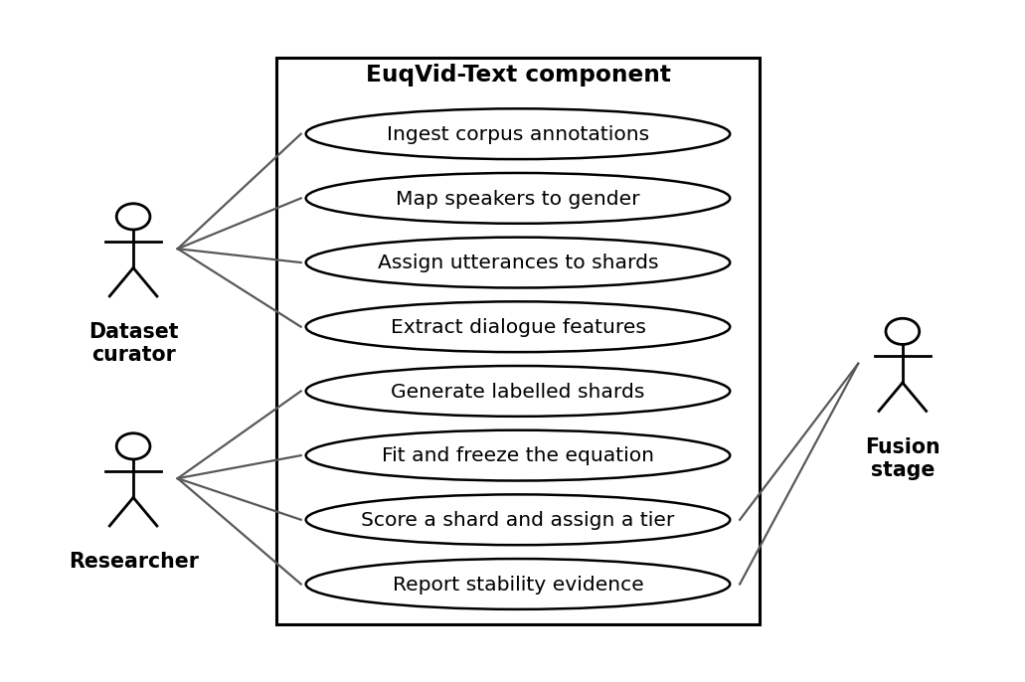
Figure 8: Use case diagram of the EuqVid-Text component

3.1.2 Commercialization
The primary market is organisations that assemble or licence video training data and are subject to internal or regulatory fairness obligations. The representative customer is a dataset lead at a mid-sized AI company who must certify that a corpus has been assessed for representational disparity before a training run is authorised, and who at present has no instrument for doing so and no defensible way to document the decision. A secondary market is academic research groups publishing video datasets, for whom a reported score becomes part of the dataset card.
The value proposition rests on timing and inspectability. The component detects representational bias at the point where correction is cheapest: because it is applied before training it requires no retraining, no model access and no labelled outcomes, and because the scoring rule is a frozen equation rather than a fitted model, results are comparable across datasets and across time and can be defended line by line to an auditor. Because it is one of four modality sub-metrics, a user learns not merely that a dataset is skewed but through which channel — a distinction that determines what remediation is even possible.
The intended release is open-source for the equation and the reference implementation, on the reasoning that an audit instrument gains value from being independently verifiable and loses it from being proprietary. Revenue, if pursued, sits above the metric rather than inside it: a hosted audit service producing certified reports, integration and consulting for organisations embedding the metric into a data pipeline, and training. Three properties are difficult for a competitor to replicate quickly — the metric operates before training rather than on finished content or trained models, it is modality-decomposed so it localises the source of disparity, and it is expressed as a frozen closed-form equation, which is a stronger position for regulatory or procurement use than a model whose behaviour cannot be inspected.

3.1.2.1 Future scope
Four extensions follow naturally from this work. The first is closing the transcript gap on film corpora: AVA ships per-frame speaking labels tied to face identities but no dialogue, and recovering speaker-attributed text for it would allow the fused score to be computed on the corpus where disparity is most expected. The second is extending beyond the binary gender framing, which is a declared limitation of the project as a whole and requires corpora annotated accordingly before it can be attempted responsibly. The third is transferring the method to other protected attributes, since nothing in the derivation is specific to gender — the same augmentation, fitting and freezing procedure applies wherever disparity between two groups can be expressed as a share. The fourth is multilingual extension, which would require re-validating the connotation lexicons in each target language rather than translating them.

4. PROJECT REQUIREMENTS

4.1 Functional requirements
The functional requirements describe what the component must do. They follow from the pipeline in Figure 5 and are traceable to the specific objectives in Section 2.2.
- FR1 — The component shall read speaker-attributed, time-aligned dialogue from corpus annotation files without requiring access to video.
- FR2 — The component shall map each speaker identifier to male, female or unknown using a documented mapping, and report the proportion of utterances excluded as unknown.
- FR3 — The component shall assign utterances to shards according to the group shard contract, partitioned by identity.
- FR4 — The component shall compute the seven dialogue disparity features per shard per gender, expressed as shares or normalised ratios.
- FR5 — The component shall report the out-of-vocabulary rate of subject-verb pairs against the connotation-frame lexicon.
- FR6 — The component shall apply the shared augmentation protocol to produce shards at known disparity levels.
- FR7 — The component shall fit a polynomial Ridge model with degree capped at two, performing feature screening inside cross-validation folds.
- FR8 — The component shall emit the fitted model as an explicit closed-form equation in raw feature units with published coefficients.
- FR9 — The component shall normalise the raw output to the interval -10 to +10 using stated bounds and assign a severity tier.
- FR10 — The component shall produce a bootstrap stability table reporting mean, standard deviation and 95% confidence interval per coefficient, with the resampling unit stated.
- FR11 — The component shall write per-shard scores to the shared versioned feature file for consumption by the fusion stage.

4.2 Non-functional requirements
The non-functional requirements describe qualities the component must exhibit. Each is stated with a criterion that can be tested rather than asserted.
- Reproducibility — two runs on the same input with a fixed seed produce byte-identical output.
- Auditability — the frozen equation fits on one page and can be evaluated by hand from the published coefficients.
- Scale invariance — doubling a shard by duplication changes the score by less than a stated tolerance.
- Portability — a new dataset is scored by applying the published equation to its extracted features alone, with no retraining.
- Performance — feature extraction for one corpus completes within a single working session on standard student hardware.
- Transparency of exclusion — every reported score is accompanied by the excluded-speaker share and the lexicon out-of-vocabulary rate.
- Maintainability — the pipeline is parameterised over the feature schema, so a column-name change requires no code change.

4.3 System requirements
Because the component opens no video and trains no deep model, its computational requirements are modest and no GPU is required at any point.
- Processing — a standard multi-core CPU. Dependency parsing is the heaviest stage and is parallelisable across clips.
- Memory — sufficient to hold one corpus’s utterance table and parse output; the largest intermediate artefact is the parsed utterance set, not the corpus media.
- Storage — annotation files and derived feature tables only, measured in gigabytes rather than terabytes, since corpus video is not required.
- Software — Python with spaCy, scikit-learn, statsmodels, SciPy and NumPy, version-pinned and seed-fixed. The entire toolchain is open-source.
- Data — read access to MELD and AMI annotation files and to the publicly released connotation-frame lexicons. Corpus licences permit academic use but not redistribution, so no corpus content is embedded in any deliverable.
- Version control — a Git repository with the corpora excluded by configuration, so that dataset material cannot be committed accidentally.

4.4 User requirements
The users of this component are dataset curators assembling or licensing video training corpora, machine-learning practitioners deciding whether a corpus is fit to train on, and fairness researchers comparing datasets. From the problem analysis in Section 1.3 and the limitations of existing systems set out in Section 1.1, four requirements follow.
- Users require a single comparable number rather than a table of per-gender quantities, because a decision about whether to train on a corpus cannot be taken from seven separate measurements without an aggregation rule they did not have to invent themselves.
- Users require an indication of severity, not merely of presence. A continuous score with defined tiers allows a curator to distinguish a corpus that warrants intervention from one that does not, which a binary verdict cannot.
- Users require the scoring rule to be inspectable, because the person who must defend a decision made on the output needs to be able to explain how the number was reached and to challenge any term in it.
- Users require the measure to be applicable without retraining and without model access, so that it can be applied at the point of dataset selection rather than after a model has been built.
These requirements are derived from the documented limitations of existing approaches. Structured interviews with domain experts and a questionnaire circulated to practitioners who assemble datasets are planned during the first phase of the project, and the requirements above will be revised against that evidence before the design is frozen.

5. GANTT CHART
The schedule below spans the academic year and is organised around the five phases of the work breakdown structure in Section 6. Two dependencies are drawn deliberately: the Phase 0 group decisions gate the start of corpus extraction, because a shard definition agreed after extraction has begun would require all four components to re-extract; and the handoff at the end of the component gates the group fusion stage. Report preparation runs continuously rather than as a terminal activity.
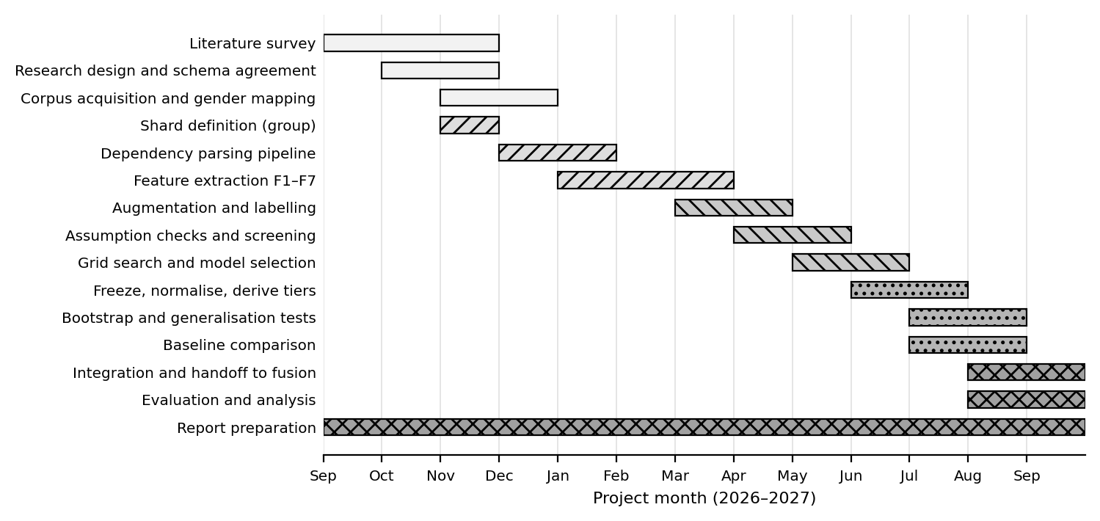
Figure 9: Gantt chart

6. WORK BREAKDOWN STRUCTURE
The work divides into five phases. Phase 0 is shared with the other three components and produces the assets none of them can decide alone — the identity-to-gender map, the shard definition and the augmentation protocol. Phases 1 to 4 are owned entirely by this component, and each produces a deliverable that is assessable on its own without the fusion stage existing.
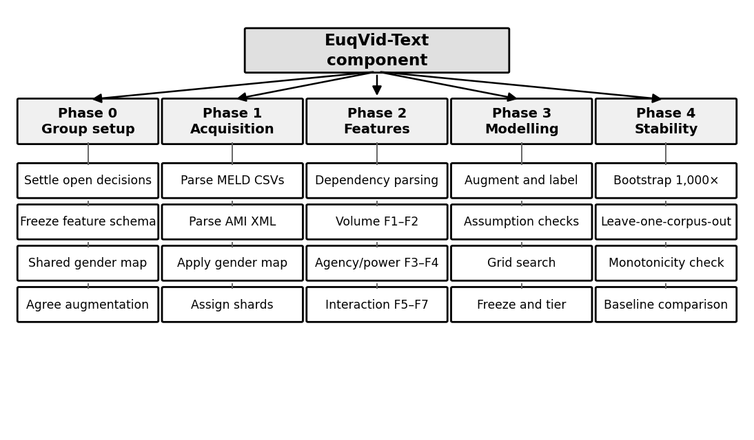
Figure 10: Work breakdown structure

7. BUDGET AND BUDGET PLAN
The component has an unusually low direct cost. It opens no video, trains no deep model and requires no GPU or cloud compute, so the toolchain is entirely open-source and the corpora are free for academic use. The dominant cost is human effort, and the only material expenses are incidental. Estimated expenses are given in Table 4.
Component | Justification | Estimated cost (LKR)
Hardware | Existing personal workstation. Dependency parsing and regression fitting run on standard student hardware; no GPU is required by this component. | Nil — existing equipment
Storage | Annotation files and derived feature tables only, in the order of a few gigabytes. Corpus video is not required. | Nil — existing capacity
Software licences | Python, spaCy, scikit-learn, statsmodels, SciPy and NumPy are open-source. The connotation-frame lexicons are publicly released by their authors. | Nil
Cloud services | Not required by this component. Listed for completeness in case group-level fusion requires shared compute. | Nil
Corpus access | MELD and AMI are freely downloadable for academic use; no registration fee applies. | Nil
Internet and data | Corpus download and literature access over the project period. | [To be confirmed]
Printing, binding and submission | Proposal, progress documents and final dissertation. | [To be confirmed]
Human effort | Estimated across literature work, extraction, modelling, evaluation and reporting over the project period. | [To be confirmed at the departmental notional rate]
Table 4: Expenses for the proposed component
Because the direct cost is close to zero, the budget risk in this component is schedule rather than money. The costly failure mode is a shard definition or feature schema agreed after extraction has begun, which would require four people to re-extract rather than one — which is why the Phase 0 dependencies are drawn explicitly in Figure 9 and listed first in the work breakdown structure.

REFERENCES
[1] S. Poria, D. Hazarika, N. Majumder, G. Naik, E. Cambria, and R. Mihalcea, “MELD: A multimodal multi-party dataset for emotion recognition in conversations,” in Proc. 57th Annu. Meeting Assoc. Comput. Linguistics, Florence, Italy, 2019, pp. 527–536.
[2] M. Sap, M. C. Prasettio, A. Holtzman, H. Rashkin, and Y. Choi, “Connotation frames of power and agency in modern films,” in Proc. 2017 Conf. Empirical Methods Natural Language Processing, Copenhagen, Denmark, 2017, pp. 2329–2334.
[3] A. Agarwal, J. Zheng, S. Kamath, S. Balasubramanian, and S. A. Dey, “Key female characters in film have more to talk about besides men: Automating the Bechdel test,” in Proc. 2015 Conf. North Amer. Chapter Assoc. Comput. Linguistics: Human Language Technologies, Denver, CO, USA, 2015, pp. 830–840.
[4] J. Zhao, T. Wang, M. Yatskar, V. Ordonez, and K.-W. Chang, “Men also like shopping: Reducing gender bias amplification using corpus-level constraints,” in Proc. 2017 Conf. Empirical Methods Natural Language Processing, Copenhagen, Denmark, 2017, pp. 2979–2989.
[5] S. Jayawardena, P. S. Haddela, T. Shyamalee, A. Ekanayake, T. Mudalige, and I. Dhanawardhana, “EuqAud: Detecting gender bias in audio datasets using polynomial regression-based metric,” IEEE Access, vol. 14, 2026.
[6] D. Bamman, B. O’Connor, and N. A. Smith, “Learning latent personas of film characters,” in Proc. 51st Annu. Meeting Assoc. Comput. Linguistics, Sofia, Bulgaria, 2013.
[7] L. A. Hendricks, K. Burns, K. Saenko, T. Darrell, and A. Rohrbach, “Women also snowboard: Overcoming bias in captioning models,” in Proc. Eur. Conf. Comput. Vision (ECCV), Munich, Germany, 2018.
[8] A. Caliskan, J. J. Bryson, and A. Narayanan, “Semantics derived automatically from language corpora contain human-like biases,” Science, vol. 356, no. 6334, pp. 183–186, 2017.
[9] “You talkin’ to me?: A network analysis of gendered speaker-addressee patterns in film screenplays,” arXiv:2607.22656, 2026.
[10] C. Gu et al., “AVA: A video dataset of spatio-temporally localized atomic visual actions,” in Proc. IEEE Conf. Comput. Vision and Pattern Recognition (CVPR), Salt Lake City, UT, USA, 2018.
[11] J. Roth et al., “AVA-ActiveSpeaker: An audio-visual dataset for active speaker detection,” arXiv:1901.01342, 2019.
[12] J. Carletta et al., “The AMI meeting corpus: A pre-announcement,” in Machine Learning for Multimodal Interaction, Berlin, Germany: Springer, 2006.

