EuqVid : A Multimodel Approach to Gender Bias Detection in Video Datasets

EuqVid-Text: A Dialogue-Based Approach to Gender Bias Detection in Video Datasets
J26-DS-343

Project Proposal Report
Fernando R. S. R - IT23449282

B.Sc. (Hons) Degree in Information Technology
Specialized in Data Science

Department of Information Technology
Faculty of Computing

Sri Lanka Institute of Information Technology
September 2026

DECLARATION

I declare that this is my own work and this proposal does not incorporate without acknowledgement any material previously submitted for a degree or diploma in any other university or institute of higher learning, and to the best of my knowledge and belief it does not contain any material previously published or written by another person except where the acknowledgement is made in the text.
Also, I hereby grant to Sri Lanka Institute of Information Technology the non-exclusive right to reproduce and distribute my thesis, in whole or in part, in print, electronic or other medium. I retain the right to use this content in whole or part in future works.
Name | Student ID | Signature
Fernando R. S. R. | IT23449282

The above candidate is carrying out research for the undergraduate Dissertation under my supervision.
Supervisor | Signature | Date
Dr. Prasanna S. Haddela

ABSTRACT
Video datasets used to train multimodal artificial intelligence systems carry gender bias not only in their imagery but in the dialogue transcripts distributed alongside it. Models trained on gender-skewed corpora reproduce and amplify that skew, so disparity present before training surfaces afterwards as measurable performance inequality, at a point where correction is expensive. Dataset documentation records provenance, licence and label schema but carries no quantitative measure of representational disparity, and no method currently converts textual gender disparity in a video dataset into a number a curator can compute before training begins.
This research proposes EuqVid-Text, the textual component of EuqVid, a four-modality pre-training audit metric extending the polynomial regression methodology of EuqAud from the audio modality into video. The component extracts scale-free dialogue disparity features across three levels — volume, interaction structure, and agency and power derived from connotation-frame lexicons — from the speaker-attributed transcripts that ship inside video corpora rather than from screenplays, which are pre-production artefacts distributed with no video dataset.
A quantitative experimental design is adopted. Ground-truth labels are produced by a shared augmentation protocol that reduces one gender’s features at controlled increments, yielding shards of known disparity. A polynomial Ridge regression model with degree capped at two is fitted with feature screening performed inside cross-validation folds, then frozen as an explicit closed-form equation in raw feature units and normalised to a shared scale from −10 to +10 with derived severity tiers. Development follows an iterative software lifecycle, so that every deliverable is assessable independently of the other three components.
Evaluation compares the equation against five dialogue-ratio and regression baselines, reports regression diagnostics per assumption, and characterises stability through 1,000-iteration bootstrap resampling at shard and identity level, leave-one-corpus-out cross-validation, and a monotonicity check on held-out perturbation curves. The frozen equation, its normalisation constants, tier thresholds and per-shard scores are delivered to the fusion stage, where they compose with the visual, temporal and acoustic sub-metrics into the complete EuqVid score.
Keywords — gender bias; dataset auditing; dialogue analysis; polynomial Ridge regression; responsible AI

ACKNOWLEDGEMENT
First, I would like to thank my supervisor, Dr. Prasanna S. Haddela, for the guidance, direction and critical comments given throughout the preparation of this proposal, and for the discussions that shaped the scope of this component.
I am grateful to the Department of Information Technology and the Faculty of Computing of the Sri Lanka Institute of Information Technology for providing the resources and the opportunity to carry out this research, and to the Centre of Excellence for AI for hosting the project.
I would also like to thank my group members of research project J26-DS-343 — Hasangani W. R. A. (IT23224384), Harischandra R. A. S. R. (IT23194908) and Sathsarani W. T. T. S. (IT23204102) — for their cooperation in agreeing the shared assets on which all four components depend: the identity-to-gender map, the shard definition and the augmentation protocol. The discussions with them established the boundaries between the four sub-metrics and the interface each component writes to, without which no one of the four could have been scoped independently.
Finally, I thank the authors of the EuqAud study, whose methodology this work extends, and my family and friends for their encouragement throughout.

TABLE OF CONTENTS
DECLARATION 1
ABSTRACT 1
ACKNOWLEDGEMENT 1
TABLE OF CONTENTS 1
LIST OF FIGURES 1
LIST OF TABLES 1
LIST OF ABBREVIATIONS 1
LIST OF APPENDICES 1
1. INTRODUCTION 1
1.1 Background and Context 1
1.2 Literature Review 1
1.3 Research Gap 1
1.4 Research Problem 1
2. OBJECTIVES 1
2.1 Main Objective 1
2.2 Specific Objectives 1
3. METHODOLOGY 1
3.1 Research methodology 1
3.2 Data, participants and experimental inputs 1
3.3 Baseline and benchmark 1
3.4 Feature set and model design 1
3.5 Evaluation metrics 1
3.6 Validation strategy 1
3.7 Development approach 1
Requirement gathering 1
Feasibility study (planning) 1
Design (system and software design documents) 1
Implementation (development) 1
Testing (review and monitor) 1
4. HIGH-LEVEL SYSTEM ARCHITECTURE 1
4.1 Overview of the proposed solution 1
4.2 The individual component and its parts 1
4.3 Overall integration 1
4.4 Individual responsibility boundary 1
5. PROJECT REQUIREMENTS 1
5.1 Requirement gathering 1
5.2 Functional requirements 1
5.3 Non-functional requirements 1
5.4 System requirements 1
5.5 User requirements 1
6. COMMERCIALIZATION PLAN 1
6.1 Target market and customer persona 1
6.2 Value proposition 1
6.3 Revenue model 1
6.4 Cost estimation 1
6.5 Pricing strategy 1
6.6 Competitive advantage 1
6.7 Intellectual property considerations 1
6.8 Future scope 1
7. BUDGET AND JUSTIFICATION 1
8. WORK BREAKDOWN STRUCTURE 1
9. GANTT CHART 1
10. REFERENCES 1
11. APPENDICES 1
Appendix 1: Requirement gathering documents 1
Appendix 2: Proposal evidence and decision log 1
Appendix 3: AI use disclosure 1
Appendix 4: Augmentation and labelling protocol 1
Appendix 5: Dataset list 1
Appendix 6: Data use and ethics documents 1

LIST OF FIGURES
Figure | Title | Page
Figure 1 | One scene read through four modalities
Figure 2 | The four levels of textual gender bias
Figure 3 | Coefficient budget at polynomial degree 2
Figure 4 | The EuqVid score scale and severity tiers
Figure 5 | Iterative software development lifecycle
Figure 6 | Sequence diagram of the EuqVid-Text component
Figure 7 | Use case diagram of the EuqVid-Text component
Figure 8 | Overall system architecture of EuqVid
Figure 9 | Component architecture of the EuqVid-Text component
Figure 10 | Work breakdown structure
Figure 11 | Gantt chart

LIST OF TABLES
Table | Title | Page
Table 1 | Research gap
Table 2 | Technologies, techniques, architectures and algorithms used
Table 3 | Datasets and experimental inputs used in this research
Table 4 | Baselines used for comparison
Table 5 | Extracted dialogue disparity features
Table 6 | Evaluation metrics
Table 7 | Individual responsibility boundary
Table 8 | Requirement gathering activities
Table 9 | Expenses for the proposed component
Table 10 | Work breakdown by phase
Table 11 | Gantt activity schedule
Table 12 | Proposal evidence and decision log
Table 13 | AI use disclosure
Table 14 | Augmentation and labelling protocol
Table 15 | Dataset list

LIST OF ABBREVIATIONS
Abbreviation | Description
AMI | Augmented Multi-party Interaction Meeting Corpus
API | Application Programming Interface
ASR | Automatic Speech Recognition
AVA | Atomic Visual Actions dataset
CI | Confidence Interval
CPU | Central Processing Unit
CV | Cross-Validation
GPU | Graphics Processing Unit
LOCO | Leave-One-Corpus-Out cross-validation
MAE | Mean Absolute Error
MELD | Multimodal EmotionLines Dataset
NLP | Natural Language Processing
OOV | Out-Of-Vocabulary
RMSE | Root Mean Squared Error
SDG | Sustainable Development Goal
SDLC | Software Development Life Cycle
VIF | Variance Inflation Factor
WBS | Work Breakdown Structure

LIST OF APPENDICES
Appendix | Title
Appendix 1 | Requirement gathering documents
Appendix 2 | Proposal evidence and decision log
Appendix 3 | AI use disclosure
Appendix 4 | Augmentation and labelling protocol
Appendix 5 | Dataset list
Appendix 6 | Data use and ethics documents

1. INTRODUCTION

1.1 Background and Context
Artificial intelligence systems trained on video are now deployed in consequential settings, and the datasets behind them are assembled from film and television material that was never produced with balanced representation as a design goal. Those datasets do not ship only imagery. They ship words — utterance transcripts, subtitles and speaker annotations — distributed as first-class training inputs. MELD, for instance, is an extension of the text-only EmotionLines corpus, so its emotion labels were annotated from dialogue in the first place [1]. Video-language models, captioning systems and video question-answering systems all ingest that text alongside the frames.
Gender bias in the text half of a video corpus is invisible to existing dataset documentation. Dataset cards report clip counts, licences and label schemas; none report whether one gender is written with systematically more to say, or with language that positions them as acting rather than as being acted upon. The distinction matters because the textual channel measures something the other channels cannot reach, as Figure 1 illustrates.
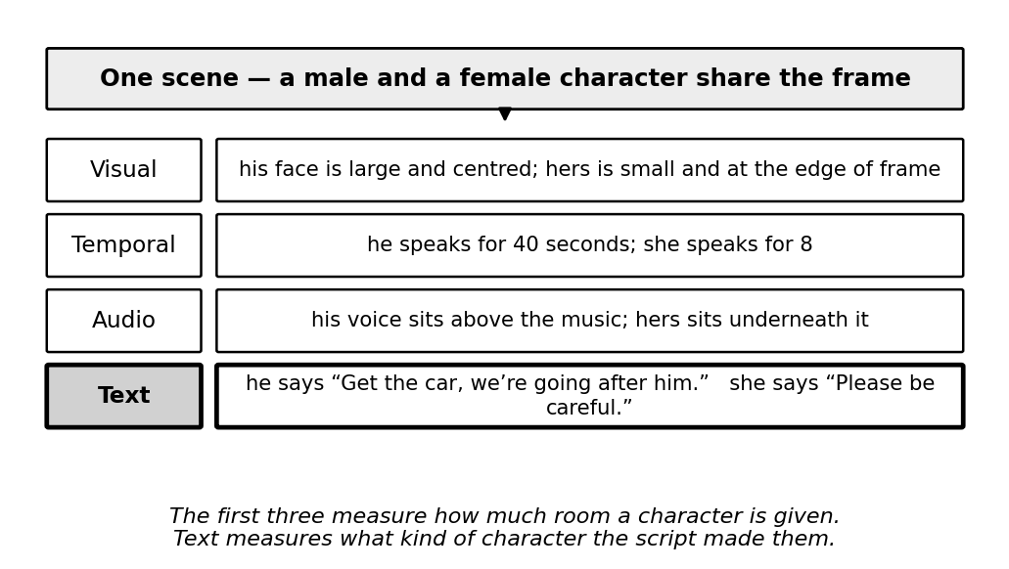
Figure 1: One scene read through four modalities
Equalise a character’s screen time, speaking seconds and loudness, and the language written for that character is unchanged. No visual, temporal or acoustic feature detects that difference, because the difference lies not in how much a character is present but in what the script gives them to do. This is what makes a textual component non-redundant within a multimodal metric rather than a fourth measurement of the same underlying quantity.
Textual gender bias operates at four levels of increasing analytical depth, summarised in Figure 2. The first three are countable and largely restate what visual and temporal measurement already suggests; the fourth requires dependency parsing and a connotation lexicon, and reaches a property of the writing that no other modality exposes.
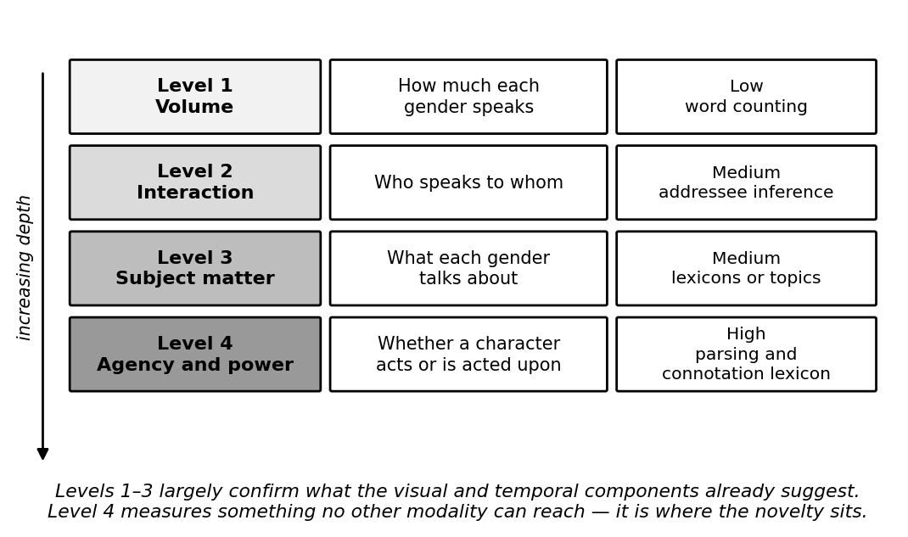
Figure 2: The four levels of textual gender bias
This work therefore addresses a measurement problem rather than a modelling problem. The aim is not to build a classifier that predicts whether a dataset is biased, but to derive an instrument that quantifies how biased it is, on a scale that a dataset curator can read, compare between corpora and defend to a third party before a single training run is authorised.

1.2 Literature Review
The evidence base divides into two strands. The first establishes that film and television text is gendered. Sap et al. [2] introduced connotation frames of power and agency, annotating verbs for the power differential and level of agency they imply for their syntactic subject, and applying the resulting lexicons to a large corpus of modern film screenplays. They found female characters written with systematically lower agency and lower power than male characters, and released the lexicons publicly. The method is interpretable and the finding robust; its limitation is that the analysis is descriptive, is performed on screenplays rather than on distributed dataset text, and yields no aggregate score. Agarwal et al. [3] built a computational version of the Bechdel test over film scripts using dependency parsing and classification, establishing that interaction structure is machine-detectable. Its output, however, is a binary verdict at film level, which can express neither severity nor comparison between datasets. Bamman et al. [6] learned latent personas of film characters from text and found the recovered archetypes strongly gendered, demonstrating that gendered characterisation is recoverable without supervision, though personas are descriptive clusters rather than a disparity measure.
The second strand justifies measuring bias before training rather than repairing a model afterwards. Zhao et al. [4] measured the gender skew of training corpora and of the predictions of models trained on them, and found that models trained on gender-skewed data are measurably more biased than the data itself. A corpus that is moderately skewed therefore yields a model that behaves as though it were severely skewed, which makes the corpus the efficient point of intervention. Hendricks et al. [7] found that captioning models predicted a subject’s gender from scene context rather than from the person depicted, reproducing dataset stereotypes at inference time; this result also rules out an apparently attractive shortcut, since generating descriptive text with a captioning model for corpora that lack transcripts would measure the captioning model’s bias rather than the dataset’s. Caliskan et al. [8] demonstrated that human-like biases are embedded in language corpora independently of any particular model, which supports treating the corpus rather than the model as the object of measurement.
Recent work confirms the concern remains active. A 2026 network analysis of gendered speaker–addressee patterns in film screenplays [9] examined 4,600 manually annotated directed dialogue events across 38 screenplays and reported male characters dominant as both speakers and addressees even in scenes with a female majority, concluding that bias in film dialogue operates through the architecture of conversation itself. Its output is a set of descriptive findings and network visualisations; it produces no dataset-level score. One methodological caution is inherited from it: that study annotated addressees manually, whereas the present component approximates addressee from turn adjacency, and this is declared as a limitation rather than left to be discovered.
Among applied systems, the Geena Davis Inclusion Quotient is the most established, measuring screen and speaking time by gender in film through automated audio and video analysis. Its function is descriptive analytics, its users are content producers rather than dataset builders, and it does not examine dialogue content, does not emit a continuous score, and is not designed to operate inside a machine-learning dataset pipeline. Dataset rebalancing tools adjust sample counts to equalise representation but operate on counts alone and provide no measure of severity. EuqAud [5] established a regression-derived closed-form gender bias score for audio datasets and is the parent methodology of this project, but its features are acoustic and its corpora are read speech recorded in quiet conditions, so neither the features nor the fitted equation transfer to text.
Taken together, the literature establishes three things: that gendered language in film and television dialogue is real and machine-measurable, that dataset-level skew propagates into and is amplified by trained models, and that a regression-derived closed-form bias score is a workable instrument in at least one modality. What it does not supply is a method that combines the three, which is the gap set out below.
[To be expanded] A submitted proposal in this area would normally cite 20 to 30 sources. Add recent work on multimodal dataset documentation, on fairness metric composition, and on transcript quality in video corpora as it is read, and record each addition in the decision log at Appendix 2.

1.3 Research Gap
While the studies above have each made progress in measuring gendered language in film and in demonstrating how dataset bias propagates into trained models, a detailed comparison reveals gaps in scope and application that this research addresses. Table 1 sets the existing approaches against the capabilities required of a pre-training textual audit metric.
Table 1: Research gap
Application reference | Dialogue-level analysis | Continuous severity score | Scale-invariant across corpora | Computable on distributed dataset text | Composes with other modalities
Research A [2] | ✓ | ✗ | ✗ | ✗ | ✗
Research B [3] | ✓ | ✗ | ✗ | ✗ | ✗
Research C [4] | ✗ | ✗ | ✓ | ✓ | ✗
Research D [5] | ✗ | ✓ | ✓ | ✓ | ✗
Proposed system | ✓ | ✓ | ✓ | ✓ | ✓

Research A [2] measures agency and power in film dialogue using connotation frames, and is the source of the Level 4 features adopted here. It analyses screenplays, which are pre-production artefacts distributed with no video dataset, and reports a descriptive finding rather than producing a score a curator can compute on their own corpus.
Research B [3] automates the Bechdel test over film scripts, establishing that interaction-level structure is machine-detectable. Its verdict is binary and at film level, so it cannot express how severe a disparity is, cannot rank two corpora against each other, and cannot be computed per dataset shard.
Research C [4] demonstrates bias amplification and proposes corpus-level constraints to reduce it. It works on images and structured labels rather than narrative dialogue, and intervenes at inference rather than measuring the dataset, so it motivates a pre-training metric without supplying one.
Research D [5] is EuqAud, which does produce a frozen, regression-derived, scale-invariant score and is the methodological parent of this work. It covers the audio modality only; its features are acoustic and its corpora are read speech recorded in quiet conditions, so neither the feature set nor the equation transfers to text, and it is a single-modality instrument rather than one designed to compose with others.
The proposed component combines dialogue-level analysis at four depths with a continuous, scale-invariant score computed on the transcripts that actually ship inside video corpora, and is designed from the outset to compose with the visual, temporal and acoustic sub-metrics. A structural consequence of that four-component design is shown in Figure 3: distributing the feature space across four sub-metrics keeps the polynomial expansion within a coefficient budget that the available number of independent shards can support, whereas a single equation over the combined feature set would not be reliably fittable.
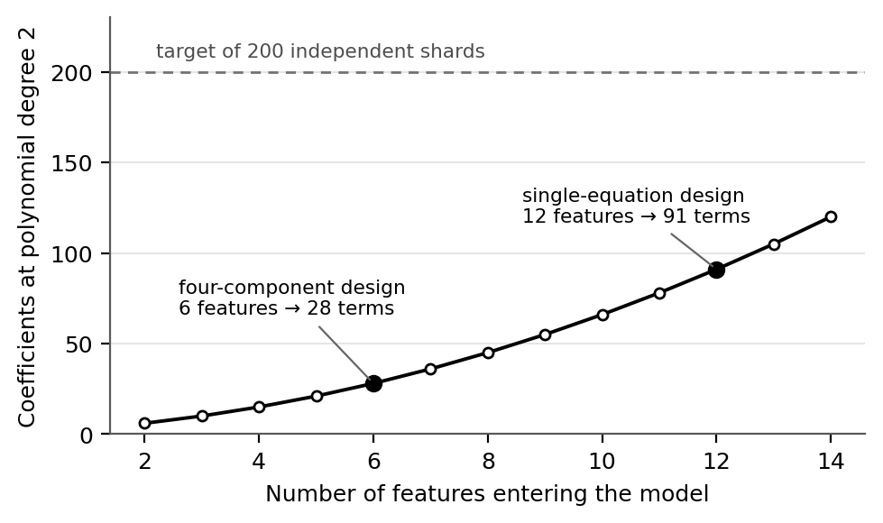
Figure 3: Coefficient budget at polynomial degree 2
Stated precisely, the gap is this: no method exists to compute a continuous, scale-invariant gender-disparity score from the speaker-attributed dialogue distributed inside a video dataset, before any model is trained, on a scale comparable with measures of visual and temporal disparity.

1.4 Research Problem
In consideration of the background and the gap identified above, three principal issues require attention within the framework of the proposed component. These serve as the major factors guiding the development and refinement of the solution.
1. How can gendered language in a video dataset be reduced to a single comparable number?
A feature table is not an answer. Presenting a dataset curator with seven per-gender quantities tells them nothing actionable until those quantities collapse into one score with a severity tier they can act on. The problem is not measurement alone but the construction of an aggregation rule that is defensible, reproducible and comparable across corpora of different sizes.
2. How can ground truth be established when no video dataset carries a bias label?
No corpus is annotated with a dataset-level bias score, so there is nothing to regress against. The problem is to manufacture ground truth under controlled conditions, perturbing real feature data at known increments so that the magnitude and direction of disparity in each training case are known because they were imposed, while keeping the resulting labels meaningful enough that an equation fitted to them transfers to unperturbed data.
3. How can the resulting measure be made auditable rather than merely accurate?
A dataset audit instrument that cannot be inspected is of limited use to the person who must defend a decision made on its output. The problem is to express the fitted relationship as a frozen closed-form equation in raw feature units, with published coefficients, stated normalisation bounds and derived tier thresholds, so that a third party can recompute any score by hand and challenge any term in it.

2. OBJECTIVES

2.1 Main Objective
The main objective of this research is to develop and freeze a closed-form, scale-invariant polynomial Ridge regression equation that maps dialogue-derived disparity features of a video dataset to a single interpretable gender-bias score on the interval −10 to +10, and to demonstrate that the equation responds monotonically to controlled disparity and that its coefficients are stable under resampling at shard and identity level. By producing a measure that requires no model training to apply, the work aims to make representational disparity in the text track of a video corpus visible at the point where correction is least expensive. The score, its severity tiers and the boundaries between them are shown in Figure 4.
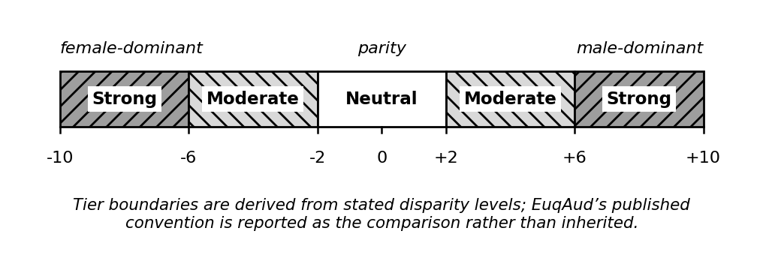
Figure 4: The EuqVid score scale and severity tiers
A score of zero denotes parity between genders, not the naturally occurring distribution of a corpus. Positive values indicate male-dominant disparity and negative values female-dominant disparity, so the sign carries direction while the magnitude carries severity. Because the same scale is used by all four sub-metrics, a reading of +6 is intended to denote the same degree of disparity whichever modality produced it, which is why the calibration reference set is a shared group asset rather than a component-private choice.

2.2 Specific Objectives
Construction of the speaker-attributed input corpus
- Build a time-aligned utterance table from MELD, AMI and AVA, carrying clip, utterance, speaker, text and timing fields, recovering the AVA transcript by automatic speech recognition attributed through the released active-speaker labels. Map each speaker identifier to male, female or unknown using a documented mapping, and report the proportion of utterances excluded for unresolved or ambiguous identity rather than dropping them silently.
Extraction of the dialogue disparity features
- Compute seven scale-free features per shard per gender across the volume, interaction and agency–power levels. Report the out-of-vocabulary rate of subject–verb pairs against the connotation-frame lexicon, since that rate determines whether the Level 4 features are viable on conversational television dialogue or whether the component falls back to Levels 1 to 3.
Generation of synthetic ground-truth bias labels
- Apply the shared group augmentation protocol to produce shards at controlled incremental disparity levels, yielding a labelled training set of at least 200 independent shards partitioned by identity so that no character spans two shards.
Fitting and selection of the sub-metric
- Fit a polynomial Ridge model with degree capped at two by cross-validated grid search over the regularisation parameter, with feature screening performed inside folds rather than on the full set beforehand, and report both nominal row count and effective sample size.
Freezing of the closed-form equation
- Express the fitted model as an explicit equation in raw feature units with scaling constants folded into the published coefficients, stated min–max normalisation bounds, and severity-tier thresholds derived from stated disparity levels rather than inherited.
Characterisation of stability and generalisation
- Run 1,000-iteration bootstrap resampling at shard and identity level, leave-one-corpus-out cross-validation, and a monotonicity check against held-out perturbation curves, reporting confidence intervals at both score and tier level.

3. METHODOLOGY

3.1 Research methodology
This research asks whether a disparity score derived from dialogue can be fitted, frozen and defended for a task on which no labelled data exists. The question cannot be answered by observation alone, because the instrument has to be built before it can be measured. The data is text: speaker-attributed, time-aligned utterances distributed inside video corpora. The labels are continuous and signed, from −10 to +10, and they must be manufactured because no corpus carries a gender-disparity annotation. Establishing that the proposed measure works therefore requires a controlled comparison against simpler scoring rules on the same shards, using the same imposed labels. A quantitative experimental design is adopted accordingly.
The methodology involves reading speaker-attributed dialogue directly from the annotation files distributed with each video corpus, mapping each speaker to a gender using a mapping shared across the whole project, and assigning utterances to identity-partitioned shards. Dependency parsing recovers the subject–verb relations that the agency and power features require, and every feature is converted to a share or a normalised ratio so that no raw magnitude enters the model. A shared augmentation protocol then perturbs the feature data at controlled increments to produce shards of known disparity, against which a polynomial Ridge regression is fitted, frozen as a closed-form equation, normalised to the interval −10 to +10 and assigned severity tiers. No video is opened at any stage of this component.
A summary of the technologies, techniques, architectures and algorithms used for the measurement of textual gender disparity is shown in Table 2 below.
Table 2: Technologies, techniques, architectures and algorithms used
Category | Items
Technologies | Python, spaCy, scikit-learn, statsmodels, SciPy, NumPy, pandas, Matplotlib, Jupyter, Git
Techniques | Dependency parsing, connotation-frame lexicon lookup, controlled feature-reduction augmentation, in-fold feature screening, min–max normalisation, bootstrap resampling, ablation study
Algorithms | Polynomial feature expansion, Ridge (L2) regression, grid search with cross-validation, Pearson and Spearman correlation, Durbin–Watson, Breusch–Pagan, variance inflation factor, Kruskal–Wallis
Architectures | Frozen closed-form regression equation; modular extraction pipeline with a pluggable feature schema; versioned shared feature file as the interface to the fusion stage

3.2 Data, participants and experimental inputs
The component consumes three classes of input: dialogue corpora that ship speaker-attributed transcripts, the publicly released connotation-frame lexicons, and the shared group assets that fix how utterances are grouped and how speakers are resolved to a gender. No human participants supply data to the modelling stage; the only human involvement is the requirement gathering described in Section 5.1. The inputs are set out in Table 3.
Table 3: Datasets and experimental inputs used in this research
Source | Type | Size | Purpose | Access
MELD [1] | Secondary, speaker-attributed | ≈13,700 utterances across 1,433 dialogues | Primary extraction and fitting corpus | Free for academic research
AMI Meeting Corpus [12] | Secondary, speaker-attributed | ≈100 hours of annotated meetings | Second domain; leave-one-corpus-out fold | Free for academic research
AVA / AVA-ActiveSpeaker [10], [11] | Secondary, speaker-attributed after transcript recovery | Film clips of 15 minutes with per-frame active-speaker labels; clip count to be verified | Third leave-one-corpus-out fold; the feature-film domain where disparity is expected | Free for academic research; transcripts recovered in this study
Connotation-frame lexicons [2] | Secondary, lexical resource | Verb-level agency and power ratings | Level 4 agency and power features | Publicly released by the authors
Augmented shard set | Primary, derived in this study | ≥200 identity-partitioned shards | Ground-truth labels for fitting and evaluation | Created in this study
Shared group assets | Primary, agreed by the group | Identity-to-gender map, shard definition, augmentation protocol | Ensures the four sub-metrics describe the same population | Internal to project J26-DS-343

Why the labels have to be manufactured. No public video corpus carries a dataset-level gender-disparity annotation, which is precisely the gap stated in Section 1.3. There is therefore nothing to regress against, and no existing dataset can be substituted. Ground truth must be imposed rather than found.
Extraction method. Each corpus is read as an utterance table rather than as media: from the distributed annotation files for MELD and AMI, and from the recovered transcript described below for AVA. The table carries clip identifier, utterance identifier, speaker identifier, utterance text and start and end timing. Speaker identifiers are resolved to male, female or unknown using the group identity-to-gender map, and the proportion of utterances falling to unknown is recorded per corpus rather than discarded silently. Utterances are then parsed with spaCy to recover subject–verb pairs, and each pair is looked up in the connotation-frame lexicon. The out-of-vocabulary rate of that lookup is recorded, because it decides whether the Level 4 features are viable on conversational dialogue or whether the component falls back to Levels 1 to 3.
Transcript recovery for AVA. AVA is the only one of the three corpora that does not ship dialogue, and it is also the only one drawn from feature film, which is the domain in which the disparity this project measures is most expected. It is therefore recovered rather than dropped. Speech is transcribed from the clip audio with an open automatic speech recognition model, and each transcribed segment is attributed to a speaker using the per-frame SPEAKING_AND_AUDIBLE labels that AVA-ActiveSpeaker already ships against a face identity, so no speaker diarisation is required and attribution rests on released annotation rather than on an estimate. Segments falling outside the clean-speech regions identified by AVA-Speech are excluded, so that music and background noise do not enter the transcript. Because AVA identities are anonymous, gender is assigned to each identity by hand rather than inferred by a classifier, which removes a second estimator from the pipeline. Two consequences are recorded rather than hidden: the recovered transcript carries word error that the annotation-derived corpora do not, quantified against a hand-checked subset and reported with every AVA result; and feature F6, which counts how often a character is named by others, requires a cast roster that AVA does not provide, so it is redefined for all three corpora as the share of third-person gendered references in each gender’s speech, a quantity computable from transcript text alone. Transcript recovery is scheduled as a Phase 1 work package and begins after the proposal is submitted.
Preparation and partitioning. Utterances are assigned to shards according to the group shard contract, partitioned by identity so that no character appears in more than one shard. Identity partitioning matters more here than a random split would, because a single recurring character contributes a large and correlated block of utterances, and allowing that character to straddle the training and test sets would inflate every reported result. Features are computed per shard per gender and expressed as shares or normalised ratios, so that a shard of 200 utterances and a shard of 2,000 produce comparable values. The augmentation protocol is then applied to the feature table, not to the raw text, reducing one gender’s features at controlled increments to produce shards whose disparity is known because it was imposed.
Licensing and redistribution. Corpus licences permit academic use but not redistribution, so no corpus content is embedded in any deliverable. The repository excludes corpus material by configuration, and only derived feature tables, the fitted coefficients and the evaluation outputs are published.
[To be confirmed] Verify the exact utterance and dialogue counts and the current licence terms for MELD, AMI and AVA on the distributors’ own pages before submission, and cite them. Record in the decision log at Appendix 2 the alternatives considered before AVA was selected as the third corpus, and the group decision that transcript recovery for it proceeds after proposal submission. Do not carry forward figures that have not been checked against the source.

3.3 Baseline and benchmark
The proposed equation has to be compared both against what a dataset curator could compute today without this research and against the strongest alternative that could be fitted on the same features. Five baselines are used, listed in Table 4. All are evaluated on the same held-out shards, against the same imposed labels, so that any difference is attributable to the scoring rule rather than to the data.
Table 4: Baselines used for comparison
No | Baseline | Why it is suitable | What it represents
B1 | Dialogue volume ratio, linearly rescaled to −10 to +10 | The simplest defensible measure of who speaks more, computable from any transcript | What a curator can already do by hand
B2 | Utterance count share by gender | The countable proxy used by screen-time analytics such as the Inclusion Quotient | Current applied practice
B3 | Speaker headcount ratio by gender | Representation as reported on a dataset card today | The documentation-level minimum
B4 | Ordinary least squares linear regression on the same seven features | Same inputs and same labels, without polynomial expansion or L2 penalty | Control for the ablation study
B5 | EuqAud equation [5] evaluated on textual features | Tests directly whether the parent audio equation transfers to text | The claim made in the research gap

B4 is the main benchmark, because it is the strongest rule that can be fitted on identical inputs; any advantage the proposed model shows over B4 is attributable to the polynomial terms and the regularisation rather than to the feature set. B1 to B3 establish whether the research is worth doing at all: if a single volume ratio tracks imposed disparity as closely as the fitted equation does, the additional machinery is not justified, and that result would be reported rather than suppressed. B5 tests the transfer claim asserted in Section 1.3, and a failure of B5 is a confirmation of the gap rather than a failure of the method.

3.4 Feature set and model design
The seven features the pipeline produces are given in Table 5. Means are used rather than standard deviations: EuqAud used standard deviations of pitch, energy and amplitude because those quantities are intrinsically gender-linked, so a mean would merely detect that a woman is present, whereas dialogue volume and agency are not intrinsically gender-linked and the signal lives in the mean.
Table 5: Extracted dialogue disparity features
# | Feature | Definition | Level
F1 | dialogue_volume_share | Words spoken by gender g divided by total words in the shard | Volume
F2 | mean_utterance_length | Mean words per utterance for gender g, normalised by the shard mean | Volume
F3 | agency_score_mean | Mean agency value of verbs for which a character of gender g is the syntactic subject [2] | Agency
F4 | power_score_mean | Mean power value over the same subject–verb pairs [2] | Power
F5 | same_gender_dialogue_share | Proportion of gender g’s utterances in an adjacent turn with a character of the same gender | Interaction
F6 | gendered_reference_ratio | Third-person gendered references in gender g’s speech, divided by that gender’s total references to people; roster-free, so it is computable on a recovered transcript | Interaction
F7 | sentiment_valence_mean | Mean sentiment polarity of gender g’s utterances | Subject matter

An eighth candidate, utterance_count_share, was deliberately excluded because it is the same quantity as the temporal component’s turn-count share, and retaining it in both sub-metrics would weight that signal twice in the fused score. This is a cross-component duplication that within-component collinearity screening cannot detect, since screening operates only on the features present in a single model.
The model is fitted in two stages. In the first, the seven features are expanded to degree two, producing the main effects, the squared terms and the pairwise interactions, and a Ridge regression is fitted over that expansion by cross-validated grid search on the regularisation parameter. Feature screening is performed inside each fold rather than once on the full set, because screening on all the data before splitting leaks information from the test folds into the selection and inflates every subsequent estimate. In the second stage the selected model is refitted on the full training set and frozen: the coefficients are written out in raw feature units, with the scaling constants folded in, so that the equation can be evaluated by hand without access to the fitted object.
Ridge regression is chosen over an unpenalised fit because the polynomial expansion makes the predictors strongly collinear by construction — a squared term is correlated with its own main effect — and an L2 penalty stabilises the coefficients under exactly that condition. Degree is capped at two because the coefficient budget shown in Figure 3 does not support a higher expansion at the number of independent shards available, and because a cubic term in a share-valued feature has no interpretation a curator could defend.

3.5 Evaluation metrics
Evaluation is reported against the criteria in Table 6. Each has a stated target fixed before fitting, so that a result can fail rather than merely be described. Targets marked provisional are revised once the pilot fit on MELD is complete, and any revision is recorded in the decision log at Appendix 2.
Table 6: Evaluation metrics
Metric | Why it is used | Target
Coefficient of determination on held-out shards | Shows how much of the imposed disparity the equation recovers | 0.85 or higher
Root mean squared error on the −10 to +10 scale | Expresses error in the units a curator reads | Below 1.0
Mean absolute error | Less sensitive to a single extreme shard than RMSE | Below 0.8
Spearman correlation between imposed level and predicted score | Ordering matters more than exact value for a severity tier | 0.95 or higher
Monotonicity violation rate on held-out perturbation curves | A score that falls as disparity rises is unusable regardless of its error | Below 5 per cent
Bootstrap coefficient sign stability over 1,000 resamples | A coefficient whose sign flips cannot be interpreted | Sign stable in 95 per cent or more
Tier agreement across bootstrap replicates | The tier, not the raw score, is what a curator acts on | 90 per cent or higher
Leave-one-corpus-out degradation | Shows the equation is not fitted to one corpus’s idiom | Drop of no more than 0.10
Scale invariance under shard duplication | A doubled shard is the same dataset and must score the same | Change below 0.1 points
Subject–verb out-of-vocabulary rate against the lexicon | Decides whether the Level 4 features are viable at all | Below 30 per cent, else fall back to Levels 1 to 3
Regression assumption diagnostics | A fitted equation whose assumptions fail cannot be defended | Durbin–Watson 1.5 to 2.5; Breusch–Pagan p above 0.05; VIF below 10
Comparison against baseline B4 | Isolates the contribution of the polynomial terms | Lower held-out RMSE than B4

3.6 Validation strategy
Validity is established in four ways.
- Model validity. Five-fold cross-validation is used, with folds partitioned by identity so that no character appears in more than one fold. Feature screening and the regularisation grid search are performed inside the training folds only, so the held-out fold is never used for selection. Both the nominal row count and the effective sample size are reported, because a shard set built from a small number of recurring characters carries far fewer independent observations than its row count suggests, and reporting only the row count would overstate the evidence behind every coefficient.
- Validity on unseen corpora. Leave-one-corpus-out cross-validation holds out an entire corpus, fits on the remainder and evaluates on the held-out corpus. This tests whether the equation has learned a property of dialogue disparity or a property of one corpus’s writing style, which a random split across pooled corpora cannot distinguish. A large degradation under this test is the result most likely to require the feature set to be revised, so it is run early rather than at the end.
- Proof that the added machinery caused the improvement. An ablation ladder fits the model on Level 1 features only, then Levels 1 and 2, then Levels 1 to 3, then the full set, and compares each against baseline B4 on identical folds. Fold-level errors are compared with a paired non-parametric test, since the same shards are scored by every rule and the errors are therefore not independent between rules. This determines whether the polynomial terms, the agency and power features, or neither, account for any advantage observed.
- Validity of the imposed labels. Because the labels are manufactured, the augmentation protocol is itself audited. The sensitivity of the fitted coefficients to the size of the augmentation increment is reported, a monotonicity check is run on held-out perturbation curves that were not used in fitting, and the equation is applied to unperturbed shards to confirm that it returns values in a plausible range rather than only behaving correctly on synthetic input. The tier thresholds are then derived from the stated disparity levels rather than inherited from EuqAud, and the derivation is published with them.
Three threats to validity are declared rather than left to be discovered. Addressee is approximated from turn adjacency rather than annotated, following the caution inherited from [9]. Gender is treated as binary because the available corpora are annotated that way, which is a limitation of the data and not a position taken by this work. Speakers who cannot be resolved are excluded, and the excluded share is reported alongside every score, since a corpus with a high unknown rate yields a score computed on a subset of its own dialogue.

3.7 Development approach
An iterative software development lifecycle was selected for this component, driven by its adaptability to evolving requirements. The determining factor is a dependency structure rather than a preference: the component consumes a feature schema agreed collectively and not yet frozen, and delivers into a fusion stage that does not yet exist, so a sequential waterfall approach would idle until both are settled. An iterative approach allows the complete pipeline to be built first against a synthetic feature table of the correct shape and real inputs substituted as they arrive, which keeps every deliverable assessable without the fusion stage existing and without any other component being complete. The stages of the lifecycle are set out below and shown in Figure 5.
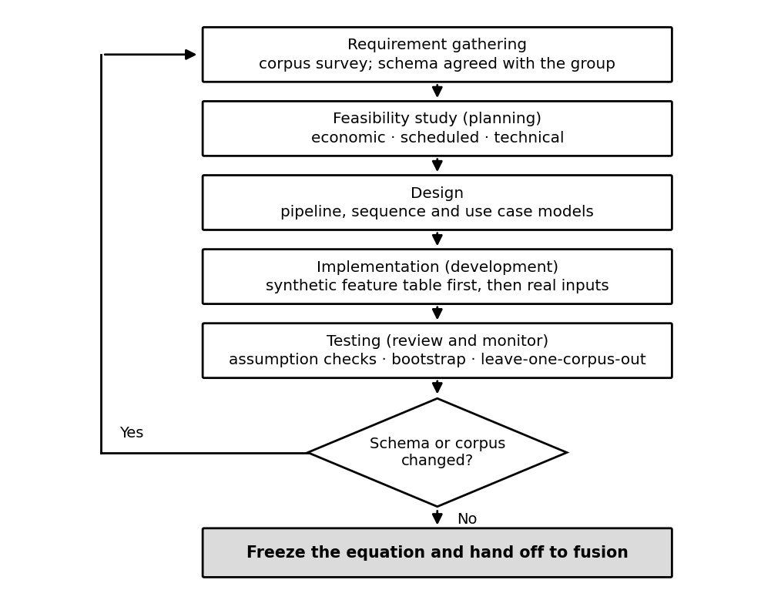
Figure 5: Iterative software development lifecycle

Requirement gathering
- Surveying the candidate corpora to establish which ship speaker-attributed dialogue, what fields each annotation format carries, and what licence governs its use.
- Agreeing the shared assets with the other three components — the identity-to-gender map, the shard definition and the augmentation protocol — since none of these can be decided by one component alone.
- Collecting requirements from dataset curators and fairness researchers through the activities set out in Section 5.1, so that the requirements in Sections 5.2 to 5.5 rest on evidence rather than on the literature alone.

Feasibility study (planning)
- Economic feasibility — the entire toolchain is open-source and the corpora are free for academic use. The only compute this component cannot supply from a personal machine is the single speech recognition pass over the AVA clips, which fits inside the free tier of a hosted notebook service, so the direct cost of the component remains effectively zero and the dominant input is the student’s own time.
- Schedule feasibility — the work divides into five phases across the academic year, with Phase 0 group decisions gating the start of extraction and the Phase 5 handoff gating the fusion stage. The schedule is shown in Section 9.
- Technical feasibility — the heaviest computational stage is dependency parsing, which is parallelisable and runs on standard student hardware. The principal technical risk is not compute but lexicon coverage, since the connotation-frame lexicon was built on screenplays while MELD is informal overlapping conversation; this is measured and reported rather than assumed, against the target stated in Table 6.

Design (system and software design documents)
- Sequence diagram — Figure 6 shows the order in which data moves through the component and where responsibility passes between this component and the shared group assets it depends on.
- Use case diagram — Figure 7 shows the actors interacting with the component and the operations available to each.
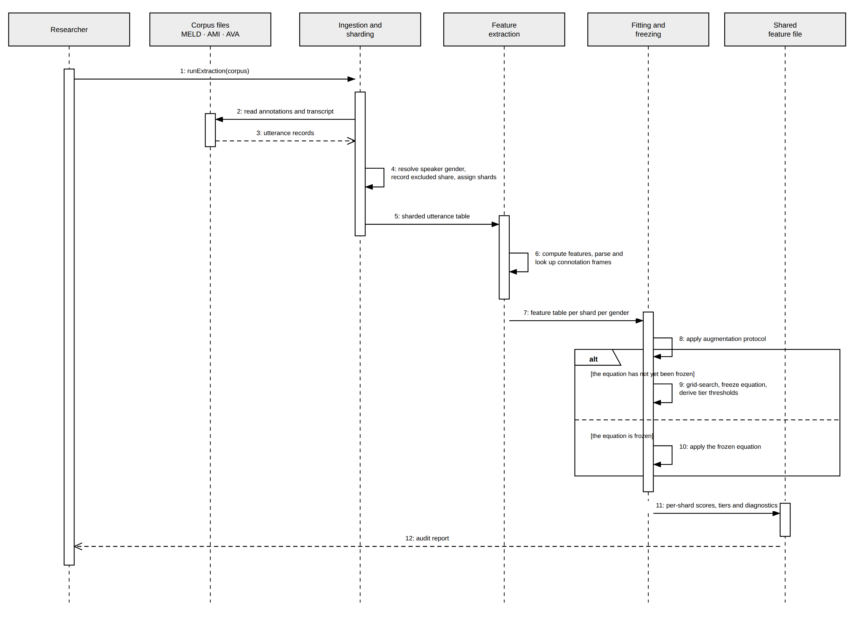
Figure 6: Sequence diagram of the EuqVid-Text component
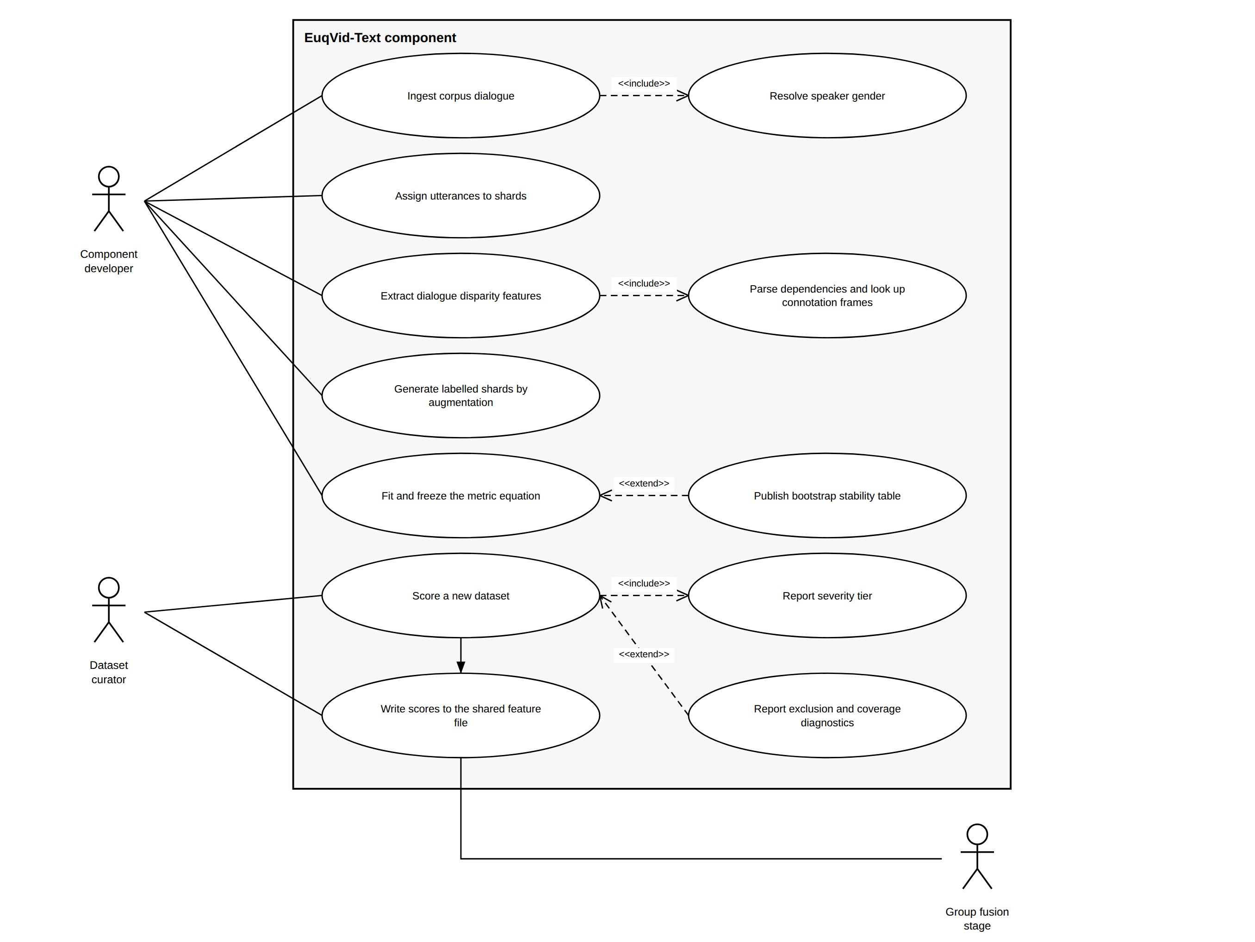
Figure 7: Use case diagram of the EuqVid-Text component

Implementation (development)
The implementation phase builds the following parts.
- An ingestion layer that reads each corpus’s annotation format into a common utterance table and applies the identity-to-gender map.
- A sharding module implementing the group shard contract with identity partitioning.
- The seven feature extractors covering the volume, interaction and agency–power levels, including the dependency-parsing and lexicon-lookup path.
- The augmentation module implementing the shared protocol and emitting labelled shards.
- The fitting and freezing module, which performs the grid search, writes the coefficients in raw feature units and emits the normalisation constants and tier thresholds.
- A scoring utility that applies the frozen equation to a new feature table with no retraining, and writes per-shard scores to the shared versioned feature file consumed by the fusion stage.
The pipeline is implemented in Python and parameterised over the feature schema, so that a column-name change costs nothing. It is built first against a synthetic feature table and switched to real corpus input as extraction completes, with notebooks and scripts seed-fixed so that any reported result reproduces exactly.

Testing (review and monitor)
Testing covers unit tests for each feature extractor against hand-computed values on a small fixture, integration tests across the ingestion, sharding, extraction and scoring stages, and reproducibility tests confirming that two seeded runs produce byte-identical output. Regression assumptions are tested per fit using Durbin–Watson, Breusch–Pagan and the variance inflation factor, and reported as pass or fail rather than suppressed. Stability is tested by 1,000-iteration bootstrap resampling at shard and identity level, generalisation by leave-one-corpus-out cross-validation, and sensitivity by a monotonicity check on held-out perturbation curves, all against the targets in Table 6.

4. HIGH-LEVEL SYSTEM ARCHITECTURE

4.1 Overview of the proposed solution
The complete system is a pre-training gender bias audit metric for video datasets, made of four modality sub-metrics that share a common data and calibration layer and compose into a single EuqVid score. The visual sub-metric measures on-screen representation from the frames. The temporal sub-metric measures how presence and turn-taking are distributed over time. The acoustic sub-metric measures speaking characteristics from the audio track. The textual sub-metric, which is this component, measures disparity in the dialogue that ships with the corpus. A fusion stage combines the four sub-scores, each already expressed on the shared −10 to +10 scale, into the complete metric.
The design is modality-decomposed by intention rather than by convenience. A single equation over the combined feature space of all four modalities would exceed the coefficient budget that the available number of independent shards can support, as Figure 3 shows, and a fused score that could not be traced back to a modality would tell a curator that a dataset is skewed without telling them through which channel — a distinction that determines what remediation is even possible. Figure 8 shows how the four sub-metrics, the shared calibration layer and the fusion stage fit together.
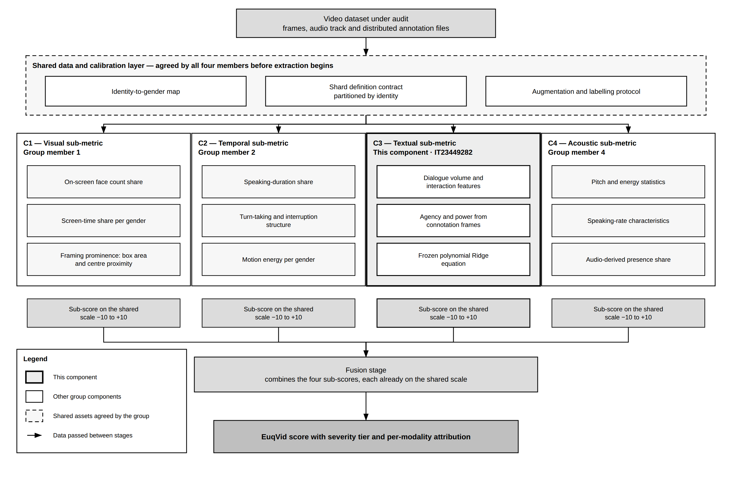
Figure 8: Overall system architecture of EuqVid
[To be completed] Name the group member who owns each of the other three sub-metrics and state the component identifier each has been assigned, so that the reader can map Figure 8 and Table 7 onto the group. Confirm the wording with the group before submission so that all four proposals describe the same architecture.

4.2 The individual component and its parts
This component has six parts, shown in Figure 9.
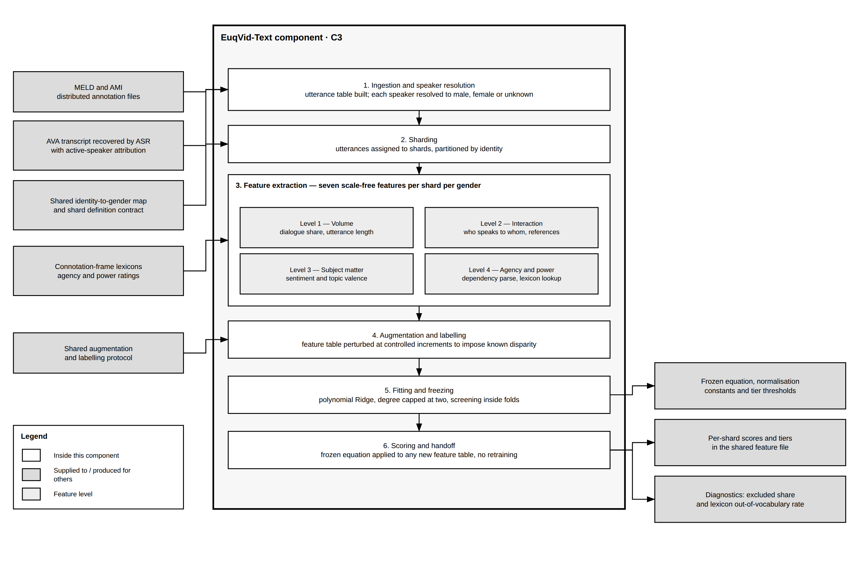
Figure 9: Component architecture diagram
- Ingestion and speaker resolution. Reads the annotation files distributed with each corpus into a common utterance table and resolves each speaker identifier to male, female or unknown using the shared identity-to-gender map, recording the excluded share.
- Sharding. Assigns utterances to shards under the group shard contract, partitioned by identity so that no character spans two shards.
- Feature extraction. Computes the seven scale-free features of Table 5 per shard per gender, including the dependency-parsing and connotation-lexicon path that the agency and power features require, and reports the out-of-vocabulary rate of that lookup.
- Augmentation and labelling. Applies the shared augmentation protocol to the feature table at controlled increments, producing shards whose disparity is known because it was imposed.
- Fitting and freezing. Fits the polynomial Ridge model with in-fold screening, then emits the frozen equation in raw feature units together with its normalisation constants and derived tier thresholds.
- Scoring and handoff. Applies the frozen equation to any new feature table without retraining and writes per-shard scores, tiers and the accompanying exclusion and coverage diagnostics to the shared versioned feature file.

4.3 Overall integration
The four sub-metrics run independently over the same corpus and meet only at the fusion stage. Each reads the same shard definition, aggregates over the same identity-to-gender map, and writes its per-shard sub-score to a shared versioned feature file keyed by corpus and shard identifier. The fusion stage reads that file and composes the four sub-scores into the complete EuqVid score. This component neither calls nor is called by the other three at run time; the coupling is through shared assets and a shared file format, which is what allows every deliverable here to be assessed without the other components existing.
Three dependencies between the four components are real and must be managed rather than assumed.
- A common identity-to-gender map. All four sub-metrics must aggregate over the same map, or the sub-scores describe different populations and their fusion is meaningless.
- A common shard definition. Fusion operates per shard, so a shard must mean the same thing in all four sub-metrics. A definition agreed after extraction has begun would require all four components to re-extract.
- A single augmentation and labelling protocol. Four private definitions of a bias level would calibrate the four sub-metrics against four different meanings, and a reading of +6 would then not denote the same degree of disparity across modalities.
A fourth constraint determines which corpora the fused score can be computed on at all: a shard must carry all four sub-scores for fusion to apply, and a corpus without a transcript yields no textual sub-score. This component therefore also defines the coverage boundary of the complete metric, and the coverage figure is reported with the score rather than assumed.
The interface itself is deliberately narrow. This component publishes, per shard, the textual sub-score on the −10 to +10 scale, its severity tier, the excluded-speaker share and the lexicon out-of-vocabulary rate. The format is agreed with the group and frozen at the end of the design phase, and integration is checked by a contract test that reads the published file and confirms the schema, the value range and the presence of the diagnostics before the fusion stage consumes it.

4.4 Individual responsibility boundary
Table 7 separates what is delivered by this component from what is shared with the group and what belongs to the other three sub-metrics, so that the assessable scope of this proposal is unambiguous.
Table 7: Individual responsibility boundary
Activity or deliverable | My responsibility | Shared responsibility | Other member
Utterance extraction and speaker resolution for the text track | ✓
The seven dialogue disparity features F1 to F7 | ✓
Dependency parsing and connotation-lexicon integration | ✓
Baseline reproduction B1 to B5 | ✓
Polynomial Ridge fitting, freezing and normalisation | ✓
Textual severity tier derivation | ✓
Stability, LOCO and monotonicity evaluation for the text sub-metric | ✓
Identity-to-gender map |  | ✓
Shard definition and shard contract |  | ✓
Augmentation and labelling protocol |  | ✓
Shared versioned feature file and its schema |  | ✓
Calibration reference set for the shared −10 to +10 scale |  | ✓
Corpus selection and licence review |  | ✓
Visual sub-metric |  |  | Visual component
Temporal sub-metric |  |  | Temporal component
Acoustic sub-metric |  |  | Acoustic component
Fusion of the four sub-scores into the EuqVid score |  |  | Fusion stage

5. PROJECT REQUIREMENTS

5.1 Requirement gathering
Requirements are collected from three groups of people through four activities. All instruments and anonymised responses are filed in Appendix 1. The people consulted are not data subjects of the modelling stage; they are the prospective users of the metric, and they are consulted because the value of an audit instrument is decided by whether the person who must defend a decision can read and challenge its output.
Table 8: Requirement gathering activities
Activity | Participants | What it establishes
Semi-structured interviews | 6 to 10 dataset curators and machine-learning practitioners | What a curator needs to see before acting on a score, and at what point a reading would actually change a decision to train
Questionnaire | 15 to 25 practitioners who assemble or select training data | Whether a single number with tiers is preferred to a feature table, and what tier boundaries are treated as actionable
Expert review | 2 to 3 fairness researchers | Whether the feature set is defensible, and whether the declared limitations are stated at the right strength
Supervisor and group review | Supervisor and the three other component owners | That the shared assets, the interface schema and the scale are agreed identically across all four components

5.2 Functional requirements
The functional requirements describe what the component must do. They follow from the pipeline in Figure 9 and are traceable to the specific objectives in Section 2.2.
- FR1 The component shall read speaker-attributed, time-aligned dialogue from corpus annotation files where the corpus ships them, and from a recovered transcript where it does not, without requiring the video stream itself at any stage after transcription.
- FR2 - The component shall map each speaker identifier to male, female or unknown using a documented mapping, and report the proportion of utterances excluded as unknown.
- FR3 - The component shall assign utterances to shards according to the group shard contract, partitioned by identity.
- FR4 - The component shall compute the seven dialogue disparity features per shard per gender, expressed as shares or normalised ratios.
- FR5 - The component shall report the out-of-vocabulary rate of subject–verb pairs against the connotation-frame lexicon.
- FR6 - The component shall apply the shared augmentation protocol to produce shards at known disparity levels.
- FR7 - The component shall fit a polynomial Ridge model with degree capped at two, performing feature screening inside cross-validation folds.
- FR8 - The component shall emit the fitted model as an explicit closed-form equation in raw feature units with published coefficients.
- FR9 - The component shall normalise the raw output to the interval −10 to +10 using stated bounds and assign a severity tier.
- FR10 - The component shall produce a bootstrap stability table reporting mean, standard deviation and 95% confidence interval per coefficient, with the resampling unit stated.
- FR11 - The component shall evaluate the frozen equation against baselines B1 to B5 on identical held-out shards and report the comparison.
- FR12 - The component shall score a previously unseen feature table by applying the frozen equation alone, with no refitting.
- FR13 - The component shall write per-shard scores, tiers and coverage diagnostics to the shared versioned feature file for consumption by the fusion stage.

5.3 Non-functional requirements
The non-functional requirements describe qualities the component must exhibit. Each is stated with a criterion that can be tested rather than asserted.
- Reproducibility - two runs on the same input with a fixed seed produce byte-identical output.
- Auditability - the frozen equation fits on one page and can be evaluated by hand from the published coefficients.
- Scale invariance - doubling a shard by duplication changes the score by less than 0.1 points on the −10 to +10 scale.
- Portability - a new dataset is scored by applying the published equation to its extracted features alone, with no retraining.
- Performance - feature extraction for one corpus completes within a single working session on standard student hardware.
- Transparency of exclusion - every reported score is accompanied by the excluded-speaker share and the lexicon out-of-vocabulary rate.
- Maintainability - the pipeline is parameterized over the feature schema, so a column-name change requires no code change.
- Interoperability - output conforms to the agreed shared feature file schema and passes the contract test before handoff.
- Data protection - no corpus content is embedded in any deliverable, and the repository excludes corpus material by configuration.

5.4 System requirements
The component opens no video and trains no deep model, so its computational requirements are modest. Modelling, parsing and evaluation run entirely on CPU. The single exception is the one-off transcription of the AVA clip audio, which is run once on a hosted GPU notebook and produces a transcript file that every later stage reads from disk.
- Processing - a standard multi-core CPU for parsing, fitting and evaluation. Dependency parsing is the heaviest of those stages and is parallelisable across clips. One stage falls outside this: the automatic speech recognition pass over the AVA clips, which is run once, offline, on a GPU-backed notebook environment, and whose output is a transcript file reused thereafter.
- Memory - sufficient to hold one corpus’s utterance table and parse output; the largest intermediate artefact is the parsed utterance set, not the corpus media.
- Storage - annotation files, the recovered AVA transcript and derived feature tables. MELD and AMI require no media at all. AVA requires the clip audio for the single transcription pass, after which only the transcript is retained, so the working footprint stays in gigabytes rather than terabytes.
- Software - Python 3.11 or later with spaCy, scikit-learn, statsmodels, SciPy, NumPy and pandas, version-pinned and seed-fixed. Jupyter for analysis notebooks. The entire toolchain is open-source.
- Data - read access to the MELD and AMI annotation files, to the AVA and AVA-ActiveSpeaker annotations and clip audio, and to the publicly released connotation-frame lexicons. Corpus licences permit academic use but not redistribution, so no corpus content and no recovered transcript is embedded in any deliverable.
- Version control - a Git repository with the corpora excluded by configuration, so that dataset material cannot be committed accidentally.

5.5 User requirements
The users of this component are dataset curators assembling or licensing video training corpora, machine-learning practitioners deciding whether a corpus is fit to train on, and fairness researchers comparing datasets. From the problem analysis in Section 1.4 and the limitations of existing systems set out in Section 1.2, four requirements follow.
- Users require a single comparable number rather than a table of per-gender quantities, because a decision about whether to train on a corpus cannot be taken from seven separate measurements without an aggregation rule they did not have to invent themselves.
- Users require an indication of severity, not merely of presence. A continuous score with defined tiers allows a curator to distinguish a corpus that warrants intervention from one that does not, which a binary verdict cannot.
- Users require the scoring rule to be inspectable, because the person who must defend a decision made on the output needs to be able to explain how the number was reached and to challenge any term in it.
- Users require the measure to be applicable without retraining and without model access, so that it can be applied at the point of dataset selection rather than after a model has been built.

6. COMMERCIALIZATION PLAN

6.1 Market Context and Opportunity

The motivation to use a tool to evaluate fairness of training datasets stems from regulatory pressure, procurement policy and reputational risk. Firms using video-based automated decision systems are increasingly obliged to be able to explain the content of the dataset used for training and prove the fact of evaluation of fairness of the system, not the assumption of its absence. The existing tools address these needs poorly: GD-IQ [3] is a commercial reporting tool designed for use in the media industry, not machine learning pipelines, and the methods described in Section 1.2 are described in the literature as results, not as tools.

The idea is thus not to compete with reporting of media analytics, but to fill the niche between academic measurement and auditing needs: a reproducible, citable and pipeline-friendly tool generating a defendable number. This is reinforced from the commercial perspective, as Garnerin et al. [16] demonstrated that inequality of turn representation leads to worse recognition, making fairness problem an operational quality problem already budgeted by the buyer.

6.2 Target Market Segments
Segment | Who they are | Why they would adopt
Primary — AI assurance and model audit firms | Independent firms performing third-party fairness and compliance assessment of deployed AI systems. | Require reproducible, citable instruments they can stand behind in a report. A published closed-form equation is defensible to a client in a way a proprietary black box is not.
Secondary — video dataset vendors and annotation providers | Organisations that license or produce labelled video corpora commercially. | A documented representational profile becomes a procurement differentiator, as documented annotation quality already is.
Secondary — broadcasters and streaming platforms | Media organisations under diversity reporting commitments, whether regulatory or voluntary. | Automated measurement replaces manual content audit, and floor allocation supplies a measure of treatment that screen-time totals cannot.
Tertiary — academic and research groups | Researchers in computational media analysis and AI fairness. | A published, citable metric with an open reference implementation; adoption here drives credibility in the paid segments.

6.3 Value Proposition
Value | Explanation
Detection before cost is incurred | Disparity is identified before training rather than after subgroup evaluation, avoiding the cost of retraining and of post-deployment remediation.
A defensible number rather than an opinion | A closed-form equation with published coefficients and documented tier boundaries can be recomputed and challenged by a third party. Proprietary scores cannot.
Measures treatment, not headcount | Detects disparity in corpora that pass count-based balance checks — the specific gap that rebalanced dataset releases leave open.
Linked to model quality, not only to ethics | Turn-level representational imbalance has a documented effect on downstream recognition performance [16], so the audit addresses a quality problem as well as a fairness one.
No model training required | Runs on the dataset on commodity hardware, so the audit does not require the infrastructure investment it is intended to justify.
Structural signal unavailable elsewhere | Floor allocation is not measured by any existing instrument, commercial or academic, and is therefore not substitutable by an incumbent.

6.4 Revenue Model
An open-core model is proposed. The equation and a reference implementation are published openly, which is necessary both for academic credibility and because a fairness instrument that cannot be independently verified has limited evidential value. Revenue is generated from the operational layer around it.
Stream | Offering | Indicative pricing | Rationale
Open core | Published equation, reference implementation, documentation. | Free, open licence. | Drives citation and adoption and establishes the metric as a standard. Auditability requires openness.
Hosted audit service | Managed pipeline accepting a corpus and returning a scored audit report with tiers, per-shard breakdown and provenance. | Per-audit fee scaled by corpus hours. | Removes infrastructure and expertise burden for organisations that need the result rather than the tool.
Compliance reporting subscription | Recurring audit with longitudinal tracking, versioned reports and evidence packs suitable for regulatory submission. | Annual subscription per organisation. | Reporting obligations recur, so the requirement is continuous rather than one-off.
Integration and consulting | Adaptation to proprietary corpora and custom annotation formats; integration into existing data pipelines. | Project-based engagement. | Enterprise corpora rarely match public annotation conventions and require bespoke readers.
Training and certification | Practitioner workshops on dataset auditing methodology. | Per-seat fee. | Adoption requires practitioners who can interpret the output; training sustains the ecosystem.

6.5 Cost Structure and Pricing Strategy
Cost category | Nature | Notes
Compute for hosted audits | Variable, per audit | Extraction rests on annotation parsing and interval arithmetic rather than on video inference, so the workload is CPU-bound and the marginal cost per audit is low.
Storage and transfer | Variable | Corpora are large; a bring-your-own-storage model in which the client grants scoped access avoids transfer and retention cost and is also the privacy-preferable arrangement.
Engineering and maintenance | Fixed | Corpus readers, format support and dependency maintenance.
Support and reporting | Fixed to semi-variable | Report preparation and client support for the compliance tier.

Pricing follows a value-based rather than cost-plus approach for the compliance tier, since the value to the client is measured against the cost of a failed audit or a retrained model rather than against compute consumption. The hosted audit tier is priced on consumption to keep initial adoption low-friction, with the open core acting as the acquisition channel.

6.6 Competitive Advantage
Competitor or alternative | Their position | Our advantage
GD-IQ [3] | Established industry instrument for screen and speaking time in film. | Proprietary and descriptive; its computation cannot be independently verified or applied by a third party to an arbitrary corpus. Ours is open, reproducible, and measures a dimension it does not.
Academic measures [1], [2], [16] | Published findings with method descriptions. | Published as studies rather than maintained tools; not calibrated, not tiered, not packaged for operational use, and in the case of [16] confined to one broadcast domain.
Rebalanced dataset releases [6] | Corrected demographic sample counts. | Address composition, not treatment. A corpus can pass their check and fail ours, which is the case that motivates the product.
Manual content audit | Human review of sampled content. | Does not scale and is not reproducible between reviewers. Our measure is deterministic given the same input.
Post-training subgroup evaluation | Measure model accuracy by subgroup after training. | Detects the problem after the cost has been incurred. Ours detects it before.

The defensible asset is not the source code, which is published, but the calibration: the augmentation operators, the validated coefficients and the tier boundaries, together with the published evidence that the metric detects disparity invisible to the prevailing convention. Reproducing that requires repeating the validation programme rather than copying an implementation.

6.7 Intellectual Property Considerations
•The formula and reference code are made available via a permissive license. An auditing tool which is not verifiable outside its own framework has little evidentiary value, and openness is therefore part of the product specification rather than an accommodation.
•The metric name is trademarked, allowing the standard to be distinguished from the open-source implementation.
•The no corpus redistribution rule holds: license terms, dates of access and version of software are recorded, and features derived are published exclusively in aggregate form.
•Previous art is acknowledged: gender-wise speaking and screen time calculation are previously established [1],[3], turn count representation is in [16]; the claim of novelty here is full allocation formula, the calibration operators and the validation, not the signal itself.
•Publication in academic venues is the way forward for establishing precedence; a peer-reviewed conference or journal in AI fairness or computational media studies is the aim.

7. BUDGET AND JUSTIFICATION
The component has an unusually low direct cost. It trains no deep model, keeps no corpus video and runs its modelling on CPU, so the toolchain is entirely open-source and the corpora are free for academic use. One stage, the single speech recognition pass that recovers the AVA transcript, needs a GPU, and it is small enough to run in the free tier of a hosted notebook service. The dominant cost is therefore human effort, and the only material expenses are incidental. Estimated expenses are given in Table 9.
Table 9: Expenses for the proposed component
Requirement | Cost (Rs.)
Development machine | Nil — existing equipment
Storage for annotation files and derived feature tables | Nil — existing capacity
Software licences | Nil — open-source toolchain
Cloud compute and GPU access for AVA transcription | Nil — free-tier hosted notebook
Corpus access | Nil — free for academic use
Internet and data over the project period
Participant incentives for requirement gathering
Printing, binding and submission
Publication or conference fee, if the paper is submitted
Contingency, 10 per cent
Total cost

Justifications:
- Development machine. Feature extraction, dependency parsing and regression fitting all run on an existing personal workstation. Parsing is the heaviest stage and is parallelisable across clips, so no additional hardware is needed.
- Storage. Annotation files, the recovered AVA transcript and derived feature tables are held, in the order of tens of gigabytes. AVA clip audio is downloaded once for transcription and not retained, and no corpus video is kept, which is what holds this cost at zero on existing equipment.
- Software licences. Python, spaCy, scikit-learn, statsmodels, SciPy, NumPy and pandas are open-source, and the connotation-frame lexicons are publicly released by their authors. This keeps the licence cost at zero and means any reviewer can repeat the work.
- Cloud compute and GPU. No deep model is trained by this component, and the modelling stages run on CPU. The one GPU-bearing stage is the single automatic speech recognition pass over the AVA clips, which is small enough to run in the free tier of a hosted notebook service and is therefore priced at nil. Should the free tier prove insufficient, the fallback is a CPU run over a longer wall-clock period rather than a paid one, so the line does not become a cost.
- Corpus access. MELD, AMI and AVA are all freely available for academic use and no registration fee applies. AVA clips are sourced from YouTube under the terms the dataset authors publish, which must be re-read before download because they govern what may be retained.
- Participant incentives. A small token for the practitioners taking part in the interviews and the questionnaire described in Section 5.1. Whether this is permitted must be confirmed with the supervisor before it is offered.
- Contingency. Ten per cent is held against the one cost that could materialise unexpectedly, which is corpus access for the third dataset if the selected corpus proves to be licensed rather than free.

8. WORK BREAKDOWN STRUCTURE
The work divides into five phases, shown in Figure 10 and listed in Table 10. Initiation establishes the problem and delivers this proposal. Planning secures the corpora and settles the assets that none of the four components can decide alone — the identity-to-gender map, the shard definition and the augmentation protocol. Design fixes the feature schema and the interface contract before any code depends on them, because a schema changed after extraction has begun forces four people to re-extract rather than one. Implementation builds the pipeline end to end, including the transcript recovery that makes AVA usable as a dialogue corpus. Finalization evaluates, freezes and hands over. Each phase produces a deliverable that is assessable on its own, without the fusion stage existing.
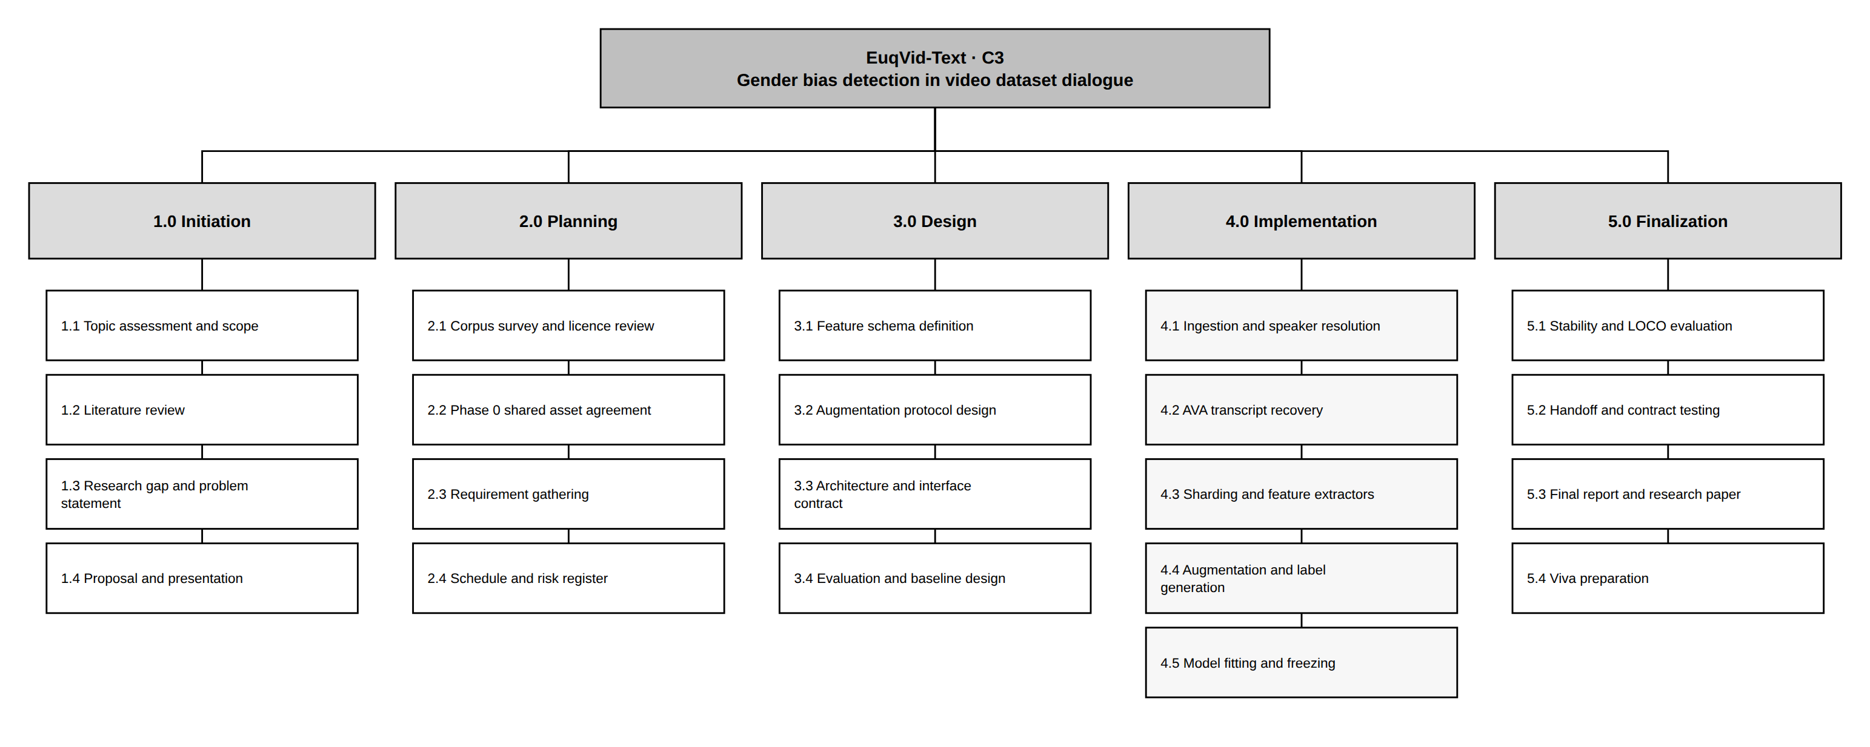
Figure 10: Work breakdown structure
Table 10: Work breakdown by phase
Phase | Tasks
1.0 Initiation | Topic assessment and scope definition, literature review, research gap and problem statement, proposal preparation, submission and presentation
2.0 Planning | Corpus survey and licence review; agreement of the identity-to-gender map, the shard definition and the augmentation protocol with the other three components; requirement gathering with practitioners; schedule and risk register
3.0 Design | Feature schema definition, augmentation protocol design, component architecture and interface contract, evaluation and baseline design
4.0 Implementation | Ingestion and speaker resolution; transcript recovery for AVA by automatic speech recognition with active-speaker attribution and manual gender annotation; sharding and the seven feature extractors; dependency parsing and lexicon integration; augmentation and label generation; model fitting, screening and freezing
5.0 Finalization | Bootstrap stability, leave-one-corpus-out and monotonicity evaluation; ablation and baseline comparison; handoff to the fusion stage and contract testing; final report and research paper; viva preparation

Timeline alignment. Phase 0 finishes at proposal submission for the documentation tasks, but the shared-asset decisions gate the start of extraction and are therefore scheduled first and treated as the critical path. Feature extraction must be complete before labels can be generated, because the augmentation protocol operates on the feature table rather than on raw text. Freezing cannot begin until model selection is settled. The Phase 5 handoff gates the group fusion stage, which is why it is scheduled to complete before the final reporting window rather than inside it. Report preparation runs continuously rather than as a terminal activity.
Balanced workload. Each of the four group members owns one modality sub-metric with the same five-phase structure. The shared tasks — the identity-to-gender map, the shard definition, the augmentation protocol, the shared feature file schema and the calibration reference set — each have one owner and three reviewers, so that no member carries more shared work than the others on top of their own component.

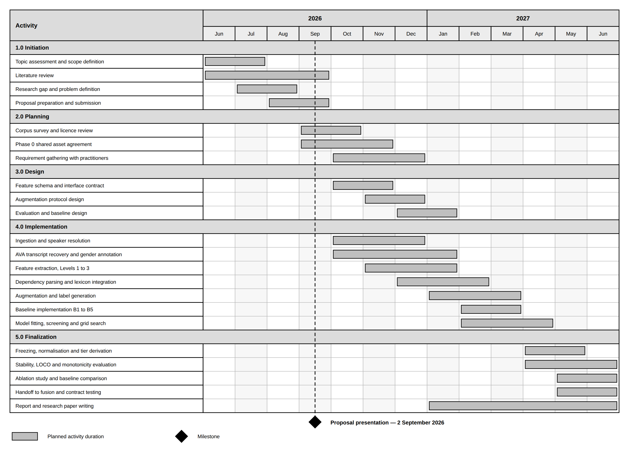
The schedule runs from June 2026 to June 2027 at month resolution and is organised around the five phases of the work breakdown structure in Section 8. It is shown in Figure 11 and listed in Table 11. Three things are drawn deliberately. The proposal presentation on 2 September 2026 is marked as a milestone, because it closes the Initiation phase and fixes the scope everything after it depends on. The Phase 0 shared asset agreement gates the start of extraction, because a shard definition agreed after extraction has begun would require all four components to re-extract rather than one. Report and paper writing runs continuously from January rather than as a terminal activity, so that a late result does not arrive with no time left to write it up.
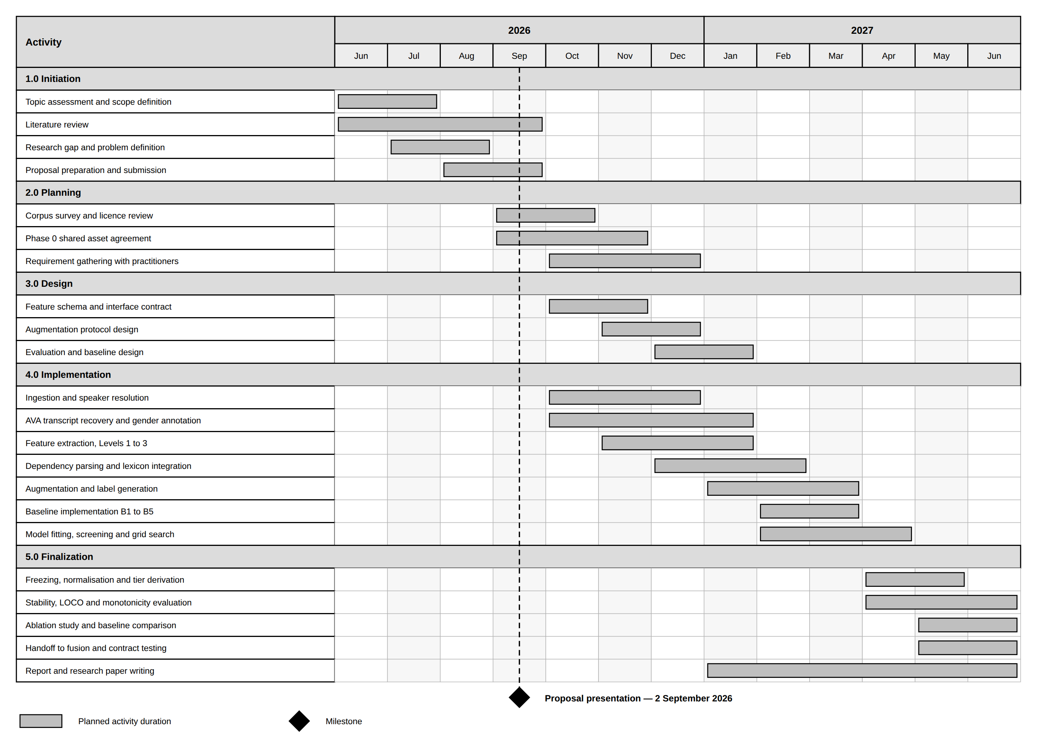
Figure 11: Gantt chart
Table 11: Gantt activity schedule
Activity | Start | End | Duration
Topic assessment and scope definition | Jun 2026 | Jul 2026 | 2 months
Literature review | Jun 2026 | Sep 2026 | 4 months
Research gap and problem definition | Jul 2026 | Aug 2026 | 2 months
Proposal preparation and submission | Aug 2026 | Sep 2026 | 2 months
Proposal presentation | 2 Sep 2026 | — | Milestone
Corpus survey and licence review | Sep 2026 | Oct 2026 | 2 months
Phase 0 shared asset agreement | Sep 2026 | Nov 2026 | 3 months
Requirement gathering with practitioners | Oct 2026 | Dec 2026 | 3 months
Feature schema and interface contract | Oct 2026 | Nov 2026 | 2 months
Augmentation protocol design | Nov 2026 | Dec 2026 | 2 months
Evaluation and baseline design | Dec 2026 | Jan 2027 | 2 months
Ingestion and speaker resolution | Oct 2026 | Dec 2026 | 3 months
AVA transcript recovery and gender annotation | Oct 2026 | Jan 2027 | 4 months
Feature extraction, Levels 1 to 3 | Nov 2026 | Jan 2027 | 3 months
Dependency parsing and lexicon integration | Dec 2026 | Feb 2027 | 3 months
Augmentation and label generation | Jan 2027 | Mar 2027 | 3 months
Baseline implementation B1 to B5 | Feb 2027 | Mar 2027 | 2 months
Model fitting, screening and grid search | Feb 2027 | Apr 2027 | 3 months
Freezing, normalisation and tier derivation | Apr 2027 | May 2027 | 2 months
Stability, LOCO and monotonicity evaluation | Apr 2027 | Jun 2027 | 3 months
Ablation study and baseline comparison | May 2027 | Jun 2027 | 2 months
Handoff to fusion and contract testing | May 2027 | Jun 2027 | 2 months
Report and research paper writing | Jan 2027 | Jun 2027 | 6 months

10. REFERENCES
[1] S. Poria, D. Hazarika, N. Majumder, G. Naik, E. Cambria, and R. Mihalcea, “MELD: A multimodal multi-party dataset for emotion recognition in conversations,” in Proc. 57th Annu. Meeting Assoc. Comput. Linguistics, Florence, Italy, 2019, pp. 527–536.
[2] M. Sap, M. C. Prasettio, A. Holtzman, H. Rashkin, and Y. Choi, “Connotation frames of power and agency in modern films,” in Proc. 2017 Conf. Empirical Methods Natural Language Processing, Copenhagen, Denmark, 2017, pp. 2329–2334.
[3] A. Agarwal, J. Zheng, S. Kamath, S. Balasubramanian, and S. A. Dey, “Key female characters in film have more to talk about besides men: Automating the Bechdel test,” in Proc. 2015 Conf. North Amer. Chapter Assoc. Comput. Linguistics: Human Language Technologies, Denver, CO, USA, 2015, pp. 830–840.
[4] J. Zhao, T. Wang, M. Yatskar, V. Ordonez, and K.-W. Chang, “Men also like shopping: Reducing gender bias amplification using corpus-level constraints,” in Proc. 2017 Conf. Empirical Methods Natural Language Processing, Copenhagen, Denmark, 2017, pp. 2979–2989.
[5] S. Jayawardena, P. S. Haddela, T. Shyamalee, A. Ekanayake, T. Mudalige, and I. Dhanawardhana, “EuqAud: Detecting gender bias in audio datasets using polynomial regression-based metric,” IEEE Access, vol. 14, 2026.
[6] D. Bamman, B. O’Connor, and N. A. Smith, “Learning latent personas of film characters,” in Proc. 51st Annu. Meeting Assoc. Comput. Linguistics, Sofia, Bulgaria, 2013.
[7] L. A. Hendricks, K. Burns, K. Saenko, T. Darrell, and A. Rohrbach, “Women also snowboard: Overcoming bias in captioning models,” in Proc. Eur. Conf. Comput. Vision (ECCV), Munich, Germany, 2018.
[8] A. Caliskan, J. J. Bryson, and A. Narayanan, “Semantics derived automatically from language corpora contain human-like biases,” Science, vol. 356, no. 6334, pp. 183–186, 2017.
[9] “You talkin’ to me?: A network analysis of gendered speaker-addressee patterns in film screenplays,” arXiv:2607.22656, 2026.
[10] C. Gu et al., “AVA: A video dataset of spatio-temporally localized atomic visual actions,” in Proc. IEEE Conf. Comput. Vision and Pattern Recognition (CVPR), Salt Lake City, UT, USA, 2018.
[11] J. Roth et al., “AVA-ActiveSpeaker: An audio-visual dataset for active speaker detection,” arXiv:1901.01342, 2019.
[12] J. Carletta et al., “The AMI meeting corpus: A pre-announcement,” in Machine Learning for Multimodal Interaction, Berlin, Germany: Springer, 2006.
[To be expanded] Twelve references are listed. A submitted proposal in this area would normally carry 20 to 30. Confirm the volume, issue and page details of reference [5] once the EuqAud paper is formally published, and complete reference [9] with its author list. Add technical sources as they are read and record each addition in Appendix 2.

11. APPENDICES

Appendix 1: Requirement gathering documents
[To be completed] File here the practitioner interview guide, the questionnaire form, the expert review form, the participant information sheet and consent form, and the anonymised responses once they are collected. Cross-reference each instrument to the activity it belongs to in Table 8.

Appendix 2: Proposal evidence and decision log
This log is kept throughout the preparation of the proposal, and the proposal matches it. Three entries drawn from decisions already taken are shown. Complete the rest from your own records.
Table 12: Proposal evidence and decision log
Date | Claim or problem | Evidence collected | Alternatives considered | Decision made | Supervisor discussion
 | Screenplays are not a valid input for a dataset audit | Sap et al. analyse screenplays [2]; no video corpus distributes them | (a) screenplays (b) captioning-model output (c) distributed transcripts | (c); (b) would measure the captioning model’s bias [7]
 | A single equation over all four modalities is not fittable | Coefficient budget at degree 2 against available independent shards (Figure 3) | (a) one combined equation (b) four modality sub-metrics | (b); (a) exceeds the coefficient budget
 | utterance_count_share duplicates the temporal sub-metric | Same quantity as the temporal turn-count share | (a) retain in both (b) drop from the text sub-metric | (b); retaining it would double-weight the signal in fusion

Appendix 3: AI use disclosure
Table 13: AI use disclosure
AI tool | Purpose of use | What was generated or assisted | How output was verified | Final student contribution
Claude | Drafting support and critical review of the proposal | Section drafts, the figure set, and challenges to the research gap, feature schema and statistical plan | Every claim traced to a cited source; every statistic re-derived by hand; corpus facts checked against distributor pages | All research decisions, the feature definitions, the domain restriction and the final wording
ChatGPT | Alternative phrasing and explanation of statistical concepts | Restatements of regression assumptions and Ridge regularisation for the methodology section | Checked against scikit-learn and statsmodels documentation and against the module notes | Selection of which explanation is correct for this design and its integration into the text
Gemini | Literature discovery and cross-checking of related work | Candidate references and summaries of prior gender-bias measures | Each reference opened at source; unverified items removed rather than cited | The judgement of relevance, the research-gap argument and the comparison in Table 1
NotebookLM | Reading and querying the source papers, including EuqAud | Summaries of and answers about the uploaded papers and the assignment brief | Every summary checked against the passage it came from before use | The reading of what EuqAud does and does not claim, and the extension argued here

When you fill the verification column, state exactly what you checked yourself. For example, that you opened every reference on the publisher’s website and confirmed the figures, that you traced every statistic back to its source, and that you compared every methodology claim against the module requirements.
When you fill the contribution column, state what is your own. For example, the research problem and gap, the scope of the component, the feature design decisions, the objectives and targets, the budget figures, the timeline, and every change made after discussing the work with your supervisor.
The use of AI does not transfer responsibility for the submitted work. The student remains responsible for accuracy, originality, validity of references, research decisions, methodology, technical choices, interpretation of evidence, and the ability to defend every part of the proposal.

Appendix 4: Augmentation and labelling protocol
Because no corpus carries a gender-disparity label, the labels used for fitting are imposed by controlled perturbation of the feature table. The tiers below define what each imposed level means, so that a score of a given magnitude denotes the same degree of disparity in all four sub-metrics.
Table 14: Augmentation and labelling protocol
Tier | Score band | Definition | Imposed condition
Parity | −1 to +1 | Neither gender is systematically advantaged in the dialogue of the shard | No reduction applied; features left at their measured values
Mild | ±1 to ±4 | A disparity is present but small enough that it may reflect the natural variation of the material | One gender’s features reduced at the smallest protocol increment
Moderate | ±4 to ±7 | A disparity a curator should be told about before the corpus is used for training | Reduction applied at the intermediate protocol increments
Severe | ±7 to ±10 | A disparity that warrants intervention before training rather than documentation alone | Reduction applied at the largest protocol increments

[To be refined] The tier boundaries above are provisional and must be derived from the stated disparity levels once the augmentation increments are fixed with the group, not inherited from EuqAud. Fix the exact increment sizes, record them here, run the pilot on MELD, and revise the bands against the monotonicity result. Record each revision in Appendix 2.

Appendix 5: Dataset list
Table 15: Dataset list
Dataset | Size | Licence | Status
MELD [1] | ≈13,700 utterances, 1,433 dialogues | Academic use, to be confirmed | Available, to be downloaded
AMI Meeting Corpus [12] | ≈100 hours of annotated meetings | Academic use, to be confirmed | Available, to be downloaded
AVA / AVA-ActiveSpeaker [10], [11] | Film clips of 15 minutes; per-frame active-speaker labels; count to be verified | Open licence for the annotations, to be confirmed; clips sourced from YouTube | Annotations available; transcripts to be recovered
Connotation-frame lexicons [2] | Verb-level agency and power ratings | Publicly released by the authors | Available
Augmented shard set | ≥200 identity-partitioned shards | Created in this study | To be built

Appendix 6: Data use and ethics documents
[To be completed] This component processes published corpora rather than data collected from people, so the ethics position differs from a study involving human subjects. File here the corpus licence terms for each dataset used, the data management and retention plan, the statement that no corpus content is redistributed, and — because the requirement gathering in Section 5.1 collects data from practitioners — the participant information sheet, the consent form and any faculty clearance required for that activity. Confirm with the supervisor whether a full ethics application is required for the interview and questionnaire stage.

