EuqVid-Text: A Dialogue-Based Approach to Gender Bias
Detection in Video Datasets
J26-DS-343
Project Proposal Report
Fernando R. S. R. — IT23449282
B.Sc. (Hons) Degree in Information Technology
Specialized in Data Science
Department of Information Technology
Faculty of Computing
Sri Lanka Institute of Information Technology
September 2026

DECLARATION
I declare that this is my own work and this proposal does not incorporate without acknowledgement any material previously submitted for a degree or diploma in any other university or institute of higher learning, and to the best of my knowledge and belief it does not contain any material previously published or written by another person except where the acknowledgement is made in the text.
Also, I hereby grant to Sri Lanka Institute of Information Technology the non-exclusive right to reproduce and distribute my thesis, in whole or in part, in print, electronic or other medium. I retain the right to use this content in whole or part in future works.

Name | Student ID | Signature
Fernando R. S. R. | IT23449282

The above candidate is carrying out research for the undergraduate Dissertation under my supervision.

Supervisor | Signature | Date
Dr. Prasanna S. Haddela

ABSTRACT
Video datasets used to train multimodal artificial intelligence systems carry gender bias not only in their imagery but in the dialogue transcripts distributed alongside it. Models trained on gender-skewed corpora have been shown to reproduce and amplify that skew, so disparity present before training surfaces afterwards as measurable performance inequality, at a point where correction is expensive. Dataset documentation records provenance, licence and label schema, but carries no quantitative measure of representational disparity, and no method currently converts textual gender disparity in a video dataset into a number a curator can compute before training begins.
This research proposes EuqVid-Text, the textual component of EuqVid, a four-modality pre-training audit metric that extends the polynomial regression methodology of EuqAud from the audio modality into video. The component extracts scale-free dialogue disparity features across three levels — volume, interaction structure, and agency and power derived from connotation-frame lexicons — from the speaker-attributed transcripts that ship inside video corpora rather than from screenplays, which are pre-production artefacts distributed with no video dataset.
A quantitative experimental design is adopted. Ground-truth labels are produced by a shared augmentation protocol that reduces one gender’s features at controlled increments, yielding shards of known disparity. A polynomial Ridge regression model with degree capped at two is fitted with feature screening performed inside cross-validation folds, then frozen as an explicit closed-form equation in raw feature units and normalised to a shared scale from −10 to +10 with derived severity tiers. Development follows iterative prototyping against a synthetic feature table, so that every deliverable is assessable independently of the other components.
Evaluation compares the equation against three dialogue-ratio baselines, reports regression diagnostics per assumption, and characterises stability through 1,000-iteration bootstrap resampling at shard and identity level, leave-one-corpus-out cross-validation, and a monotonicity check on held-out perturbation curves. The frozen equation, its normalisation constants, tier thresholds and per-shard scores are delivered to the fusion stage, where they compose with the visual, temporal and acoustic sub-metrics into the complete EuqVid score.

Keywords — gender bias; dataset auditing; dialogue analysis; polynomial Ridge regression; responsible AI

TABLE OF CONTENTS

LIST OF FIGURES
Figure 1: One scene read through four modalities
Figure 2: The four levels of textual gender bias
Figure 3: Coefficient budget at polynomial degree 2
Figure 4: The EuqVid score scale and severity tiers
Figure 5: High-level system architecture of EuqVid
Figure 6: EuqVid-Text component pipeline
Figure 7: Iterative prototyping development approach
Figure 8: Sequence of data flow through the component
Figure 9: Use case diagram of the EuqVid-Text component
Figure 10: Work breakdown structure
Figure 11: Gantt chart

LIST OF TABLES
Table 1: Research gap
Table 2: Corpora and text availability for this component
Table 3: Extracted dialogue disparity features
Table 4: Technologies
Table 5: Evaluation metrics
Table 6: Functional requirements
Table 7: Non-functional requirements
Table 8: System requirements

LIST OF ABBREVIATIONS
Abbreviation | Description
AMI | Augmented Multi-party Interaction Meeting Corpus
ASR | Automatic Speech Recognition
AVA | Atomic Visual Actions dataset
CNN | Convolutional Neural Network
CV | Cross-Validation
MELD | Multimodal EmotionLines Dataset
NLP | Natural Language Processing
OOV | Out-Of-Vocabulary
SDG | Sustainable Development Goal
VIF | Variance Inflation Factor

1. INTRODUCTION

1.1 Background & Literature survey
Artificial intelligence systems trained on video are now deployed in consequential settings, and the datasets behind them are assembled from film and television material that was never produced with balanced representation as a design goal. Those datasets do not ship only imagery. They ship words — utterance transcripts, subtitles and speaker annotations — distributed as first-class training inputs. MELD, for instance, is an extension of the text-only EmotionLines corpus, so its emotion labels were annotated from dialogue in the first place [1]. Video-language models, captioning systems and video question-answering systems all ingest that text alongside the frames.
Gender bias in the text half of a video corpus is invisible to existing dataset documentation. Dataset cards report clip counts, licences and label schemas; none report whether one gender is written with systematically more to say, or with language that positions them as acting rather than as being acted upon. The distinction matters because the textual channel measures something the other channels cannot reach, as Figure 1 illustrates.
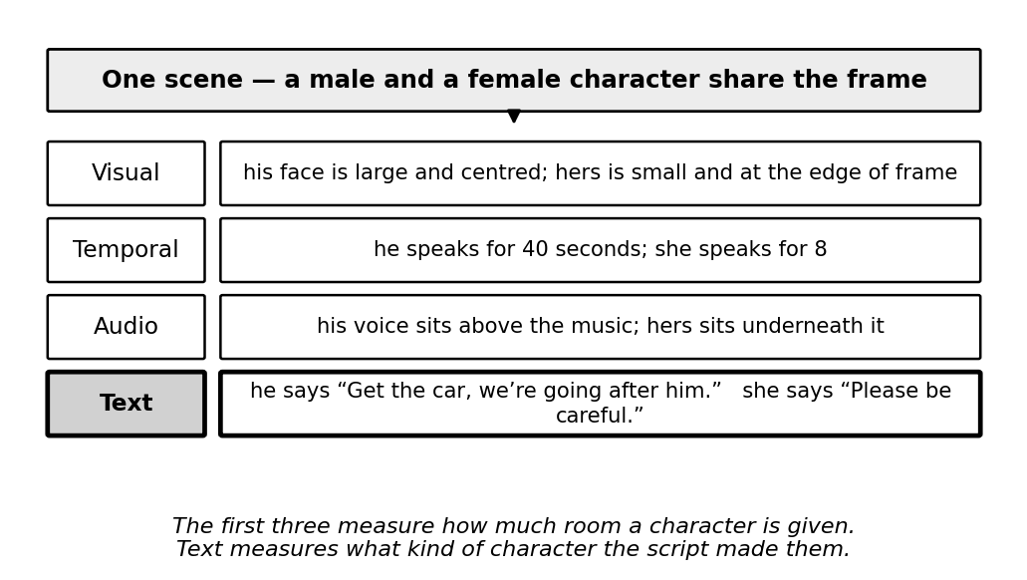
Figure 1: One scene read through four modalities
Equalise a character’s screen time, speaking seconds and loudness, and the language written for that character is unchanged. No visual, temporal or acoustic feature detects that difference, because the difference lies not in how much a character is present but in what the script gives them to do. This is what makes a textual component non-redundant within a multimodal metric rather than a fourth measurement of the same underlying quantity.
Textual gender bias operates at four levels of increasing analytical depth, summarised in Figure 2. The first three are countable and largely restate what visual and temporal measurement already suggests; the fourth requires dependency parsing and a connotation lexicon, and reaches a property of the writing that no other modality exposes.
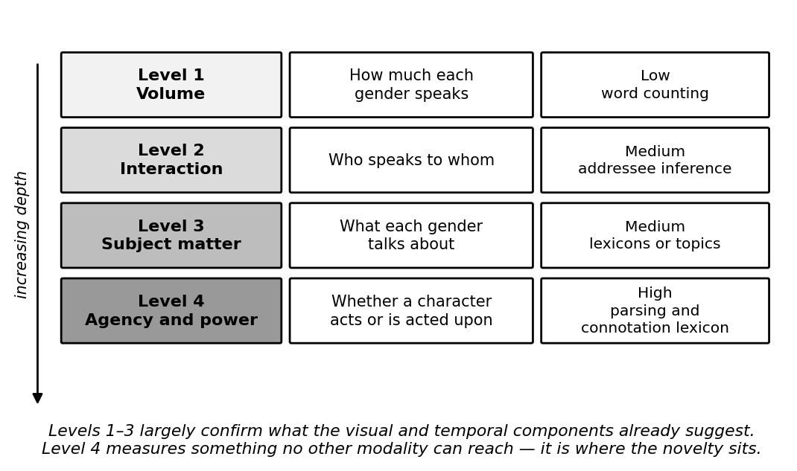
Figure 2: The four levels of textual gender bias
The evidence base divides into two strands. The first establishes that film and television text is gendered. Sap et al. [2] introduced connotation frames of power and agency, annotating verbs for the power differential and level of agency they imply for their syntactic subject, and applying the resulting lexicons to a large corpus of modern film screenplays. They found female characters written with systematically lower agency and lower power than male characters, and released the lexicons publicly. The method is interpretable and the finding robust; its limitation is that the analysis is descriptive, is performed on screenplays rather than on distributed dataset text, and yields no aggregate score. Agarwal et al. [3] built a computational version of the Bechdel test over film scripts using dependency parsing and classification, establishing that interaction structure — who speaks to whom — is machine-detectable. Its output, however, is a binary verdict at film level, which can express neither severity nor comparison between datasets. Bamman et al. [6] learned latent personas of film characters from text and found the recovered archetypes strongly gendered, demonstrating that gendered characterisation is recoverable without supervision, though personas are descriptive clusters rather than a disparity measure and the method requires a large corpus per fit, which is unsuited to per-shard scoring.
The second strand is the more consequential, because it justifies measuring bias before training rather than repairing a model afterwards. Zhao et al. [4] measured the gender skew of training corpora and of the predictions of models trained on them, and found that models trained on gender-skewed data are measurably more biased than the data itself. A corpus that is moderately skewed therefore yields a model that behaves as though it were severely skewed, which makes the corpus the efficient point of intervention. Hendricks et al. [7] found that captioning models predicted a subject’s gender from scene context rather than from the person depicted, reproducing dataset stereotypes at inference time; this result also rules out an apparently attractive shortcut, since generating descriptive text with a captioning model for corpora that lack transcripts would measure the captioning model’s bias rather than the dataset’s. Caliskan et al. [8] demonstrated that human-like biases are embedded in language corpora independently of any particular model, which supports treating the corpus rather than the model as the object of measurement.
Recent work confirms the concern remains active. A 2026 network analysis of gendered speaker–addressee patterns in film screenplays [9] examined 4,600 manually annotated directed dialogue events across 38 screenplays and reported male characters dominant as both speakers and addressees even in scenes with a female majority, concluding that bias in film dialogue operates through the architecture of conversation itself. Its output is a set of descriptive findings and network visualisations; it produces no dataset-level score. One methodological caution is inherited from it: that study annotated addressees manually, whereas the present component approximates addressee from turn adjacency, and this is declared as a limitation rather than left to be discovered.
Among applied systems, the Geena Davis Inclusion Quotient is the most established, measuring screen and speaking time by gender in film through automated audio and video analysis, and used by studios and advocacy organisations to produce representation reports. Its function is descriptive analytics; its users are content producers rather than dataset builders; and it does not examine dialogue content, does not emit a continuous score, and is not designed to operate inside a machine-learning dataset pipeline. Dataset rebalancing tools adjust sample counts to equalise representation, but operate on counts alone and provide no measure of severity. EuqAud [5] established a regression-derived closed-form gender bias score for audio datasets and is the parent methodology of this project, but its features are acoustic and its corpora are read speech recorded in quiet conditions, so neither the features nor the fitted equation transfer to text.

1.2 Research Gap
While the studies above have each made progress in measuring gendered language in film and in demonstrating how dataset bias propagates into trained models, a detailed comparison reveals gaps in scope and application that this research addresses. Table 1 sets the existing approaches against the capabilities required of a pre-training textual audit metric.
Approach | Dialogue-level  analysis | Continuous  severity score | Scale-invariant  across corpora | Computable on  distributed  dataset text | Composes with  other modalities
Research A [2] | ✓ | ✗ | ✗ | ✗ | ✗
Research B [3] | ✓ | ✗ | ✗ | ✗ | ✗
Research C [4] | ✗ | ✗ | ✓ | ✓ | ✗
Research D [5] | ✗ | ✓ | ✓ | ✓ | ✗
Proposed component | ✓ | ✓ | ✓ | ✓ | ✓
Table 1: Research gap
Research A [2] measures agency and power in film dialogue using connotation frames, and is the source of the Level 4 features adopted here. It analyses screenplays, which are pre-production artefacts distributed with no video dataset, and reports a descriptive finding rather than producing a score a curator can compute.
Research B [3] automates the Bechdel test over film scripts, establishing that interaction-level structure is machine-detectable. Its verdict is binary and film-level, so it cannot express how severe a disparity is, cannot rank two corpora, and cannot be computed per dataset shard.
Research C [4] demonstrates bias amplification and proposes corpus-level constraints to reduce it. It works on images and structured labels rather than narrative dialogue, and intervenes at inference rather than measuring the dataset, so it motivates a pre-training metric without supplying one.
Research D [5] is EuqAud, which does produce a frozen, regression-derived, scale-invariant score, and is the methodological parent of this work. It covers the audio modality only; its features are acoustic and its corpora are read speech in quiet conditions, so neither the feature set nor the equation transfers to text, and it is a single-modality instrument rather than one designed to compose.
The proposed component combines dialogue-level analysis at four depths with a continuous, scale-invariant score computed on the transcripts that actually ship inside video corpora, and is designed from the outset to compose with the visual, temporal and acoustic sub-metrics rather than to stand alone. A structural consequence of that four-component design is shown in Figure 3: distributing the feature space across four sub-metrics keeps the polynomial expansion within a coefficient budget that the available number of independent shards can support, whereas a single equation over the combined feature set would not be reliably fittable.
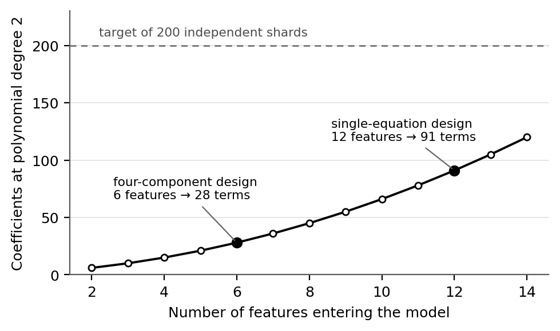
Figure 3: Coefficient budget at polynomial degree 2
Stated precisely, the gap is this: no method exists to compute a continuous, scale-invariant gender-disparity score from the speaker-attributed dialogue distributed inside a video dataset, before any model is trained, on a scale comparable with measures of visual and temporal disparity.

1.3 Research Problem
From the background and the gap identified above, three problems require attention within the framework of the proposed component. These guide the development and refinement of the solution.
1. How can gendered language in a video dataset be reduced to a single comparable number?
A feature table is not an answer. Presenting a dataset curator with seven per-gender quantities tells them nothing actionable until those quantities collapse into one score with a severity tier they can act on. The problem is not measurement alone but the construction of an aggregation rule that is defensible, reproducible and comparable across corpora of different sizes.
2. How can ground truth be established when no video dataset carries a bias label?
No corpus is annotated with a dataset-level bias score, so there is nothing to regress against. The problem is to manufacture ground truth under controlled conditions, by perturbing real feature data at known increments so that the magnitude and direction of disparity in each training case are known because they were imposed, while keeping the resulting labels meaningful enough that an equation fitted to them transfers to unperturbed data.
3. How can the resulting measure be made auditable rather than merely accurate?
A dataset audit instrument that cannot be inspected is of limited use to the person who must defend a decision made on its output. The problem is to express the fitted relationship as a frozen closed-form equation in raw feature units, with published coefficients, stated normalisation bounds and derived tier thresholds, so that a third party can recompute any score by hand and challenge any term.

2. OBJECTIVES

2.1 Main Objectives
The main objective of this research is to develop and freeze a closed-form, scale-invariant polynomial Ridge regression equation that maps dialogue-derived disparity features of a video dataset to a single interpretable gender-bias score on the interval −10 to +10, and to demonstrate that the equation responds monotonically to controlled disparity and that its coefficients are stable under resampling at shard and identity level. The score, its severity tiers and the boundaries between them are shown in Figure 4.
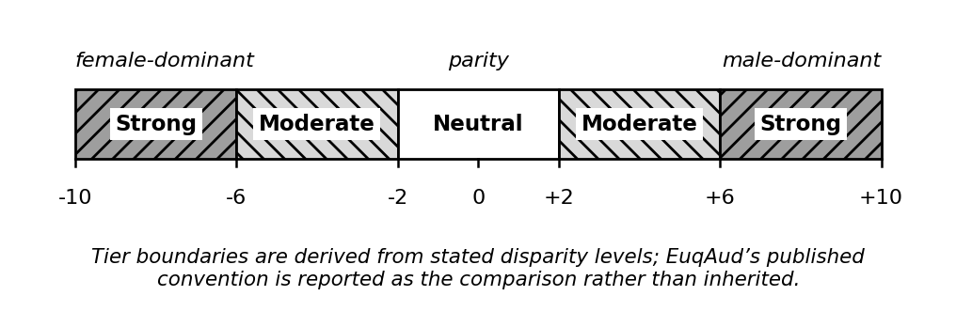
Figure 4: The EuqVid score scale and severity tiers
A score of zero denotes parity between genders, not the naturally occurring distribution of a corpus. Positive values indicate male-dominant disparity and negative values female-dominant disparity, so the sign carries direction while the magnitude carries severity. Because the same scale is used by all four sub-metrics, a reading of +6 is intended to denote the same degree of disparity whichever modality produced it, which is why the calibration reference set is a shared group asset rather than a component-private choice.

2.2 Specific Objectives
Six sub-objectives must be met in order to achieve the main objective. Each states a deliverable that can be checked as present or absent and a quantity that can be reported.
Construct the input corpus
- Build a time-aligned, speaker-attributed and gender-mapped utterance table from MELD and AMI and at least one further dialogue corpus, and report the proportion of utterances excluded for unresolved or ambiguous speaker identity rather than dropping them silently.
Extract the dialogue disparity features
- Compute seven scale-free features per shard per gender across volume, interaction and agency–power levels, and report the out-of-vocabulary rate of subject–verb pairs against the connotation-frame lexicon, since that rate determines whether the Level 4 features are viable on conversational television dialogue.
Generate ground-truth labels
- Apply the shared group augmentation protocol to produce shards at controlled incremental disparity levels, yielding a labelled training set of at least 200 independent shards partitioned by identity.
Fit and select the model
- Fit a polynomial Ridge model with degree capped at two by cross-validated grid search over the regularisation parameter, with feature screening performed inside folds rather than on the full set beforehand, reporting both nominal row count and effective sample size.
Freeze the equation
- Express the fitted model as an explicit closed-form equation in raw feature units with scaling constants folded into the published coefficients, stated min–max normalisation bounds, and severity-tier thresholds derived from stated disparity levels.
Characterise stability and generalisation
- Run 1,000-iteration bootstrap resampling at shard and identity level, leave-one-corpus-out cross-validation, and a monotonicity check against held-out perturbation curves, reporting confidence intervals at both score and tier level.

3. METHODOLOGY
The research question asks whether a quantitative relationship can be established between measurable properties of a corpus and a defined degree of representational disparity, and whether that relationship can be expressed in a fixed, auditable form. The question is predictive rather than exploratory, the data are numerical aggregates over text rather than narrative accounts, and the relationship must be estimated from cases whose disparity is known. A quantitative experimental design using controlled feature perturbation to generate ground truth, followed by regularised polynomial regression to derive a closed-form equation, is therefore the appropriate methodology. This follows the design validated for the audio modality by EuqAud [5]; the contribution here is its transfer to a different modality with a different feature space.
Regularised regression is selected over an unconstrained model for a specific reason. The dialogue features are correlated by construction, since volume, utterance count and mean length are algebraically linked. L2 regularisation shrinks correlated predictors together rather than selecting arbitrarily among them, which keeps the frozen equation stable across corpora. A sparse alternative such as L1 would drop one of a correlated pair, and which one it drops could differ between datasets, making the published equation unreproducible.

3.1 Proposed solution

3.1.1 Software solution
EuqVid computes a single gender-bias score for a video dataset from four modality sub-metrics derived independently and then fused. The visual sub-metric measures what the frame gives each gender, the temporal sub-metric measures how the timeline is shared, the textual sub-metric measures what the script gives each gender, and the acoustic sub-metric measures how each gender’s voice is treated in the sound. The boundary rule agreed by the group is that the frame belongs to Visual, time to Temporal, words to Text and sound to Audio. Figure 5 shows the overall architecture with the component proposed here highlighted.
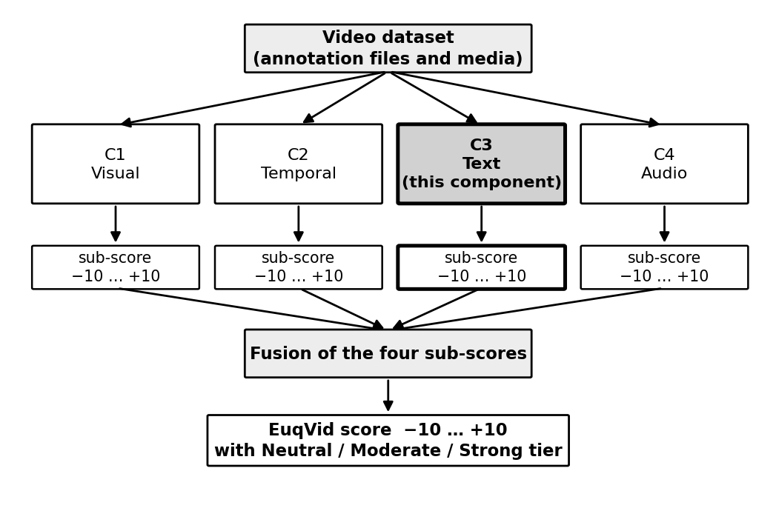
Figure 5: High-level system architecture of EuqVid
Three dependencies between the components are real and must be managed rather than assumed. All four must aggregate over the same identity-to-gender map, or the sub-scores describe different populations and cannot be combined. All four must use the same shard definition, since fusion operates per shard. And all four must share one augmentation and labelling protocol, because four private definitions of a bias level would calibrate the sub-metrics against four different meanings. A fourth dependency constrains which corpora the fused score can be computed on at all: a shard must carry all four sub-scores for fusion to apply, and a corpus without a transcript yields no textual sub-score. Where a modality is unavailable the fused score is computed in a documented reduced form, and the reduced form is shown to track the full form on corpora where both are computable.
Within the component, processing proceeds through the pipeline shown in Figure 6. No video is opened at any stage; every input is an annotation file.
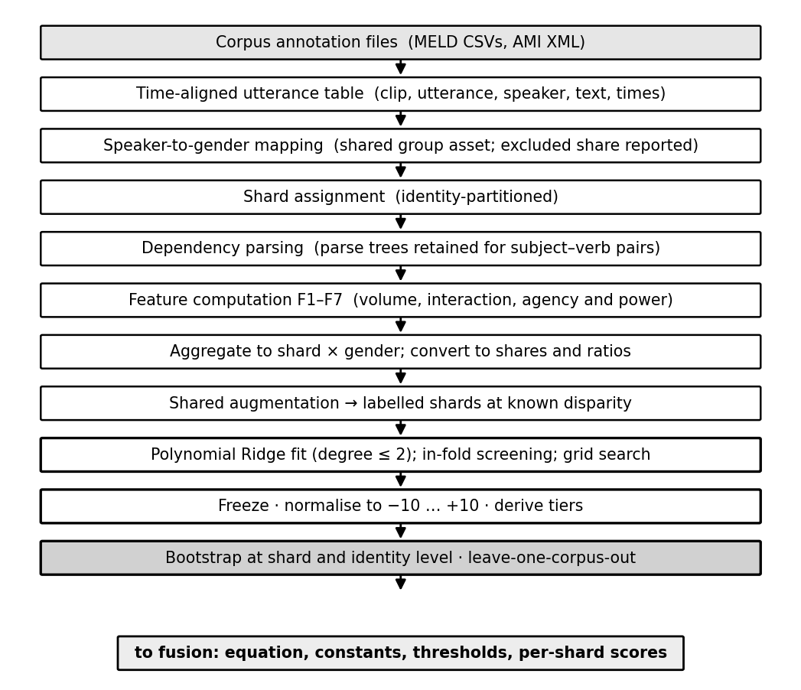
Figure 6: EuqVid-Text component pipeline
Two properties of that pipeline deserve emphasis. All features are expressed as shares or normalised ratios and no raw magnitude enters the model, because a raw count grows with corpus size and an equation fitted on raw counts would score a large balanced dataset as more biased than a small skewed one. And means are used rather than standard deviations: EuqAud used standard deviations of pitch, energy and amplitude because those quantities are intrinsically gender-linked, so a mean would merely detect that a woman is present, whereas dialogue volume and agency are not intrinsically gender-linked and the signal lives in the mean. Table 2 records which corpora supply the text this pipeline requires, and Table 3 the features it produces.
Corpus | Text available to this component | Access | Role
MELD [1] | Utterance CSVs carrying Utterance, Speaker, StartTime, EndTime, Dialogue_ID and Utterance_ID, with shipped emotion and sentiment labels | Open, no registration | Primary fitting corpus; negative control
AMI [12] | Manual annotation XML at word level, joined to speaker segments | Open, CC BY 4.0 | Contrast corpus, multi-party and non-narrative
AVA [10], [11] | None. Ships face boxes and per-frame speaking labels, but no transcript | Open | Not usable by this component at present; see limitation L1
Table 2: Corpora and text availability for this component
# | Feature | Definition | Level
F1 | dialogue_volume_share | Words spoken by gender g divided by total words in the shard | Volume
F2 | mean_utterance_length | Mean words per utterance for gender g, normalised by the shard mean | Volume
F3 | agency_score_mean | Mean agency value of verbs for which a character of gender g is the syntactic subject [2] | Agency
F4 | power_score_mean | Mean power value over the same subject–verb pairs [2] | Power
F5 | same_gender_dialogue_share | Proportion of gender g’s utterances in an adjacent turn with a character of the same gender | Interaction
F6 | mention_ratio | Times a character of gender g is named by others, divided by the times they speak | Interaction
F7 | sentiment_valence_mean | Mean sentiment polarity of gender g’s utterances | Subject matter
Table 3: Extracted dialogue disparity features
An eighth candidate, utterance_count_share, was deliberately excluded. It is the same quantity as the temporal component’s turn-count share, and retaining it in both sub-metrics would weight that signal twice in the fused score. This is a cross-component duplication that within-component collinearity screening cannot detect, because screening operates only on the features present in a single model.
The development approach is iterative prototyping, shown in Figure 7. The determining factor is a dependency structure rather than a preference: the component consumes a feature schema agreed collectively and not yet frozen, and delivers into a fusion stage that does not yet exist, so a sequential approach would idle until both are settled. Building the complete pipeline first against a synthetic feature table of the correct shape, then substituting real inputs as they arrive, keeps every deliverable assessable without the fusion stage existing and without any other component being complete.
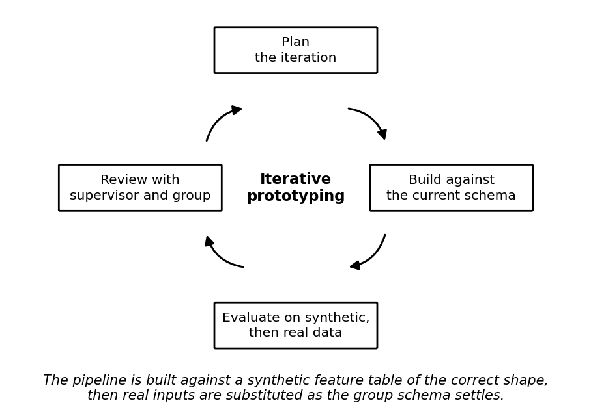
Figure 7: Iterative prototyping development approach
Figure 8 shows the order in which data moves through the component and where responsibility passes between this component and the shared group assets it depends on.
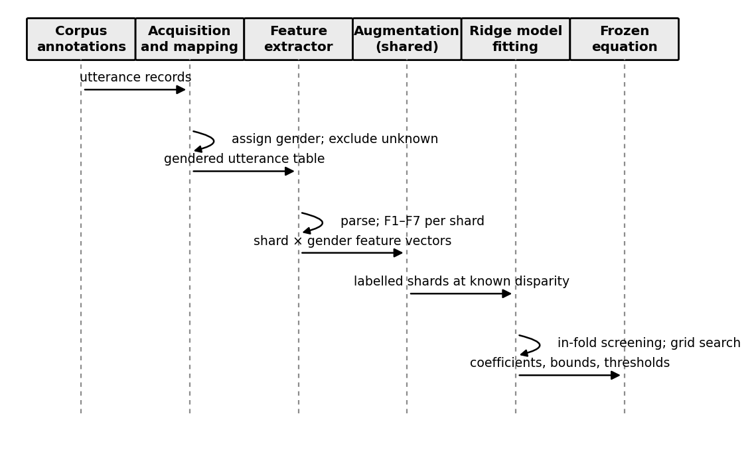
Figure 8: Sequence of data flow through the component
The actors interacting with the component and the operations available to them are shown in Figure 9. A dataset curator scores a corpus and reads a tier; a researcher inspects the equation and the stability evidence behind it; and the fusion stage consumes the per-shard scores and the frozen equation.
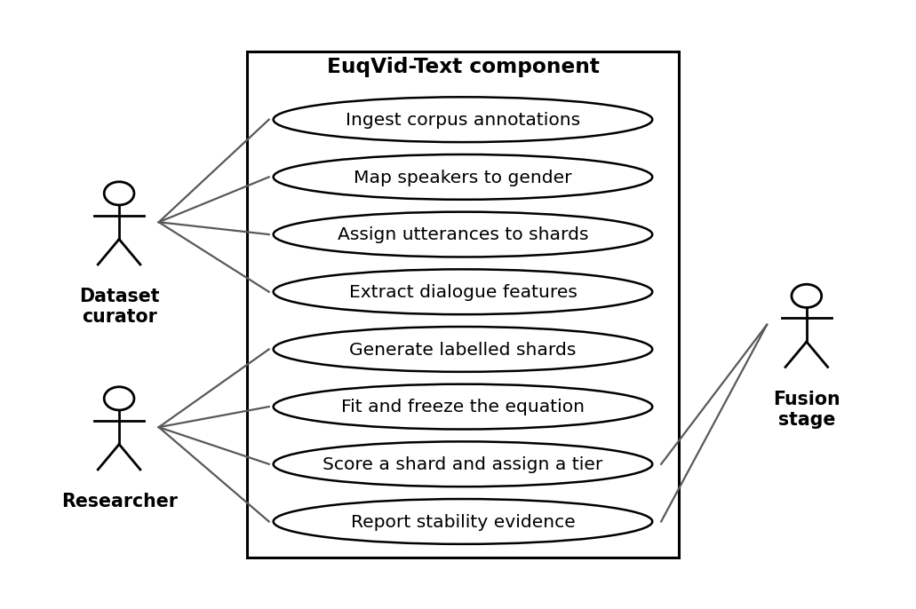
Figure 9: Use case diagram of the EuqVid-Text component
Technologies are chosen for interpretability and reproducibility rather than for performance, since the deliverable is an equation that must be defensible line by line rather than a model optimised for throughput. They are listed in Table 4.
Purpose | Technology | Justification
Language and environment | Python, seed-fixed notebooks and scripts | Reproducibility is a requirement rather than a convenience for a frozen equation others are expected to apply
Dependency parsing | spaCy | Supplies the subject–verb relations the Level 4 features require; bag-of-words representations cannot
Regression and selection | scikit-learn — PolynomialFeatures, Ridge, GridSearchCV, Pipeline | Pipeline objects keep feature screening inside cross-validation folds, which prevents selection leakage
Regression diagnostics | statsmodels — Durbin–Watson, Breusch–Pagan, variance inflation factor | Tests the assumptions the regression depends on, reported per fit rather than assumed
Resampling | SciPy and NumPy | Bootstrap resampling at shard and identity level
Lexical resource | Connotation-frame lexicons of power and agency [2] | Publicly released by their authors and the anchor for the Level 4 features
Table 4: Technologies
Success is measured against the criteria in Table 5. The three baselines against which the equation is compared are the dialogue-volume ratio, the utterance-count ratio and the character-count ratio. The third supports a specific and informative experiment: MELD’s main cast is three female and three male, so a character-count baseline classifies it as unbiased by construction. If the proposed equation registers disparity on MELD, that disparity cannot originate in counts, and must come from volume, interaction or agency — which answers the question “why not simply count characters?” with a demonstration rather than an argument.
Metric | Why relevant | Target or comparison
R² against the synthetic disparity label | Measures whether the equation recovers the disparity deliberately injected | Reported; compared against EuqAud’s published fit, with no pre-committed target
Spearman ρ on held-out perturbation curves | A bias score that does not rise with injected bias is not measuring bias | Monotonic ordering expected; ρ reported per corpus
Variance inflation factor | Polynomial expansion multiplies features together and inflates multicollinearity | All retained terms below the conventional threshold of 10
Durbin–Watson statistic | Tests residual independence, an assumption the regression depends on | Reported per fit; departure from approximately 2 flagged
Breusch–Pagan test | Tests homoscedasticity of residuals | Reported as pass or fail per fit, not suppressed
Bootstrap 95% confidence interval per coefficient | Distinguishes real terms from artefacts of the particular shards fitted | Reported for every term; terms whose interval spans zero flagged
Tier reassignment rate across resamples | Tier stability matters more than score stability, since the tier is what a curator acts on | Reported; high reassignment at a boundary indicates the boundary is not real
Lexicon out-of-vocabulary rate | Determines whether the Level 4 features are viable on conversational dialogue | Reported per corpus; informs whether F3 and F4 are retained
Kruskal–Wallis effect size | Non-parametric comparison of how sharply each measure separates disparity levels | Compared against the three baselines above
Table 5: Evaluation metrics
Validity is established in four ways, each addressing a distinct threat. Sensitivity is tested against shards whose disparity was set by controlled augmentation, establishing that the score tracks a known quantity. Stability is established by bootstrap resampling at shard and identity level rather than row level, because row-level resampling on synthetically expanded data produces confidence intervals that are fictitiously narrow. Generalisation is tested by leave-one-corpus-out cross-validation. Specificity is established against MELD as a negative control, since a metric that scores a balanced ensemble near zero is evidence against false positives — framed in advance as the intended result rather than presented afterwards as a disappointing finding. Independent validation of the complete EuqVid score against human perception and downstream model disparity is conducted by the validation stage of the group project and lies outside the boundary of this component, which derives the equation but does not validate the metric.
Six limitations are declared in advance. L1: AVA ships no transcript, so this component cannot score the group’s film corpus as matters stand. L2: identity-disjoint sharding is in tension with MELD’s six recurring leads, so either sharding is performed at episode or scene level with leakage documented, or fewer shards are accepted and the coefficient budget revisited. L3: the connotation-frame lexicon was built on screenplays while MELD is informal overlapping conversation, so coverage is measured rather than assumed. L4: addressee is approximated from turn adjacency and degrades in scenes with three or more speakers. L5: gender is derived from a character-name mapping rather than given, non-binary and ambiguous characters are excluded rather than forced into a binary, and the excluded share is reported. L6: all corpora are English, so findings do not transfer to other languages without re-validation.
Work is distributed across five phases, shown in Figure 10, and scheduled as shown in Figure 11.
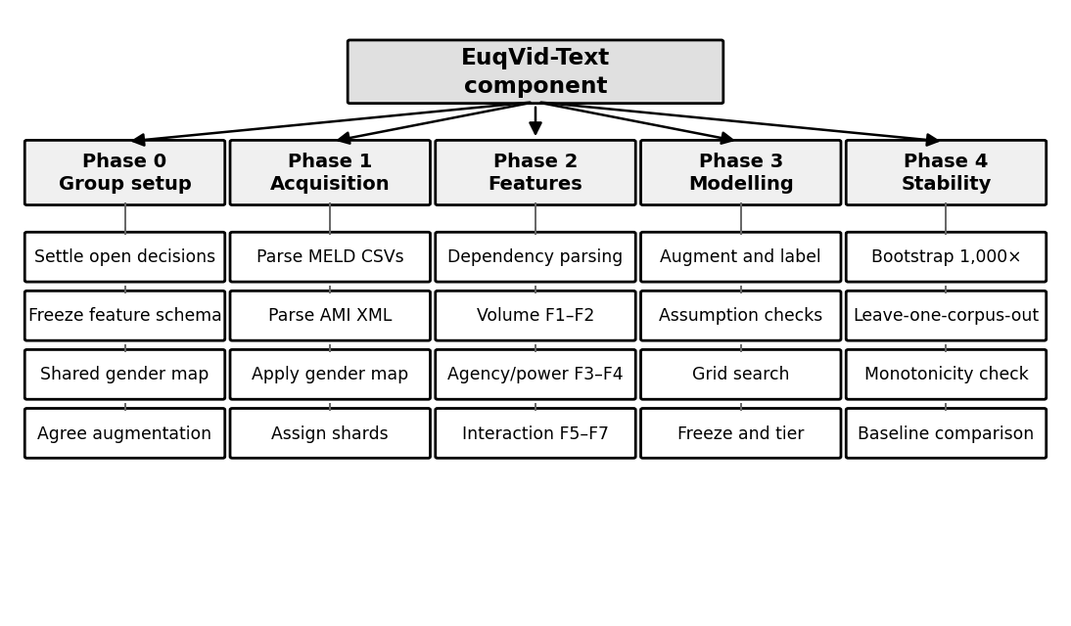
Figure 10: Work breakdown structure
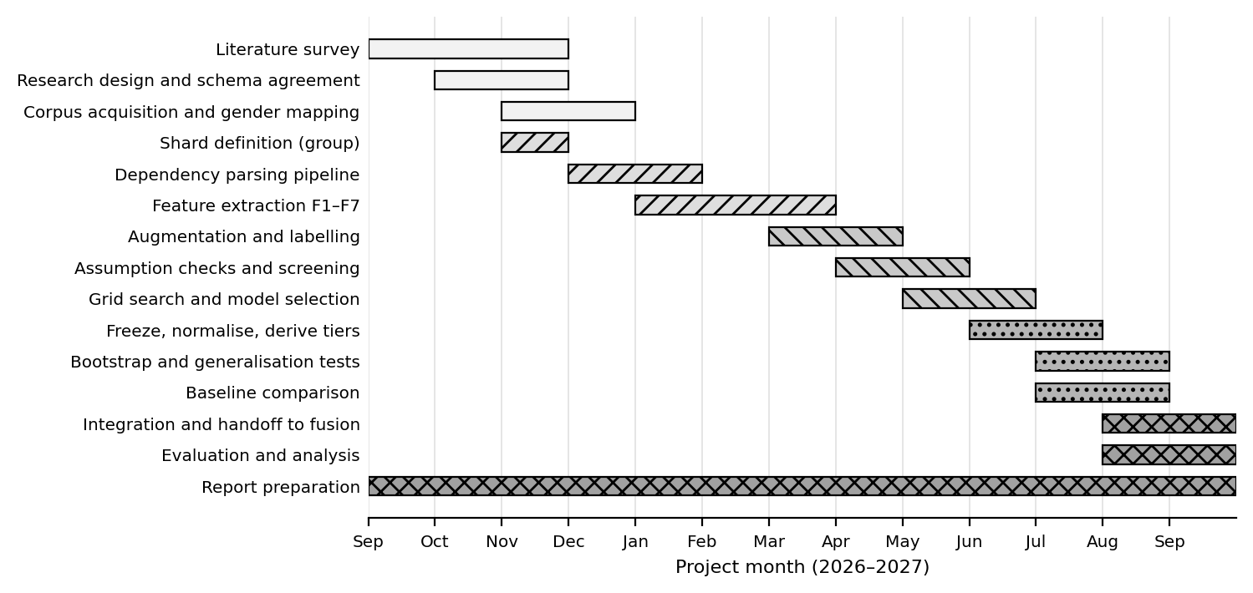
Figure 11: Gantt chart

3.1.2 Commercialization
The primary market is organisations that assemble or licence video training data and are subject to internal or regulatory fairness obligations. The representative customer is a dataset lead at a mid-sized AI company who must certify that a corpus has been assessed for representational disparity before a training run is authorised, and who at present has no instrument for doing so and no defensible way to document the decision. A secondary market is academic research groups publishing video datasets, for whom a reported score becomes part of the dataset card.
The value proposition rests on timing and inspectability. The component detects representational bias at the point where correction is cheapest: because it is applied before training it requires no retraining, no model access and no labelled outcomes, and because the scoring rule is a frozen equation rather than a fitted model, results are comparable across datasets and across time and can be defended line by line to an auditor. Because it is one of four modality sub-metrics, a user learns not merely that a dataset is skewed but through which channel — a distinction that determines what remediation is even possible.
The intended release is open-source for the equation and the reference implementation, on the reasoning that an audit instrument gains value from being independently verifiable and loses it from being proprietary. Revenue, if pursued, sits above the metric rather than inside it: a hosted audit service producing certified reports, integration and consulting for organisations embedding the metric into a data pipeline, and training. Pricing under such a model would be per-audit or subscription, benchmarked against existing data-governance and model-auditing tooling.
Three properties are difficult to replicate quickly. The metric operates before training, where descriptive tools such as the Geena Davis Inclusion Quotient operate on finished content and model-auditing tools operate after training. It is modality-decomposed, so it localises the source of disparity rather than only reporting its presence. And it is expressed as a frozen closed-form equation, which is a stronger position for regulatory or procurement use than a model whose behaviour cannot be inspected. On intellectual property, the equation is a mathematical expression and is published rather than protected, since its value in this application depends on being citable and checkable; the corpora used are third-party and governed by licences that permit academic use but not redistribution, so no corpus content is embedded in any deliverable; and the connotation-frame lexicons are publicly released by their authors [2] and are attributed rather than incorporated as original work.

3.1.2.1 Future scope
Four extensions follow naturally. The first is closing the transcript gap on film corpora: AVA ships per-frame speaking labels tied to face identities but no dialogue, and recovering speaker-attributed text for it would let the fused score be computed on the corpus where disparity is most expected. The second is extending beyond the binary gender framing, which is a declared limitation of the project as a whole and requires corpora annotated accordingly before it can be attempted responsibly. The third is transferring the method to other protected attributes, since nothing in the derivation is specific to gender — the same augmentation, fitting and freezing procedure applies wherever disparity between two groups can be expressed as a share. The fourth is multilingual extension, which would require re-validating the connotation lexicons in each target language rather than translating them.

4. PROJECT REQUIREMENTS

4.1 Functional requirements
The functional requirements describe what the component must do. They follow from the pipeline in Figure 6 and are traceable to the specific objectives in Section 2.2.
ID | Requirement
FR1 | The component shall read speaker-attributed, time-aligned dialogue from corpus annotation files without requiring access to video.
FR2 | The component shall map each speaker identifier to male, female or unknown using a documented mapping, and shall report the proportion of utterances excluded as unknown.
FR3 | The component shall assign utterances to shards according to the group shard contract, partitioned by identity.
FR4 | The component shall compute the seven dialogue disparity features per shard per gender, expressed as shares or normalised ratios.
FR5 | The component shall report the out-of-vocabulary rate of subject–verb pairs against the connotation-frame lexicon.
FR6 | The component shall apply the shared augmentation protocol to produce shards at known disparity levels.
FR7 | The component shall fit a polynomial Ridge model with degree capped at two, performing feature screening inside cross-validation folds.
FR8 | The component shall emit the fitted model as an explicit closed-form equation in raw feature units with published coefficients.
FR9 | The component shall normalise the raw output to the interval −10 to +10 using stated bounds and assign a severity tier.
FR10 | The component shall produce a bootstrap stability table reporting mean, standard deviation and 95% confidence interval per coefficient, with the resampling unit stated.
FR11 | The component shall write per-shard scores to the shared versioned feature file for consumption by the fusion stage.
Table 6: Functional requirements

4.2 Non-functional requirements
The non-functional requirements describe qualities the component must exhibit. Each is stated with a criterion that can be tested rather than asserted.
ID | Requirement | Measurable criterion
NFR1 | Reproducibility | Two runs on the same input with a fixed seed produce byte-identical output
NFR2 | Auditability | The frozen equation fits on one page and can be evaluated by hand from published coefficients
NFR3 | Scale invariance | Doubling a shard by duplication changes the score by less than a stated tolerance
NFR4 | Portability | A new dataset is scored by applying the published equation to its extracted features alone, with no retraining
NFR5 | Performance | Feature extraction for one corpus completes within a single working session on standard student hardware
NFR6 | Transparency of exclusion | Every reported score is accompanied by the excluded-speaker share and the lexicon OOV rate
NFR7 | Maintainability | The pipeline is parameterised over the feature schema, so a column-name change requires no code change
Table 7: Non-functional requirements

4.3 System requirements
Because the component opens no video and trains no deep model, its computational requirements are modest and no GPU is required. The requirements below are those of the development and execution environment.
Category | Requirement
Processing | Standard multi-core CPU. Dependency parsing is the heaviest stage and is parallelisable across clips; no GPU is required at any point in this component.
Memory | Sufficient to hold one corpus’s utterance table and parse output in memory; the largest intermediate artefact is the parsed utterance set, not the corpus media.
Storage | Annotation files and derived feature tables only. Corpus video is not required by this component, so storage is measured in gigabytes rather than terabytes.
Software | Python with spaCy, scikit-learn, statsmodels, SciPy and NumPy; version-pinned and seed-fixed. All components of the toolchain are open-source.
Data | Read access to MELD and AMI annotation files and to the connotation-frame lexicons. Corpus licences permit academic use but not redistribution, so no corpus content is embedded in any deliverable.
Version control | Git repository with the corpora excluded by configuration, so that dataset material cannot be committed accidentally.
Table 8: System requirements

4.4 User requirements
The users of this component are dataset curators assembling or licensing video training corpora, machine-learning practitioners deciding whether a corpus is fit to train on, and fairness researchers comparing datasets. From the problem analysis in Section 1.3 and the limitations of existing systems set out in Section 1.1, four requirements follow.
- Users require a single comparable number rather than a table of per-gender quantities, because a decision about whether to train on a corpus cannot be taken from seven separate measurements without an aggregation rule they did not have to invent themselves.
- Users require an indication of severity, not merely of presence. A continuous score with defined tiers allows a curator to distinguish a corpus that warrants intervention from one that does not, which a binary verdict cannot.
- Users require the scoring rule to be inspectable, because the person who must defend a decision made on the output needs to be able to explain how the number was reached and to challenge any term in it.
- Users require the measure to be applicable without retraining and without model access, so that it can be applied at the point of dataset selection rather than after a model has been built.
These requirements are derived from the documented limitations of existing approaches rather than from primary elicitation. Structured interviews with domain experts and a questionnaire circulated to practitioners who assemble datasets are planned during the first phase of the project, and the requirements above will be revised against that evidence before the design is frozen.

REFERENCES
[1] S. Poria, D. Hazarika, N. Majumder, G. Naik, E. Cambria, and R. Mihalcea, “MELD: A multimodal multi-party dataset for emotion recognition in conversations,” in Proc. 57th Annu. Meeting Assoc. Comput. Linguistics, Florence, Italy, 2019, pp. 527–536.
[2] M. Sap, M. C. Prasettio, A. Holtzman, H. Rashkin, and Y. Choi, “Connotation frames of power and agency in modern films,” in Proc. 2017 Conf. Empirical Methods Natural Language Processing, Copenhagen, Denmark, 2017, pp. 2329–2334.
[3] A. Agarwal, J. Zheng, S. Kamath, S. Balasubramanian, and S. A. Dey, “Key female characters in film have more to talk about besides men: Automating the Bechdel test,” in Proc. 2015 Conf. North Amer. Chapter Assoc. Comput. Linguistics: Human Language Technologies, Denver, CO, USA, 2015, pp. 830–840.
[4] J. Zhao, T. Wang, M. Yatskar, V. Ordonez, and K.-W. Chang, “Men also like shopping: Reducing gender bias amplification using corpus-level constraints,” in Proc. 2017 Conf. Empirical Methods Natural Language Processing, Copenhagen, Denmark, 2017, pp. 2979–2989.
[5] S. Jayawardena, P. S. Haddela, T. Shyamalee, A. Ekanayake, T. Mudalige, and I. Dhanawardhana, “EuqAud: Detecting gender bias in audio datasets using polynomial regression-based metric,” IEEE Access, vol. 14, 2026.
[6] D. Bamman, B. O’Connor, and N. A. Smith, “Learning latent personas of film characters,” in Proc. 51st Annu. Meeting Assoc. Comput. Linguistics, Sofia, Bulgaria, 2013.
[7] L. A. Hendricks, K. Burns, K. Saenko, T. Darrell, and A. Rohrbach, “Women also snowboard: Overcoming bias in captioning models,” in Proc. Eur. Conf. Comput. Vision (ECCV), Munich, Germany, 2018.
[8] A. Caliskan, J. J. Bryson, and A. Narayanan, “Semantics derived automatically from language corpora contain human-like biases,” Science, vol. 356, no. 6334, pp. 183–186, 2017.
[9] “You talkin’ to me?: A network analysis of gendered speaker-addressee patterns in film screenplays,” arXiv:2607.22656, 2026.
[10] C. Gu et al., “AVA: A video dataset of spatio-temporally localized atomic visual actions,” in Proc. IEEE Conf. Comput. Vision and Pattern Recognition (CVPR), Salt Lake City, UT, USA, 2018.
[11] J. Roth et al., “AVA-ActiveSpeaker: An audio-visual dataset for active speaker detection,” arXiv:1901.01342, 2019.
[12] J. Carletta et al., “The AMI meeting corpus: A pre-announcement,” in Machine Learning for Multimodal Interaction, Berlin, Germany: Springer, 2006.

