
Department of Computer Science
College of Computer and Cyber Sciences
SE431 – Software Maintenance and Evolution
Legacy Library Management System
Phase 2: Maintenance
Library Management System: MR-01 and MR-02

1. Introduction
Phase 2 addresses the maintenance and evolution of the legacy Library Management System (LMS) analyzed in Phase 1. The legacy system is a single-file Python application of approximately 130 lines that implements six core requirements: active members can borrow books, up to three books per member, only when available, for 14 days, with a late-return fine, and a basic search feature.
The legacy codebase is functional but exhibits several architectural weaknesses documented in Phase 1, most notably a monolithic structure, direct database access from every function, and pervasive primitive obsession. These weaknesses make the system fragile under change, as any modification ripples across multiple functions and tables.
Phase 2 responds to two change requests issued by the university:
- MR-01: Support for multiple copies per book.
- MR-02: Replacement of the underlying database technology without changing observable behavior.

Each request is analyzed using the four-step framework required by the project specification: (1) Maintenance Classification, (2) Impact Analysis, (3) Proposed Design, and (4) Implementation. The two requests were deliberately chosen to represent different maintenance categories. MR-01 exercises the domain logic of the system, whereas MR-02 exercises its persistence layer.

2. Environment Preparation
Before analyzing the change requests, the team established a reproducible baseline of the legacy system.
The project follows the Git commit sequence specified in Phase 6:
SE431-Project-phase2/
├── 01-legacy/
│ └── lms_original.py (original code, unchanged)
├── 02-comprehension/ (Phase 1 deliverables)
└── 03-maintenance/
├── migrate.py (data migration script)
├── repository.py (persistence layer)
├── service.py (business logic)
├── phase2_B_MR02.py (main entry point)
└── library.db (baseline database)

The legacy system was executed to generate its initial database. Two operations were performed:
Operation | Input | Output | Observation
Borrow | Member S1, Book 1 | Book borrowed. Due: 2026-11-25 | Loan created successfully
Borrow | Member S2, Book 1 | Book is unavailable | Confirms single-copy limitation

The second operation demonstrates the core limitation addressed by MR-01: because books.available is a binary flag, once a book is borrowed by one member, it becomes completely unavailable to all other members, even if the library owns multiple physical copies.
The baseline database contained:
Table | Contents
members | 2 rows: S1 (Ali, ACTIVE), S2 (Sara, ACTIVE)
books | 3 rows; Clean Code with available = 0; the others with available = 1
loans | 1 active loan: S1 borrowed Clean Code on 2026-11-11, due 2026-11-25, returned = 0

This baseline serves as the reference point for validating the migration script developed in MR-02.

3. MR-01: Support for Multiple Copies per Book

3.1 Maintenance Classification
 | Classification
Primary category | Perfective Maintenance
Secondary category | Adaptive Maintenance

MR-01 is classified primarily as perfective because it enhances an existing functional requirement rather than correcting a defect. The original requirement R3 (“A book can only be borrowed when available”) was implemented as a binary availability flag (available INTEGER where 1 means available and 0 means borrowed). MR-01 extends this rule into a multi-copy availability model, which is a functional enhancement of an existing behavior.
The adaptive dimension arises from the trigger of the change. The library acquired additional physical copies, which changed the real-world operational context. The system must adapt to this new operational reality, which is a defining characteristic of adaptive maintenance per ISO/IEC 14764.
The following table documents the exact lines that confirm the binary (single-copy) assumption and justify the perfective classification:
Location | Code Fragment | Implication
setup() — DDL | available INTEGER | A single binary column represents availability
borrow() — validation | if book[0] == 0: return False | Availability is checked as a boolean
borrow() — update | UPDATE books SET available=0 WHERE id=? | Borrowing forces the book to be unavailable
return_book() — update | UPDATE books SET available=1 WHERE id=? | Returning forces the book to be available
search_books() — display | print(..., "Available:", bool(row[3])) | The UI itself expects a boolean

Every one of these fragments is correct under the original single-copy assumption. No defect exists in the codebase. The classification therefore cannot be corrective. It is also not preventive, because there is no latent defect that MR-01 anticipates — the change introduces a new capability (multiple copies), which is the defining characteristic of perfective maintenance.
Question | Answer
Is there a defect to fix? | No
Does observable functionality change? | Yes — from binary to multi-copy availability
Primary classification | Perfective
Secondary classification | Adaptive
Trigger | Business change (additional copies purchased)

3.2 Impact Analysis

3.2.1 Affected Components
The following components of the legacy system are affected by MR-01:
Component | Impact Level | Type | Reason
setup() | Major | Direct | The DDL of the books table must be changed to store copy counts, and sample data must be updated.
search_books() | Minor | Direct | The query and display format must change to show available/total instead of True/False.
borrow() | Major | Direct | The core logic changes from a boolean check to a counter-based check and decrement.
return_book() | Moderate | Direct | Availability must be incremented instead of set to a fixed value.
main() | None | — | The inputs (member_id, book_id) remain unchanged.

Ripple effect
Four of the five functions are affected, which demonstrates that MR-01 is not a superficial change; it touches the core of the system. This ripple effect is a direct consequence of the architectural weaknesses documented in Phase 1 — namely, the absence of a persistence layer and the duplication of SQL across functions.

3.2.2 Affected Database Tables
Two representation strategies were considered for modeling multiple copies:
Strategy | Description | Advantages | Disadvantages
A. Counters | Store total_copies and available_copies as integer columns in books. | Simple; minimal code change. | No per-copy tracking; cannot represent damaged or lost copies.
B. Copy Entity | Introduce a separate book_copies table with one row per physical copy. | Precise tracking; supports damaged/lost states; aligns with Phase 4 equipment requirements. | More joins; larger code change.

Strategy B was selected because (1) it directly aligns with the Phase 4 requirement that each piece of equipment (laptop, camera) has a unique serial identifier, (2) it reduces the primitive obsession smell documented in Phase 1, and (3) it supports a richer state model (AVAILABLE, BORROWED, DAMAGED, LOST).
The database impact under Strategy B is:
Table | Change Type | Detail
books | Drop column available | Availability is no longer stored here
books | No other change | id, title, author unchanged
book_copies | New table | copy_id (PK), book_id (FK), status
loans | Drop column book_id | Replaced by copy_id
loans | Add column copy_id | FK to book_copies

Two risks are notable: first, the existing loans records must be migrated to reference a specific copy; second, partial writes must be avoided by using a transaction around the loan creation and the copy status update.

3.3 Proposed Design
The new schema under Strategy B is:
CREATE TABLE books(
id INTEGER PRIMARY KEY,
title TEXT,
author TEXT
);

CREATE TABLE book_copies(
copy_id INTEGER PRIMARY KEY AUTOINCREMENT,
book_id INTEGER NOT NULL,
status TEXT NOT NULL DEFAULT 'AVAILABLE',
CHECK (status IN ('AVAILABLE','BORROWED','DAMAGED','LOST')),
FOREIGN KEY(book_id) REFERENCES books(id)
);

CREATE TABLE loans(
id INTEGER PRIMARY KEY AUTOINCREMENT,
member_id TEXT,
copy_id INTEGER NOT NULL,
borrow_date TEXT,
due_date TEXT,
returned INTEGER DEFAULT 0,
FOREIGN KEY(copy_id) REFERENCES book_copies(copy_id),
FOREIGN KEY(member_id) REFERENCES members(id)
);

The class-level design isolates the copy-selection logic into the repository, which allows the service layer to remain independent of the schema. The borrow() operation follows this sequence:
- Verify the member exists and is ACTIVE.
- Verify the book exists.
- Check the member's active loan count against the limit of 3.
- Select the first AVAILABLE copy of the book (FIFO).
- Insert the loan with the selected copy_id.
- Mark the copy as BORROWED.
- Commit the transaction.

3.4 Implementation
The implementation was refactored into three modules — repository.py, service.py, and phase2_B_MR02.py — as part of the architecture introduced in MR-02. The borrow operation in the service layer is:
def borrow(self, member_id, book_id):
member = self.repo.find_member(member_id)
if not member:
return False, "Member not found"
if member["status"] != "ACTIVE":
return False, "Member is not active"

book = self.repo.find_book(book_id)
if not book:
return False, "Book not found"

if self.repo.count_active_loans(member_id) >= MAX_BOOKS:
return False, "Borrowing limit reached"

copy_id = self.repo.find_available_copy(book_id)
if copy_id is None:
return False, "No copies available"

today = datetime.now()
due = today + timedelta(days=LOAN_DAYS)
self.repo.create_loan(member_id, copy_id,
today.isoformat(), due.isoformat())
self.repo.mark_copy_borrowed(copy_id)

return True, f"Borrowed copy #{copy_id}. Due: {due.date()}"

The implementation was validated with the following test scenario:
Step | Input | Expected Output | Result
Search "Code" | — | Available: 3/3 | ✓
Borrow S1, Book 1 | S1, 1 | Borrowed copy #1 | ✓
Borrow S2, Book 1 | S2, 1 | Borrowed copy #2 | ✓
Borrow S2, Book 1 | S2, 1 | Borrowed copy #3 | ✓
Borrow S1, Book 1 | S1, 1 | No copies available | ✓
Return S2, Book 1 | S2, 1 | Copy #2 returned | ✓
Search "Code" | — | Available: 1/3 | ✓

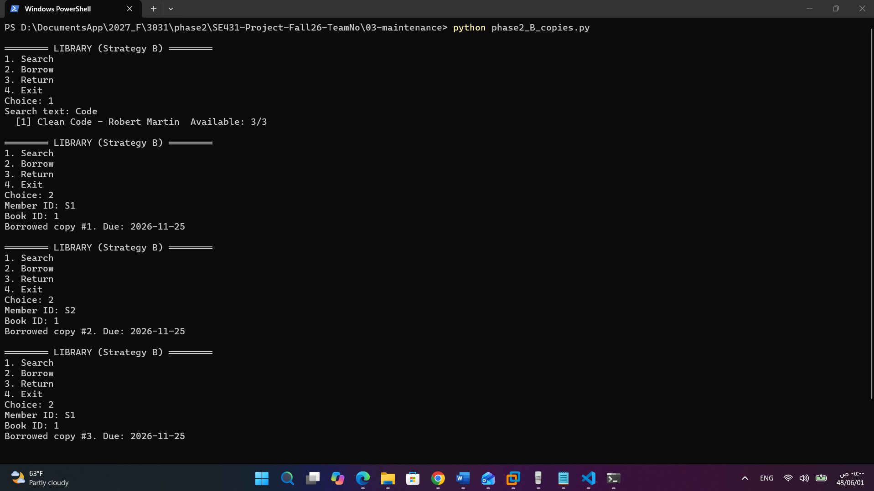
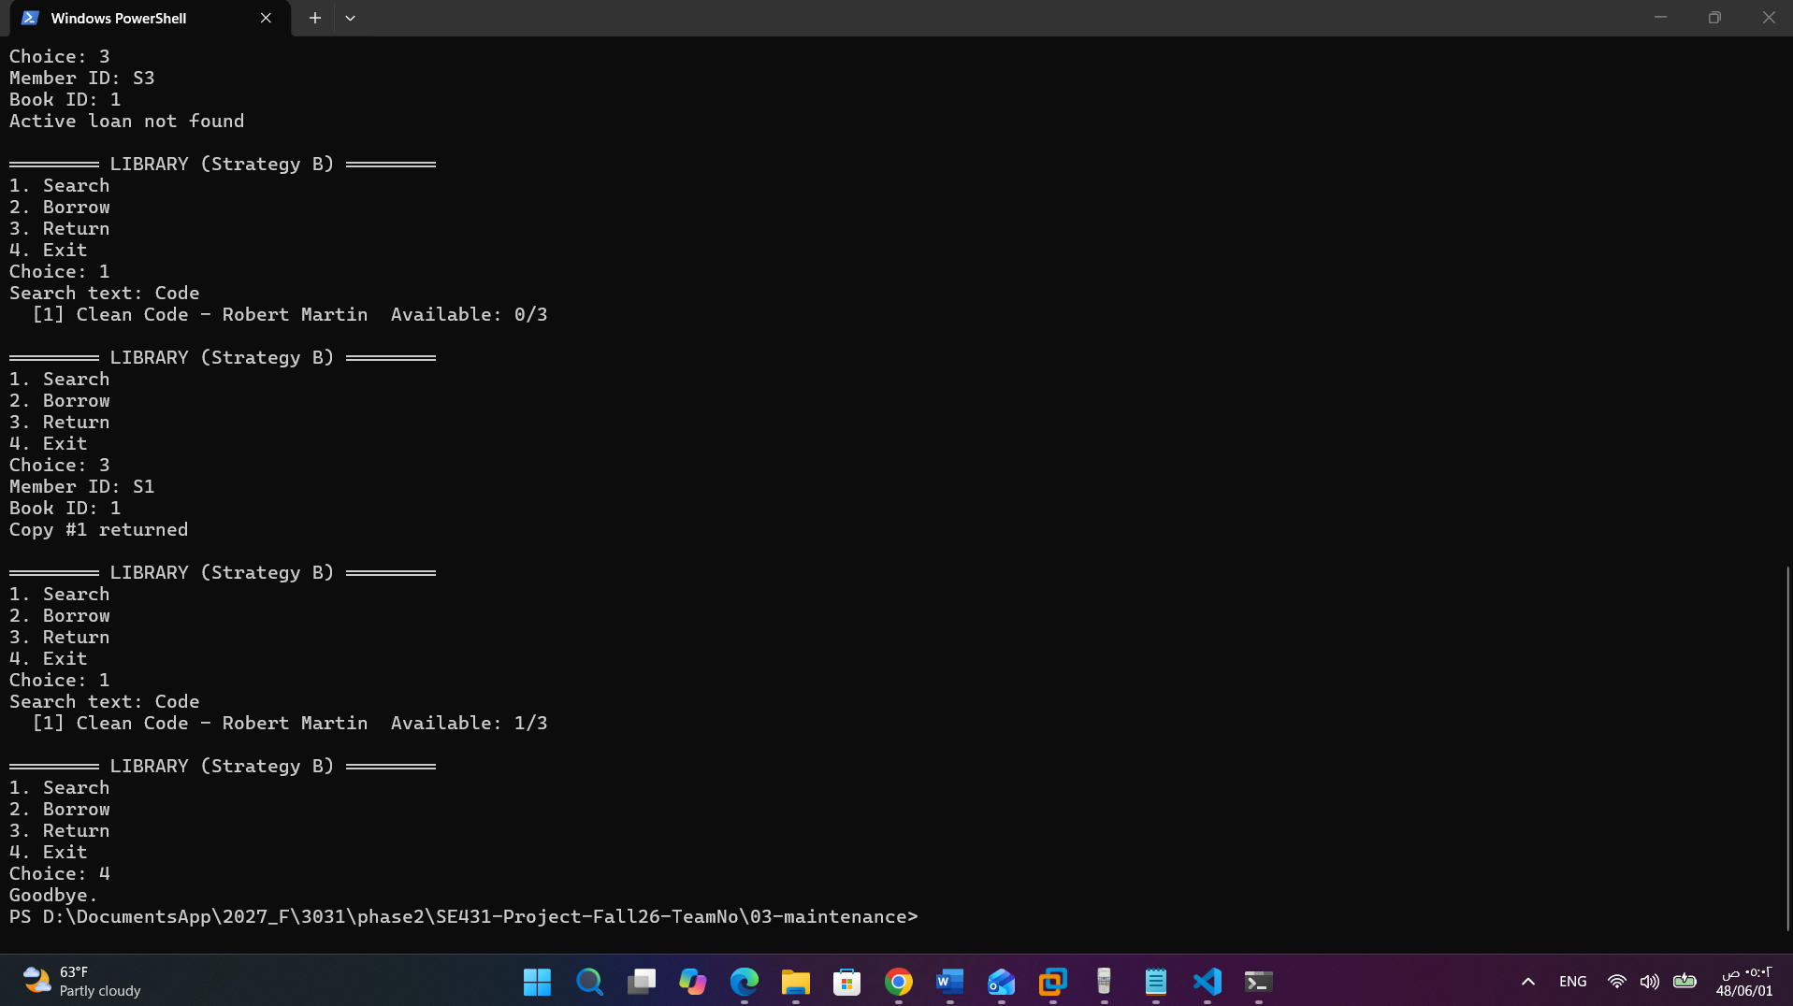
The test confirms that MR-01 preserves all six original requirements while adding multi-copy support. Notably, the return operation restores the exact copy that was borrowed (Copy #2), demonstrating that Strategy B delivers a capability that Strategy A (counters) cannot.

4. MR-02: Replace the Database Implementation

4.1 Maintenance Classification
 | Classification
Primary category | Adaptive Maintenance
Secondary category | Preventive Maintenance

MR-02 is classified primarily as adaptive because its core objective is to preserve functional behavior while replacing the underlying persistence technology. This is the defining characteristic of adaptive maintenance per ISO/IEC 14764. The system must adapt to a new database platform without changing what the users observe.
The preventive dimension stems from SQLite's architectural limitation: the default journaling mode allows only one writer at a time, which would become a bottleneck for a university-wide deployment with hundreds of concurrent users. The migration to a multi-writer database therefore prevents a scalability risk that would materialize in production.
MR-02 is not corrective because SQLite is not defective — its behavior is well-defined and correct for the current scale. It is not perfective because no new feature is added; the requirement explicitly states that business functionality should remain unchanged.
Question | Answer
Is there a defect to fix? | No
Does observable functionality change? | No (must remain unchanged)
Primary classification | Adaptive
Secondary classification | Preventive
Trigger | Scalability and portability concern

4.2 Impact Analysis

4.2.1 Affected Components
The legacy code embeds SQL in every function. The impact of MR-02 is therefore distributed across all data-touching functions:
Component | Impact Level | Reason
setup() | Rewrite | Driver import and connection string change
search_books() | Rewrite | SQL dialect (LIKE vs ILIKE, placeholder style)
borrow() | Rewrite | Transaction semantics and lastrowid handling
return_book() | Rewrite | Same as above
main() | No logic change | Only configuration of setup() changes

Root cause
The total number of changed lines in a naive approach is proportional to the entire codebase (~130 lines). This is unacceptable because it violates the Open/Closed Principle. The root cause is the absence of a persistence abstraction — the same architectural weakness identified in Phase 1 as “direct DB access”.

4.2.2 Affected Database Tables
The three existing tables (members, books, loans) must be migrated. The differences between SQLite and PostgreSQL that affect the migration are:
Feature | SQLite | PostgreSQL
Placeholder | ? | %s
Auto-increment | INTEGER PRIMARY KEY AUTOINCREMENT | SERIAL
Case-insensitive match | LIKE (by default) | ILIKE
Boolean | INTEGER (0/1) | BOOLEAN
lastrowid semantics | supported | via RETURNING id

Each of these differences must be encapsulated in the repository, so that the service layer is unaffected.

4.3 Proposed Design
The proposed architecture introduces three layers and applies the Repository Pattern with Dependency Inversion:

UI Layer: main()
menu · input() · print()
▼
Service Layer: LibraryService
borrow / return / search · business rules (14 days, max 3, fine) · No SQL
▼ depends on interface
Repository Interface: LibraryRepository
persistence operations expressed in domain terms
▼
SQLiteRepository |  | PostgresRepository

The repository interface exposes persistence operations that are expressed in domain terms (find_member, find_available_copy, create_loan, etc.). Each implementation (SQLiteRepository, PostgresRepository) encapsulates the specifics of its database. A factory function selects the implementation based on a single configuration flag:
DB_TYPE = "sqlite" # change to "postgres" to switch

This design realizes the Open/Closed Principle: adding support for a third database (e.g., MySQL) requires only a new repository class, with no modification to the service layer.

4.4 Implementation
The implementation consists of repository.py (interface + SQLite + PostgreSQL implementations), service.py (business logic), and phase2_B_MR02.py (UI). The service layer was verified to contain no SQL and no database-specific imports:
# service.py
def borrow(self, member_id, book_id):
member = self.repo.find_member(member_id)
if not member:
return False, "Member not found"
if member["status"] != "ACTIVE":
return False, "Member is not active"
book = self.repo.find_book(book_id)
if not book:
return False, "Book not found"
if self.repo.count_active_loans(member_id) >= MAX_BOOKS:
return False, "Borrowing limit reached"
copy_id = self.repo.find_available_copy(book_id)
if copy_id is None:
return False, "No copies available"
today = datetime.now()
due = today + timedelta(days=LOAN_DAYS)
self.repo.create_loan(member_id, copy_id,
today.isoformat(), due.isoformat())
self.repo.mark_copy_borrowed(copy_id)
return True, f"Borrowed copy #{copy_id}. Due: {due.date()}"

The migration script migrate.py was developed to move the baseline library.db to the new schema:
- Members are copied directly.
- Books are copied directly, and one base copy is created per book.
- Each legacy loan (identified by book_id) is mapped to the corresponding new copy_id.
- Active loans mark their copy as BORROWED.
- Foreign keys are checked, and the invariant “active loans = BORROWED copies” is verified automatically.
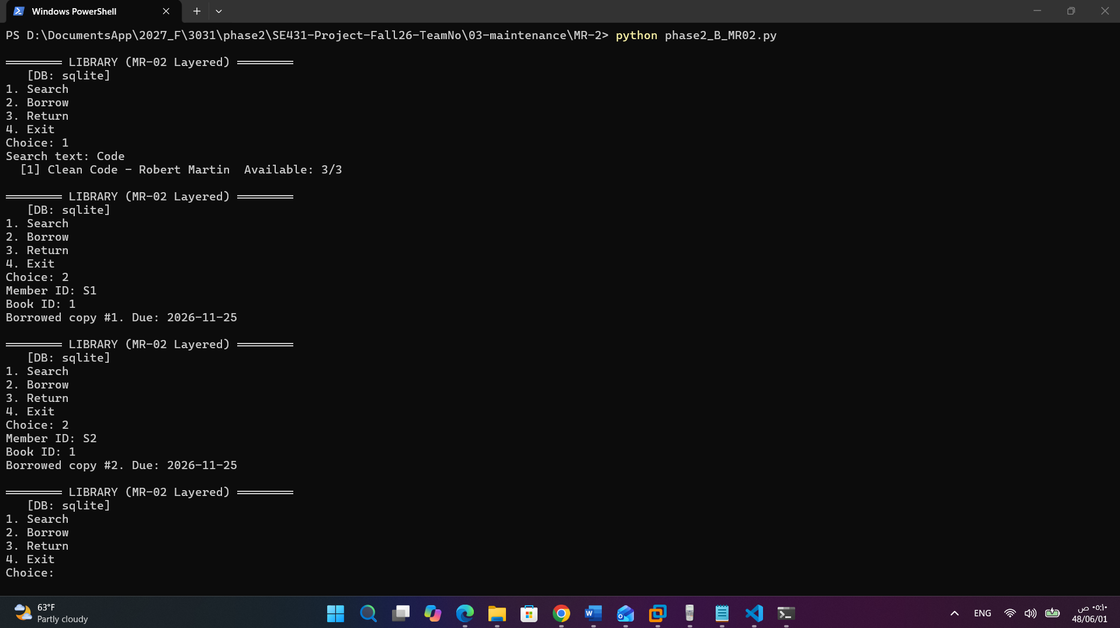

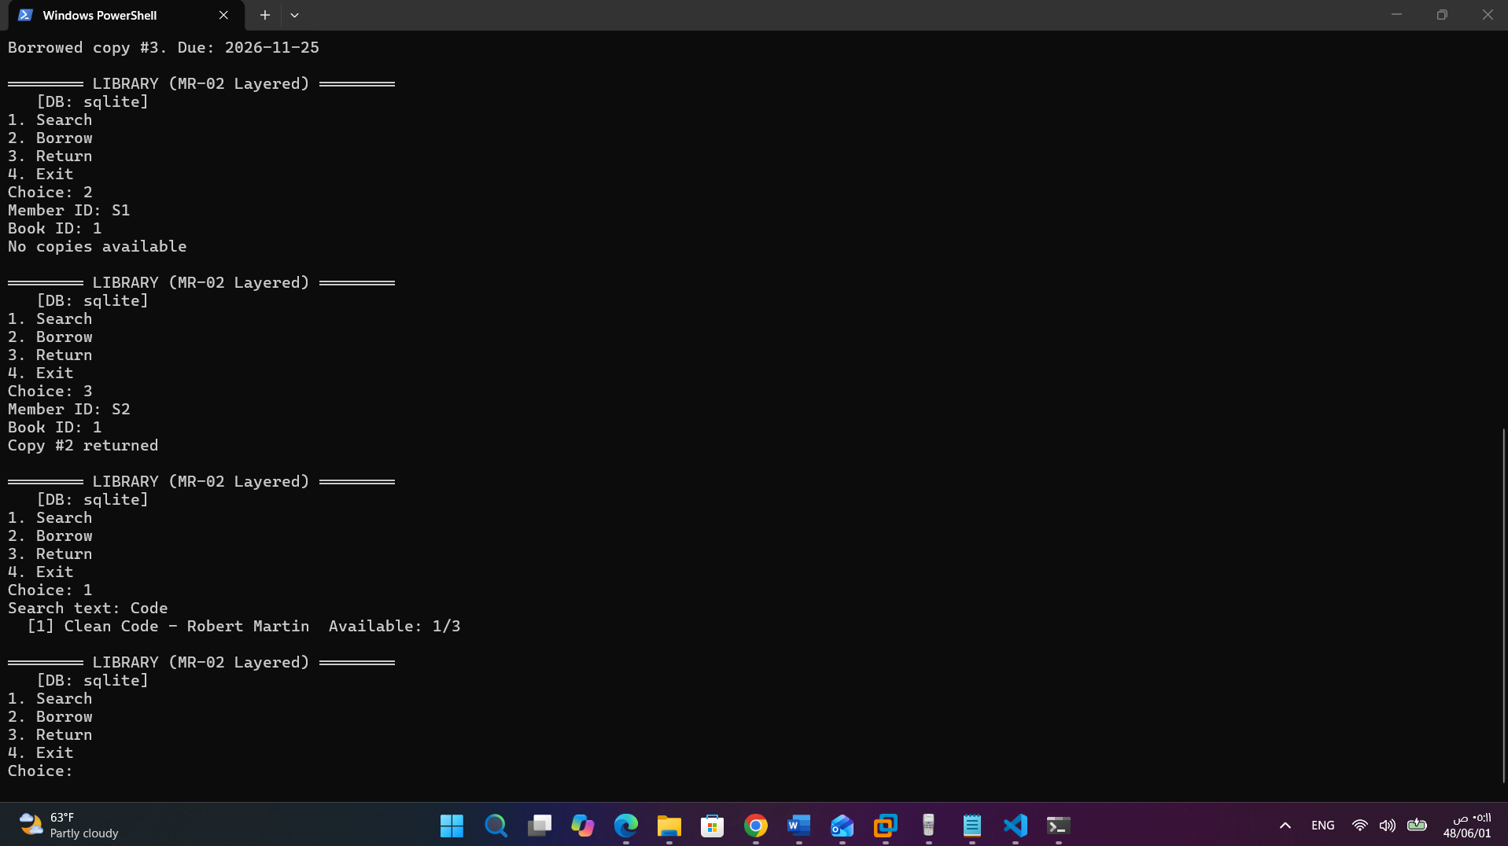
The migration was executed on the baseline database and produced the following output:
8. INTEGRITY CHECKS
Foreign key violations: 0
Members : 2 (expected 2) ✓
Books : 3 (expected 3) ✓
Copies : 3 (expected 3 base copies)
Loans : 1 (expected 1) ✓
Active loans : 1
BORROWED copies: 1
✓ Consistency: active loans = BORROWED copies

9. FINAL INVENTORY
Book 1: Clean Code total=1 avail=0 borrowed=1
Book 2: Refactoring total=1 avail=1 borrowed=0
Book 3: Design Patterns total=1 avail=1 borrowed=0

After migration, the new system was verified against the migrated data. The Clean Code title correctly reported Available: 0/1, reflecting that its single base copy is on loan to S1. Returning the loan produced Copy #1 returned and updated availability to 1/1.
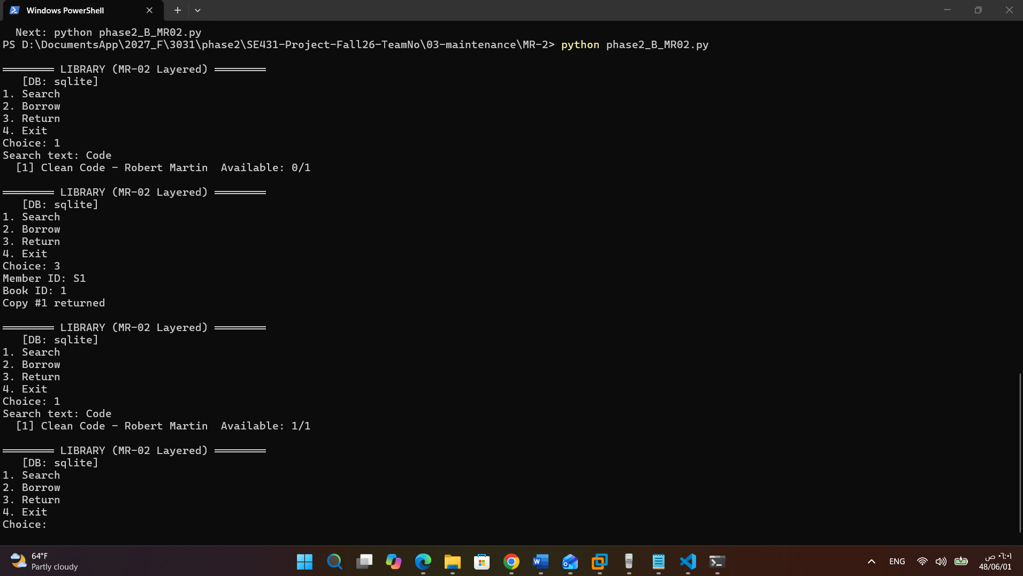

5. Summary
MR | Classification | Affected Components | Affected Tables | Design Pattern
MR-01 | Perfective (+ Adaptive) | setup, borrow, return_book, search_books | books (modified), book_copies (new), loans (modified) | Copy Entity + CHECK constraints
MR-02 | Adaptive (+ Preventive) | All functions + main | All tables (DDL migration) | Repository + Dependency Inversion + Factory

6. Conclusion
Phase 2 demonstrated that the two change requests, despite appearing independent, share a common root cause: the legacy system's absence of a persistence abstraction. MR-01 changes the data model; MR-02 changes the data technology. Both are localized in the new architecture thanks to the Repository Pattern and the layered design.
The maintenance classification of the two requests also illustrates a broader lesson in software evolution. MR-01 is driven by a business change (additional copies), and MR-02 is driven by a technical concern (scalability and portability). The ability to classify and isolate these two drivers — business and technical — is what distinguishes a maintainable system from a fragile one.
The reengineered architecture produces measurable quality improvements that will be quantified in Phase 5 (LOC, function count, cyclomatic complexity, code smells, DB dependencies). It also provides a foundation for Phase 4, in which a reusable domain architecture for a parallel Equipment Borrowing System will be proposed.

