
Gym Service System (GSS)

Ranyah Alharbi

Course: SE262 – Software Engineering
Instructor: Dr. Hazrina Sofian

Table of Contents
1. Introduction 4
1.1 Purpose 4
1.2 Scope 4
1.3 Acronyms and Definitions 4
1.4 References 4
2. Positioning 5
2.1 Problem Statement 5
2.2 Product Position Statement 5
3. Stakeholder and User Descriptions 6
3.1 Stakeholder Summary 6
3.2 User Descriptions 6
3.3 User Environment 6
3.4 User Needs 6
3.5 Alternatives and Competition 7
4. Context Diagram 8
5. Use Case Model Study 8
5.1 Use Case Diagram 8
5.2 Description of Use Cases 9
UC1: Login 9
UC2: Register Account 9
UC3: Subscribe to Membership Plan 9
UC4: Book Training Session 9
UC5: Track Attendance 9
UC6: Manage Training Schedule (Trainer) 9
UC7: Manage User Accounts (Administrator) 9
UC8: Send Notifications 9
5.3 Use Case Priority Table 10
6. Actors Studies 10
7. Requirements 11
7.1 Functional Requirements 11
7.2 Non-Functional Requirements 11
7.3 Constraints 11
8. UML Class Diagram 12
8.1 Class Descriptions 12
8.2 Relationships and Multiplicities 13
9. UML Activity Diagrams 13
9.1 Detailed Activity Diagrams 13
9.2 Alternative Activity Diagram & Decision Analysis 14
10. UML Sequence Diagrams 14
10.1 UC1: Login 14
10.2 UC3: Subscribe to Membership 15
10.3 UC4: Book Training Session 15
15
11. Graphical User Interfaces (GUIs) 16
11.1 Screenshots & Design 16
11.2 Source Code 19
12. Professional and Ethical Standards (KPI 4.1) 27
13. Impact of Engineering Solutions (KPI 4.2) 28

1. Introduction

1.1 Purpose
The purpose of this Software Requirements Specification (SRS) document is to collect, analyze, and define the main requirements and functionalities of the Gym Service System (GSS).
This document identifies the intended users of the system and describes their needs in managing gym services such as membership registration, session booking, attendance tracking, and payment management. It serves as a communication reference between stakeholders and the development team to ensure a shared understanding of the system requirements before implementation.
Additionally, this document supports system planning, development activities, and future maintenance processes.

1.2 Scope
This document applies to the Gym Service System (GSS), which is designed to improve the management of gym operations through a centralized digital platform.
The system allows members to create accounts, subscribe to membership plans, reserve training sessions, track attendance records, and receive notifications about their bookings and subscriptions. Trainers can manage their training schedules and monitor assigned sessions, while administrators can manage user accounts, attendance records, services, membership plans, and payment information.
The proposed system aims to reduce manual administrative work, improve service accessibility, and enhance communication between administrators, trainers, and members through an organized and user-friendly environment.

1.3 Acronyms and Definitions
Term | Definition
GSS | Gym Service System
SRS | Software Requirements Specification
Administrator | A system user responsible for managing accounts, services, and system operations
Member | A registered gym user who subscribes to services
Trainer | A gym staff member responsible for conducting training sessions
Authentication | The process of verifying user identity using login credentials
Membership Plan | A subscription package that allows access to gym services
Booking | The process of reserving a training session through the system
UC | Use Case
ACT | Actor
FR | Functional Requirement
NFR | Non-Functional Requirement

1.4 References
- IEEE Std 830-1998 – Recommended Practice for Software Requirements Specifications.
- Sommerville, I. (2016). Software Engineering (10th ed.). Pearson Education.
- Pressman, R. S., & Maxim, B. R. (2015). Software Engineering: A Practitioner's Approach (8th ed.). McGraw-Hill.
- SE-262 Software Engineering course lecture slides – Dr. Hazrina Sofian, Spring 2026.

2. Positioning

2.1 Problem Statement
Field | Description
Problem of | Gym operations are managed manually, leading to frequent errors and delays.  There is no centralized system connecting membership, booking, and payment processes.  Members and trainers cannot easily access or update their information.  Attendance tracking is done manually, increasing the risk of inaccurate records.  Administrators spend excessive time managing data through paper-based methods.
Affected Stakeholders | Gym Members, Trainers, Administrators
Impact of Problems | Increased administrative errors and wasted time.  Poor communication between staff and members.  Difficulty tracking gym activities efficiently.  Loss of membership and payment records.  Low member satisfaction due to lack of organized services.
Proposed Solution | Provide users with a centralized digital platform that:  - Automates membership registration, session booking, and attendance tracking.  - Allows members to manage their subscriptions and bookings online.  - Enables trainers to manage their schedules and assigned sessions.  - Gives administrators full control over accounts, payments, and services.  - Sends automated notifications to keep users informed.

2.2 Product Position Statement
Field | Description
Who is it for? | Gym members, trainers, and administrators.
Who needs it? | - Need an efficient and organized way to manage gym services.  - Need a system that connects membership, booking, attendance, and payment in one place.
GSS is | A centralized digital platform for gym management.
Which allows | - Members to register, subscribe, and book training sessions.  - Trainers to manage their schedules and monitor sessions.  - Administrators to manage accounts, payments, and services.  - Automated notifications to users regarding bookings and subscriptions.
Unlike | Manual paper-based systems and limited fitness tracking apps that do not offer full integration.
Our product | Offers a user-friendly interface and ensures easy access to all gym services for members, trainers, and administrators.

3. Stakeholder and User Descriptions
To achieve a satisfactory product, it is important to identify the various stakeholders and users of the new system, and to involve them throughout the development process.

3.1 Stakeholder Summary
Name | Representation | Role
Administrator | System Management | Manages user accounts, membership plans, attendance records, and payment information to ensure the system runs smoothly.
Trainer | Gym Staff | Manages training schedules, monitors assigned sessions, and tracks member attendance.
Member | Registered Gym User | Subscribes to membership plans, books training sessions, tracks attendance, and receives system notifications.

3.2 User Descriptions
Name | Description | Stakeholder
Administrator | Has full access to the system. Responsible for creating and managing accounts, configuring membership plans, and overseeing all gym operations through the GSS platform. | Administrator
Trainer | Has intermediate system access. Uses the GSS to view and manage assigned training sessions, update schedules, and monitor member participation. | Trainer
Member | Has basic system access. Registers an account, subscribes to a membership plan, books training sessions, and views attendance history. | Member

3.3 User Environment
The Gym Service System (GSS) is designed to operate in an online environment and can be accessed through web browsers on desktop and mobile devices. Users are expected to have a stable internet connection to access system features such as booking sessions, tracking attendance, and managing memberships. The system supports different types of users including administrators, trainers, and members, each with different access levels and permissions.

3.4 User Needs
Need | Priority | Problem | Current Situation | Proposed Solution
Member Registration & Membership Management | High | No centralized system for managing memberships. | Memberships registered manually using paper forms. | Provide an online registration and membership management module.
Session Booking | High | Members cannot book sessions easily. | Bookings made in person or by phone. | Allow members to book and cancel sessions through the system.
Attendance Tracking | High | Attendance tracked manually, leading to errors. | Recorded on paper sheets. | Implement an automated attendance tracking system.
Payment Management | High | No digital payment tracking system exists. | Payments handled manually with no digital records. | Provide a payment module that tracks subscriptions and fees.
Notifications | Medium | Users not notified about bookings or membership updates. | No notification system in place. | Send automatic notifications to users about bookings, payments, and updates.

3.5 Alternatives and Competition
Currently, many gyms rely on manual methods such as paper records and spreadsheets to manage their operations, which can lead to errors and inefficiencies. Some existing fitness applications provide limited features such as workout tracking but do not fully integrate membership management and session booking. The Gym Service System (GSS) aims to provide a complete and integrated solution that improves efficiency, reduces administrative workload, and enhances communication between users.
Alternative | Limitation | GSS Advantage
Manual Paper Records | Error-prone, slow, no real-time access. | Fully digital, automated, centralized.
Generic Fitness Apps | Focused on workouts only; no membership or payment management. | Integrates membership, booking, attendance, and payment in one platform.
Spreadsheets | Prone to human error; not accessible to all stakeholders simultaneously. | Multi-user access with role-based permissions.

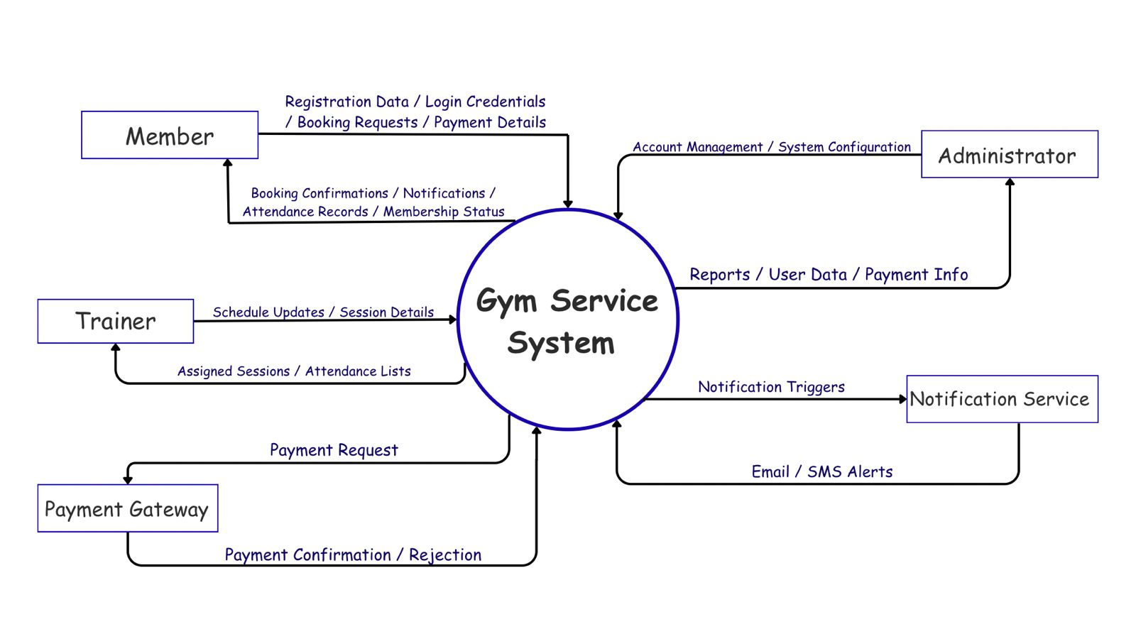
4. Context Diagram

5. Use Case Model Study

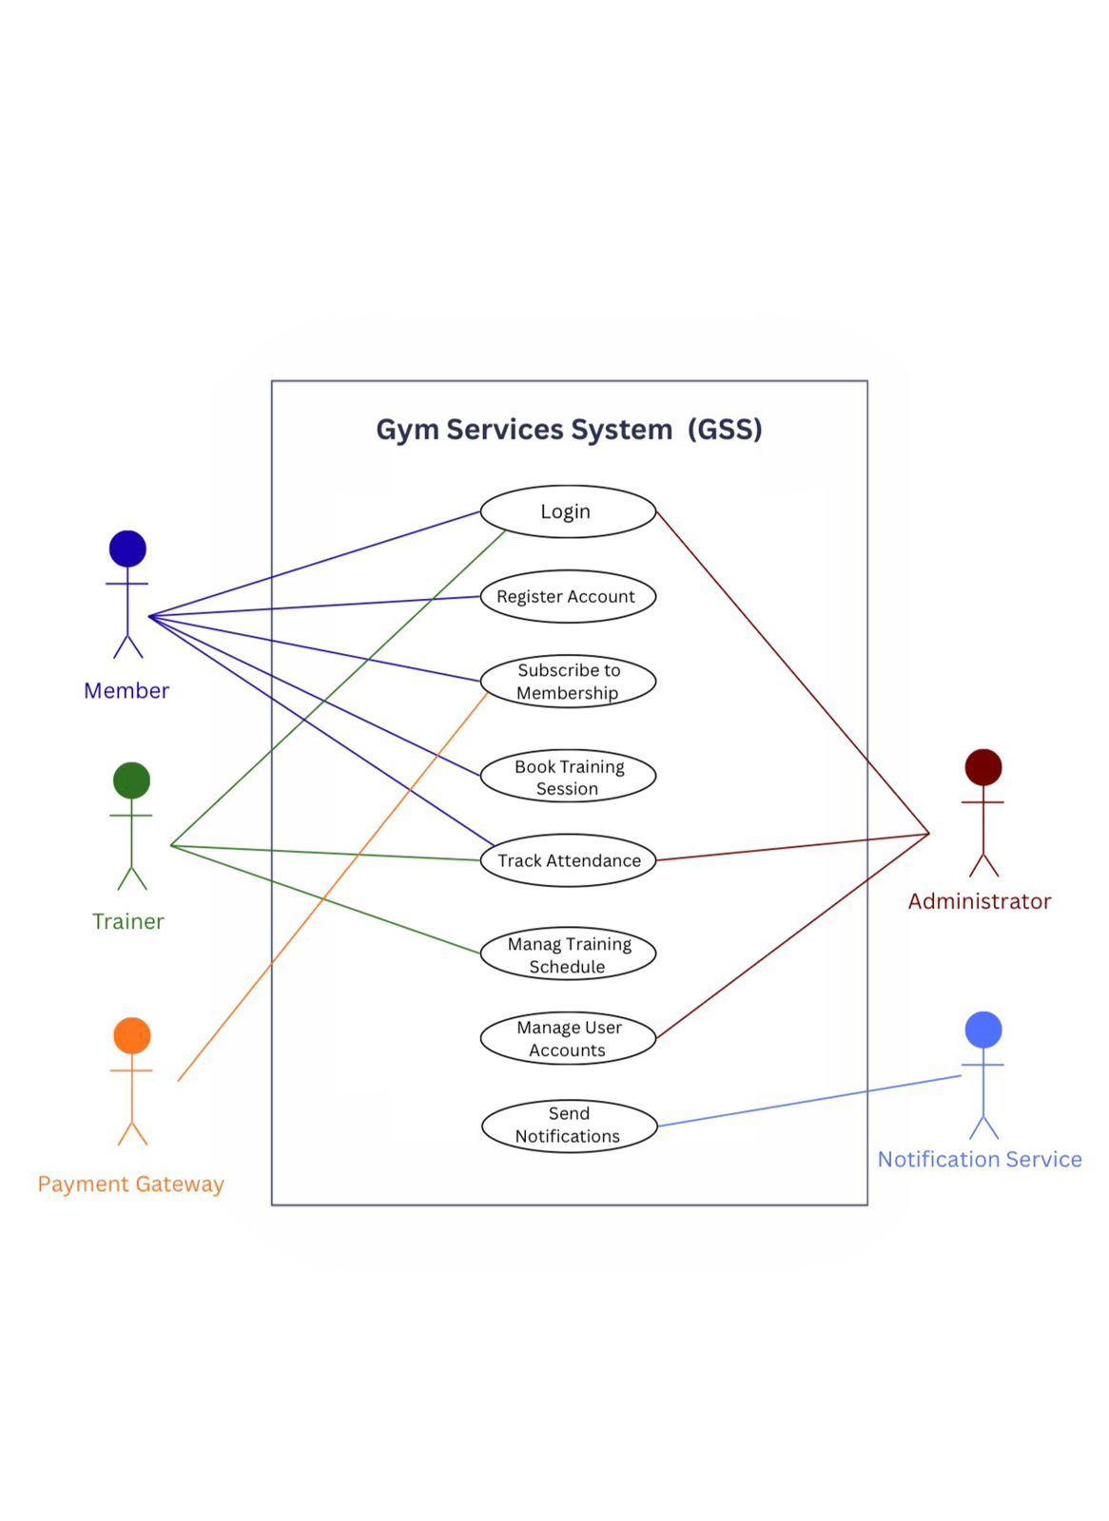
5.1 Use Case Diagram

5.2 Description of Use Cases

UC1: Login
This use case in the Gym Service System involves the authentication process, where Members, Trainers, and Administrators input their credentials (username/email and password). This essential step ensures a robust layer of authentication, safeguarding the platform and allowing authorized users to engage with GSS features effectively.

UC2: Register Account
This use case allows new Members to create an account in the Gym Service System by providing personal information such as name, email, phone number, and password. Upon successful registration, the member gains access to the system and can subscribe to membership plans and book sessions.

UC3: Subscribe to Membership Plan
This use case enables registered Members to browse available membership plans and subscribe to a plan of their choice. The system processes the subscription, records the payment, and activates the membership. Members receive a confirmation notification upon successful subscription.

UC4: Book Training Session
This use case allows Members with an active membership to browse available training sessions and book a session with a trainer. The system checks session availability, reserves the slot, and sends a confirmation notification to the member. Members may also cancel their booking through this use case.

UC5: Track Attendance
This use case allows the system to automatically record and update attendance for Members who attend booked sessions. Administrators can view overall attendance reports, and Members can access their personal attendance history to monitor their progress.

UC6: Manage Training Schedule (Trainer)
This use case allows Trainers to view their assigned training sessions, update session details, and manage their weekly schedule through the GSS platform. Trainers can also view the list of members enrolled in each session.

UC7: Manage User Accounts (Administrator)
This use case provides Administrators with full control over user accounts. Administrators can add new user accounts, update existing account information, deactivate or delete accounts, and assign roles (Member or Trainer) within the system.

UC8: Send Notifications
This use case is triggered automatically by the system to send notifications to Members and Trainers. Notifications are sent for events such as booking confirmations, session reminders, membership expiration alerts, and payment updates.

5.3 Use Case Priority Table
Use Case ID | Use Case Name | Priority
UC01 | Login | High
UC02 | Register Account | High
UC03 | Subscribe to Membership Plan | High
UC04 | Book Training Session | High
UC05 | Track Attendance | High
UC06 | Manage Training Schedule | Medium
UC07 | Manage User Accounts | High
UC08 | Send Notifications | Medium

6. Actors Studies
The following table describes the actors involved in the Gym Service System (GSS), their roles, and their responsibilities within the system.

Actor ID | Actor Name | Description
ACT1 | Administrator | Administrators manage and create user accounts (Members and Trainers), configure membership plans, oversee attendance records, manage payment information, and ensure the overall smooth operation of the GSS platform.
ACT2 | Trainer | Trainers are gym staff members who interact with the GSS to view and manage their assigned training sessions, update their weekly schedules, and monitor the attendance and participation of members enrolled in their sessions.
ACT3 | Member | Members are registered gym users who interact with the GSS to create accounts, subscribe to membership plans, book and cancel training sessions, track their attendance history, and receive automated system notifications about their subscriptions and bookings.
ACT4 | Payment Gateway | An external system that processes payment transactions initiated by Members when subscribing to membership plans. The Payment Gateway confirms or rejects transactions and returns the payment status to the GSS.
ACT5 | Notification Service | An external service responsible for delivering automated notifications (via email or SMS) to Members and Trainers. The GSS triggers this service when key events occur such as booking confirmations, membership renewals, and session reminders.

7. Requirements

7.1 Functional Requirements
ID | Functional Requirement
FR01 | The system shall allow users (Members, Trainers, and Administrators) to create accounts and log in securely using valid credentials.
FR02 | The system shall allow Members to browse and subscribe to available membership plans.
FR03 | The system shall allow Members to book and cancel training sessions.
FR04 | The system shall allow Trainers to view and manage their assigned training sessions and schedules.
FR05 | The system shall allow Administrators to manage user accounts (add, update, deactivate, and delete).
FR06 | The system shall allow Administrators to configure and manage membership plans and gym services.
FR07 | The system shall automatically track and store attendance records for Members attending booked sessions.
FR08 | The system shall process and record payment information for membership subscriptions through the Payment Gateway.
FR09 | The system shall send automated notifications to Members and Trainers regarding bookings, session reminders, membership expiration, and payment updates.
FR10 | The system shall provide Administrators with attendance and payment reports.

7.2 Non-Functional Requirements
ID | Category | Non-Functional Requirement
NFR01 | Usability | The system shall provide a user-friendly and intuitive interface accessible to users with minimal technical experience.
NFR02 | Performance | The system shall respond to user interactions within 3 seconds under normal operating conditions.
NFR03 | Availability | The system shall be available 24 hours a day, 7 days a week, with a minimum uptime of 99%.
NFR04 | Security | The system shall encrypt all user data and enforce role-based access control to protect user privacy.
NFR05 | Accessibility | The system shall be accessible through modern web browsers on both desktop and mobile devices.
NFR06 | Scalability | The system shall be scalable to support up to 1,000 concurrent users without degradation in performance.
NFR07 | Reliability | The system shall implement data backup mechanisms to prevent data loss in case of failure.

7.3 Constraints
ID | Constraint
C01 | The system requires a stable internet connection for all users to access its features.
C02 | The system is limited to supported modern web browsers and internet-connected devices.
C03 | The development and delivery must comply with the SE-262 course requirements and submission deadlines.
C04 | The system is limited by the available technologies, tools, and team resources within the project scope.
C05 | The system must comply with applicable data protection and privacy regulations.

8. UML Class Diagram
The Class Diagram represents the static structure of the Gym Service System (GSS). It illustrates the core classes, their attributes, operations, and the relationships between them.
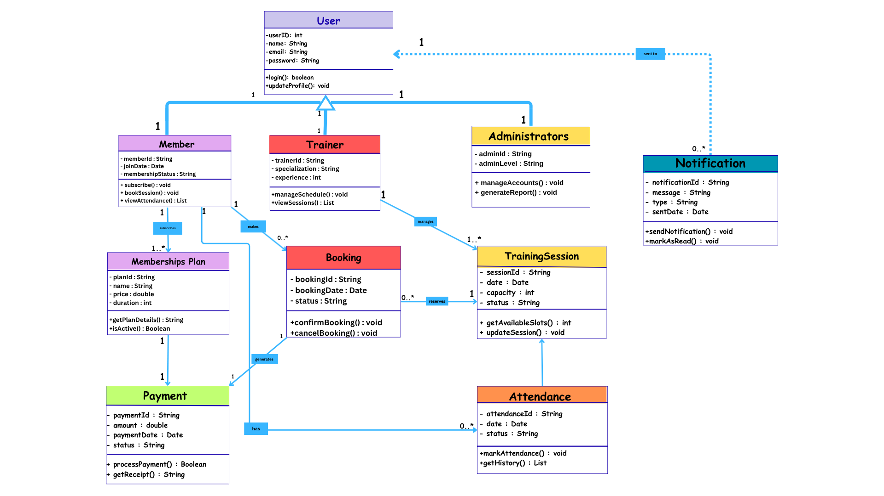

8.1 Class Descriptions
• Member: Represents the gym members. It stores personal details and manages interactions with memberships and training sessions.
• Membership: Defines the different subscription plans available (e.g., Monthly, Yearly) and their respective costs.
• Trainer: Stores information about the gym staff, their specialties, and their assigned schedules.
• Training Session: Manages the details of specific gym classes, including time, date, and assigned trainer.
• Payment: Handles the financial transactions made by members for their subscriptions.

8.2 Relationships and Multiplicities
• Member - Membership: A one-to-one or one-to-many relationship where a member can subscribe to a specific plan.
• Member - Training Session: A many-to-many relationship as a member can book multiple sessions, and each session can have multiple attendees.
• Trainer - Training Session: A one-to-many relationship where one trainer is responsible for managing several sessions.
• Member - Payment: A one-to-many relationship where a member can have multiple payment records over time.

9. UML Activity Diagrams
This section illustrates the dynamic workflow of the system using Activity Diagrams for the main use cases.

9.1 Detailed Activity Diagrams
The following diagrams show the flow for Login, Membership Subscription, and Booking Sessions.

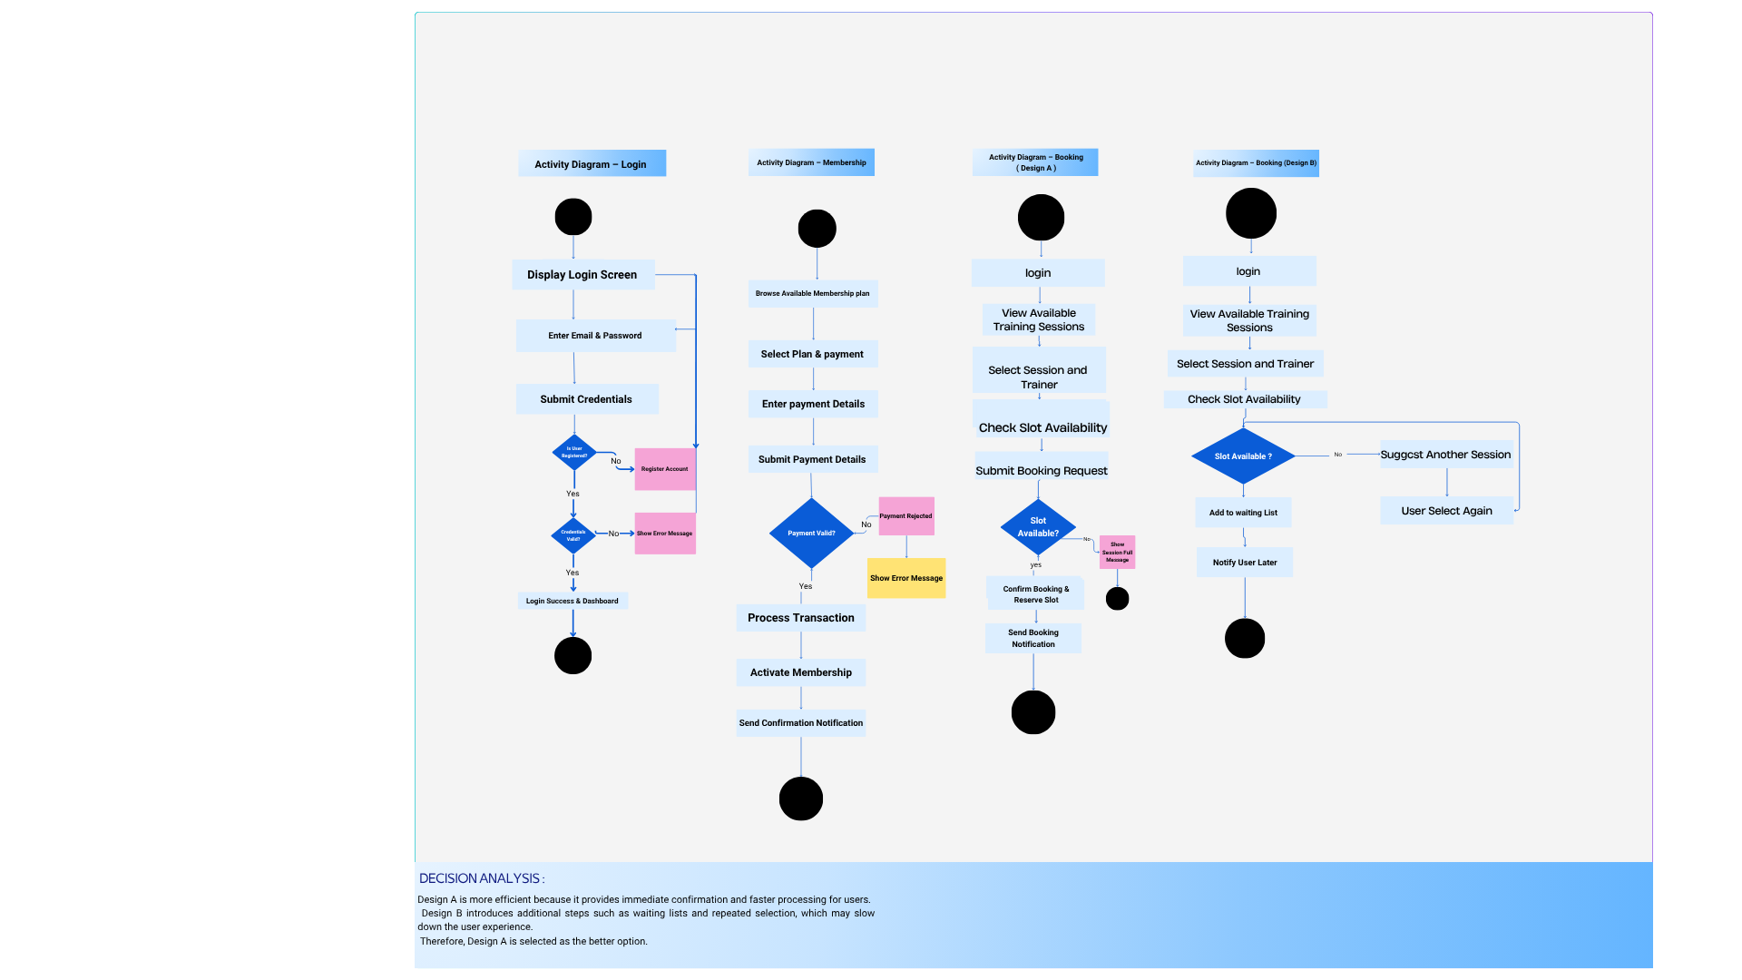

9.2 Alternative Activity Diagram & Decision Analysis
We designed an Alternative Flow for the Payment Process.
- Standard Flow: Select Plan -> Enter Payment Details -> Success.
- Alternative Flow: If payment fails, the system provides an error message and allows a retry with a different card instead of restarting the whole process.
- Decision Analysis: The alternative flow was chosen because it enhances usability and ensures a better user experience by handling errors gracefully.

10. UML Sequence Diagrams
The following sequence diagrams illustrate the dynamic interaction between system objects to fulfill functional requirements FR01, FR02, and FR03, showing how messages are exchanged over time to complete key user tasks.

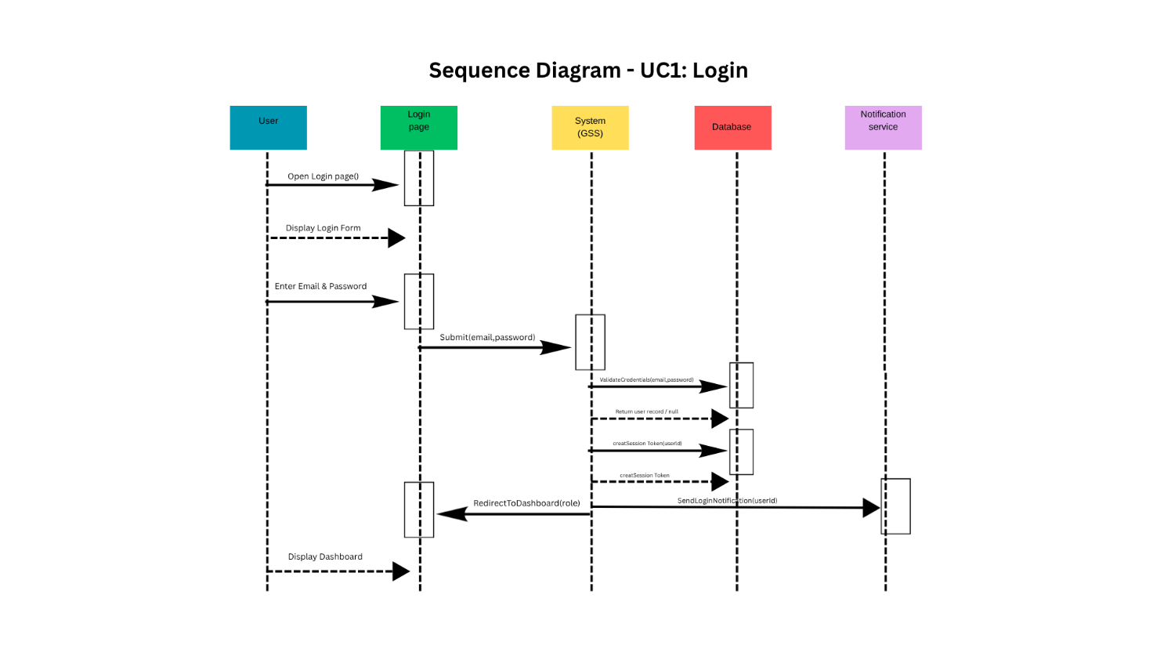
10.1 UC1: Login

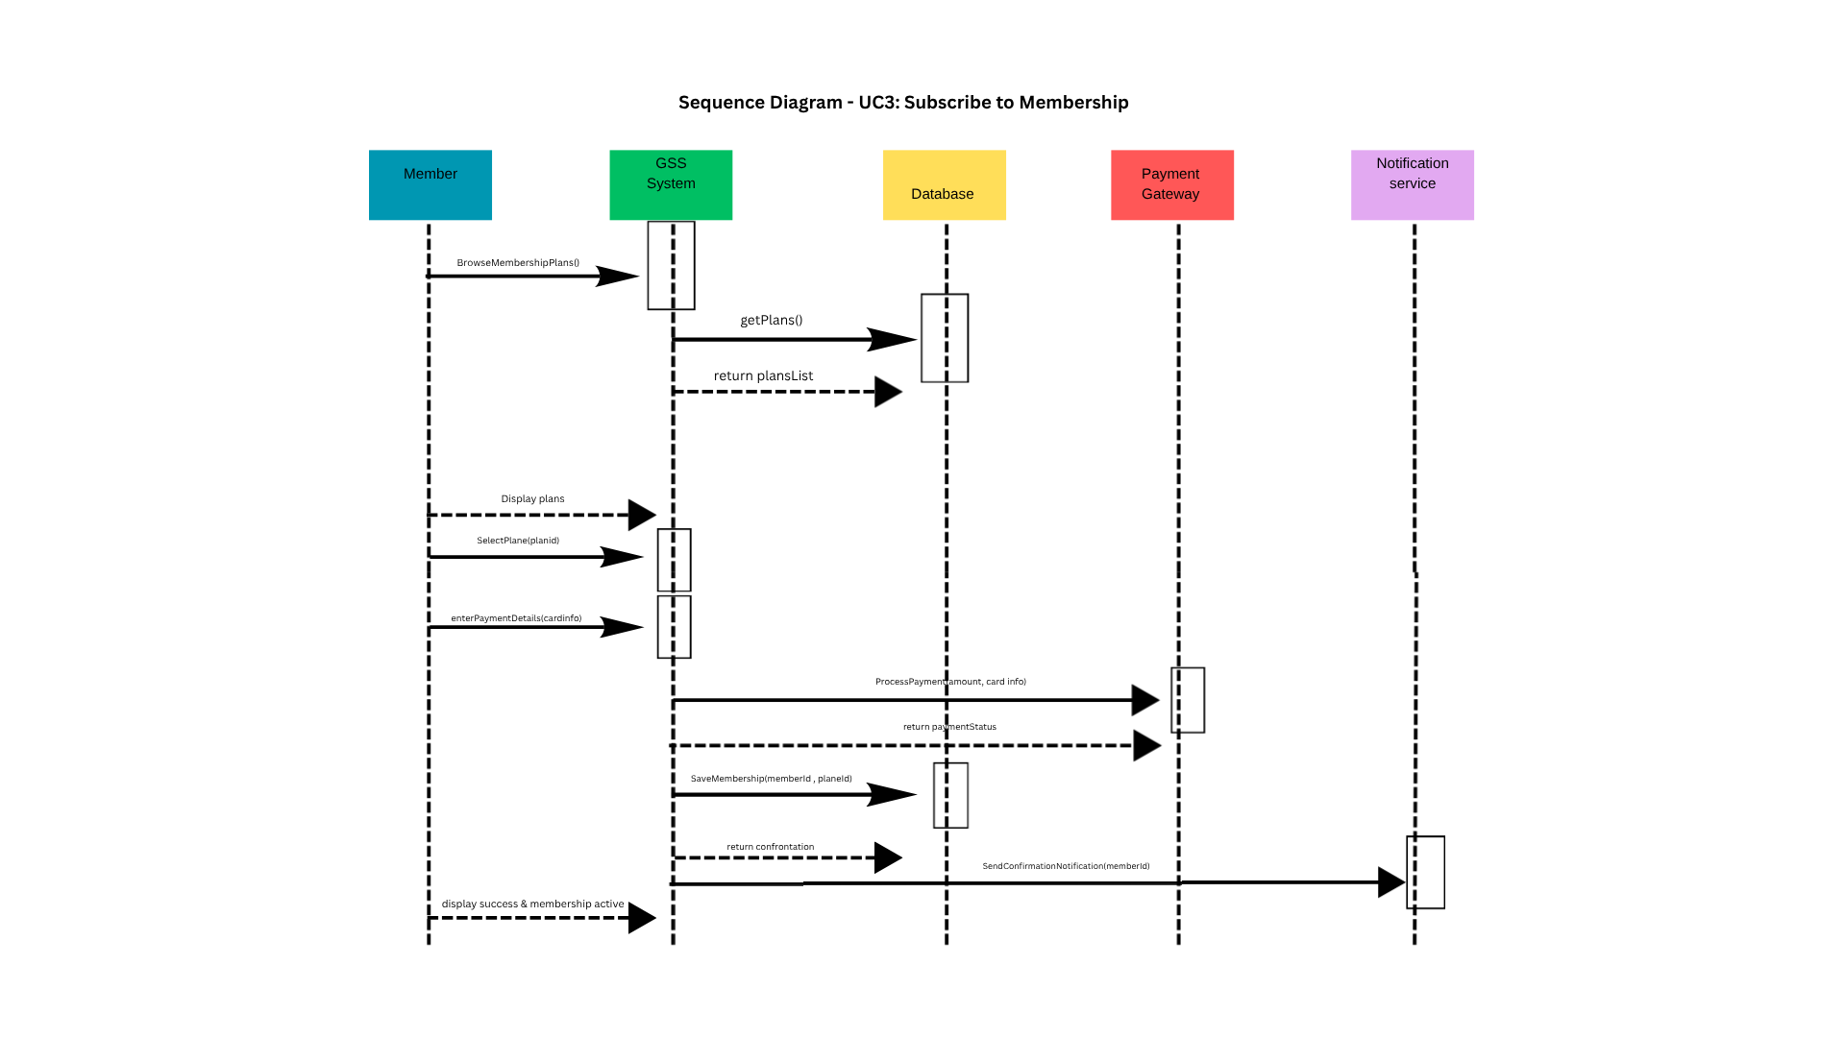
10.2 UC3: Subscribe to Membership

10.3 UC4: Book Training Session

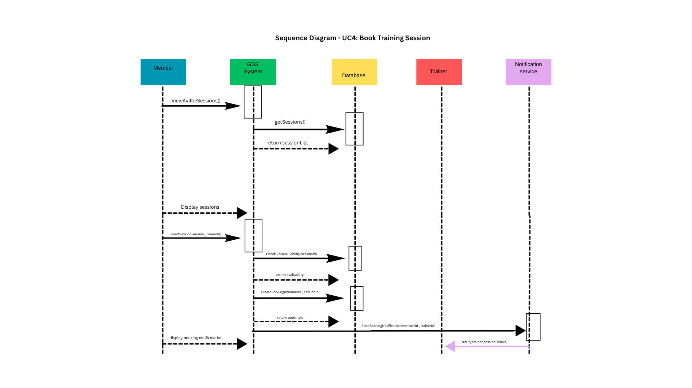

11. Graphical User Interfaces (GUIs)

11.1 Screenshots & Design
• Main Menu Design: An intuitive dashboard allowing users to navigate to Booking, Membership, and Profile settings.
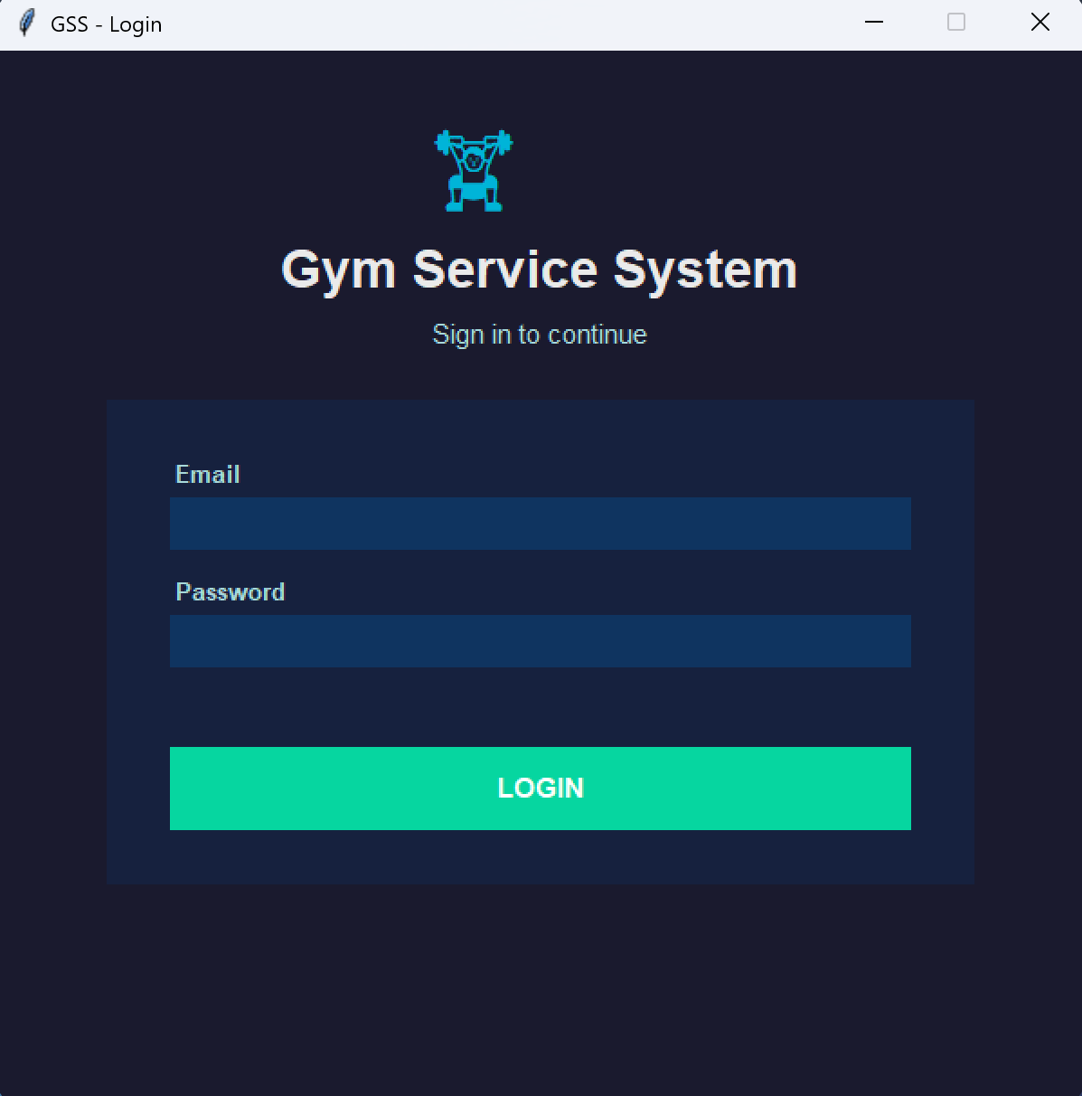
• Additional GUIs: Including a Login Screen for authentication and a Booking Dashboard for session management.
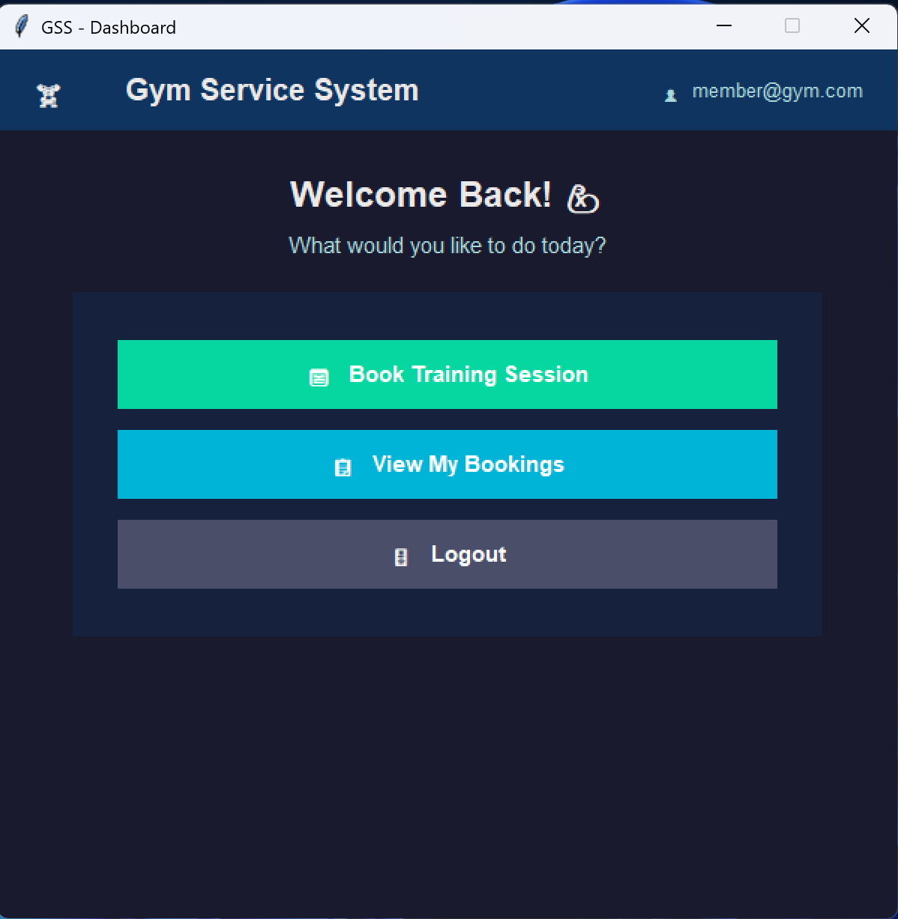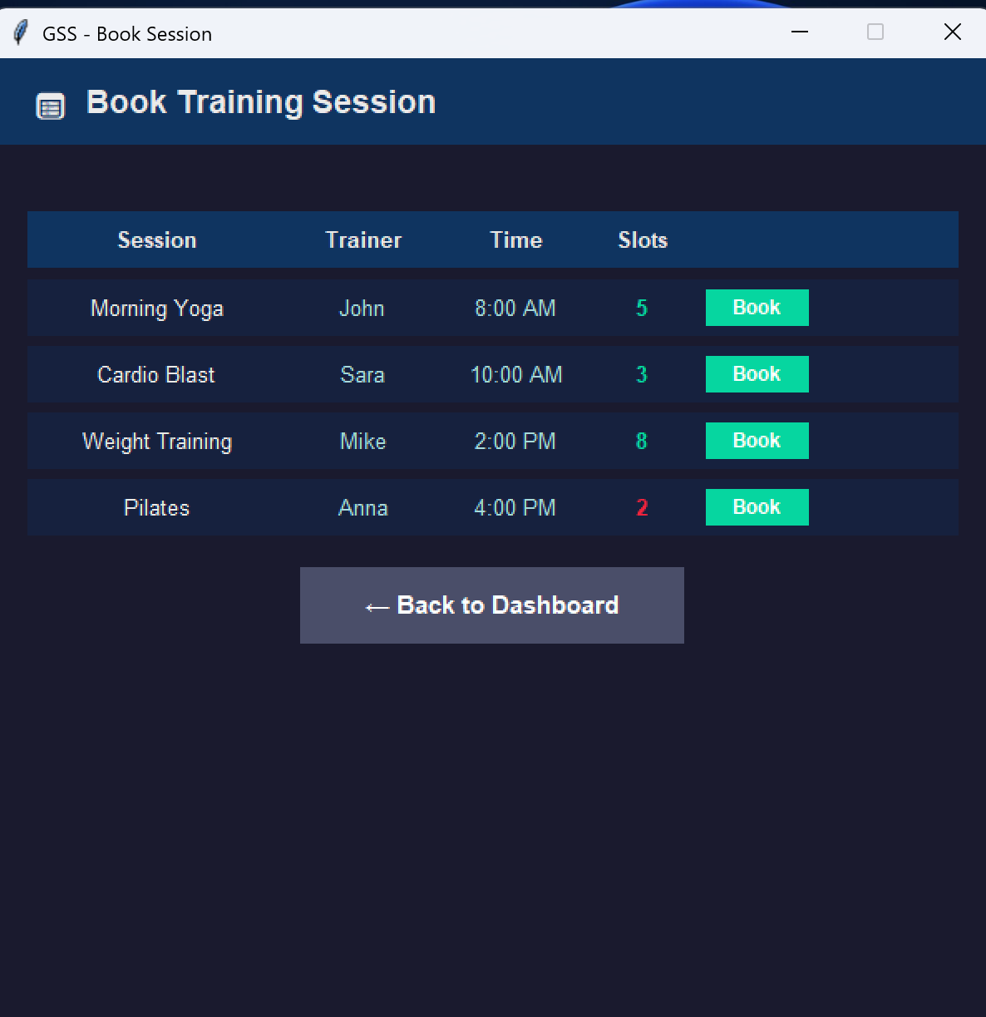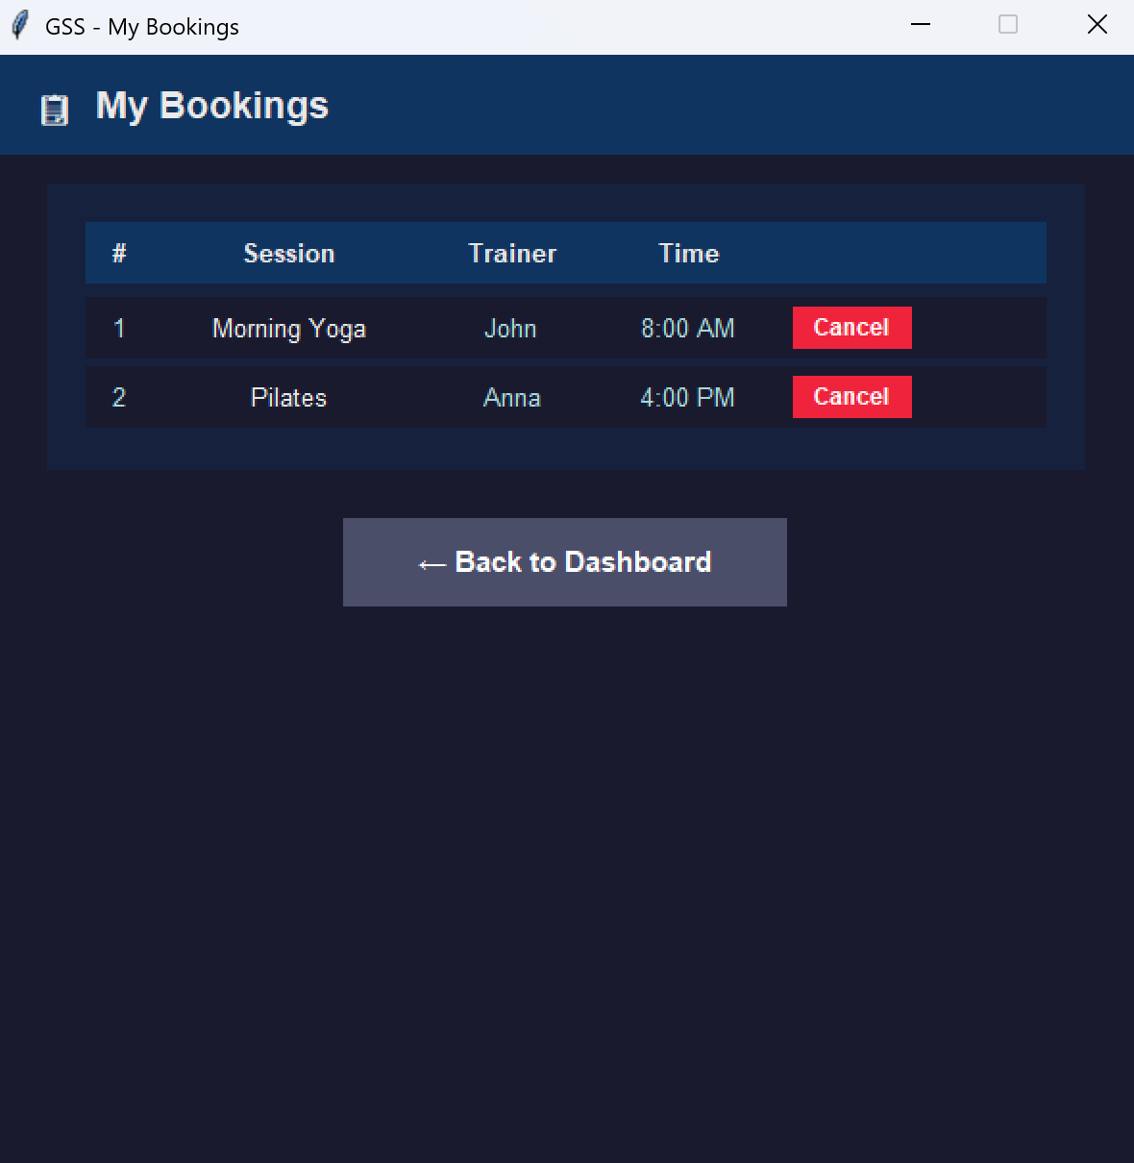

11.2 Source Code
The system is developed using Python (Tkinter) to ensure a responsive and functional interface.

import tkinter as tk
# Colors
BG_DARK = "#1A1A2E"
BG_CARD = "#16213E"
ACCENT = "#0F3460"
GREEN = "#00B4D8"
BTN_GREEN = "#06D6A0"
BTN_RED = "#EF233C"
BTN_GRAY = "#4A4E69"
TXT_W = "#EAEAEA"
TXT_G = "#A8DADC"
# Data
users = {
"admin@gym.com": "admin123",
"member@gym.com": "member123"
}
sessions = [
{"id": 1, "name": "Morning Yoga", "trainer": "John", "time": "8:00 AM", "slots": 5},
{"id": 2, "name": "Cardio Blast", "trainer": "Sara", "time": "10:00 AM", "slots": 3},
{"id": 3, "name": "Weight Training", "trainer": "Mike", "time": "2:00 PM", "slots": 8},
{"id": 4, "name": "Pilates", "trainer": "Anna", "time": "4:00 PM", "slots": 2},
]
# Global bookings list
bookings = []
def make_btn(parent, text, cmd, color=BTN_GREEN, width=22):
return tk.Button(parent, text=text, command=cmd,
font=("Helvetica", 11, "bold"),
bg=color, fg="white", activebackground=color,
relief="flat", bd=0, cursor="hand2",
width=width, height=2)
def clear():
for w in root.winfo_children():
w.destroy()
def is_booked(email, session_id):
return any(b["email"] == email and b["session_id"] == session_id for b in bookings)
# Screen 1: Login
def show_login():
clear()
root.title("GSS - Login")
root.configure(bg=BG_DARK)
tk.Label(root, text="🏋️", font=("Helvetica", 40), bg=BG_DARK, fg=GREEN).pack(pady=(30, 5))
tk.Label(root, text="Gym Service System", font=("Helvetica", 22, "bold"), bg=BG_DARK, fg=TXT_W).pack()
tk.Label(root, text="Sign in to continue", font=("Helvetica", 11), bg=BG_DARK, fg=TXT_G).pack(pady=(4, 20))
card = tk.Frame(root, bg=BG_CARD, padx=35, pady=30)
card.pack(padx=60, pady=5, fill="x")
tk.Label(card, text="Email", font=("Helvetica", 10, "bold"), bg=BG_CARD, fg=TXT_G, anchor="w").pack(fill="x")
email_var = tk.StringVar()
tk.Entry(card, textvariable=email_var, font=("Helvetica", 11), bg=ACCENT,
fg=TXT_W, insertbackground="white", relief="flat", bd=5).pack(fill="x", pady=(2, 12))
tk.Label(card, text="Password", font=("Helvetica", 10, "bold"), bg=BG_CARD, fg=TXT_G, anchor="w").pack(fill="x")
pass_var = tk.StringVar()
tk.Entry(card, textvariable=pass_var, show="*", font=("Helvetica", 11), bg=ACCENT,
fg=TXT_W, insertbackground="white", relief="flat", bd=5).pack(fill="x", pady=(2, 12))
error_lbl = tk.Label(card, text="", font=("Helvetica", 10), bg=BG_CARD, fg=BTN_RED)
error_lbl.pack()
def login():
email = email_var.get().strip()
pw = pass_var.get().strip()
if not email or not pw:
error_lbl.config(text="Please fill in all fields")
return
if email in users and users[email] == pw:
show_dashboard(email)
else:
error_lbl.config(text="Invalid email or password")
make_btn(card, "LOGIN", login).pack(pady=(10, 0), fill="x")
# Screen 2: Dashboard
def show_dashboard(email):
clear()
root.title("GSS - Dashboard")
root.configure(bg=BG_DARK)
bar = tk.Frame(root, bg=ACCENT, pady=12)
bar.pack(fill="x")
tk.Label(bar, text="🏋️ Gym Service System", font=("Helvetica", 15, "bold"),
bg=ACCENT, fg=TXT_W).pack(side="left", padx=20)
tk.Label(bar, text=f"👤 {email}", font=("Helvetica", 10),
bg=ACCENT, fg=TXT_G).pack(side="right", padx=20)
tk.Label(root, text="Welcome Back! 💪", font=("Helvetica", 18, "bold"),
bg=BG_DARK, fg=TXT_W).pack(pady=(25, 5))
tk.Label(root, text="What would you like to do today?", font=("Helvetica", 11),
bg=BG_DARK, fg=TXT_G).pack(pady=(0, 20))
card = tk.Frame(root, bg=BG_CARD, padx=30, pady=25)
card.pack(padx=50, fill="x")
for text, cmd, color in [
("📅 Book Training Session", lambda: show_booking(email), BTN_GREEN),
("📋 View My Bookings", lambda: view_bookings(email), GREEN),
("🚪 Logout", show_login, BTN_GRAY),
]:
make_btn(card, text, cmd, color=color, width=30).pack(pady=7, fill="x")
# Screen 3: Book Session
def show_booking(email):
clear()
root.title("GSS - Book Session")
root.configure(bg=BG_DARK)
bar = tk.Frame(root, bg=ACCENT, pady=12)
bar.pack(fill="x")
tk.Label(bar, text="📅 Book Training Session", font=("Helvetica", 14, "bold"),
bg=ACCENT, fg=TXT_W).pack(side="left", padx=20)
status_var = tk.StringVar()
status_lbl = tk.Label(root, textvariable=status_var, font=("Helvetica", 11, "bold"),
bg=BG_DARK, fg=BTN_GREEN)
status_lbl.pack(pady=8)
header = tk.Frame(root, bg=ACCENT, pady=6)
header.pack(fill="x", padx=20)
for col, w in [("Session", 18), ("Trainer", 10), ("Time", 10), ("Slots", 6), ("", 10)]:
tk.Label(header, text=col, font=("Helvetica", 10, "bold"),
bg=ACCENT, fg=TXT_W, width=w).pack(side="left", padx=3)
list_frame = tk.Frame(root, bg=BG_DARK)
list_frame.pack(fill="x", padx=20, pady=4)
def book(s):
if is_booked(email, s["id"]):
status_var.set(f"⚠️ Already booked: {s['name']}!")
status_lbl.config(fg="#F4A261")
return
if s["slots"] <= 0:
status_var.set(f"❌ No slots available for {s['name']}!")
status_lbl.config(fg=BTN_RED)
return
s["slots"] -= 1
bookings.append({
"email": email,
"session_id": s["id"],
"session": s["name"],
"trainer": s["trainer"],
"time": s["time"]
})
status_var.set(f"✅ {s['name']} booked successfully!")
status_lbl.config(fg=BTN_GREEN)
show_booking(email) # refresh
def render_rows():
for widget in list_frame.winfo_children():
widget.destroy()
for s in sessions:
booked = is_booked(email, s["id"])
row_bg = "#1e2d40" if booked else BG_CARD
slot_color = BTN_GREEN if s["slots"] > 2 else BTN_RED
row = tk.Frame(list_frame, bg=row_bg, pady=6)
row.pack(fill="x", pady=3)
tk.Label(row, text=s["name"], font=("Helvetica", 10), bg=row_bg, fg=TXT_W, width=18).pack(side="left",
padx=3)
tk.Label(row, text=s["trainer"], font=("Helvetica", 10), bg=row_bg, fg=TXT_G, width=10).pack(side="left",
padx=3)
tk.Label(row, text=s["time"], font=("Helvetica", 10), bg=row_bg, fg=TXT_G, width=10).pack(side="left",
padx=3)
tk.Label(row, text=str(s["slots"]), font=("Helvetica", 10, "bold"),
bg=row_bg, fg=slot_color, width=6).pack(side="left", padx=3)
if booked:
tk.Label(row, text="✓ Booked", font=("Helvetica", 9, "bold"),
bg=row_bg, fg=BTN_GREEN, width=10).pack(side="left", padx=8)
else:
tk.Button(row, text="Book", font=("Helvetica", 9, "bold"),
bg=BTN_GREEN, fg="white", relief="flat", bd=0,
cursor="hand2", width=8,
command=lambda s=s: book(s)).pack(side="left", padx=8)
render_rows()
make_btn(root, "← Back to Dashboard",
lambda: show_dashboard(email), color=BTN_GRAY, width=25).pack(pady=12)
# Screen 4: View Bookings
def view_bookings(email):
clear()
root.title("GSS - My Bookings")
root.configure(bg=BG_DARK)
bar = tk.Frame(root, bg=ACCENT, pady=12)
bar.pack(fill="x")
tk.Label(bar, text="📋 My Bookings", font=("Helvetica", 14, "bold"),
bg=ACCENT, fg=TXT_W).pack(side="left", padx=20)
def render():
for w in card.winfo_children():
w.destroy()
my = [b for b in bookings if b["email"] == email]
if not my:
tk.Label(card, text="You have no bookings yet.",
font=("Helvetica", 12), bg=BG_CARD, fg=TXT_G).pack(pady=20)
return
h = tk.Frame(card, bg=ACCENT, pady=5)
h.pack(fill="x", pady=(0, 5))
for col, w in [("#", 3), ("Session", 16), ("Trainer", 10), ("Time", 10), ("", 10)]:
tk.Label(h, text=col, font=("Helvetica", 10, "bold"),
bg=ACCENT, fg=TXT_W, width=w).pack(side="left", padx=3)
for i, b in enumerate(my, 1):
row = tk.Frame(card, bg=BG_DARK, pady=5)
row.pack(fill="x", pady=2)
tk.Label(row, text=str(i), font=("Helvetica", 10), bg=BG_DARK, fg=TXT_G, width=3).pack(side="left", padx=3)
tk.Label(row, text=b["session"], font=("Helvetica", 10), bg=BG_DARK, fg=TXT_W, width=16).pack(side="left",
padx=3)
tk.Label(row, text=b["trainer"], font=("Helvetica", 10), bg=BG_DARK, fg=TXT_G, width=10).pack(side="left",
padx=3)
tk.Label(row, text=b["time"], font=("Helvetica", 10), bg=BG_DARK, fg=TXT_G, width=10).pack(side="left",
padx=3)
def cancel(b=b):
for s in sessions:
if s["id"] == b["session_id"]:
s["slots"] += 1
break
bookings.remove(b)
render()
tk.Button(row, text="Cancel", font=("Helvetica", 9, "bold"),
bg=BTN_RED, fg="white", relief="flat", bd=0,
cursor="hand2", width=8, command=cancel).pack(side="left", padx=8)
card = tk.Frame(root, bg=BG_CARD, padx=20, pady=20)
card.pack(padx=30, pady=15, fill="both")
render()
make_btn(root, "← Back to Dashboard",
lambda: show_dashboard(email), color=BTN_GRAY, width=25).pack(pady=10)
# Main
root = tk.Tk()
root.geometry("600x580")
root.resizable(False, False)
show_login()
root.mainloop()

12. Professional and Ethical Standards (KPI 4.1)
The development of the Gym Service System (GSS) follows recognized professional and ethical standards in software engineering:
1. IEEE Code of Ethics
The GSS development team follows the IEEE Code of Ethics, which requires engineers to act in the public interest and protect user privacy. Based on this standard, we designed the system with role-based access control, ensuring that Members, Trainers, and Administrators can only access data relevant to their roles. This directly influenced our Class Diagram, where each user class (Member, Trainer, Administrator) has separate attributes and operations.
2. SDAIA Personal Data Protection Law (PDPL 2021)
The GSS complies with the Saudi Data & AI Authority (SDAIA) Personal Data Protection Law (PDPL 2021). This law requires that personal data be collected, stored, and processed securely. As a result of this standard:
• We added NFR04 (Security) in the Non-Functional Requirements to enforce data encryption.
• We implemented role-based access in the system design to prevent unauthorized access to member payment and personal information.
3. Ethical Case Study Reflection
A key ethical concern in gym management systems is the misuse of personal data such as payment information and attendance records. Our team decided to restrict payment data access to Administrators only, and members can only view their own records. This decision was driven by the principle of data minimization outlined in both IEEE and SDAIA standards.

13. Impact of Engineering Solutions (KPI 4.2)
The Gym Service System (GSS) creates a significant positive impact across multiple dimensions:
1. Global Impact
Digital gym management systems are becoming a global standard in the fitness industry. GSS aligns with this trend by providing a centralized platform that can be adapted for gyms worldwide. The system supports multi-user access and automated notifications, which are features common in globally recognized gym management solutions such as Mindbody and Glofox.
2. Economic Impact
• GSS reduces operational costs by eliminating the need for manual administrative work and paper-based record keeping.
• The system minimizes financial losses caused by booking errors and missed payments through automated payment tracking.
• By improving member satisfaction through easy booking and notifications, the gym can increase member retention, directly improving revenue.
3. Environmental Impact
• Moving from paper-based registration and booking to a fully digital platform reduces paper waste significantly.
• Automated notifications via SMS/Email reduce the need for printed reminders, contributing to the gym’s sustainability goals.
• The system runs on existing devices (mobile and desktop), requiring no additional hardware, which reduces electronic waste.
4. Societal Impact
• GSS promotes a healthier lifestyle by making gym services more accessible and easier to use for community members.
• The system supports people of different technical backgrounds through its user-friendly interface, making fitness services inclusive.
• By automating administrative tasks, gym staff can focus more on member support and training quality, improving overall community health services.

