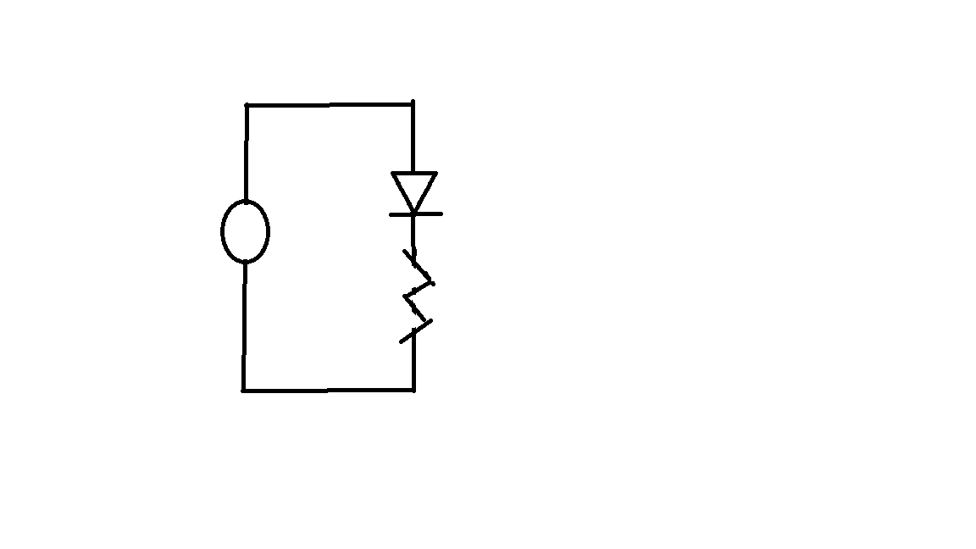

Current-Voltages Characteristics Curves

|  |
| --- |
|  |
|  |
| June 12  NSU REU Project  Ranye and Anya |

# Current-Voltages Characteristic Curves

|  |
| --- |
| Background: We created a circuit with a known resistor (2.2k Ohms), LED diode, wires, breadboard, and the analog discovery kit. A resistor resists electrical energy. A diode allows current to flow in one direction and the LED will light if it has enough current flowing through it. A breadboard allows us to build circuits to test. The analog discovery kit is a portable power supply that allows us to measure voltage drops and apply voltages for the breadboard. We understand the KVL explains the voltages applied equals to the total voltage drops between the resistor and the diode. We want to find the current-voltage characteristics of a LED diode.  Process:   1. **Connect the resistor in series with the diode and the power supply from the ADB.**     Circuit on Breadboard |

1. Increase the voltage of the supply from 0 to 5 in steps of 0.5

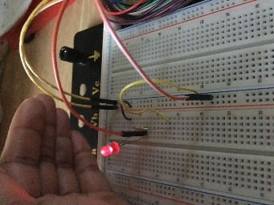

*LED lights up after applying 1.5V*

1. Tabulate your result and any necessary calculated values.

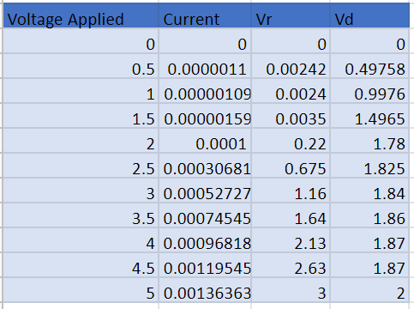

Vr = Voltage drop of resistance, Vd = Voltage drop of diode

1. Measure and record the voltage drop across the LED and the resistor. Plot the IV characteristic curve for the LED used. (a graph of current Vs voltage)

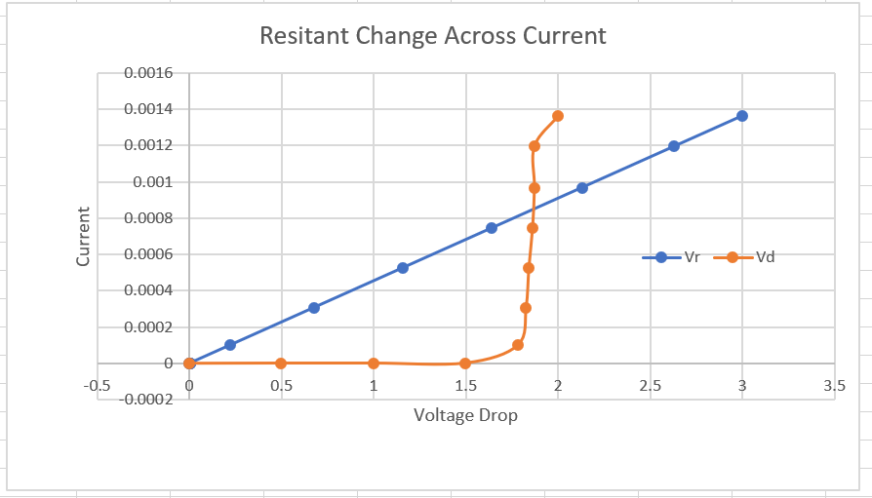

As the voltage increases, the current flowing through the diode does not increase until the voltage reaches 1.5 V

As the voltage increases, the current flowing through the resistor increases

Conclusion:

The applied voltage is equal to the voltage drop of the resistor and the diode. After calculating the voltage drop of the resistor, we were able to find the voltage drop of the diode. We concluded that as the voltage increases, the current increases, which in return increases the current through the resistor. However, the diode current does not increase until a voltage of 1.5 is applied. Therefore, we able to determine that the diode voltage and current are not linear. The diode curve is exponential while the resistor curve is linear.