Android based Crowdsourced

Disaster Alert & Safety App

Design Document

Version 1.0



Group Id: F25PROJECT384C7

Supervisor Name : Irshad Nasir

Revision History

Date (dd/mm/yyyy) | Version | Description | Author
12-01-2026 | 1.0 | Natural disasters such as floods, earthquakes, and fires can strike unexpectedly, putting lives and property at risk. Timely information during such events is crucial, yet traditional communication channels are often slow or unreliable. The Crowdsourced Disaster Alert & Safety App (SoSync) is an Android-based mobile application designed to address this challenge. It enables users to report disasters in real time, receive instant alerts based on their location, and verify reports collectively. By integrating features like interactive maps, SOS alerts, and an admin verification system, the app leverages community participation and cloud technologies to enhance disaster preparedness, response, and overall public safety. | bc240222825

Table of Contents

- Introduction of Design Document
- Entity Relationship Diagram (ERD)
- Sequence Diagrams
- Architecture Design Diagram
- Class Diagram
- Database Design
- Interface Design
- Test Cases

- Introduction of Design Document
The Design Document for the Crowdsourced Disaster Alert & Safety App (Sosync) serves as a detailed blueprint that transforms the Software Requirements Specification (SRS) into a clear and structured plan for implementation. This document explains how the system will be built, how its components will interact, and how data will be managed throughout the application. The primary purpose of this design phase is to provide developers, testers, and stakeholders with a shared understanding of the system’s architecture, functionality, and behavior before the actual coding process begins. By defining technical and logical structures in advance, the design document minimizes ambiguity and ensures that development proceeds in an organized and efficient manner.

This document includes several essential design components that collectively define the complete system.

The Architecture Design presents the overall structure of the application, highlighting the use of an Expo-based React Native mobile application as the front end. Expo is selected to simplify development, testing, and deployment while ensuring cross-platform compatibility. The backend primarily utilizes Firebase services such as Authentication, Firestore or Realtime Database, Storage, and Cloud Messaging to support real-time reporting, media handling, and notifications. If additional business logic, advanced processing, or third-party integrations are required, a Node.js backend may be introduced to handle server-side operations and APIs.

The Entity Relationship Diagram (ERD) presents a clear representation of the system’s data model by illustrating entities such as users, disaster reports, votes, SOS alerts, and admins, along with their relationships. This helps in organizing data efficiently, reducing redundancy, and maintaining data integrity. A well-structured ERD supports smooth data retrieval and ensures that the system can handle large volumes of real-time data during emergencies.

The Use Case Diagrams and Sequence Diagrams describe how users and admins interact with the system over time. These diagrams clearly define workflows such as user registration, disaster reporting, community voting, SOS activation, and admin verification. By visualizing step-by-step interactions, developers gain insight into system behavior, making it easier to implement accurate and coordinated logic.

The Class Diagram provides an object-oriented view of the system, identifying major classes such as User, DisasterReport, VoteManager, NotificationService, and SOSManager. This modular structure improves code maintainability and allows future enhancements without disrupting existing functionality.

The Database Design section defines collections, fields, and relationships used in Firebase, ensuring efficient storage, real-time updates, and secure access control.

The Interface Design section focuses on user experience, detailing key screens such as login, report creation, map view, report details, SOS screen, and admin dashboard, with an emphasis on simplicity and quick access during emergencies.

The Test Cases and Validation Strategy ensure that all functional and non-functional requirements are met. Testing covers authentication, reporting, voting, notifications, SOS functionality, performance, and security.

The design phase plays a critical role in the software development lifecycle by identifying potential risks early, reducing development cost, and improving collaboration.

This Design Document serves as a solid foundation for building a reliable, scalable, and user-centered disaster alert system that enhances public safety and community resilience.

- Entity Relationship Diagram (ERD) (To be developed using Microsoft Visio or any other drawing software of your choice)

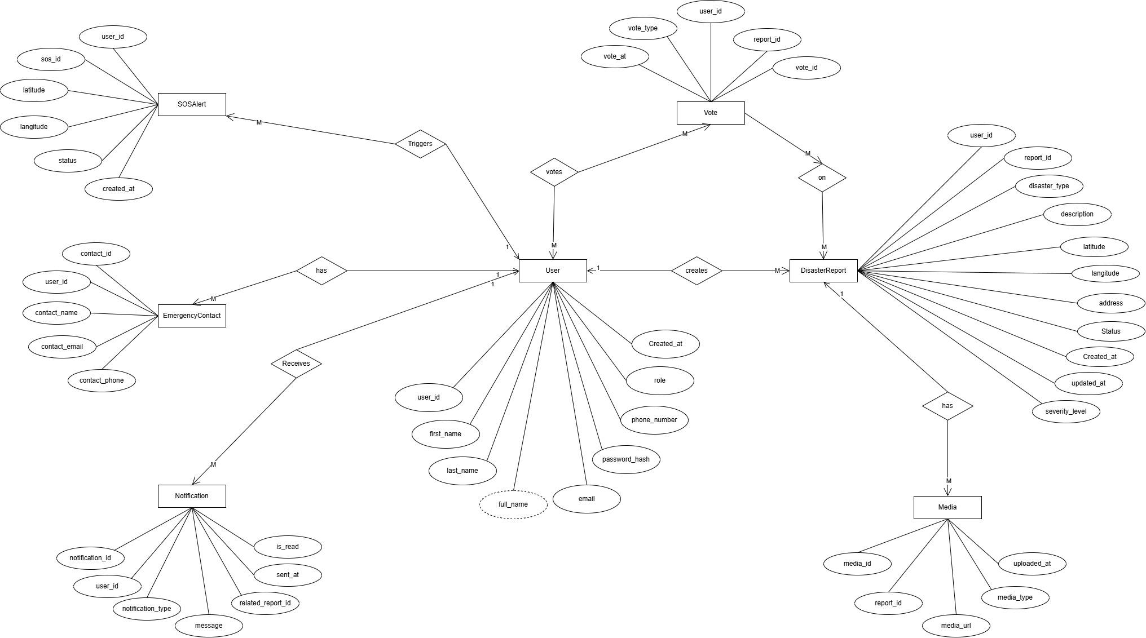

- Sequence Diagrams (To be developed using Rational Rose or any other drawing software of your choice)
User Diagram
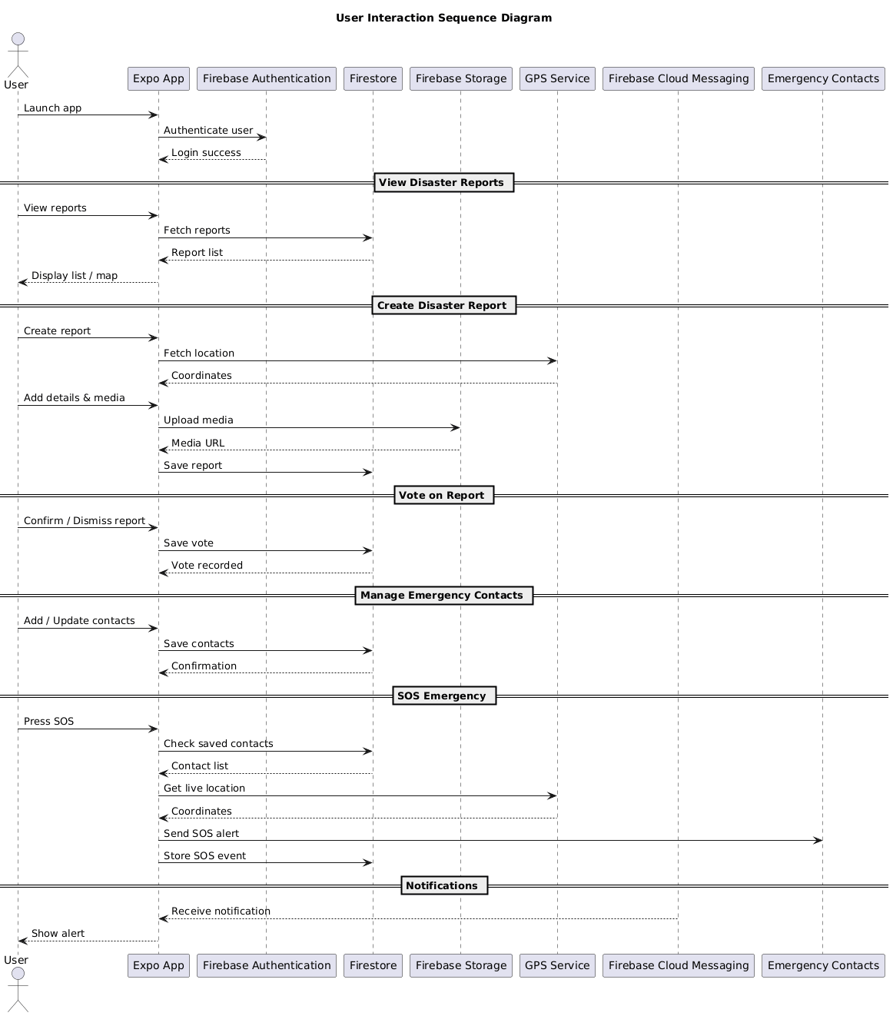
Admin diagram
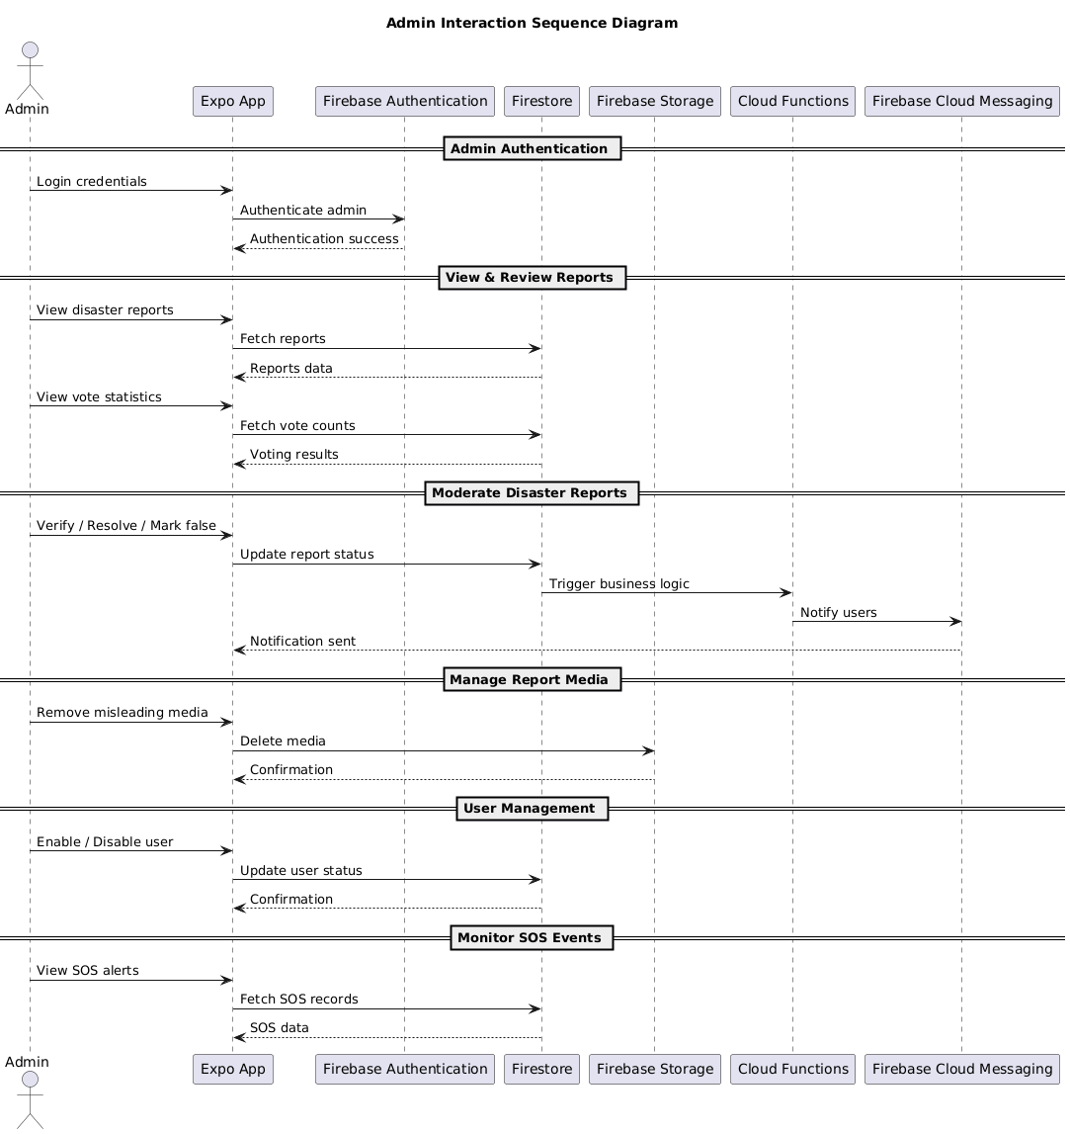

System Diagram
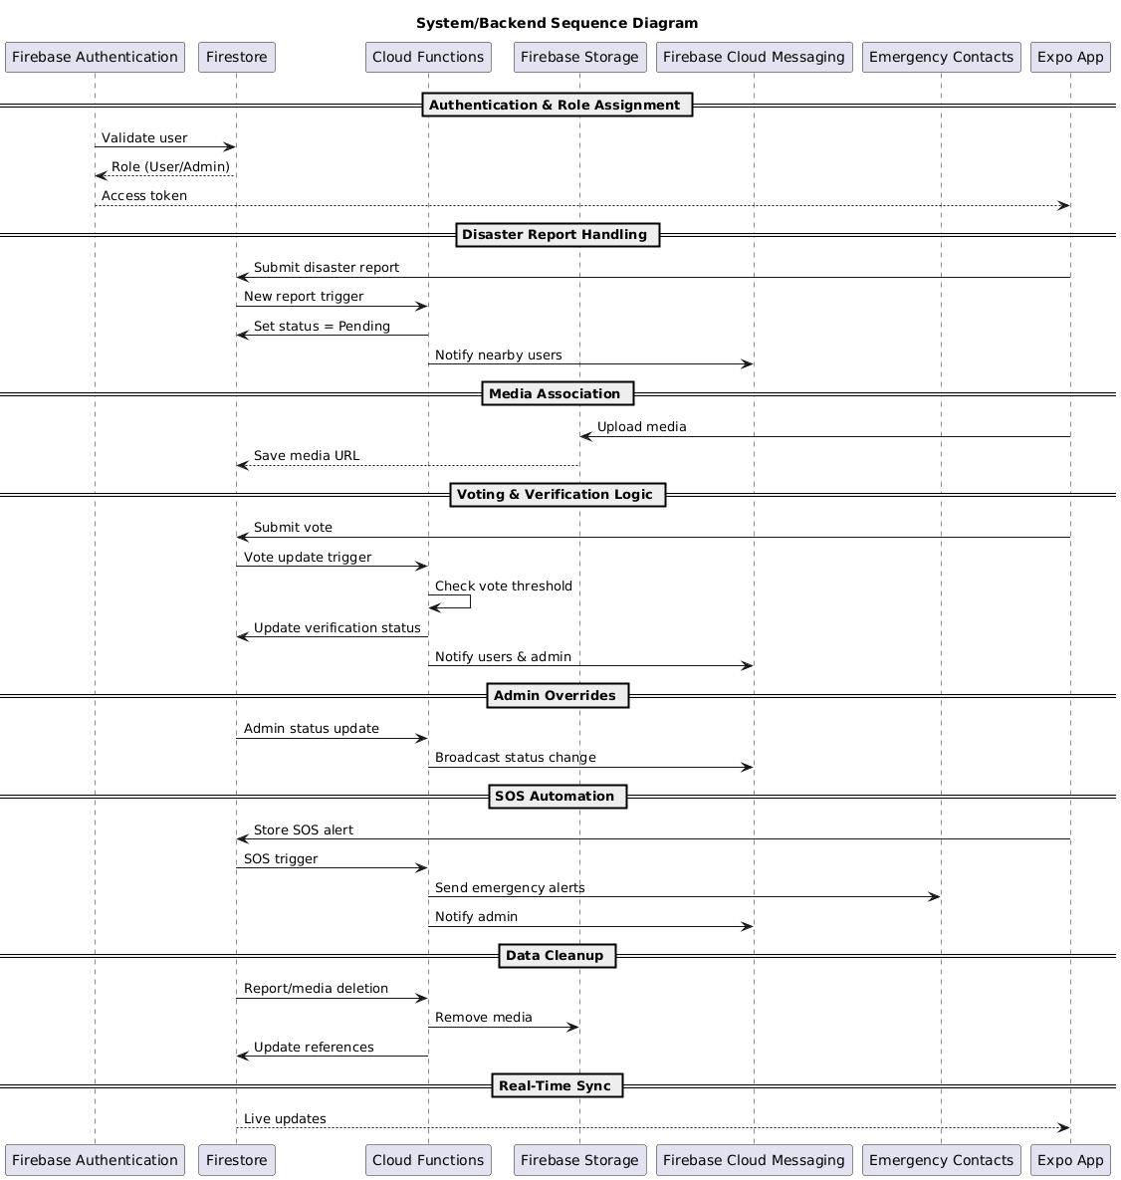

- Architecture Design Diagram

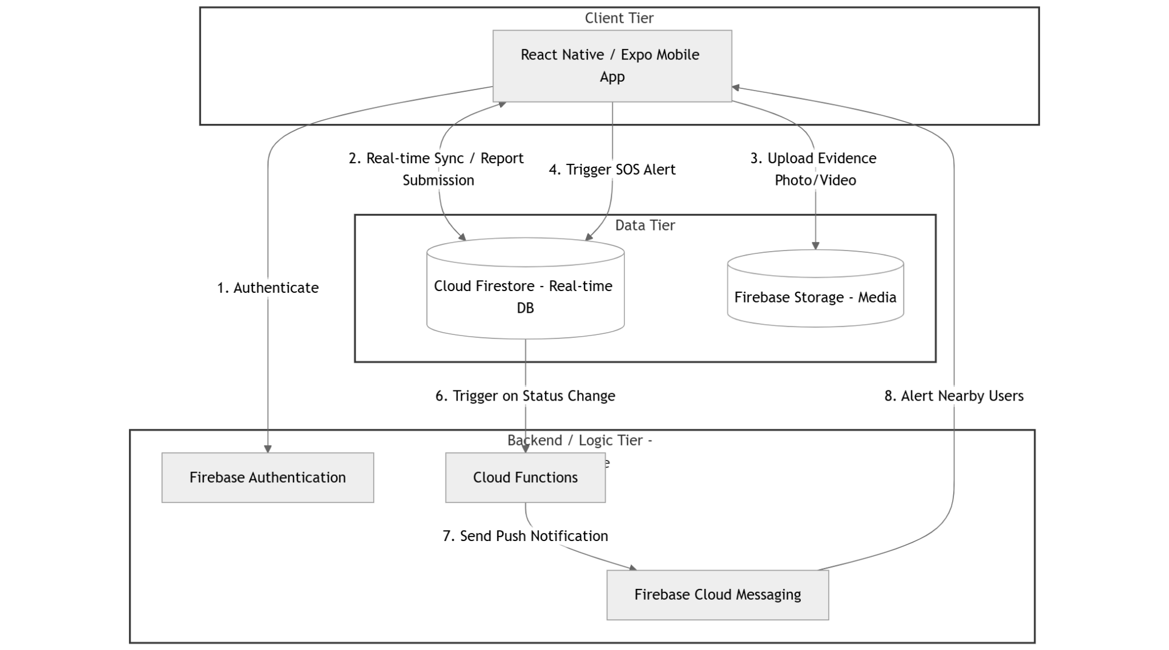
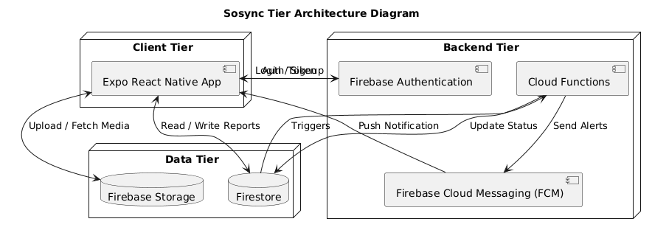

- Class Diagram

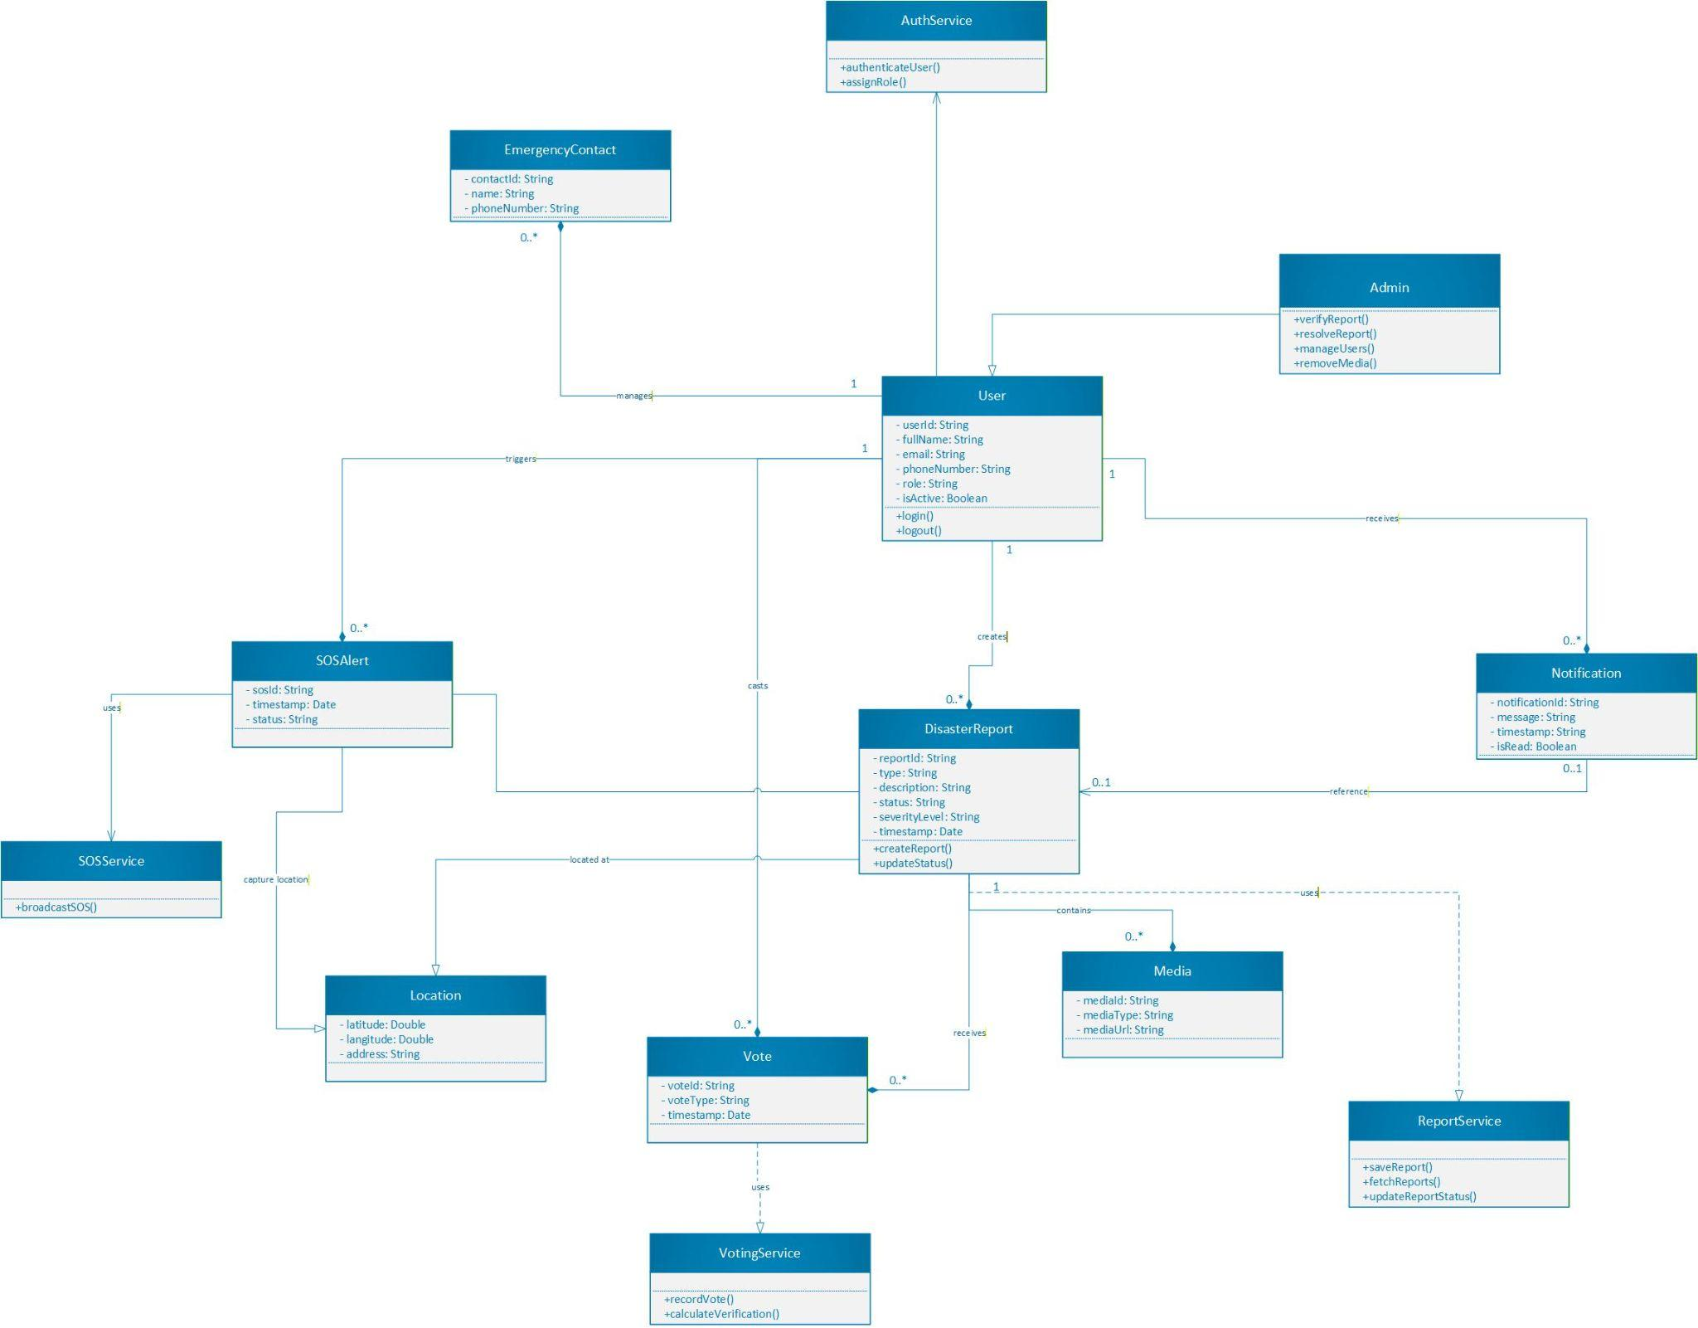

- Database Design

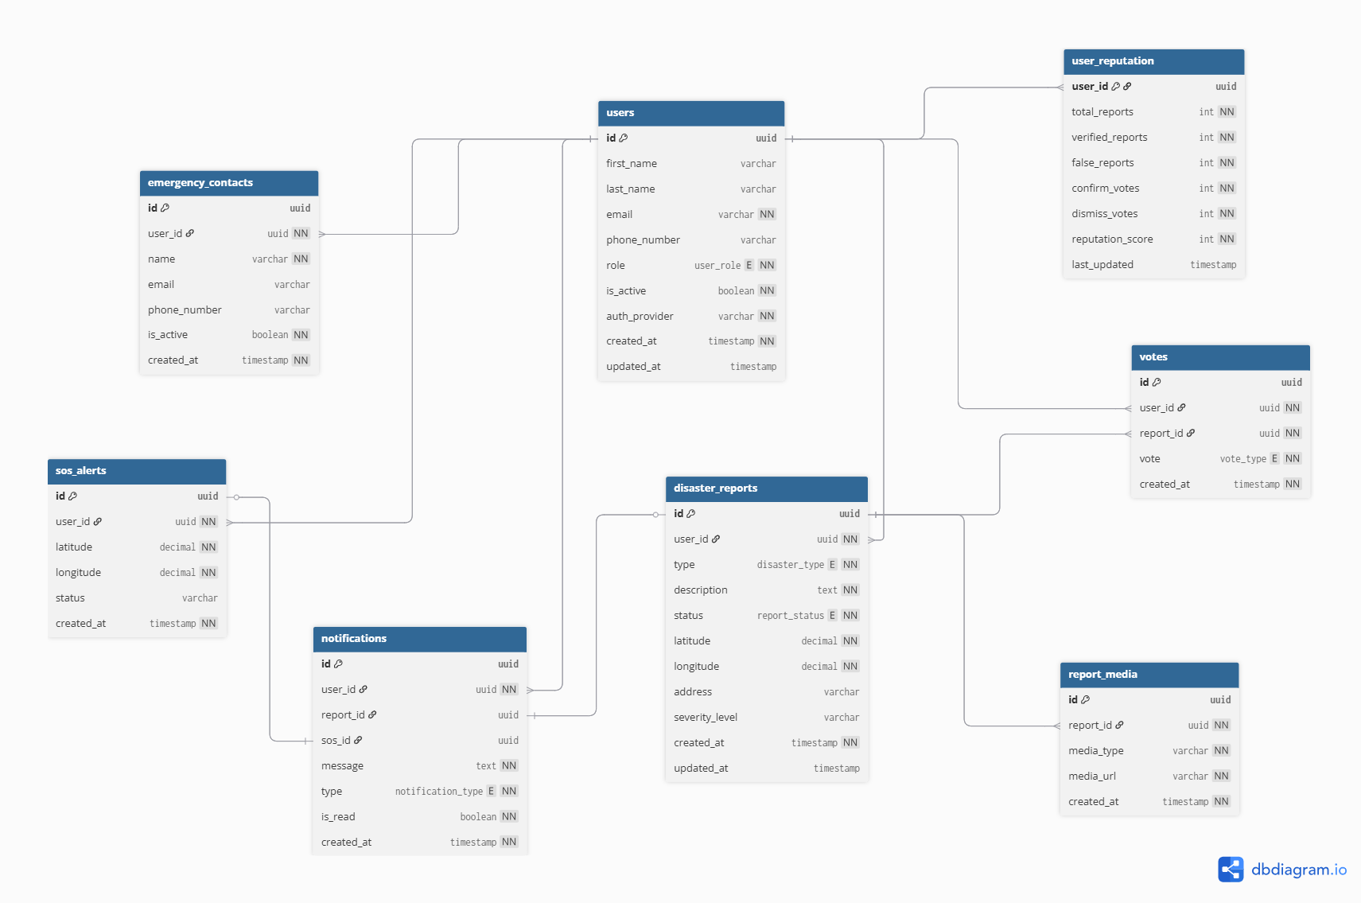

- Interface Design

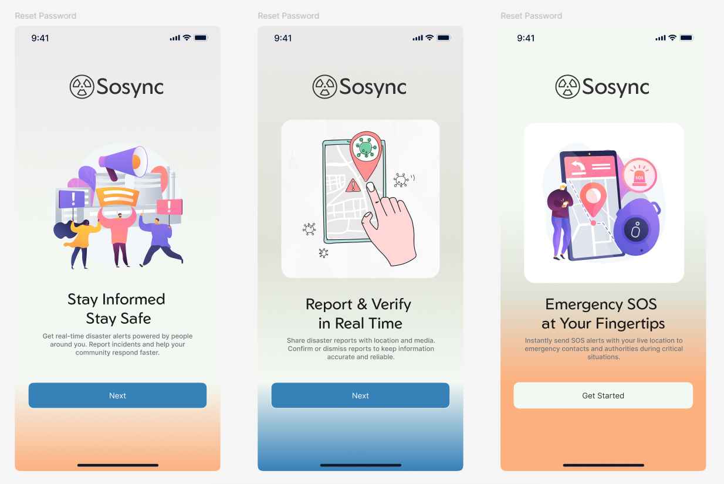

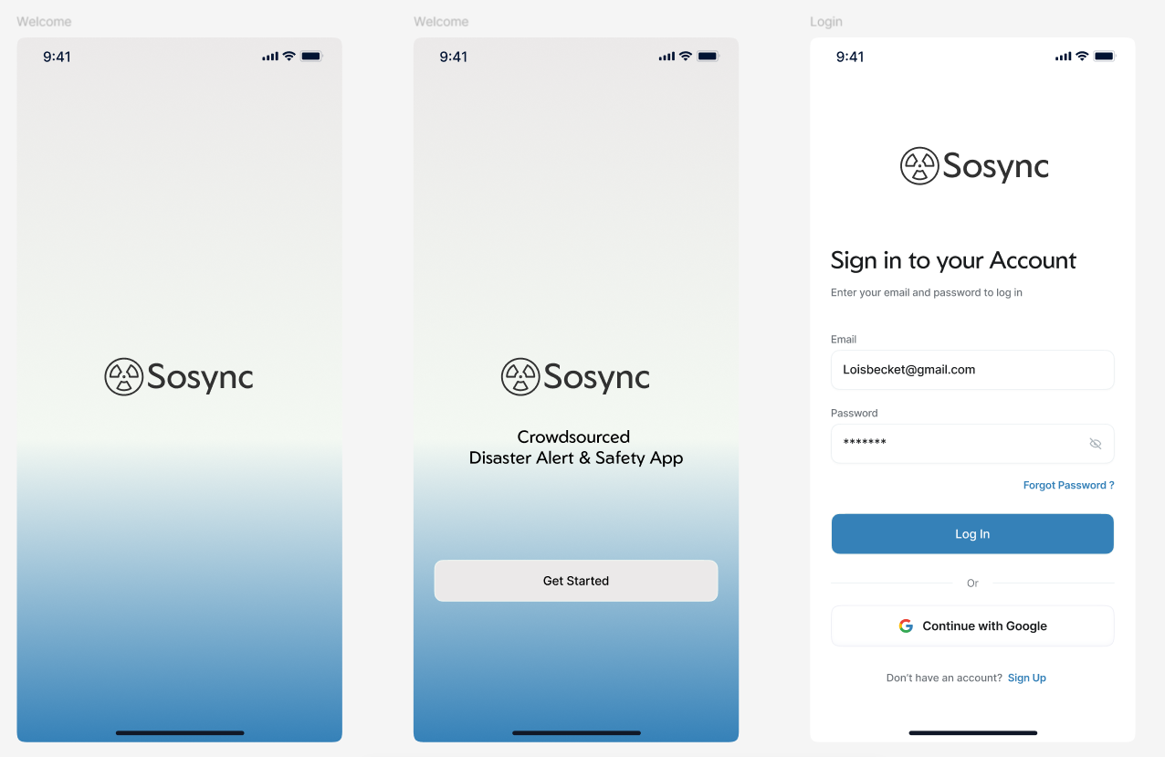
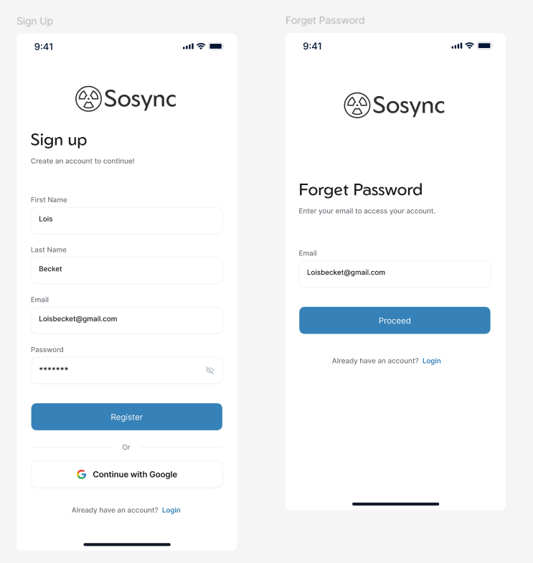

- Test Cases

Test Case: verify that a user can register

Field | Details
Test Case ID | TC-01
Use Case Name | UC-01 – User Registration (Email)
Description | Verify that a new user can register using a valid email and password
Input | Valid email, valid password
Expected Output | User account is created and user is logged in
Result (Pass/Fail) | Pass
Tested By / Actor | User

Test case: verify that user can login

Field | Details
Test Case ID | TC-02
Use Case Name | UC-02 – User Login (Email)
Description | Verify login using registered email and password
Input | Registered email, correct password
Expected Output | User authenticated and redirected to dashboard
Result (Pass/Fail) | Pass
Tested By / Actor | User

Test Case: Login using Google Auth

Field | Details
Test Case ID | TC-03
Use Case Name | UC-03 – User Login (Google)
Description | Verify login using Google authentication
Input | Google account credentials
Expected Output | User logged in and profile created if first-time login
Result (Pass/Fail) | Pass
Tested By / Actor | User

Test case: verify that user can logout

Field | Details
Test Case ID | TC-04
Use Case Name | UC-04 – User Logout
Description | Verify that user can log out successfully
Input | Logout request
Expected Output | User session terminated and redirected to login screen
Result (Pass/Fail) | Pass
Tested By / Actor | User

Test case: verify that user can update profile

Field | Details
Test Case ID | TC-05
Use Case Name | UC-05 – Update User Profile
Description | Verify that user can update profile information
Input | Updated name / phone number
Expected Output | Profile data updated successfully
Result (Pass/Fail) | Pass
Tested By / Actor | User

Test case: Add emergency contact

Field | Details
Test Case ID | TC-06
Use Case Name | UC-06 – Add Emergency Contact
Description | Verify user can add an emergency contact
Input | Contact name, phone or email
Expected Output | Emergency contact saved successfully
Result (Pass/Fail) | Pass
Tested By / Actor | User

Test case: Update / Delete Emergency Contact

Field | Details
Test Case ID | TC-07
Use Case Name | UC-07 – Update/Delete Emergency Contact
Description | Verify user can update or delete emergency contacts
Input | Updated contact details or delete request
Expected Output | Contact updated or removed successfully
Result (Pass/Fail) | Pass
Tested By / Actor | User

Test Case: Create Disaster Report

Field | Details
Test Case ID | TC-08
Use Case Name | UC-08 – Create Disaster Report
Description | Verify user can submit a disaster report
Input | Disaster type, description, GPS location
Expected Output | Report saved with status PENDING
Result (Pass/Fail) | Pass
Tested By / Actor | User

Test case: Upload Media to Disaster Report

Field | Details
Test Case ID | TC-09
Use Case Name | UC-09 – Upload Media
Description | Verify user can upload image/video with report
Input | Image or video file
Expected Output | Media uploaded and linked to report
Result (Pass/Fail) | Pass
Tested By / Actor | User

Test Case: View Disaster Reports (List / Map)

Field | Details
Test Case ID | TC-10
Use Case Name | UC-10 – View Disaster Reports
Description | Verify reports are viewable in list and map views
Input | View reports request
Expected Output | Reports displayed with location and status
Result (Pass/Fail) | Pass
Tested By / Actor | User

Test case: Vote on Disaster Report

Field | Details
Test Case ID | TC-11
Use Case Name | UC-11 – Vote on Disaster Report
Description | Verify user can confirm or dismiss a report
Input | Vote type (Confirm / Dismiss)
Expected Output | Vote recorded and affects verification logic
Result (Pass/Fail) | Pass
Tested By / Actor | User

Test case: Send SOS Alert

Field | Details
Test Case ID | TC-12
Use Case Name | UC-12 – Send SOS Alert
Description | Verify SOS alert can be sent with live location
Input | SOS button press, GPS location
Expected Output | SOS stored and alerts sent to contacts
Result (Pass/Fail) | Pass
Tested By / Actor | User

Test case: View Notifications

Field | Details
Test Case ID | TC-13
Use Case Name | UC-13 – View Notifications
Description | Verify user can view received notifications
Input | Open notifications screen
Expected Output | Notifications displayed correctly
Result (Pass/Fail) | Pass
Tested By / Actor | User

Test case: Mark Notification as Read

Field | Details
Test Case ID | TC-14
Use Case Name | UC-14 – Mark Notification as Read
Description | Verify user can mark notifications as read
Input | Notification selected
Expected Output | Notification marked as read
Result (Pass/Fail) | Pass
Tested By / Actor | User

Test case: Admin Login

Field | Details
Test Case ID | TC-15
Use Case Name | UC-15 – Admin Login
Description | Verify that an admin can log in with valid credentials
Input | Admin email, correct password
Expected Output | Admin authenticated and redirected to admin dashboard
Result (Pass/Fail) | Pass
Tested By / Actor | Admin

Test case: View All Disaster Reports (Admin)

Field | Details
Test Case ID | TC-16
Use Case Name | UC-16 – View All Disaster Reports
Description | Verify admin can view all disaster reports
Input | Request to view reports
Expected Output | All reports displayed with details and status
Result (Pass/Fail) | Pass
Tested By / Actor | Admin

Test case: Verify Disaster Report

Field | Details
Test Case ID | TC-17
Use Case Name | UC-17 – Verify Disaster Report
Description | Verify admin can mark a report as verified
Input | Report ID, status = VERIFIED
Expected Output | Report status updated and notifications sent
Result (Pass/Fail) | Pass
Tested By / Actor | Admin

Test case: Mark Disaster Report as Resolved

Field | Details
Test Case ID | TC-18
Use Case Name | UC-18 – Resolve Disaster Report
Description | Verify admin can mark a disaster report as resolved
Input | Report ID, status = RESOLVED
Expected Output | Report marked resolved and users notified
Result (Pass/Fail) | Pass
Tested By / Actor | Admin

Test case: Mark Disaster Report as False Alarm

Field | Details
Test Case ID | TC-19
Use Case Name | UC-19 – Mark False Alarm
Description | Verify admin can mark a report as false alarm
Input | Report ID, status = FALSE_ALARM
Expected Output | Report updated and reputation adjusted
Result (Pass/Fail) | Pass
Tested By / Actor | Admin

Test case: Manage Users (Activate / Deactivate)

Field | Details
Test Case ID | TC-20
Use Case Name | UC-20 – Manage Users
Description | Verify admin can activate or deactivate a user
Input | User ID, active/inactive status
Expected Output | User status updated successfully
Result (Pass/Fail) | Pass
Tested By / Actor | Admin

Test case: Remove Report Media

Field | Details
Test Case ID | TC-21
Use Case Name | UC-21 – Remove Report Media
Description | Verify admin can remove inappropriate media
Input | Media ID
Expected Output | Media deleted from storage and database
Result (Pass/Fail) | Pass
Tested By / Actor | Admin

Test case: Send Push Notification (System)

Field | Details
Test Case ID | TC-22
Use Case Name | UC-22 – Send Push Notification
Description | Verify system sends notifications on events
Input | Disaster report or SOS trigger
Expected Output | Push notification delivered to users
Result (Pass/Fail) | Pass
Tested By / Actor | System (Firebase Cloud Messaging)

Test case: Calculate Report Verification (System)

Field | Details
Test Case ID | TC-23
Use Case Name | UC-23 – Calculate Report Verification
Description | Verify system calculates verification based on votes
Input | Multiple user votes
Expected Output | Report verification status updated correctly
Result (Pass/Fail) | Pass
Tested By / Actor | System (Cloud Functions)

Test case: Update User Reputation (System)

Field | Details
Test Case ID | TC-24
Use Case Name | UC-24 – Update User Reputation
Description | Verify system updates user reputation scores
Input | Verified/false reports, votes
Expected Output | User reputation updated accurately
Result (Pass/Fail) | Pass
Tested By / Actor | System (Cloud Functions)

Test case: Store Media in Firebase Storage

Field | Details
Test Case ID | TC-25
Use Case Name | UC-25 – Store Media
Description | Verify system stores uploaded media securely
Input | Image or video file
Expected Output | Media stored and URL saved in database
Result (Pass/Fail) | Pass
Tested By / Actor | System

Test case: Track User Location (GPS)

Field | Details
Test Case ID | TC-26
Use Case Name | UC-26 – Track User Location
Description | Verify system captures user GPS location
Input | Device GPS coordinates
Expected Output | Location captured accurately
Result (Pass/Fail) | Pass
Tested By / Actor | System

