INSTITUTE OF SPACE TECHNOLOGY,

ISLAMABAD.

**Computer Networks**

Assignment 2

Submitted To:

**Sir Faran**

Submitted By:

**Rao Ahmed Bin Aleem**

**210201071**

# **BS-CS-02-B**

The **ClientAssignII.exe** and **ServerAssignII.exe**, both are running on **localhost**.

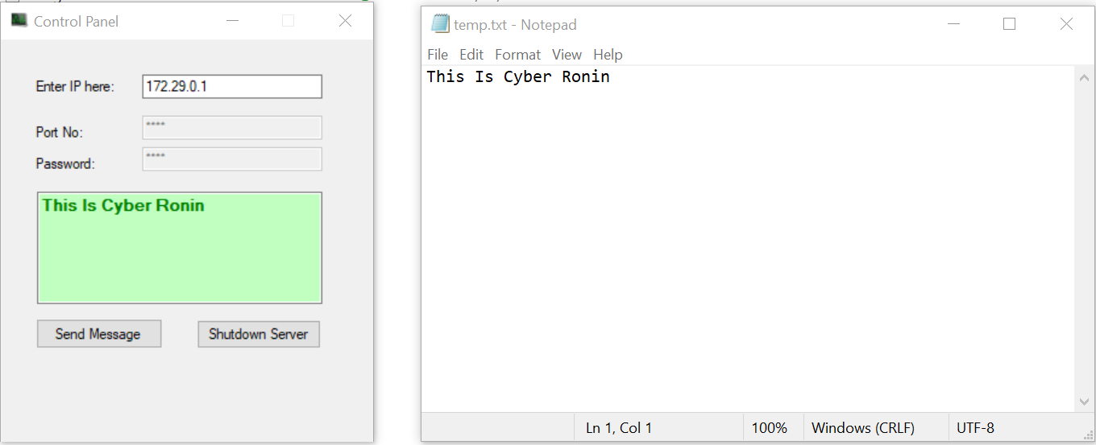

Below is the screen shot of the packet send form the **ClientAssignII.exe** to **ServerAssignII.exe** in **Wireshark**:

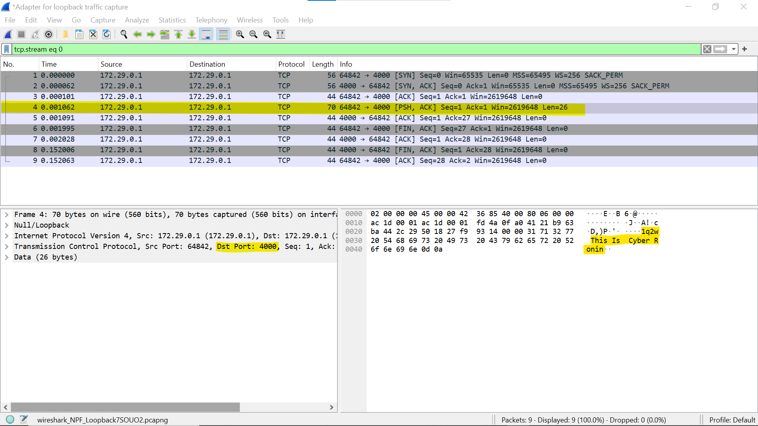

From the picture we can see:

**Task 1:**

That **password** is : **1q2w**

**Task 2:**

And **Destination port** is : **4000**

**Task 3:**

1. the message packet size is 26 bytes 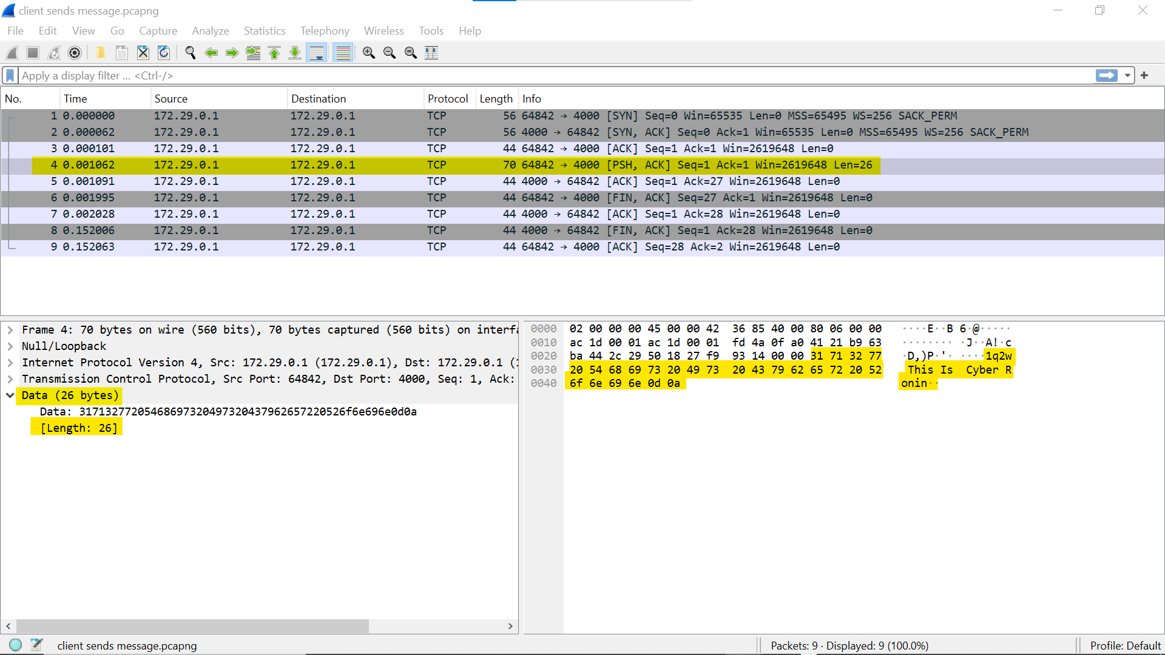
2. for shutdown packet size is 6 bytes

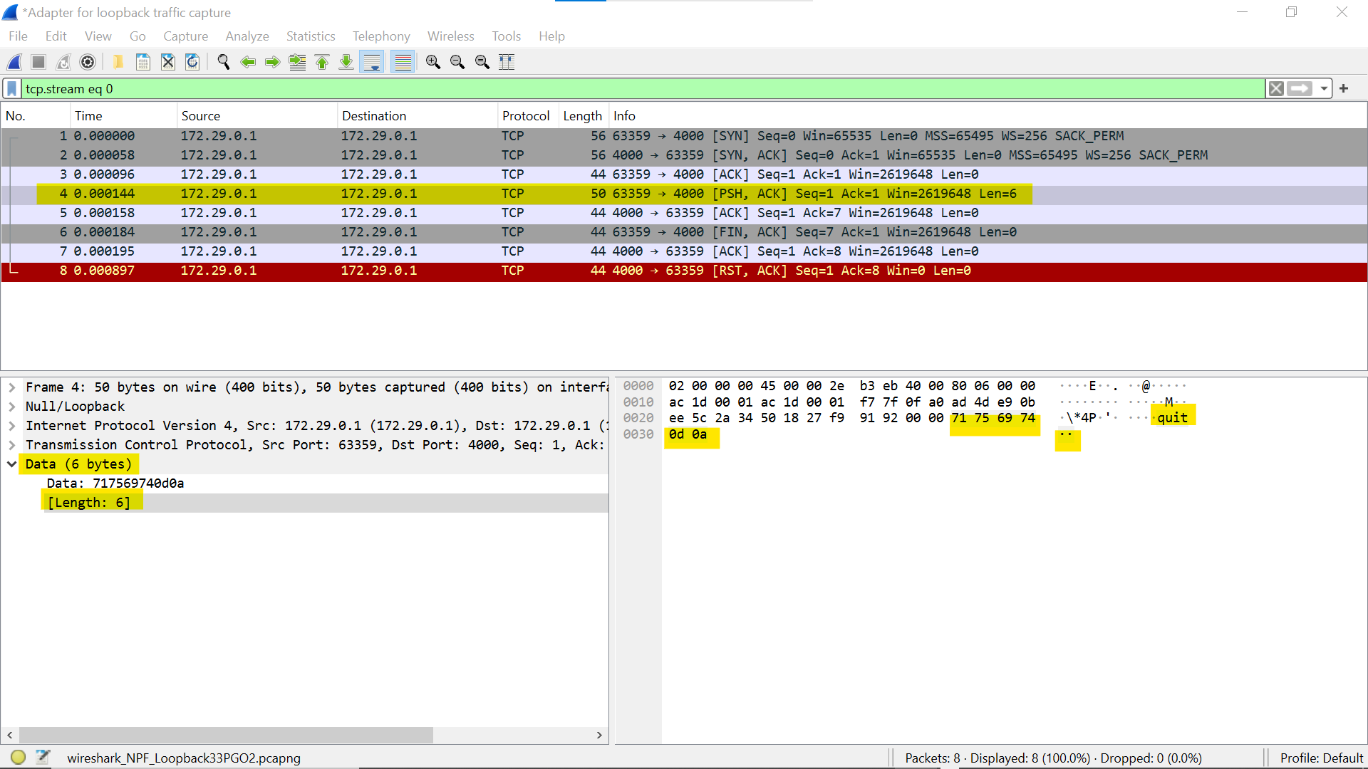

**Task 4:**

Now using **NetCat**, I will send the message instead of using the **ClientAssignII.exe** program. There are multiple ways to do so;

**Method 1:** Enter the new line in the **message.txt** (the file which contains message to be send). In this case you do not need to mention the **-c flag**.

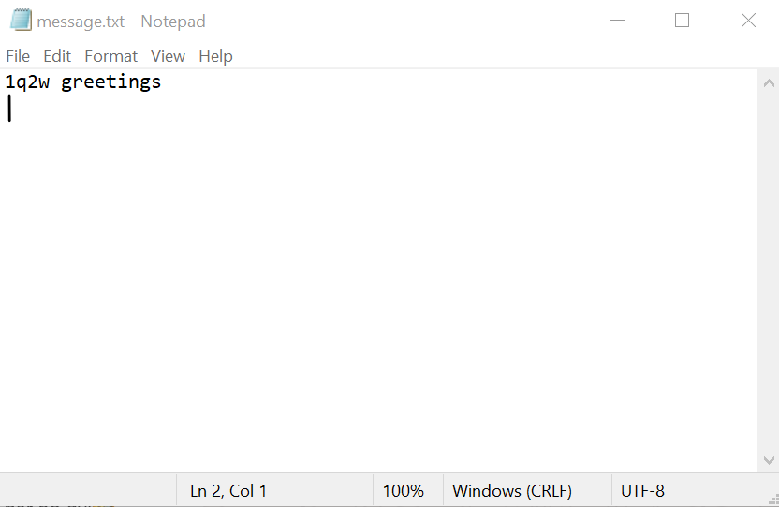

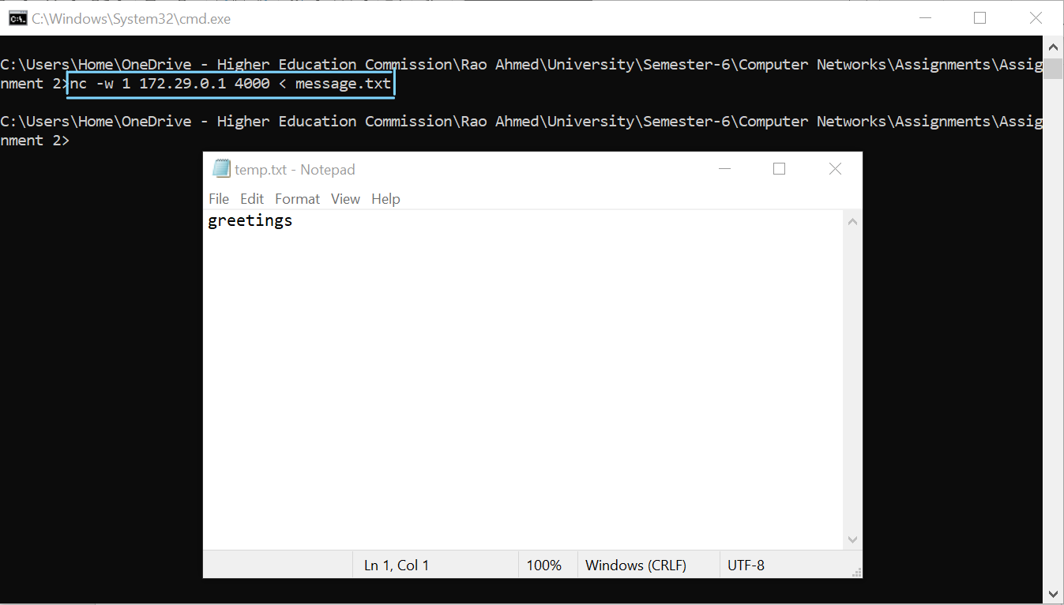

**Command**: the command in this case is

**nc -w 1 172.29.0.1 4000 < message.txt**

**Command break down:**

**nc**: it is the netcat tool

**-w** **1**: this flag set a 1 second timeout for the connection.

**172.29.0.1**: The IP address to connect to

**4000**: The port number to connect to

**<** : redirects the content of the file

**message.txt**: The contents of the file to be sent over the connection.

**Method 2:** Mention the **-c flag** to send the **carriage return** and **line feed** instead of **line feed** only. In this case you do not need to enter a new line in the **message.txt** file.

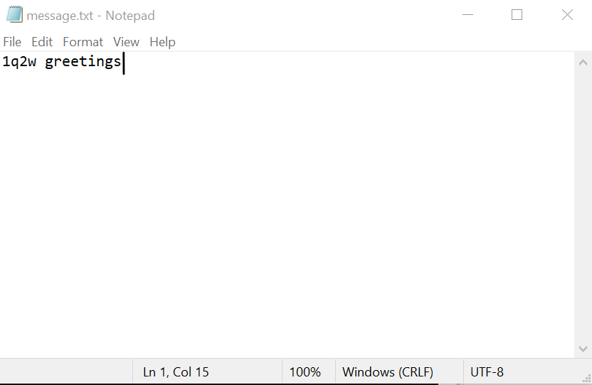

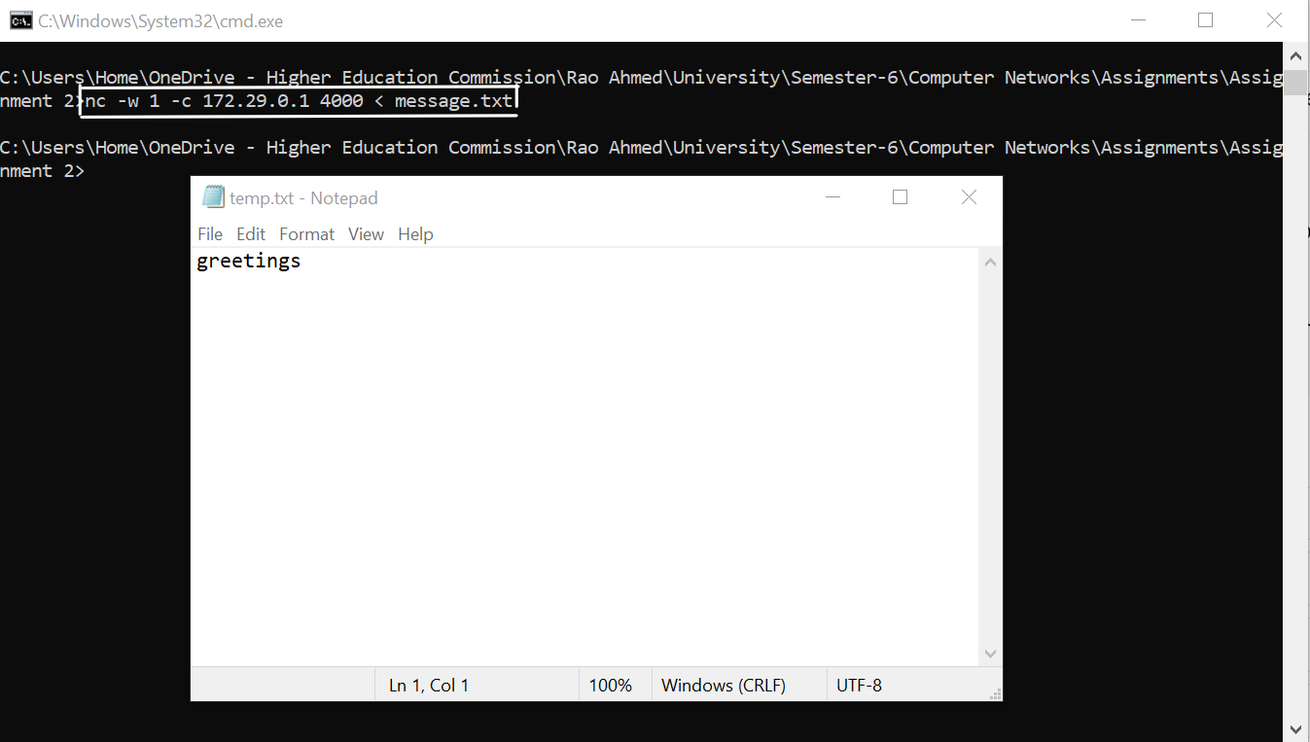

**Command:** **nc -w 1 -c 172.29.0.1 4000 < message.txt**

**Command break down:**

**nc:** it is the netcat tool

**-w 1**: this flag set a 1 second timeout for the connection.

**-c** : this flag send CRLF (carriage return + line feed) instead of just LF (line feed)

**172.29.0.1:** The IP address to connect to

**4000:** The port number to connect to

**<** : redirects the content of the file

**message.txt**: The contents of the file to be sent over the connection.