**Day 3 - API Integration and Data Migration Report**

**Bandage Objective:** On Day 3 of the **Bandage** project, the focus was on integrating API data into **Sanity CMS** to enable dynamic content updates for the marketplace. Instead of manually adding product details, the API integration made the process more efficient and scalable.

1. **Sanity CMS Schema Design:**

To manage product data smoothly, I created a schema called **"product"** in Sanity CMS. This schema includes the following fields:

• **Title:** The name of the product (text).

* **Description:** A detailed overview of the product (long text).
* **Product Image:** The main image of the product.
* **Price:** The cost of the product (numeric value).
* **Tags:** A list of keywords to categorize the product.
* **Discount Percentage:** Any discount applied to the product.
* **Is New:** A yes/no flag to indicate if the product is newly added.

1. **API Integration and Data Migration:**

I pulled product data from an external API, which provided details like images, titles, descriptions, prices, and tags. Once retrieved, I mapped this data to the appropriate fields in the **Sanity CMS** schema, ensuring seamless integration and dynamic content updates.

**Populating Data in Sanity CMS:**

Once the API data was fetched, I dynamically filled the product fields in **Sanity CMS**. This automated approach ensured that product details remained accurate and consistent across the platform without manual entry.

**Data Migration:**

Using the **Sanity CLI**, I exported the dataset from **Sanity CMS** as a backup and later re-imported it for testing. This process ensured that the data was well-structured and displayed correctly on the frontend.

### ****Steps Taken for Data Migration:****

#### **1. Exporting Data:**

I used the **Sanity CLI** to export data from **Sanity CMS**, creating a backup of all product information. This step ensured data safety before making any changes or further operations.

### ****2. Verifying the Data:****

I carefully reviewed the exported **JSON** file to ensure all fields were correctly populated. This step was crucial in making sure the data would be accurately fetched and displayed on the frontend without any issues.

### ****3. Re-importing Data:****

Once the data was verified, I re-imported the dataset into **Sanity CMS**. This final step ensured a smooth migration process and confirmed that everything was functioning as expected.

### ****Tools Used:****

#### **1. Sanity Studio:**

I used **Sanity Studio** for **schema creation**, **content management**, and **displaying product data** in a structured and user-friendly way.

**Sanity Vision:**

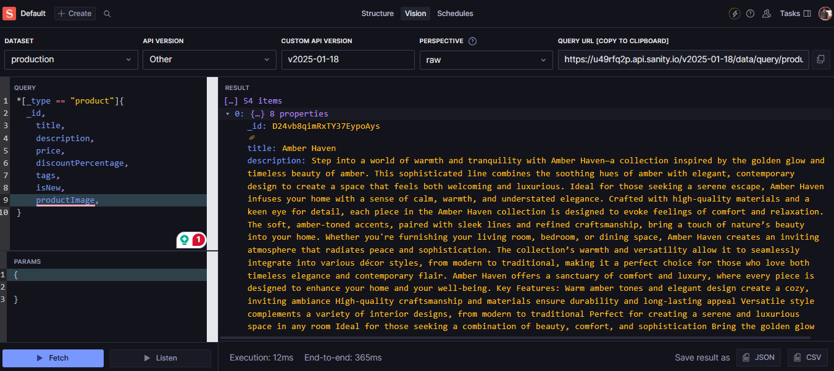

**Sanity DataSet:**

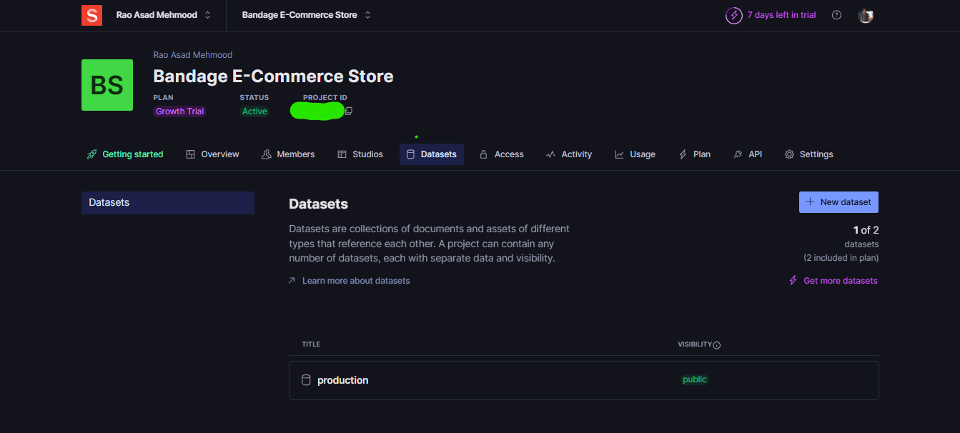

### ****Sanity CLI:****

I used **Sanity CLI** for **exporting and importing datasets**, ensuring data consistency and maintaining backups for safety.

### ****Screenshots & Frontend Display:****

#### **1. Sanity CMS Fields:**

Included a screenshot of **Sanity Studio** showing the populated product fields, such as images, descriptions, and prices, to visualize how the data is structured and managed.

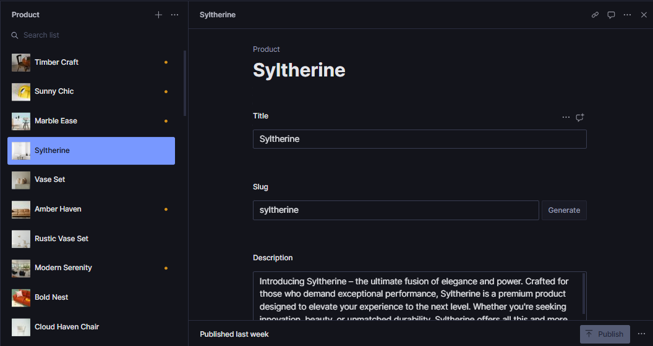

### ****Frontend Display:****

**Included a screenshot showcasing how the product data is dynamically rendered on the marketplace frontend, ensuring a seamless user experience.**

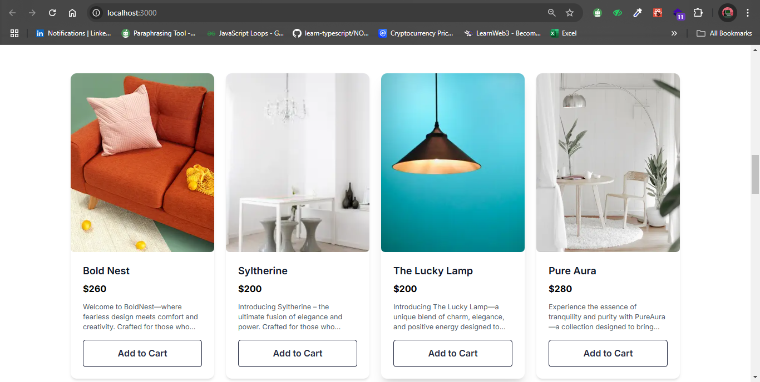

**Product Detail Page Display:**

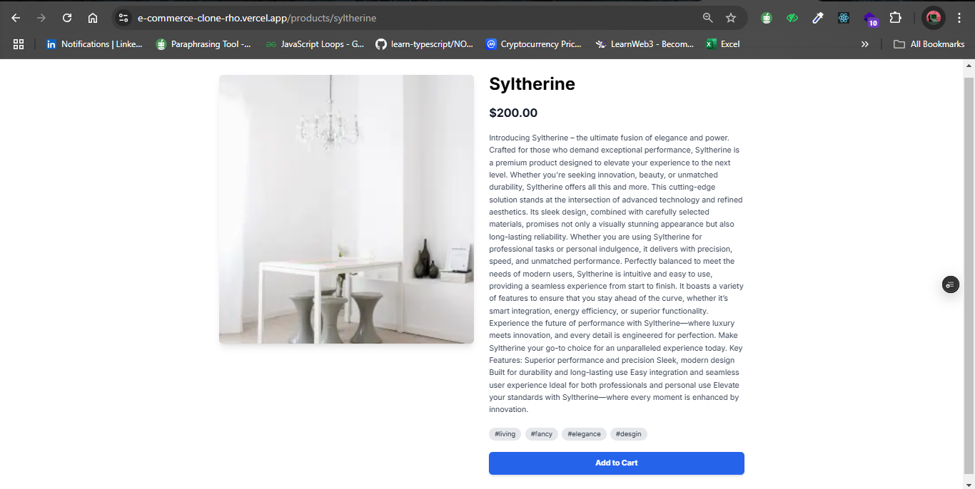

**Conclusion:**

The API integration and data migration for the Bandage project were successfully finished, making the system more efficient and scalable. This integration improved the process of adding and updating product data in the marketplace, while the migration ensured that the data remained consistent and accurate. With these improvements, the Bandage project is now more flexible and easier to manage.

