National University of Computer and Emerging Sciences - Agentic AI (AI4015) - Assignment Beta, Question 1
SaafHawa: closed-source API vs self-hosted open-weight model - evidence and numbers
Roll number: 23K-0001

Parameters (derived from roll number)
R = last two digits = 01. D = digit sum (2+3+0+0+0+1 = 6) mod 10 = 6.
Parameter | Formula | Value
Q - normal daily queries | 1,500 + 25 x R | 1,525
N - LLM calls per query (first attempt) | 5 + (R mod 4) | 6
p - tool-call failure probability | 0.04 + 0.01 x D | 0.10
H - heatwave days per month | 4 + (R mod 4) | 5
B - monthly inference budget | 1,200 + 10 x R | USD 1,210
T - end-to-end latency target | 10 - (R mod 3) | 9 s
Derived: monthly queries = 25 x 1,525 + 5 x (5 x 1,525) = 76,250. Heatwave-day traffic = 7,625 queries, of which 35% (2,668.75) arrive 12:00-14:00.
Honesty notes for the reader: (1) cells marked NV are 'not verified' - I could not confirm them from a primary source; (2) the median tool latency in Section 2.6 (0.601 s) is measured from my own timing log (250 calls, 8-9 Nov 2026), submitted as timing_log.csv; (3) the config.json values in Section 2.4 are shown in the screenshot taken from the Hugging Face model page (Figure 2).

Section 1 - Model comparison (12 models, 4 providers per side)
Closed: OpenAI, Anthropic (x2), Google (x2), xAI. Open-weight: OpenAI, DeepSeek, Alibaba (x2), Mistral. All prices USD per million tokens. Non-reasoning / lowest-reasoning setting stated per model. Yellow = flagged (NV, unverified or recalled).
Model (provider) | Type | Parameters | Context / max output | Price $/M: input / cached / output (cache write); provider | Rate limits, new paid tier (RPM / TPM) | TTFT / output tok/s | Benchmarks (tool-use benchmark marked T) | Native tools / JSON output / reasoning settings (setting used) | Licence / commercial self-hosting | Sources [see list]; accessed 09 Nov 2026
GPT-5.4 mini (OpenAI) | Closed | Not disclosed | 400K / 128K | 0.75 / 0.075 / 4.50 (no write fee); OpenAI | Build tier: 5,000 RPM / 2,000,000 TPM | TTFT NV / 191 tok/s | T: NV (no mini-specific tau2 figure found). Terminal-Bench 4.0: 2.5% (Vals AI). Third-party GPQA 87.5% (low confidence) | Function calling Yes / Structured outputs Yes / effort none (default), low, medium, high, xhigh (USED: none) | Proprietary / No | [S1] pricing, limits, ctx, features; [S6] speed, Terminal-Bench; [S10] GPQA
Claude Haiku 5.5 (Anthropic) | Closed | Not disclosed | 1M / 128K | 0.10 / 0.01 / 0.50 (5-min write 0.125; 1-h write 0.20); prompts <=100K (above 100K: 0.50/0.05/2.50) | NV (Tier-1 Haiku 5.5 limits not captured) | TTFT 0.59 s / 183 tok/s (measured, effort low, thinking off; Oct 2026) | AA Intelligence Index 43; T: AutomationBench-AA 35% (AA says likely understated by refusals); Terminal-Bench 4.0 39.2% (Anthropic) / 33% (AA) | Tool use Yes / Structured output Yes / effort param (default medium) + adaptive thinking (USED: thinking disabled, effort low) | Proprietary / No | [S2][S3] price, ctx; [S4] min cache 512; [S5] AA; [S6] speed; [S7] Terminal-Bench
Claude Sonnet 5.5 (Anthropic) | Closed | Not disclosed | 1M / 128K | 2.00 / 0.10 / 10.00 (write 2.50; 1-h 4.00) | NV | NV / NV | Terminal-Bench 4.0 70.6% (Anthropic table); AA Intelligence Index: NV on same scale; T: NV | Tool use Yes / Structured output Yes / adaptive thinking is default (USED: thinking disabled, effort low) | Proprietary / No | [S2] price; [S3] ctx pattern; [S7] benchmark
Gemini 3.5 Flash (Google) | Closed | Not disclosed | 1,048,576 / 65,536 | 1.50 / 0.15 / 9.00 (implicit cache: no write fee; explicit storage $1.00/M-token-hour) | NV (Tier-1 not captured) | NV / NV | Third-party GPQA Diamond 82.8%; BenchLM public-lane score 50.7; T: NV | Function calling Yes / Structured output Yes / thinking levels (USED: lowest/minimal) - exact level names NV | Proprietary / No | [S8] price; [S10] ctx, max out, GPQA; [S9]; [S32] BenchLM score
Gemini 3.1 Flash-Lite (Google) | Closed | Not disclosed | 1M / NV | 0.25 / 0.025 / 1.50 (secondary source) | NV | NV / NV | NV (no verified benchmark captured) | Function calling Yes (assumed from family) / JSON Yes (assumed) / thinking levels (USED: lowest) | Proprietary / No | [S9] benchmlm price table only
Grok 4 Fast (xAI) | Closed | Not disclosed | 2M / 30K | 0.20 / 0.05 / 0.50 (no write fee); non-reasoning variant used | 480 RPM / 4,000,000 TPM (Sep-2025 report; DATED) | NV / NV | SWE-bench Verified 45.4% (aggregator, reasoning variant); T: NV | Function calling Yes / Structured output Yes / separate reasoning and non-reasoning models (USED: grok-4-fast-non-reasoning) | Proprietary / No | [S11] price; [S12] limits, ctx; [S13] max out, SWE-bench
gpt-oss-120b (OpenAI) | Open weight | 117B total / 5.1B active (MoE) | 131,072 / 131K | 0.039 / n.a. / 0.158; Geodd (OpenRouter headline 0.03 / 0.17, provider unnamed) | NV (provider-specific) | TTFT 0.82 s / 265 tok/s (AA, 'high' variant) | AA Intelligence Index 24 (high variant); GPQA Diamond 67.1% (low effort); T: tau-bench retail 49.4% (low effort; OpenAI model card Table 3) | Function calling Yes / structured output Yes / reasoning low-medium-high only, cannot be turned off (USED: low) | Apache 2.0 / Yes | [S14] params, price, licence; [S15]; [S16] speed, AA; [S17] GPQA; [S30] tau-bench
gpt-oss-20b (OpenAI) | Open weight | ~21B total / ~3.6B active (MoE) - from model card, not re-verified | 131K / NV | 0.03 / n.a. / 0.14; lowest listed on getdeploying (provider name not captured) | NV | NV / NV | AA Intelligence Index 24 (high, DataLearner); GPQA Diamond 56.8% (low effort); T: tau-bench retail 35.0% (low effort; OpenAI model card Table 3) | Function calling Yes / structured output Yes / low-medium-high (USED: low) | Apache 2.0 / Yes | [S14] price line; [S31] DataLearner AA list; [S30]
DeepSeek V4 Flash-0731 (DeepSeek) | Open weight | 284B total / 13B active (HF card lists 304B) | 1M / 384K | 0.08 / n.a. / 0.252; DigitalOcean. First-party API: 0.14 / 0.0028 / 0.28 | DeepSeek API: concurrency limit 2,500 (no RPM/TPM published in source) | TTFT 0.89 s (Makora via AA) / NV | AA Intelligence Index 47 (Max effort, Makora listing); Terminal-Bench 2.1 82.7 (vendor-stated); T: NV | Tool calling Yes / JSON output Yes (API docs; not re-fetched) / thinking vs non-thinking, effort modes (USED: non-thinking) | MIT / Yes | [S18] price, 'retired' flag; [S19] params, limits; [S27] AA speed
Qwen3.6-35B-A3B (Alibaba) | Open weight | 35B total / 3B active (MoE) | 262K / 66K | 0.07 / n.a. / 0.42; EmpirioLabs AI (Alibaba list 0.375 / 2.25) | NV | TTFT 2.22 s / 155 tok/s (AA, reasoning variant) | AA Intelligence Index 32 (AA page) [43 on Doubleword, v4.0]; GPQA 84; T: tau2-bench Telecom 95 (Doubleword, citing AA) | Function calling Yes / structured output Yes / thinking and non-thinking (USED: non-thinking) | Apache 2.0 / Yes | [S20] params, price; [S16] AA speed; [S21] benchmarks
Qwen3.6-27B (Alibaba) | Open weight | 27B dense (hybrid Gated DeltaNet + gated attention) | 262K / 66K | 0.60 / n.a. / 3.60; Alibaba Cloud and Novita (same) | NV | NV / NV | AA Intelligence Index 46 (Makora FP4 listing); T: NV | Function calling Yes (family) / JSON Yes (family) / thinking modes (USED: non-thinking) | Apache 2.0 / Yes | [S22] params, price; [S27] AA index
Mistral Small 3.2 24B Instruct (Mistral) | Open weight | 24B dense | 131,072 (config) / NV | 0.060 / n.a. / 0.180; Kilo Gateway (OpenRouter 0.094 / 0.25) | NV | NV / NV | MMLU-Pro 69.06%; Wildbench v2 65.33%; T: NV (vendor says function-calling template improved, no score) | Function calling Yes / structured output Yes / no reasoning mode | Apache 2.0 / Yes | [S23] price, benchmarks, features; [S24] config.json values

Source list (all accessed 09 Nov 2026)
[S1] https://developers.openai.com/api/docs/models/gpt-5.4-mini
[S2] https://platform.claude.com/docs/en/build-with-claude/prompt-caching (pricing table)
[S3] https://platform.claude.com/docs/en/models/haiku-5-5/overview
[S4] https://dev.to/hassann/how-to-use-the-claude-haiku-55-api--1981 (secondary: 512-token minimum cacheable prompt)
[S5] https://artificialanalysis.ai/ja/articles/claude-haiku-5-5 (Artificial Analysis, 7 Oct 2026)
[S6] https://www.gradually.ai/en/llm-comparison/claude-haiku-5.5-vs-gpt-5.4-mini/
[S7] https://computingforgeeks.com/?p=173523
[S8] https://ai.google.dev/gemini-api/docs/pricing
[S9] https://benchlm.ai/google/api-pricing
[S10] https://tech-insider.org/claude-haiku-vs-gemini-flash-vs-gpt-5-4-mini-2026/
[S11] https://glama.ai/mcp/servers/@tetsuo-ai/grok-api-mcp/blob/34e8a2fd0fa50f77e7e1894f18eb2f26c2fdb13c/src/data/models-pricing.md (mirror of xAI pricing)
[S12] https://venturebeat.com/ai/what-to-know-about-grok-4-fast-for-enterprise-use-cases
[S13] https://anotherwrapper.com/llm-pricing/grok-4-fast-reasoning
[S14] https://getdeploying.com/llms/gpt-oss-120b
[S15] https://openrouter.ai/models/openai/gpt-oss-120b
[S16] https://artificialanalysis.ai/models/comparisons/qwen3-6-35b-a3b-vs-gpt-oss-120b
[S17] https://langdb.ai/app/models/gpt-oss-120b
[S18] https://getdeploying.com/llms/deepseek-v4-flash
[S19] https://datanorth.ai/news/deepseek-releases-deepseek-v4-flash-0731
[S20] https://getdeploying.com/llms/qwen3.6-35b-a3b
[S21] https://doubleword.ai/models/qwen3-6-35b-a3b
[S22] https://getdeploying.com/llms/qwen3.6-27b
[S23] https://modelcompare.dev/models/mistral/small-3-2-24b-instruct (and /ja/ page)
[S24] https://huggingface.co/mistralai/Mistral-Small-3.2-24B-Instruct-2506 (config.json, screenshot in Figure 2); third-party config copies used earlier: huggingface.co/gratex/mistral-small-3.2-24b-Instruct-GPTQ-W4A16
[S25] https://www.runpod.io/pricing
[S27] https://artificialanalysis.ai/providers/makora
[S30] OpenAI gpt-oss model card, Table 3 (arXiv:2508.10925, https://arxiv.org/pdf/2508.10925) - tau-bench and GPQA figures at the 'low' reasoning level, the setting used
[S31] https://www.datalearner.com/en/leaderboards/external/aa-quality-index
[S32] https://benchlm.ai/md/compare/gemini-3-5-flash-vs-qwen3-6-35b-a3b.md

Unverified values and their effect
Two values I could not verify are (a) the prefill speed used to grow time-to-first-token with context (20,000 tok/s, an assumption for both latency candidates; no provider publishes it) and (b) the hidden reasoning-token overhead of gpt-oss-120b at its lowest ('low') effort, which cannot be switched off and for which I found no provider-reported average, so Sections 2.1 and 2.2 add zero extra tokens. Further gaps: minimum cacheable prefixes for Sonnet 5.5, Gemini and Grok (assumed 1,024 tokens), new-account rate limits for most models, TTFT and tool-use benchmark scores for several models, and gpt-oss-120b speed, which comes from a 'high'-effort listing. The effect is bounded: with inputs of at most 6,000 tokens, halving the assumed prefill speed adds at most 0.25 s per call, about 1.5 s to the six-call baseline and about 0.75 s to the three-call design, which does not change the ranking of the two candidates (their gap is about 1.9 s) or whether either meets T; hidden reasoning tokens would raise gpt-oss-120b output cost roughly in proportion (even doubling its output tokens adds only about USD 30 per month because its output rate is USD 0.158/M); and a wrong cache-minimum assumption only matters for the three over-budget or near-budget models, so it cannot change which models fit within B except for borderline cases. All of these are single input cells in the workbook (Assumptions sheet) so they can be corrected and the results recomputed. Haiku 5.5 TTFT (0.59 s) and speed (183 tok/s) were originally unverified; they now come from a third-party measurement [S7].

Section 2 - Calculations (all formulas live in Q1_Calculations.xlsx)

2.1 Token volume
Input tokens of call k = 2,000 + 800(k-1): 2,000; 2,800; 3,600; 4,400; 5,200; 6,000 -> sum 24,000. Outputs: 5 x 350 + 600 = 2,350.
Retries: calls 1..5 each fail with p = 0.10 and are repeated once with the same input and same 350 output tokens. Extra input = 0.10 x (2,000+2,800+3,600+4,400+5,200) = 0.10 x 18,000 = 1,800. Extra output = 0.10 x 5 x 350 = 175.
Expected per query: input 24,000 + 1,800 = 25,800; output 2,350 + 175 = 2,525; LLM calls = 6 + 0.1 x 5 = 6.5.
Monthly queries: normal days (30 - 5) x 1,525 = 38,125; heatwave days 5 x (5 x 1,525) = 38,125; total 76,250. Monthly input = 25,800 x 76,250 = 1,967,250,000 tokens; output = 2,525 x 76,250 = 192,531,250 tokens.

2.2 API cost with and without prompt caching
No caching: cost = (input_M x price_in + output_M x price_out). With caching on the 1,500-token prefix: per query the prefix appears in 6.5 calls = 9,750 tokens. Conservative assumption: call 1 of every query writes the cache (1,500 tokens at the write price, 1.25 x input for Anthropic, no premium for OpenAI/Google/xAI), and the remaining 5.5 calls read it (8,250 tokens at the cached price); the other 16,050 input tokens are billed at the normal rate. Models whose cache price was not found are treated as having no caching. All prefixes (1,500) exceed the minimums used (Haiku 5.5: 512 tokens; GPT-5.4 mini, Sonnet 5.5, Gemini, Grok: 1,024 assumed/recalled; DeepSeek first-party: 64). Lifetimes: Anthropic 5 min (refreshed on each hit; 1 h option at 2x write), OpenAI roughly 5-10 min idle, others not verified.
Model | Price source | Monthly, no cache | Monthly, with cache | Within B=$1,210 (no cache) | Within B (cache)
GPT-5.4 mini | OpenAI | $2,341.83 | $1,917.21 | No | No
Claude Haiku 5.5 | Anthropic | $292.99 | $239.23 | Yes | Yes
Claude Sonnet 5.5 | Anthropic | $5,859.81 | $4,721.78 | No | No
Gemini 3.5 Flash | Google | $4,683.66 | $3,834.42 | No | No
Gemini 3.1 Flash-Lite | Google | $780.61 | $639.07 | Yes | Yes
Grok 4 Fast | xAI | $489.72 | $395.36 | Yes | Yes
gpt-oss-120b | Geodd (lowest listed) | $107.14 | $107.14 | Yes | Yes
gpt-oss-20b | lowest listed (provider not captured) | $85.97 | $85.97 | Yes | Yes
DeepSeek V4 Flash | DigitalOcean (lowest listed) | $205.90 | $205.90 | Yes | Yes
Qwen3.6-35B-A3B | EmpirioLabs AI (lowest listed) | $218.57 | $218.57 | Yes | Yes
Qwen3.6-27B | Alibaba Cloud / Novita | $1,873.46 | $1,873.46 | No | No
Mistral Small 3.2 24B | Kilo Gateway (lowest listed) | $152.69 | $152.69 | Yes | Yes
DeepSeek V4 Flash (1st-party, extra) | DeepSeek API | $329.32 | $243.02 | Yes | Yes
Within budget in both cases: Claude Haiku 5.5, Gemini 3.1 Flash-Lite, Grok 4 Fast, gpt-oss-120b, gpt-oss-20b, DeepSeek V4 Flash, Qwen3.6-35B-A3B, Mistral Small 3.2 24B (and DeepSeek first-party). Over budget in both cases: GPT-5.4 mini, Claude Sonnet 5.5, Gemini 3.5 Flash, Qwen3.6-27B. Caching never changes a model's in/out-of-budget status here.

2.3 Peak load and rate limits
Heatwave day = 5 x 1,525 = 7,625 queries; 35% = 2,668.75 queries in 120 min -> 22.24 queries/min (0.371/s). LLM requests/min = 22.24 x 6.5 = 144.6. Tokens/min = 22.24 x (25,800 + 2,525) = 629,936 (input 573,781; output 56,155).
Checks against verified limits: GPT-5.4 mini Build tier 5,000 RPM / 2,000,000 TPM -> OK (144.6 RPM, 0.63M TPM). Grok 4 Fast 480 RPM / 4,000,000 TPM (2025 report, dated) -> OK. Averages only: real bursts need headroom of 2-3x, which these limits still cover. Other providers' new-account limits are NV.

2.4 Self-hosting memory - Mistral Small 3.2 24B Instruct (standard GQA full attention)
config.json (screenshot of huggingface.co/mistralai/Mistral-Small-3.2-24B-Instruct-2506, Files -> config.json, shown below as Figure 2): num_hidden_layers = 40, num_key_value_heads = 8, head_dim = 128 (hidden_size 5,120 / 32 heads = 160 would be wrong - head_dim is listed explicitly), sliding_window = null, max_position_embeddings = 131,072.
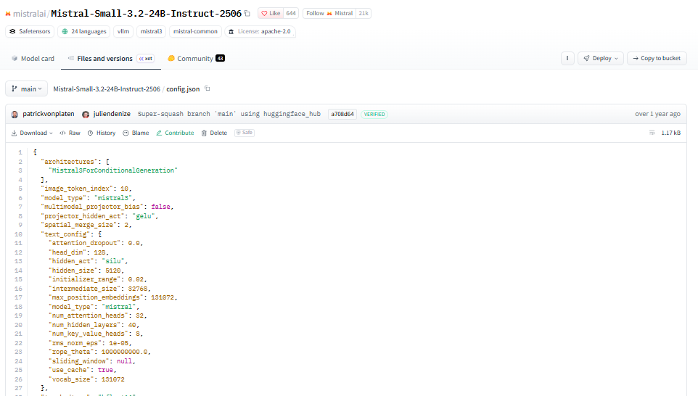
Figure 2: config.json of Mistral-Small-3.2-24B-Instruct-2506 (text_config: 40 layers, 8 KV heads, head_dim 128, sliding_window null).
Quantity | Working | Result
Weights FP16 | 24e9 x 2 bytes | 48.0 GB
Weights 8-bit | 24e9 x 1 byte | 24.0 GB
Weights 4-bit | 24e9 x 0.5 byte (excl. quantisation scales) | 12.0 GB
Longest sequence in agent loop | call 6 input 6,000 + final output 600 | 6,600 tokens
KV cache per sequence (FP16) | 2 x 40 x 8 x 128 x 6,600 x 2 bytes | 1,081,344,000 B = 1.081 GB (160 KiB/token)
GPU chosen | NVIDIA L40S, 48 GB (RunPod, USD 0.79/h) | 48 GB
Usable memory | 48 x (1 - 0.10) | 43.2 GB
Max concurrent sequences (4-bit weights, FP16 KV) | INT((43.2 - 12.0) / 1.081) | 28
Concurrent sessions needed at current peak | 0.371 q/s x T (9 s) | 3.34 -> 4
GPUs required | ROUNDUP(4 / 28) | 1
Decimal GB used throughout. Capacity is memory-bound only, as specified; decode compute may bind earlier on an L40S.

2.5 Break-even
Self-host cost: 1 GPU x USD 0.79 x 720 h = USD 568.80 per month, constant until one GPU's capacity is exceeded. One GPU carries 28 concurrent sequences = 28 / (5 x 0.35 / 7,200 s x 9 s) = 12,800 daily queries; a second GPU is needed above that (step function, USD 1,137.60), and so on.
Comparator: after the architectural change (2.6) neither candidate meets T = 9 s for full completion (Haiku 11.93 s, gpt-oss-120b 10.07 s), so the rule 'use the lower-latency candidate' selects gpt-oss-120b. gpt-oss-120b is faster by about 1.9 s, mainly because Haiku 5.5's measured output speed at low effort (183 tok/s) is below the 265 tok/s reported for gpt-oss-120b (a 'high'-effort listing, so its real low-effort speed could differ). gpt-oss-120b costs USD 107.14 per month at Q = 1,525 (USD 0.0703 per daily query).
Q* = 568.80 / 0.07026 = 8,096 queries/day (5.31 x today's Q). Above 12,800/day the second GPU makes API cheaper again until 16,192/day, after which self-hosting stays cheaper (sustained crossing). If two GPUs are required for availability, the first crossing is 16,192/day.
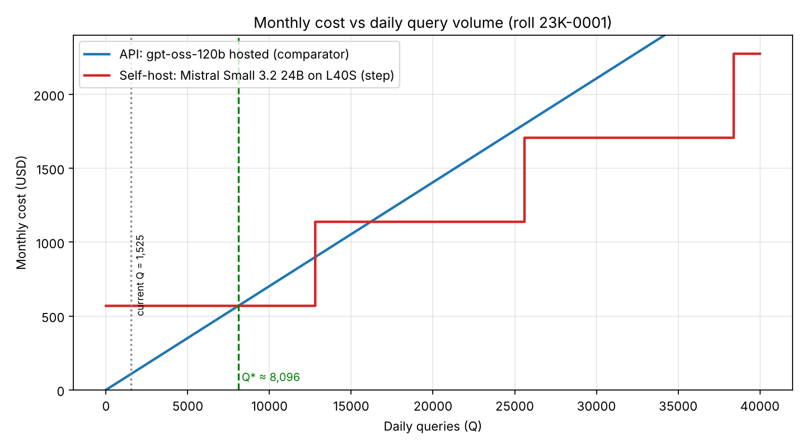
Is Q* realistic? At about 5.3x the current volume it is reachable if SaafHawa succeeds citywide (Karachi's population is far larger than 8,000 daily WhatsApp queries), but at today's 1,525 queries/day the API is 5x cheaper (USD 107 vs 569) and carries none of the operational burden: one GPU is a single point of failure, needs monitoring, patching and on-call, and Mistral Small 3.2 24B is a weaker tool-caller than the hosted candidates. The honest conclusion is that cost alone does not justify self-hosting for an organisation of this size; data-residency or latency control would have to be the reason.

2.6 Latency budget
Model: per call latency = TTFT_k + output_k / throughput, where TTFT_k = TTFT_ref + max(0, input_k - 1,000) / 20,000 tok/s (prefill rate ASSUMED). Tool delay = median tool latency x (N - 1). Expected retry delay = p x sum of latencies of calls 1..N-1 (an invalid tool call is not executed, so only the LLM call repeats). Candidates (the two best verified within-budget options that have speed data): Claude Haiku 5.5 (TTFT 0.59 s, 183 tok/s, measured at effort low with thinking off [S7]) and gpt-oss-120b hosted (TTFT 0.82 s, 265 tok/s, Artificial Analysis).
Median tool latency used: 0.601 s - MEASURED. Pooled median of all 250 timings in timing_log.csv (OpenAQ 50 calls, Open-Meteo 100, heat-index 50, knowledge-base lookup 50; two days, 8 and 9 Nov 2026; both API tools have well over 20 calls on each day). Per-tool medians: OpenAQ 0.880 s, Open-Meteo 0.715 s, heat index about 0.00001 s, KB lookup about 0.0002 s. Because 100 of the 250 timings are local near-instant calls, the pooled median is lower than the median of the two network APIs alone (0.787 s); the pooled median is what the assignment specifies, so it is used as stated.
Component (seconds) | Claude Haiku 5.5 | gpt-oss-120b
BASELINE (6 sequential calls): sum of LLM calls | 17.28 | 14.69
BASELINE tool delays 5 x median (0.601 s) | 3.01 | 3.01
BASELINE expected retry delay | 1.32 | 1.14
BASELINE end-to-end | 21.60 (exceeds T=9) | 18.83 (exceeds T=9)
CHANGE: parallel tools - 3 LLM calls (500/350/600 output tokens) | 10.12 | 8.36
CHANGE: tool delays 2 stages x median | 1.20 | 1.20
CHANGE: expected retry delay | 0.60 | 0.51
AFTER-CHANGE end-to-end (full completion) | 11.93 (exceeds T=9) | 10.07 (exceeds T=9)
After change with streaming: time to first token of final answer | 8.65 (meets T) | 7.81 (meets T)
Architectural change proposed (one): run the independent tools - air quality, weather and knowledge-base lookup - in parallel from a single LLM call, then compute the heat index (which depends on temperature and humidity) in code and answer: 6 LLM calls become 3 (inputs 2,000 / 4,400 / 5,200 tokens), cutting latency from about 21.6 s (Haiku) and 18.8 s (gpt-oss-120b) to about 11.9 s and 10.1 s. Full completion still misses T = 9 s by about 2.9 s and 1.1 s respectively; streaming the final answer brings the first visible answer token to about 8.7 s and 7.8 s, which meets T. A second step that would close the gap for full completion is routing the first (planning) call to a smaller model. These numbers still depend on the assumed prefill rate (20,000 tok/s).

Recommendation to the technical lead
On the evidence gathered: use a hosted API now. At 76,250 queries a month, seven closed or open-weight hosted models cost under USD 500 and the cheapest closed option that fits B with a strong capability index is Claude Haiku 5.5 (about USD 293, or USD 239 with caching), while hosted gpt-oss-120b costs about USD 107. Self-hosting costs USD 569 for a single unredundant GPU and only wins above roughly 8,100 queries a day. The municipal pollution summary should not rely on a single model's recall: compute figures in code from the tool outputs and let the model only phrase them. Several comparison cells are NV and should be filled before a final decision.

Submission checklist
- Parameters page, comparison table, calculations and cost plot: this document.
- Spreadsheet: Q1_Calculations.xlsx.
- Raw timing log: timing_log.csv (250 rows, 8-9 Nov 2026), also pasted in the ToolLog sheet; script: measure_tool_latency.py.
- config.json screenshot: Figure 2 in Section 2.4 (also submitted as config_screenshot.PNG).
- AI-use declaration: AI_Use_Declaration.md.

