Assignment Beta, Question 2: LoRA, QLoRA, DoRA and AdaLoRA for tool calling
Student ID: 23K-0001 | Base model: Qwen2.5-1.5B-Instruct | Hardware: Google Colab free T4 (fp16)

1. Section 1: LoRA theory (W0 is 4096 x 4096, r = 16)
(a) Trainable parameters. LoRA learns dW = BA with B of size 4096 x 16 and A of size 16 x 4096.
- A: 16 x 4096 = 65,536
- B: 4096 x 16 = 65,536
- Total = 2 x 4096 x 16 = 131,072 trainable parameters.
(b) Percentage. W0 has 4096 x 4096 = 16,777,216 parameters, so 131,072 / 16,777,216 = 0.78125 % (equivalently 2r/d = 32/4096).
(c) Why B = 0 and A random. With B = 0, dW = BA = 0, so at step 0 the adapted model is exactly the pretrained model and training starts from the pretrained behaviour. Learning still starts: the gradient with respect to B depends on A, which is non-zero, so B moves on the first step, and A then receives gradient too (its gradient is proportional to B). A is random to break symmetry between the r rank components. If both were zero, both gradients would be zero (each is proportional to the other) and nothing would ever train. If both were random, dW = BA would be a non-zero random matrix on the very first forward pass, injecting noise into every adapted layer, spiking the loss and spending early updates repairing the damage instead of learning the task.
(d) What each variant solves that plain LoRA does not.
- QLoRA (memory). LoRA still holds the frozen base weights in 16-bit, which dominates memory. QLoRA stores the frozen base in 4-bit NF4 (levels placed at quantiles of a normal distribution, which suits roughly Gaussian pretrained weights), adds double quantisation (the quantisation constants are quantised too) and uses paged optimizers (optimizer state is paged between GPU and CPU memory so memory spikes do not cause out-of-memory crashes). The adapters and compute stay in 16-bit.
- DoRA (learning quality at low rank). In LoRA, the magnitude and direction of a weight change are entangled in one low-rank update. DoRA splits each weight into a magnitude vector and a direction matrix, applies LoRA only to the direction and trains the magnitude directly. This behaves more like full fine-tuning and tends to be more accurate and stable at the same rank, at the price of extra training compute.
- AdaLoRA (where rank is spent). LoRA gives every matrix the same rank although some layers need more capacity than others. AdaLoRA writes the update in an SVD-like form with an orthogonality penalty, scores each singular value by importance, and prunes the least important ones under a global rank budget, so rank ends up where it is needed.

2. Experimental setup
All five rows share the same base model, data, seed (42), epochs (2), learning rate (2e-4, cosine schedule, 5% warmup), optimizer (AdamW), target modules (q, k, v, o projections) and effective batch size 16 (2 per step x 8 accumulation; the batch was reduced from 4 x 4 after a GPU out-of-memory error, which does not change the maths). LoRA alpha was 2r throughout. Data: 2,000 examples from glaive-function-calling-v2 (first turn must be a function call, at most 512 tokens): 1,800 for training, 200 held out and never used in training. The model sees a system prompt listing the available functions plus an instruction to reply with one JSON object only, and the loss is computed only on the JSON answer. The untuned base model received exactly the same prompt. Decoding is greedy.
Metrics, all out of 200 test examples: JSON validity (the whole raw output parses with json.loads), tool accuracy (valid JSON with the correct function name), full match (correct function and every argument exactly equal). Peak memory is torch.cuda.max_memory_allocated() over loading plus training. T4 GPUs have no bf16, so everything ran in fp16.

3. Results (r = 8; AdaLoRA starts at 12 and targets 8)
Method | Trainable params | % of model | Peak GPU (GB) | Train (min) | Valid JSON | Tool acc | Full match
Base (no tuning) | 0 | 0 | not measured | 0 | 200 | 200 | 190 (95.0%)
LoRA | 2,179,072 | 0.141% | 7.31 | 10.4 | 200 | 200 | 195 (97.5%)
QLoRA (NF4) | 2,179,072 | 0.141% | 7.77 | 13.5 | 200 | 200 | 196 (98.0%)
DoRA | 2,279,424 | 0.148% | 7.98 | 13.2 | 200 | 200 | 195 (97.5%)
AdaLoRA | 3,270,064 | 0.212% | 7.58 | 13.7 | 200 | 200 | 190 (95.0%)

The AdaLoRA parameter count reflects its starting rank-12 allocation; ranks are pruned towards 8 during training. Percentages use the 1,543,714,304-parameter base model.
Inference time for the 200 test prompts (batch of 8, greedy, single measurement on a shared Colab GPU, so roughly 10% noise):
Method | Unmerged (s) | Merged into base (s)
Base | 68.5 | -
LoRA | 92.6 | 62.5
QLoRA | 137.5 | not merged
DoRA | 144.7 | 61.3
AdaLoRA | 99.6 | not merged

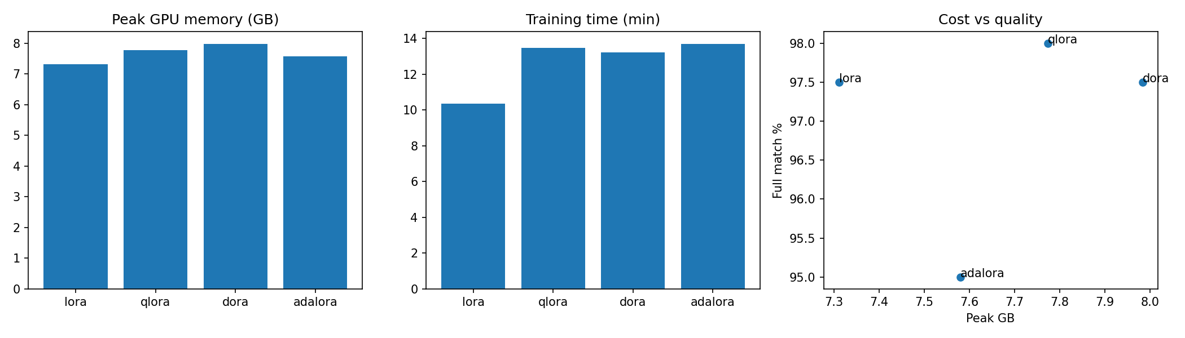
Figure 1: Peak GPU memory, training time, and cost versus quality (r = 8).
With 200 test examples one example is 0.5 percentage points and the sampling error on a score near 98% is about plus or minus 2 points. So LoRA, QLoRA and DoRA (195, 196, 195) are statistically tied, and only the 5 to 6 example gap between them and the base model or AdaLoRA is even suggestive.

4. Section 3: Is a bigger rank better?
QLoRA scored highest by one example (196 versus 195), so it was used for the rank sweep. This is a near-coin-flip choice, not a clear win. The r = 8 point is the same run as in the table above.
Rank | Trainable params | Peak GPU (GB) | Train (min) | Tool acc | Full match
4 | 1,089,536 | 7.757 | 13.3 | 100% | 194
8 | 2,179,072 | 7.774 | 13.5 | 100% | 196
16 | 4,358,144 | 7.814 | 13.1 | 100% | 196
32 | 8,716,288 | 7.891 | 13.1 | 100% | 196

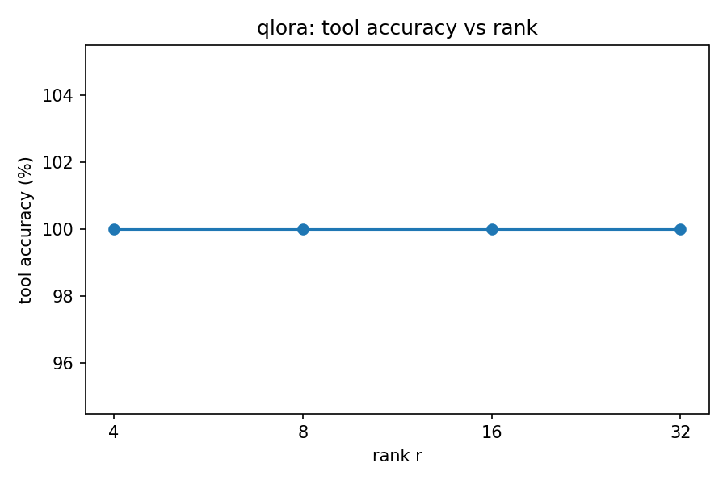
Figure 2: QLoRA tool accuracy versus rank.
Conclusion. The graph is a flat line at 100% tool accuracy for every rank, and full match moves by at most two examples (194 to 196), which is inside the noise. Doubling the rank bought nothing measurable here. It cost very little too: going from r = 4 to r = 32 multiplied trainable parameters by 8 but raised peak memory by only 0.13 GB (about 1.7%) and left training time unchanged, because the frozen base model and the activations dominate memory. So the honest reading is that I am spending slightly more memory for the same result, but the extra spend is tiny. A limit on this conclusion: tool accuracy is already at its ceiling, so this test cannot reveal a benefit of higher rank on a harder task.

5. Report (Section 4)

Your call
If I had to ship one next Monday it would be LoRA with the adapter merged into the base weights. Accuracy: 195 versus 196 for QLoRA is a tie within noise. Memory and training time: LoRA was the cheapest to train (7.31 GB peak, 10.4 minutes against 13 to 14 minutes for the others). Inference speed: merged LoRA served the test set in 62.5 s, about a third faster than unmerged LoRA (92.6 s) and 2.2 times faster than QLoRA (137.5 s), because a merged adapter is just ordinary weights with no extra computation.
The merge behaviour is what separates the methods in production. LoRA and DoRA both merge cleanly (DoRA went from 144.7 s to 61.3 s once merged, so its overhead is a cost of training and of unmerged serving). QLoRA cannot be merged without dequantising the 4-bit base, adding the update and re-quantising, which loses precision; so it is normally served with the adapter alongside the 4-bit base and keeps its dequantisation overhead (137.5 s). DoRA gave no accuracy gain here to justify its extra training cost, and AdaLoRA did not improve on the base model. QLoRA would be my choice only if the serving GPU were too small for a 16-bit model, which is not our situation: its training memory was in fact higher than LoRA's in this experiment.
Caveat: timings are single runs on a shared Colab T4, so the differences between merged LoRA, merged DoRA and the base model (61 to 68 s) are within noise; the large gaps (unmerged versus merged, QLoRA versus merged) are not.

Where it still breaks
The best model (QLoRA, r = 8) got only 4 of 200 test examples wrong, so I can show four rather than five. Each is an argument-level error.
Customer message | Correct call | Model produced | Label
I am looking for movies with Tom Hanks. | search_movies {"keyword": "Tom Hanks"} | search_movies {"actors": ["Tom Hanks"]} | made-up argument
Create a task named Buy groceries due tomorrow. | create_task {"task_name": "Buy groceries", "due_date": "2022-05-15"} | create_task with due_date "2022-12-31" | wrong argument value
Looking for a mystery book by Agatha Christie, published 1934, title forgotten. | search_books with title "", author, genre, published_year | same call but the empty title argument omitted | missing argument
Create an event for my birthday party on the 25th of next month, 7pm to 10pm, at my house. | create_event {"title": "My Birthday Party", "start_time": "2022-05-25T19:00:00", "end_time": "2022-05-25T22:00:00", "location": "My house"} | create_event with title "Birthday Party", times in 2023-04 with a Z suffix and an end time of 23:00 | wrong argument values

Pattern. There are no wrong-tool, broken-JSON or refusal errors at all; every failure is in argument values. Three of the four involve values the message does not determine: relative dates ("tomorrow", "next month") that the reference answer resolves to an arbitrary 2022 date the model cannot know, and an empty-string placeholder that the reference keeps and the model sensibly drops. These are closer to label noise than model mistakes. Only the first (inventing an actors argument instead of using keyword) is a genuine schema error. In an e-commerce setting the equivalent risk would be wrong dates or amounts inside a correct refund or tracking call, so argument validation in the backend is worth more than further tuning.

The agentic angle
In a router, refund and shipping setup, all three agents can share one frozen base model held once in GPU memory, with a small adapter per agent. At r = 8 our adapter has 2.18 million parameters, roughly 4 MB in fp16, against about 3 GB for a full 1.5B model, so three agents cost one base model plus about 12 MB instead of about 9 GB. Training one adapter took about 10 minutes and 7.3 GB on a free T4, where full fine-tuning would not fit. Serving stacks can also keep many adapters resident and route each request to the right one over the same base weights, so a new specialist is an upload rather than a new deployment.
One real risk of swapping adapters while the system is live is a race on which adapter is active. If the active adapter is a piece of shared state on the model object, a request that arrives mid-swap, or an in-flight request when the swap happens, can be served by the wrong or a half-loaded adapter, for example the refund agent's weights answering a shipping question and issuing an unauthorised refund call. Mitigations are per-request adapter selection, immutable versioned adapters, canary rollout, and validating every proposed action against the agent's allowed functions before execution. Adapters are also tied to the exact base model they were trained on, so a base upgrade silently invalidates them.

What surprised me
- The untuned base model was already almost perfect. It produced valid JSON on 200 of 200 outputs and chose the correct function 200 of 200 times. Fine-tuning only moved full match from 190 to 195 or 196, about 2.5 to 3 points. This is partly because the base model got the same strict JSON-only instruction as the tuned models (I did not test it without that instruction) and partly because each glaive prompt lists only a few functions, so tool selection is easy. The benchmark is close to saturated and cannot separate the methods.
- QLoRA used more memory than LoRA (7.77 GB versus 7.31 GB), the opposite of what I expected. My untested guess is that, for a model this small, the 4-bit saving on the weights is offset by the fp32 upcasting that the k-bit preparation step applies to the embedding and normalisation layers, and by activations and the 152k-word vocabulary loss, which dominate at this scale. QLoRA was also slower to train (13.5 versus 10.4 minutes) and to serve.
- LoRA, QLoRA and DoRA behaved almost identically. Their loss curves track each other closely (final logged losses 0.0037, 0.0036 and 0.0036), so 4-bit quantisation and weight decomposition cost nothing and gained nothing on this task.
- AdaLoRA looked broken but may not be. Its logged training loss started at 6.6 and ended at 1.75 while the other methods sat near 0.003, and its test score equalled the base model's (190). PEFT adds an orthogonality penalty to AdaLoRA's loss, which would explain part of the gap, so the numbers are not comparable. I have not shown whether AdaLoRA actually learned much in 226 steps; I treat its result as unresolved rather than as evidence that adaptive rank does not work.

AI-use declaration
I used Claude (Anthropic) to explain the LoRA theory in Section 1, to write the Colab/PEFT notebook code, to debug library errors, and to help structure and draft this report. I ran all experiments myself on Google Colab, and the results tables, rank sweep and failure examples come from my own runs.

