Assignment 3 End to End ML Versioning
Muhammad Haris 23L-0807 MLOps 7-A
In this assignment I built a fully connected ANN for Fashion MNIST and connected the project with Git, DVC, GitHub and Google Drive. The final model achieved 87.72 percent test accuracy, which is above the required 85 percent target.

Part A Git workflow
I initialized the repository on main, created dev for feature work, and kept the history unsquashed. I used the requested log variants, unstaged and staged diffs, two dot and three dot branch comparisons, stash and pop, rebase, soft and hard reset, git mv and git rm. The two dot diff compares branch tips, while the three dot diff shows work introduced since the common merge base.
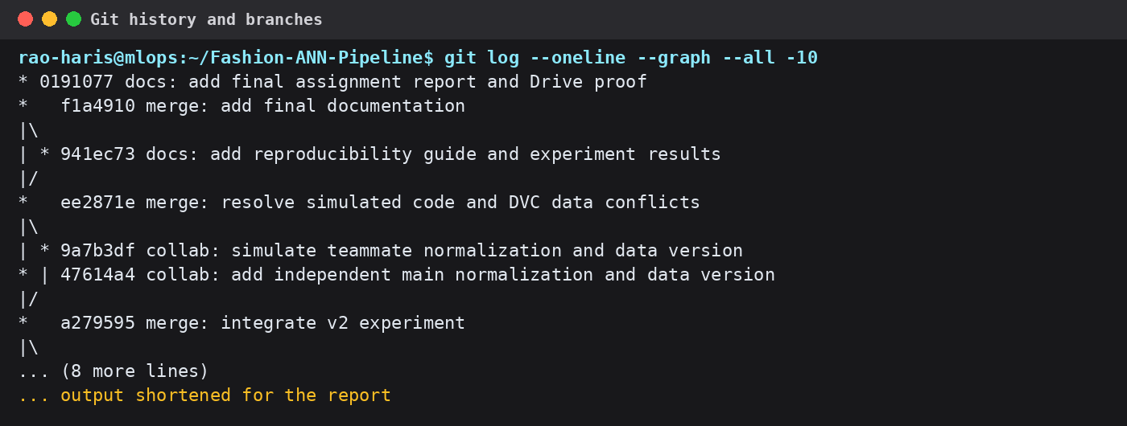
Figure 1 Actual Git graph branches and version tags
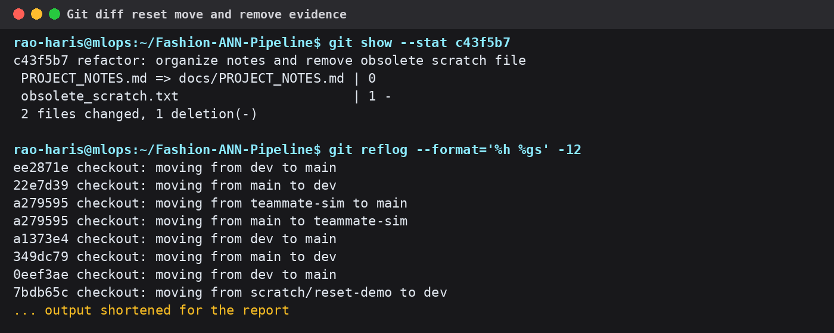
Figure 2 Actual tracked workflow and reset evidence

Part B Modular TensorFlow pipeline
The implementation is divided into prepare.py, preprocess.py, train.py and evaluate.py. The stages load Fashion MNIST, normalize and split the arrays, train a Flatten Dense Dropout Dense ANN, and produce metrics.json with a confusion matrix. Hyperparameters are loaded from params.yaml instead of being hard coded.
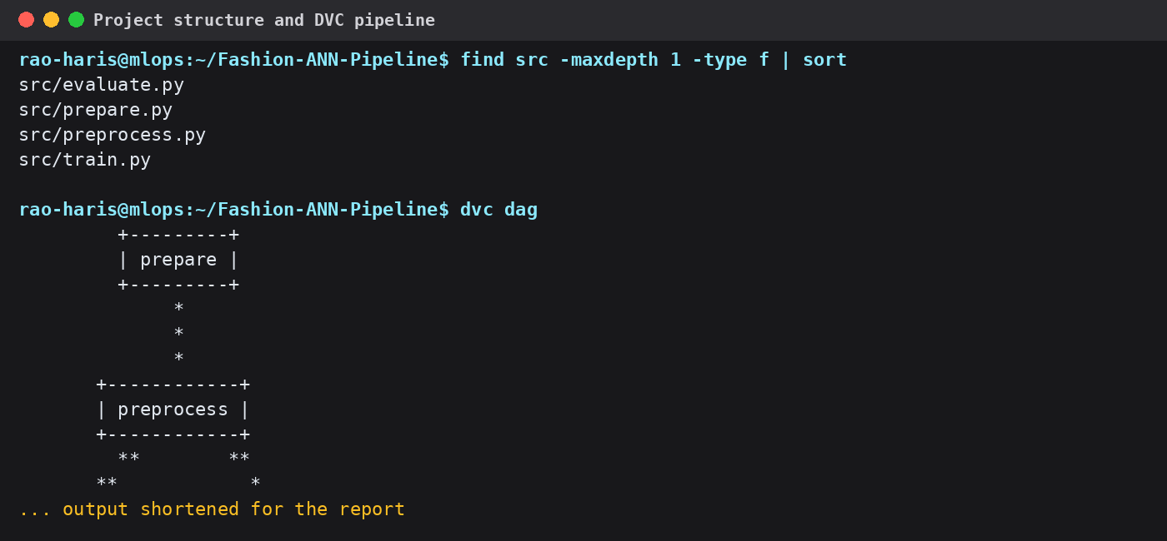
Figure 3 Real project files DVC graph and clean pipeline status

Part C DVC and Google Drive
DVC was initialized after the first Git commit. Raw data, processed data, models and metrics are stored in the DVC cache instead of Git. The default remote points to the supplied Google Drive folder. OAuth files are kept only in ignored local files. The terminal output below confirms that the cache and remote are synchronized.
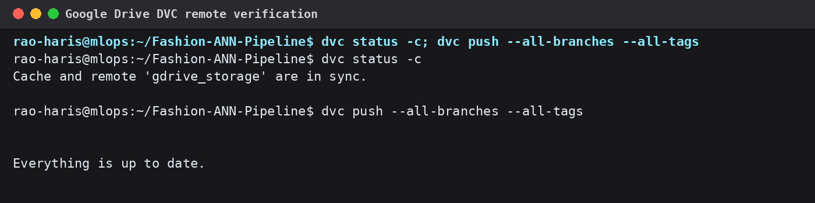
Figure 4 Genuine DVC remote verification output

Part D Reproducible experiments
The dvc.yaml file contains prepare, preprocess, train and evaluate stages. Stage dependencies and parameters are recorded in dvc.lock. The first reproduction executed all four stages. For v2 I changed only dense_units from 128 to 256. Prepare and preprocess were skipped because their inputs did not change; train reran and evaluate reran because it depends on the trained model.
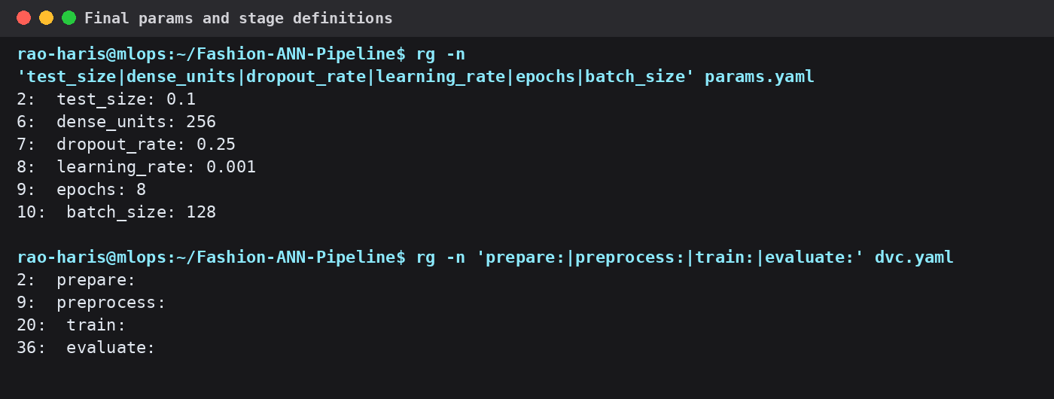
Figure 5 Final params and four DVC stage definitions
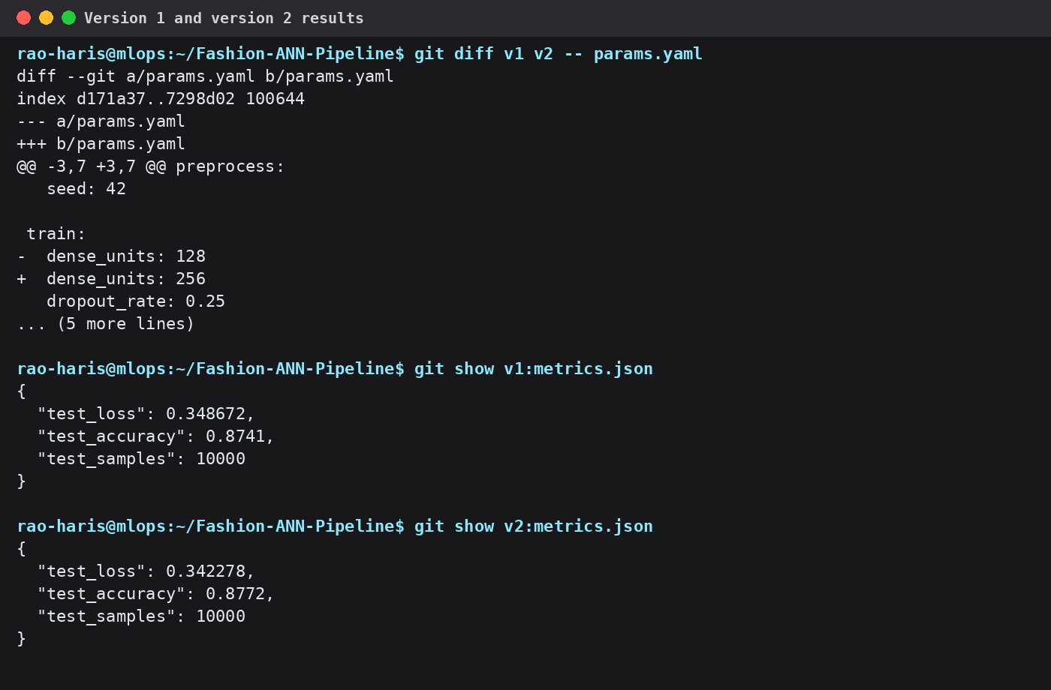
Figure 6 Actual parameter diff and metrics stored in Git
Version | Dense units | Test loss | Test accuracy
v1 | 128 | 0.348672 | 87.41%
v2 | 256 | 0.342278 | 87.72%
Table 1 v1 and v2 comparison

Part E Conflict and resolution
I simulated collaboration with main and teammate-sim. Both branches changed the same normalization function and regenerated overlapping DVC outputs. The merge therefore produced a source conflict and different hashes in dvc.lock and metrics.json. The merge-tree command below reconstructs those conflicts directly from the real branch commits without changing the final clean working tree.
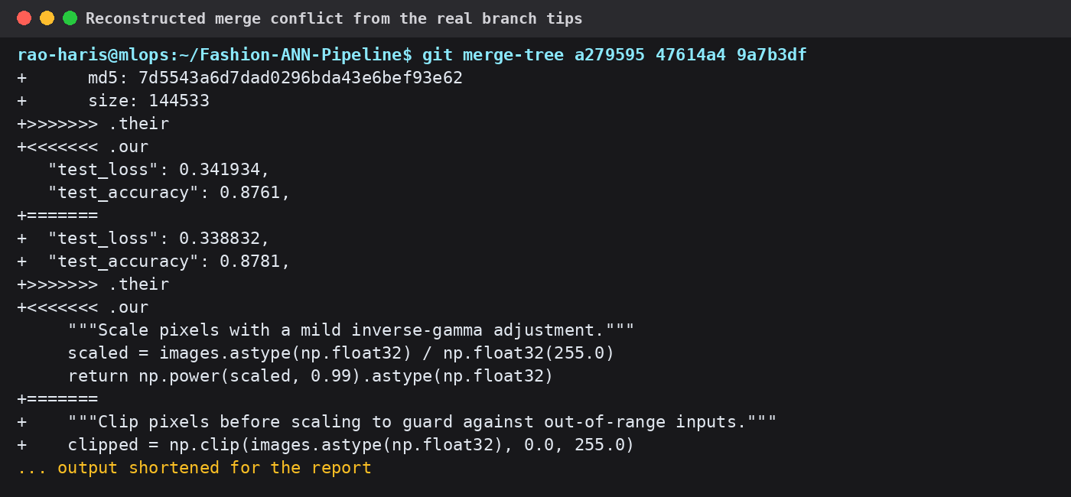
Figure 7 Actual code data and metric conflict markers
I resolved the source by combining clipping with explicit float32 division and range validation. I then regenerated the authoritative DVC state instead of keeping a stale branch hash. The final merge commit records the resolution, dvc status is clean, and all DVC objects have been pushed.
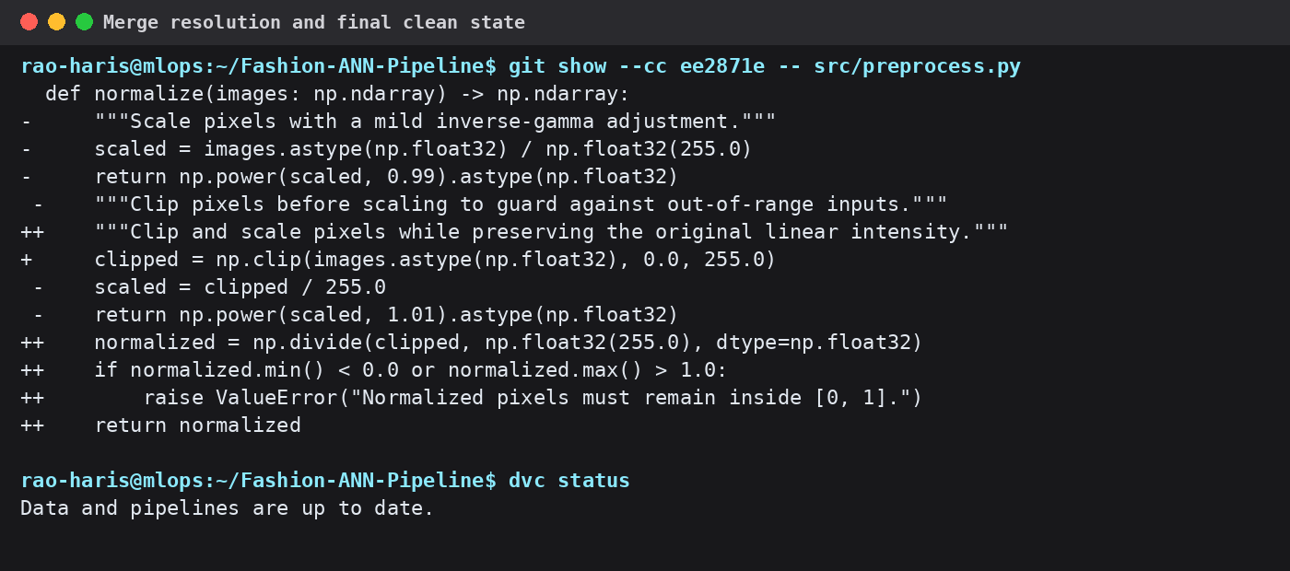
Figure 8 Actual combined diff and clean DVC status

Submission links
GitHub repository https://github.com/RaoHaris535/Fashion-ANN-Pipeline
Google Drive remote https://drive.google.com/drive/folders/1iyOk52bAA4H6i9_KrBaXYRkjCInOuMYg
Final result The repository is pushed, v1 and v2 are tagged, dvc.lock is committed, and the local pipeline and Google Drive remote are synchronized.

