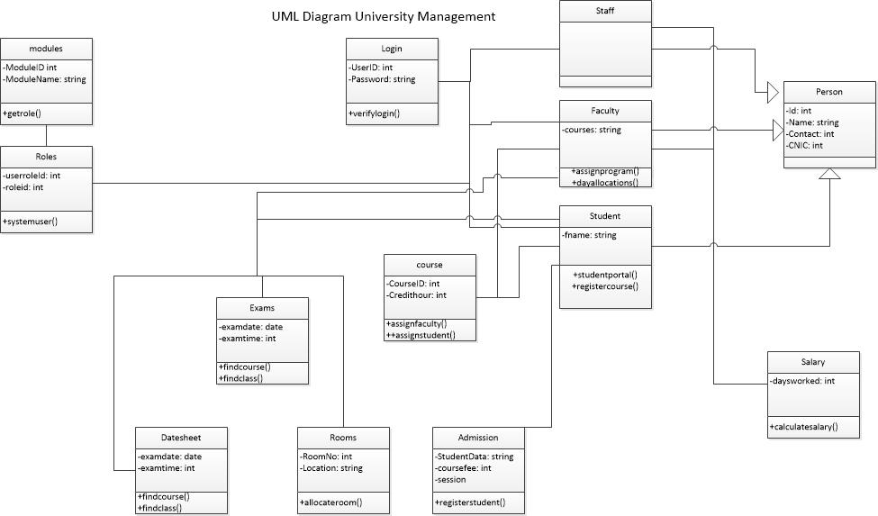Once the application gets started. It will give us a view of main page which will have the options of Module and select your role. If you are a faculty member, it will ask you to enter you details via form and those details will create your login in the database, upon using the login detail you get registered with, you would be able to see your salary and fetch your classes’ schedule. If you’re an existing student you have to login using your login details. After that it will show you student dashboard where you would able to see your transcript, Marks, Rooms assigned for lectures. If you’re a data administrator. After login you would be able to enroll faculty, schedule Classrooms for lecture and date sheet for examinations. The administrator will also be able to add the salary details of faculty and other staff. In admission section, new incoming student will fill up the form, after the form ends up. The system will assign him an id once he will press the submit button. The new applicant would also be able to check the application status and details given in it.

Database is connected using Mysql and every process is stored and search and retrived in database using sql queries the screen shots of database has been uploaded on this site.

The UMS will be used by the following users:

1. Prospective students
2. Enrolled students
3. Faculty members

The UMS will feature the following departments:

1. Admissions
2. Accounts
3. Examinations
4. Class Scheduling

It will allow the users do the following activities:

PROSPECTIVE STUDENTS:

1. Fill out admission forms
2. Enroll in a program

CURRENT STUDENTS:

1. Enroll in classes
2. View Class Schedule
3. Pay Fee
4. View grades

FACULTY MEMBERS:

1. Approve admission applications
2. View class schedules
3. View Salary information
4. Assign grades to students

**PROBLEM STATEMENT**

The current management system in UMT is dysfunctional. It does not allow prospective students to fill out an online application form, view admission status, etc. Moreover, the system is often down during period of heavy usage: course registration, etc. It does not completely automate all functions.

**PROPOSED SOLUTION**

Our goal with this project is to completely revamp the existing system. We aim to build a sound University Management System using C Sharp and employ principles of Object Oriented Programming.

The UMS will be developed by a team of following programmers:

|  |  |  |
| --- | --- | --- |
| **Sr.** | **Programmer** | **Department** |
| 1 | Mr. Shakeel-ur-Rehman | Admissions |
| 2 | Mr. Amir Qureshi | Accounts |
| 3 | Mr. Hassan Kaleem | Examinations |
| 4 | Mr. Haseeb Ahsen Malik | Schools-Class Scheduling |

All of the above will work jointly to develop the main menu, user interface and work on the Main class.