**Software & Construction Development**

**Assignment # 01**

**Application Name: Quantiles Calculator**

**Name: Muhammad Faizan**

**ID: 20K-0366**

**Submission Date: 10 Sep 2022**

**About:**

The **Quantiles Calculator** can calculate the five-number summary of the numerical dataset, which includes minimum, maximum, Quantile 1, Quantile 2, Quantile 3, and Inter-Quantile-Range.

**How to use the Application:**

1. Open the application and enter the dataset in which numbers should be separated with white spaces.

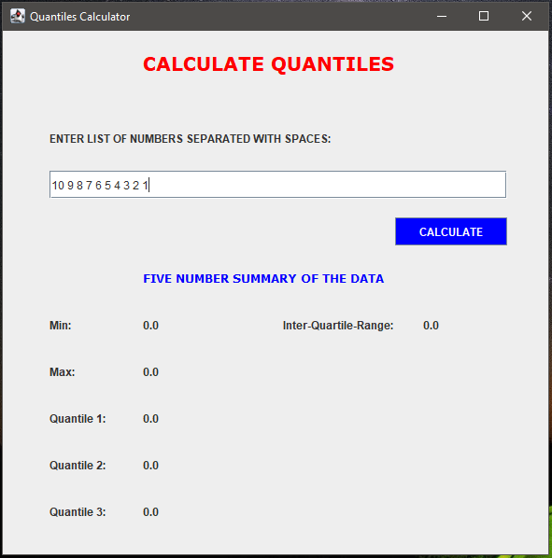

1. Then, enter the “Calculate” Button in order to calculate the summary of the data.

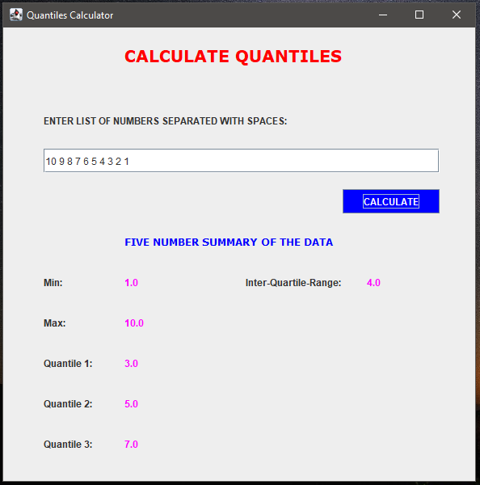

1. You can reset the text field by erasing all the text using backspaces and then pressing calculate.

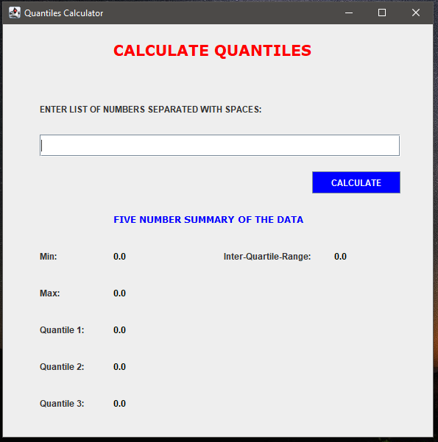

1. Also, you will not be able to enter the alphabet and special characters, if you do then the text field will be disabled. So, this is the error preventive technique.

