Rao Tariq Jameel
CLOUD SECURITY ENGINEER (ASPIRANT)

BERUFSERFAHRUNG
- IT Manager – Rizq Group of Colleges, Multan
- 6+ years Linux and Networking self-study experience
- Experienced with GitHub-based technical documentation
- Focused on Zero Trust, Network Defense, and Cloud Security
- Knowledge in Linux administration and system hardening

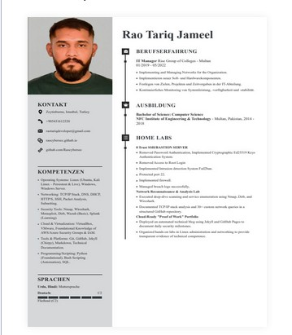

KONTAKT
- Luleburgaz, Turkey
■ +90 543 161 2520
✉■ raotariqdeveloper@gmail.com
- github.com/Raocybersec
- raocybersec.github.io

KOMPETENZEN
- Operating Systems: Linux (Ubuntu, Kali), Windows, Windows Server
- Networking: TCP/IP, DNS, DHCP, HTTP/S, SSH, Packet Analysis
- Security Tools: Nmap, Wireshark, Metasploit, Dirb, Wazuh, Splunk
- Cloud & Virtualization: AWS/Azure Basics, VMware, VirtualBox
- Programming/Scripting: Python, Bash, SQL

SPRACHEN
English – Professional Turkish – Fluent Hindi/Urdu – Native

AUSBILDUNG

Bachelor of Science: Computer Science
NFC Institute of Engineering & Technology – Multan, Pakistan Graduation Year: 2018
Dean’s List Honors | Programming Contest Champion

HOME LABS

Zero Trust Bastion Server
- Removed password authentication and implemented Ed25519 keys
- Disabled root login and secured SSH access
- Configured firewall and Fail2ban intrusion detection

Network Recon & Analysis Lab
- Performed packet analysis and TCP/IP testing using Nmap, Dirb, and Wireshark
- Documented 30+ custom network queries in GitHub repository

Cloud-Ready “Proof of Work” Portfolio
- Developed automated security blog using Jekyll and GitHub Pages
- Organized Linux administration and networking labs

