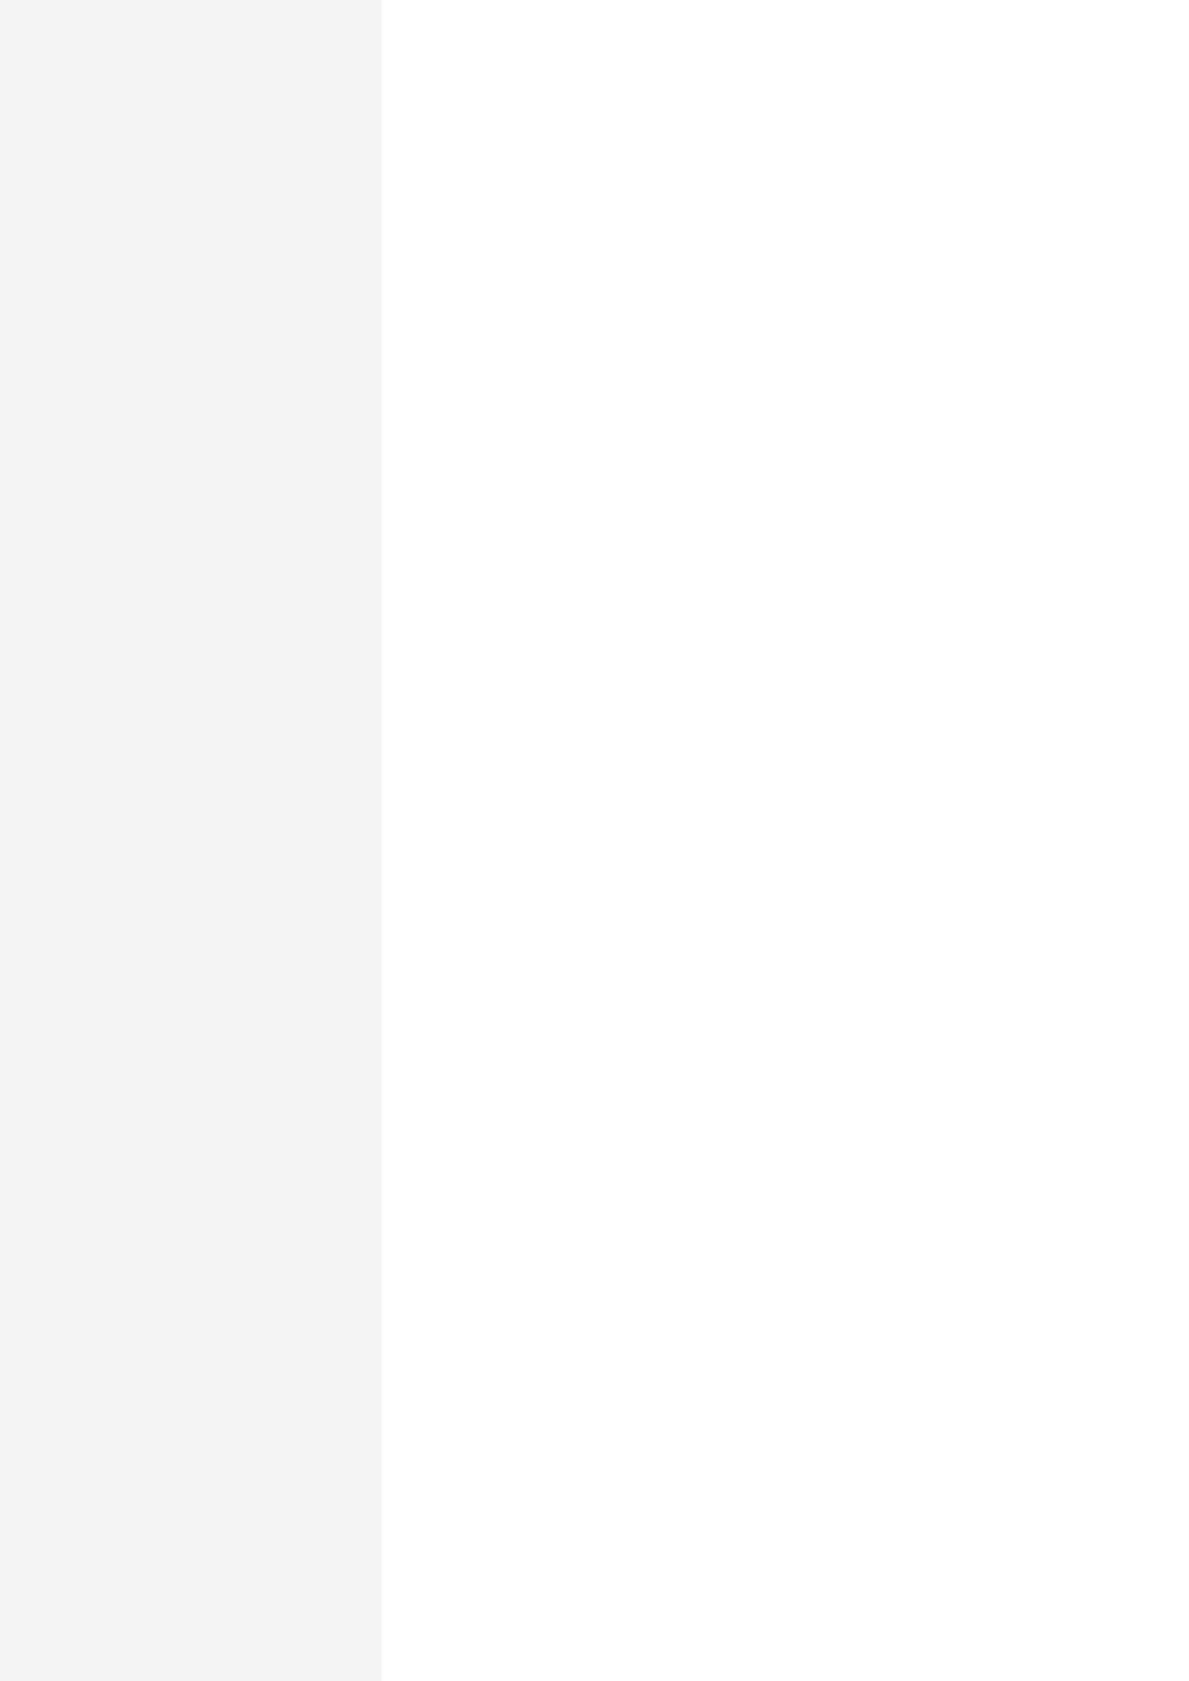

First Name Last Name
Date of birth: 11/10/1929 Nationality: Indian Gender: Male

CONTACT
Addreess Line 1, Address line 2 Postal Code City, India (Work)
example@gmail.com (+91) 1111111111
https://www.linkedinid.com 9999999999 (Skype)

ABOUT ME
Dedicated and highly skilled Civil Engineer with a strong background in infrastructure design, project management, and construction supervision. Seeking a challenging position to utilize my technical expertise, leadership abilities, and innovative problem-solving skills in contributing to the successful completion of engineering projects.

WORK EXPERIENCE
01/01/2023 – 01/01/2024 City, India
Occupation or position held Employer
- Lead a team of engineers in the design and analysis of structural components for commercial and residential projects.
- Conduct feasibility studies, site investigations, and environmental impact assessments for proposed projects.
- Collaborate with architects, contractors, and clients to ensure project requirements are met within budget and time constraints.
- Implement and maintain quality control measures to ensure the integrity and safety of construction projects

01/01/2022 – 01/01/2023 City, India
Occupation or position held Employer
- Assisted in the planning and design of infrastructure projects, including roads, bridges, and drainage systems.
- Prepared detailed engineering drawings using AutoCAD and Civil 3D software.
- Conducted on-site inspections to monitor construction progress and ensure compliance with design speciﬁcations.
- Contributed to the development of project budgets and timelines.

DIGITAL SKILLS
skill1 skill 2 skill 3 skill 4 skill 5 skill 6 skill 7 skill 8 skill 9 skill 10

EDUCATION AND TRAINING
01/01/2012 – 01/01/2016 City, India
Title of qualiﬁcation awarde Organisation providing education and training

LANGUAGE SKILLS
MOTHER TONGUE(S): Malayalam
Other language(s):
English

Listening C2 Spoken production B2
Reading C2 Spoken interaction C1
Writing C1

Hindi

Listening A1 Spoken production B1
Reading B1 Spoken interaction B1
Writing C2

Levels: A1 and A2: Basic user; B1 and B2: Independent user; C1 and C2: Proﬁcient user
Are you looking professional resume writers
Elite Resumes : you can connect with us
WhatsApp : +91 9995613126
Email : Support@eliteresumes.in


