A framework for creating dialogues inspired by Skyrim’s Creation Kit.

About:

This framework is designed for games where NPCs conversations can change dynamically. Dialogue is structured around reusable branches that become available when specific conditions are met. Creating new conditions is simple, making it easy to expand the system for complex, reactive interactions.
The system uses Godot Resources as modular data assets representing dialogue components. These resources can be saved as individual files, making it easy to reuse them elsewhere. Because these dialogue pieces are regular Godot resources, you can create, edit, and assign them to NPCs just like any other resource in your project.

To use these resources, add the “Dialogue Component” node to anything you want to be able to “talk” (NPCs, signs, etc.). This node has a start() function that can be called to trigger the attached “Dialogue Tree.”

Currently, there is no custom visual editor, but you can use Godot’s default inspector to edit dialogue. Editing large trees can be overwhelming, but you can work on branches individually and then drag and drop them into your tree.

Technical Structure:

Custom Nodes:
Global: Handles signals, global variables and functions. Must be added as an autoload named “Global”
Dialogue: Manages triggering and displaying dialogue through dialogue boxes. Must be added as an autoload named “Dialogue”
Dialogue Component: You can attach your Dialogue Tree to this node. It has a start() function that displays the contents of the Dialogue Tree.

Resource Types:
  - CharacterID: Holds character metadata (name, portrait, faction, etc.) and is used to identify and sync character-related actions like animations.
  - DialogueResponse: Represents a single line of dialogue, containing text, linked CharacterID, and parameters like idle animation or facial emotion.
  - DialogueTopic: A selectable dialogue option containing a label, an array of DialogueResponses, optional next DialogueBranch, and flags (say once, goodbye, random). Includes arrays of Conditions and Functions to govern availability and trigger effects.
  - DialogueBranch: Groups together DialogueTopics in an array.
  - DialogueTree: Assigned to Dialogue Component node, it can hold multiple DialogueBranches and a Greeting(DialogueResponse) to start conversations.
  - Function: Modular logic resources with a run() method, used to apply effects or changes when a topic is triggered. Extensible by creating new inherited resources.
  - Condition: Modular logic resources with a check() method returning a boolean, used to determine if dialogue topics are available based on game state or variables.

Getting Started:

1. Add the Autoloads
First, add the Global and Dialogue scripts as Autoloads in the Project Settings and enable them.
These are required for handling global signals and dialogue UI logic.
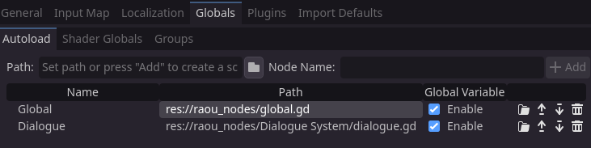

2. Add the Dialogue Component
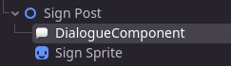

Add the Dialogue Component node to any object you want to be able to "talk" (NPCs, signs, etc.).
In the Dialogue Component, you’ll see a field to attach or create a new Dialogue Tree. If you already created one, you can just load it using Godot’s “Quick Load” or “Load” options in the resource picker(the arrow pointing down).
Alternatively, you can create a local Tree just for this object by clicking the “New Dialogue Tree”
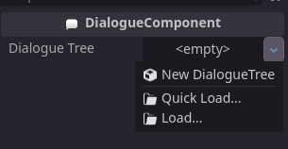

3. Add a Greeting
A Greeting is the first message shown to the player when they start a conversation. It’s a DialogueResponse, and you only need to fill in the response text — the other fields are optional.
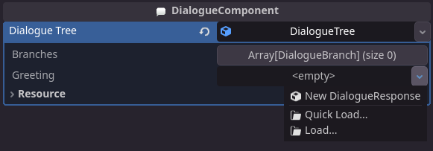
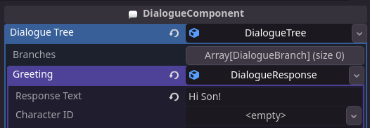
A Greeting is the first message shown/said to the player once they initiate the Dialogue.(You only need to fill the Response Text, all other fields are optional)

You can create signs, for example, by just filling the “Greeting” and leaving the “Branches” array empty.

4)Now that you have a Greeting set up. You can trigger the dialogue by calling the start() function from the Dialogue Component.
In my example, I attached a timer to the Dialogue Component and told it to run “start” at timeout.
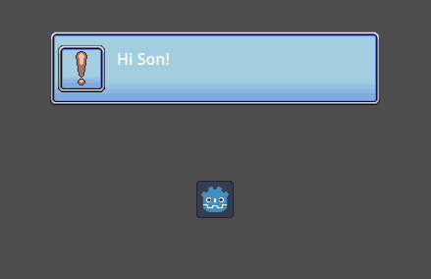

However, how you’ll call that its entirely up to you and how your game works(a mouse button click, a key press, etc)

You can attach multiple Dialogue Branches to the “Branches” array, and the game will display them if the conditions are met.
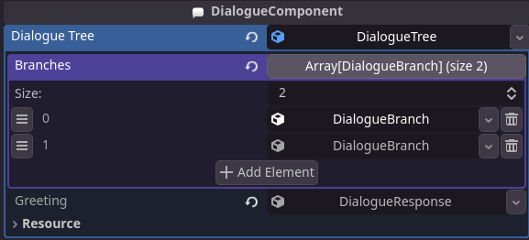

Tip: For better organization, you can give each resource its unique name by editing the “name” field in the “resource” section of each resource.

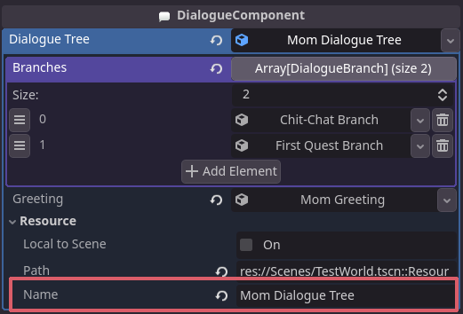

The system is made of 7 types of resources:

Resource 1:
CharacterID: This is a resource that can hold a variety of info about a character. Right now it only holds the name, but it can be expanded to hold information like: how much this character likes the player, their faction, their name, a character portrait, maybe a custom colour for their dialogue box, etc.
The point is that this is a resource that can be attached to a character and holds information about them, so its easy to access this information anytime its needed. You can, for example, pass an ID as a signal parameter using a method from an AnimationPlayer function, and then each character will compare their own ID to the one being signalled, if the IDs match, they can perform the desired animation.

Resource 2:
Dialogue Response: Those are the individual lines a character will say. In this resource you can set:
Text: the text the character will say
CharacterID: you can set a specific “characterID” for this. If you do, you can pass the following parameters that any entity that has that characterID attached to them will follow:
IdleAnimation: The animation the character set above will perform as they say the line
Since this is passed through a signal, you can easily add new parameters to pass like:
Emotion: Similar to the above, but controls only the facial expression(This is not implemented though, as the details heavily depends on how the project handles facial animation.)

Resource 3:
Dialogue Topic: This is the “topic” of a specific series of responses. It also functions as dialogue options(the player can pick a “topic” to talk about, and the NPC will respond with a series of “responses”).
It has:
Text: Whats gonna be displayed as a dialogue option for the player to pick
Responses: An typed array of DialogueResponses. Once a topic has started, it’ll go through every single response here.
Next Branch: You can choose a new Dialogue Branch to start once this topic is through.
Flags:
Say Once: This topic can only be triggered once per game
Goodbye: Once this topic is through, the dialogue box is closed.
Random: Instead of going through the Responses Array in a linear way, it’ll pick a random one from the array and display that instead.

Functions: Array of functions to run when this topic is triggered.
Conditions: Array of conditions to check to see if this topic is displayed.

Resource 4:
Dialogue Branch: Holds reference to an array of Topics.
Resource 5:
Dialogue Tree: Its what you assign to the “Dialogue Component” and holds the information of the entitys dialogue. It holds a reference fo an array of Dialogue Branches and a Greeting(the first message to be displayed, it uses a DialogueResponse resource).

Resource 6:
Function: functions are also custom Resources that have a “run” function. Each function you need must be created as a new Resource that inherits from the “Function” resource, and you must overwrite the “run” function. For example:
“Var Setter” function is a new resource called “Variable Setter”, when it runs it sets a value to the specified variable. Since it inherits from “Function”, it can be attached to the “Function” array from the Dialogue Topic and will run automatically.

Resource 7:
Condition: Similar to the “Functions”, but instead of a method(“run)” that returns a void, its a method(check) that returns a bool, each type of condition has its own method of checking if its true, but they’ll always run then “DialogueTopic” check the conditions and will either return true or false

Dialogue System Overview:

- Design Philosophy:
Inspired by Skyrim’s Creation Kit dialogue system, it emphasizes modularity, extensibility, and data-driven design. Logic is tightly integrated via reusable Condition and Function resources without hardcoded behavior, enabling flexible content creation.
- Runtime Behavior:
- When a conversation starts, the player first sees a Greeting, which is a single DialogueResponse set in the DialogueTree.
- The player is then presented with a list of available DialogueTopics drawn from the current DialogueBranch. Topics are filtered by evaluating their associated Conditions.
- If no branch is assigned or no topics are available due to unmet conditions, only the Greeting is shown and no topic options appear.
- When the player selects a DialogueTopic, its associated DialogueResponses are displayed in sequence.
- After all responses have been shown, one of three things happens depending on the topic’s flags and configuration:
  - The dialogue returns to the start, showing the Greeting and available topics again.
  - The conversation ends if the topic has the “Goodbye” flag set.
  - The dialogue transitions to another DialogueBranch if the topic specifies a next branch, showing a new set of topics.

- Additional Details:
Custom AnimationPlayer-derived node is used to handle dialogue interruptions and per-character animation triggers, circumventing Godot’s default AnimationPlayer pause behavior.

