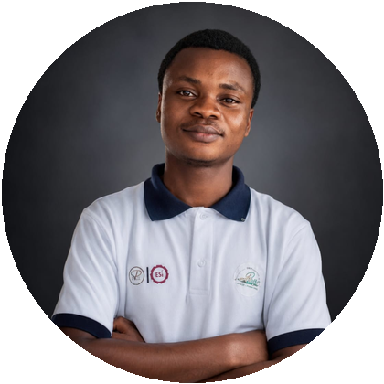 | KOFFI N'GUESSAN RAOUL  Higher Technician in Electronics, IT and Telecommunications · TS EIT 3 · INP-HB  +225 07 79 55 30 55 | nguessan.koffi24@inphb.ci | linkedin.com/in/n-guessan-raoul | potfolio-three-brown.vercel.app | 05 85 72 24 72

PROFILE
TS EIT 3 student at INP-HB (2026–2027), developing applications and digital, IoT and systems solutions. Also interested in AI and network administration.
PROFESSIONAL EXPERIENCE
SOUTARAH GROUP · Computer networks and systems intern · Aug 3–Oct 2, 2026 Studied, designed and deployed a wired, Wi-Fi and server infrastructure: Ethernet deployment, cabling, equipment and server configuration, interconnection and testing.
MANDIGO SARL · Introductory web development internship · Bouaké · Jul–Aug 2025
JPH ÉLECTRONIQUE · Final-year electronic maintenance internship · Bouaké · Dec 2023–Jan 2024
EDUCATION & CERTIFICATIONS
2026–2027 Third-year TS EIT · 2025–2026: second year, Higher Technician programme · 2024–2025: common core in Information and Communication Technologies · INP-HB.
Earlier qualifications Electronics Technician Certificate, EPCT Bouaké (regional laureate), 2023–2024 · BEPC, 2019–2020.
Training 3D Design & Printing, FabLab Solidaire / Orange Digital Center (Nov 2–4, 2026) · Cisco Networking Academy: cybersecurity, IT Customer Support Basics, IoT · Campus Citoyen (2025).
SKILLS
Development HTML, CSS, JavaScript, PHP, React.js, Angular, Node.js, Express.js, Python, Django, Java.
Data & mobile MySQL, PostgreSQL, MongoDB · Flutter (hands-on practice).
Systems & networks Linux, Ubuntu, Kali Linux, Ubuntu Server, Windows Server · systems configuration and administration · computer networks.
Electronics & tools ESP32, Arduino, C++, IoT, Proteus, Bootstrap.
Currently studying Hadoop / MapReduce · Electrical AutoCAD.
SELECTED PROJECTS
SmartEnergy · Complete IoT electricity-consumption monitoring · React.js, Node.js, Express, ESP32.
GeoGuard · In progress Satellite imagery analysis, change detection and alerts.
IA_Imprim / IntelImprim · In progress AI-assisted grading application.
FleetPro · In progress Fleet, driver, assignment and preventive maintenance management.
Supermarket · Complete Product, sales, inventory and customer management · PHP, PostgreSQL, JavaScript.
Robot simulator · Prototype 2D robotic-arm simulation and kinematics.
Other projects Boutique-Rose / OURYA, Bolikro Chez Wolf and Soutarah vehicle catalogue (complete) · IvoireDomi (in progress).

