Java : Object Oriented Programming Language

Why you need to learn Java?:
1. Top 3 most popular languages.
2. Extremely flexible(business enterprises, web apps, android apps, games).

Basics ::
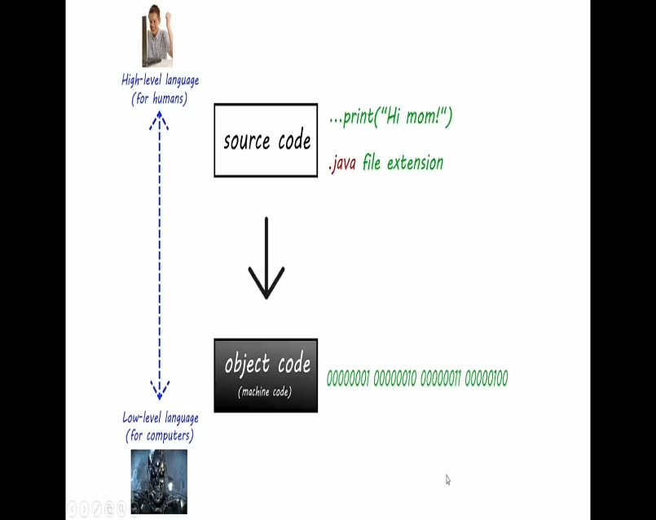
High-level language :human understandable language.
Low-level language :machine understandable language. (Binary language)

Java : Compiled language
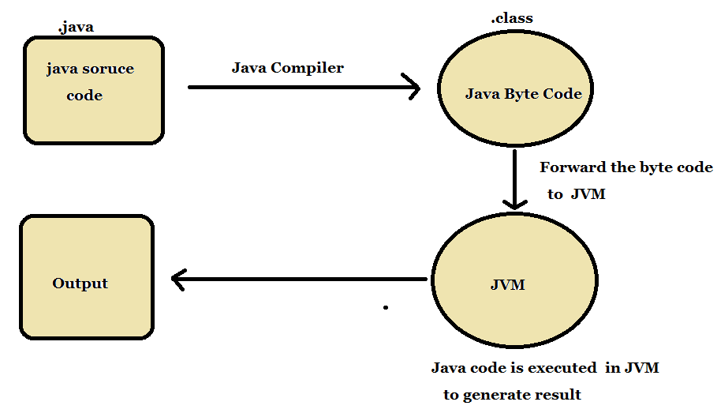
Why? ; In order for the Java Virtual Machine to understand the Java code (.java file), it must first be compiled into an intermediate format called bytecode (.class file) (JVM).
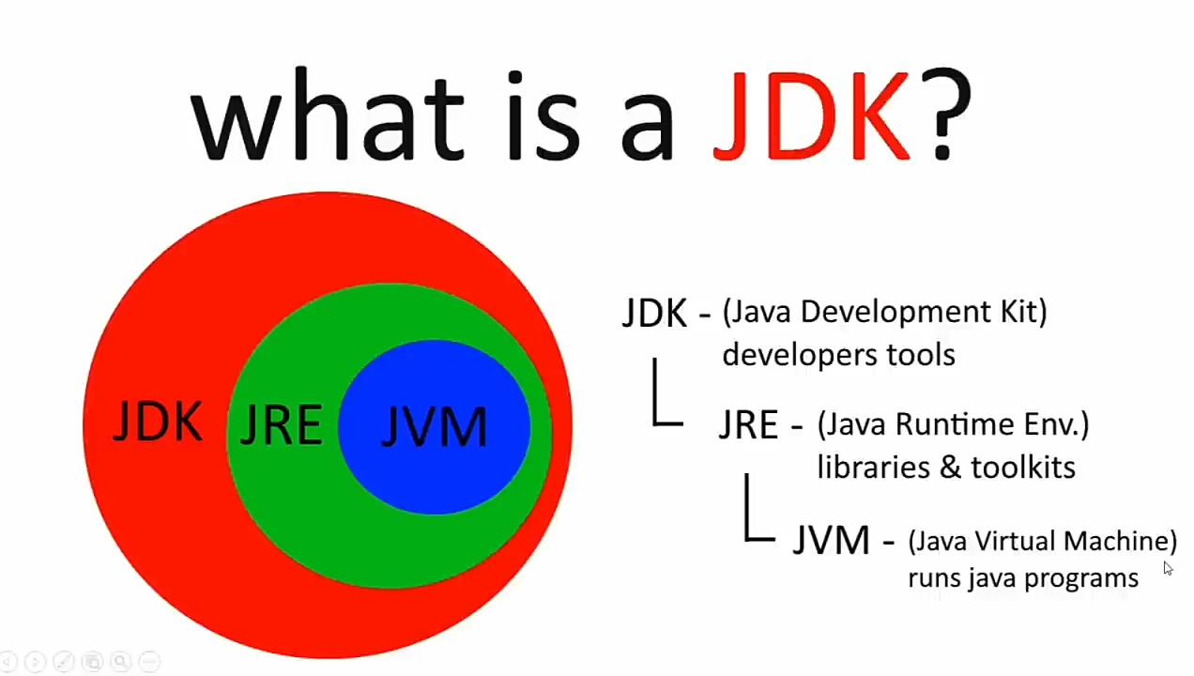
WORA (Write Once Run Anywhere):
Java applications are called WORA (Write Once Run Anywhere). This means a programmer can develop Java code on one system and can expect it to run on any other Java-enabled system without any adjustment. This is all possible because of JVM

