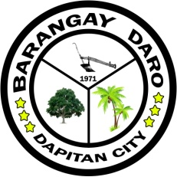

Republic of the Philippines
Province of Zamboanga del Norte
Barangay Daro
City of Dapitan

OFFICE OF THE PUNONG BARANGAY

Barangay Certification

TO WHOM IT MAY CONCERN:

THIS IS TO CERTIFY THAT _{{full_name}}, of legal age, married and a bona-fide resident of {{address}}. She is Biological Mother of her son Mr. Porceso L. Colot Jr.

It certifies further they belong to the indigent families in this barangay.

This certification is issued upon the request of the above name person who is in need financial assistance in your good office.

Issued this {{issued_date_long}} at Barangay Daro, Dapitan City.

DIOSDADA T. SANGUAL
Punong Barangay

