Architecture Design
for
DegreeOverview
Version 1.0 approved
Prepared by Bohui WU, Xuan WANG, Fuhao RUAN, Yu WU
Lily
04/14/2021
Table of Contents
Table of Contents ii
Revision History ii
1. Overview 1
1.1 Project description 1
1.2 References 1
1.3 Design purpose 1
2. Overall description 2
2.1 Use case diagram and class diagram 2
2.2 Design model 3
2.3 System architecture 3
3. System architecture 5
3.1 Course Information Subsystem 5
3.1.1 Description 6
3.1.2 Database 6
3.2 Search Subsystem 7
3.2.1 Description 7
3.2.2 Database 7
3.3 Outcome Dependency Visualization Subsystem 7
3.3.1 Description 8
3.3.2 Database 8
3.4 Performance Report Subsystem 8
3.4.1 Description 9
3.4.2 Database 10
3.5 User Subsystem 10
3.5.1 Description 12
3.5.2 Database 12
3.6 Analysis Subsystem 12
3.6.1 Description 13
3.6.2 Database 13
4. Assessment 13
4.1 Stability 13
4.2 Reusability 14
4.3 Scalability 14
5. Alternative design (optional) 15
6. More considerations 15
7. Appendix 15

Revision History
Name | Date | Reason For Changes | Version
Bohui WU, Xuan WANG, Fuhao RUAN, Yu WU | 04/21/2021 | The first version of the document. | 1.0

Overview

Project description
DegreeOverview is a course definition system that aims to help course designers better plan and design university courses and enables both the lecturers and students to understand and visualize the relationships between courses and their intended learning outcome.

References
Software Requirement Specification for DegressOverview v1.4 by Lily.

Design purpose
This document aims to introduce the overall structure of the system and divide the system into several manageable subsystems. Each subsystem is expected to function with little dependency on other subsystems so the developers can work concurrently and almost independently on the project. Additionally, a change in the subsystem should have little effect on other subsystems.

Overall description

Use case diagram and class diagram

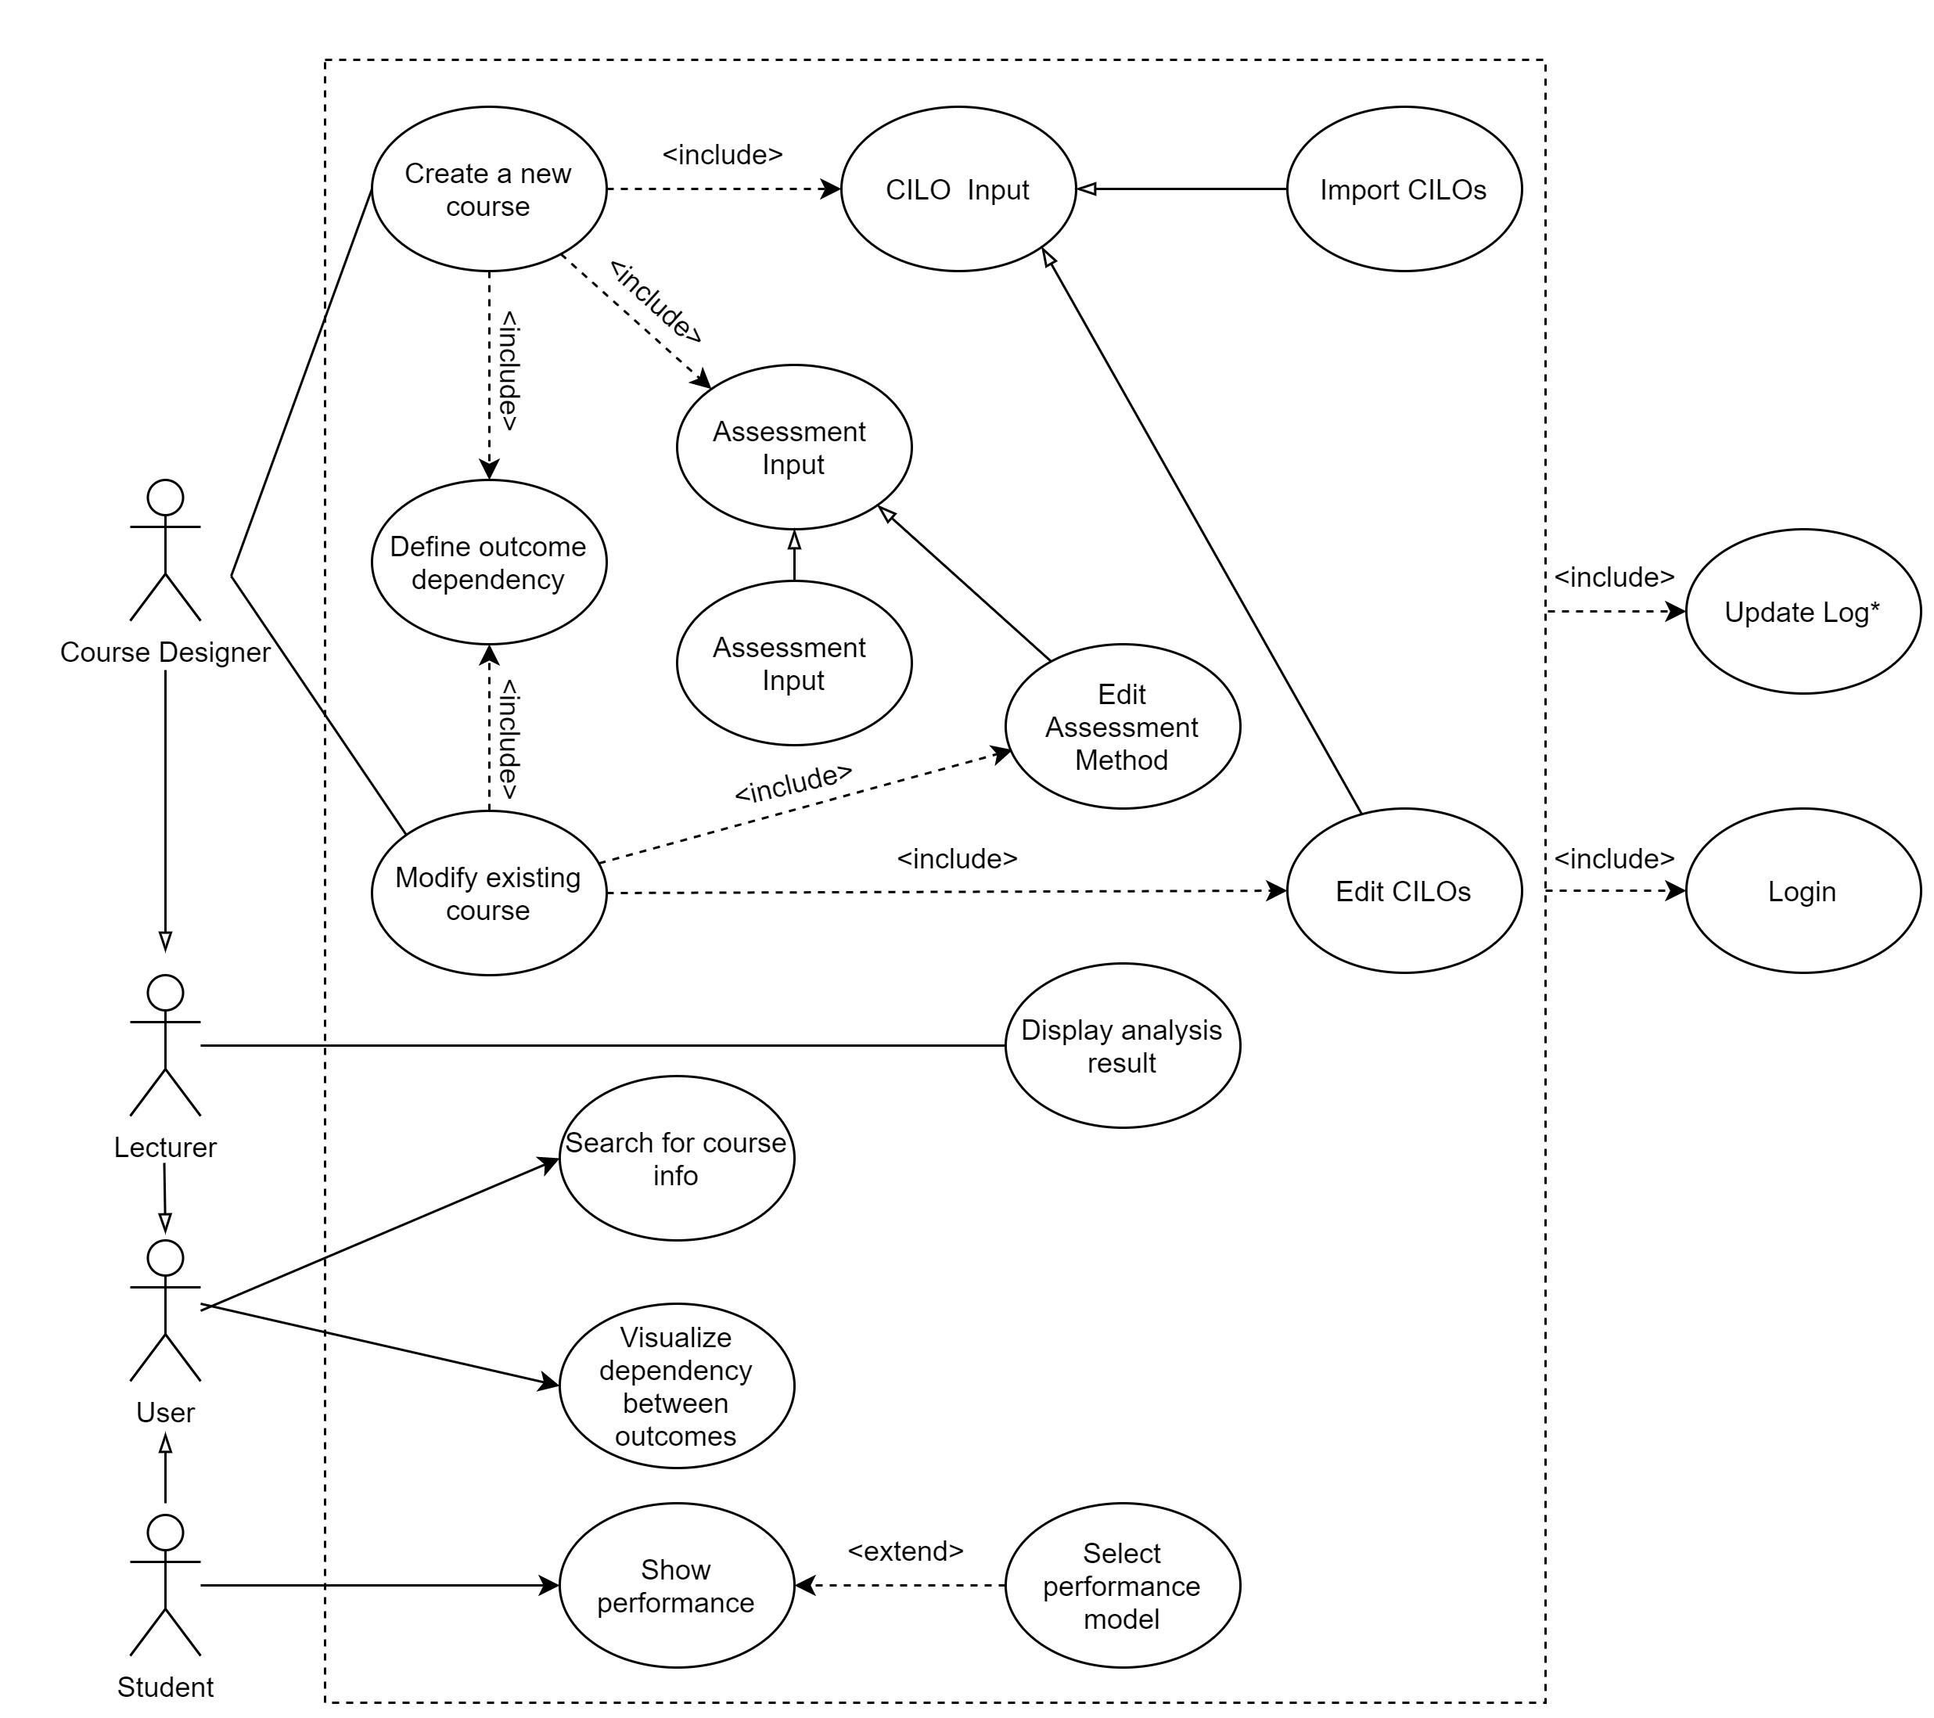
Figure 1: Use case diagram

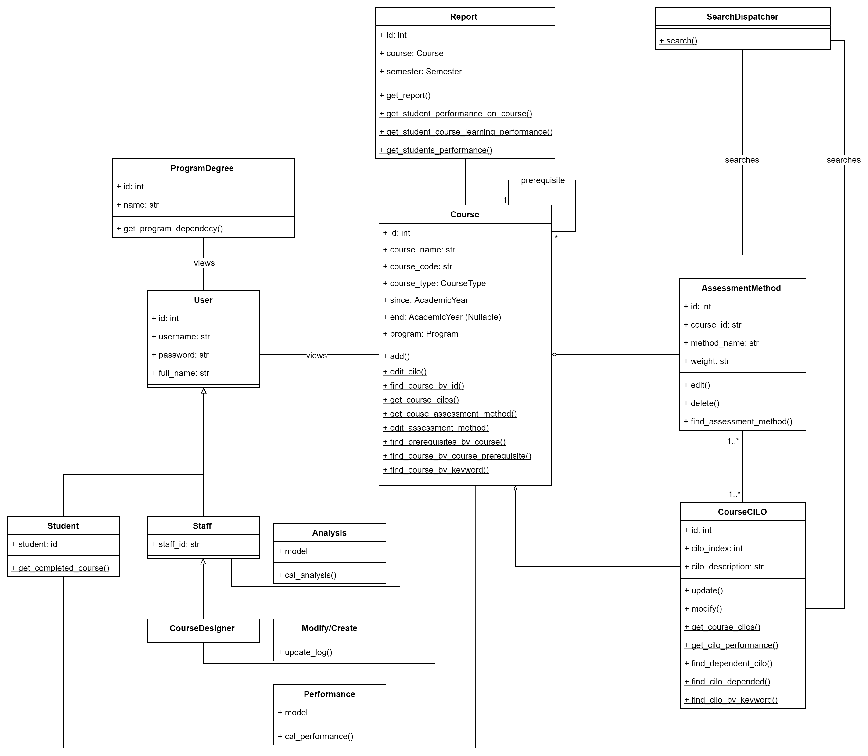

Figure 2: Class diagram

Design model
This system uses the Model-View-Controller (MVC) architecture, where the controller receives requests from users, retrieves all the necessary information needed to present to the user from the model, and forwards the information to views and presents it to the end-user.

System architecture
The system is divided into six subsystems:
- Course Information Subsystem;
- Search Subsystem;
- Outcome Dependency Visualization Subsystem;
- Performance Report Subsystem;
- User Subsystem;
- Analysis Subsystem.

The diagram is shown as follows:
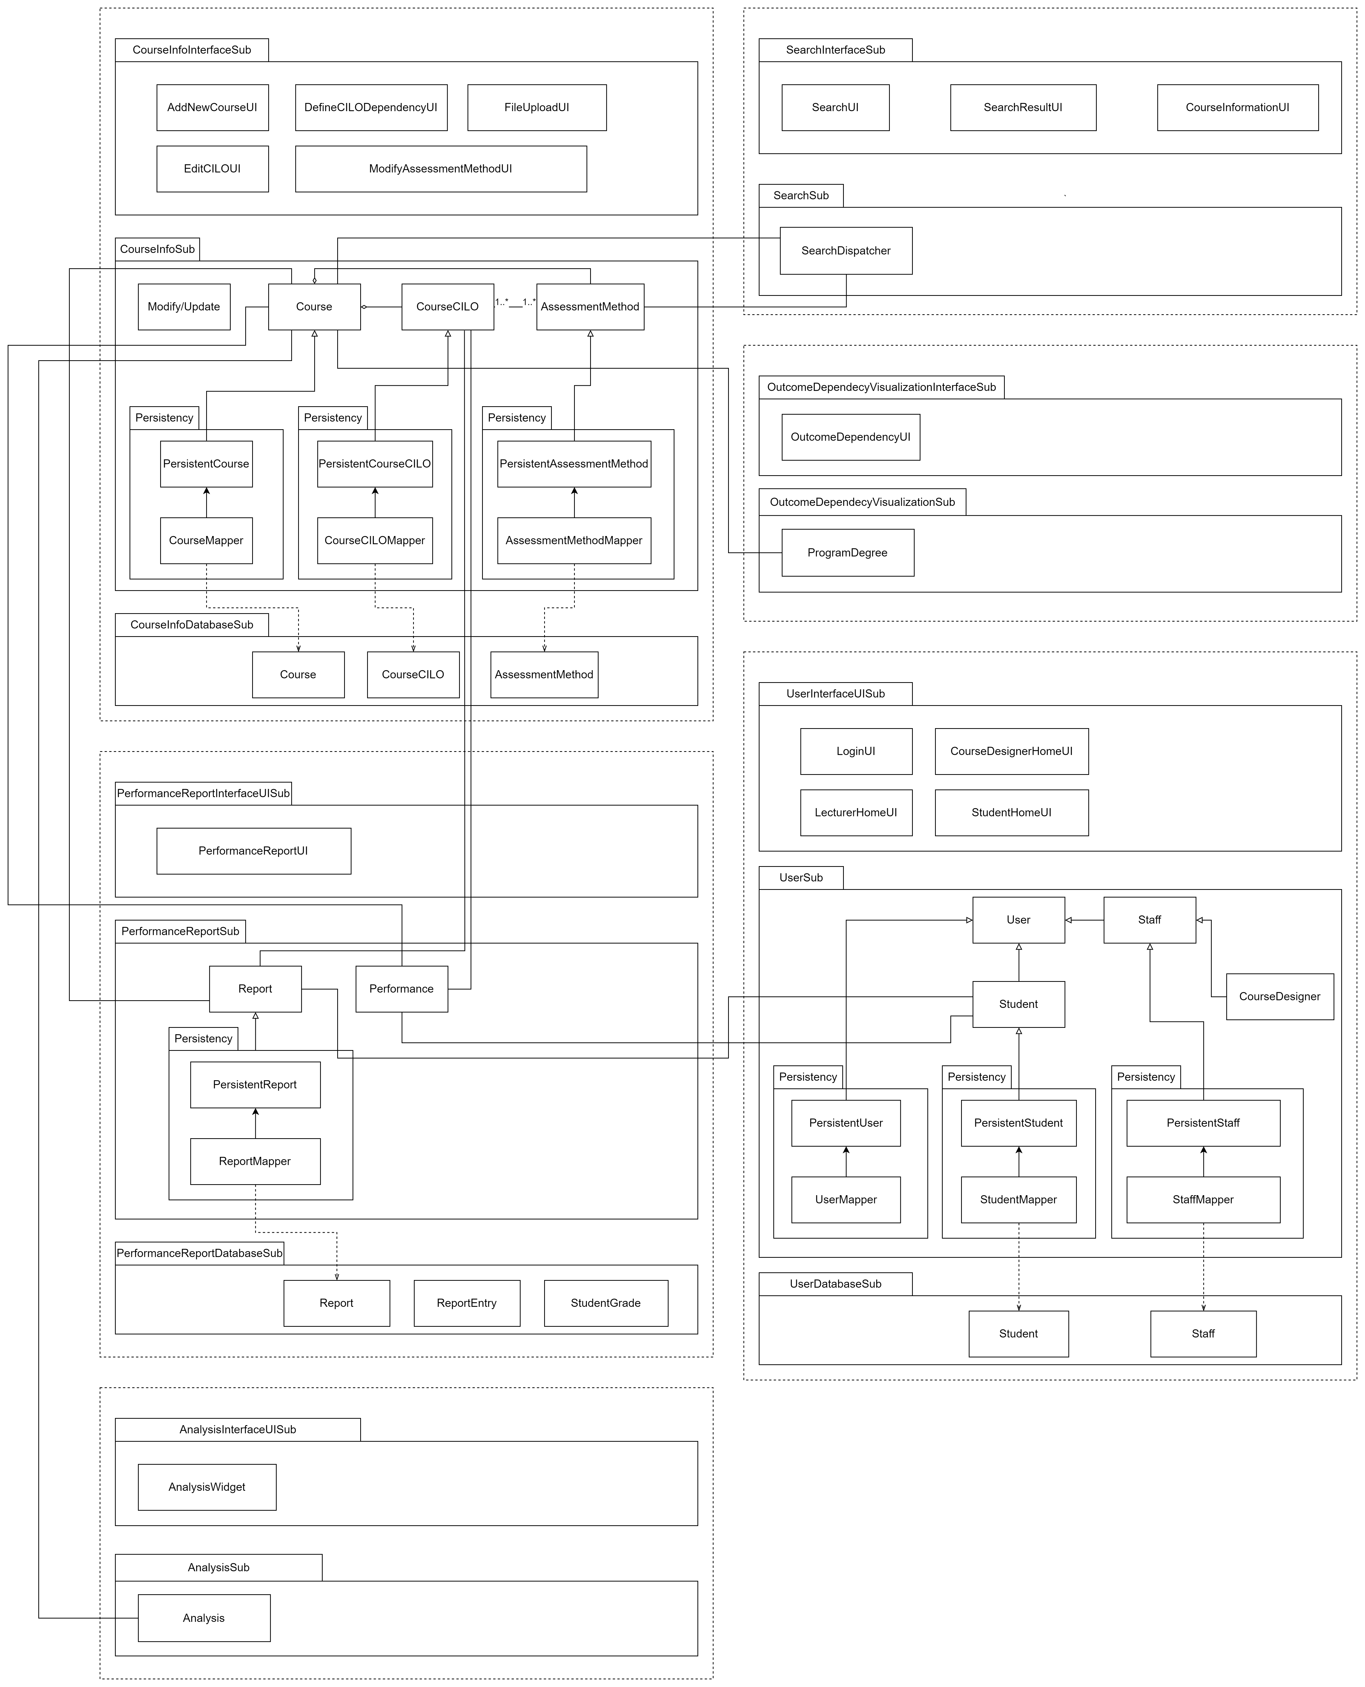

System architecture

Course Information Subsystem
The subsystem has three parts, namely the CourseInfoInterfaceSub, CourseInfoSub, and the CourseInfoDatabaseSub. The detail of the diagram is shown as follows:
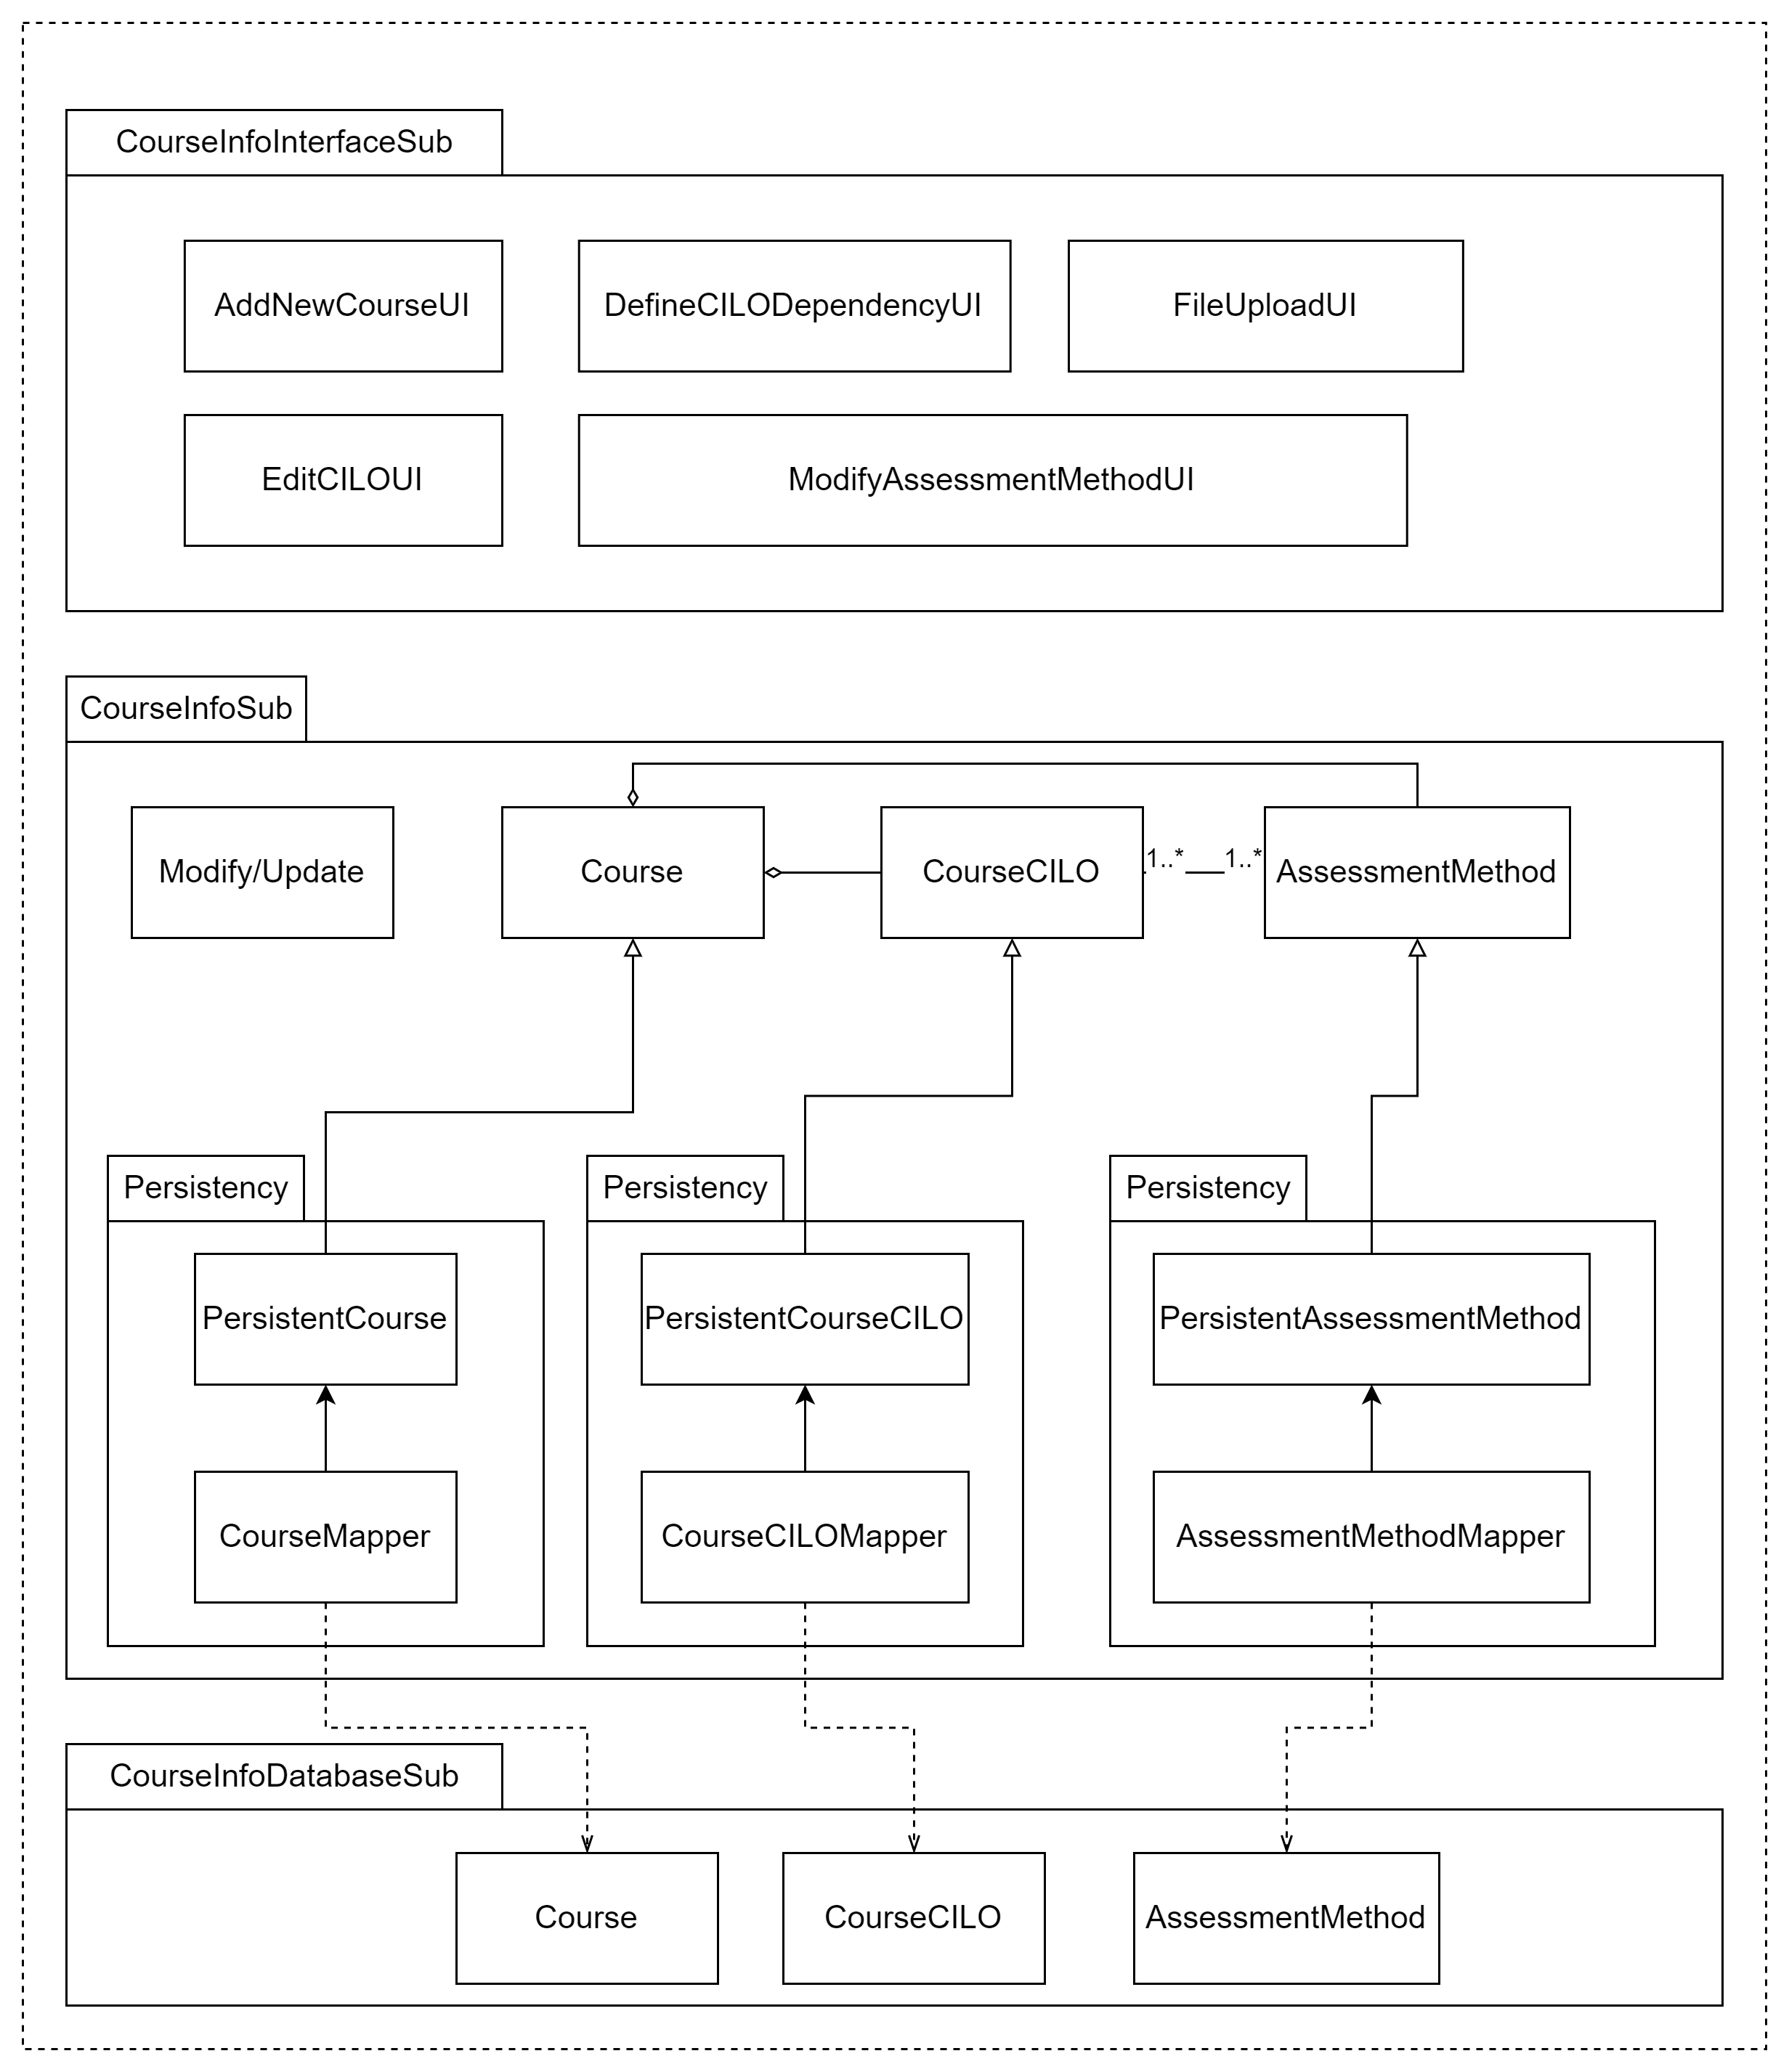

Description
The subsystem concerns the course information of the system. The CourseInfoInterfaceSub contains all the user interfaces of the subsystem. The CourseInfoSub contains all the application logic. The CourseInfoDatabaseSub handles all the interactions between the class objects and the database within the subsystem.

In CourseInfoInterfaceSub:
- AddNewCourseUI: contains the form to add a new course;
- DefineCILODependencyUI: contains the form to define CILO dependencies;
- FileUploadUI: will display an upload widget so that the user can upload a file upon import;
- EditCILOUI: contains the form used when the course designer wants to update the course CILOs;
- ModifyAssessmentMethodUI: contains the form used when the course designer wants to update the course assessment methods.

In CourseInfoSub:
- Modify/Update: handles the modification of course information.
- Course class: logics related to a course;
- CourseCILO: handles logics related to course CILOs;
- AssessmentMethod: handles logics related to course assessment methods.

In CourseInfoDatabaseSub:
- Course: handles the interactions between the class object and table “course” in the database;
- CourseCILO: handles the interactions between the class object and table “cilo” in the database;
- AssessmentMethod: handles the interactions between class object and table “assessment_method” in the database.

Database
course
course_id | course_name | course_code | course_type | since | ends | program

cilo
cilo_id | course_id | cilo_index | cilo_description

cilo_dependency
dependency_id | cilo_id | dependent_cilo_id

assessment_method
method_id | course_id | method_name | weight

Search Subsystem
The subsystem has two parts, namely the SearchInterfaceSub and the SearchSub. The detail of the diagram is shown as follows:
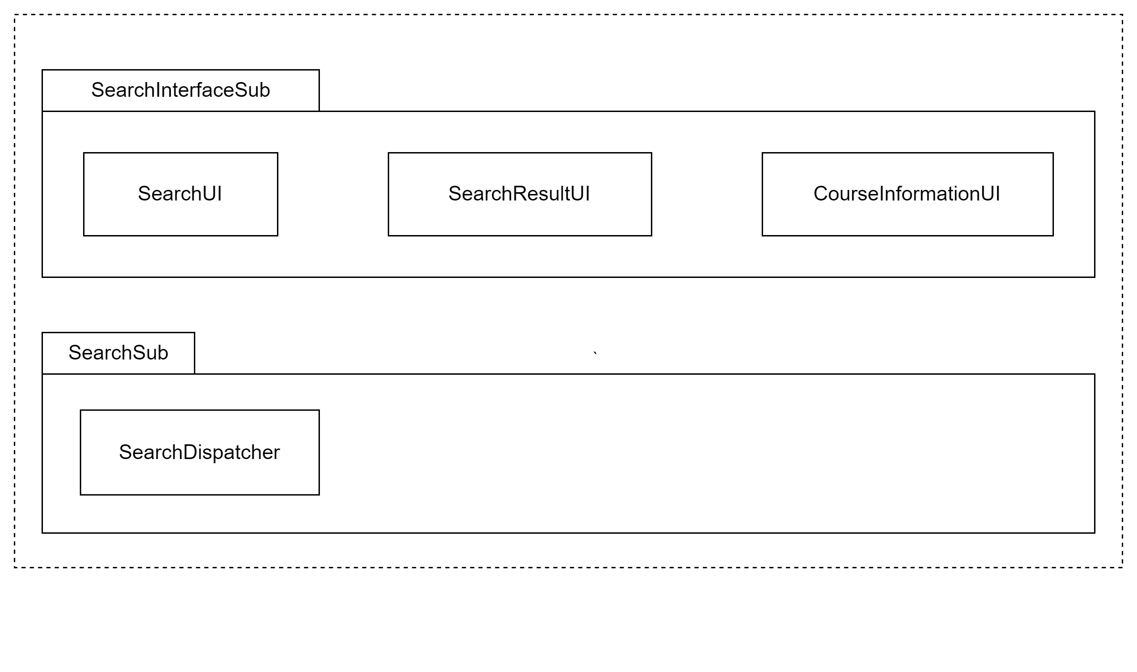

Description
The subsystem concerns the search function of the system. The SearchInterfaceSub contains all the user interfaces of the subsystem. The SearchSub contains all the application logic related to searching.

In SearchInterfaceSub:
- SearchUI: the entry page of the search function;
- SearchResultUI: the page that shows the results of a search;
- CourseInformationUI: displays the course information.

In SearchSub:
- SearchDispatcher: the dispatcher that calls other classes for the specific type of search.

Database
None.

Outcome Dependency Visualization Subsystem
The subsystem has two parts, namely the OutcomeDependecyVisualizationInterfaceSub and the OutcomeDependecyVisualizationSub. The detail of the diagram is shown as follows:

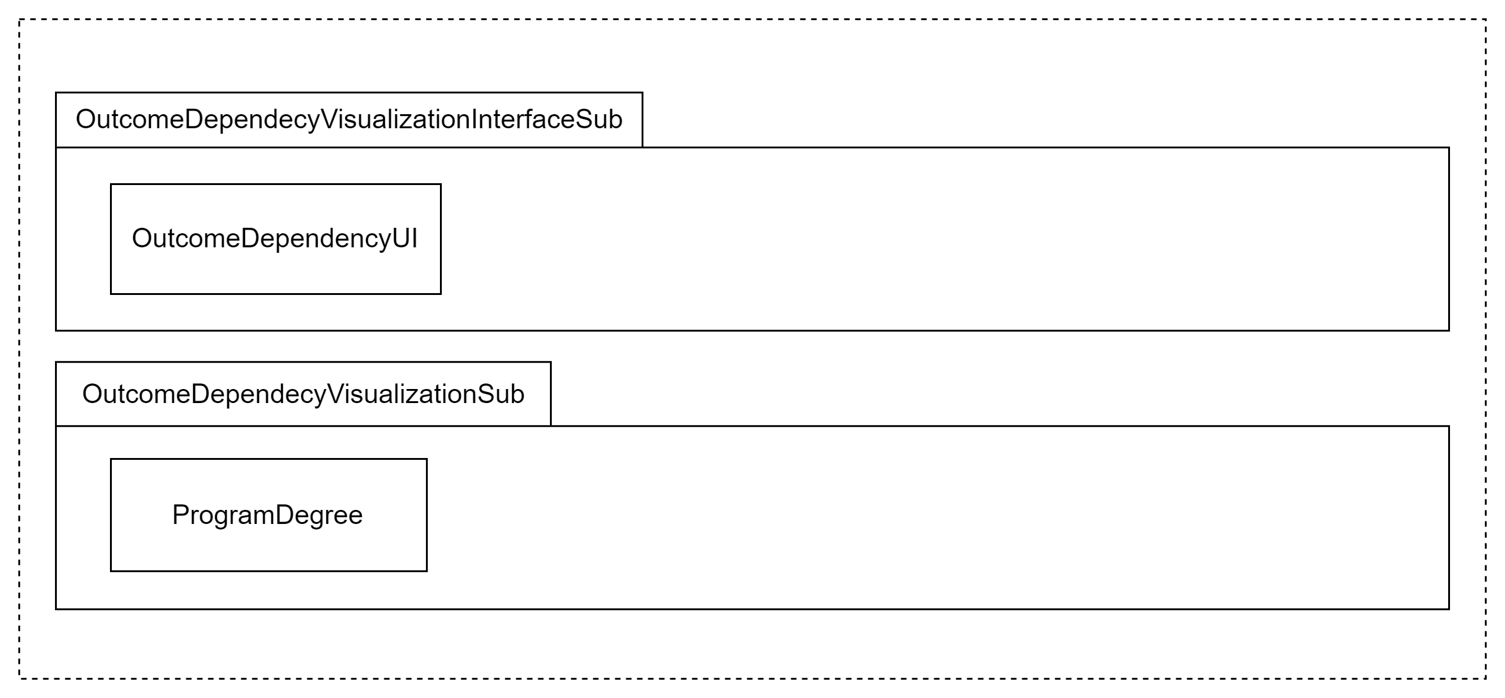

Description
The subsystem concerns the ability to visualize the dependency across a degree. The OutcomeDependecyVisualizationInterfaceSub contains all the user interfaces of the subsystem. The OutcomeDependecyVisualizationSubcontains all the application logic related to the visualization.

In OutcomeDependecyVisualizationInterfaceSub:
- OutcomeDependencyUI: display the visualization of outcome dependency across a degree.

In OutcomeDependecyVisualizationSub:
- ProgramDegree: handles the logic of visualizing the outcome dependency.

Database
None.

Performance Report Subsystem
The subsystem has three parts, namely the PerformanceReportInterfaceUISub, PerformanceReportSub, and the PerformanceReportDatabaseSub. The detail of the diagram is shown as follows:

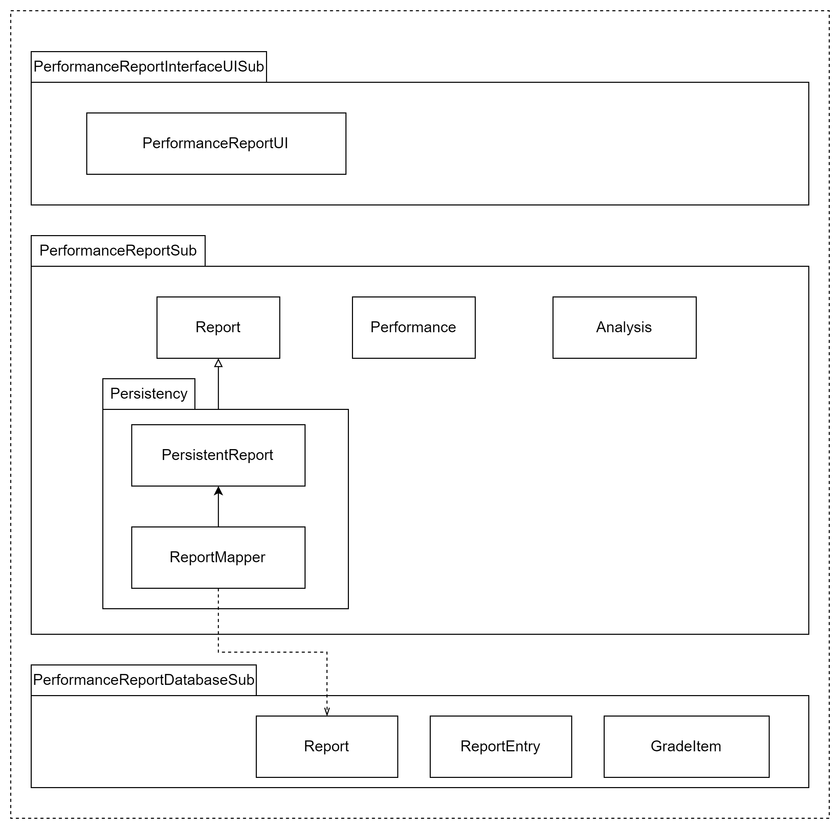

Description
The subsystem concerns visualizing a student’s learning performance on a course. The PerformanceReportInterfaceUISub contains all the user interfaces of the subsystem. The PerformanceReportSub contains all the application logic of the subsystem. The PerformanceReportDatabaseSub handles all the interactions between the class objects and the database.

In PerformanceReportInterfaceUISub:
- PerformanceReportUI: displays the performance report.

In PerformanceReportSub:
- Report: handles the logic of a report.
- Performance: the logic related to calculating the student’s performance on CILOs of courses.

In PerformanceReportDatabaseSub:
- Report: the grade report of a course in a semester. Handles the interactions between class object and table “report” in the database;
- ReportEntry: an entry of the grade report that is related to a student. Handles the interactions between class object and table “report_entry” in the database
- GradeItem: an item of the student’s grade on an assessment method in a particular ReportEntry. Handles the interactions between class object and table “grade_item” in the database

Database
report
report_id | course | semester

report_entry
entry_id | report_id | student_id

grade_item
entry_id | method_id | mark

User Subsystem
The subsystem has three parts, namely the UserInterfaceUISub, UserSub, and the UserDatabaseSub. The detail of the diagram is shown as follows:

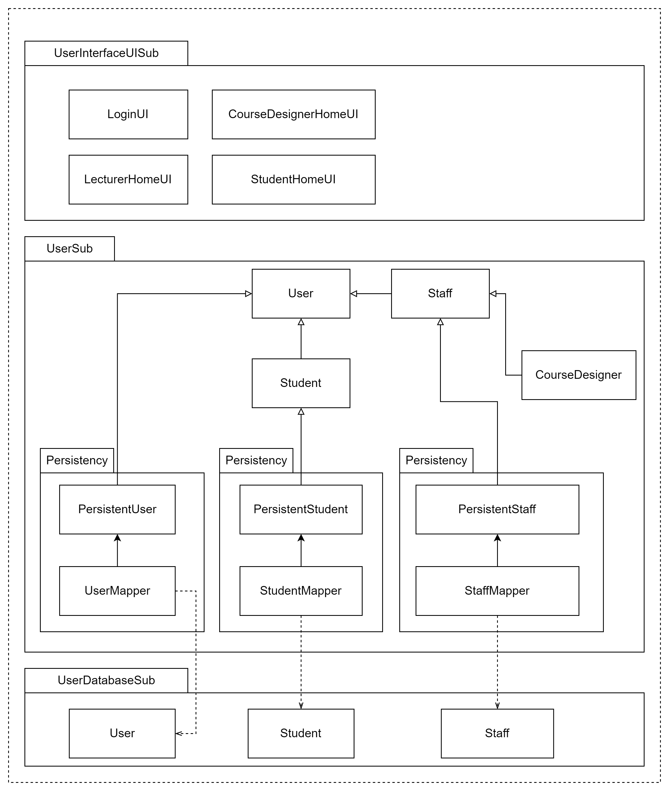

Description
The subsystem concerns the identity of users. The UserInterfaceUISub contains all the user interfaces of the subsystem. The UserSub contains all the application logic of the subsystem. The UserDatabaseSubhandles all the interactions between the class objects and the database.

In UserInterfaceUISub:
- LoginUI: the form used for user logins;
- CourseDesignerHomeUI: the home page for course designers;
- LecturerHomeUI: the home page for lecturers;
- StudentHomeUI: the home page for students.

In UserSub:
- User: the user class object.
- Student : the student class object. Inherits from the class User.
- Staff : the staff class object. Contains the logic of staff. Inherits from the class User.
- CourseDesigner : the course designer class object. Contains the logic of staff. Inherits from the class Staff.

In UserDatabaseSub:
- User: handles the interactions between class object and table “user” in the database;
- Student: handles the interactions between class object and table “student” in the database;
- Staff: handles the interactions between class object and table “staff” in the database.

Database
user
user_id | password | full_name

student
student_id

staff
staff_id | is_course_designer

Analysis Subsystem
The subsystem has two parts, namely the AnalysisInterfaceUISub and AnalysisSub. The detail of the diagram is shown as follows:

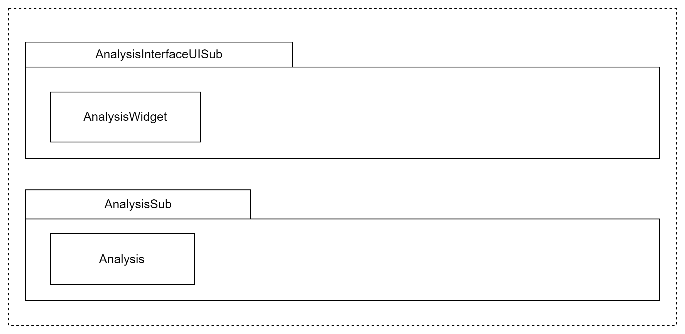

Description
The subsystem concerns the analysis of the CILO achievements for a course. The AnalysisInterfaceUISub contains the interface of the subsystem. The AnalysisSub contains all the application logic of the subsystem.

In AnalysisInterfaceUISub:
- AnalysisWidget: a widget that can be integrated into other user interfaces.

In AnalysisSub:
- Analysis: handles the logic of analyzing the CILO achievements for a course.

Database
None.

Assessment

Stability
The Model-View-Controller architecture provides stability to the overall system by separating the data, application logic, and user interfaces. Communication between boundaries is done through well-defined interfaces. A change in a section of the code only has a minor impact on the overall system.

Reusability
Many components in the MVC architecture can be reused to increase the reusability of the code in the system. Most notably, the data returned from the models are display-neutral and can be used in any view of the system. This avoids code duplication and makes the code more maintainable.

Scalability
The system is easy to extend under the MVC architecture since each section (the model, view, and controller) only performs a specific function, and functions are not integrated into the entire system, but instead, a plugin of the development framework. Extending the system means only adding plugins to the system and defining new connections with the existing subsystems.

Alternative design (optional)
None.

More considerations
The reader may consider reading Software Requirement Specification for DegressOverview v1.4 prepared by Lily for a better understanding of the architecture design.

Appendix
None.

