Detailed Design
for
DegreeOverview
Version 1.0 approved
Prepared by Bohui WU, Xuan WANG, Fuhao RUAN, Yu WU
Lily
04/27/2021
Table of Contents
Table of Contents ii
Revision History ii
1. Overview 1
1.1 Project description 1
1.2 References 1
1.3 Design purpose 1
2. Overall description 2
2.1 Class diagram 2
2.2 Refinements 2
3. Detailed design 3
3.1 Class diagram 3
3.2 Classes 3
3.2.1 Course 4
3.2.2 CourseCILO 5
3.2.3 AssesmentMethod 7
3.2.4 ProgramDegree 8
3.2.5 User 8
3.2.6 Student 9
3.2.7 Staff 9
3.2.8 CourseDesigner 10
3.2.9 Report 10
3.2.10 Analysis 10
3.2.11 Modification 11
3.2.12 Performance 11
3.2.13 SearchDispatcher 12
4. Alternative detailed design 13
5. More considerations 13

Revision History
Name | Date | Reason For Changes | Version
Bohui WU, Xuan WANG, Fuhao RUAN, Yu WU | 04/27/2021 | The first version of the document. | 1.0

Overview

Project description
DegreeOverview is a course definition system that aims to help course designers better plan and design university courses and enables both the lecturers and students to understand and visualize the relationships between courses and their intended learning outcome.

References
Software Requirement Specification for DegressOverview v1.4 by Lily.
Architecture Design for DegreeOverview v1.0 by Lily.

Design purpose
This document aims to provide a detailed description for each class of the architecture described in Architecture Design for DegreeOverview v1.0 by Lily. It is expected to reduce the ambiguity introduced in the previous documents so that all developers of the project have a thorough understanding of the project’s structure.

Overall description

Class diagram
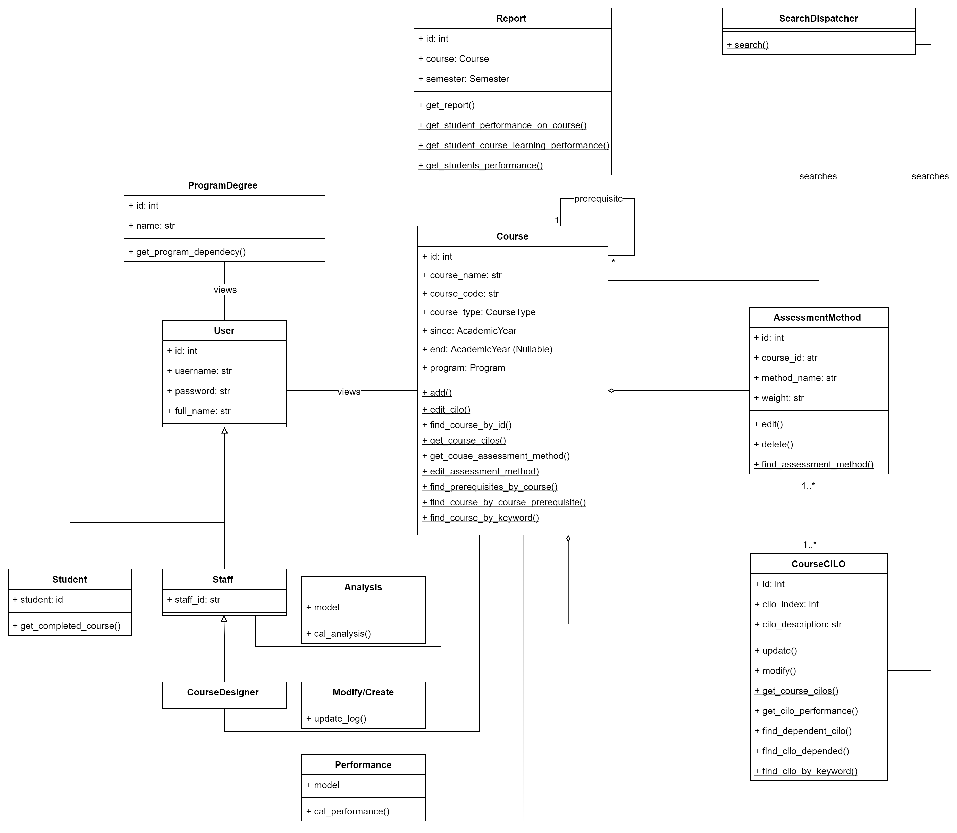

Figure 2.1: Old class diagram

Refinements
In this refined class diagram, details including the class functions, class methods, visibilities, quantifiers, and constraints are specified. The details of the refinement are discussed in great detail in section 3.2.

Detailed design

Class diagram 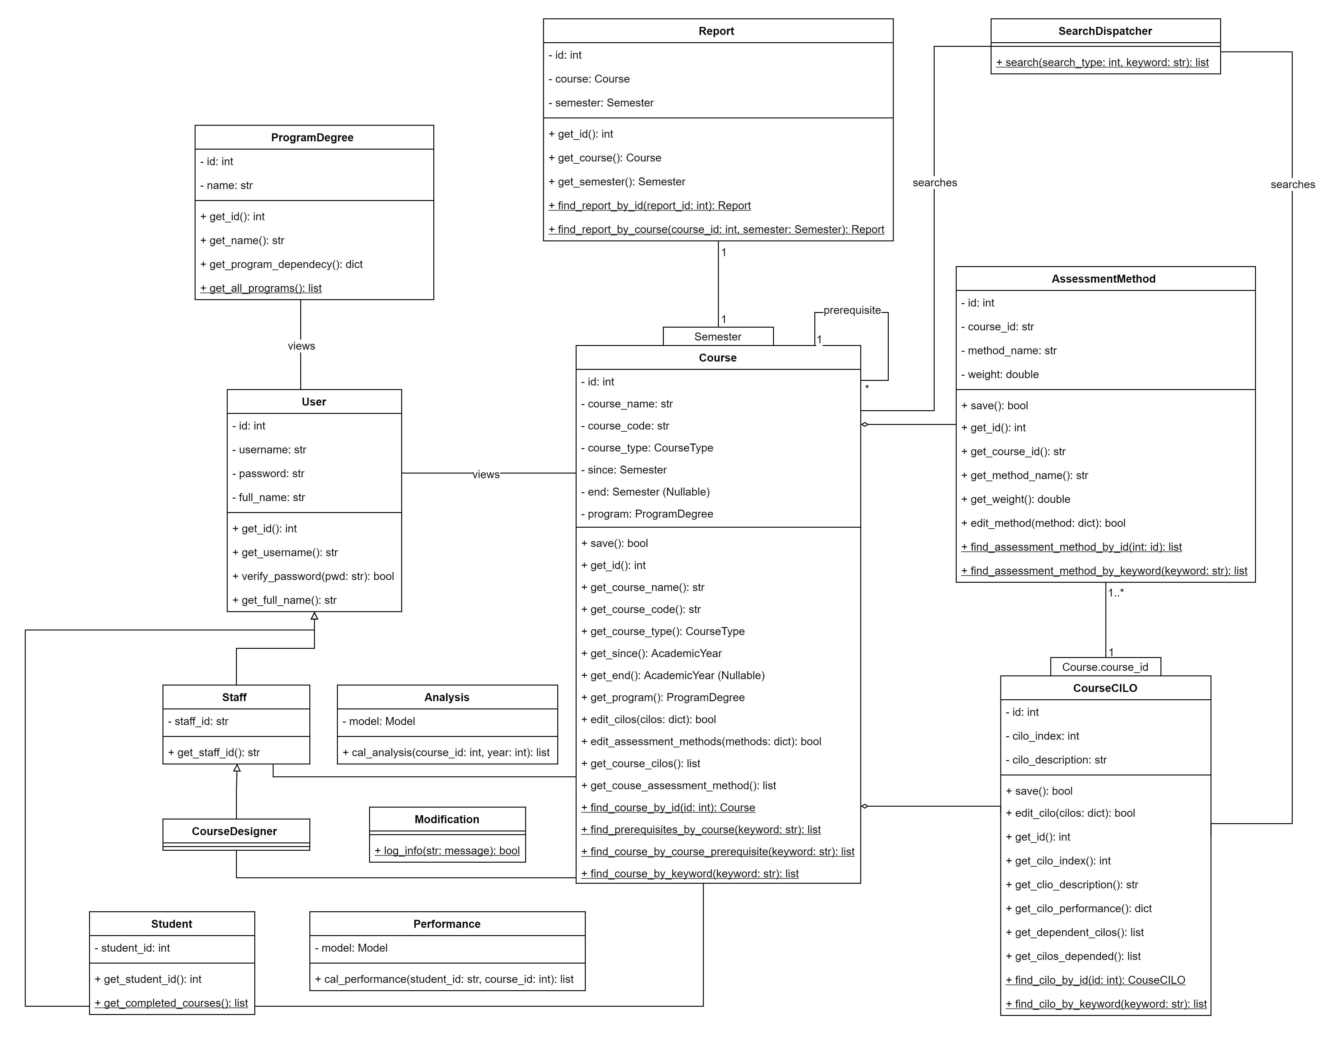
Figure 3.1: Refined class diagram

Changelog:
- No major changes were made to the class diagram except for added two quantifiers between Course and Report, and CourseCILO and AssessmentMethod.

Classes

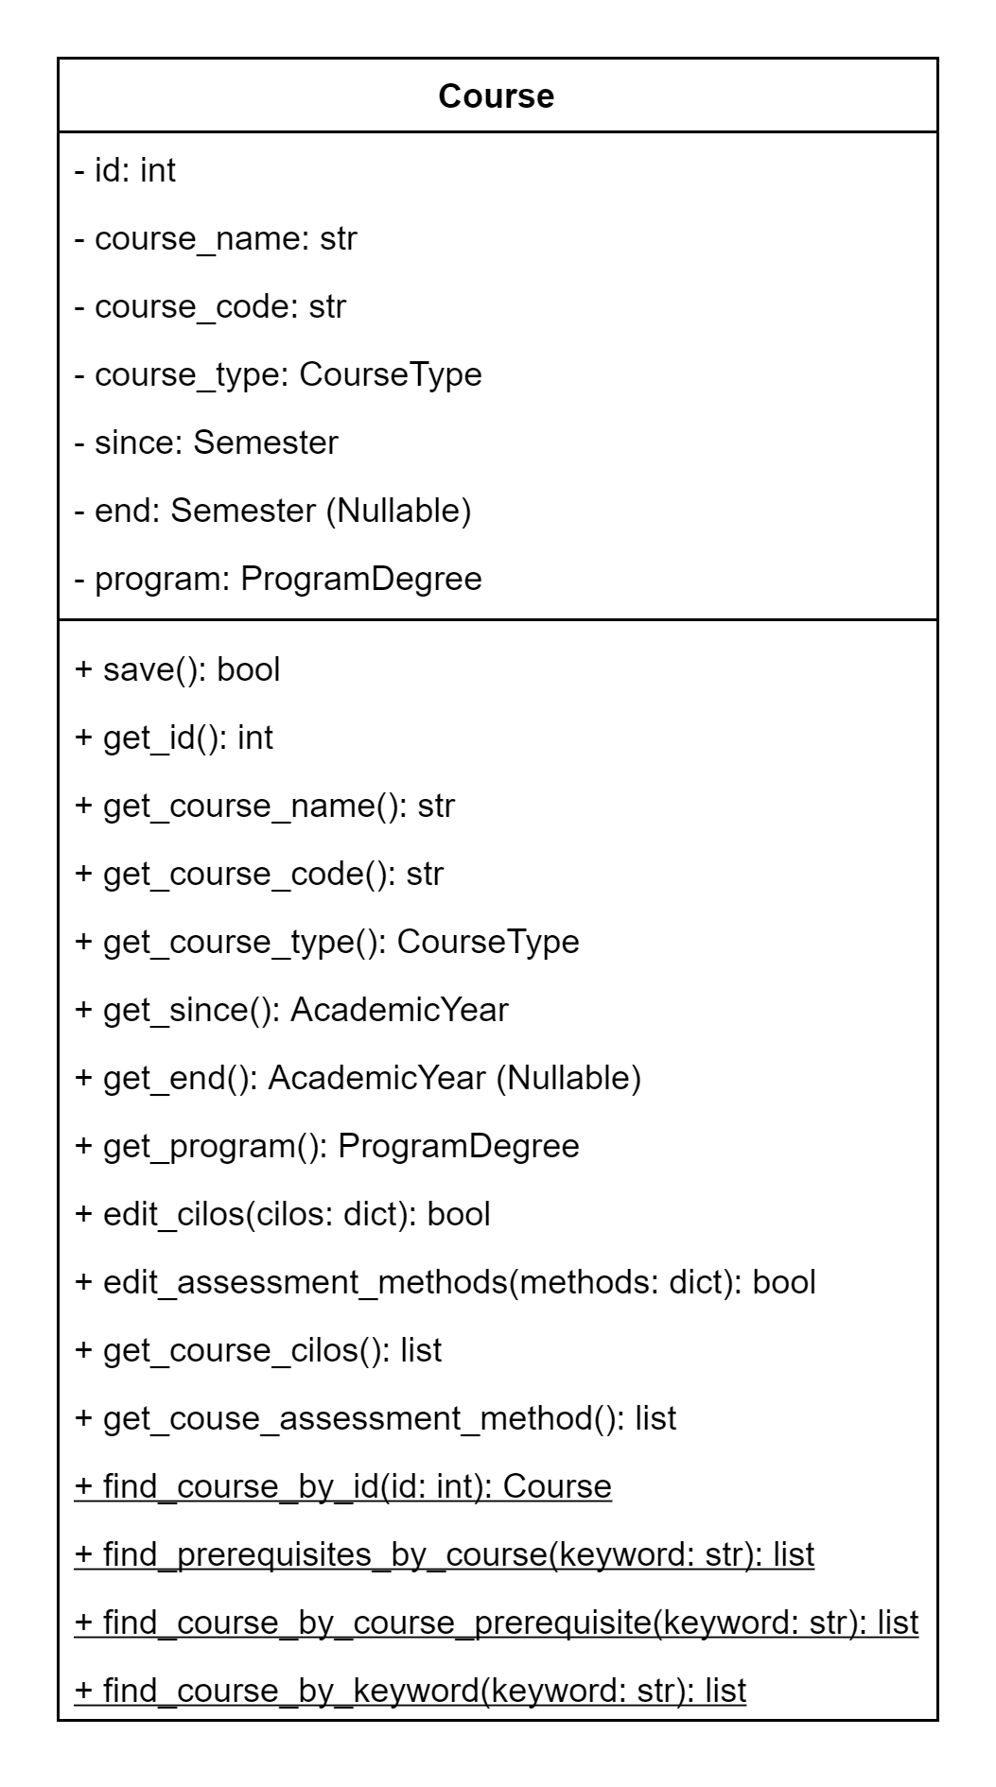
Course

Figure 3.2: Class diagram for Course
Explanations

All changes to the class diagram are as follows:
- All the attributes of the class were marked “private” in this version;
- The getters for the attributes were added;
- The method “save” was added to the diagram. The method issues commit signals to Flask-SQLAlchemy;
- A redundant method “add” were removed;
- For "edit_cilos"
  - An argument named “cilos” and is of type dictionary was added. The dictionary contains the new CILOs parsed from the JSON data from the frontend;
  - A return type of bool was added. The Boolean value indicates whether or not the operation was successful.
- For "edit_assessment_methods":
  - The named was changed from "edit_assessment_method" to "edit_assessment_methods";
  - An argument named “methods” and is of type dictionary was added. The dictionary contains the new assessment methods parsed from the JSON data from the frontend;
  - A return type of bool was added. The Boolean value indicates whether or not the operation was successful.
- For "get_course_cilos":
  - A return type of list was added. The list contains CourseCILO(s) of the course;
  - Removed the static indicator;
- For “get_course_assessment_method”:
  - A return type of list was added. The list contains the AssessmentMethod of the course.
- For “find_course_by_id”:
  - An argument named “id” and is of type int was added;
  - A return type of Course was added.
- For "find_prerequisites_by_course":
  - An argument named “keyword” and is of type string was added;
  - A return type of list was added. The list contains a list of prerequisites.
- For “find_course_by_course_prerequisite”:
  - An argument named “keyword” and is of type string was added;
  - A return type of list was added. The list contains courses that match the requirements provided.
- For "find_couse_by_keyword":
  - An argument named “keyword” and is of type string was added;
  - A return type of list was added. The list contains a list of courses.

Constraints (optional)

def edit_assessment_methods(self, methods: dict) -> bool
Pre-condition: the dictionary methods must have a length of at least one.
Post-condition: the return value corresponds to the following values:
- true: the operation was successful.
- false: the operation failed (reasons could be: validation error, system internal error, database error).

CourseCILO
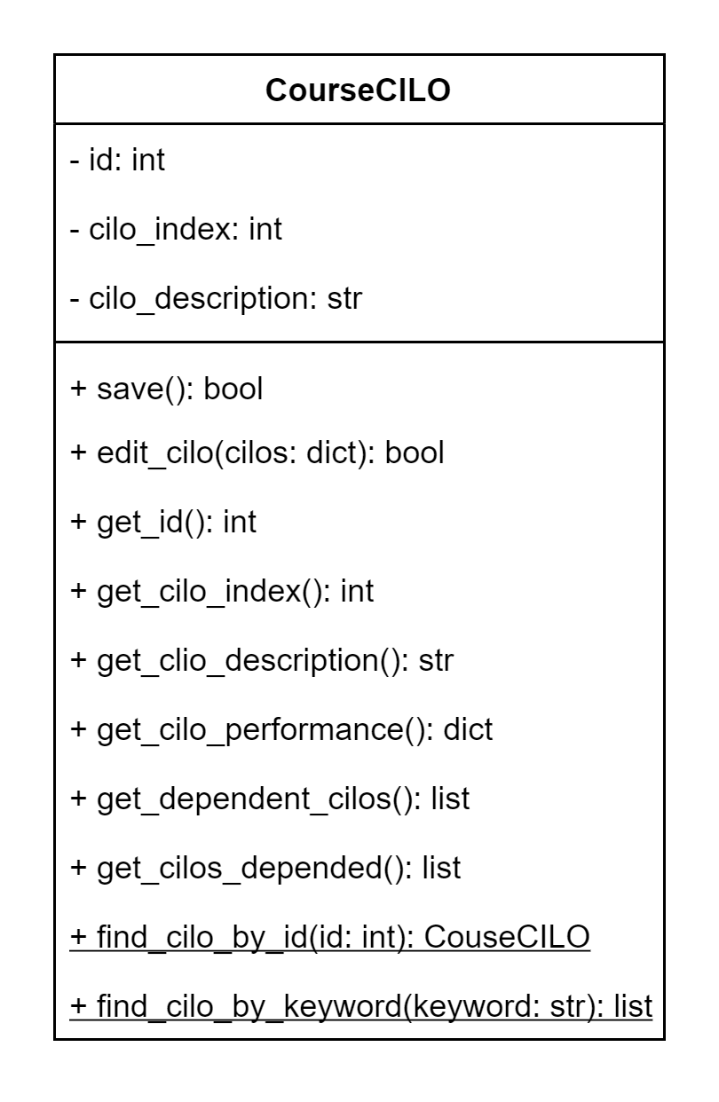

Figure 3.3: Class diagram for CourseCILO
Explanations

All changes to the class diagram are as follows:
- All the attributes of the class were marked “private” in this version;
- The getters for the attributes were added;
- A “save” method was added to the diagram. The method issues commit signals to Flask-SQLAlchemy;
- A redundant method “add” were removed;
- For "edit_cilo"
  - Name changed from "edit" to "edit_cilo";
  - An argument named “cilos” and is of type dictionary were added. The dictionary contains the new CILOs parsed from the JSON data from a Course object;
  - A return type of bool was added. The Boolean value indicates whether or not the operation was successful.
- Removed “get_course_cilos”;
- For “get_cilo_performance”:
  - A return type of dictionary was added. The dictionary contains the performance data that can be easily parsed and passed to the frontend.
- For “get_dependent_cilos”:
  - Renamed from “find_dependent_cilo” to “get_dependent_cilos”;
  - A return type of list was added. The list contains the CILO’s dependent CILO(s).
- For "get_cilos_depended":
  - Renamed from "find_cilos_depended" to "get_cilos_depended";
  - A return type of list was added. The list contains the CILOs depending on the current CILO.
- Added “find_cilo_by_id”;
- For “find_cilo_by_keyword”:
  - An argument named “keyword” and is of type string was added.
  - A return type of list was added. The list contains the list of CourseCILOs that match the provided keyword.
- For “get_dependent_cilos”:
  - Renamed from “find_dependent_cilo” to “get_dependent_cilos”;
  - An argument named “keyword” and is of type string was added;
  - A return type of list was added. The list contains a list of prerequisites.
- For "get _cilos_depended":
  - Renamed from "find_cilo_depended" to "get_cilos_depended";
  - Removed the static specifier.
- For "find_couse_by_keyword":
  - An argument named “keyword” and is of type string was added;
  - A return type of list was added. The list contains a list of courses.

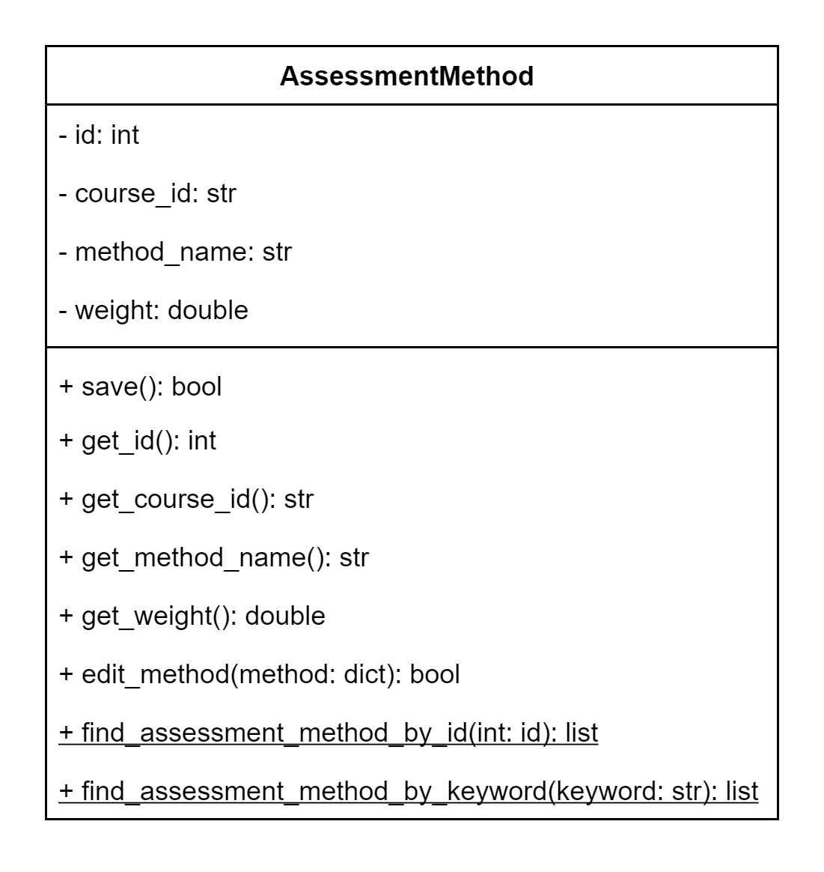
AssesmentMethod

Figure 3.4: Class diagram for AssessmentMethod
Explanations

All changes to the class diagram are as follows:
- All the attributes of the class were marked “private” in this version;
- The getters for the attributes were added;
- A “save” method was added to the diagram. The method issues commit signals to Flask-SQLAlchemy;
- For "edit_method":
  - Renamed from "edit" to "edit_method";
  - An argument named “methods” and is of type dictionary was added. The dictionary contains the new assessment methods passed from the Course class;
  - A return type of bool was added. The Boolean value indicates whether or not the operation was successful.
- Deleted the method “delete”;
- Deleted the class function “find_assessment_method”;
- Added class function “find_assessment_method_by_id”;
- Added class function “find_assessment_method_by_keyword”.

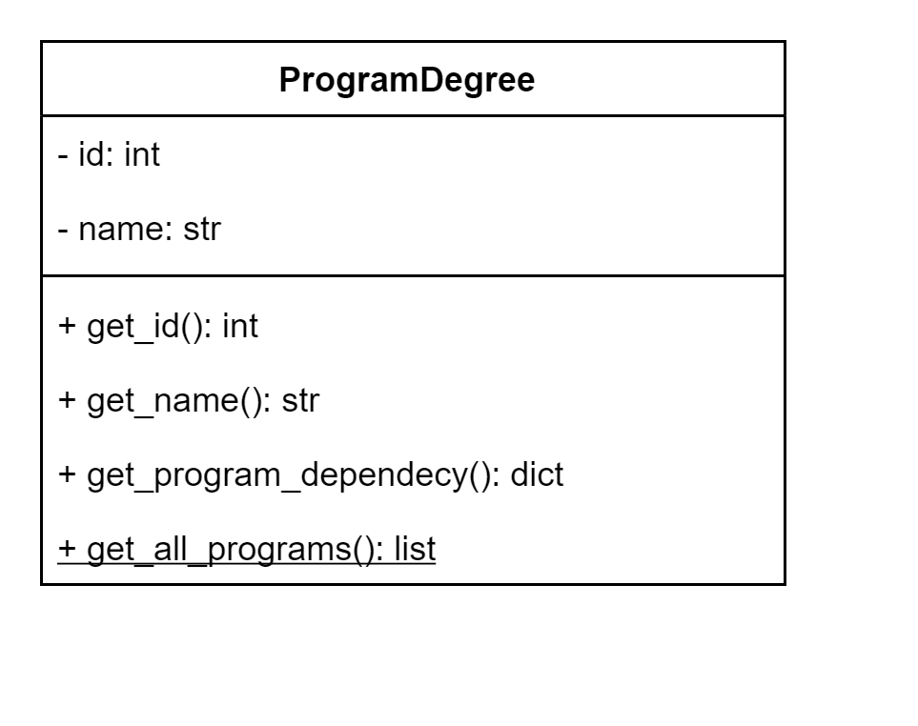
ProgramDegree

Figure 3.5: Class diagram for ProgramDegree
Explanations

All changes to the class diagram are as follows:
- All the attributes of the class were marked “private” in this version;
- The getters for the attributes were added;
- For “get_program_dependency”:
  - A return type of dictionary was added. The dictionary contains all the information needed to construct a visualization in the frontend for the given degree.
- Added method “get_all_programs” that returns all the programs in the database.

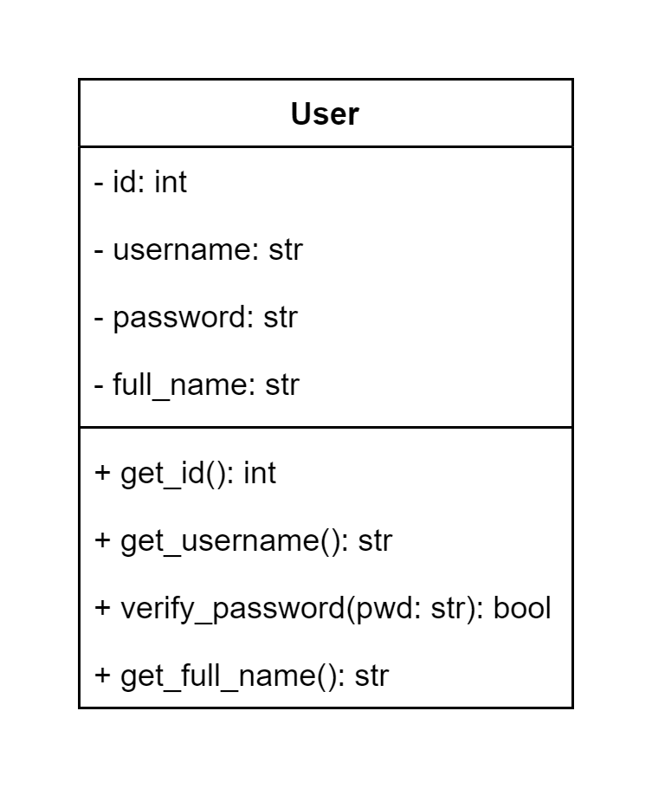
User

Figure 3.6: Class diagram for User
Explanations

All changes to the class diagram are as follows:
- All the attributes of the class were marked “private” in this version;
- The getters for the attributes were added, except for the password;
- For "verify_password":
  - Renamed from "get_password" to "verify_password";
  - The method takes in a password in plaintext (unhashed) and returns a Boolean value indicating whether the password is correct or not.

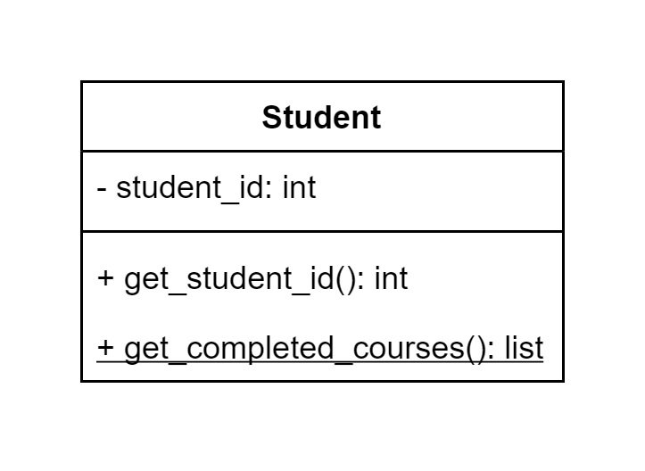
Student

Figure 3.7: Class diagram for Student
Explanations

All changes to the class diagram are as follows:
- All the attributes of the class were marked “private” in this version;
- The getters for the attributes were added;
- For “get_completed_courses”:
  - Renamed from “get_completed_course” to “get_completed_courses”;
  - The method returns a list of courses that the student has completed.

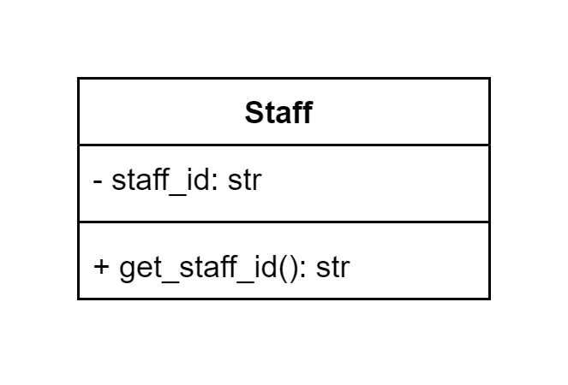
Staff

Figure 3.8: Class diagram for Staff
Explanations

All changes to the class diagram are as follows:
- The attribute “staff_id” of the class was marked “private” in this version;
- The getter for the attribute was added.


CourseDesigner

Figure 3.9: Class diagram for CourseDesigner
Explanations

No changes were made to this class.

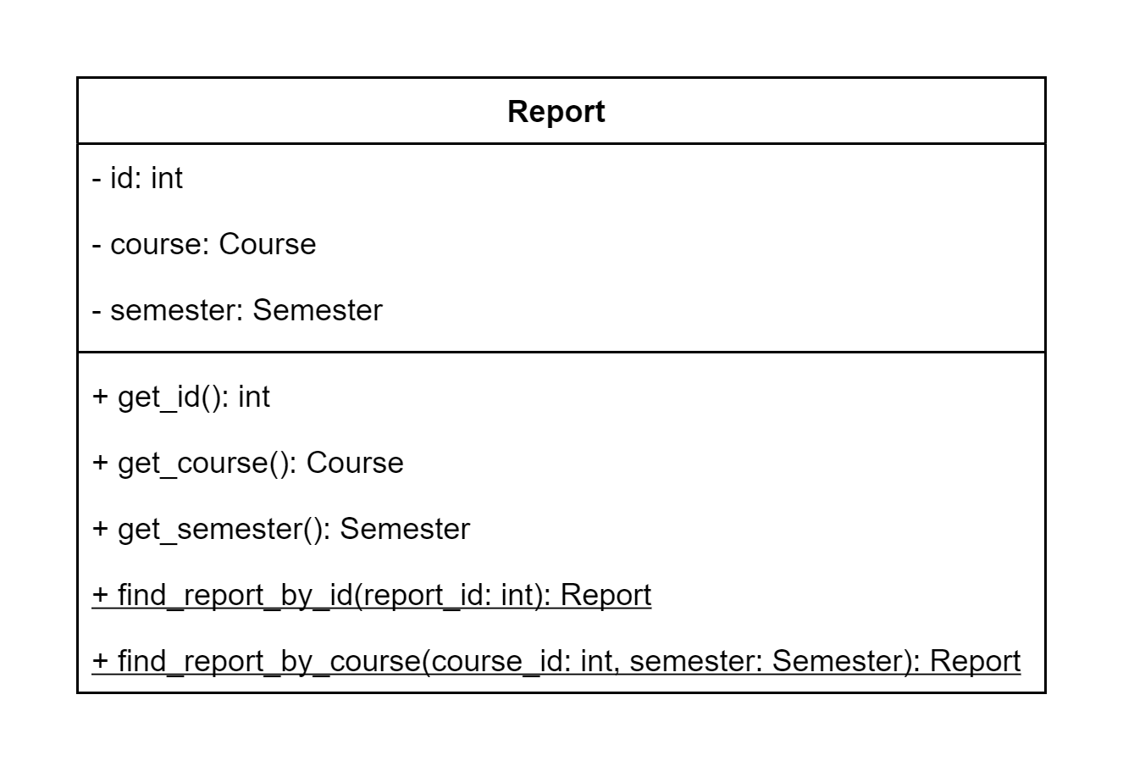
Report

Figure 3.10: Class diagram for Report
Explanations

All changes to the class diagram are as follows:
- All the attributes of the class were marked “private” in this version;
- The getters for the attributes were added;
- Removed “get_student_performance_on_course”;
- Removed “get_student_course_learning_performance”;
- Removed “get_students_performance”;
- For “find_report_by_id”:
  - Renamed from “get_report” to “find_report_by_id”.
  - Takes in one argument, “report_id,” which has a type of int;
  - The class function returns an instance of Report.
- Added “find_report_by_couse”.

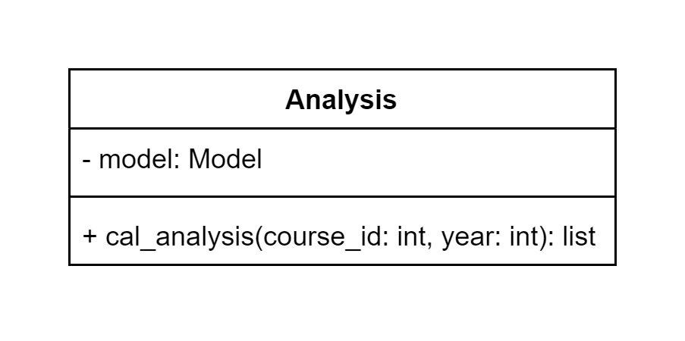
Analysis

Figure 3.11: Class diagram for Analysis
Explanations

All changes to the class diagram are as follows:
- All the attributes of the class were marked “private” in this version;
- The getters for the attributes were added;
- For "cal_analysis":
  - The parameter “course_id” was specified;
  - The method returns a list of the CILO’s average performance in the given year of a course.

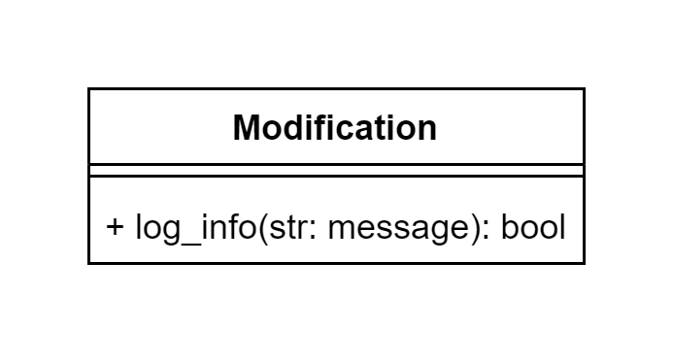
Modification

Figure 3.12: Class diagram for Modification
Explanations

The class was renamed from “Modify/Create” to “Modification.” Other changes to the class diagram are as follows:
- For "log_info":
  - Renamed from "update_log" to "log_info";
  - The method takes in a string called message and returns a Boolean value indicating whether the password is correct or not.

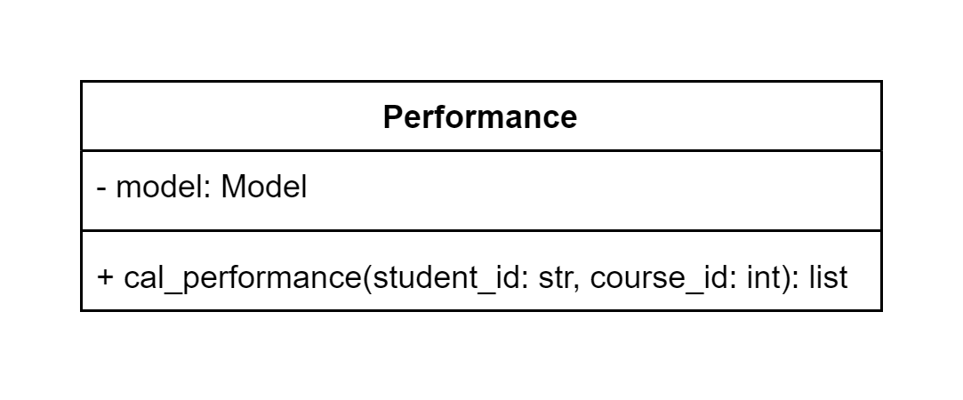
Performance

Figure 3.13: Class diagram for Performance
Explanations

All changes to the class diagram are as follows:
- The attribute “model” was marked “private” in this version;
- For "cal_performance":
  - The attribute “student_id” and “course_id” were specified;
  - The method returns a dictionary containing the performance report for a given student on a given course.

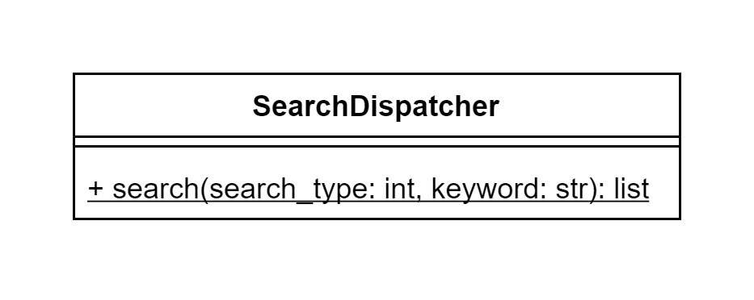
SearchDispatcher

Figure 3.14: Class diagram for SearchDispatcher
Explanations

All changes to the class diagram are as follows:
- For “search”:
  - The two attributes “search_type” and “keyword” were added;
  - The class function serves as a portal and invokes other search functions based on the user’s provided type of search;
  - The class function returns a list of results requested by the user.

Alternative detailed design
None.

More considerations
In case the reader found the document elusive, it is recommended that the user can refer to Architecture Design for DegreeOverview v1.0 by Lily for a deeper understanding.

