Software Requirements Specification

for

DegreeOverview

Version 1.2 approved

Prepared by Bohui WU, Xuan WANG, Fuhao RUAN, Yu WU

Lily

03/30/2021

Table of Contents

Table of Contents ii

Revision History ii

1. Introduction 1

1.1 Purpose 1

1.2 Document Conventions 1

1.3 Intended Audience and Reading Suggestions 1

1.4 Project Scope 1

1.5 References 1

2. Overall Description 2

2.1 Product Perspective 2

2.2 Product Features 2

2.3 User Classes and Characteristics 3

2.4 Operating Environment 3

2.5 Design and Implementation Constraints 3

2.6 User Documentation 3

2.7 Assumptions and Dependencies 4

3. System Features 5

3.1 Login 5

3.2 Create a New Course 5

3.3 Edit Course CILOs and their Dependencies 6

3.4 Edit Assessment Methods and their Relationships with CILOs 7

3.5 Search 8

3.6 Course Information 9

3.7 Visualize Outcome Dependencies 10

3.8 Performance Report 10

4. External Interface Requirements 12

4.1 User Interfaces 12

4.2 Hardware Interfaces 24

4.3 Software Interfaces 24

4.4 Communications Interfaces 24

5. Other Nonfunctional Requirements 25

5.1 Performance Requirements 25

5.2 Safety Requirements 25

5.3 Security Requirements 25

5.4 Software Quality Attributes 25

6. Other Requirements 26

Appendix A: Glossary 26

Appendix B: Analysis Models 26

Appendix C: Issues List 26

Revision History

|  |  |  |  |
| --- | --- | --- | --- |
| **Name** | **Date** | **Reason For Changes** | **Version** |
| Bohui WU,  Xuan WANG,  Yu WU,  Fuhao RUAN | 03/16/2021 | The first version. | 1.0 |
| Bohui WU,  Xuan WANG,  Yu WU,  Fuhao RUAN | 03/22/2021 | The second version:  1). Corrected mistakes in SRS v1.0 according to feedback.  2). Section 3.1 and 3.2;  3). UI design from 1-7. | 1.1 |
| Bohui WU,  Xuan WANG,  Yu WU,  Fuhao RUAN | 03/30/2021 | The third version:  1). Corrected mistakes in SRS v1.1 according to feedback;  2). Completed section 3 and section 4. | 1.2 |

# Introduction

## Purpose

The software requirement specification (SRS) is for the project “DegreeOverview” from Lily. This document is designed to describe the whole system.

## Document Conventions

In this document, all dates will be written using the date and time notation in the United States, which is MM/dd/yyyy.

In this document, **bold text** indicates the content is of great significance, and the reader should pay more attention to it. *Italic text* is used when company names and product names are mentioned.

## Intended Audience and Reading Suggestions

The intended readers of the document and their reading suggestions are as follows:

* Product managers: section 1 to section 3;
* System architects: section 2 and section 3;
* Software developers: from section 1 to section 6;
* Testers: section 2 to section 6.

## Project Scope

DegreeOverview is a course definition system that aims to help course designers better plan and design university courses and enables both the lecturers and students to understand and visualize the relationships between courses and their intended learning outcome.

## References

Software Development Workshop III Project V3

# Overall Description

## Product Perspective

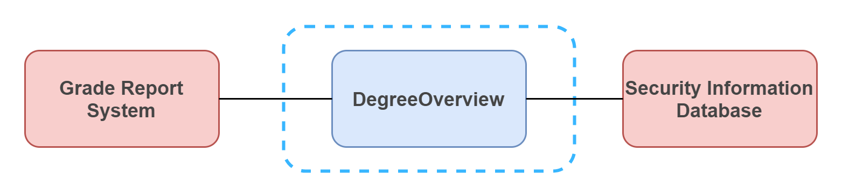

DegreeOverview is a software designed to deploy to a server running Windows Server. However, to function properly, some of the data may come from other independent systems within the campus. In this case, DegreeOverview needs to be connected to the university’s Security Information Database and the Grade Report System.

## Product Features

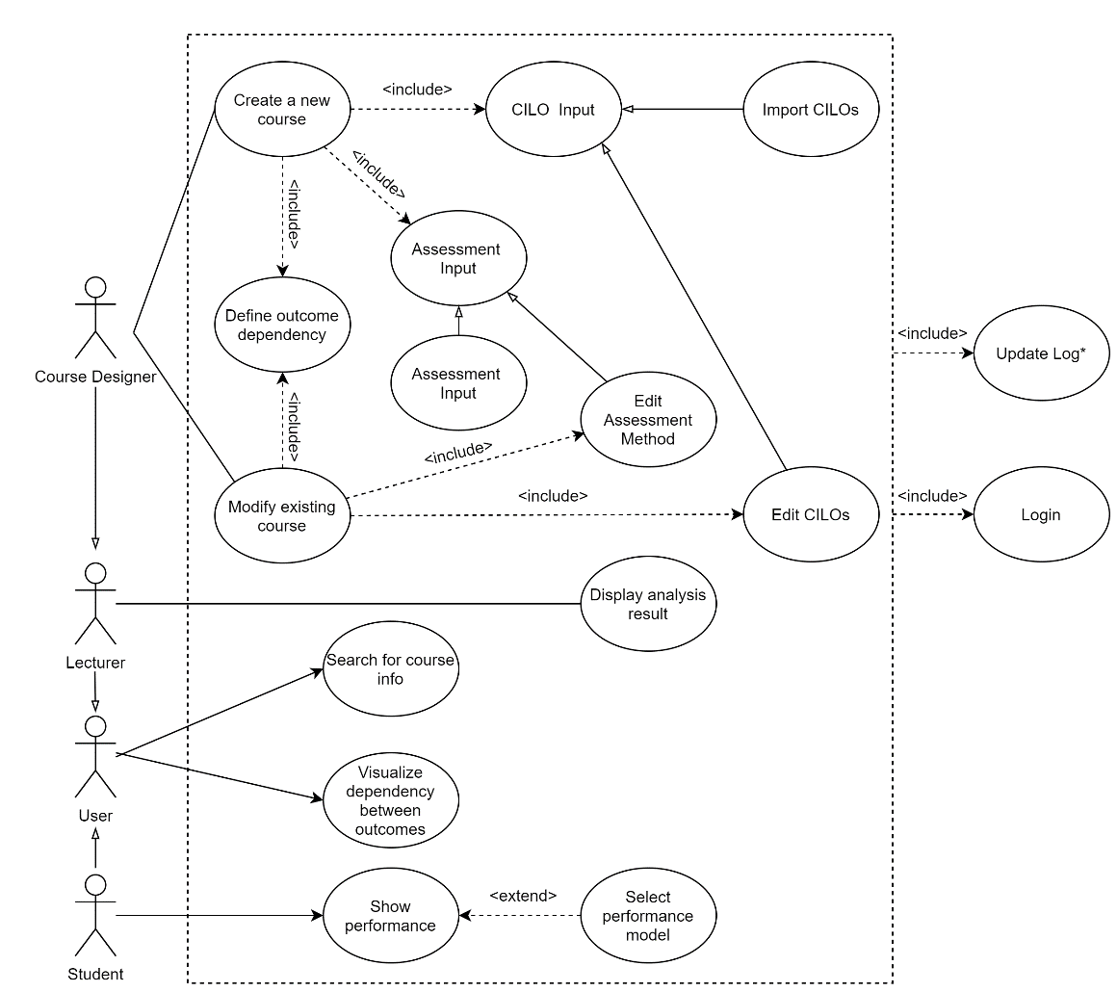

The following description is directly quoted from the *Software Development Workshop III Project V3*.

**For Lecturers (Course Designer)**

* Search for information about any course available in the system.
* Input or import, edit the CILOs of a course (refer to the syllabus sample document)
* Input or import, edit assessment methods of a course (refer to the syllabus sample document).
* Define the dependencies between CILOs of courses (CILOs of a course can depend on some CILOs of its prerequisite courses).
* Define the relationships between the learning outcomes (CILOs) and the course assessment and their percentages (refer to the syllabus document.
* Visualize the dependencies between learning outcomes across a degree.
* See what courses offer a particular learning outcome.

**For Normal Lectures (Non-Course Designer)**

* Search for information about any course available in the system.
* See the analysis results (not a MUST function).
* The lecturer can check the CILO achievements for a course (e.g., students’ average performance in one year on a CILO, comparing average performance for different years on a CILO).

**For Students**

* Visualize the dependencies between learning outcomes across a degree.
* See what courses offer a particular learning outcome.
* See his or her performance on various learning outcomes.

## User Classes and Characteristics

There are three classes of users, lecturers (course designers), regular lecturers (non-course designers), and students. They all come from the same university. The division of their classes is based on their role in the university. For the subset of functions allowed, please refer to section 2.2. They all have access to the Internet and are equipped with basic knowledge about how to use a browser on a computer.

## Operating Environment

**Back-end**

* Operating system: Windows 7 or above.

**Front-end**

* Chrome 89.0.4389.82 or above.

## Design and Implementation Constraints

This software system has no design and implementation constraint.

## User Documentation

No user manual or online help is provided.

## Assumptions and Dependencies

The server should be connected to the network where it will be accessible by the end-users. The users must be able to connect to the network that the server can be reached. The course designers should have access to Microsoft Excel, Google Sheets, Numbers, or other similar spreadsheet applications.

# System Features

## Login

3.1.1 Description and Priority

Users can log in to the system through the login page. This feature should have the highest priority since the user can perform no actions without logging into the system.

3.1.2 Stimulus/Response Sequences

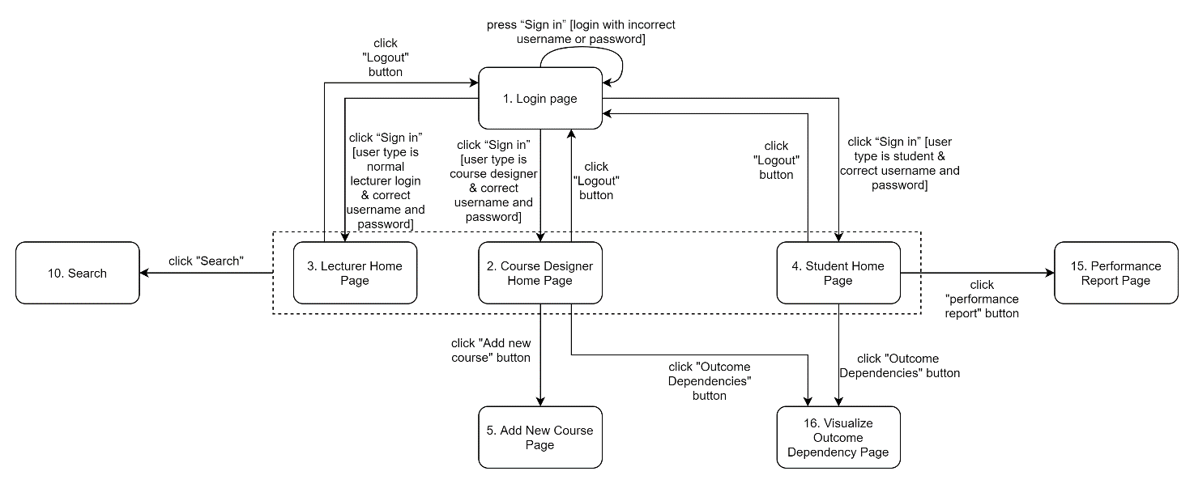

3.1.3 Functional Requirements

REQ-1: The username and password are stored and queried from the university’s security information database.

REQ-2: The university’s security information database can distinguish the type of user based on the username.

REQ-3: If the username and password are correct, the user will be taken to the appropriate page. For example, if the system identifies the user as a student, it will take the user to the student’s main page.

REQ-4: The logged-in user can click on the logout button from the dropdown menu at the top-right corner to log out of the system. After logging out, the user will be taken back to the login page.

REQ-5: After logging in, users should be welcomed by the “Courses” page.

## Create a New Course

3.2.1 Description and Priority

Course designers can create new courses using this feature. This feature is of high priority.

3.2.2 Stimulus/Response Sequences

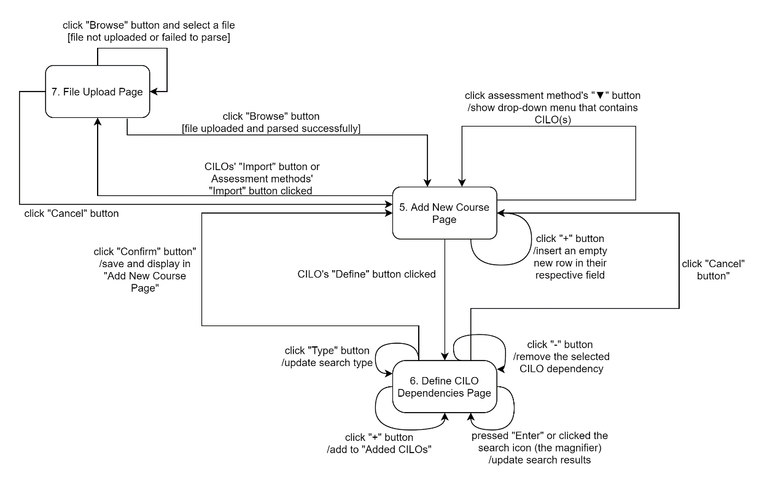

3.2.3 Functional Requirements

REQ-1: This feature is only accessible to the course designers.

REQ-2: Course designers can input information about the course (e.g., course name, course code, and course type).

REQ-3: Course designers can input or import (in the form of a .xlsx file), edit the CILOs of a course.

REQ-4: Course designers can input or import (in the form of a .xlsx file), edit the assessment methods and their percentages of the course.

REQ-5: Course designers can define the dependencies between CILOs of courses by searching and adding CILOs in existing courses.

REQ-6: Course designers can define the relationships between the CILOs and the course assessment methods and their percentages.

REQ-7: The operation should be logged.

## Edit Course CILOs and their Dependencies

3.3.1 Description and Priority

Course designers can use this feature to define and modify CILOs and their dependencies. This function has a high priority.

3.3.2 Stimulus/Response Sequences

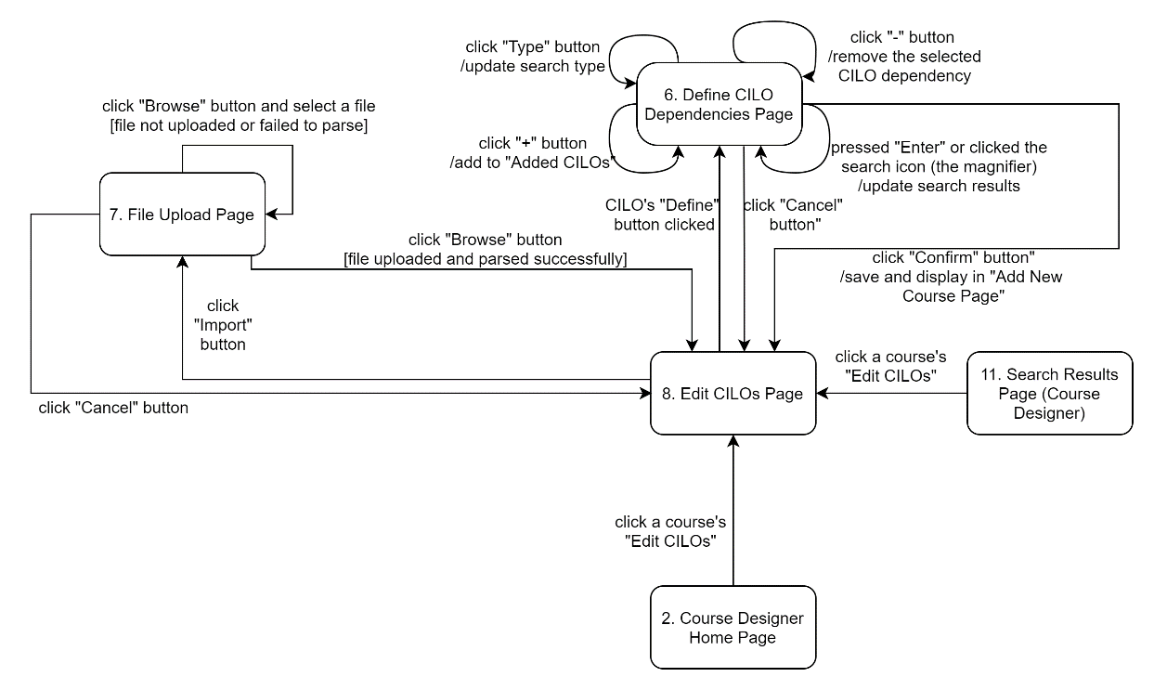

3.3.3 Functional Requirements

REQ-1: This feature can only be accessed by course designers.

REQ-2: Refer to REQ-3 in section 3.2.3.

REQ-3: Refer to REQ-5 in section 3.2.3.

REQ-4: When a CILO is changed, its previous version should remain in the system.

REQ-5: The operation should be logged.

## Edit Assessment Methods and their Relationships with CILOs

3.4.1 Description and Priority

Course designers can use this feature to define and modify assessment methods and their relationships with CILOs. This function has a high priority.

3.4.2 Stimulus/Response Sequences

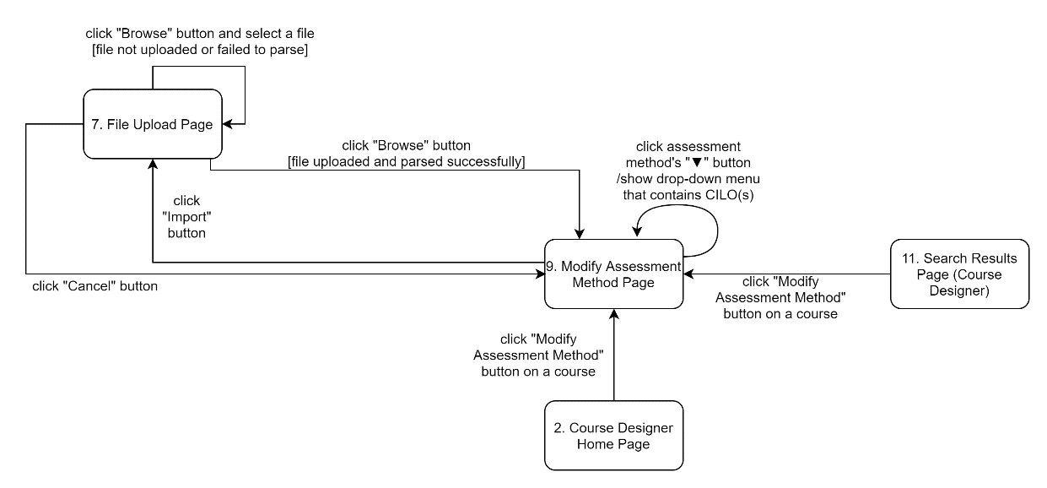

3.4.3 Functional Requirements

REQ-1: This feature can only be accessed by course designers

REQ-2: Refer to REQ-4 in section 3.2.3.

REQ-3: Refer to REQ-6 in section 3.2.3.

REQ-4: When a CILO is changed, its previous version should remain in the system.

REQ-5: The operation should be logged.

## Search

3.5.1 Description and Priority

Students, normal lecturers, and course designers can use this feature to search course/CILOs by inputting keywords. And find the prerequisite courses or the courses that use this course as a prerequisite by inputting the course's name. This function has a high priority.

3.5.2 Stimulus/Response Sequences

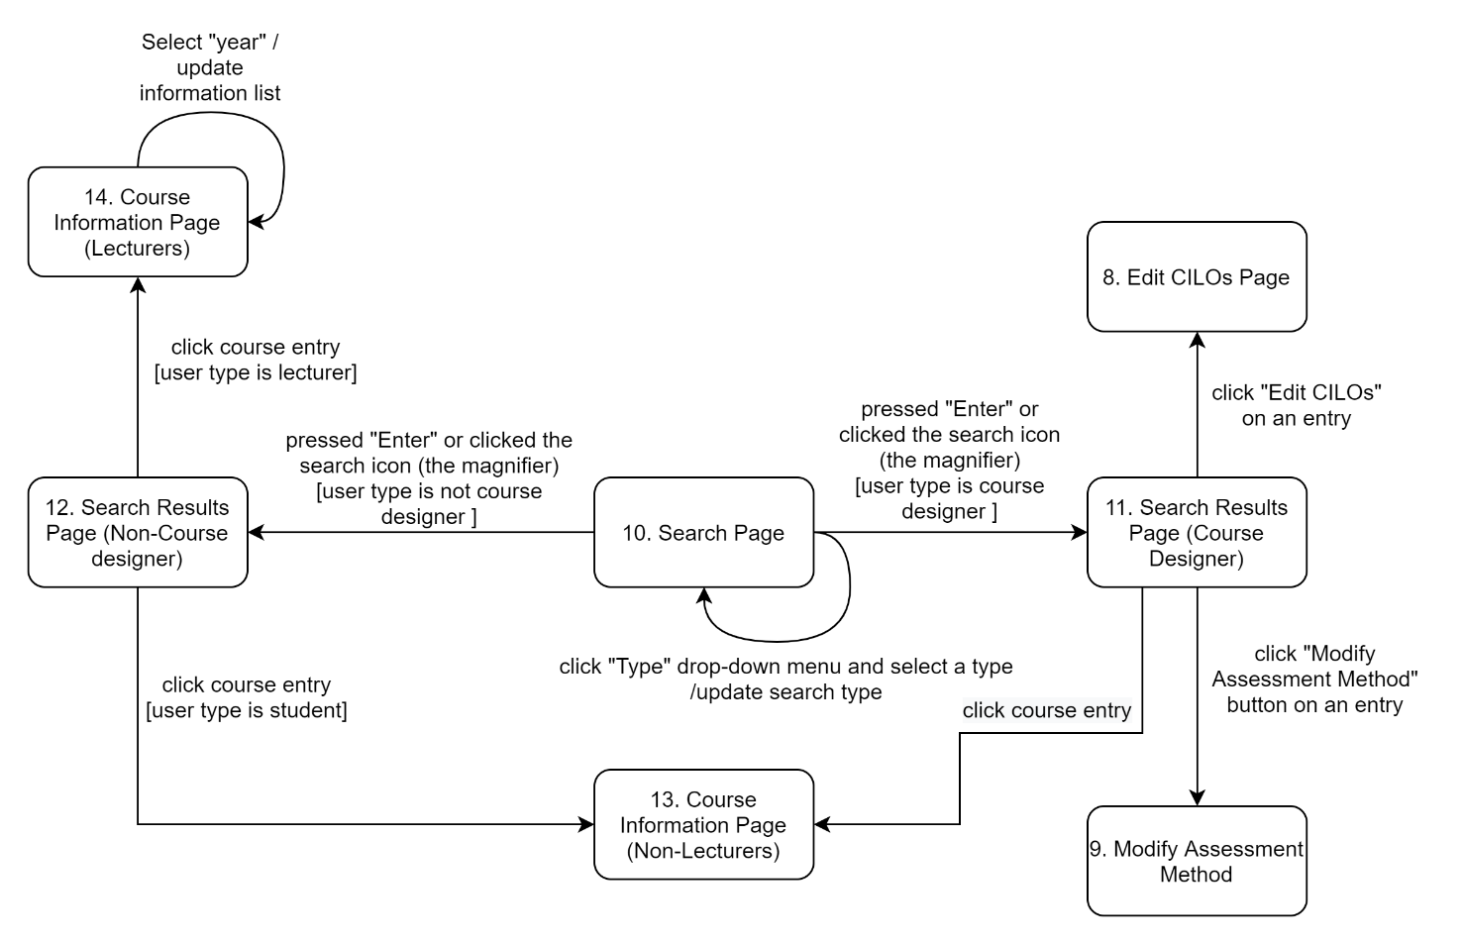

3.5.3 Functional Requirements

REQ-1: Users should be able to search by providing keywords to find the course or CILOs.

REQ-2: Clicking on one of the search results should show information about the course.

REQ-3: Course designers can choose “Edit CILOs” or “Modify Assessment Method” in the search result.

## Course Information

3.6.1 Description and Priority

Users can read the course’s basic information and analysis results in this feature. This function has a high priority.

3.6.2 Stimulus/Response Sequences

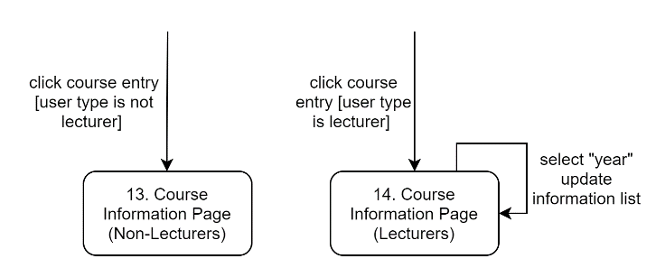

3.6.3 Functional Requirements

REQ-1: The user can arrive at the course information page from both the search results and the courses page (UI 2, 3, 4).

REQ-2: The course information page should show basic information about the course, including the CILOs, assessment methods, course name, course code, course type (MR, ME, or FE), the learning outcome of the courses, and the prerequisite courses or the courses that use this course as a prerequisite.

REQ-3: On the course information page, lecturers should be able to see the CILO achievements of a course in any given academic year.

## Visualize Outcome Dependencies

3.7.1 Description and Priority

This feature visualizes the dependencies between learning outcomes across a degree. This function priority is high.

3.7.2 Stimulus/Response Sequences

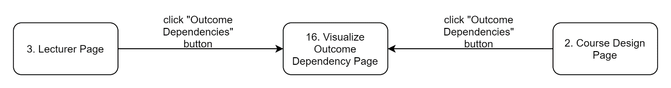

3.7.3 Functional Requirements

REQ-1: The feature can only be accessed by course designers and students.

REQ-2: Visualize the dependency between the learning outcomes across a degree.

## Performance Report

3.2.1 Description and Priority

Students can use this feature to see their performance on different CILOs. This function has a high priority.

3.2.2 Stimulus/Response Sequences

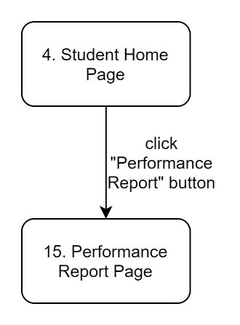

3.2.3 Functional Requirements

REQ-1: The grade report should come from the “Grade Report System.”

REQ-2: The calculation of the performance on a CILO should be consistent with the calculation method provided in Software Development Workshop III Project V3.

# External Interface Requirements

## User Interfaces

1. Login page

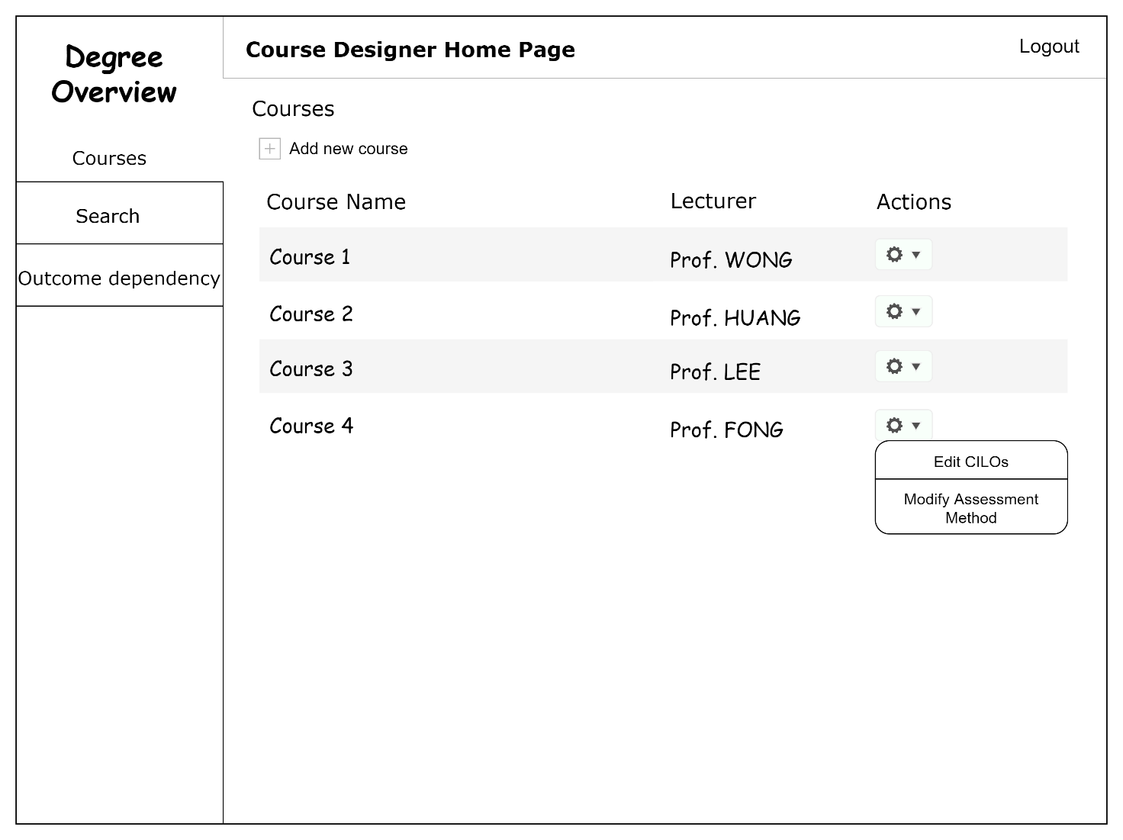

2. Course Designer Home Page

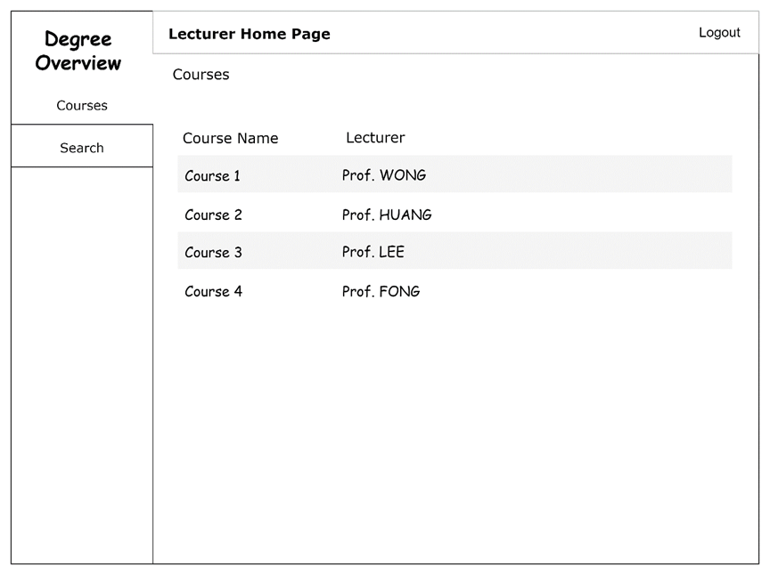

3. Lecturer Home Page

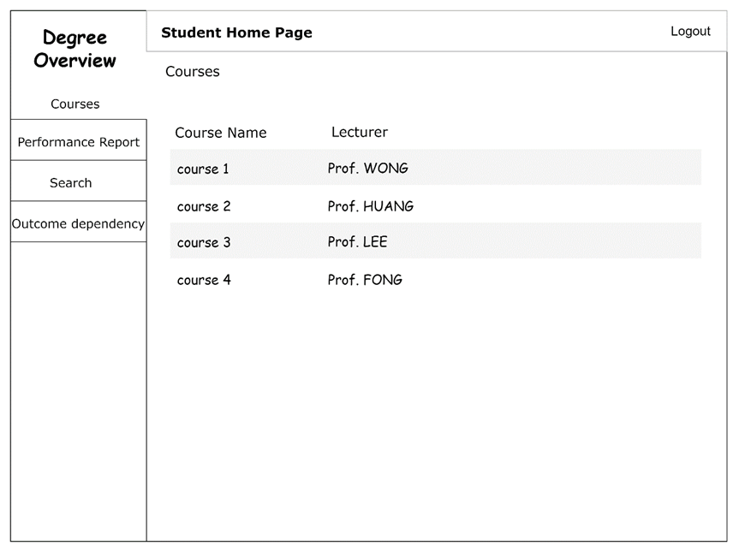

4. Student Home Page

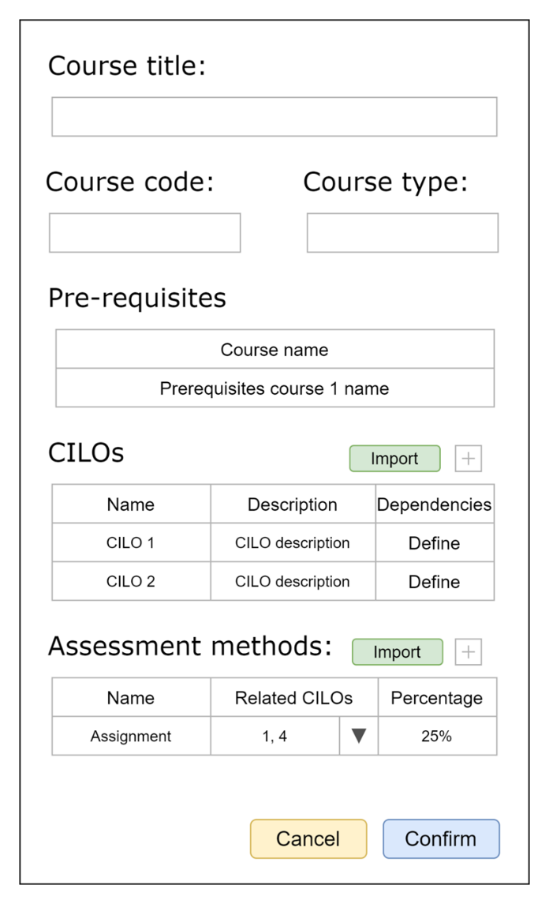

5. Add New Course Page

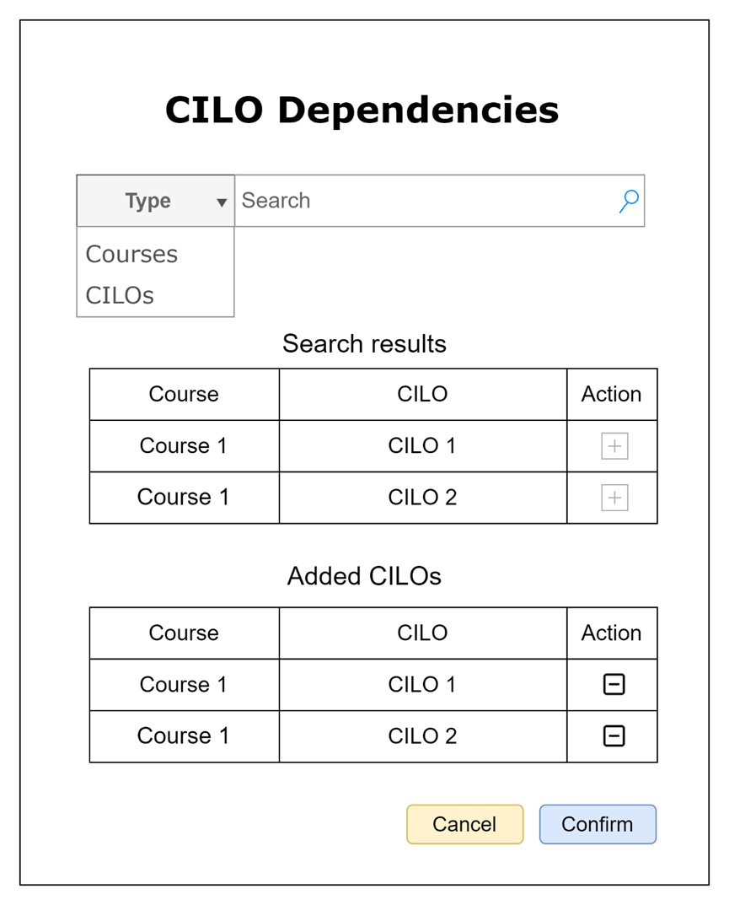

6. Define CILO Dependencies Page

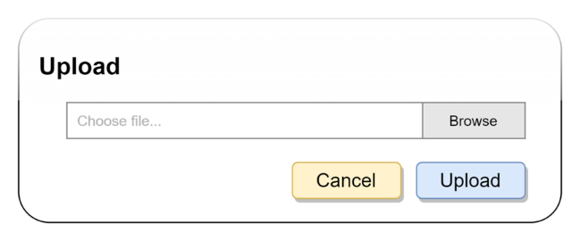

7. File upload page

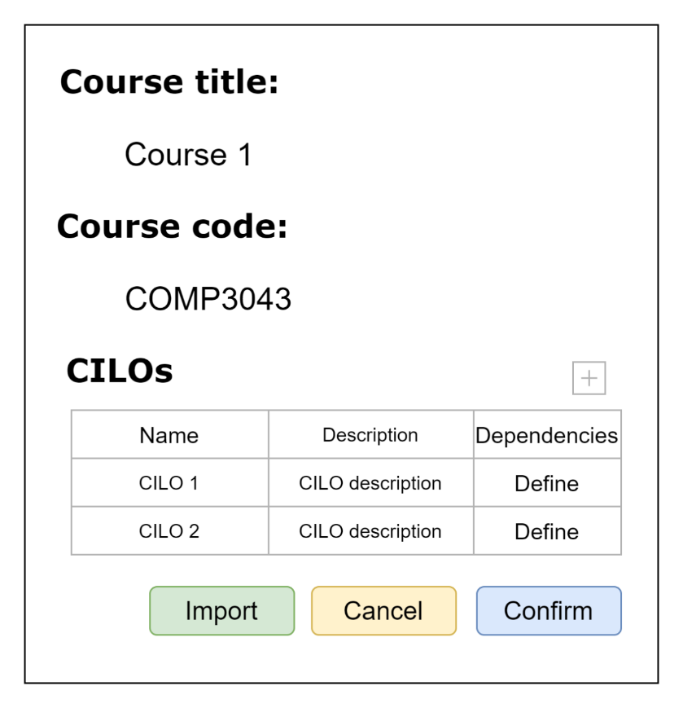

8. Edit CILOs Page

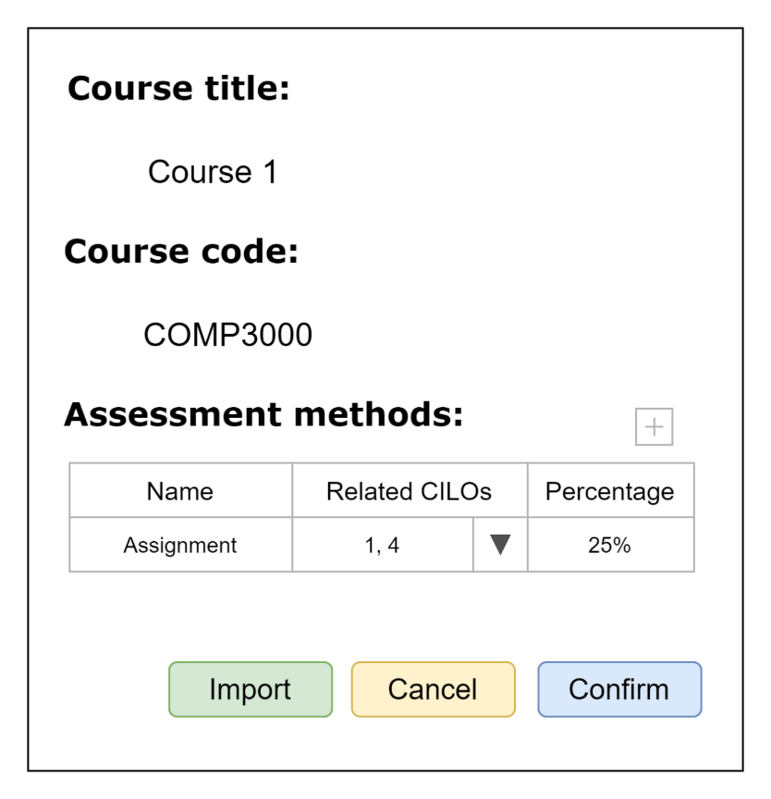

9. Modify Assessment Method Page

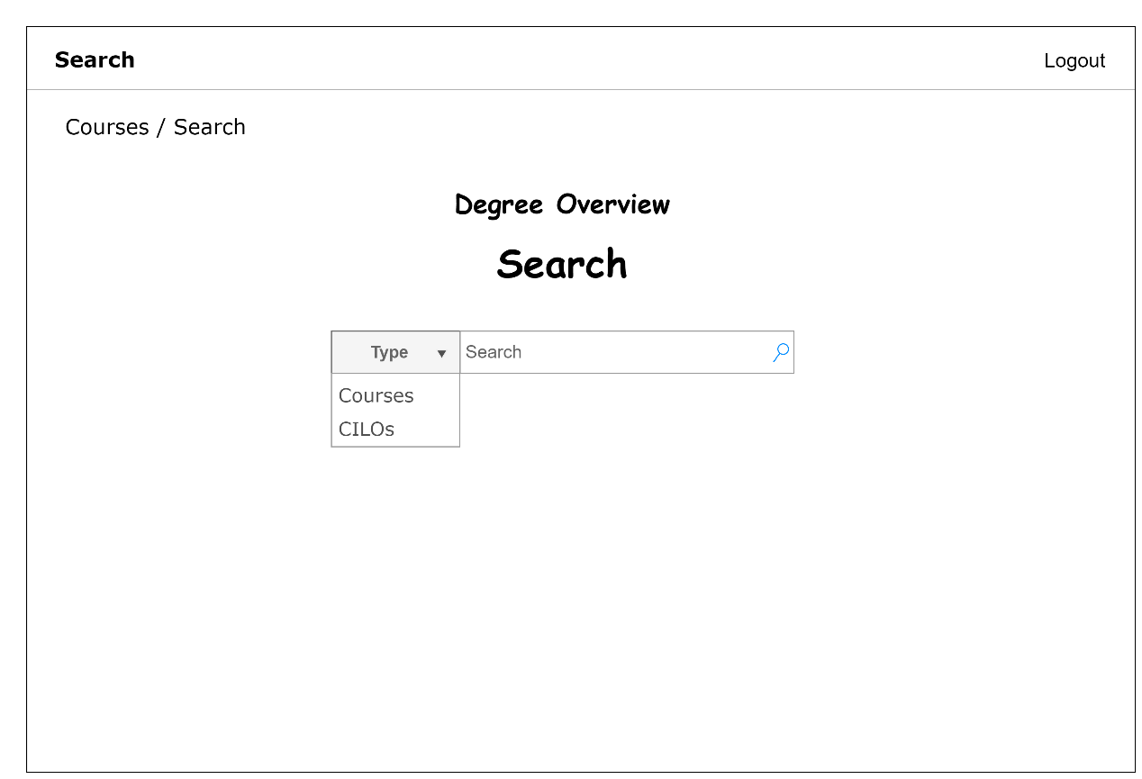

10. Search

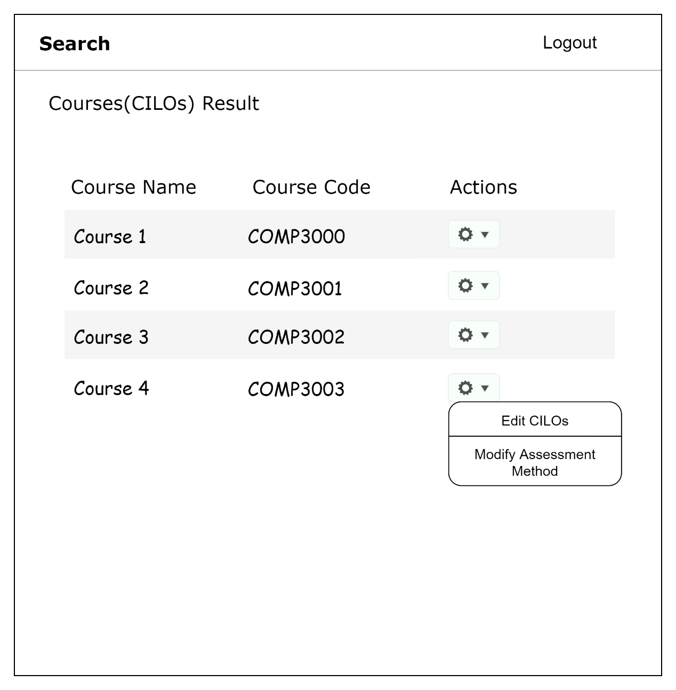

11. Search Results Page (Course Designer)

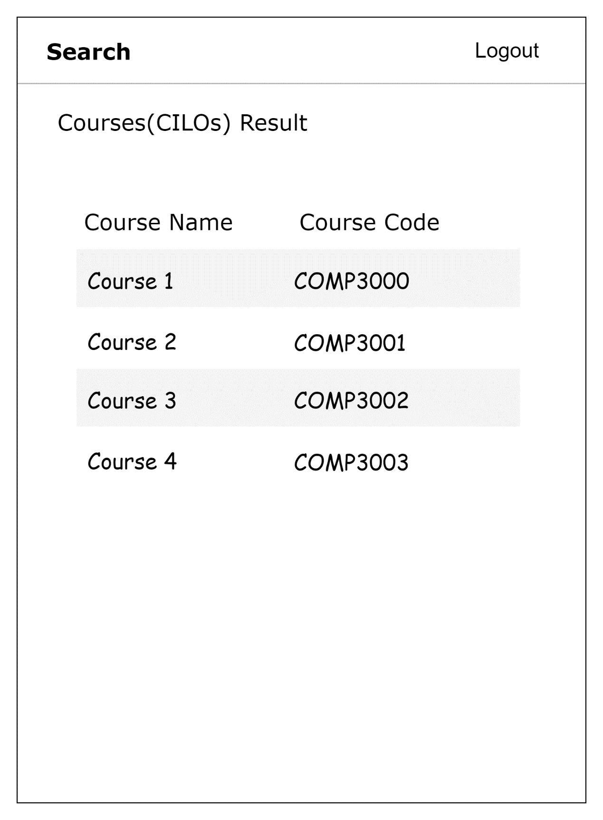

12. Search Results Page (Non-Course designer)

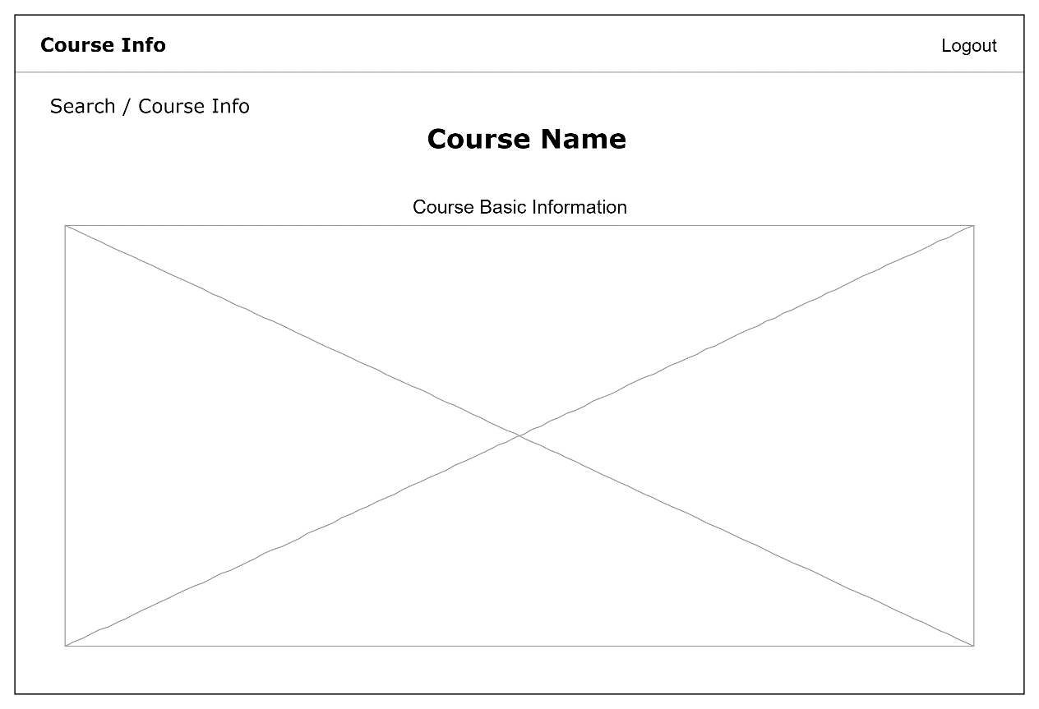

13. Course Information Page (Non-Lecturers)

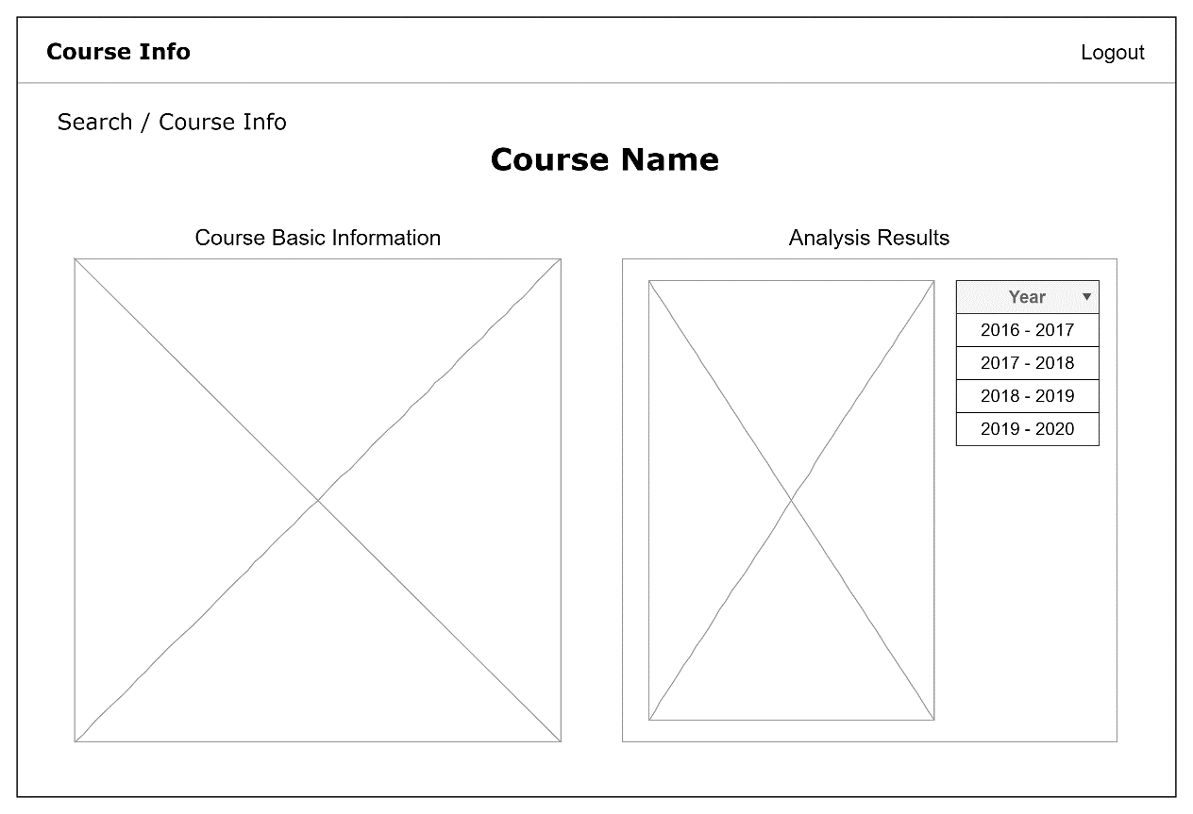

14. Course Information Page (Lecturers)

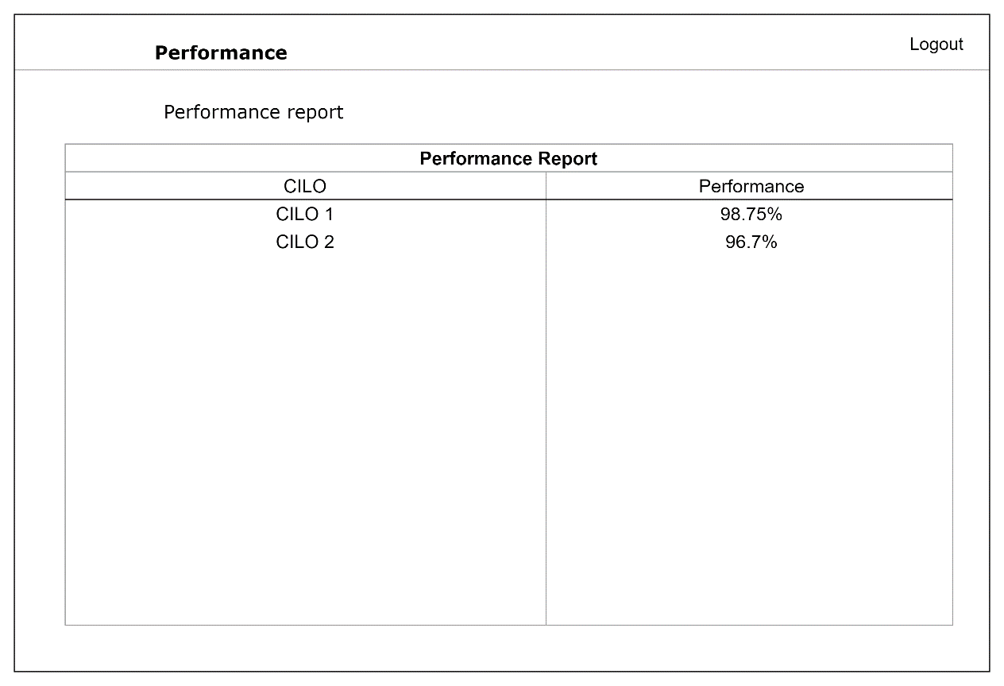

15. Performance Report Page

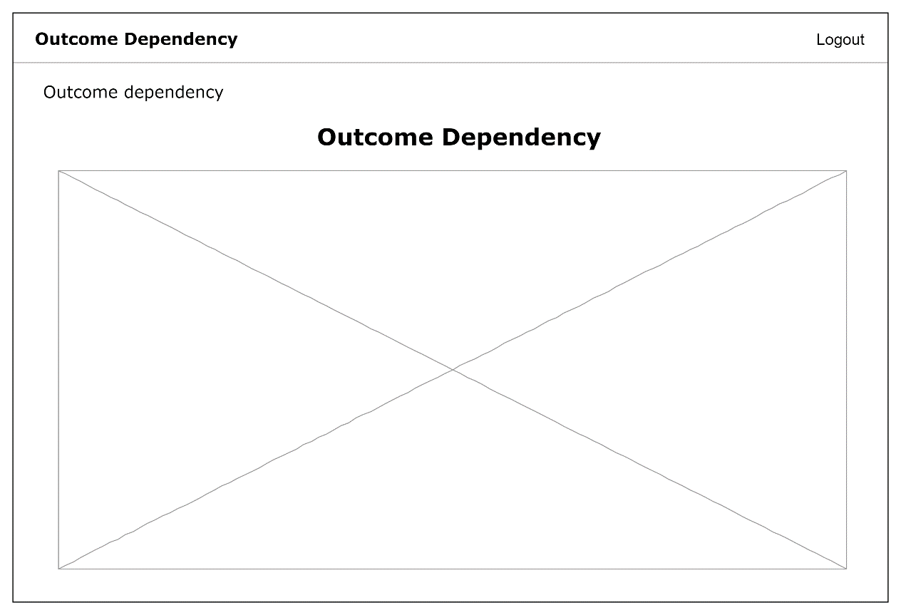

16. Visualize Outcome Dependency Page

## Hardware Interfaces

The software does not interact directly with any physical devices.

## Software Interfaces

**Database**

* The software requires a relational database to store all the information enclosed within the software. In this case, MySQL is preferred.

**Grade Report System**

* MySQL default socket interface.

**Security Information System**

* MySQL default socket interface.

**Web Server**

* The web server (e.g., Apache or Nginx), will forward traffic from port 80 or 443 to the desired running port of the software, and receive traffic from the application port.

## Communications Interfaces

Users can access the front-end via HTTP or HTTPS.

# Other Nonfunctional Requirements

## Performance Requirements

All operations should take less than one second to complete (ignoring network congestion).

## Safety Requirements

The system does not have any safety requirements.

## Security Requirements

The system should allow the user to configure TLS certificates on their own to secure all network traffic between the server and the users.

The system strictly separates all the interfaces which can be used by the front-end with the actual manipulation of the database to avoid malicious operations from the users.

## Software Quality Attributes

**Easy to use**

* The software must provide a friendly and easy-to-use graphical user interface.

**Scalability**

* The structure of the software must be modular enough that it is easy for any further developments.

**Security**

* The system should prevent unauthorized users or users without a particular privilege to access any information they are not supposed to access.

**Ethical**

* When accessing information of another system (e.g., the *security information database*), the software should only access the information it needs.
* The development team should have no access to the system once it is delivered.
* The development team should receive no statistics and collect no user data from the deployed system.

# Other Requirements

The system has no other requirements.

Appendix A: Glossary

HTTP: Hypertext Transfer Protocol

HTTPS: Hypertext Transfer Protocol Secure

Appendix B: Analysis Models

TO BE ADDED.

Appendix C: Issues List

None.